Connect to NOAA5006 VPN with cisco anyconnect: erav-e.noaa.gov/nesdis5006hq

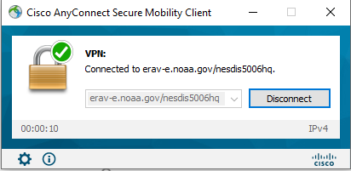

The NESDIS SSO Jira does not have NASA PIV cards or users in their ICAM. You need to validate using your NOAA login userid and password at the following site: [https://noaaonline.noaa.gov/login.html](https://gcc02.safelinks.protection.outlook.com/?url=https%3A%2F%2Fnoaaonline.noaa.gov%2Flogin.html&data=04%7C01%7Ctaft.r.irons%40nasa.gov%7C0a7dd1b9ac8f47098c4008d98e99961f%7C7005d45845be48ae8140d43da96dd17b%7C0%7C0%7C637697612579007867%7CUnknown%7CTWFpbGZsb3d8eyJWIjoiMC4wLjAwMDAiLCJQIjoiV2luMzIiLCJBTiI6Ik1haWwiLCJXVCI6Mn0%3D%7C1000&sdata=HysT9AjYTAxwFzquZcUTYu2dTO5VHXyQbsYEg8PEw7E%3D&reserved=0)

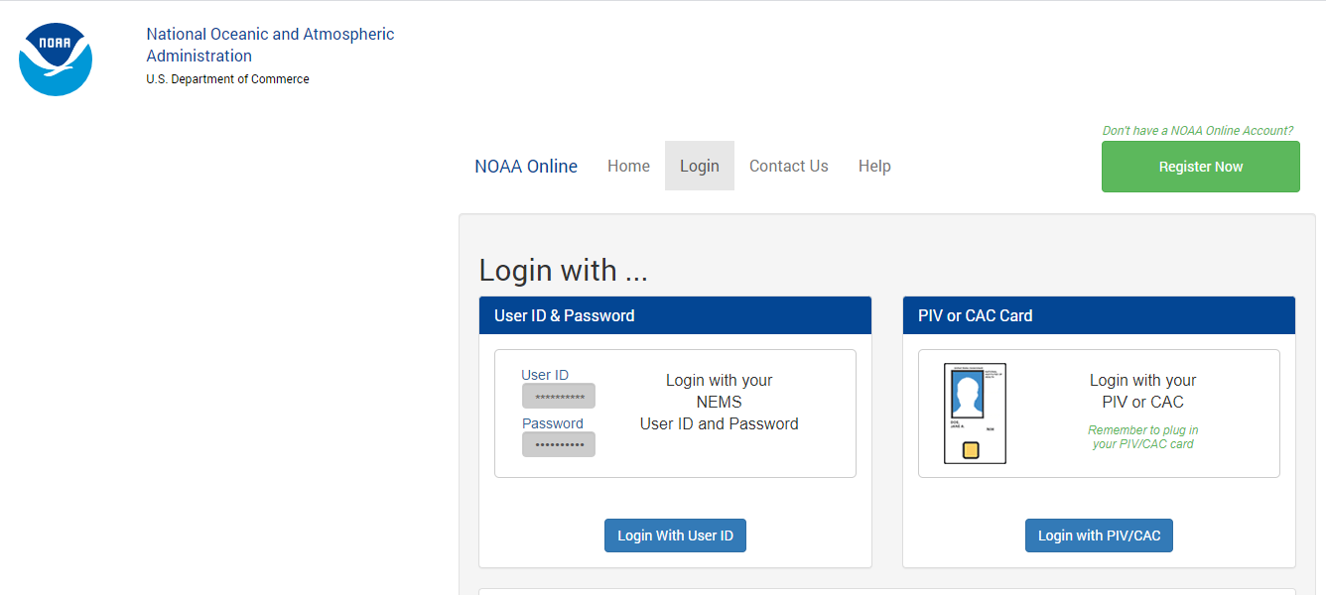

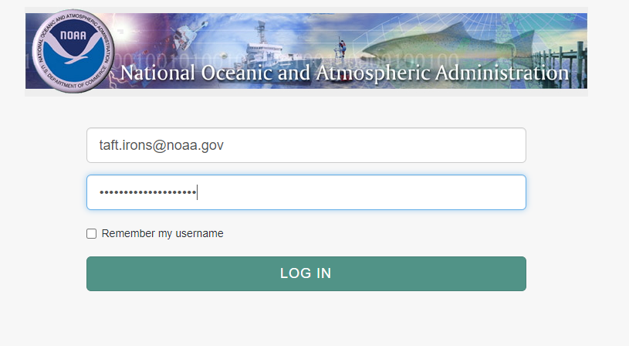

Click accept and you will see the following page, leave this up at all times when accessing Jira:

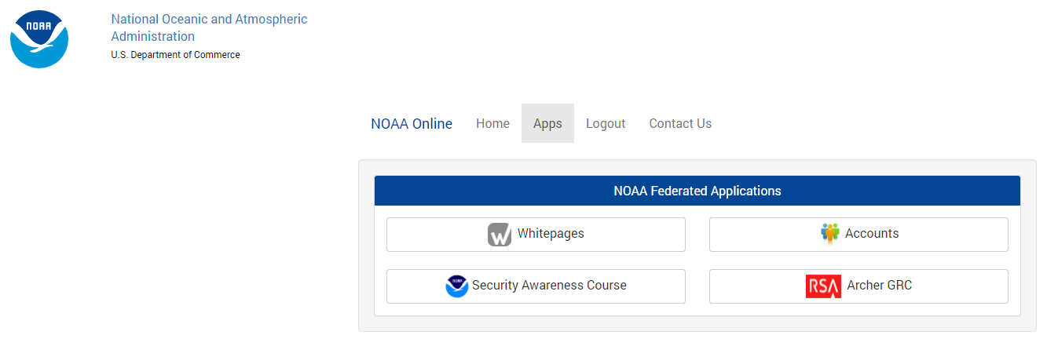

Now proceed to the Jira GOES-R Geocloud project at: <https://daksha.nesdis-hq.noaa.gov/jira/secure/Dashboard.jspa>

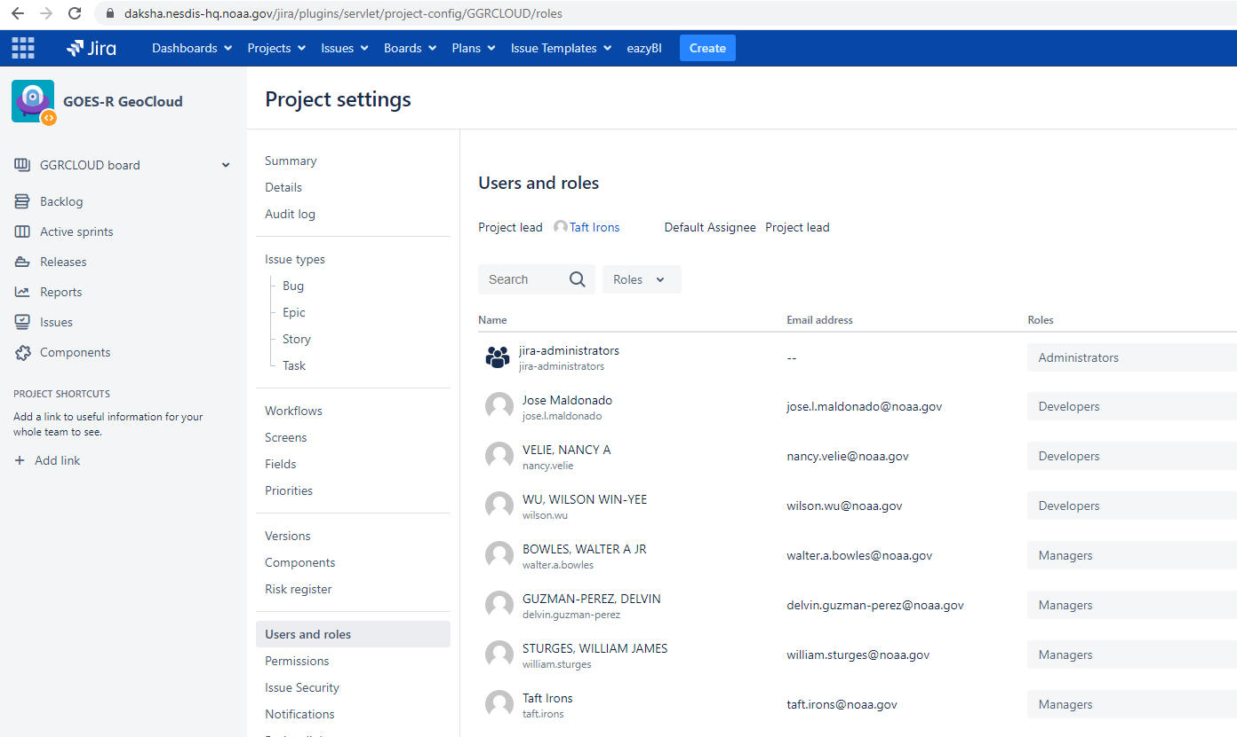

For any issues, email [Taft.R.Irons@nasa.gov](mailto:Taft.R.Irons@nasa.gov)

If it is a NOAA ICAM issue, contact [icam.id.team@noaa.gov](mailto:icam.id.team@noaa.gov)