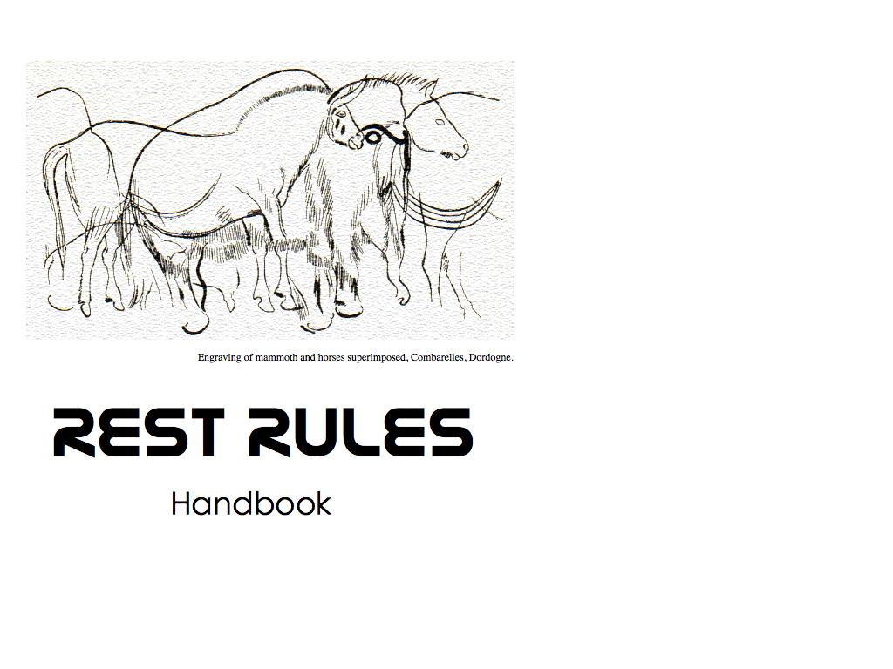
Draft Version 0.1.0
Contributors
• Pat Cappelaere, Vightel, pat@cappelaere.com
• Peter Rushforth, GeoConnections Peter.Rushforth@NRCan-RNCan.gc.ca
• Herve Caumont, Terradue herve.caumont@terradue.com
• Pedro Gonçalves, Terradue pedro.goncalves@terradue.com
• Volker Mische, Couchbase volker@couchbase.com
• Jeff Harrison, The Carbon Project jharrison@thecarbonproject.com
• Peter Vretanos, CubeWerx, pvmobile@cubewerx.com
Table of Contents
• End Point
– is valid and available
• Landing Page
– uses HTML5
– has links to Discovery Documents in Head
• OpenSearch Document
– is accessible
– HTML API Search
– Atom API Search
• Discovery Service
– Using_Google_API_Discovery_Document
– Using_Geoservices_Discovery_Catalog
– Using_Atompub
– No Discovery Document
• API Explorer
– link can be discovered
• Uniform Interface
– uses limited http verbs
– follows idempotence rules
• Content Negotiation
– uses Accept and Content-Type headers
– allows representation suffixes
– supports custom mime types
• Atom Feeds
– are available for lists of resources
– may be extended
– are extended using GData 2.0 protocol
• Compression
– should use GZIP as possible to reduce bandwidth
• Caching
– [Caching Headers] (#Caching_Caching)
– GData 2.0 Caching Headers
– Expires Headers
– Frontend Caching
• Hypermedia As The Engine Of State
– Embedded links in resources
– Defines links relations
• Security
– defines security protocol
• Cross Origin Resource Sharing
– supports cross-origin resource sharing

Valid Endpoint
As an External Application I want to make sure that the supplied end point url available So that can start interfacing with the web service
rationale We want to make sure that the web service exists and is available
Acceptance Criteria
Given a supplied url When I make a HEAD request Then it is valid and available
HTML5
As an External Application I want scrape the head of landing page So that I can find various document links
rationale This allows the application to mine to API. It requires the page to be properly formatted using HTML5.
Acceptance Criteria
Given a published web service endpoint When I access the landing page Then I can find an HTML5 namespace
Links to Discovery Documents in Head
As an External Application I want to find links to the various Discovery Documents So that I can understand API
rationale This allows an external application to get knowledge information regarding the service
Acceptance Criteria
Given the available web service endpoint
When I access the page Then I can find a link to the API discovery document And I can find a link to the OpenSearch document And I can find a link to the API Explorer document And I can find a link to the Documentation root And I can find a link to an atom feed
OpenSearch Document
As an External Application I want to find OpenSearch Document and Exercise search So that I can provide in-browser search to my users
rationale This allows a browser to provide in-line custom search
Acceptance Criteria
Given link to OpenSearch document When I follow the link Then OpenSearch Document is accessible
OpenSearch Document
As an External Application I want to find OpenSearch Document and Exercise search in HTML format So that I can can provide in-browser search to my users
rationale This allows a browser to provide in-line custom search
Acceptance Criteria
Given link to OpenSearch document When I follow the link and specify HTML output Then I should get results in html
OpenSearch Document
As an External Application I want to find OpenSearch Document and Exercise search in HTML format So that I can provide in-browser search to my users
rationale This allows a browser to provide in-line custom search
Acceptance Criteria
Given link to OpenSearch document When I follow the link and specify ATOM output Then I should get results in Atom format
Google API Discovery Document
As an External Application I want to find API Discovery Document So that I can can get knowledge of API
rationale This allows an application to get context information to access API
Acceptance Criteria
Given link to API Discovery document is accessible When I follow the link Then API Discovery Document is accessible
Acceptance Criteria
Given link to API Discovery document is accessible When I follow the link Then document should contain service metadata Then document should contain resource collections Then document should contain schemas Then document should contain security protocol
GeoServices API Discovery Document
As an External Application I want to find API Discovery Document So that I can can get knowledge of API
rationale This allows an application to get context information to access API
Acceptance Criteria
Given link to Catalog document is accessible When I follow the link Then Catalog Document is accessible And Catalog Document should be accessible with proper headers as well
Acceptance Criteria
Given link to API Discovery document is accessible When I follow the link Then document should contain service metadata Then document should contain service collections Then document should contain folders
Acceptance Criteria
Given link to API Discovery document is accessible When I follow the link Then document should point to service catalogs Then services should have their own description documents
Acceptance Criteria
Given link to Service document is accessible When I follow the link Then service description is available Then service description document should contain description Then service description document should contain list of published resources Then service description document should contain list of schemas Then service description document should contain security information
Acceptance Criteria
Given link to folder document is accessible When I follow the link Then service description is available Then folders should have their own description documents

AtomPub Service Discovery Document
As an External Application I want to find the AtomPub Service Discovery Document So that I can can get knowledge of API
rationale Follow the AtomPub Discovery Service - TO BE IMPLEMENTED

No Discovery Document
As an External Application I want to find API Discovery Document So that I can can get knowledge of API
rationale Not offering a discovery document is not very helpful! Sorry!

Limited HTTP Verbs
As an External Application I want to access resources using limited HTTP verbs So that I can can reduce interface complexity
rationale This allows an application to access resources in a limited and consistent manner
Acceptance Criteria
Given link to API Discovery document When I exercise API Then it uses limited http verbs
Idempotence
As an External Application I want to access resources using limited HTTP verbs So that I can can reduce interface complexity
**rationale This allows an application to access resources in a limited and consistent manner
Acceptance Criteria
Given link to API Discovery document When I exercise API Then it follows idempotence rules
Accepts and Content-Type Headers
As an External Application I want to control the output resource representation using Accept Headers So that I can can get a representation that I can process
rationale This allows an external application to get resources using a specific representation that may be easier to process.
Acceptance Criteria
Given list a resource urls and for each url When I set the header: Accept=text/html Then I obtain a resource with Content-Type=text/html
Acceptance Criteria
Given list a resource urls and for each url When I set the header: Accept=application/json Then I obtain a resource with Content-Type=application/json
Acceptance Criteria
Given list a resource urls and for each url When I set the header: Accept=application/rip_me (or any invalid mime type) Then I get a 406 error

Allow Representation Suffixes
As an External User I want to control the output resource representation using additional suffixes to the url So that I can can get a representation that I can process without using Accept Headers
rationale This allows an external user to get specific resource representation directly from the browser without using Accept headers
Acceptance Criteria
Given list a resource urls and for each url When I add .html extension to the URL Then I obtain a resource with Content-Type=text/html
Acceptance Criteria
Given list a resource urls and for each url When I add .json extension to the URL Then I obtain a resource with Content-Type=application/json
Acceptance Criteria
Given list a resource urls and for each url When I set .xyz or invalid extension to the URL Then I get a 406 error
Custom Mime Types
As an External Application I want to use Custom Mime Types for Content Negotiation So that I can can signify my acceptance of the interface and get proper resource representation
Acceptance Criteria
Given desire to use Content Negotiation to constrain the interface When I use Mime-types in Accept headers to determine the proper resource representation to retrieve Then I use one of the existing IANA-approved mime-types that service may support
Acceptance Criteria
Given desire to use custom media type for Content Negotiation to constrain the interface When I use custom Mime-type in Accept headers to determine the proper resource representation to output Then I use existing IANA-approved mime-types And I use a profile information attribute And I use a version information attribute And I use a describedby information attribute to point to an existing schema or profile document
rationale Content negotiation is important in some cases to specify a particular resource representation. The danger is to expand the concept to domain specific content. Some organizations have been pushing for custom media types of the form: application/vnd.myapp+json. This form extends the defined application/json mime-type and specifies the vendor-domain specific content vnd.myapp. This is problematic and turns out to hurt more than help content negotiation. It requires developers to change their browser settings to accept the new type and may require IT administrators to change firewall/proxy settings (which my cause some friction for highy secured environments). It will not scale easily. An alternate form may be used to alleviate those problems but does not seem to be of much value either if the application provides a schema or profile (which it should). This alternate form is, using a json example: application/json; profile='vnd.myapp'; version='1.0'; describedby='http://myapp.com/schema.rnc'. It is highly likely that the schema and/or profile will contain version information and all domain specific content. This schema and/or profile will have been accessed in the discovery phase making that over-specification unnecessary and overly complex with no value added.
Atom Feeds available for lists of resources
As a user I want to access list of resources using ATOM Format So that I can subscribe to and visualize the data feed in browser
rationale This allows a user to subscribe to particular data feed using a familiar NewsFeed Reader. If the feed is published to an aggregator, the user can receive notifications on changes.
Acceptance Criteria
Given list of resources, for each resource end point When I use GET with an application/atom+xml Accept Header Then server returns application/atom+xml content And it returns a valid feed And I can see that the feed is published to an aggregator
Atom Feeds may be extended
As a web service I want to extend ATOM protocol So that I can publish my custom resources in a meaningful way for external applications
rationale This allows an external application to mine the entries of a feed without having to parse the HTML content of the entry. ATOM Extensions can be done using the GData 2.0 or 1.0 protocol, or OData 1.0.
Atom Feeds can be extended using Gdata 2.0 protocol
As a server I want to extend the ATOM protocol using GData 2.0 So that I can publish my own resources in a meaningful way
rationale This allows an external Application to have access to the resources in a meaningful way without having to parse the HTML content
Acceptance Criteria
Given list of resources, for each resource end point When I use GET with an application/atom+xml Accept Header Then feed uses etag attribute And feed uses category tag and proper accessible schema And feed uses OpenSearch namespace and attributes And entries use etag attribute And entries use category tag and proper accessible format
Caching Headers
As a web service I want to pay attention to caching header information So that I can avoid sending superfluous data
rationale This reduces overall bandwidth.
GData 2.0 Caching Headers
As a web service I want to pay attention to caching header information So that I can avoid sending superfluous data
rationale This reduces overall bandwidth.
Acceptance Criteria
Given http transaction When using GData 2.0 protocol Then I should use GData-Version 2.0 in headers Then I should use ETag in headers Then I should use Last-Modified in headers Then I should return a 304 Not Modified if using If-None-Match Then I should return a 304 Not Modified if using Last-Modified Then I should support Conditional Replace with If-Match in headers Then I should support Conditional Replace with If-Match in headers Then I should support Override Replace with If-Match: * in headers Then I should support Conditional Delete with If-Match in headers Then I should support Delete with If-Match: * in headers

