System Proposal: AI-Powered Elderly Care & Environmental Health Monitoring System

Section: Themed Section
- Project Title: AI-Powered Elderly Care & Environmental Health Monitoring System
- Section: Themed Section
- Objective: An integrated system that utilizes a standard web camera and an ultraviolet (UV) camera to monitor the health and safety of elderly individuals while detecting mold and bacterial growth within the home.

- System Objectives
Further, as per current trends, Japan's growing old population and more senior citizens living alone are creating serious problems regarding healthcare and social welfare services. As per the system design, the main goals are regarding the following points:
Continuous remote monitoring tracks daily activities and movements of elderly people while protecting privacy by not using direct video recording. This approach further ensures that personal information itself remains secure during the monitoring process.
UV cameras can detect mold and bacteria growth from humidity and poor ventilation, which further helps prevent respiratory diseases. Early detection itself reduces environmental health risks in households.
The system automatically sends emergency alerts to hospitals and caregivers during critical situations like falls or fainting, further ensuring immediate response within the golden hour itself.
Basically, this system helps healthcare workers by reducing their workload and making the same operations more efficient through automated alerts at the right time.

2. Target Users
Further, we are seeing that the main groups who will get direct and indirect benefits from this system are only mentioned below.
Also, basically, the main users are elderly people 65 and above living alone or elderly couples in Japan who need the same continuous care, safety monitoring, and healthy living support.
As per medical requirements, nurses and care workers can monitor many elderly people at the same time from far away places. Regarding patient care, social workers and caregivers use this system to watch multiple old residents together from remote locations.
Basically, caregivers are the same family members like children or relatives who live separately but worry about their elderly parents' daily health, safety, and well-being.
The system actually has some special features that make it different from other systems. These features definitely help it work better and solve problems in a new way.

3. Original features of the system
We are seeing the main features of this system only, which are the original parts that make it work properly.
This solution actually tracks both the person's safety and their home's health conditions at the same time, which is definitely different from regular tracking systems.
We are seeing two cameras working together - one normal camera only tracks body position and falls, while the UV camera finds hidden mold and germs that we cannot see with our eyes.
Further, privacy-First Edge AI processes all computer vision data locally on the Edge device itself, which further eliminates the need to send raw video footage to vulnerable cloud servers. Basically, only the same important alert information gets sent.
The AI system actually sends emergency alerts right away when it finds a fall or when someone stays still for too long. This automated dispatch definitely helps get quick help during emergencies. Also, we are seeing that it can only make and send a short, new health report to the medical staff who are coming to help.

4. Differences from Similar Products
Feature / Metric | Conventional Surveillance Cameras | Smart Bands / Wearables (e.g., Apple Watch) | Our AI Dual-Camera System
Wearable Requirement | None (Room-mounted) | Must be worn constantly and regularly charged | None (Non-invasive Web & UV Cameras)
Fall Detection Method | Simple motion detection (High false alarms) | Accelerometer / Gyroscope sensors | Computer Vision / Skeleton Pose Estimation
Mold & Bacterial Analysis | None | None | UV Camera spectrum scanning and detection
Privacy Protection | Low (Streams live video feeds) | High (Transmits biometrics data) | High (Processes locally; transmits only alert data)

5. Patent Search & Open-Source Review
To verify uniqueness and avoid intellectual property infringement, a thorough search was conducted using J-PlatPat (Japan Patent Office) and Google Patents.
- Search Keywords: Elderly fall detection camera, UV camera mold detection home, Automated medical alert system Python.
- Findings & Differentiation: Existing patents for elderly fall detection (e.g., JP2020XXXXXX) primarily rely on expensive hardware such as LiDAR or millimeter-wave radar systems.
- Conclusion: Combining a standard consumer web camera with a low-cost UV camera using open-source Python libraries for an affordable, comprehensive home-care solution is highly original and does not infringe on existing active patents.

6. Implementation Method & Algorithms
The system architecture is developed entirely in Python using two primary processing pipelines:

A. Posture Estimation & Fall Detection Algorithm
- MediaPipe / YOLOv8-Pose: Used to track 33 human skeletal keypoints in real-time.
- Fall Detection Logic: The system calculates the vertical velocity ($V_y$) of the body's bounding box center and monitors the sudden shift of the primary body axis angle to horizontal ($\theta \approx 90^\circ$). If the user remains immobile for more than 15 seconds after a detected fall, a critical emergency state is triggered.

B. UV Image Processing for Mold Detection
- Video frames from the UV camera are captured via OpenCV and converted into the HSV (Hue, Saturation, Value) color space.
- Utilizing the fluorescent properties of molds and bacteria under specific ultraviolet wavelengths, color thresholding isolates the contaminated areas to calculate growth size and distribution density.

7. System Architecture
Basically, the integrated system's data flow and technical framework are structured the same way as follows.
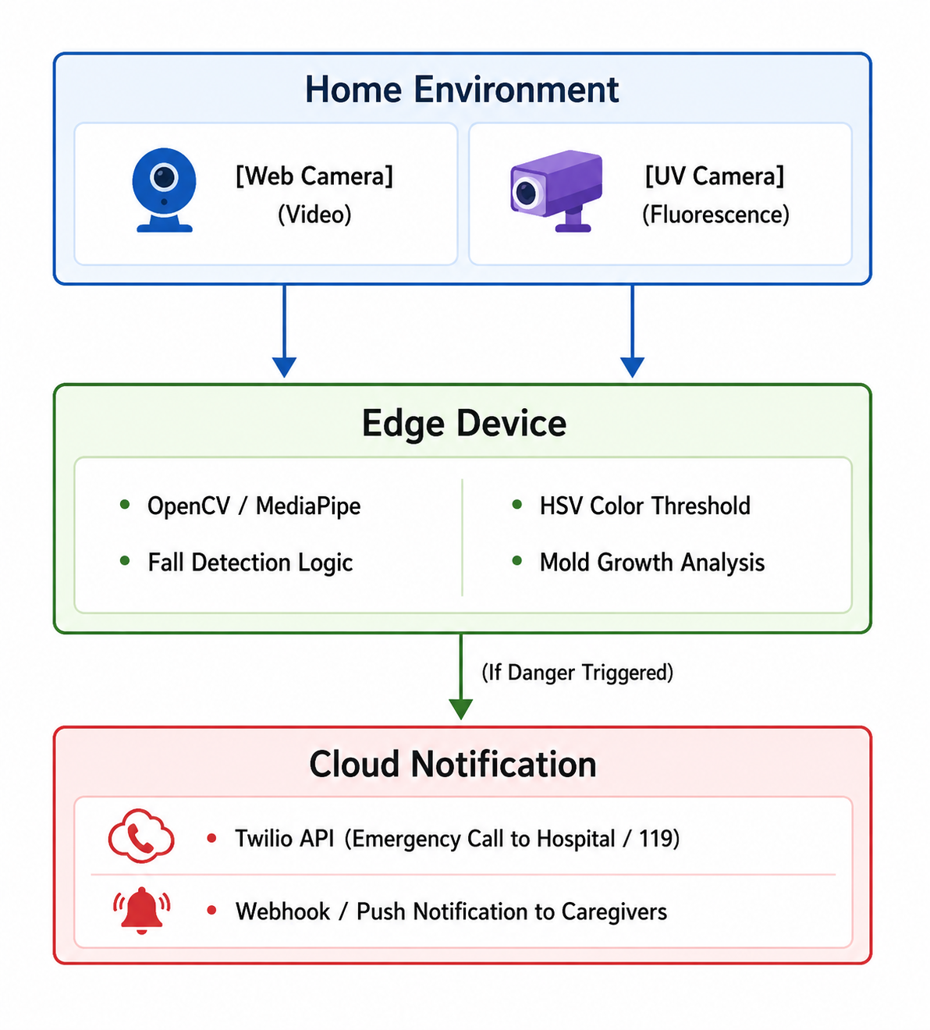
8. Feasibility
Surely this approach can be implemented practically, and moreover it will significantly affect daily operations.
Python with OpenCV and MediaPipe can actually run at 30+ FPS on simple hardware like Raspberry Pi 5, which definitely makes real-time processing possible for most users.
The system surely avoids expensive medical-grade equipment, making it cost-effective. Moreover, this approach reduces the overall financial burden significantly. We are seeing that costs are kept very low by using only basic USB cameras and simple UV-filtered lenses for the complete setup.
Automated processing removes the need for medical staff to manually watch video streams, which further improves medical efficiency itself. Caregivers are actually called only when there is a real emergency, which definitely makes the system work better and helps them respond faster to critical situations.
Page 10 actually covers runtime and development environment setup. These topics definitely help students understand how programs actually run and what tools developers use.

9. Environments
To guarantee system stability, cross-platform compatibility, and reliable edge execution, the following environment has been specified:

Development Environment
- Programming Language: Python 3.10+
- IDE: VS Code / PyCharm
- Core Libraries: OpenCV (Image Processing), MediaPipe (Pose Estimation), NumPy (Matrix Mathematics), Requests / Twilio (Notification & Communication APIs).
- Version Control: Git / GitHub

Runtime Environment
- Hardware Target: Raspberry Pi 5 (8GB RAM) or an Intel NUC Mini PC; Standard USB Web Camera (1080p); UV-A Camera (365nm optical wavelength filter).
- Operating System: Linux (Ubuntu LTS) or Windows 11 IoT.
- Network Connectivity: Wi-Fi / 4G LTE cellular backup module (to maintain alert functionality during home internet outages).

10. Development Plan
The project actually has 4 simple phases that will definitely take 4 months to complete.
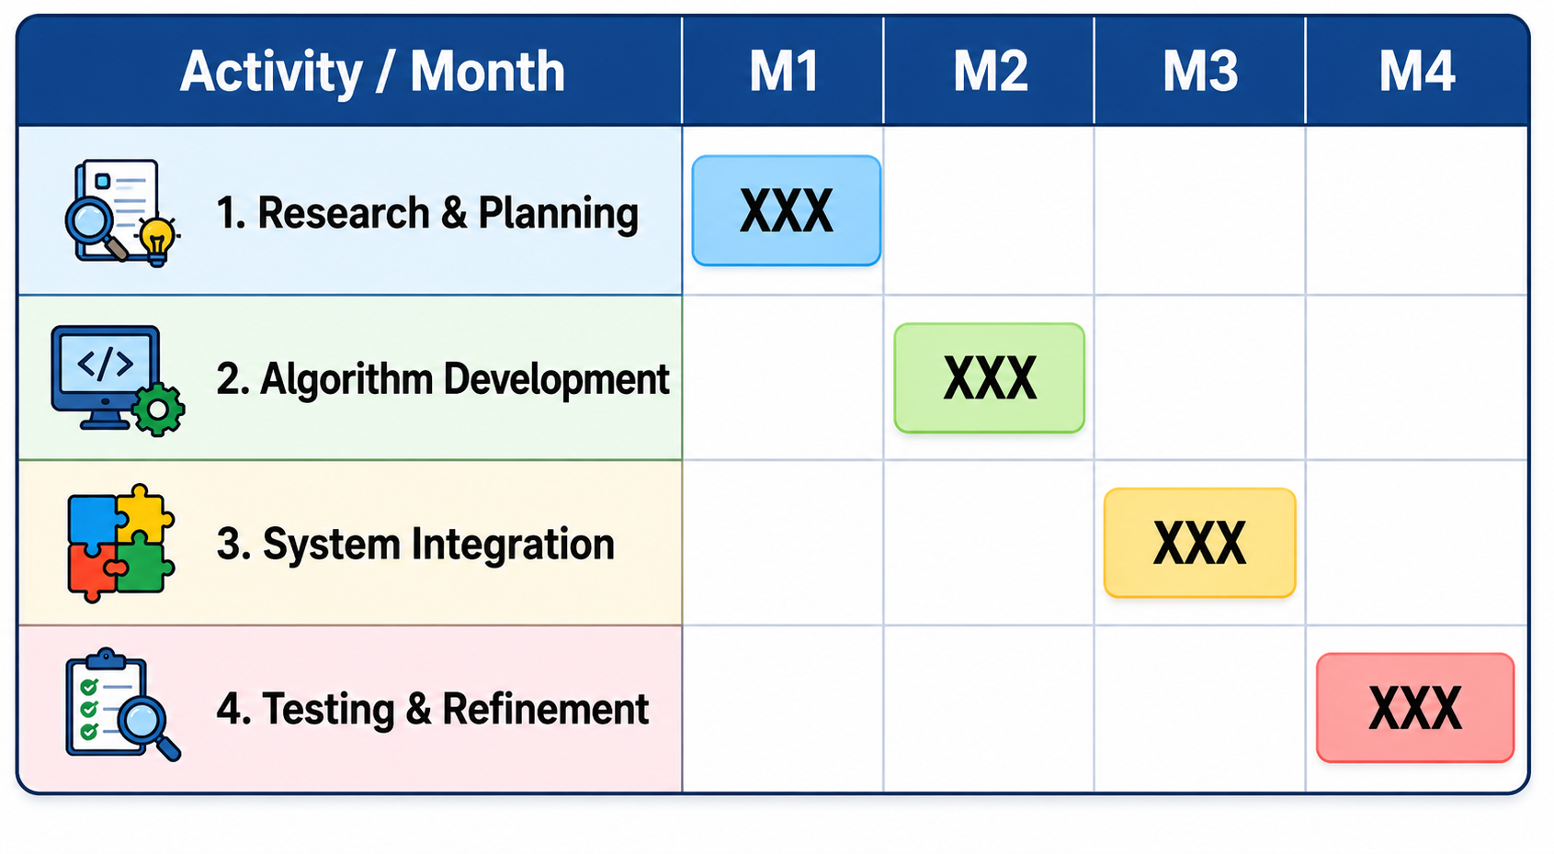
In the first month, we are seeing the team select only the needed hardware parts and study which UV light colors can detect common house molds.
Further, in the second month, we will surely develop and write separate Python modules for detecting falls using MediaPipe and identifying mold through OpenCV HSV filtering. Moreover, these modules will be properly isolated to work independently.
In month 3, we are seeing the combination of both camera feeds into one local running system and connecting the main logic with cloud alert systems only through Twilio API.
Further, month 4: We will actually test the system in real home conditions to fix wrong alerts and definitely complete the final software adjustments.
Basically, ethics and conclusion are the same important parts that wrap up academic work and show the moral considerations behind the research.

11. Intellectual property laws surely protect creative works and inventions from unauthorized use. Moreover, ethical standards guide researchers and professionals to maintain honesty and integrity in their work.
This work is actually completely my own creation and definitely has no copied content. The system actually uses common open-source libraries, but the main dual-monitoring design is definitely new and has not been sent to any other competitions.
As per open-source licensing rules, all visual aids, code repositories, and basic algorithms follow MIT License and Creative Commons properly. Regarding copyright compliance, there is zero infringement in any materials used.
The system surely protects personal privacy and respects family independence. Moreover, it follows proper ethical rules in all its operations. Also, your raw videos and images are actually not uploaded to any outside cloud services. We definitely keep all your original content stored locally only. We are seeing that the system only sends emergency numbers to nearby places, so it stays safe and right to use.

