Project Output Document
Project-02: Deploy Your Code on a Docker Container using Jenkins on AWS
Application: kanban-style-task-manager
Repository: https://github.com/capricarun/kanban-dashboard
Prepared by: Arun Kumar R
Date: 25 August 2026

Contents
- 1. Objective & Architecture
- 2. Part A - Application Setup (Local Run)
- 3. Part B - AWS Account & EC2 Setup (from scratch)
- 4. Part C - Install Docker & Jenkins on EC2
- 5. Part D - Docker Containerization (Dockerfile Walkthrough)
- 6. Part E - Docker Security
- 7. Part F - Container Registry (Amazon ECR) & Versioning
- 8. Part G - Jenkins Configuration
- 9. Part H - CI/CD Pipeline (Jenkinsfile Walkthrough)
- 10. Part I - GitHub Webhook
- 11. Part J - Health Check & Validation
- 12. Part K - Logging & Monitoring
- 13. Part L - Docker Resource Limits
- 14. Part M - Zero/Minimal Downtime Deployment (Bonus)
- 15. Deliverables & Full Screenshot/Proof Checklist

1. Objective & Architecture
Deploy the kanban-style-task-manager application using Docker, Jenkins, and AWS EC2, and implement a fully automated CI/CD workflow from GitHub to production. Once the pipeline is live, no manual deployment step should be required - a git push alone takes new code to a running, health-checked container.

Pipeline flow
GitHub --push--> Jenkins (webhook trigger)
-> Checkout source
-> docker build (multi-stage) + tag with build number / git SHA
-> docker push to Amazon ECR
-> deploy.sh on EC2 (blue/green container swap)
-> Health check new container BEFORE routing traffic to it
-> Mark pipeline pass/fail; auto-rollback on failure

What you will end up with
- One EC2 instance running both Jenkins (port 8080) and the deployed app container (port 8081).
- An Amazon ECR repository holding versioned images: app:<build-number> and app:<git-sha>.
- A Jenkins Pipeline job that builds automatically on every GitHub push via a webhook.
- A blue/green deploy script that never exposes a broken build to users.

2. Part A - Application Setup (Local Run)
Do this once on your own laptop first, before touching Docker, to confirm the app itself is healthy.

Steps
- Clone the repository:
git clone https://github.com/Vennilavanguvi/kanban-dashboard.git
cd kanban-dashboard
- Install dependencies:
npm install
- Run it in dev mode and open it in a browser:
npm run dev
# Vite prints a Local URL, typically http://localhost:5173/
- Or build the production bundle and preview it exactly as it will run in the container:
npm run build
npm run preview -- --port 4173
curl -I http://localhost:4173/

App facts you need for the rest of this document
- Stack: React 18 + TypeScript + Vite + Tailwind CSS
- Backend: None - it is a pure static single-page app
- Env variables: None required
- Data storage: Browser localStorage (client-side only)
- Build command: npm run build (outputs static files to ./dist)
- App port in container: 8080 (served by nginx)
- Public app port on EC2: 8081 (mapped to the container via the edge router)
Proof / screenshot to capture: Terminal showing npm run build succeeding, plus a browser screenshot (or curl -I output showing HTTP/1.1 200) of the running kanban board.
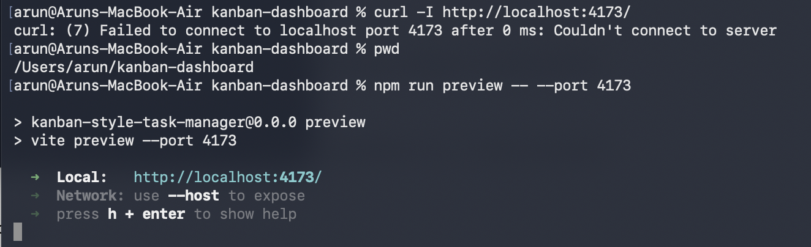

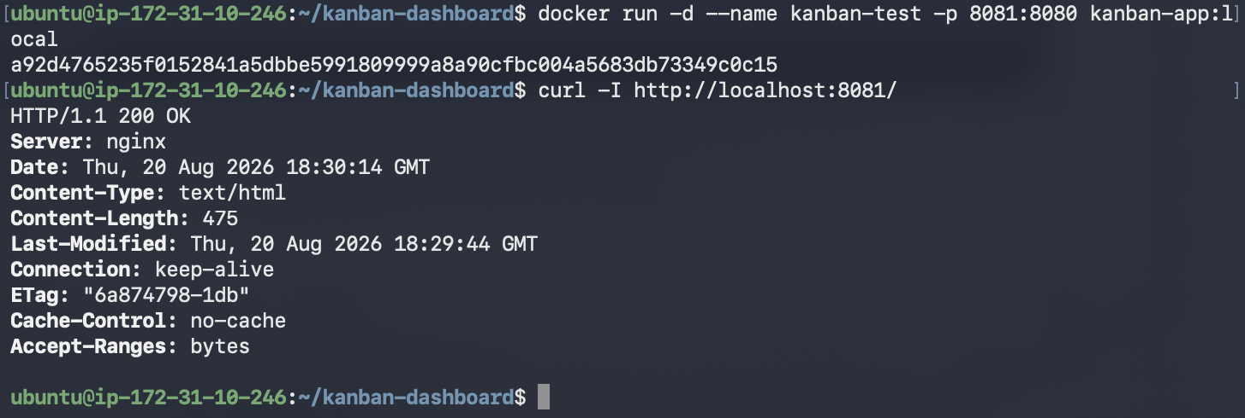

3. Part B - AWS Account & EC2 Setup (from scratch)

B.1 Create an AWS account
- Go to https://aws.amazon.com/ and click Create an AWS Account.
- Provide an email, password, and account name; verify the email.
- Add a payment method (required even for free-tier) and complete identity verification (phone OTP).
- Choose the Basic support plan (free).
Note: If your course provides an AWS Academy / Vocareum lab account instead, log in through the course portal - IAM user/role creation may be restricted there; see the Troubleshooting section for the workaround.

B.2 Choose an instance size
This one EC2 instance will run Jenkins AND Docker AND your app container. Jenkins alone is comfortable with 2 GB+ RAM.
- t3.micro (1 vCPU / 1 GB) - free tier: Works for a demo but is tight; add a 2 GB swap file (steps below) or Jenkins may stall during builds.
- t3.small (2 vCPU / 2 GB) - recommended: Smooth experience for this project; low cost if you're outside free tier.
- t3.medium (2 vCPU / 4 GB): Most comfortable if you plan to keep experimenting.

B.3 Launch the EC2 instance
- Open the EC2 console -> Launch instance.
- Name: kanban-cicd-host.
- AMI: Ubuntu Server 22.04 LTS (or Amazon Linux 2023 - this guide uses Ubuntu commands).
- Instance type: t3.small (or your chosen size above).
- Key pair: create a new key pair (e.g. kanban-key.pem), download it, and keep it safe - you cannot download it again.
- Network settings -> Edit security group rules, add:
  - SSH, TCP 22, source = My IP
  - Custom TCP, port 8080, source = My IP (Jenkins UI)
  - Custom TCP, port 8081, source = 0.0.0.0/0 (the app - public so anyone can view your kanban board)
Note: Only open exactly these three ports. Do not open the app's internal port 8080-inside-the-container to the internet directly - only the router's 8081 should be public.
- Storage: 20 GiB gp3 is plenty.
- Click Launch instance, wait until Status checks show 2/2 passed.
- Note the Public IPv4 address - you'll use it throughout this document as 13.204.63.192.
Proof / screenshot to capture: Screenshot of the EC2 console showing the running instance, its public IP, and the Security Group inbound rules (22 / 8080 / 8081).

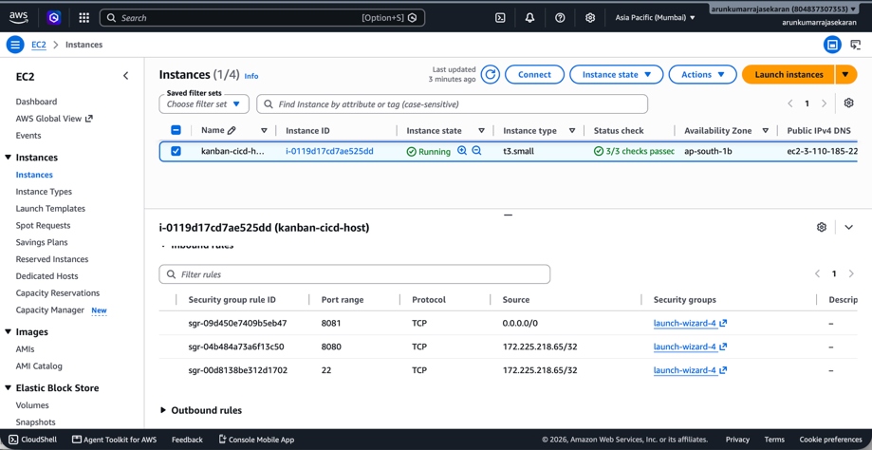

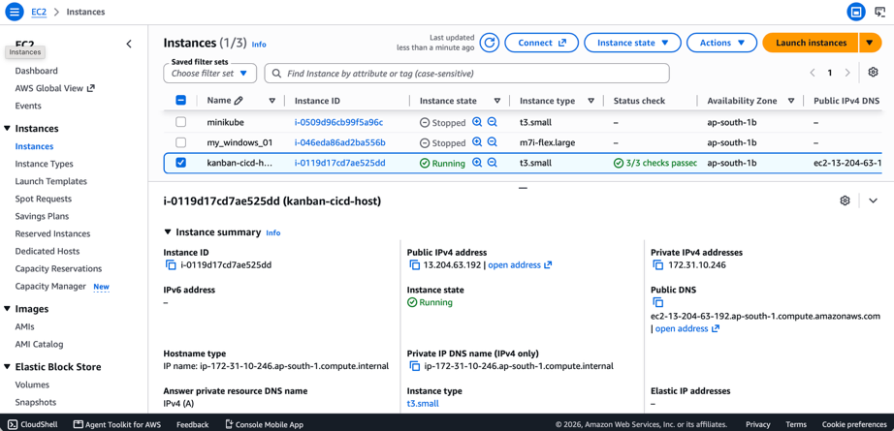

B.4 Connect over SSH
chmod 400 kanban-key.pem
ssh -i kanban-key.pem ubuntu@<EC2_PUBLIC_IP>
Note: (Optional, only needed on t3.micro) Add swap so builds don't OOM: sudo fallocate -l 2G /swapfile && sudo chmod 600 /swapfile && sudo mkswap /swapfile && sudo swapon /swapfile

4. Part C - Install Docker & Jenkins on EC2

C.1 Install Docker
sudo apt-get update -y
sudo apt-get install -y ca-certificates curl gnupg
sudo install -m 0755 -d /etc/apt/keyrings
curl -fsSL https://download.docker.com/linux/ubuntu/gpg | sudo gpg --dearmor -o /etc/apt/keyrings/docker.gpg
echo "deb [arch=$(dpkg --print-architecture) signed-by=/etc/apt/keyrings/docker.gpg] \
https://download.docker.com/linux/ubuntu $(. /etc/os-release && echo $VERSION_CODENAME) stable" | \
sudo tee /etc/apt/sources.list.d/docker.list > /dev/null
sudo apt-get update -y
sudo apt-get install -y docker-ce docker-ce-cli containerd.io docker-compose-plugin
sudo usermod -aG docker ubuntu
sudo usermod -aG docker jenkins # (run again after installing Jenkins below)
sudo systemctl enable --now docker
docker --version
Note: Log out and back in (or run `newgrp docker`) after `usermod` for the group change to take effect.

C.2 Install Jenkins
sudo apt-get install -y fontconfig openjdk-17-jre
curl -fsSL https://pkg.jenkins.io/debian-stable/jenkins.io-2023.key | \
sudo tee /usr/share/keyrings/jenkins-keyring.asc > /dev/null
echo "deb [signed-by=/usr/share/keyrings/jenkins-keyring.asc] \
https://pkg.jenkins.io/debian-stable binary/" | \
sudo tee /etc/apt/sources.list.d/jenkins.list > /dev/null
sudo apt-get update -y
sudo apt-get install -y jenkins
sudo usermod -aG docker jenkins
sudo systemctl enable --now jenkins
sudo systemctl restart docker
sudo systemctl status jenkins
- Install the AWS CLI (needed for ECR login inside the Jenkins pipeline):
curl "https://awscli.amazonaws.com/awscli-exe-linux-x86_64.zip" -o "awscliv2.zip"
sudo apt-get install -y unzip && unzip awscliv2.zip && sudo ./aws/install
aws --version
- In your browser, go to http:// 13.204.63.192:8080
- Unlock Jenkins using the initial admin password:
sudo cat /var/lib/jenkins/secrets/initialAdminPassword
- Choose Install suggested plugins, then create your first admin user.
Proof / screenshot to capture: Screenshot of the Jenkins 'Getting Started' unlock screen, and one of the Jenkins dashboard after setup, both showing the EC2 public IP in the browser address bar.
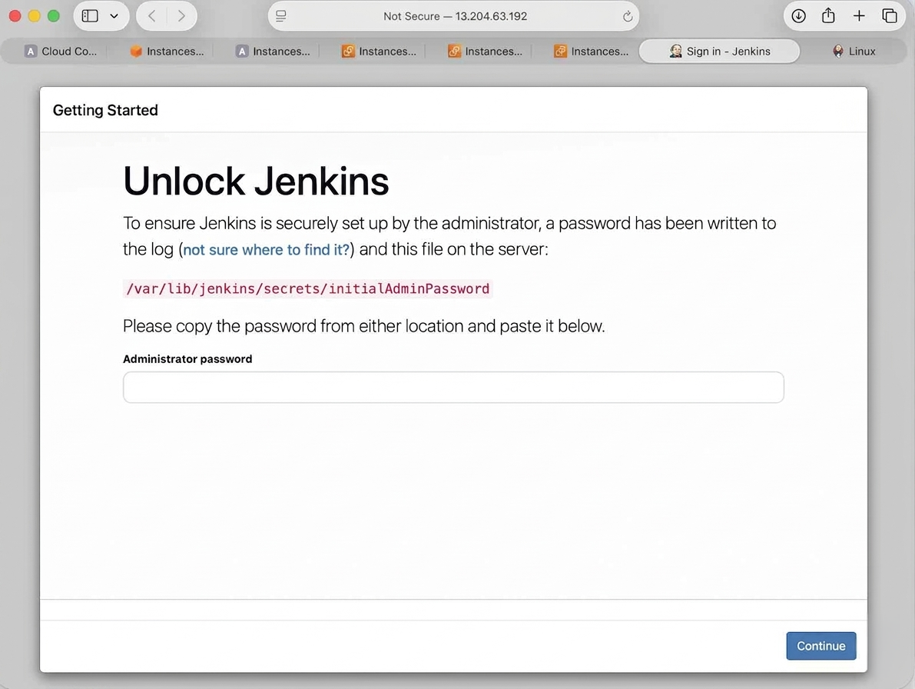

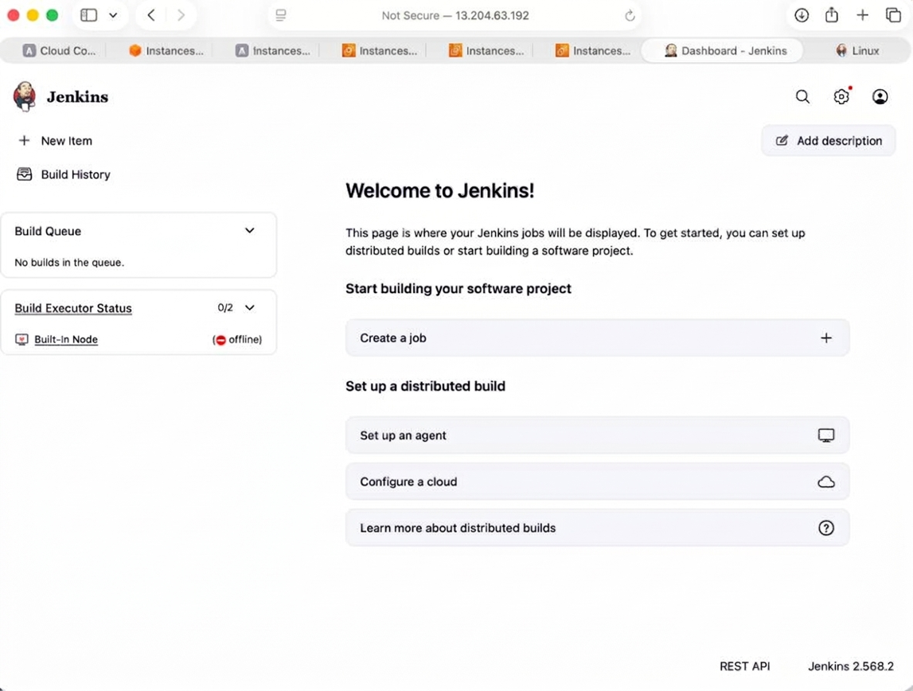

5. Part D - Docker Containerization (Dockerfile Walkthrough)
The Dockerfile, nginx.conf, and .dockerignore are already written for you in this repo (see the code bundle delivered alongside this document, or copy them from the Appendix-style listing below). This section explains what each part does and how to prove it works.

Design decisions
- Multi-stage build: Stage 1 (node:20-alpine) installs deps and runs npm run build. Stage 2 (nginxinc/nginx-unprivileged:1.27-alpine) only copies the compiled ./dist output - no source code, no node_modules, no build tools ship in the final image.
- EXPOSE 8080 only - the single port the app is actually served on.
- HEALTHCHECK runs curl against http://127.0.0.1:8080/ every 30s so Docker (and our deploy script) can tell a container is truly serving traffic, not just 'running'.

Add the files to your local clone and push to your own fork/repo
Copy Dockerfile, nginx.conf, .dockerignore, Jenkinsfile, and the deploy/ folder (from the delivered code bundle) into the root of your cloned kanban-dashboard repo, then:
git checkout -b cicd-setup
git add Dockerfile nginx.conf .dockerignore Jenkinsfile deploy/ README.md
git commit -m "Add Docker, Jenkins CI/CD pipeline"
git push -u origin cicd-setup
# then open a PR / merge to main in your own GitHub fork
Note: You need push access, so first fork the repo to your own GitHub account (or ask to be added as a collaborator) - Jenkins and the webhook in Part I will point at YOUR fork's URL.

Build and test on the EC2 instance
cd ~/kanban-dashboard
docker build -t kanban-app:local .
docker run -d --name kanban-test -p 8081:8080 kanban-app:local
curl -I http://localhost:8081/
docker ps
docker stop kanban-test && docker rm kanban-test
Proof / screenshot to capture: Terminal output of `docker build` completing successfully, and `curl -I` returning HTTP/1.1 200 OK against port 8081.
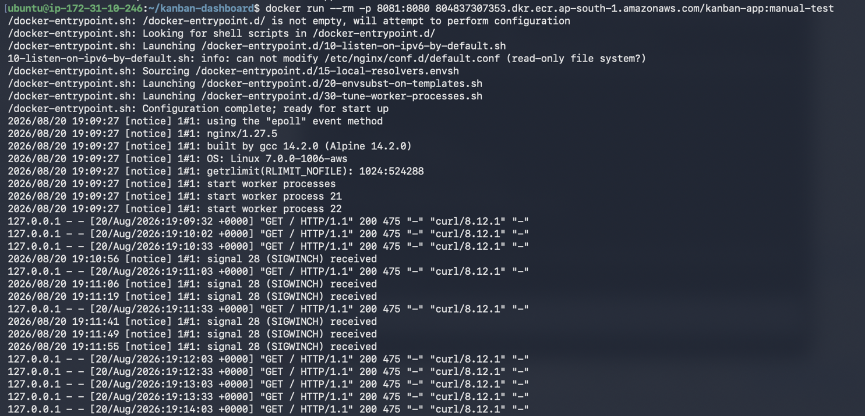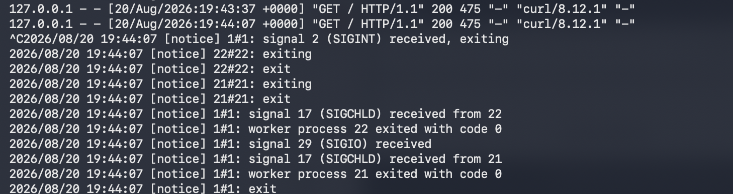
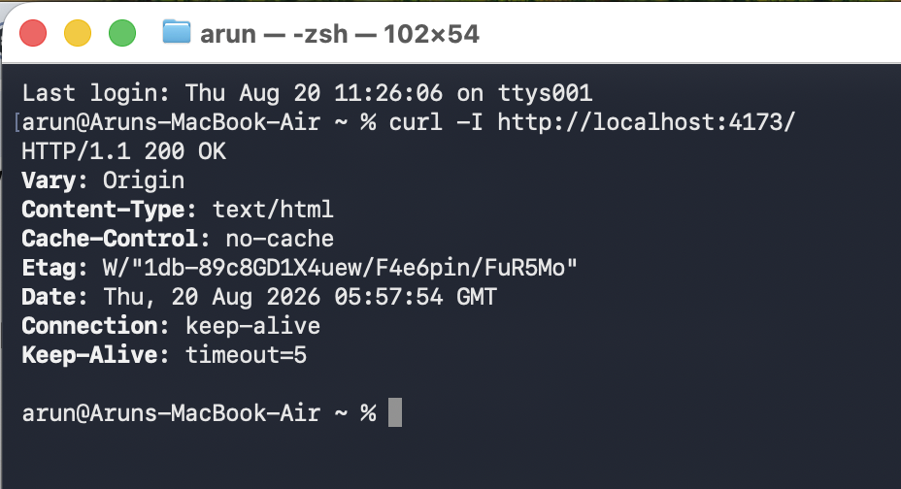

6. Part E - Docker Security
- Minimal base image: node:20-alpine for the build stage, nginxinc/nginx-unprivileged:1.27-alpine for runtime - both Alpine-based, small attack surface.
- Non-root user: The runtime stage runs as the built-in nginx user (uid 101), enforced with an explicit USER nginx directive.
- No secrets in the image: The app needs no env vars or tokens. .dockerignore excludes .env, .git, and any local config from the build context entirely.
- .dockerignore: Excludes node_modules, .git, dist, .env*, logs, and the Dockerfile/README themselves from being copied into images.
- Unused packages removed: apk cache is cleared (`rm -rf /var/cache/apk/*`) right after installing curl.

Verify
docker inspect --format='{{.Config.User}}' kanban-app:local # -> nginx
docker history kanban-app:local # inspect layers
# optional image scan (if Docker Scout / Trivy is available):
docker scout cves kanban-app:local || trivy image kanban-app:local
Proof / screenshot to capture: Output of `docker inspect --format='{{.Config.User}}'` showing 'nginx' (non-root), and a scan report (Docker Scout or Trivy) showing no embedded secrets/high-severity findings.

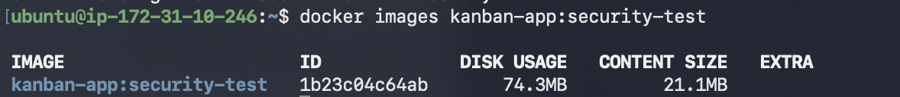

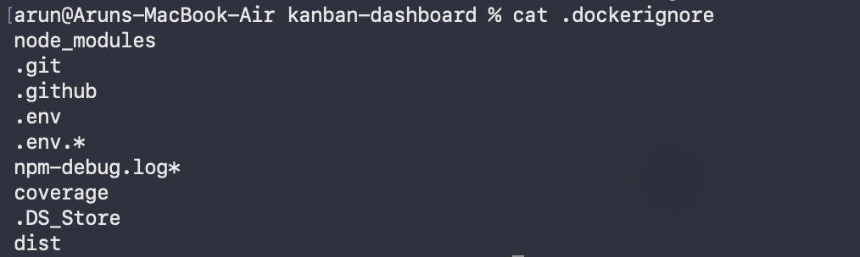
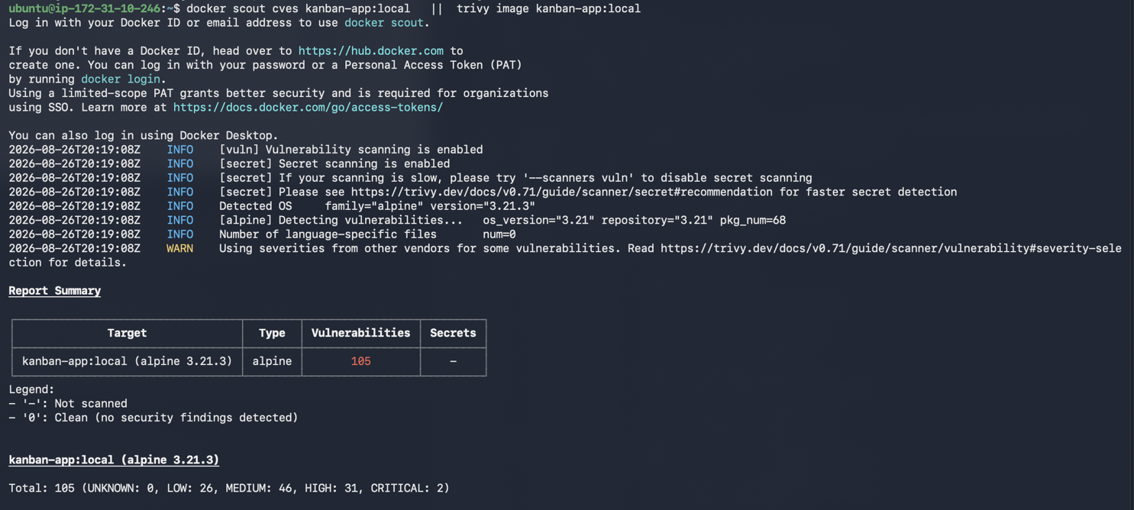

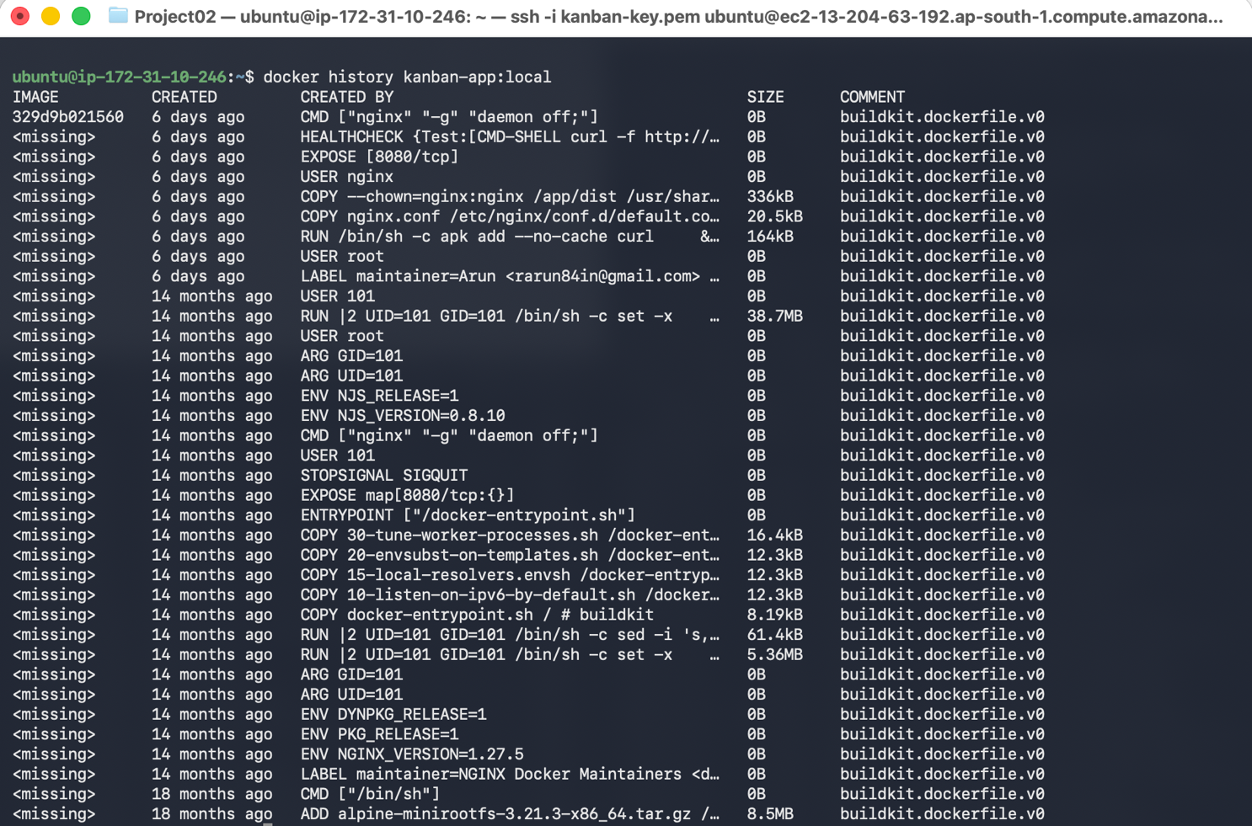

7. Part F - Container Registry (Amazon ECR) & Versioning

F.1 Create the ECR repository
- AWS Console -> ECR -> Create repository.
- Visibility: Private. Name: kanban-app.
- Leave scan-on-push enabled (free vulnerability scanning on every push).
- Create, then copy the repository URI, e.g.:
123456789012.dkr.ecr.ap-south-1.amazonaws.com/kanban-app
Proof / screenshot to capture: Screenshot of the ECR console showing the empty kanban-app repository and its URI.

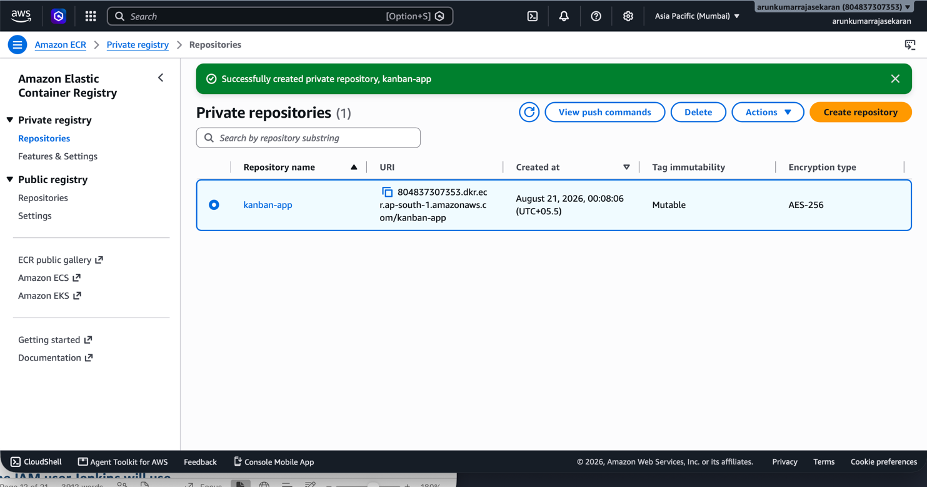

F.2 Push one image manually first (to prove the credentials/permissions work)
aws configure # enter an IAM user's access key / secret / region (see F.3)
aws ecr get-login-password --region ap-south-1 | \
docker login --username AWS --password-stdin 123456789012.dkr.ecr.ap-south-1.amazonaws.com
docker tag kanban-app:local 123456789012.dkr.ecr.ap-south-1.amazonaws.com/kanban-app:manual-test
docker push 123456789012.dkr.ecr.ap-south-1.amazonaws.com/kanban-app:manual-test

- Pull it back down on the same (or another) machine to confirm it works identically:
docker rmi 123456789012.dkr.ecr.ap-south-1.amazonaws.com/kanban-app:manual-test
docker pull 123456789012.dkr.ecr.ap-south-1.amazonaws.com/kanban-app:manual-test
docker run --rm -p 8081:8080 123456789012.dkr.ecr.ap-south-1.amazonaws.com/kanban-app:manual-test
Proof / screenshot to capture: Screenshot of the ECR repository now showing the manual-test tag, plus terminal output of the successful docker pull + docker run.

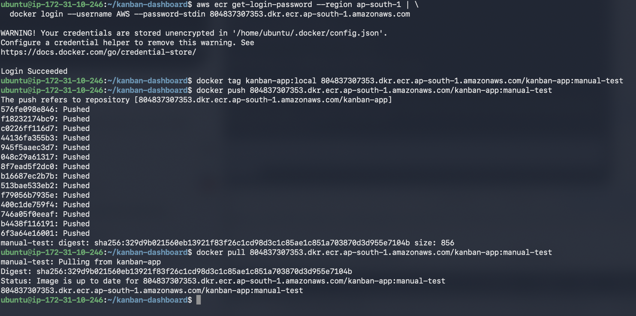

F.3 Create the IAM user Jenkins will use
- IAM Console -> Users -> Create user -> name: jenkins-ecr-deployer, access type: Programmatic access (Access key).
- Attach policy: AmazonEC2ContainerRegistryPowerUser (push/pull only - do not grant broader admin access).
- Save the Access Key ID and Secret Access Key - you'll paste these into Jenkins Credentials in Part G, never into any file in the repo.
Note: If your AWS Academy/lab account blocks creating new IAM users, use the lab-provided credentials instead, or attach an IAM role with ECR push permission directly to the EC2 instance (Instance Profile) so Jenkins never needs stored keys at all - see Troubleshooting.

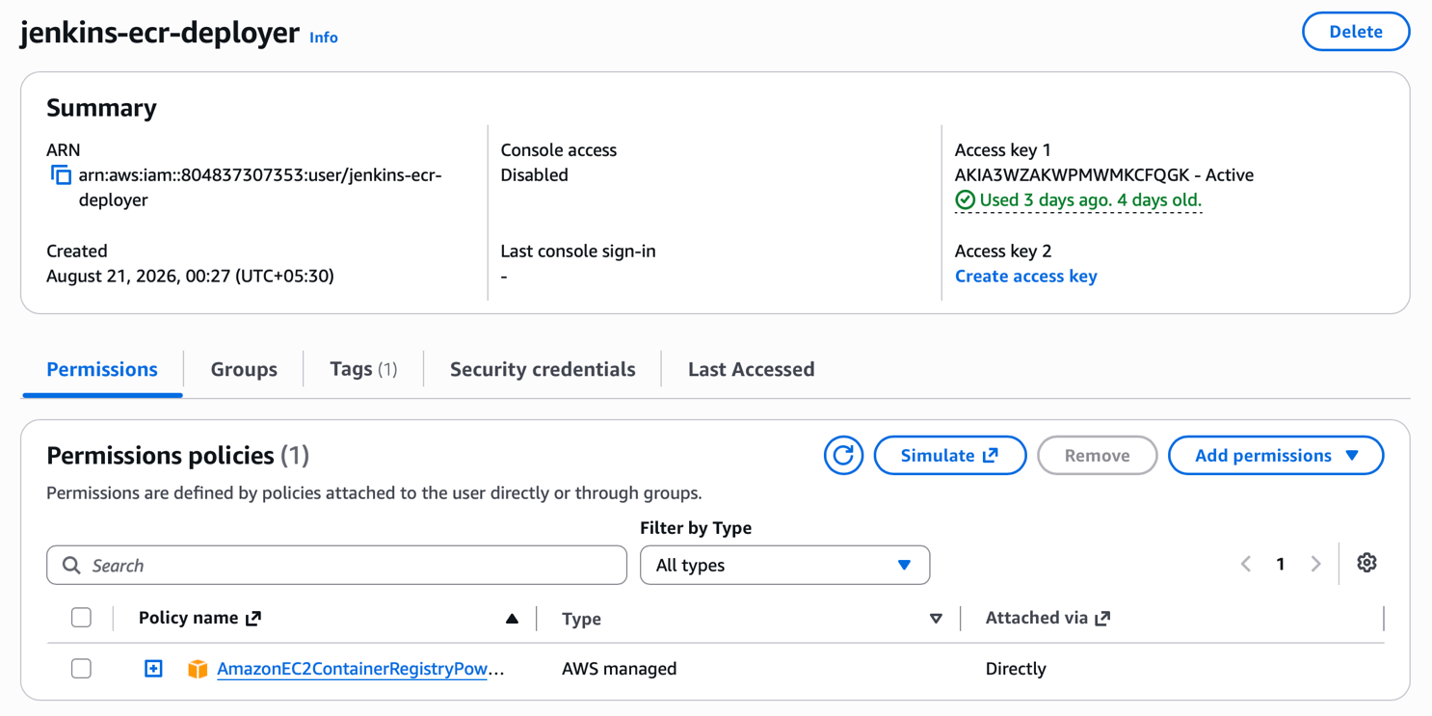

F.4 Tagging convention used by the pipeline
- kanban-app:<jenkins-build-number> - e.g. kanban-app:47
- kanban-app:<git-short-sha> - e.g. kanban-app:a1b2c3d
Both tags point at the same image; latest is never relied on alone, so you can always trace a running container back to the exact commit and build.

8. Part G - Jenkins Configuration

G.1 Install required plugins
- Manage Jenkins -> Plugins -> Available plugins, install:
  - Git
  - Docker Pipeline
  - Credentials Binding
- Restart Jenkins if prompted.
Proof / screenshot to capture: Screenshot of the Installed plugins list showing Git, Docker Pipeline, and Credentials Binding.

G.2 Add credentials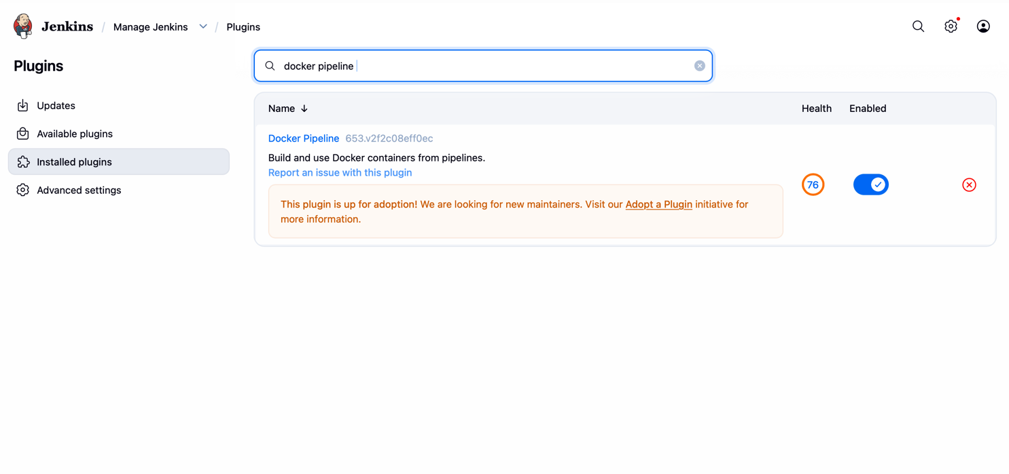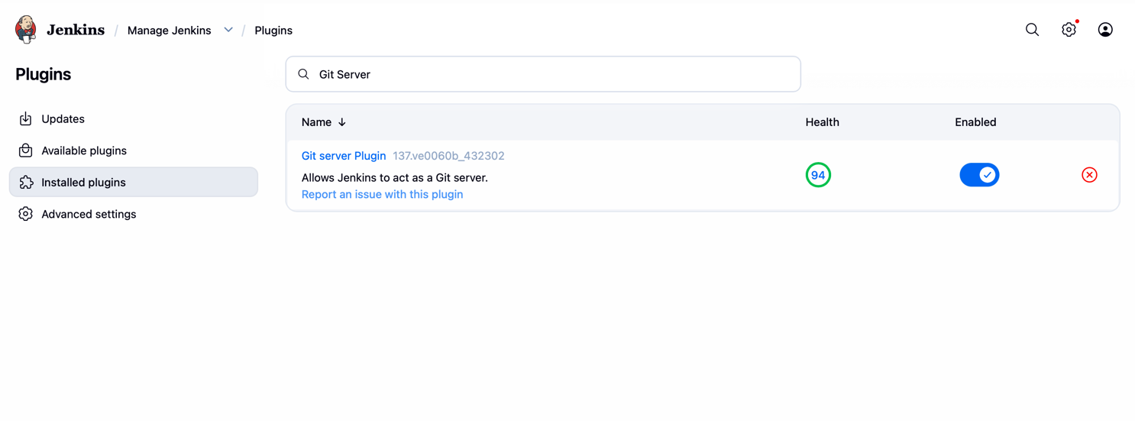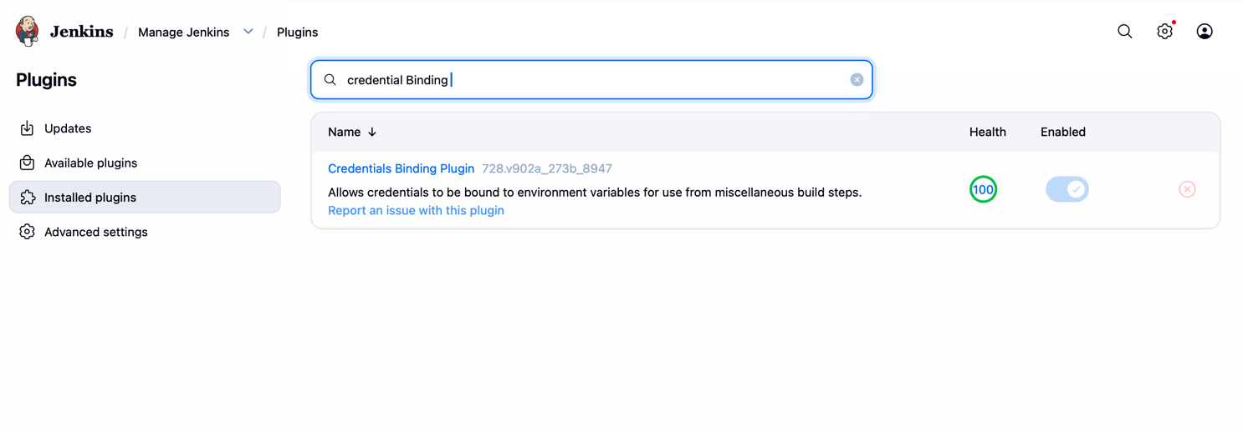
- Manage Jenkins -> Credentials -> System -> Global credentials -> Add Credentials.
- Kind: Username with password. ID: aws-ecr-creds. Username = AWS Access Key ID, Password = AWS Secret Access Key.
- (If your GitHub repo is private) Add a second credential: Kind: Username with password (or SSH key), ID: github-creds, using a GitHub Personal Access Token as the password.
Proof / screenshot to capture: Screenshot of the Credentials list showing aws-ecr-creds (and github-creds if used) with their IDs visible, but never the secret values.

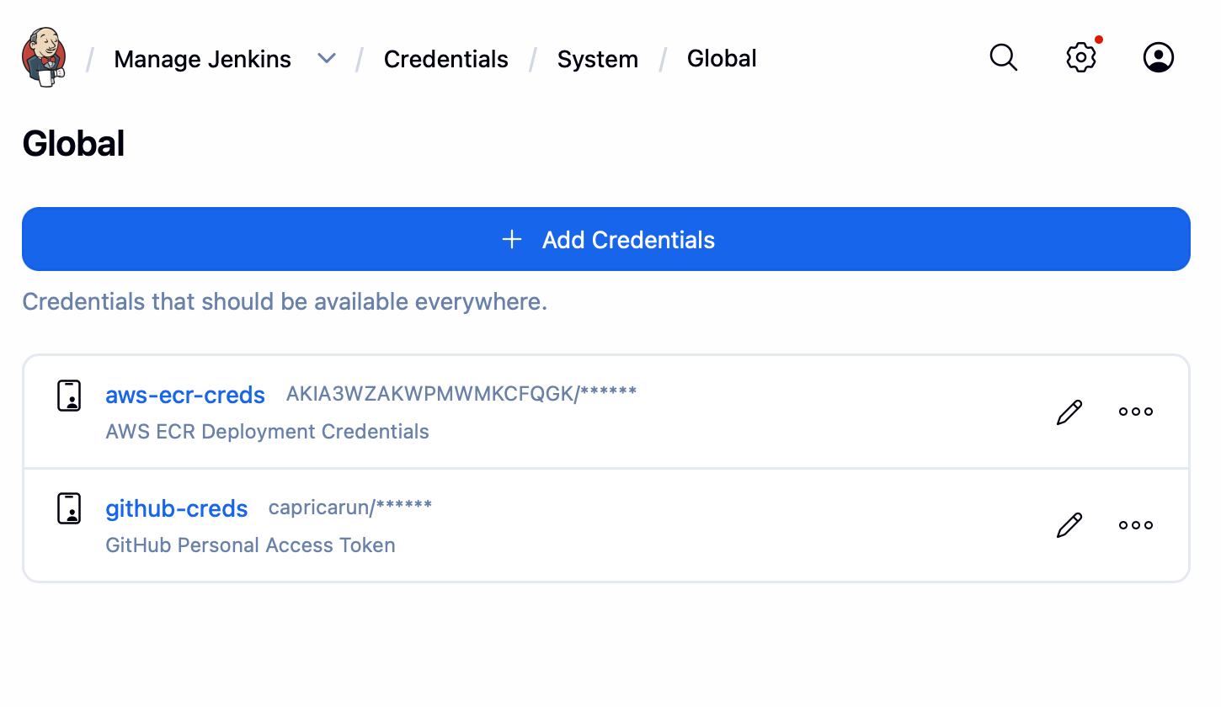

G.3 Connect Jenkins to your GitHub repo & create the Pipeline job
- Jenkins Dashboard -> New Item -> name: kanban-cicd -> type: Pipeline -> OK.
- Under General, tick GitHub project and paste your fork's URL.
- Under Build Triggers, tick GitHub hook trigger for GITScm polling (this is what makes the webhook in Part I work).
- Under Pipeline, set Definition = Pipeline script from SCM, SCM = Git, Repository URL = your fork's clone URL, Branch = */cicd-setup (or main once merged), Script Path = Jenkinsfile.
- Save, then click Build Now once manually to confirm the whole pipeline runs end-to-end.
Proof / screenshot to capture: Screenshot of the Pipeline job configuration page, and a screenshot of a fully green (all-stages-passed) 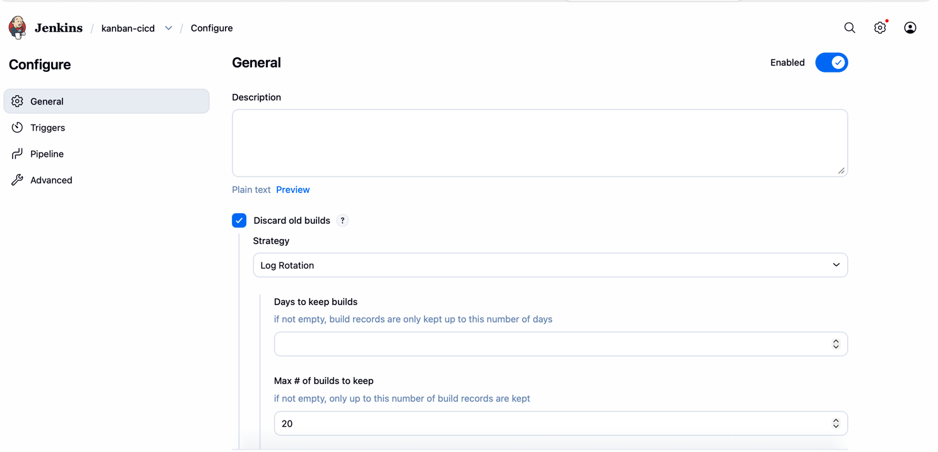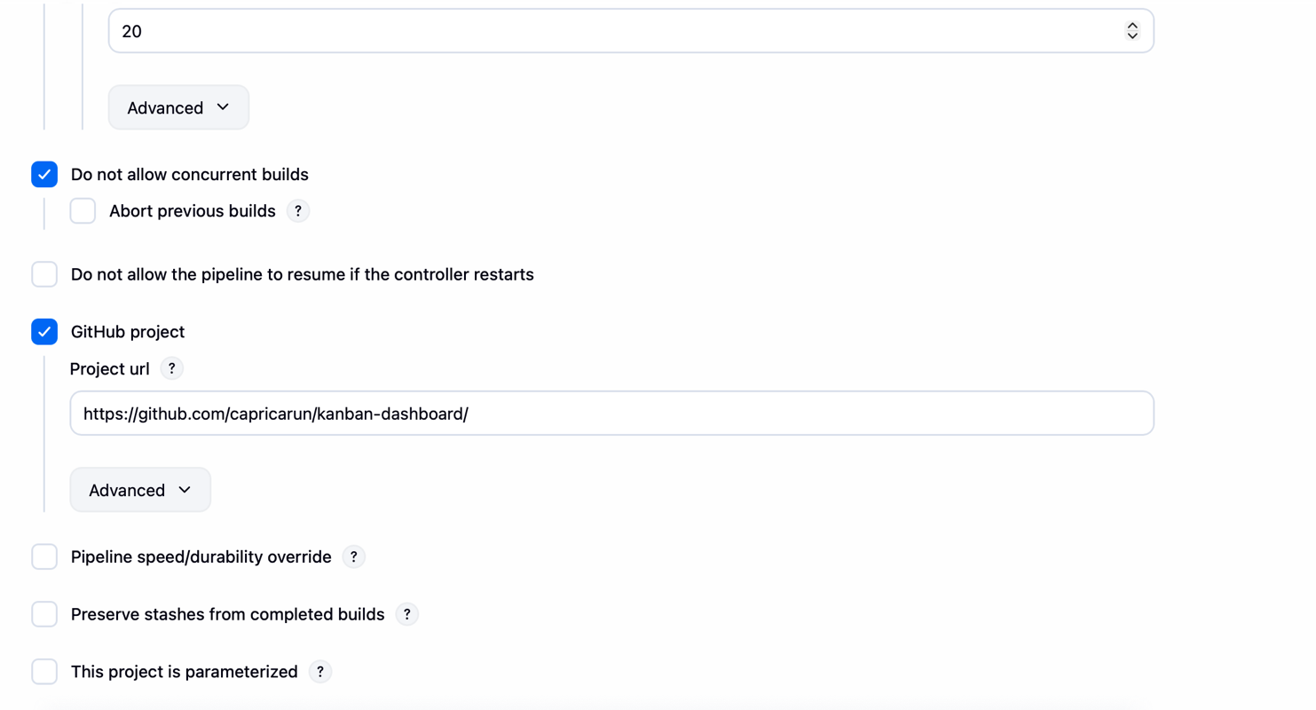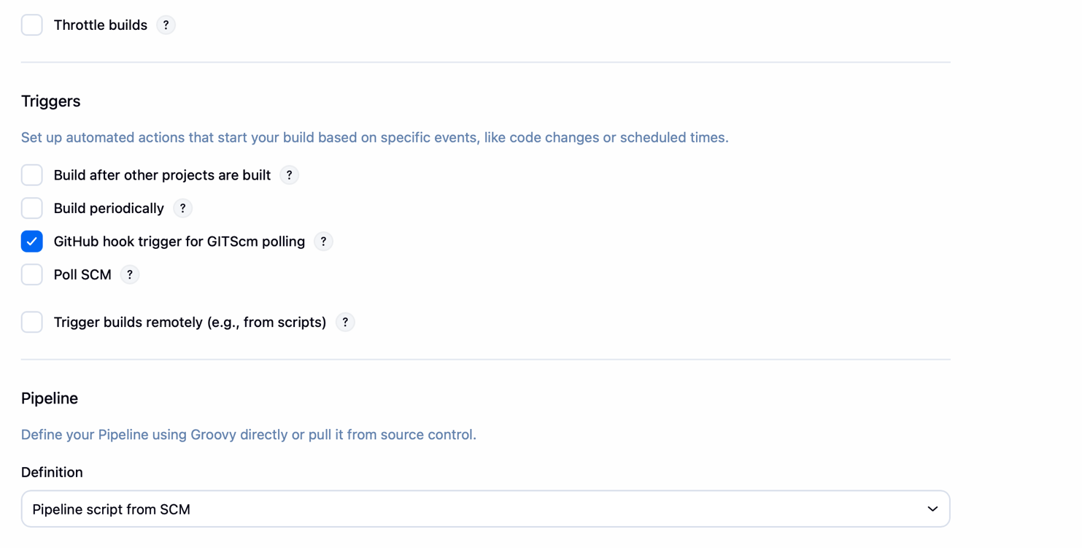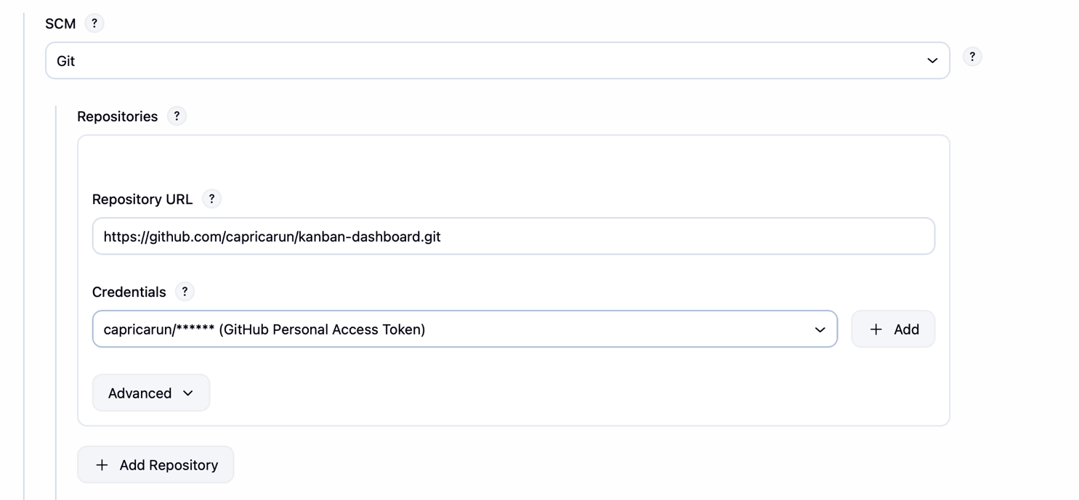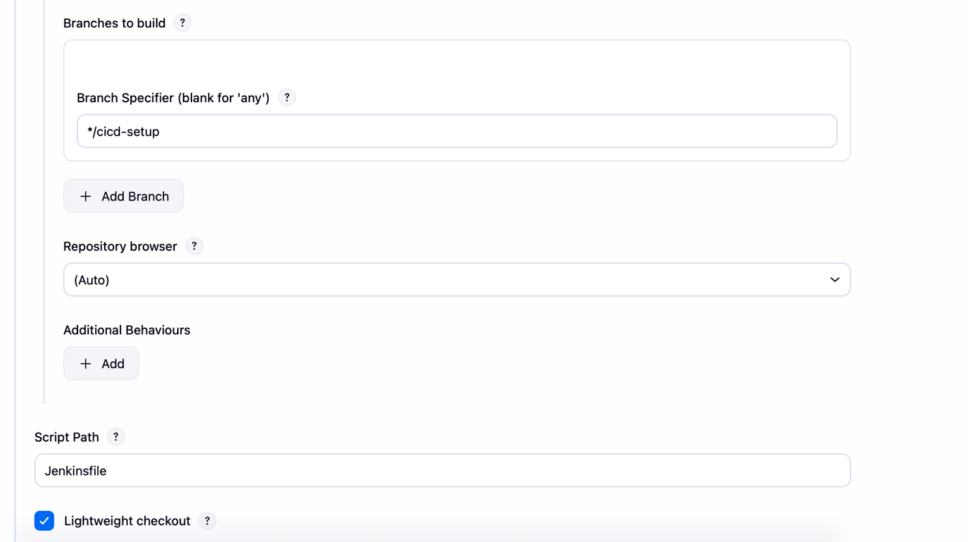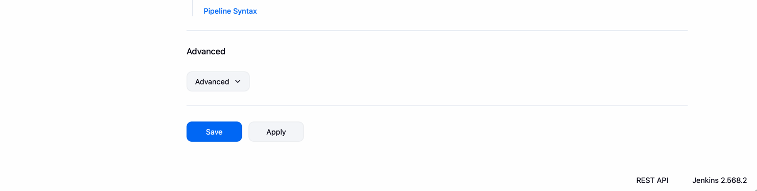build in the Stage View.
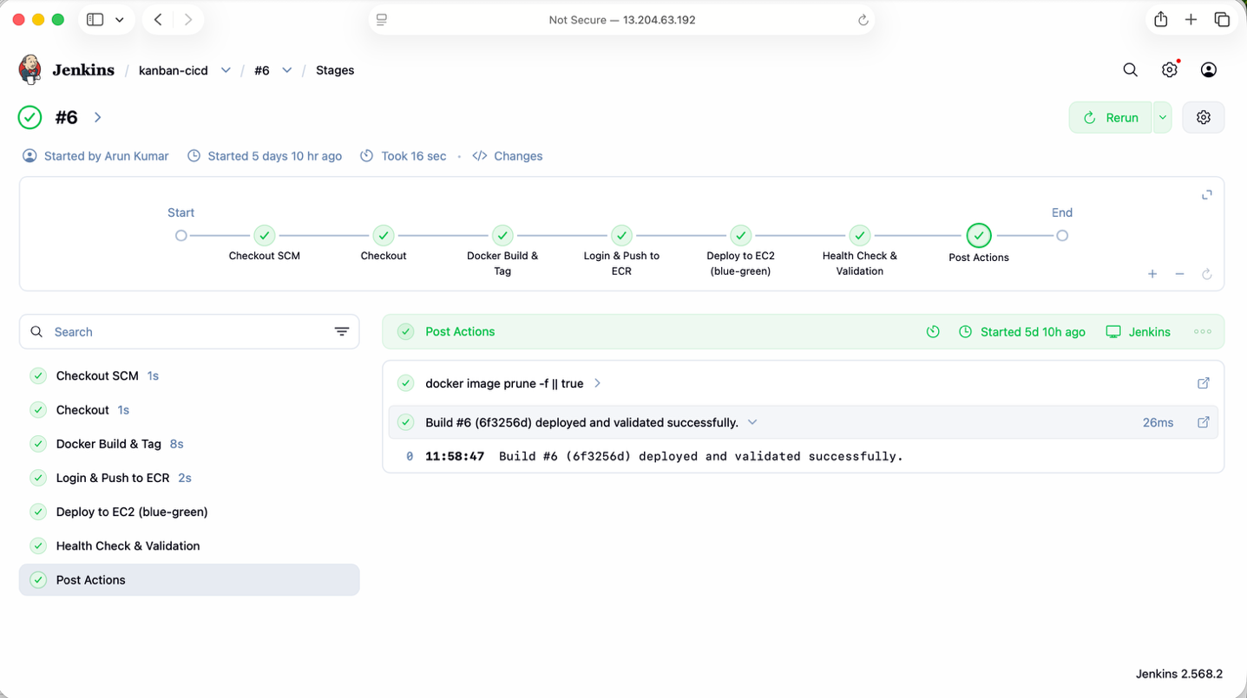

9. Part H - CI/CD Pipeline (Jenkinsfile Walkthrough)
The full Jenkinsfile is included in the code bundle. Its stages map directly to the assignment's rubric:
- Checkout: checkout scm - pulls the exact commit that triggered the build; records its short git SHA.
- Docker Build & Tag: docker build -t <repo>:<build-number> -t <repo>:<git-sha> . - single build, two tags.
- Login & Push to ECR: Uses the aws-ecr-creds credential via withCredentials(...) - the keys exist only in memory for this stage, never printed to the console log, never committed to the repo.
- Deploy to EC2 (blue-green): Runs deploy/deploy.sh <image> locally on the same EC2 host Jenkins is running on (per the assignment: 'EC2 hosts both Jenkins and the running app container').
- Health Check & Validation: curl's the app through the public port and checks docker ps - the build is only marked successful if this passes.
- post { failure { ... } }: Automatically runs deploy/rollback.sh to redeploy the last known-good image if any stage fails.

Before your first run, edit these values at the top of the Jenkinsfile
AWS_REGION = 'ap-south-1' // your AWS region
AWS_ACCOUNT_ID = '123456789012' // your 12-digit AWS account ID
ECR_REPO_NAME = 'kanban-app'
APP_HOST_PORT = '8081' // must match the Security Group app port
Proof / screenshot to capture: Screenshot of one full pipeline run's Console Output, scrolled to show all six stages executing and the final SUCCESS line - plus a second screenshot of a deliberately-broken run (e.g. a bad Dockerfile line) showing a FAILED stage, to prove failure is detected, not just success.

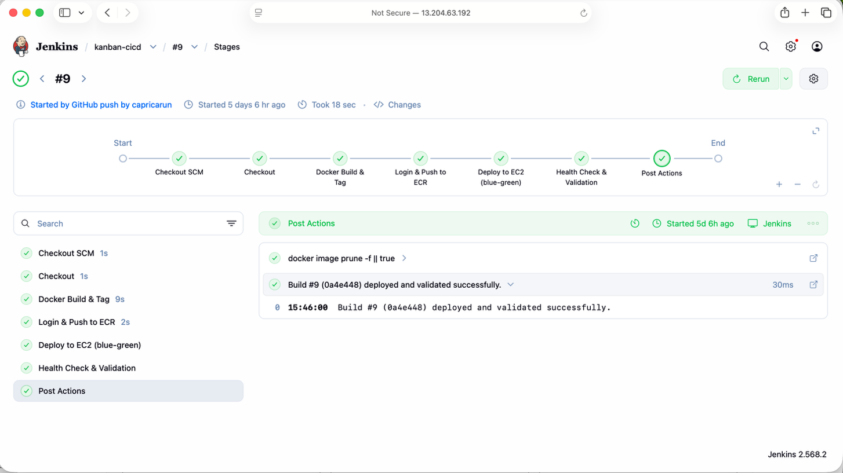

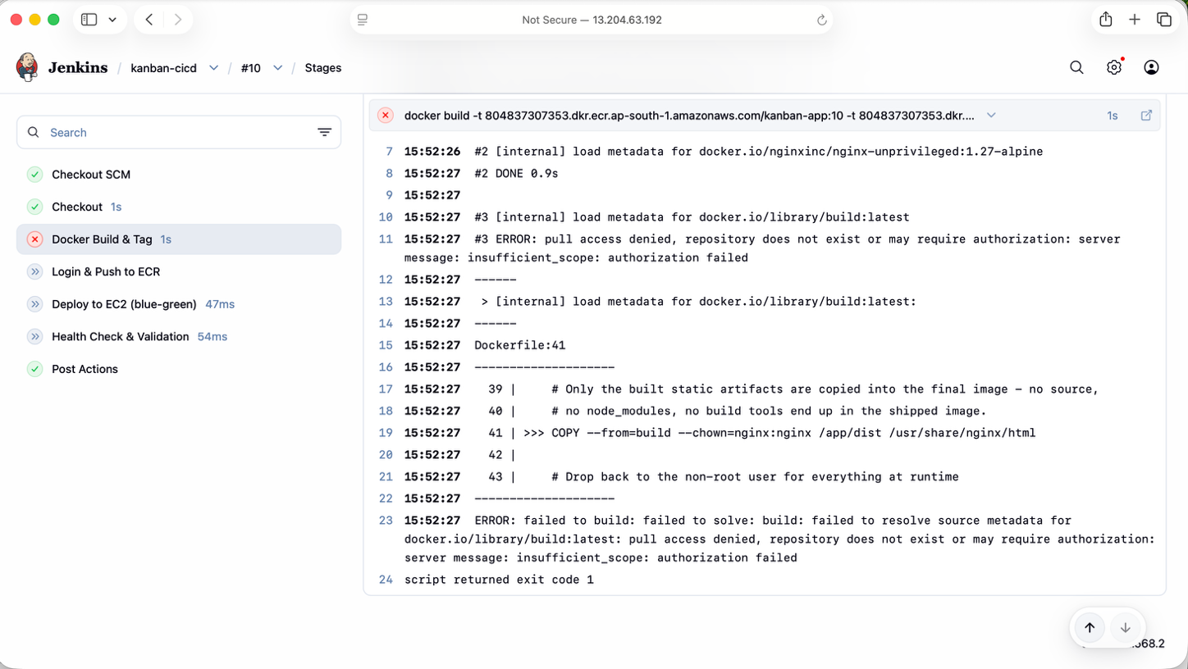

10. Part I - GitHub Webhook
- On GitHub, open your fork -> Settings -> Webhooks -> Add webhook.
- Payload URL: http://13.204.63.192:8080/github-webhook/ .
- Content type: application/json. Leave the secret blank for this project (or set one and configure it in Jenkins' GitHub plugin settings for extra credit).
- Which events: Just the push event.
- Add webhook - GitHub will send a ping; it should show a green check mark under Recent Deliveries.
- Test it: make a small change (e.g. edit a label in src/App.tsx), commit, and push to the branch your Jenkins job is watching.
git add -A && git commit -m "Test webhook trigger" && git push
- Watch the Jenkins job start automatically within a few seconds - no one clicked Build Now.
Proof / screenshot to capture: Screenshot of the GitHub webhook 'Recent Deliveries' showing a successful (green) delivery, and a screenshot of the Jenkins build history showing a build that started from 'started by GitHub push' rather than a manual trigger.
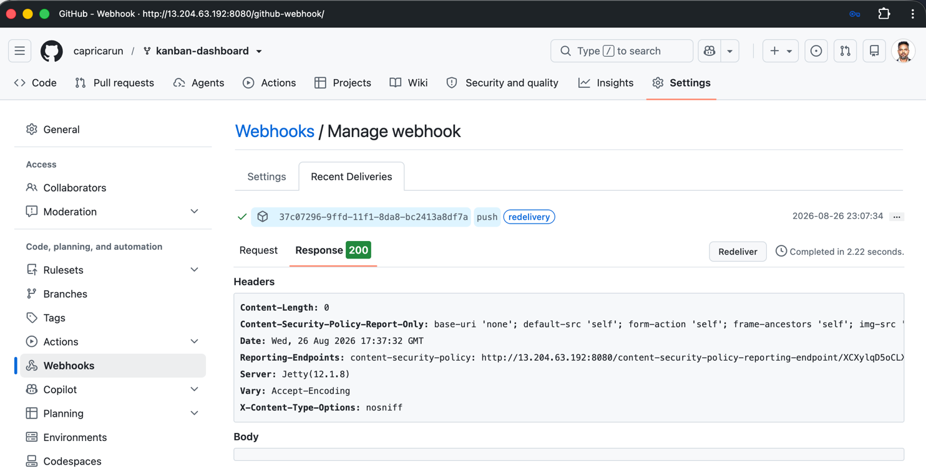
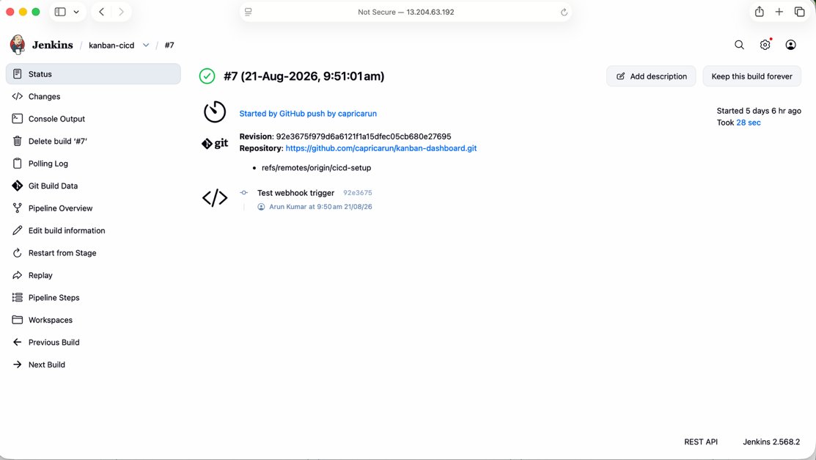

11. Part J - Health Check & Validation
A container that is merely running is not the same as a deployment that succeeded. The pipeline and deploy script enforce three layers of validation before anything is considered 'done':
- docker ps - confirms the container process exists and is not restarting/crash-looping.
- Docker HEALTHCHECK status (docker inspect --format='{{.State.Health.Status}}') - confirms the app inside the container actually answers HTTP requests, not just that the process started.
- curl against the public app port from Jenkins itself - confirms the full path (host networking, the edge router, the container) works end-to-end, exactly as a real user would experience it.
docker ps --filter name=kanban-app
docker inspect --format='{{.State.Health.Status}}' kanban-app-blue
curl -fsS http://13.204.63.192:8081/healthz
curl -o /dev/null -s -w 'HTTP %{http_code}\n' http://13.204.63.192:8081
Proof / screenshot to capture: Terminal output of all three checks above, run right after a pipeline deploy, all showing healthy/200.

12. Part K - Logging & Monitoring
- Jenkins build history: open the kanban-cicd job -> Build History. Click into one passing and one failing build's Console Output.
- Container logs and health status:
docker ps -a
docker logs --tail 100 kanban-app-blue
docker inspect kanban-app-blue | grep -A 15 '"Health"'
- To generate a genuine failing build for the 'proof of a fail' screenshot, temporarily break something on purpose (e.g. push a Dockerfile with a typo in the base image name, or a route in nginx.conf that 404s) - then revert it.
Proof / screenshot to capture: Two Console Output screenshots (one pass, one fail) with the exact stage/line that failed visible, plus `docker logs` output that shows the same failure reflected at the container level.

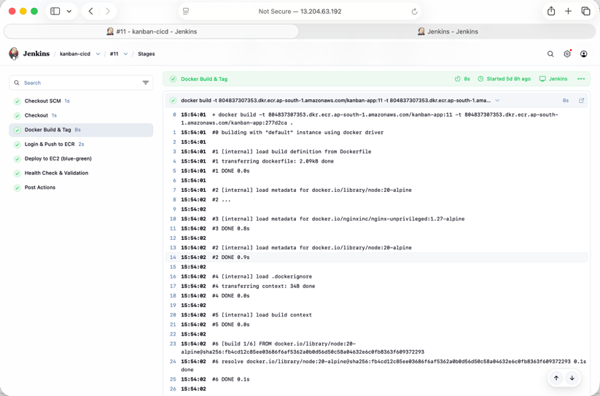

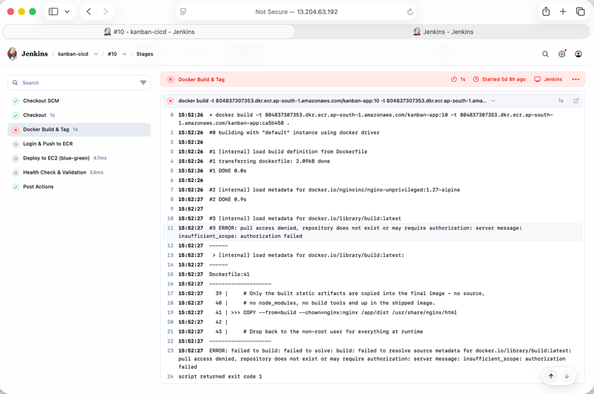

13. Part L - Docker Resource Limits
deploy/deploy.sh starts the app container with:
--memory=300m --cpus=0.5

Justification
On a t3.small (2 vCPU / 2 GB), Jenkins itself typically needs ~1-1.5 GB of RAM during a build, plus the OS and Docker daemon need headroom. Capping the app container at 300 MB / 0.5 vCPU means even a memory leak or runaway process in the app can never starve Jenkins or crash the host - it will simply hit its own limit and get OOM-killed/throttled, which is visible in `docker inspect` and easy to diagnose. Adjust these values up if you choose a larger instance, or down if you move to a t3.micro.
docker inspect --format='{{.HostConfig.Memory}} bytes / {{.HostConfig.NanoCpus}} nanocpus' kanban-app-blue
docker stats --no-stream kanban-app-blue
Proof / screenshot to capture: Output of `docker inspect` showing the configured Memory/NanoCpus limits, and `docker stats` showing actual usage comfortably under those caps.
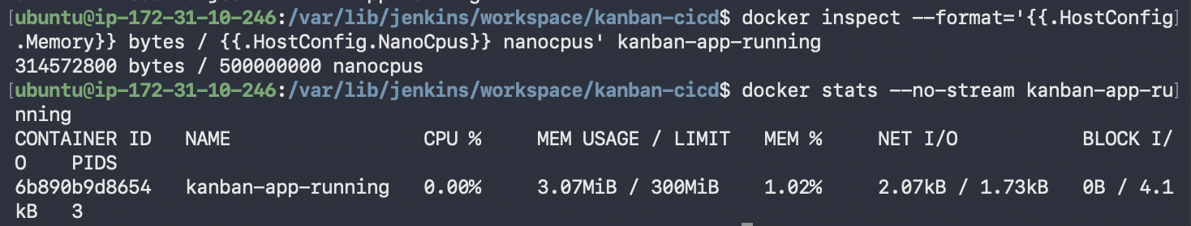

14. Part M - Zero/Minimal Downtime Deployment (Bonus)
deploy/deploy.sh implements blue/green deployment:
- A lightweight nginx 'edge router' container is the only thing bound to the public app port (8081). It's created once and left running.
- Each deploy starts the NEW version as the opposite color (blue<->green) alongside the currently-live one - both containers can run at the same time, on an internal Docker network, with no port conflict.
- The script polls the new container's Docker HEALTHCHECK status (up to 30 seconds) before doing anything else.
- Only once the new container reports healthy does the script rewrite the router's config to point at it and reload nginx (a sub-second, connection-preserving switch).
- The old container is removed only after the switch is confirmed working end-to-end through the public port.
- If the new container never becomes healthy, it is discarded, the old one is left completely untouched, and the pipeline stage fails - so a broken build is never shown to a real visitor. This is the same mechanism as the CI/CD pipeline's rollback.

Prove it
- Open the app in a browser tab and leave it open: http://13.204.63.192:8081/
- In another terminal, watch containers while a deploy runs:
watch -n1 'docker ps --filter name=kanban-app'
- Trigger a new deploy (push a small commit). Confirm the browser tab is never interrupted, and that for a brief window both kanban-app-blue and kanban-app-green appear in docker ps together before the old one is removed.
Proof / screenshot to capture: A short screen recording or two closely-timed screenshots of `docker ps` showing both colors running simultaneously mid-deploy, plus confirmation the browser tab kept working throughout.

Video Capture
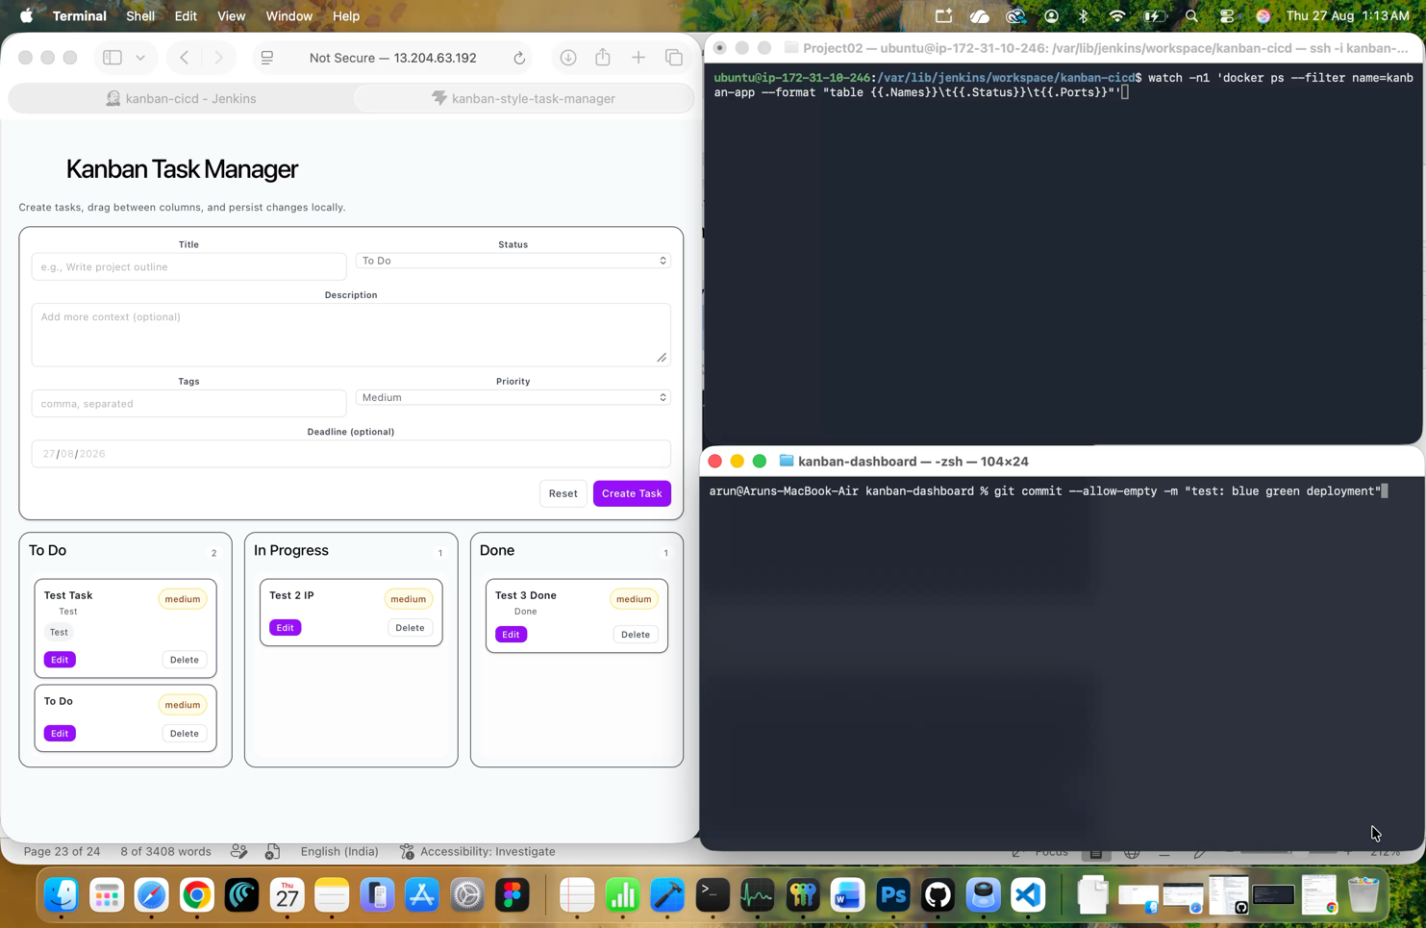
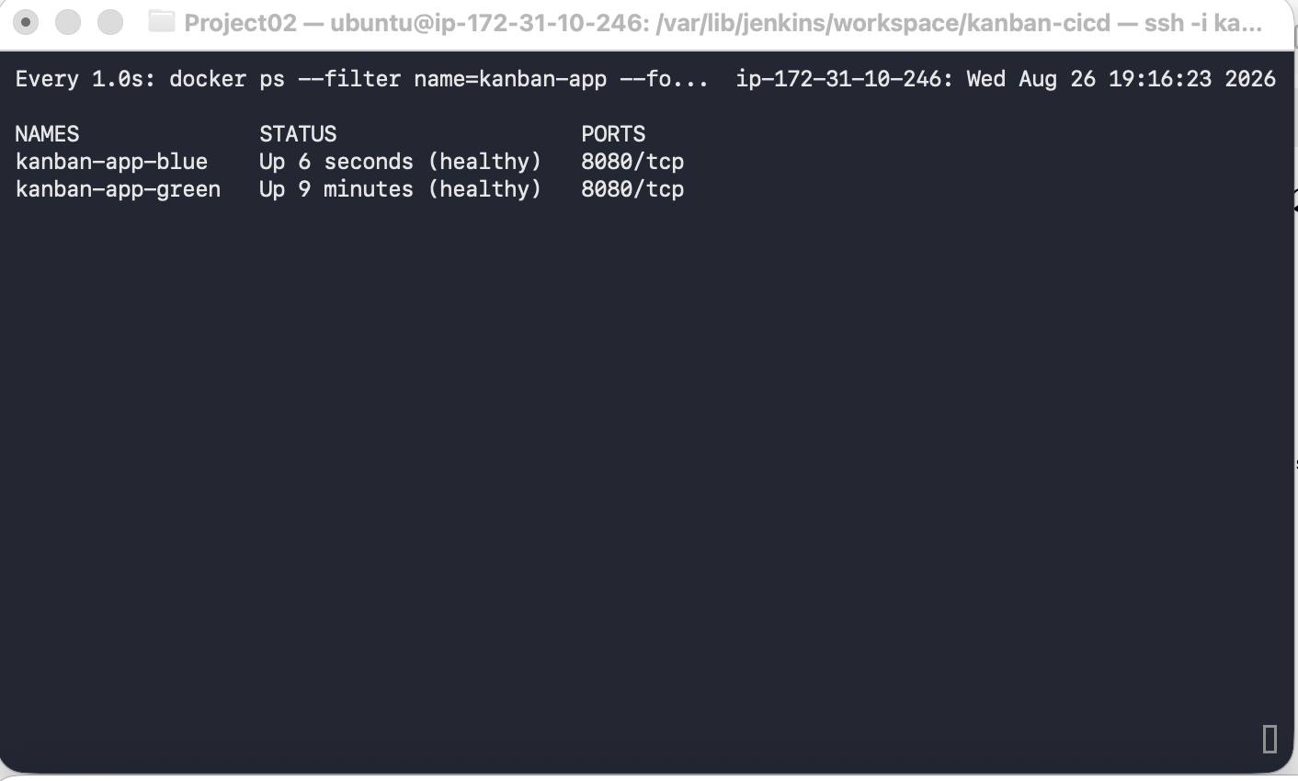
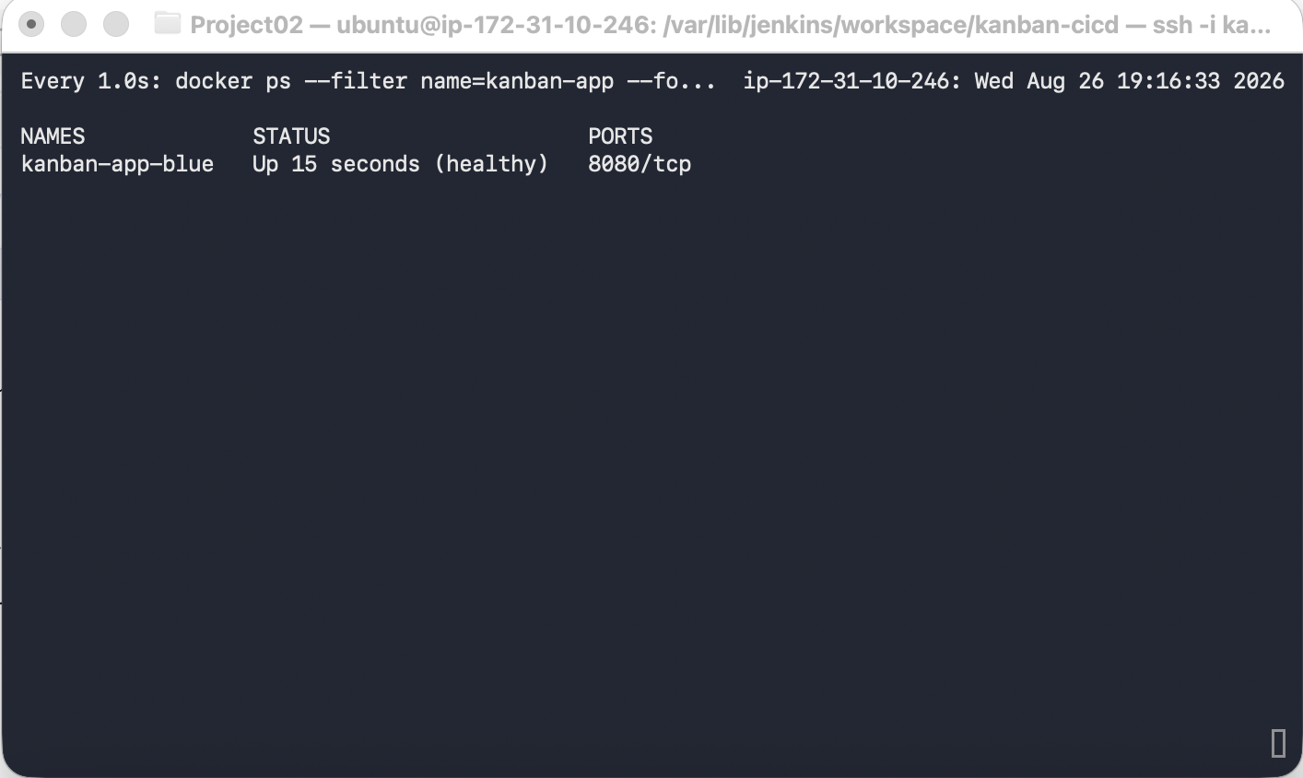

15. Deliverables & Full Screenshot/Proof Checklist

Deliverables to submit
- GitHub repository (your fork, with Dockerfile / Jenkinsfile / deploy scripts / README.md merged in)
https://github.com/capricarun/kanban-dashboard
- Dockerfile
- Jenkinsfile
- README.md
- Amazon ECR repository (link or account/region/repo name): 804837307353.dkr.ecr.ap-south-1.amazonaws.com/kanban-app
- Application URL: http://13.204.63.192:8080/
- All screenshots/evidence listed in each section

