PROJECT 03 · GUVI × HCL
Terraform Pipeline Runbook
Automating AWS Infrastructure Deployment Using Terraform and GitHub Actions
Provision a full AWS environment with Terraform, then deploy it from GitHub Actions through a pipeline that stops and waits for your approval before it touches anything. This document contains every command, every file, and every screenshot the brief asks for.
AWS RESOURCES | MODULES | PIPELINE JOBS | WORKING TIME | RUNNING COST
20 | 2 | 3 | ~2 hours | Free tier

Application URL : http://3.111.230.101

Contents
Every heading is a real Word heading, so the navigation pane (View → Navigation Pane) jumps to any step.
SECTION | WHAT IT COVERS
What you are building | The pipeline, the twenty AWS resources, the repository layout
Requirement coverage | Each requirement in the brief mapped to a file and a screenshot
Phase 1 — Prerequisites | Terraform 1.10+, AWS CLI, empty GitHub repository, folder structure
Phase 2 — Bootstrap the backend | State bucket, lock table, GitHub OIDC provider, CI role
Phase 3 — The Terraform configuration | Providers, backend, variables, root resources, outputs, .gitignore
Phase 4 — The two modules | Networking and compute modules, and the user data script
Phase 5 — The CI/CD workflow | The three-job pipeline and the README
Phase 6 — Connect GitHub to AWS | The role secret and the approval environment
Phase 7 — Run the pipeline | Format, push, watch, approve, verify
Phase 8 — Collect your evidence | AWS and GitHub screenshots, submission checklist
Troubleshooting | The failures that actually happen, and what each one means
Teardown | Destroying the stack in the right order

What you are building
One Terraform configuration, two reusable modules, and a three-job GitHub Actions pipeline. Pushing to main plans the change and publishes the plan as a downloadable artifact. Nothing is applied until a human approves the deployment, and what gets applied is the exact plan that was reviewed.

The pipeline
STAGE | WHAT RUNS
[object Object] | checkout → aws oidc → fmt → init → validate → plan → upload tfplan artifact. Runs on every push and pull request.
⏸ Approval gate | The production environment holds the pipeline here until a reviewer approves it.
[object Object] | download tfplan → init → apply tfplan → publish outputs. Skipped on pull requests.
[object Object] | describe VPC, subnets, IGW, routes → describe EC2, EIP, SG → check S3 versioning, encryption, access block → check IAM role and profile → curl the landing page.

The AWS resources
The plan creates twenty resources. On a first run the plan output ends with “Plan: 20 to add, 0 to change, 0 to destroy.”
MODULE | RESOURCES
networking | VPC, 2 public subnets in 2 availability zones, internet gateway, public route table, 2 route table associations, security group, 2 ingress rules, 1 egress rule
compute | EC2 instance, Elastic IP, IAM role, inline S3 policy, SSM policy attachment, instance profile
root | S3 bucket, versioning, encryption, public access block, ownership controls, random name suffix

Repository layout
.
├── .github/workflows/terraform.yml the CI/CD pipeline
├── bootstrap/ run once, from your laptop
│ ├── main.tf state bucket + GitHub OIDC role
│ ├── variables.tf
│ └── outputs.tf
├── modules/
│ ├── networking/ VPC, subnets, IGW, routing, SG
│ │ ├── main.tf
│ │ ├── variables.tf
│ │ └── outputs.tf
│ └── compute/ EC2, EIP, IAM role, profile
│ ├── main.tf
│ ├── variables.tf
│ ├── outputs.tf
│ └── user_data.sh.tftpl installs and starts nginx
├── backend.tf S3 remote state + locking
├── versions.tf provider pins, default tags
├── variables.tf every configurable input
├── main.tf S3 bucket + module wiring
├── outputs.tf IDs, IP, URL, bucket name
├── terraform.tfvars your values
├── .gitignore
└── README.md

Requirement coverage
Every numbered requirement in the brief, and where it is satisfied. Work through the phases in order and each row takes care of itself — use this table at the end to check nothing is missing before you submit.
REQUIREMENT | WHERE IT LIVES | PROOF TO CAPTURE
Terraform infrastructure | main.tf, both modules | AWS Console screenshots of VPC, EC2, S3, IAM
Variables & outputs | variables.tf, outputs.tf | The two files, plus the outputs table in the run summary
Reusable modules | modules/networking, modules/compute | Folder structure and a successful apply log
Remote state & locking | backend.tf, .gitignore | S3 console showing the state object; the init log
EC2 web server | user_data.sh.tftpl | Browser screenshot of the landing page on the Elastic IP
S3 configuration | main.tf | S3 console: Properties (versioning, encryption) and Permissions
AWS security | modules/compute/main.tf, bootstrap/main.tf | IAM role and instance profile, security group rules, no keys in repo
GitHub Actions CI/CD | .github/workflows/terraform.yml | The workflow file and a full green run
Format / init / validate | Steps 3–5 of the plan job | Expanded step logs from the run
Plan & artifact | Steps 6–7 of the plan job | Run page showing the downloadable plan artifact
Approval before apply | environment: production | The “Review deployments” prompt and your approval
Outputs & trigger | Apply job, on: push | Run summary table; the commit that triggered the run
Infrastructure validation | Job 3 | Validation job logs, all green

Phase 1 — Prerequisites
~20 minutes · on your local machine
Four things need to be in place before any Terraform runs. Skipping the version check here is the single most common cause of a failed init later.
STEP 1.1

Install Terraform 1.10 or newer
Version matters. Native S3 state locking (use_lockfile) arrived in Terraform 1.10 — on anything older, init will reject the backend block.
terminal
# macOS
brew tap hashicorp/tap
brew install hashicorp/tap/terraform

# Windows
winget install HashiCorp.Terraform

# Verify — must report v1.10.0 or higher
terraform version

CHECKPOINT
The output starts with Terraform v1.1x.x. If it is older, upgrade before continuing.

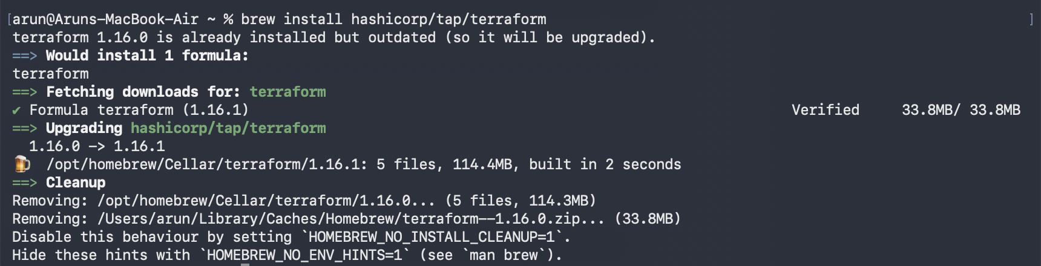
STEP 1.2

Configure the AWS CLI
You need local credentials for the one-time bootstrap only. After that, GitHub Actions authenticates on its own and no keys are stored anywhere.
terminal
aws configure
# AWS Access Key ID: ...
# AWS Secret Access Key: ...
# Default region name: ap-south-1
# Default output format: json

# Confirm which identity you are using
aws sts get-caller-identity

The IAM user you use here needs permission to create IAM roles, S3 buckets and an OIDC identity provider. AdministratorAccess is fine for a learning account.
CHECKPOINT
get-caller-identity returns your account ID, user ID and ARN. Note the account ID — you will recognise it in resource names shortly.
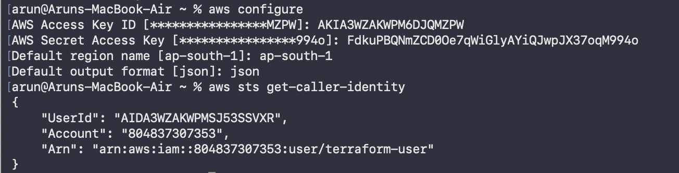
STEP 1.3

Create an empty GitHub repository
Create it on github.com — public or private, both work. Do not add a README, licence or .gitignore from the template; you will add your own. Then, locally:
terminal
mkdir terraform-aws-github-actions
cd terraform-aws-github-actions
git init -b main
git remote add origin https://github.com/capricarun/terraform-aws-github-actions.git

STEP 1.4

Create the folder structure
terminal
mkdir -p .github/workflows bootstrap modules/networking modules/compute

NOTE
Every file in the phases that follow is complete and copy-ready. Create each file at the path shown in its header and paste the whole block — nothing is abbreviated or left as an exercise.
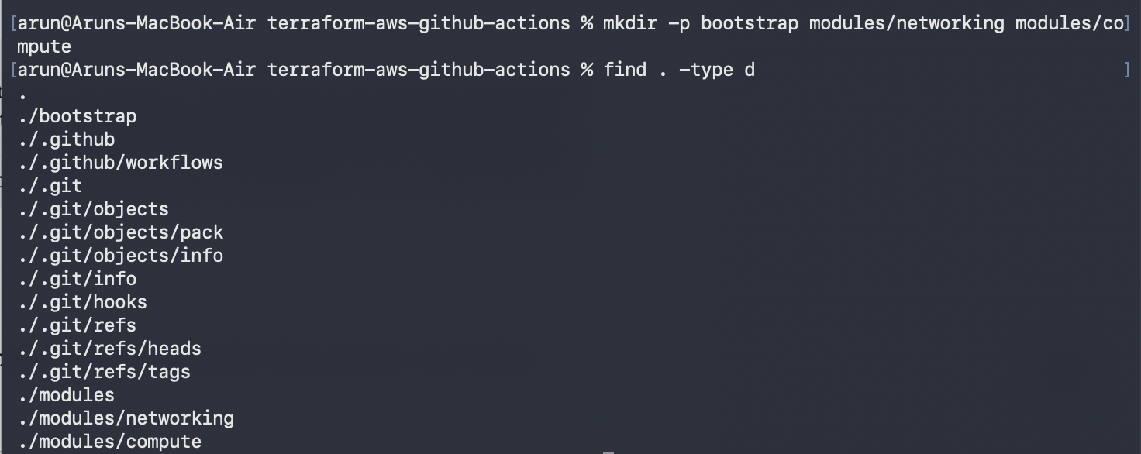

Phase 2 — Bootstrap the backend
~20 minutes · run once, from your laptop
A chicken-and-egg problem: Terraform stores its state in an S3 bucket, but something has to create that bucket first. This small separate stack does it, and creates the IAM role GitHub Actions will assume. It uses local state, because the remote backend does not exist yet.
WHY OIDC
The brief requires no hardcoded AWS credentials. Storing an access key as a GitHub secret would technically satisfy “not in code”, but it is a long-lived key sitting in a repository setting. OIDC is better: GitHub presents a short-lived signed token, AWS verifies it, and hands back credentials that expire in an hour. Nothing durable is ever stored. The trust policy is scoped to your repository, so no other repo — even in the same organisation — can assume the role.

STEP 2.1

Write the bootstrap stack
Three files. The first creates the state bucket, the optional lock table, the GitHub OIDC provider, and a tightly scoped IAM role.
bootstrap/main.tf HCL
terraform {
required_version = ">= 1.10.0"

required_providers {
aws = {
source = "hashicorp/aws"
version = "~> 5.0"
}
}

# Deliberately local state. This stack creates the remote backend that the
# main stack uses, so it cannot store its own state there. Keep the file
# generated here; it is small and easy to re-create if lost.
}

provider "aws" {
region = var.aws_region

default_tags {
tags = {
Project = var.project_name
Purpose = "terraform-bootstrap"
ManagedBy = "Terraform"
}
}
}

data "aws_caller_identity" "current" {}

locals {
state_bucket_name = "${var.project_name}-tfstate-${data.aws_caller_identity.current.account_id}"
lock_table_name = "${var.project_name}-tflock"
app_bucket_prefix = "${var.project_name}-*"
}

# ---------------------------------------------------------------------------
# Remote state bucket
# ---------------------------------------------------------------------------

resource "aws_s3_bucket" "tfstate" {
bucket = local.state_bucket_name

tags = {
Name = local.state_bucket_name
}
}

resource "aws_s3_bucket_versioning" "tfstate" {
bucket = aws_s3_bucket.tfstate.id

versioning_configuration {
status = "Enabled"
}
}

resource "aws_s3_bucket_server_side_encryption_configuration" "tfstate" {
bucket = aws_s3_bucket.tfstate.id

rule {
apply_server_side_encryption_by_default {
sse_algorithm = "AES256"
}
bucket_key_enabled = true
}
}

resource "aws_s3_bucket_public_access_block" "tfstate" {
bucket = aws_s3_bucket.tfstate.id

block_public_acls = true
block_public_policy = true
ignore_public_acls = true
restrict_public_buckets = true
}

# Optional. Only needed if you are pinned to Terraform < 1.10 and must use
# dynamodb_table in the backend instead of use_lockfile.
resource "aws_dynamodb_table" "tflock" {
count = var.create_dynamodb_lock_table ? 1 : 0

name = local.lock_table_name
billing_mode = "PAY_PER_REQUEST"
hash_key = "LockID"

attribute {
name = "LockID"
type = "S"
}

tags = {
Name = local.lock_table_name
}
}

# ---------------------------------------------------------------------------
# GitHub OIDC: lets the workflow assume a role with no stored AWS keys
# ---------------------------------------------------------------------------

resource "aws_iam_openid_connect_provider" "github" {
count = var.create_oidc_provider ? 1 : 0

url = "https://token.actions.githubusercontent.com"
client_id_list = ["sts.amazonaws.com"]
thumbprint_list = ["6938fd4d98bab03faadb97b34396831e3780aea1"]

tags = {
Name = "github-actions-oidc"
}
}

# Used when the provider already exists in the account (it is account-wide,
# so a second one cannot be created). Set create_oidc_provider = false.
data "aws_iam_openid_connect_provider" "existing" {
count = var.create_oidc_provider ? 0 : 1

url = "https://token.actions.githubusercontent.com"
}

locals {
oidc_provider_arn = var.create_oidc_provider ? aws_iam_openid_connect_provider.github[0].arn : data.aws_iam_openid_connect_provider.existing[0].arn
}

data "aws_iam_policy_document" "github_assume_role" {
statement {
sid = "AllowGitHubActionsToAssumeRole"
effect = "Allow"
actions = ["sts:AssumeRoleWithWebIdentity"]

principals {
type = "Federated"
identifiers = [local.oidc_provider_arn]
}

condition {
test = "StringEquals"
variable = "token.actions.githubusercontent.com:aud"
values = ["sts.amazonaws.com"]
}

# Scoped to this repository only. Any other repo presenting a GitHub
# token is refused, even inside the same organisation.
condition {
test = "StringLike"
variable = "token.actions.githubusercontent.com:sub"
values = ["repo:${var.github_owner}/${var.github_repo}:*"]
}
}
}

resource "aws_iam_role" "github_actions" {
name = "${var.project_name}-github-actions"
description = "Assumed by GitHub Actions in ${var.github_owner}/${var.github_repo}"
assume_role_policy = data.aws_iam_policy_document.github_assume_role.json

tags = {
Name = "${var.project_name}-github-actions"
}
}

data "aws_iam_policy_document" "github_actions" {
statement {
sid = "TerraformStateAccess"
effect = "Allow"
actions = [
"s3:ListBucket",
"s3:GetObject",
"s3:PutObject",
"s3:DeleteObject",
]
resources = [
aws_s3_bucket.tfstate.arn,
"${aws_s3_bucket.tfstate.arn}/*",
]
}

statement {
sid = "StateLockTable"
effect = "Allow"
actions = [
"dynamodb:GetItem",
"dynamodb:PutItem",
"dynamodb:DeleteItem",
"dynamodb:DescribeTable",
]
resources = ["arn:aws:dynamodb:${var.aws_region}:${data.aws_caller_identity.current.account_id}:table/${local.lock_table_name}"]
}

# Networking and compute. EC2 resources are largely un-scopable by ARN at
# create time, so this is service-scoped rather than resource-scoped.
statement {
sid = "NetworkingAndCompute"
effect = "Allow"
actions = ["ec2:*"]
resources = ["*"]
}

# Application buckets only. The role cannot touch unrelated buckets.
statement {
sid = "ApplicationBuckets"
effect = "Allow"
actions = ["s3:*"]
resources = [
"arn:aws:s3:::${local.app_bucket_prefix}",
"arn:aws:s3:::${local.app_bucket_prefix}/*",
]
}

# Enough IAM to manage the EC2 instance role and profile, nothing more.
statement {
sid = "InstanceRoleManagement"
effect = "Allow"
actions = [
"iam:CreateRole",
"iam:DeleteRole",
"iam:GetRole",
"iam:PassRole",
"iam:TagRole",
"iam:UntagRole",
"iam:ListRoleTags",
"iam:ListRolePolicies",
"iam:GetRolePolicy",
"iam:PutRolePolicy",
"iam:DeleteRolePolicy",
"iam:AttachRolePolicy",
"iam:DetachRolePolicy",
"iam:ListAttachedRolePolicies",
"iam:CreateInstanceProfile",
"iam:DeleteInstanceProfile",
"iam:GetInstanceProfile",
"iam:TagInstanceProfile",
"iam:AddRoleToInstanceProfile",
"iam:RemoveRoleFromInstanceProfile",
"iam:ListInstanceProfilesForRole",
]
resources = [
"arn:aws:iam::${data.aws_caller_identity.current.account_id}:role/${var.project_name}-*",
"arn:aws:iam::${data.aws_caller_identity.current.account_id}:instance-profile/${var.project_name}-*",
]
}
}

resource "aws_iam_role_policy" "github_actions" {
name = "${var.project_name}-github-actions-policy"
role = aws_iam_role.github_actions.id
policy = data.aws_iam_policy_document.github_actions.json
}

bootstrap/variables.tf HCL
variable "aws_region" {
description = "Region the state bucket and lock table are created in."
type = string
default = "ap-south-1"
}

variable "project_name" {
description = "Must match project_name in the main stack. Names are derived from it."
type = string
default = "project03"
}

variable "github_owner" {
description = "Your GitHub username or organisation, for example capricarun."
type = string
}

variable "github_repo" {
description = "The repository name this role may be assumed from."
type = string
}

variable "create_oidc_provider" {
description = "Set false if the GitHub OIDC provider already exists in this account. It is account-wide, so only one can exist."
type = bool
default = true
}

variable "create_dynamodb_lock_table" {
description = "Create a DynamoDB lock table. Only needed for Terraform < 1.10, which has no native S3 locking."
type = bool
default = true
}

bootstrap/outputs.tf HCL
output "state_bucket_name" {
description = "Paste this into the bucket field in backend.tf."
value = aws_s3_bucket.tfstate.bucket
}

output "state_bucket_region" {
description = "Paste this into the region field in backend.tf."
value = var.aws_region
}

output "lock_table_name" {
description = "Only needed if you use dynamodb_table instead of use_lockfile."
value = try(aws_dynamodb_table.tflock[0].name, "not created")
}

output "github_actions_role_arn" {
description = "Save this as the AWS_ROLE_TO_ASSUME secret in your GitHub repository."
value = aws_iam_role.github_actions.arn
}

output "backend_block" {
description = "The exact backend.tf contents for this account. Copy and paste it."
value = <<-EOT
terraform {
backend "s3" {
bucket = "${aws_s3_bucket.tfstate.bucket}"
key = "project03/terraform.tfstate"
region = "${var.aws_region}"
encrypt = true
use_lockfile = true
}
}
EOT
}

STEP 2.2

Apply it
Substitute your own GitHub username and repository name.
terminal
cd bootstrap
terraform init
terraform apply \
-var="github_owner=YOUR_GITHUB_USERNAME" \
-var="github_repo=YOUR_REPO_NAME"

Review the plan, type yes, and wait about thirty seconds.
IF THIS FAILS
EntityAlreadyExists: OpenIDConnectProvider means your account already has the GitHub provider — it is account-wide and only one can exist. Re-run with -var="create_oidc_provider=false" and the stack will look up the existing one instead.
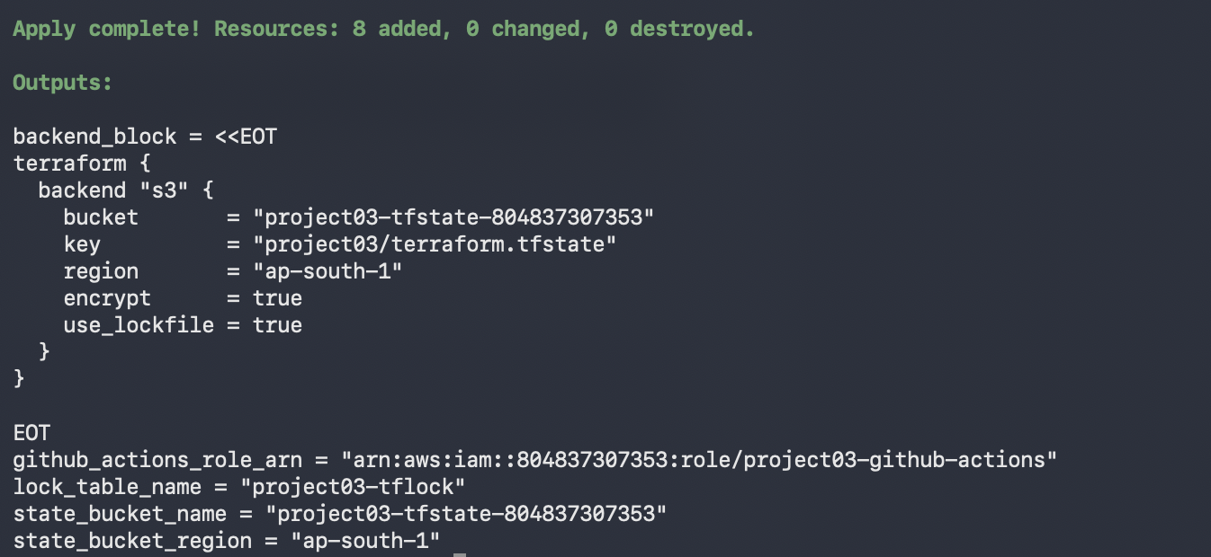
STEP 2.3

Record the two values you need
terminal
terraform output state_bucket_name
terraform output github_actions_role_arn

# Prints a ready-made backend block for your account
terraform output -raw backend_block

cd ..

Keep both. The bucket name goes into backend.tf in the next phase; the role ARN becomes a GitHub secret in phase 6.
CHECKPOINT
In the AWS Console, S3 shows a new bucket named project03-tfstate-<your-account-id>, and IAM → Roles shows project03-github-actions. Screenshot both now — they are part of your remote-state and security evidence.

Phase 3 — The Terraform configuration
~35 minutes · the root module
Now the main stack. These files go in the repository root; the two modules follow in phase 4.
STEP 3.1

Provider requirements and default tags
default_tags applies Project, Environment and ManagedBy to every taggable resource automatically — useful when you are asked to prove which resources Terraform owns.
versions.tf HCL
terraform {
required_version = ">= 1.10.0"

required_providers {
aws = {
source = "hashicorp/aws"
version = "~> 5.0"
}
random = {
source = "hashicorp/random"
version = "~> 3.6"
}
}
}

provider "aws" {
region = var.aws_region

default_tags {
tags = {
Project = var.project_name
Environment = var.environment
ManagedBy = "Terraform"
}
}
}

STEP 3.2

The remote backend
Replace the bucket value with the bucket name from step 2.3, and set region to match your region.
backend.tf HCL
terraform {
# Remote state in S3. State is NEVER committed to Git (see .gitignore).
#
# use_lockfile = true is Terraform's native S3 state locking (Terraform 1.10+).
# It writes a .tflock object next to the state file and needs no DynamoDB table.
#
# If you are pinned to Terraform < 1.10, delete use_lockfile and uncomment
# dynamodb_table instead (the bootstrap stack creates that table for you).
backend "s3" {
bucket = "REPLACE_ME-tfstate-ap-south-1"
key = "project03/terraform.tfstate"
region = "ap-south-1"
encrypt = true
use_lockfile = true

# dynamodb_table = "REPLACE_ME-tflock"
}
}

NOT INTERPOLATABLE
Backend blocks cannot use variables — the backend is configured before variables are evaluated. The bucket name must be a literal string. This is a Terraform limitation, not an oversight.

STEP 3.3

Variables
Everything the brief asks to be configurable, plus validation blocks that fail fast with a readable message instead of a confusing AWS API error twenty seconds into an apply.
variables.tf HCL
variable "aws_region" {
description = "AWS region all resources are created in."
type = string
default = "ap-south-1"
}

variable "project_name" {
description = "Short name prefixed to every resource name and tag."
type = string
default = "project03"

validation {
condition = can(regex("^[a-z0-9-]{3,20}$", var.project_name))
error_message = "project_name must be 3-20 characters, lowercase letters, digits and hyphens only."
}
}

variable "environment" {
description = "Deployment environment. Becomes part of every resource name."
type = string
default = "dev"

validation {
condition = contains(["dev", "staging", "prod"], var.environment)
error_message = "environment must be one of: dev, staging, prod."
}
}

variable "vpc_cidr" {
description = "CIDR block for the VPC."
type = string
default = "10.0.0.0/16"

validation {
condition = can(cidrnetmask(var.vpc_cidr))
error_message = "vpc_cidr must be a valid IPv4 CIDR block, for example 10.0.0.0/16."
}
}

variable "public_subnet_cidrs" {
description = "CIDR blocks for the two public subnets, one per availability zone."
type = list(string)
default = ["10.0.1.0/24", "10.0.2.0/24"]

validation {
condition = length(var.public_subnet_cidrs) == 2
error_message = "Exactly two public subnet CIDRs are required."
}
}

variable "instance_type" {
description = "EC2 instance type for the web server."
type = string
default = "t3.micro"
}

variable "ami_id" {
description = "AMI ID for the web server. Leave empty to auto-select the newest Amazon Linux 2023 AMI in the region."
type = string
default = ""
}

variable "allowed_http_cidr" {
description = "CIDR allowed to reach the web server on port 80. Public by design so the landing page is reachable."
type = string
default = "0.0.0.0/0"
}

variable "allowed_ssh_cidr" {
description = "CIDR allowed to reach port 22. Leave empty to create no SSH rule at all (recommended: use SSM Session Manager)."
type = string
default = ""
}

variable "root_volume_size" {
description = "Size of the EC2 root EBS volume in GiB."
type = number
default = 8
}

STEP 3.4

Root resources and module wiring
The S3 bucket lives here rather than in a module because both the compute module (which needs its ARN for the IAM policy) and the outputs reference it. A random four-byte suffix keeps the bucket name globally unique.
main.tf HCL
data "aws_availability_zones" "available" {
state = "available"
}

# Newest Amazon Linux 2023 image, used only when var.ami_id is left empty.
data "aws_ami" "amazon_linux" {
most_recent = true
owners = ["amazon"]

filter {
name = "name"
values = ["al2023-ami-2023.*-x86_64"]
}

filter {
name = "virtualization-type"
values = ["hvm"]
}
}

resource "random_id" "bucket_suffix" {
byte_length = 4
}

locals {
name_prefix = "${var.project_name}-${var.environment}"
availability_zones = slice(data.aws_availability_zones.available.names, 0, 2)
ami_id = var.ami_id != "" ? var.ami_id : data.aws_ami.amazon_linux.id
bucket_name = "${var.project_name}-${var.environment}-app-${random_id.bucket_suffix.hex}"
}

# ---------------------------------------------------------------------------
# S3 application bucket: versioned, encrypted, no public access
# ---------------------------------------------------------------------------

resource "aws_s3_bucket" "app" {
bucket = local.bucket_name

tags = {
Name = "${local.name_prefix}-app"
}
}

resource "aws_s3_bucket_versioning" "app" {
bucket = aws_s3_bucket.app.id

versioning_configuration {
status = "Enabled"
}
}

resource "aws_s3_bucket_server_side_encryption_configuration" "app" {
bucket = aws_s3_bucket.app.id

rule {
apply_server_side_encryption_by_default {
sse_algorithm = "AES256"
}
bucket_key_enabled = true
}
}

resource "aws_s3_bucket_public_access_block" "app" {
bucket = aws_s3_bucket.app.id

block_public_acls = true
block_public_policy = true
ignore_public_acls = true
restrict_public_buckets = true
}

resource "aws_s3_bucket_ownership_controls" "app" {
bucket = aws_s3_bucket.app.id

rule {
object_ownership = "BucketOwnerEnforced"
}
}

# ---------------------------------------------------------------------------
# Modules
# ---------------------------------------------------------------------------

module "networking" {
source = "./modules/networking"

name_prefix = local.name_prefix
vpc_cidr = var.vpc_cidr
public_subnet_cidrs = var.public_subnet_cidrs
availability_zones = local.availability_zones
allowed_http_cidr = var.allowed_http_cidr
allowed_ssh_cidr = var.allowed_ssh_cidr
}

module "compute" {
source = "./modules/compute"

name_prefix = local.name_prefix
ami_id = local.ami_id
instance_type = var.instance_type
root_volume_size = var.root_volume_size
subnet_id = module.networking.public_subnet_ids[0]
security_group_id = module.networking.web_security_group_id

s3_bucket_arn = aws_s3_bucket.app.arn
s3_bucket_name = aws_s3_bucket.app.bucket

project_name = var.project_name
environment = var.environment
aws_region = var.aws_region
}

STEP 3.5

Outputs
The five the brief names, plus four more that the validation job uses to verify resources exist.
outputs.tf HCL
output "vpc_id" {
description = "ID of the VPC."
value = module.networking.vpc_id
}

output "public_subnet_ids" {
description = "IDs of the two public subnets."
value = module.networking.public_subnet_ids
}

output "security_group_id" {
description = "ID of the web server security group."
value = module.networking.web_security_group_id
}

output "ec2_instance_id" {
description = "ID of the EC2 web server instance."
value = module.compute.instance_id
}

output "elastic_ip" {
description = "Elastic IP address attached to the web server."
value = module.compute.elastic_ip
}

output "application_url" {
description = "Public URL of the landing page served by the EC2 instance."
value = "http://${module.compute.elastic_ip}"
}

output "s3_bucket_name" {
description = "Name of the versioned, encrypted application bucket."
value = aws_s3_bucket.app.bucket
}

output "iam_role_name" {
description = "Name of the IAM role attached to the EC2 instance profile."
value = module.compute.iam_role_name
}

output "iam_instance_profile_name" {
description = "Name of the EC2 instance profile."
value = module.compute.instance_profile_name
}

STEP 3.6

Your values
terraform.tfvars HCL
aws_region = "ap-south-1"
project_name = "project03"
environment = "dev"

vpc_cidr = "10.0.0.0/16"
public_subnet_cidrs = ["10.0.1.0/24", "10.0.2.0/24"]

instance_type = "t3.micro"

# Leave empty to auto-select the newest Amazon Linux 2023 AMI for the region.
# Set an explicit AMI ID here if your evaluator asks to see the variable used.
ami_id = ""

allowed_http_cidr = "0.0.0.0/0"

# Empty string means no SSH rule is created at all.
allowed_ssh_cidr = ""

ON COMMITTING TFVARS
This file is committed deliberately — it holds only public configuration and the workflow needs it at plan time. The .gitignore in the next step ignores *.tfvars in general and re-includes this one specific file. Never put secrets in it.

STEP 3.7

The .gitignore
The brief is explicit that Terraform state must never reach GitHub. State files contain every resource ID and, for some resource types, secrets in plain text.
.gitignore text
# ---------------------------------------------------------------------------
# Terraform state. NEVER commit this: it holds resource IDs and can hold
# secrets in plain text. State lives in the S3 backend instead.
# ---------------------------------------------------------------------------
*.tfstate
*.tfstate.*
*.tfstate.backup
.terraform.tfstate.lock.info

# Provider plugins and module cache
**/.terraform/*
.terraform/

# Plan files. Generated per run and published as a workflow artifact.
tfplan
*.tfplan
tfplan.txt
plan.out

# Crash logs
crash.log
crash.*.log

# Variable files may contain account-specific or sensitive values.
# terraform.tfvars is committed here on purpose: it holds only public,
# non-secret configuration and the workflow needs it.
*.tfvars
*.tfvars.json
!terraform.tfvars
!example.tfvars

# CLI config
.terraformrc
terraform.rc

# Override files are for local experiments
override.tf
override.tf.json
*_override.tf
*_override.tf.json

# Credentials, keys — never commit any of these
*.pem
*.ppk
.env
.env.*
credentials
aws_credentials

# Editor and OS noise
.vscode/
.idea/
.DS_Store
Thumbs.db

# NOTE: .terraform.lock.hcl is deliberately NOT ignored. Commit it so CI
# installs the exact provider versions you tested with.

COMMIT THE LOCK FILE
.terraform.lock.hcl is deliberately NOT ignored. It pins exact provider versions and checksums. Without it, the apply job could install a different provider version than the plan job did, and applying the saved plan will fail.
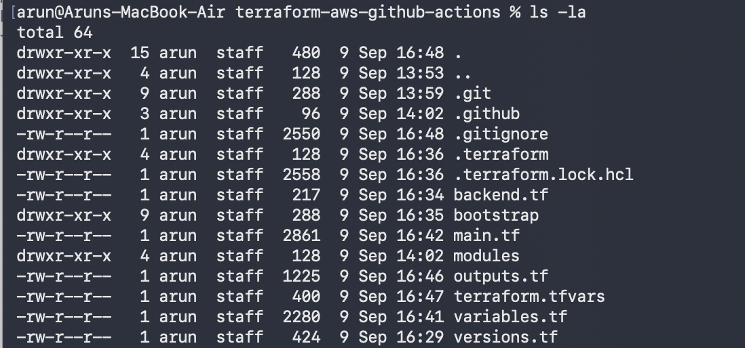

Phase 4 — The two modules
~30 minutes · networking and compute
A module is just a folder with its own variables, resources and outputs. The root module calls each with explicit inputs and reads explicit outputs back — nothing crosses the boundary implicitly.
STEP 4.1

Networking module
VPC, two public subnets across two availability zones, internet gateway, route table with a default route, and the associations that make the subnets genuinely public. Security group rules are separate resources rather than inline blocks, so each rule shows up individually in the plan and can be reviewed on its own.
modules/networking/main.tf HCL
resource "aws_vpc" "this" {
cidr_block = var.vpc_cidr
enable_dns_support = true
enable_dns_hostnames = true

tags = {
Name = "${var.name_prefix}-vpc"
}
}

resource "aws_internet_gateway" "this" {
vpc_id = aws_vpc.this.id

tags = {
Name = "${var.name_prefix}-igw"
}
}

resource "aws_subnet" "public" {
count = length(var.public_subnet_cidrs)

vpc_id = aws_vpc.this.id
cidr_block = var.public_subnet_cidrs[count.index]
availability_zone = var.availability_zones[count.index]
map_public_ip_on_launch = true

tags = {
Name = "${var.name_prefix}-public-${count.index + 1}"
Tier = "public"
}
}

resource "aws_route_table" "public" {
vpc_id = aws_vpc.this.id

route {
cidr_block = "0.0.0.0/0"
gateway_id = aws_internet_gateway.this.id
}

tags = {
Name = "${var.name_prefix}-public-rt"
}
}

resource "aws_route_table_association" "public" {
count = length(aws_subnet.public)

subnet_id = aws_subnet.public[count.index].id
route_table_id = aws_route_table.public.id
}

# ---------------------------------------------------------------------------
# Security group. Rules are separate resources so each one is independently
# addressable in the plan and least-privilege changes are easy to review.
# ---------------------------------------------------------------------------

resource "aws_security_group" "web" {
name = "${var.name_prefix}-web-sg"
description = "Web server: inbound HTTP only, all outbound"
vpc_id = aws_vpc.this.id

tags = {
Name = "${var.name_prefix}-web-sg"
}

lifecycle {
create_before_destroy = true
}
}

resource "aws_vpc_security_group_ingress_rule" "http" {
security_group_id = aws_security_group.web.id
description = "HTTP from allowed CIDR"
cidr_ipv4 = var.allowed_http_cidr
from_port = 80
to_port = 80
ip_protocol = "tcp"

tags = {
Name = "${var.name_prefix}-allow-http"
}
}

# Created only when allowed_ssh_cidr is set. Left empty, the instance has no
# SSH exposure at all and is reached through SSM Session Manager instead.
resource "aws_vpc_security_group_ingress_rule" "ssh" {
count = var.allowed_ssh_cidr != "" ? 1 : 0

security_group_id = aws_security_group.web.id
description = "SSH from a single administrative CIDR"
cidr_ipv4 = var.allowed_ssh_cidr
from_port = 22
to_port = 22
ip_protocol = "tcp"

tags = {
Name = "${var.name_prefix}-allow-ssh"
}
}

resource "aws_vpc_security_group_egress_rule" "all" {
security_group_id = aws_security_group.web.id
description = "All outbound traffic"
cidr_ipv4 = "0.0.0.0/0"
ip_protocol = "-1"

tags = {
Name = "${var.name_prefix}-allow-egress"
}
}

modules/networking/variables.tf HCL
variable "name_prefix" {
description = "Prefix applied to every resource name in this module."
type = string
}

variable "vpc_cidr" {
description = "CIDR block for the VPC."
type = string
}

variable "public_subnet_cidrs" {
description = "CIDR blocks for the public subnets."
type = list(string)
}

variable "availability_zones" {
description = "Availability zones, one per public subnet, in the same order."
type = list(string)
}

variable "allowed_http_cidr" {
description = "CIDR allowed inbound on port 80."
type = string
default = "0.0.0.0/0"
}

variable "allowed_ssh_cidr" {
description = "CIDR allowed inbound on port 22. Empty string creates no SSH rule."
type = string
default = ""
}

modules/networking/outputs.tf HCL
output "vpc_id" {
description = "ID of the VPC."
value = aws_vpc.this.id
}

output "vpc_cidr" {
description = "CIDR block of the VPC."
value = aws_vpc.this.cidr_block
}

output "internet_gateway_id" {
description = "ID of the internet gateway."
value = aws_internet_gateway.this.id
}

output "public_subnet_ids" {
description = "IDs of the public subnets, in the order their CIDRs were supplied."
value = aws_subnet.public[*].id
}

output "route_table_id" {
description = "ID of the public route table."
value = aws_route_table.public.id
}

output "web_security_group_id" {
description = "ID of the web server security group."
value = aws_security_group.web.id
}

A SUBNET IS NOT PUBLIC BY ITSELF
Three things together make it public: map_public_ip_on_launch, a route table with a 0.0.0.0/0 route to an internet gateway, and an association binding that route table to the subnet. Miss the association and instances launch with a public IP that routes nowhere.
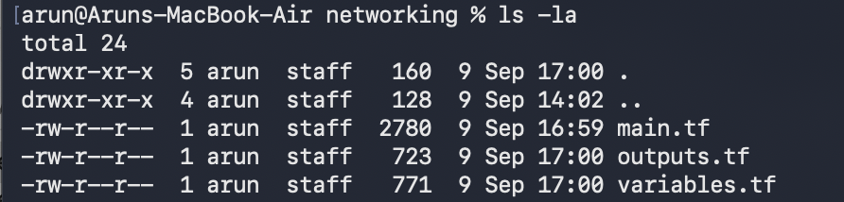
STEP 4.2

Compute module
The IAM role and instance profile come first, because the instance references the profile. The policy grants exactly two things on exactly one bucket — that is what “least privilege” means concretely.
modules/compute/main.tf HCL
# ---------------------------------------------------------------------------
# IAM role + instance profile.
# The instance gets NO access keys. It receives temporary credentials from the
# instance metadata service, scoped to exactly one bucket.
# ---------------------------------------------------------------------------

data "aws_iam_policy_document" "ec2_assume_role" {
statement {
sid = "AllowEC2ToAssumeThisRole"
effect = "Allow"
actions = ["sts:AssumeRole"]

principals {
type = "Service"
identifiers = ["ec2.amazonaws.com"]
}
}
}

resource "aws_iam_role" "ec2" {
name = "${var.name_prefix}-ec2-role"
description = "Role assumed by the ${var.name_prefix} web server"
assume_role_policy = data.aws_iam_policy_document.ec2_assume_role.json

tags = {
Name = "${var.name_prefix}-ec2-role"
}
}

# Least privilege: list only this bucket, read/write only this bucket's objects.
data "aws_iam_policy_document" "s3_access" {
statement {
sid = "ListOnlyThisBucket"
effect = "Allow"
actions = ["s3:ListBucket"]
resources = [var.s3_bucket_arn]
}

statement {
sid = "ReadWriteObjectsInThisBucket"
effect = "Allow"
actions = ["s3:GetObject", "s3:PutObject"]
resources = ["${var.s3_bucket_arn}/*"]
}
}

resource "aws_iam_role_policy" "s3_access" {
name = "${var.name_prefix}-s3-access"
role = aws_iam_role.ec2.id
policy = data.aws_iam_policy_document.s3_access.json
}

# Lets you open a shell on the instance through Session Manager, so no SSH
# port and no key pair are needed.
resource "aws_iam_role_policy_attachment" "ssm" {
role = aws_iam_role.ec2.name
policy_arn = "arn:aws:iam::aws:policy/AmazonSSMManagedInstanceCore"
}

resource "aws_iam_instance_profile" "ec2" {
name = "${var.name_prefix}-ec2-profile"
role = aws_iam_role.ec2.name

tags = {
Name = "${var.name_prefix}-ec2-profile"
}
}

# ---------------------------------------------------------------------------
# EC2 web server
# ---------------------------------------------------------------------------

resource "aws_instance" "web" {
ami = var.ami_id
instance_type = var.instance_type
subnet_id = var.subnet_id
vpc_security_group_ids = [var.security_group_id]
iam_instance_profile = aws_iam_instance_profile.ec2.name

user_data_replace_on_change = true

user_data = templatefile("${path.module}/user_data.sh.tftpl", {
project_name = var.project_name
environment = var.environment
aws_region = var.aws_region
s3_bucket_name = var.s3_bucket_name
})

# IMDSv2 only: blocks the SSRF-style credential theft that IMDSv1 allows.
metadata_options {
http_endpoint = "enabled"
http_tokens = "required"
http_put_response_hop_limit = 1
}

root_block_device {
volume_type = "gp3"
volume_size = var.root_volume_size
encrypted = true

tags = {
Name = "${var.name_prefix}-root"
}
}

tags = {
Name = "${var.name_prefix}-web"
Role = "web-server"
}
}

resource "aws_eip" "web" {
domain = "vpc"
instance = aws_instance.web.id

tags = {
Name = "${var.name_prefix}-eip"
}

depends_on = [aws_instance.web]
}

modules/compute/variables.tf HCL
variable "name_prefix" {
description = "Prefix applied to every resource name in this module."
type = string
}

variable "ami_id" {
description = "AMI ID for the instance."
type = string
}

variable "instance_type" {
description = "EC2 instance type."
type = string
}

variable "root_volume_size" {
description = "Root EBS volume size in GiB."
type = number
default = 8
}

variable "subnet_id" {
description = "Public subnet the instance is launched into."
type = string
}

variable "security_group_id" {
description = "Security group attached to the instance."
type = string
}

variable "s3_bucket_arn" {
description = "ARN of the application bucket the instance role is scoped to."
type = string
}

variable "s3_bucket_name" {
description = "Name of the application bucket, shown on the landing page and used by user data."
type = string
}

variable "project_name" {
description = "Project name, shown on the landing page."
type = string
}

variable "environment" {
description = "Environment name, shown on the landing page."
type = string
}

variable "aws_region" {
description = "Region, used by the AWS CLI call in user data."
type = string
}

modules/compute/outputs.tf HCL
output "instance_id" {
description = "ID of the EC2 instance."
value = aws_instance.web.id
}

output "private_ip" {
description = "Private IP of the EC2 instance."
value = aws_instance.web.private_ip
}

output "elastic_ip" {
description = "Elastic IP address associated with the instance."
value = aws_eip.web.public_ip
}

output "elastic_ip_allocation_id" {
description = "Allocation ID of the Elastic IP."
value = aws_eip.web.id
}

output "iam_role_name" {
description = "Name of the IAM role assumed by the instance."
value = aws_iam_role.ec2.name
}

output "iam_role_arn" {
description = "ARN of the IAM role assumed by the instance."
value = aws_iam_role.ec2.arn
}

output "instance_profile_name" {
description = "Name of the instance profile attached to the instance."
value = aws_iam_instance_profile.ec2.name
}

STEP 4.3

The user data script
This runs once, as root, on first boot. It installs nginx, writes a landing page showing live instance metadata, starts the service, and copies the page to S3 — which proves the instance profile works, since there are no credentials on the box.
modules/compute/user_data.sh.tftpl bash + HCL template
#!/bin/bash
set -euxo pipefail

# Terraform substitutes $${...} placeholders below at plan time.
# Shell variables use bare $NAME so Terraform leaves them alone.

dnf update -y || true
dnf install -y nginx

# The standard AL2023 AMI ships the AWS CLI, minimal variants do not.
if ! command -v aws >/dev/null 2>&1; then
dnf install -y awscli-2 || true
fi

# IMDSv2: fetch a session token first, then read metadata with it.
TOKEN=$(curl -sS -X PUT "http://169.254.169.254/latest/api/token" \
-H "X-aws-ec2-metadata-token-ttl-seconds: 300")

meta() {
curl -sS -H "X-aws-ec2-metadata-token: $TOKEN" \
"http://169.254.169.254/latest/meta-data/$1"
}

INSTANCE_ID=$(meta instance-id)
INSTANCE_TYPE=$(meta instance-type)
AVAILABILITY_ZONE=$(meta placement/availability-zone)
DEPLOYED_AT=$(date -u '+%Y-%m-%d %H:%M:%S UTC')

cat > /usr/share/nginx/html/index.html <<HTML
<!doctype html>
<html lang="en">
<head>
<meta charset="utf-8">
<meta name="viewport" content="width=device-width, initial-scale=1">
<title>${project_name} — provisioned by Terraform</title>
<style>
:root { color-scheme: dark; }
* { box-sizing: border-box; }
body {
margin: 0; min-height: 100vh; display: grid; place-items: center;
background: #12111a; color: #edebf2; padding: 24px;
font-family: ui-sans-serif, system-ui, -apple-system, "Segoe UI", sans-serif;
}
.card {
width: 100%; max-width: 560px; background: #1a1922;
border: 1px solid #2c2a36; border-radius: 14px; padding: 36px;
}
.badge {
display: inline-block; font-size: 11px; letter-spacing: .12em;
text-transform: uppercase; color: #9d8bff; border: 1px solid #3b3550;
border-radius: 999px; padding: 5px 12px; margin-bottom: 20px;
}
h1 { margin: 0 0 8px; font-size: 30px; line-height: 1.15; letter-spacing: -.02em; }
p.lede { margin: 0 0 28px; color: #9c97ac; font-size: 15px; line-height: 1.55; }
dl { display: grid; grid-template-columns: auto 1fr; gap: 10px 20px; margin: 0; font-size: 13px; }
dt { color: #9c97ac; }
dd {
margin: 0; text-align: right;
font-family: ui-monospace, SFMono-Regular, "SF Mono", Menlo, monospace;
word-break: break-all;
}
footer {
margin-top: 28px; padding-top: 18px; border-top: 1px solid #2c2a36;
color: #6f6b7f; font-size: 12px;
}
</style>
</head>
<body>
<main class="card">
<span class="badge">${environment}</span>
<h1>${project_name} is live.</h1>
<p class="lede">
This nginx server was installed and started by Terraform user data on
first boot. Nothing here was configured by hand.
</p>
<dl>
<dt>Instance ID</dt><dd>$INSTANCE_ID</dd>
<dt>Instance type</dt><dd>$INSTANCE_TYPE</dd>
<dt>Availability zone</dt><dd>$AVAILABILITY_ZONE</dd>
<dt>Region</dt><dd>${aws_region}</dd>
<dt>S3 bucket</dt><dd>${s3_bucket_name}</dd>
<dt>Deployed</dt><dd>$DEPLOYED_AT</dd>
</dl>
<footer>
Terraform &rarr; GitHub Actions &rarr; AWS
</footer>
</main>
</body>
</html>
HTML

systemctl enable nginx
systemctl start nginx

# Proves the instance profile works: no keys on this box, yet it can write to
# its own bucket. Never fail the boot if this call does not succeed.
aws s3 cp /usr/share/nginx/html/index.html \
"s3://${s3_bucket_name}/landing-page/index.html" \
--region "${aws_region}" || echo "S3 upload skipped"

TWO KINDS OF DOLLAR SIGN
In a .tftpl template, ${name} is substituted by Terraform before the script is ever uploaded, while $NAME is left alone for the shell to expand at boot. That is why instance metadata uses bare $INSTANCE_ID and the project name uses braces. Getting these backwards is the most common templating mistake.

EVIDENCE TO CAPTURE
This file is your proof for the “EC2 Web Server” requirement. Later, pair it with a browser screenshot of the rendered page.
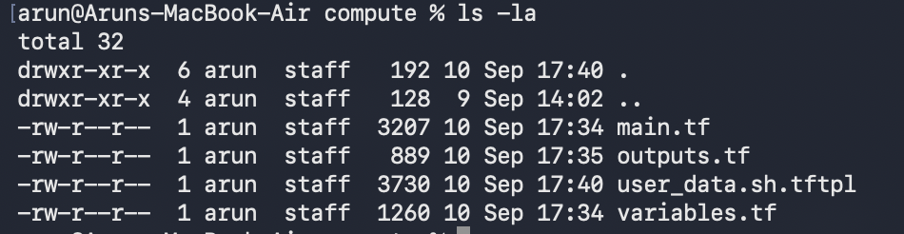

Phase 5 — The CI/CD workflow
~15 minutes · GitHub Actions
All ten required steps, split across three jobs so the approval gate can sit between planning and applying.
STEP 5.1

Write the workflow
.github/workflows/terraform.yml YAML
name: Terraform AWS Infrastructure

# Any push to main runs the full pipeline. Pull requests stop after the plan,
# so a reviewer sees the proposed change without anything being applied.
on:
push:
branches: [main]
pull_request:
branches: [main]
workflow_dispatch:

# Only one deployment at a time. A second push waits instead of racing the
# first for the state lock.
concurrency:
group: terraform-${{ github.ref }}
cancel-in-progress: false

permissions:
contents: read
id-token: write # required to request the OIDC token for AWS

env:
AWS_REGION: ap-south-1
TF_VERSION: "latest" # pin to an exact version, e.g. "1.10.5", for reproducible runs
PLAN_ARTIFACT: terraform-plan

jobs:
# ---------------------------------------------------------------------
# 1. Format, initialise, validate, plan, and publish the plan artifact
# ---------------------------------------------------------------------
plan:
name: Format, Validate & Plan
runs-on: ubuntu-latest

steps:
- name: Checkout repository
uses: actions/checkout@v4

- name: Configure AWS credentials via OIDC
uses: aws-actions/configure-aws-credentials@v4
with:
role-to-assume: ${{ secrets.AWS_ROLE_TO_ASSUME }}
aws-region: ${{ env.AWS_REGION }}
role-session-name: gha-terraform-plan-${{ github.run_id }}

- name: Setup Terraform
uses: hashicorp/setup-terraform@v3
with:
terraform_version: ${{ env.TF_VERSION }}
terraform_wrapper: false

- name: Terraform Format
id: fmt
run: terraform fmt -check -recursive -diff

- name: Terraform Init
id: init
run: terraform init -input=false

- name: Terraform Validate
id: validate
run: terraform validate -no-color

- name: Terraform Plan
id: plan
run: terraform plan -input=false -no-color -out=tfplan

- name: Render plan as text
run: terraform show -no-color tfplan > tfplan.txt

- name: Upload plan artifact
uses: actions/upload-artifact@v4
with:
name: ${{ env.PLAN_ARTIFACT }}-${{ github.run_id }}
path: |
tfplan
tfplan.txt
retention-days: 5
if-no-files-found: error

- name: Publish plan summary
run: |
{
echo "## Terraform Plan"
echo ""
echo '```'
head -c 60000 tfplan.txt
echo '```'
} >> "$GITHUB_STEP_SUMMARY"

# ---------------------------------------------------------------------
# 2. Wait for a human, then apply exactly the plan that was reviewed
# ---------------------------------------------------------------------
apply:
name: Approve & Apply
runs-on: ubuntu-latest
needs: plan
if: github.event_name != 'pull_request'

# This is the approval gate. The job will not start until a reviewer
# configured on the "production" environment approves it.
environment:
name: production
url: ${{ steps.outputs.outputs.application_url }}

steps:
- name: Checkout repository
uses: actions/checkout@v4

- name: Configure AWS credentials via OIDC
uses: aws-actions/configure-aws-credentials@v4
with:
role-to-assume: ${{ secrets.AWS_ROLE_TO_ASSUME }}
aws-region: ${{ env.AWS_REGION }}
role-session-name: gha-terraform-apply-${{ github.run_id }}

- name: Setup Terraform
uses: hashicorp/setup-terraform@v3
with:
terraform_version: ${{ env.TF_VERSION }}
terraform_wrapper: false

- name: Download the approved plan
uses: actions/download-artifact@v4
with:
name: ${{ env.PLAN_ARTIFACT }}-${{ github.run_id }}

- name: Terraform Init
run: terraform init -input=false

# Applying the saved plan file, not re-planning. What was approved is
# exactly what gets built.
- name: Terraform Apply
run: terraform apply -input=false -no-color tfplan

- name: Terraform Outputs
id: outputs
run: |
terraform output

APP_URL=$(terraform output -raw application_url)
echo "application_url=$APP_URL" >> "$GITHUB_OUTPUT"

{
echo "## Deployment Outputs"
echo ""
echo "| Output | Value |"
echo "| --- | --- |"
echo "| VPC ID | \`$(terraform output -raw vpc_id)\` |"
echo "| EC2 Instance ID | \`$(terraform output -raw ec2_instance_id)\` |"
echo "| Elastic IP | \`$(terraform output -raw elastic_ip)\` |"
echo "| Security Group | \`$(terraform output -raw security_group_id)\` |"
echo "| IAM Role | \`$(terraform output -raw iam_role_name)\` |"
echo "| S3 Bucket | \`$(terraform output -raw s3_bucket_name)\` |"
echo "| Application URL | $APP_URL |"
} >> "$GITHUB_STEP_SUMMARY"

# ---------------------------------------------------------------------
# 3. Prove the infrastructure is real and the web server actually answers
# ---------------------------------------------------------------------
validate-infrastructure:
name: Infrastructure Validation
runs-on: ubuntu-latest
needs: apply
if: github.event_name != 'pull_request'

steps:
- name: Checkout repository
uses: actions/checkout@v4

- name: Configure AWS credentials via OIDC
uses: aws-actions/configure-aws-credentials@v4
with:
role-to-assume: ${{ secrets.AWS_ROLE_TO_ASSUME }}
aws-region: ${{ env.AWS_REGION }}
role-session-name: gha-terraform-verify-${{ github.run_id }}

- name: Setup Terraform
uses: hashicorp/setup-terraform@v3
with:
terraform_version: ${{ env.TF_VERSION }}
terraform_wrapper: false

- name: Terraform Init
run: terraform init -input=false

- name: Read outputs into the environment
run: |
{
echo "VPC_ID=$(terraform output -raw vpc_id)"
echo "INSTANCE_ID=$(terraform output -raw ec2_instance_id)"
echo "ELASTIC_IP=$(terraform output -raw elastic_ip)"
echo "BUCKET=$(terraform output -raw s3_bucket_name)"
echo "SG_ID=$(terraform output -raw security_group_id)"
echo "ROLE_NAME=$(terraform output -raw iam_role_name)"
echo "PROFILE_NAME=$(terraform output -raw iam_instance_profile_name)"
echo "APP_URL=$(terraform output -raw application_url)"
} >> "$GITHUB_ENV"

- name: Verify VPC and networking
run: |
aws ec2 describe-vpcs --vpc-ids "$VPC_ID" \
--query 'Vpcs[0].{State:State,Cidr:CidrBlock}' --output table
aws ec2 describe-subnets --filters "Name=vpc-id,Values=$VPC_ID" \
--query 'Subnets[].{Subnet:SubnetId,AZ:AvailabilityZone,Cidr:CidrBlock,PublicIP:MapPublicIpOnLaunch}' \
--output table
aws ec2 describe-internet-gateways \
--filters "Name=attachment.vpc-id,Values=$VPC_ID" \
--query 'InternetGateways[0].InternetGatewayId' --output text
aws ec2 describe-route-tables --filters "Name=vpc-id,Values=$VPC_ID" \
--query 'RouteTables[].{RT:RouteTableId,Assocs:length(Associations)}' --output table

- name: Verify EC2 instance and Elastic IP
run: |
aws ec2 describe-instances --instance-ids "$INSTANCE_ID" \
--query 'Reservations[0].Instances[0].{State:State.Name,Type:InstanceType,AZ:Placement.AvailabilityZone,Profile:IamInstanceProfile.Arn}' \
--output table
aws ec2 describe-addresses --public-ips "$ELASTIC_IP" \
--query 'Addresses[0].{IP:PublicIp,Instance:InstanceId}' --output table

- name: Verify security group rules
run: |
aws ec2 describe-security-group-rules \
--filters "Name=group-id,Values=$SG_ID" \
--query 'SecurityGroupRules[].{Egress:IsEgress,Port:FromPort,Proto:IpProtocol,Cidr:CidrIpv4}' \
--output table

- name: Verify S3 bucket is versioned, encrypted and private
run: |
aws s3api get-bucket-versioning --bucket "$BUCKET"
aws s3api get-bucket-encryption --bucket "$BUCKET"
aws s3api get-public-access-block --bucket "$BUCKET"

- name: Verify IAM role and instance profile
run: |
aws iam get-role --role-name "$ROLE_NAME" \
--query 'Role.{Name:RoleName,Arn:Arn}' --output table
aws iam get-instance-profile --instance-profile-name "$PROFILE_NAME" \
--query 'InstanceProfile.Roles[].RoleName' --output text

# User data takes a couple of minutes on first boot. Poll rather than
# assuming the server is up the moment Terraform finishes.
- name: Verify the web server responds
run: |
echo "Polling $APP_URL"
for attempt in $(seq 1 40); do
if curl -fsS --max-time 5 "$APP_URL" -o /tmp/landing.html; then
echo "Web server answered on attempt $attempt"
grep -o '<title>[^<]*</title>' /tmp/landing.html || true
{
echo "## Validation Passed"
echo ""
echo "The landing page is live at [$APP_URL]($APP_URL)."
} >> "$GITHUB_STEP_SUMMARY"
exit 0
fi
echo "attempt $attempt: not ready yet, waiting 15s"
sleep 15
done
echo "Web server did not respond within 10 minutes"
exit 1

STEP 5.2

Three decisions worth being able to defend
DECISION | WHY
id-token: write | Without this permission the workflow cannot request an OIDC token and the AWS credentials step fails with a confusing “Credentials could not be loaded” error.
Apply the saved plan file | terraform apply tfplan applies precisely what the reviewer saw. Re-planning inside the apply job would let the infrastructure drift between approval and execution — the approval would be meaningless.
environment: production | This one line is the entire approval mechanism. GitHub pauses the job and notifies the reviewers configured on that environment. Nothing else in the workflow enforces it.

STEP 5.3

Add the README
The brief lists README.md as a submission item. Cover what gets built, the pipeline shape, how to run it, and how to tear it down.
README.md Markdown
# AWS Infrastructure Automation with Terraform and GitHub Actions

Provisions a complete AWS environment with Terraform and deploys it through a
GitHub Actions pipeline that requires human approval before anything is applied.

## What gets built

| Layer | Resources |
| --- | --- |
| Networking | VPC, 2 public subnets across 2 AZs, internet gateway, public route table + 2 associations, security group with explicit ingress/egress rules |
| Compute | EC2 instance (Amazon Linux 2023, nginx installed by user data), Elastic IP, IAM role, IAM instance profile |
| Storage | S3 bucket with versioning, AES256 encryption, and all public access blocked |

## Pipeline

```
push to main
└─ plan job fmt → init → validate → plan → upload plan artifact
└─ apply job ⏸ manual approval → apply the approved plan → outputs
└─ validate job verify every resource → poll the web server
```

The apply job is gated by the `production` GitHub environment. It will not
start until a configured reviewer approves it, and it applies the exact saved
plan file that was reviewed — not a fresh plan.

## Repository layout

```
.
├── .github/workflows/terraform.yml CI/CD pipeline
├── bootstrap/ one-time: state bucket + OIDC role
│ ├── main.tf
│ ├── variables.tf
│ └── outputs.tf
├── modules/
│ ├── networking/ VPC, subnets, IGW, routing, security group
│ │ ├── main.tf
│ │ ├── variables.tf
│ │ └── outputs.tf
│ └── compute/ EC2, EIP, IAM role, instance profile
│ ├── main.tf
│ ├── variables.tf
│ ├── outputs.tf
│ └── user_data.sh.tftpl installs and starts nginx
├── backend.tf S3 remote state + native state locking
├── versions.tf provider requirements and default tags
├── variables.tf all configurable inputs
├── main.tf S3 bucket + module wiring
├── outputs.tf VPC ID, instance ID, EIP, URL, bucket
├── terraform.tfvars non-secret configuration values
└── .gitignore keeps state and plans out of Git
```

## Prerequisites

- An AWS account with permission to create IAM roles
- Terraform 1.10 or newer (needed for `use_lockfile` native S3 state locking)
- AWS CLI configured locally, used only for the one-time bootstrap
- A GitHub repository

## Setup

### 1. Bootstrap the backend and the CI role

Run once, from your own machine.

```bash
cd bootstrap
terraform init
terraform apply \
-var="github_owner=YOUR_GITHUB_USERNAME" \
-var="github_repo=YOUR_REPO_NAME"
```

Note the two outputs:

- `state_bucket_name` → paste into `bucket` in `backend.tf`
- `github_actions_role_arn` → save as the `AWS_ROLE_TO_ASSUME` repository secret

### 2. Point the backend at your bucket

Edit `backend.tf` and replace the `bucket` value with `state_bucket_name`.
Set `region` to match.

### 3. Configure GitHub

- **Settings → Secrets and variables → Actions → New repository secret**
Name `AWS_ROLE_TO_ASSUME`, value = the role ARN from bootstrap.
- **Settings → Environments → New environment**
Name it `production`, tick **Required reviewers**, and add yourself.

### 4. Push

```bash
terraform fmt -recursive
git add .
git commit -m "Add Terraform infrastructure and CI/CD pipeline"
git push origin main
```

The workflow runs the plan, then waits for your approval on the `production`
environment. Approve it, and the apply and validation jobs run.

## Configuration

Everything is driven by variables in `terraform.tfvars`:

| Variable | Default | Purpose |
| --- | --- | --- |
| `aws_region` | `ap-south-1` | Region for all resources |
| `project_name` | `project03` | Name prefix for every resource |
| `environment` | `dev` | `dev`, `staging` or `prod` |
| `vpc_cidr` | `10.0.0.0/16` | VPC address range |
| `public_subnet_cidrs` | `["10.0.1.0/24", "10.0.2.0/24"]` | One CIDR per subnet |
| `instance_type` | `t3.micro` | EC2 size |
| `ami_id` | `""` | Empty auto-selects newest Amazon Linux 2023 |
| `allowed_http_cidr` | `0.0.0.0/0` | Who can reach port 80 |
| `allowed_ssh_cidr` | `""` | Empty creates no SSH rule at all |

## Outputs

`vpc_id`, `public_subnet_ids`, `security_group_id`, `ec2_instance_id`,
`elastic_ip`, `application_url`, `s3_bucket_name`, `iam_role_name`,
`iam_instance_profile_name`.

## Security notes

- **No AWS keys anywhere.** GitHub Actions assumes an IAM role through OIDC.
The trust policy is scoped to this repository, so no other repo can assume it.
- **No keys on the instance either.** The EC2 instance gets temporary
credentials from its instance profile, scoped to one bucket.
- **IMDSv2 required**, hop limit 1, which blocks SSRF-style credential theft.
- **No SSH by default.** Shell access is through SSM Session Manager.
- **State is encrypted** in a private, versioned bucket and never committed.

## Teardown

```bash
terraform destroy
```

Then, if you want the backend gone too:

```bash
aws s3 rm "s3://YOUR_STATE_BUCKET" --recursive
cd bootstrap && terraform destroy
```

Phase 6 — Connect GitHub to AWS
~10 minutes · repository settings
STEP 6.1

Add the role ARN as a secret
In your repository: Settings → Secrets and variables → Actions → New repository secret.
FIELD | VALUE
Name | AWS_ROLE_TO_ASSUME
Secret | The github_actions_role_arn output from step 2.3, for example arn:aws:iam::804837307353:role/project03-github-actions
NOTE
A role ARN is not actually secret — it grants nothing without a valid OIDC token from your repository. It is stored as a secret so the account ID stays out of public logs.

STEP 6.2

Create the approval gate
Settings → Environments → New environment. Name it exactly production — the workflow references that name.
- Tick Required reviewers.
- Add yourself (up to six reviewers are allowed).
- Click Save protection rules.
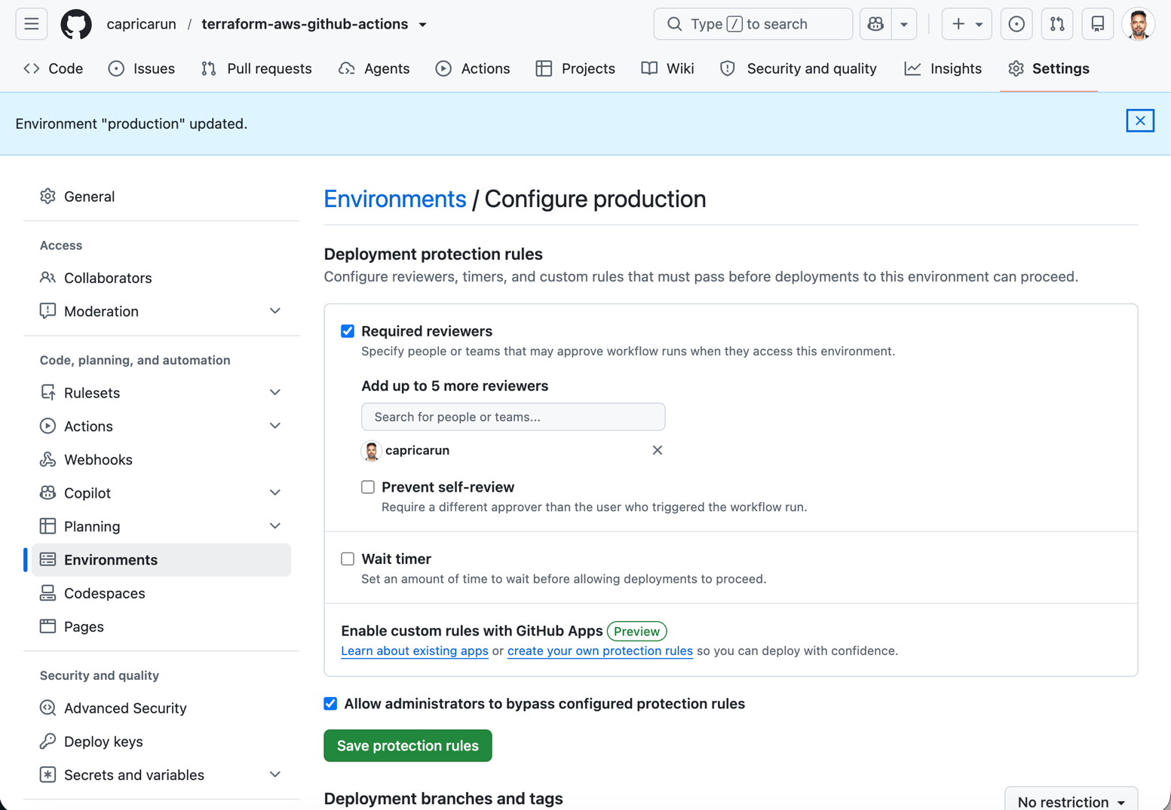
EASY TO MISS
If you create the environment but leave “Required reviewers” unticked, the apply job runs immediately with no pause. The approval requirement is a property of the environment, not of the workflow file — and it is a graded requirement.

EVIDENCE TO CAPTURE
- The environment settings page showing Required reviewers enabled
- The repository secrets page listing AWS_ROLE_TO_ASSUME (the value stays hidden, which is the point)

Phase 7 — Run the pipeline
~25 minutes · mostly waiting
STEP 7.1

Format and validate locally first
Do this before you push. The workflow runs terraform fmt -check, which fails the entire run on a single misaligned equals sign — a frustrating way to burn a run.
terminal
# Rewrites every file to canonical formatting
terraform fmt -recursive

# Downloads providers and configures the S3 backend
terraform init

# Catches type errors, missing arguments, bad references
terraform validate

CHECKPOINT
init ends with “Terraform has been successfully initialized!” and validate reports “Success! The configuration is valid.” A .terraform.lock.hcl now exists — commit it.

IF INIT FAILS
NoSuchBucket means the bucket name in backend.tf does not match the bootstrap output. “Unsupported argument: use_lockfile” means your Terraform is older than 1.10.
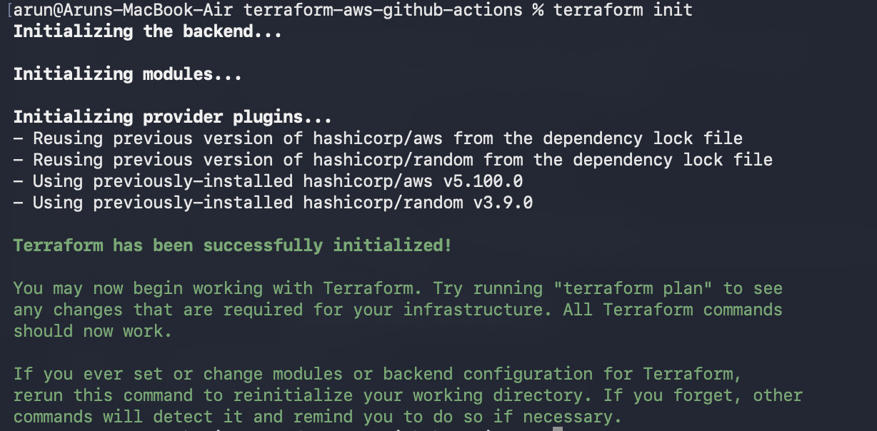
STEP 7.2

Push and trigger the run
terminal
git add .
git status # confirm no .tfstate and no .terraform/ are staged

git commit -m "Add Terraform infrastructure and CI/CD pipeline"
git push -u origin main

CHECKPOINT
git status lists your .tf files, the workflow, .gitignore, README.md and .terraform.lock.hcl — and nothing matching *.tfstate or .terraform/. If state appears, fix .gitignore before committing.
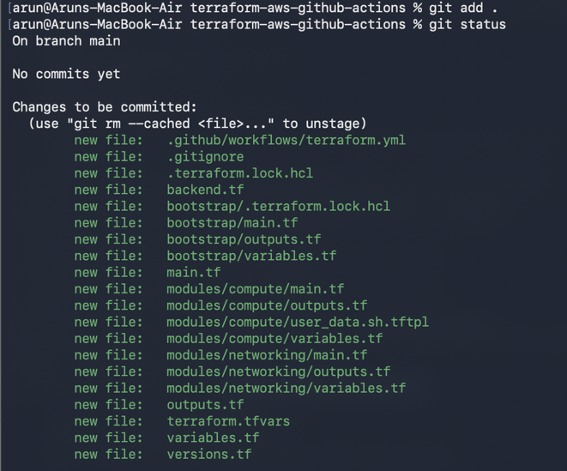
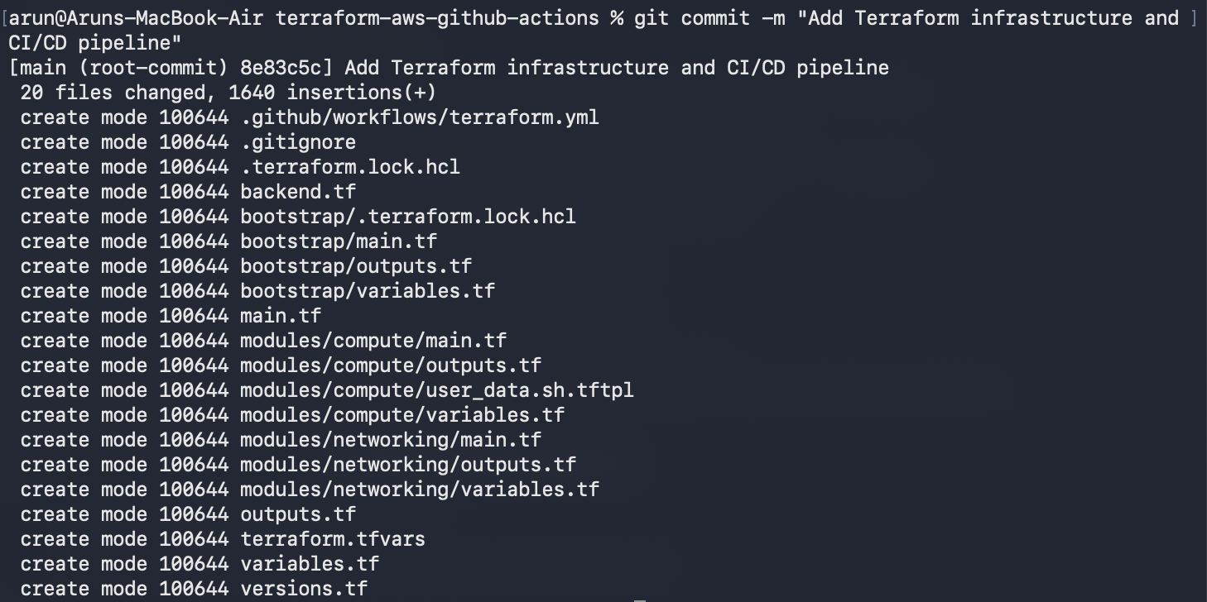
STEP 7.3

Watch the plan job
Open the Actions tab. The plan job takes two to three minutes. Expand each step as it completes — those expanded logs are your evidence for the format, init, validate and plan requirements.
When it finishes, scroll to the bottom of the run page. Under Artifacts there is a downloadable terraform-plan-<run id> containing both the binary plan and its human-readable rendering.
EVIDENCE TO CAPTURE
- Each of the fmt, init, validate and plan steps expanded, showing green ticks
- The run page with the plan artifact visible in the Artifacts section
- The plan summary rendered on the run's summary page
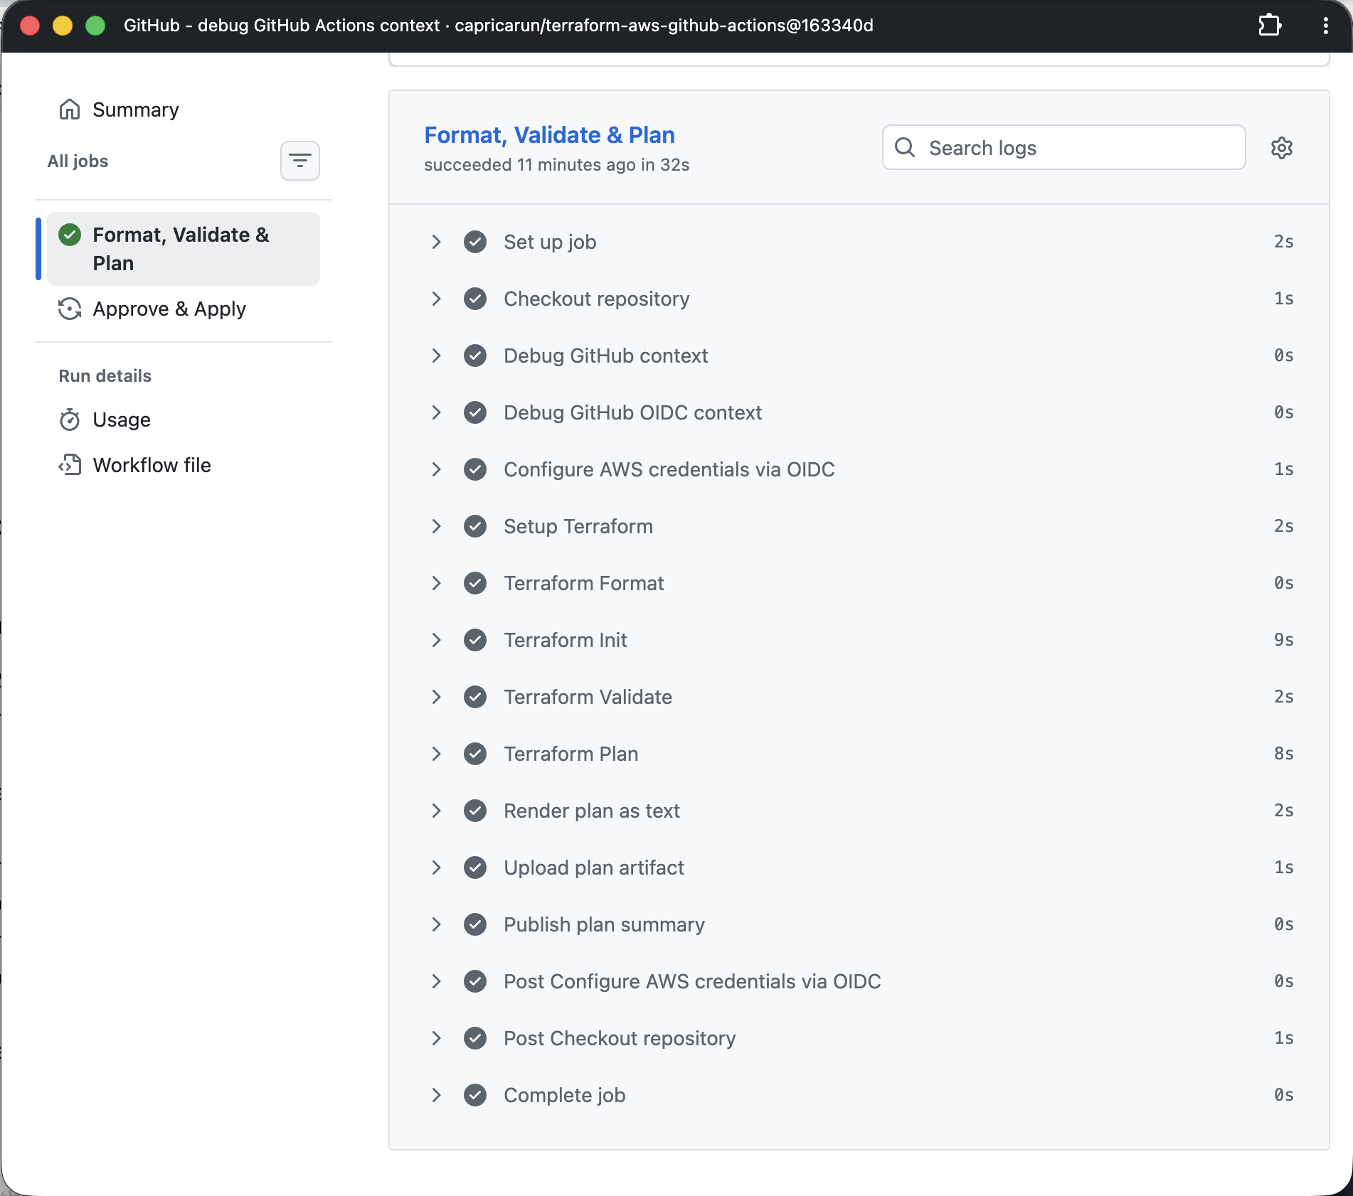
STEP 7.4

Approve the deployment
The apply job now shows Waiting, with a yellow Review deployments button at the top of the run. This pause is the graded requirement — screenshot it before you click.
Click Review deployments, tick production, and choose Approve and deploy.
EVIDENCE TO CAPTURE
- The run page showing the apply job waiting for review
- The “Review deployments” dialog with the production environment listed
- The approval recorded in the run timeline afterwards

STEP 7.5

Watch the apply and validation jobs
The apply takes two to four minutes; the Elastic IP and the EC2 instance are the slow parts. Then the validation job runs its checks and polls the landing page until nginx answers, which is usually another 60 to 120 seconds after the instance appears.
When everything is green, open the run's Summary page. The apply job wrote a table there:
OUTPUT | EXAMPLE VALUE
VPC ID | vpc-063b37ac97ce68dc6
EC2 Instance ID | i-0204099172dc3b1a2
Elastic IP | 3.111.230.101
S3 Bucket | project03-dev-app-a6dc09ba
Application URL | http://3.111.230.101

Open the application URL in a browser. You should see the landing page, showing the instance ID, availability zone and bucket name that the instance read from its own metadata at boot.
CHECKPOINT
All three jobs green, the outputs table populated, and the landing page loading over HTTP on the Elastic IP.
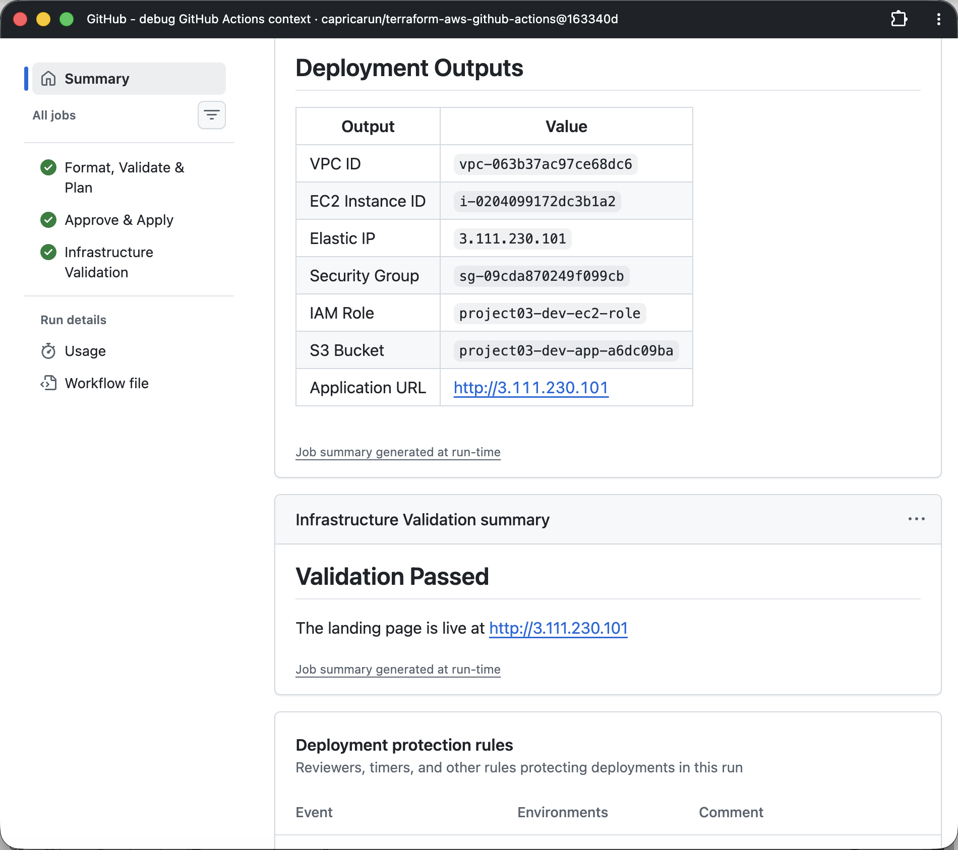

AWS Console Screenshots
