**Clemson Tiger Tour User Manual (Version 4)**

**Project Name: Clemson Tiger Tour**

**Project Instructor: Dr. Pargas**

**Team Members Hongda Li, Zian Chen (Anson)**

**Project Title: Clemson Tiger Tour**

Table of Contents

Table of Contents 1

Introduction 1

Clemson Tiger Tour main page 2

Clemson Camera Hunting 3

Tiger Guide 7

Tour Guide Route 7

Compass guide 8

Settings 9

# Introduction

Clemson Tiger Tour is a tour guide IOS application you can use when you visit Clemson University campus. It will give you a dynamic path guide via compass shown on the Clemson campus map.

This application can display the name of buildings with labels on the screen when the user points the camera lens to those buildings. Detailed descriptions of one building will show up if the label of that building is clicked. The label will also show the distance between your current location and that building.

The labels will move together with those buildings on the screen when the user scans the landscape horizontally.

And it will also provide the user with a dynamic path guide via compass shown on the Clemson University campus map.

# Clemson Tiger Tour main page

To view info about Clemson Tiger Tour you can press the left button in the upper left hand corner of the screen, then press info page button on the bottom left corner of the side menu. Here you can read basic information about this application and the general idea of how to use the application. Please see below screenshot 1 as reference.

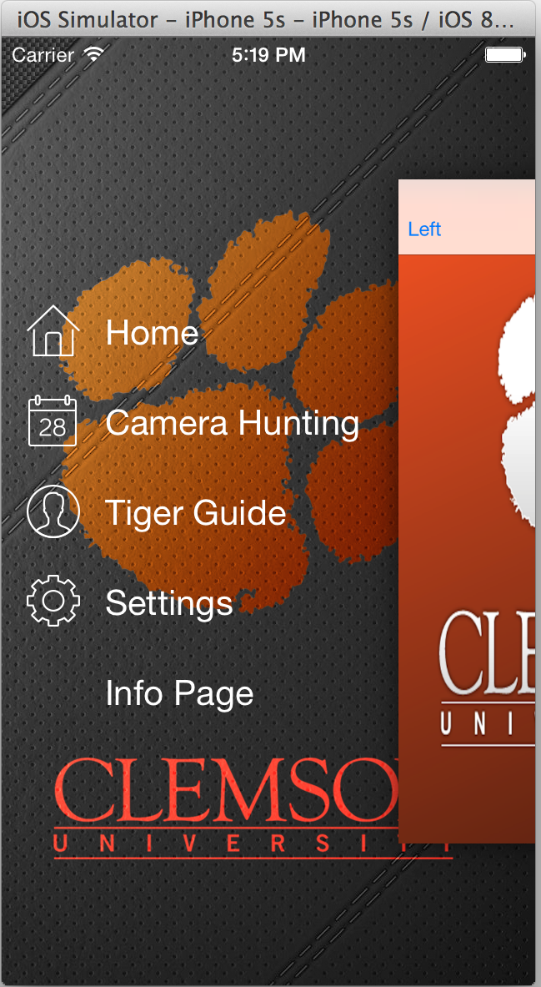

**Screenshot 1 left side menu**

# Clemson Camera Hunting

Basically you can “hunt” a building by simply open camera hunting feature and point the camera of your device to that building. To do this, just click Camera Hunting button on screenshot 1 above and then you will open “camera hunting” sub view just like screenshot 2 below.

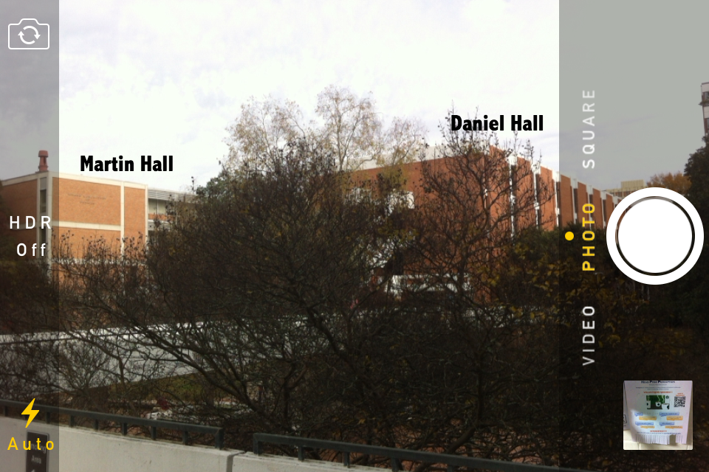

**Screenshot 2 Camera hunting view**

For example now you are pointing your camera to this direction and Martin Hall, Daniel Hall are in your camera screen. This view will have a label with building name on top of each building. If you scan your camera from this direction towards another direction continuously and smoothly, the label of each building will move accordingly with the building they are on.

You can also set “hunting radius” in Settings menu on main page shown in Screenshot 1 to determine how far you want “hunting” from your current location. For instance, if you magnify your “hunting radius”, you will see Jordan Hall appear in your camera screen, just like screenshot 3 below.

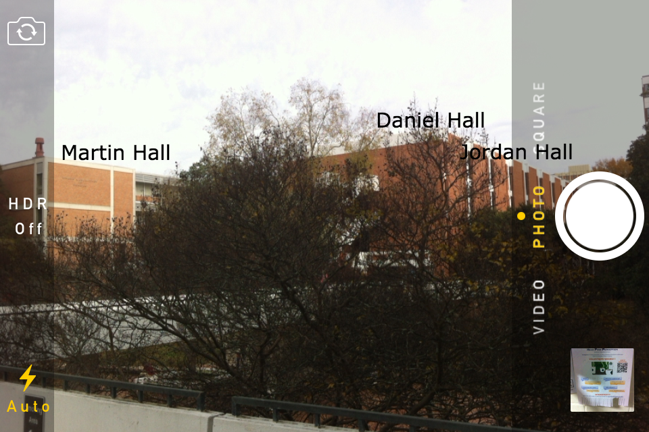

**Screenshot 3 Magnify hunting radius**

If you are interested in one particular building, you can click the label of that building and then an information page will show up. For example, if you click Martin Hall, you will see an information page just like screenshot 4 below.

If you are interested in the building, you can click on the information page on the screen and this will lead you to the Tour Guide mode.

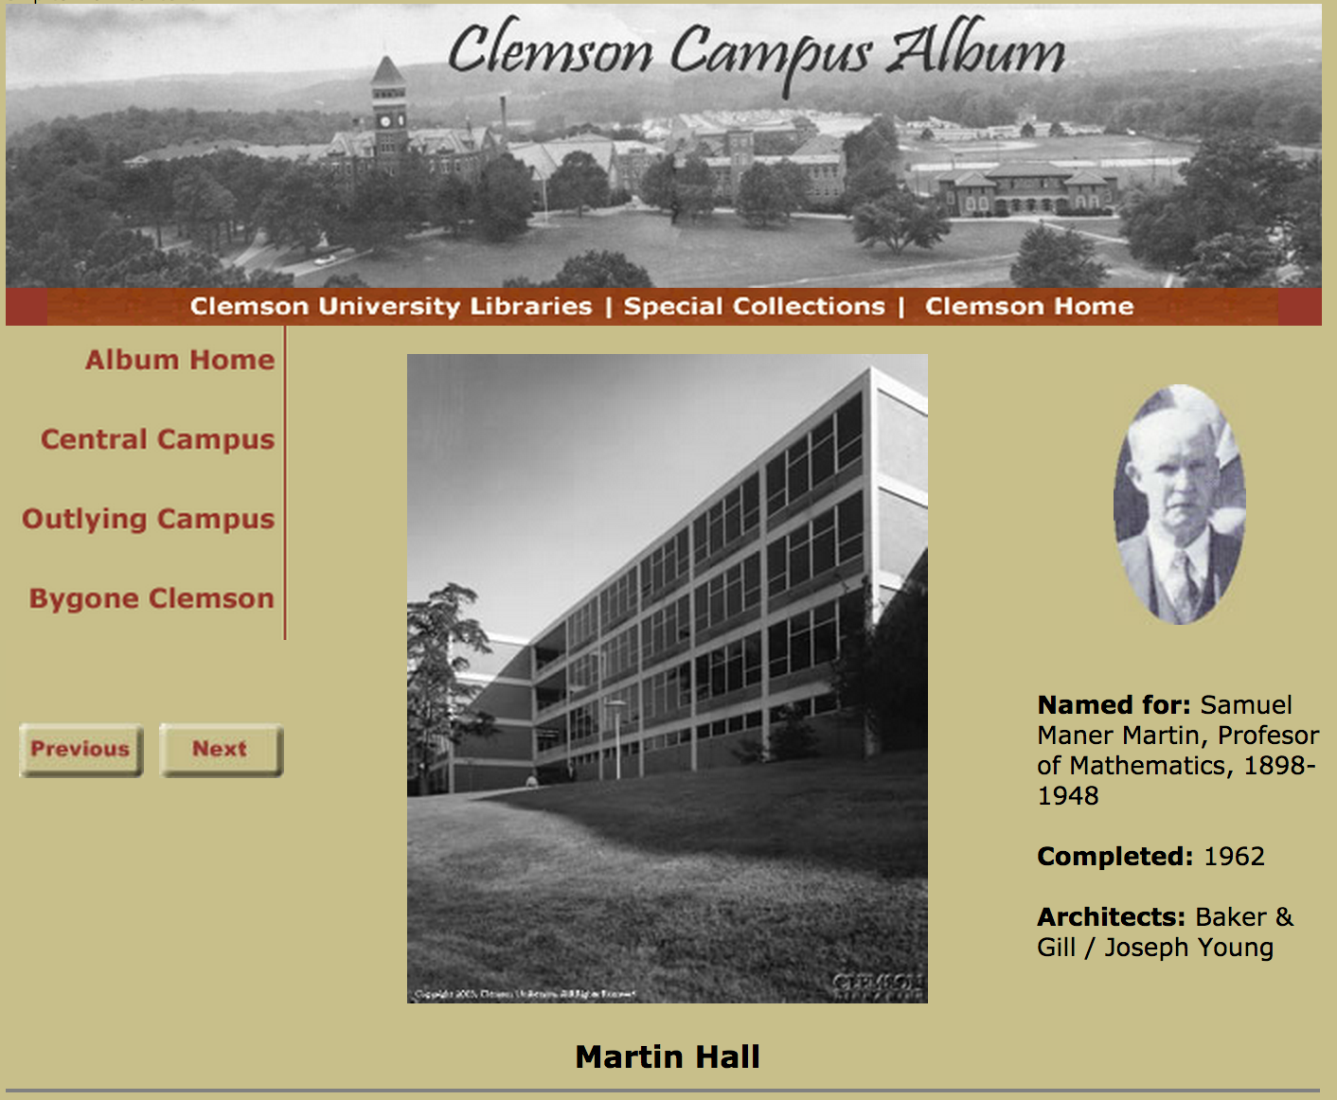

**Screenshot 4 Martin Hall Info Page**

However, some labels of buildings will also show up even if you cannot see them directly from this “camera hunting” screen. That is because the radius of your hunting range is bigger than your sight. In this case, the labels only indicate the directions of buildings beyond your sight and display the distances between your current position and each of those buildings. So the Camera Hunting feature provides you with a chance to identify objectives far away from you.

# Tiger Guide

# Tour Guide Route

In the information page of a particular building, if you click the page, then the screen will switch to tiger guide view just like below screenshot5. There will be two pins, a blue dot and a compass on the screen. The two pins indicate your start position and the destination on the map. The blue dot indicates your current position and the compass shows the direction of the destination. You can follow the compass to get to the destination.

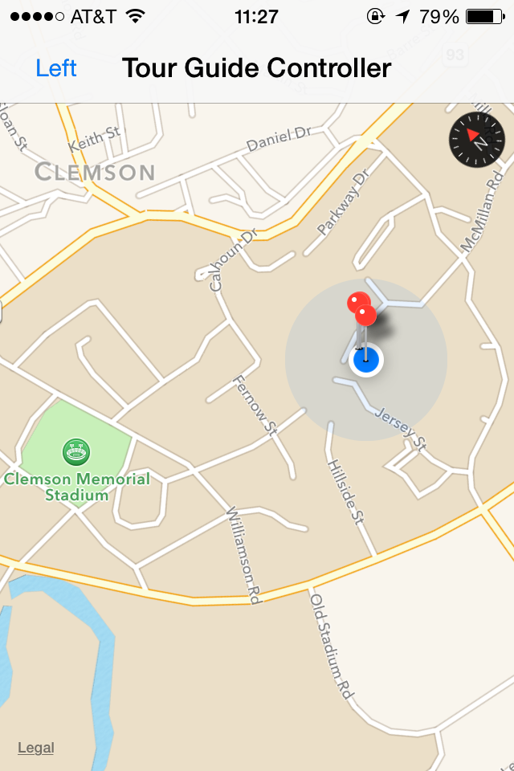

**Screenshot 5 Tiger guide view**

# Compass guide

The compass on top right corner in screenshot 5 is a dynamic direction guide always pointing to your destination. When you start walking to your destination, this compass will change its pointer accordingly based on your every step. And it will also tell you how far you are away from your destination. The compass direction and the distance will update promptly.

# Settings

This is a view which you can modify your setting for this application. For example, you can set radius of your search range for “camera hunting”, you can also set whether you want get your Internet connection through 4G or WI-FI. And you can even get software update on this “Setting” page.