**CSC 478 Fall 2018 – Team #4: Poker Game**

**User Manual**

**Version 0.2**

**10/18/2018**

Table of Contents

2 Installation Instructions 3

3 Summary 3

4 How to play 3

4.1 Launching the game 3

4.2 Starting a game 3

4.3 Actions during a hand 5

4.3.1 Call 6

4.3.2 Raise 7

4.3.3 Fold 8

4.3.4 Muck 9

4.3.5 Show Cards 10

4.3.6 End Game 11

4.4 Actions while in lobby 11

5 Rules of the game 12

5.1 OBJECT OF THE GAME 12

5.2 THE DEAL 12

5.3 THE PLAY 12

5.4 POKER HAND 12

# Installation Instructions

# Summary

This game will allow you to play seven card stud with up to 5 computer players. See the Rules of the Game for more in description of how to play.

# How to play

## Launching the game

To launch the game, execute the TBD file.

## Starting a game

After the game is launched, you will see a pop up asking for your name. Fill out your desired name and click OK:

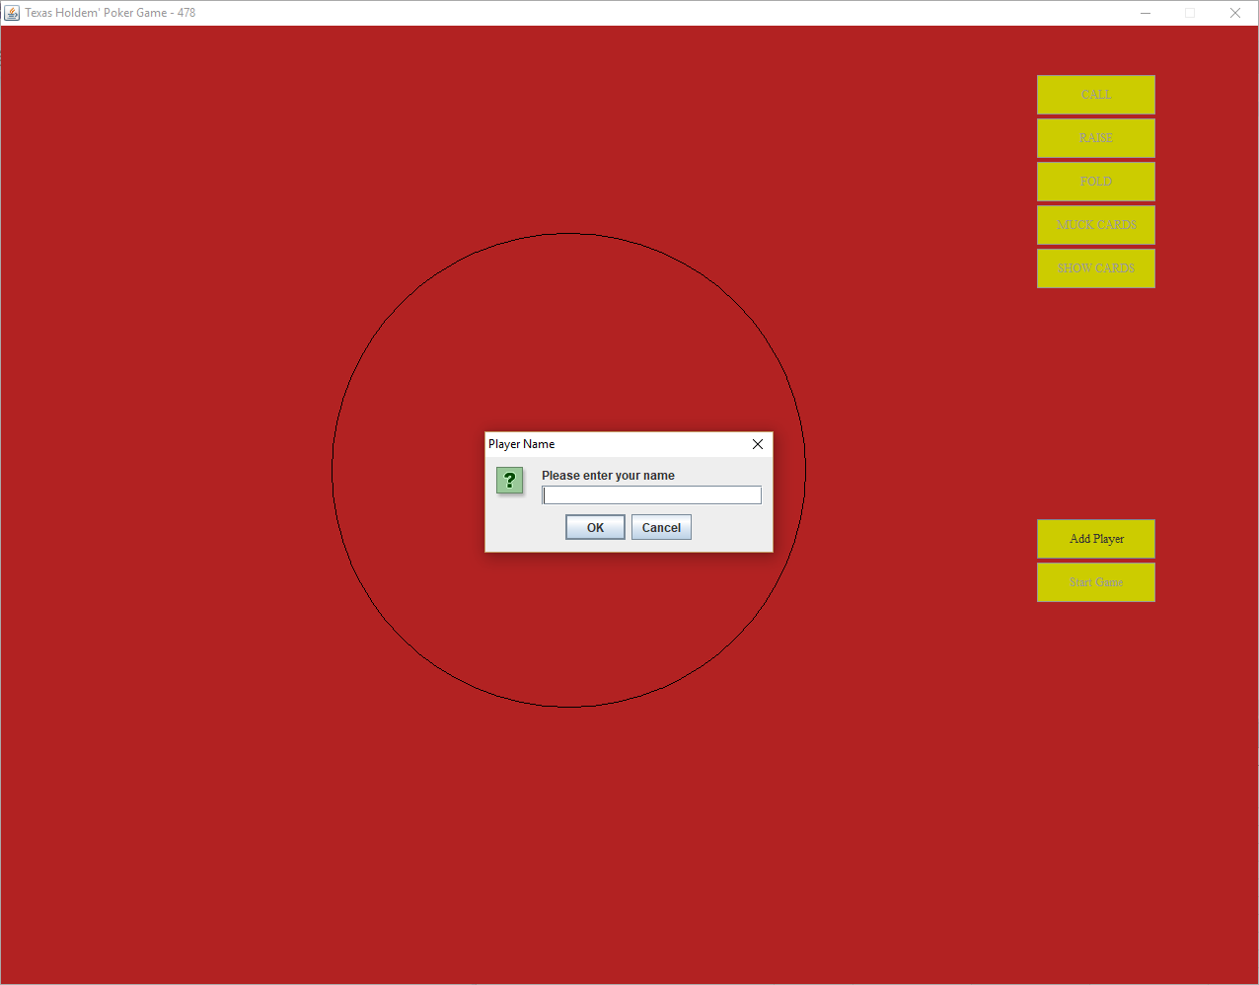

You will then be presented with the gaming area. You can see yourself seated at the table, but before you can start a game you’ll need to add at least one more computer player. To do that click the Add Player button:

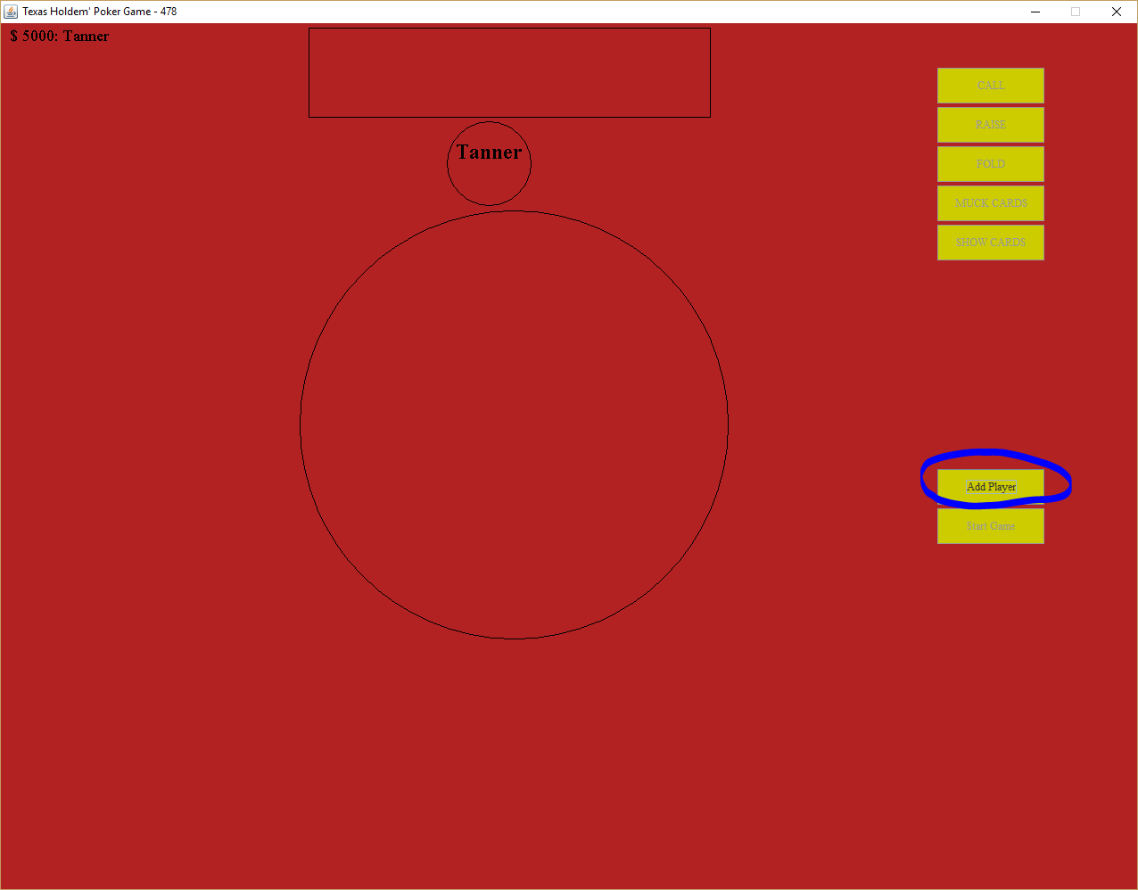

This will add a new computer player to the game, and at this point you can begin the game if you choose to by clicking Start Game:

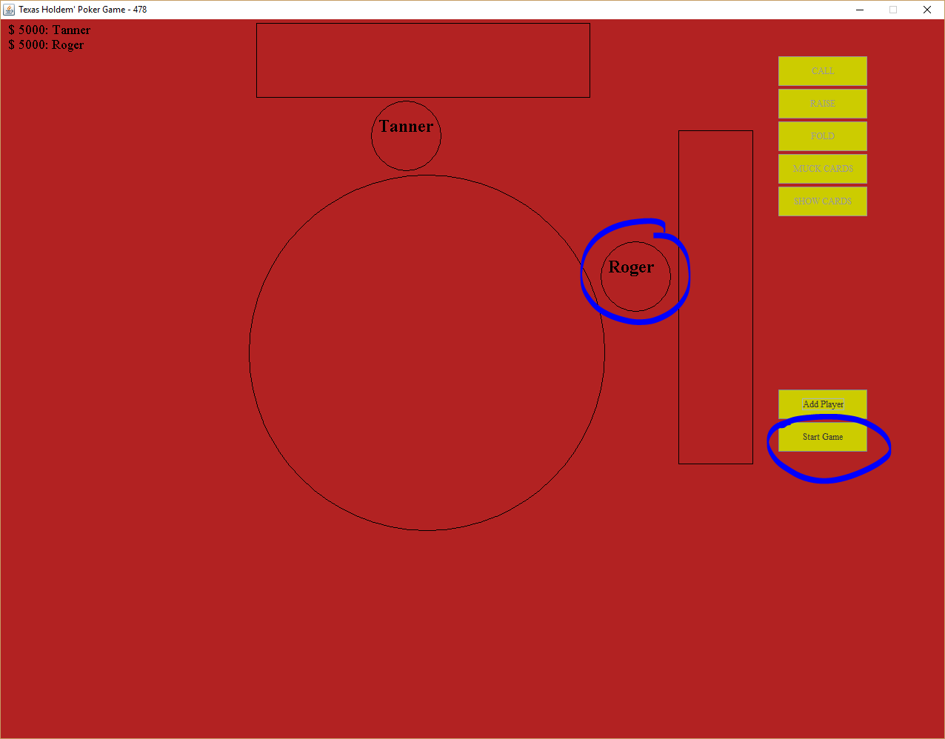

## Actions during a hand

After you click Start Game, the hand will begin. You will see your cards laid out by your name. You will also see the current money totals for each player in the game. The table contains the round information, what the current bet is, with the total pot is at and whether it is your turn.

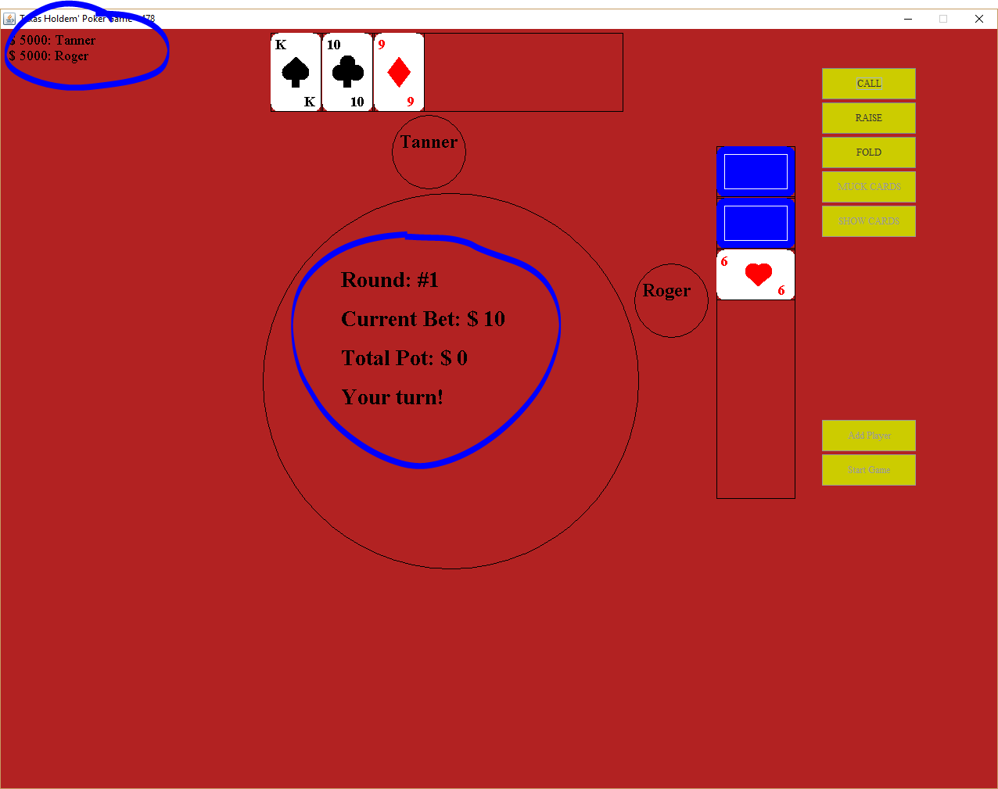

### Call

During your turn if you want to call, press the call button

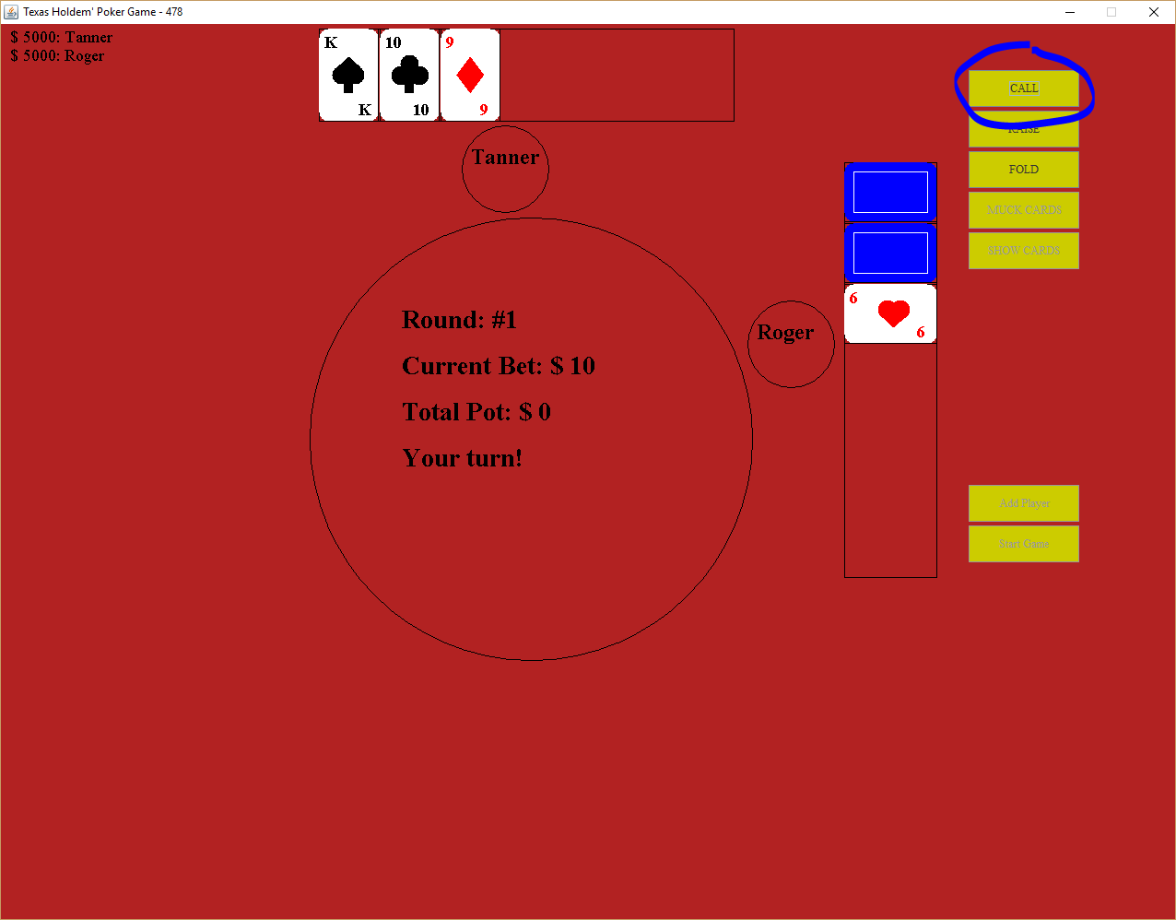

### Raise

If you want to raise the bet, click on the Raise button:

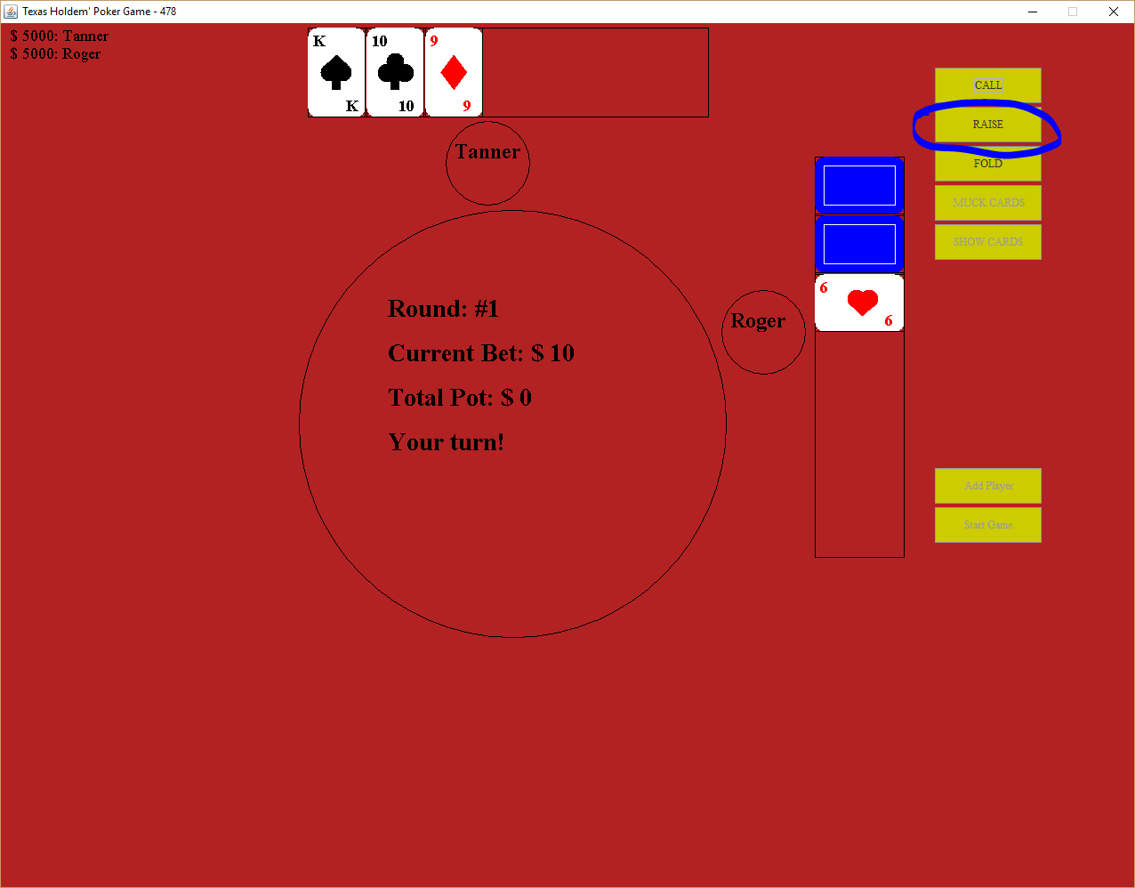

### Fold

Press this button to fold your hand and remove yourself from the hand:

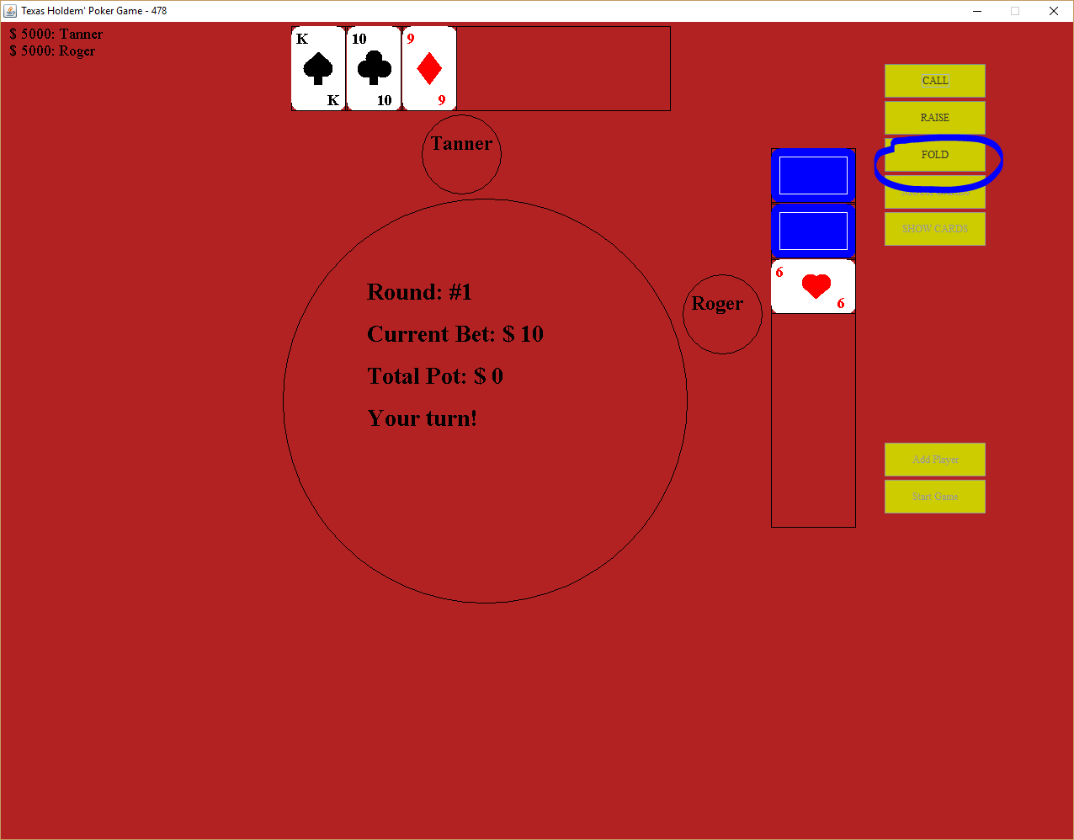

**NOTE: Certain Actions will not always be available. When an action is not available to you it will be greyed out and you won’t be able to click the button.**

### 

### Muck

If the option is available to muck your cards, you can click on the Muck button:

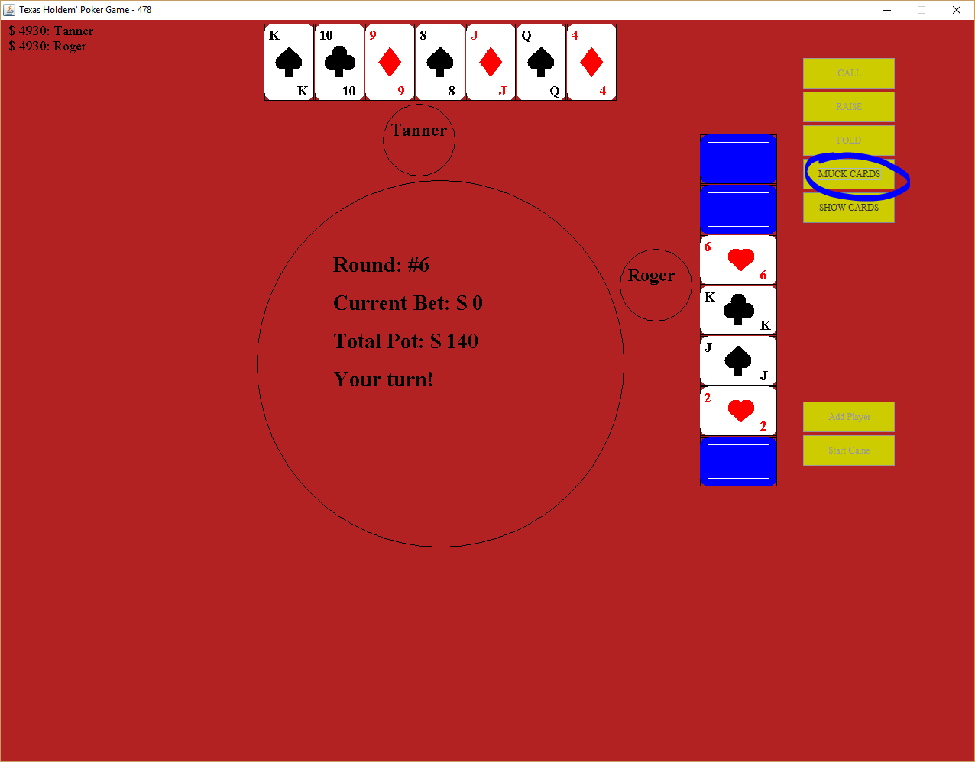

### Show Cards

At the end of a hand, click Show Cards to see who is the winner of the round:

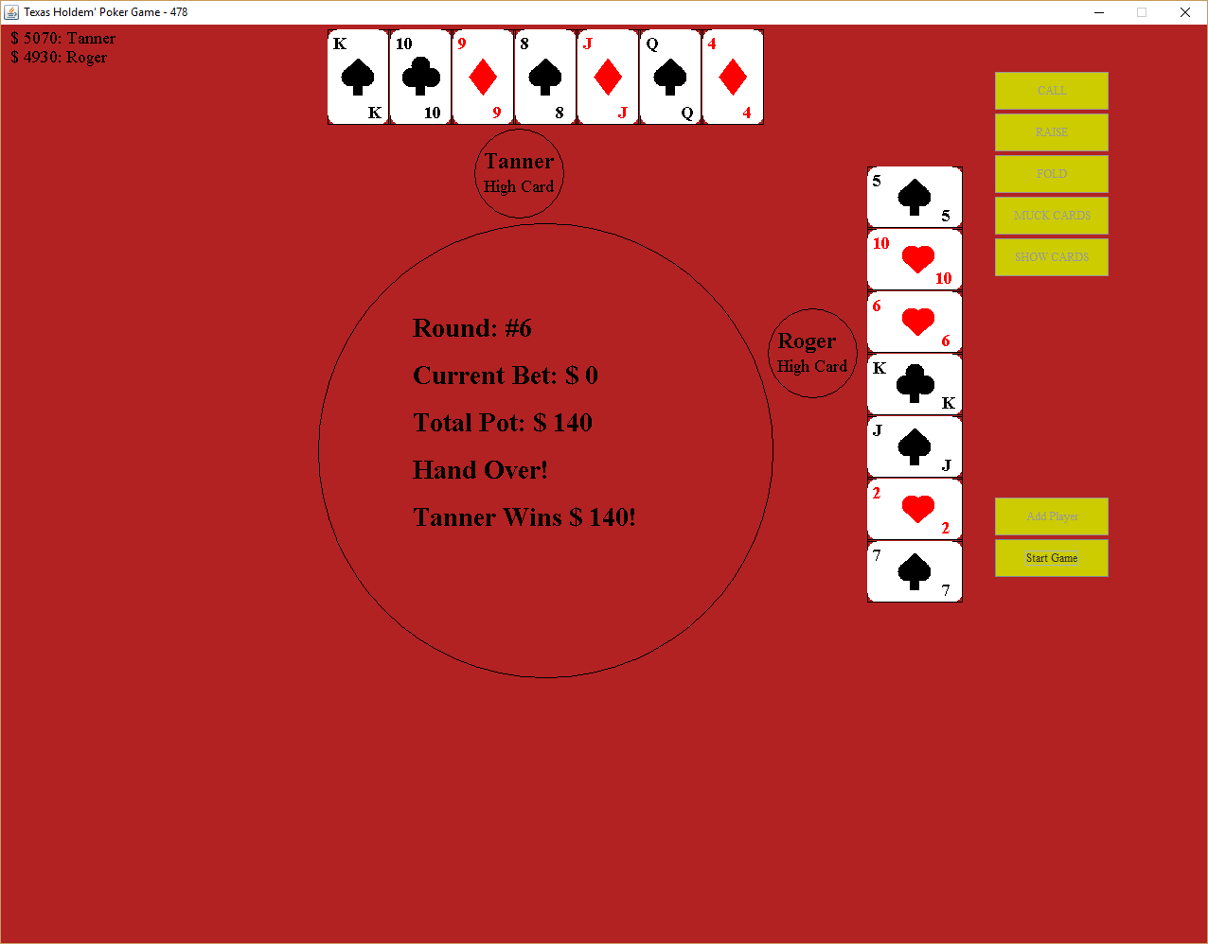

### End Game

To exit the program, click the X button in the upper right corner.

## Actions while in lobby

# Rules of the game

## 

**NOTE**: The following test is copied directly from the following link: <https://www.bicyclecards.com/how-to-play/seven-card-stud-poker/>

## **OBJECT OF THE GAME**

The goal of each player is to win the pot, which contains all the bets that the players have made in any one deal. A player makes a bet in hopes that he has the best pot, which to give the impression that he does. In most Poker versions, the top combination of five cards is the best hand.

## **THE DEAL**

Each player receives two cards face down and then one card face up, dealt one at a time in rotation.

## **THE PLAY**

After the initial deal, there is a betting interval.  
Each active player receives three more face up cards and one more face down card, with a betting interval after each round of cards dealt.  
In the showdown, each player turns up all his hole cards and selects five of his seven cards as his hand. The player must separate these cards from the other two, which he discards.  
The player cannot reclaim his discards upon finding that a better five-card combination could have been made.

## **POKER HAND**

**Five of a Kind** - This is the highest possible hand and can occur only where at least one card is wild, such as a Joker. Examples of five of a kind would be four 10s and a wild card or two Queens and three wild cards.

**Straight Flush** - This is the highest possible hand when only the standard pack is used, and there are no wild cards. A straight flush consists of five cards of the same suit in sequence, such as 10, 9, 8, 7, 6 of hearts.

**Four of a Kind** - This is the next highest hand. An example is four aces or four 3s.

**Full House** - This colorful hand is made up of three cards of one rank and two cards of another rank, such as three 8s and two 4s.

**Flush**- Five cards all of the same suit, but not all in sequence, is a flush. An example is Q, 10, 7, 6, and 2 of clubs.

**Straight** - Five cards in sequence, but not all of the same suit is a straight. An example is 9♥, 8♣, 7♠, 6♦, 5♥.

**Three of a Kind** - This combination contains three cards of the same rank, and the other two cards each of a different rank, such as three Jacks, a seven, and a four.

**Two Pairs** - This hand contains a pair of one rank and another pair of a different rank, plus any fifth card of a different rank, such as Q, Q, 7, 7, 4.

**One Pair** - This frequent combination contains just one pair with the other three cards being of different rank. An example is 10, 10, K, 4, 3.

**No Pair** - This very common hand contains "nothing." None of the five cards pair up, nor are all five cards of the same suit or consecutive in rank. When more than one player has no pair, the hands are rated by the highest card each hand contains, so that an ace-high hand beats a king-high hand, and so on.