CAMARINES SUR POLYTECHNIC COLLEGES
Smart Campus Vehicle Management System
Dashboards, Flowcharts, and Database ER Diagram
Laravel 12 + MongoDB · ESP32 RFID · YOLOv9 parking

Table of Contents
1. System overview
2. Database entity-relationship diagram
3. Login and role-based routing
4. Admin portal
5. Guard portal
6. Student / Staff portal
7. Cross-cutting process flows
8. URL summary by role

1. System overview
The Smart Campus Vehicle Management System (VMS) controls campus vehicle entry, visitor RFID, parking occupancy, and a three-strike violation policy. The website is Laravel 12 with MongoDB. ESP32 boards at Entry and Exit call the RFID API; Laravel decides grant or deny. Optional YOLOv9 cameras update parking slots.
Three signed-in dashboards exist: Admin (/admin), Guard (/guard), and Student/Staff (/user). Visitors have no website login; Guards register them and issue a temporary RFID card.
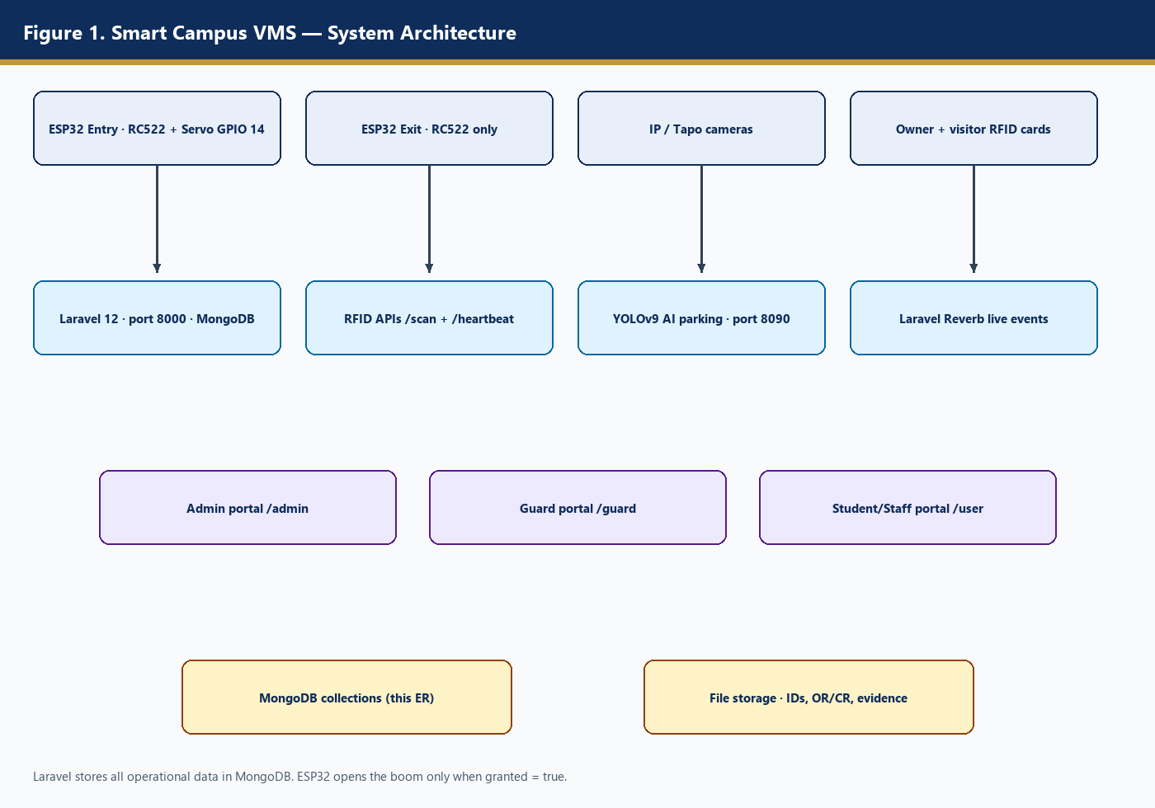
Figure 1. System architecture — hardware, APIs, dashboards, and MongoDB.

2. Database entity-relationship diagram
Data lives in MongoDB (database name capstone). Each Eloquent model maps to a collection. Documents use a sequential integer id (HasSequentialId) as a logical primary key, and child documents store integer foreign keys. MongoDB does not enforce those FKs; Laravel relationships do.
Figure 11 is the conceptual (Chen) view used in oral defense. Figure 12 is the logical Crow’s-foot diagram with attributes taken from the model $fillable arrays.
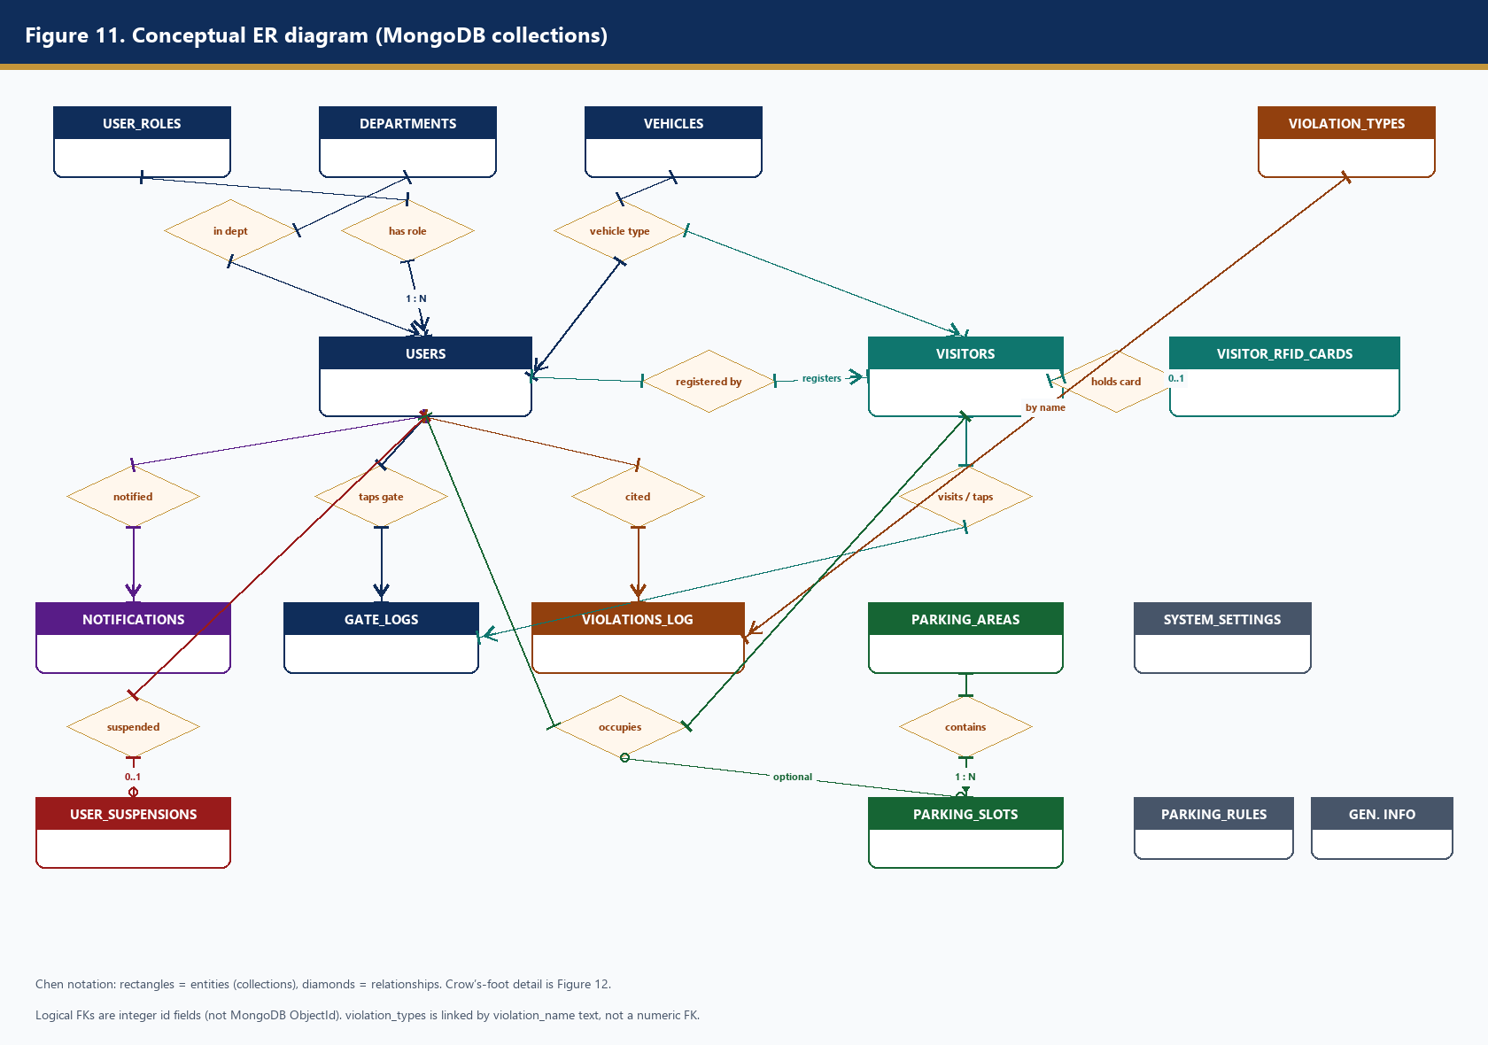
Figure 11. Conceptual ER diagram of the main collections and relationships.
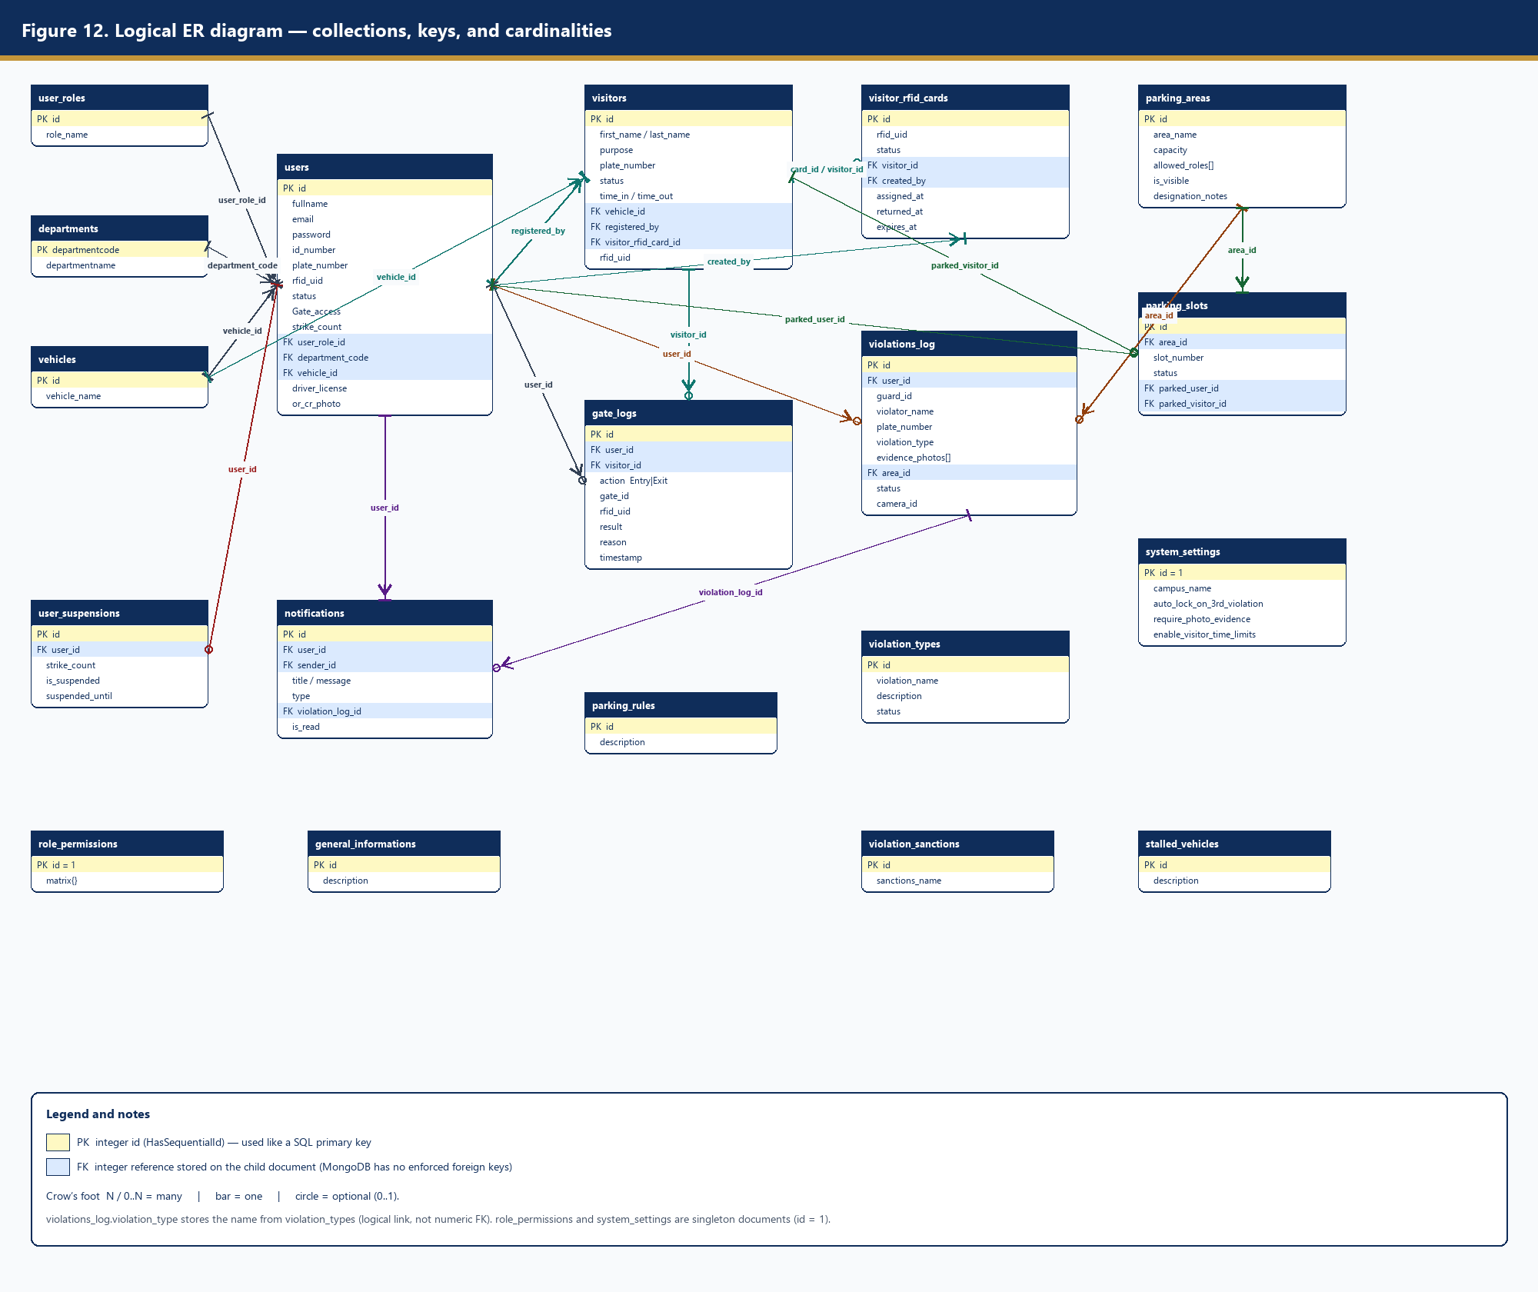
Figure 12. Logical ER diagram with primary keys, foreign keys, and cardinalities.

2.1 Collection catalog
Collection | Model | Role in the system
users | User | Admin, Guard, Student, Staff accounts; plate, RFID UID, strikes, Gate_access
user_roles | UserRole | Admin, Guard, Student, Staff, Visitor role names
departments | Department | College/office codes for staff/students
vehicles | Vehicle | Lookup of vehicle types (car, motorcycle, …)
visitors | Visitor | Walk-in guests registered by Guard
visitor_rfid_cards | VisitorRfidCard | Temporary RFID pool assigned to a visit
gate_logs | GateLog | Every RFID tap: Entry/Exit, granted or denied
parking_areas | ParkingArea | Lots/zones and allowed_roles
parking_slots | ParkingSlot | Slot status; optional parked user or visitor
violations_log | ViolationLog | Citations + evidence; drives strike_count
violation_types | ViolationType | Catalog of citation names (Admin Settings)
notifications | Notification | In-app messages to users/guards
user_suspensions | UserSuspension | Lock record after 3 strikes
parking_rules | ParkingRule | Official rules shown on /user dashboard
general_informations | GeneralInformation | Campus notices on /user dashboard
system_settings | SystemSetting | Singleton: auto-lock, photo evidence, visitor time limits
role_permissions | RolePermission | Singleton permission matrix
violation_sanctions | ViolationSanction | Sanction name lookup
stalled_vehicles | StalledVehicle | Stalled-vehicle note lookup

Core cardinalities: one user_role has many users; one user has many gate_logs, notifications, and violations_log; one parking_area has many parking_slots; a visitor optionally holds one visitor_rfid_card (and the card points back via visitor_id). A parking_slot is occupied by at most one user or one visitor. A gate_log belongs to either a user_id or a visitor_id, not both.

3. Login and role-based routing
After password check, email must be verified. Pending, denied, or 3-strike locked accounts cannot open a dashboard. Granted users go to Admin → /admin, Guard → /guard, Student or Staff → /user.
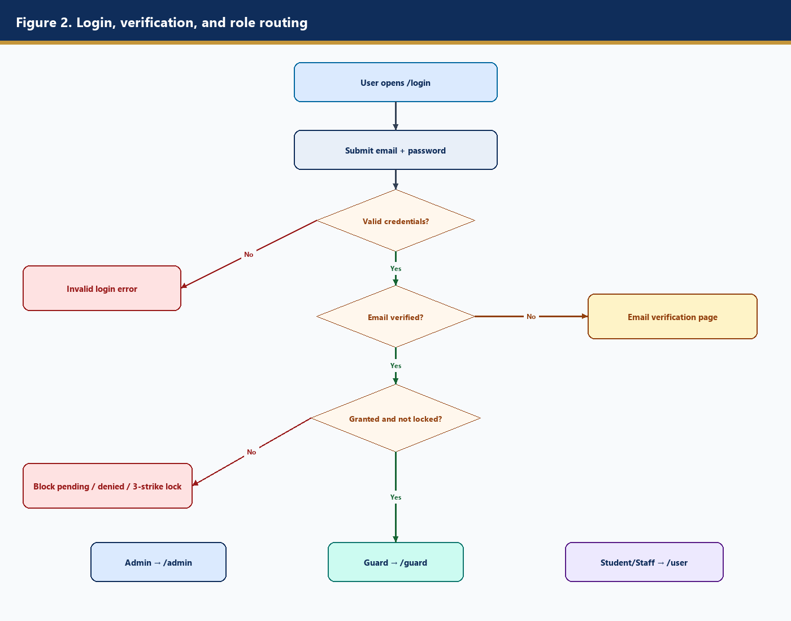
Figure 2. Authentication and dashboard routing flowchart.

4. Admin portal

4.1 Admin Dashboard (/admin)
Campus health check: user counts, active violations, today’s gate_logs, parking occupancy, visitor counts, weekly trends, violation-type chart, 2nd-strike watch list, and recent violations_log rows. It does not open the boom.
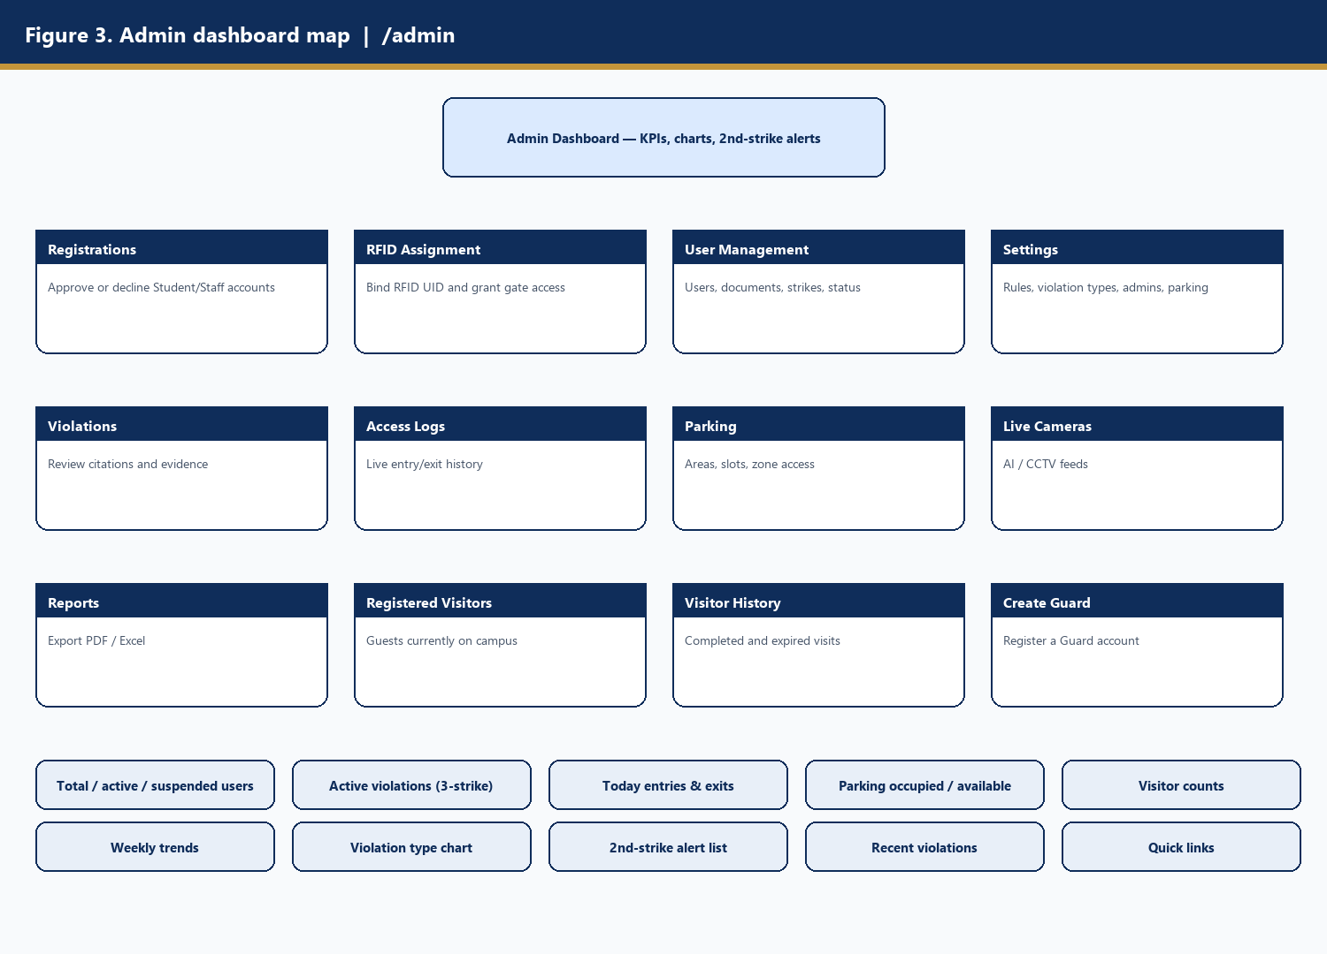
Figure 3. Admin dashboard widgets and module map.

4.2 Registrations (/admin/registrations)
Pending users become Granted or Denied. Approval opens /user. RFID gate access stays off until RFID Assignment. Guards are created under Settings / Create Guard.

4.3 RFID Assignment (/admin/rfid)
Binds users.rfid_uid and sets Gate_access = Granted so ESP32 taps can succeed.
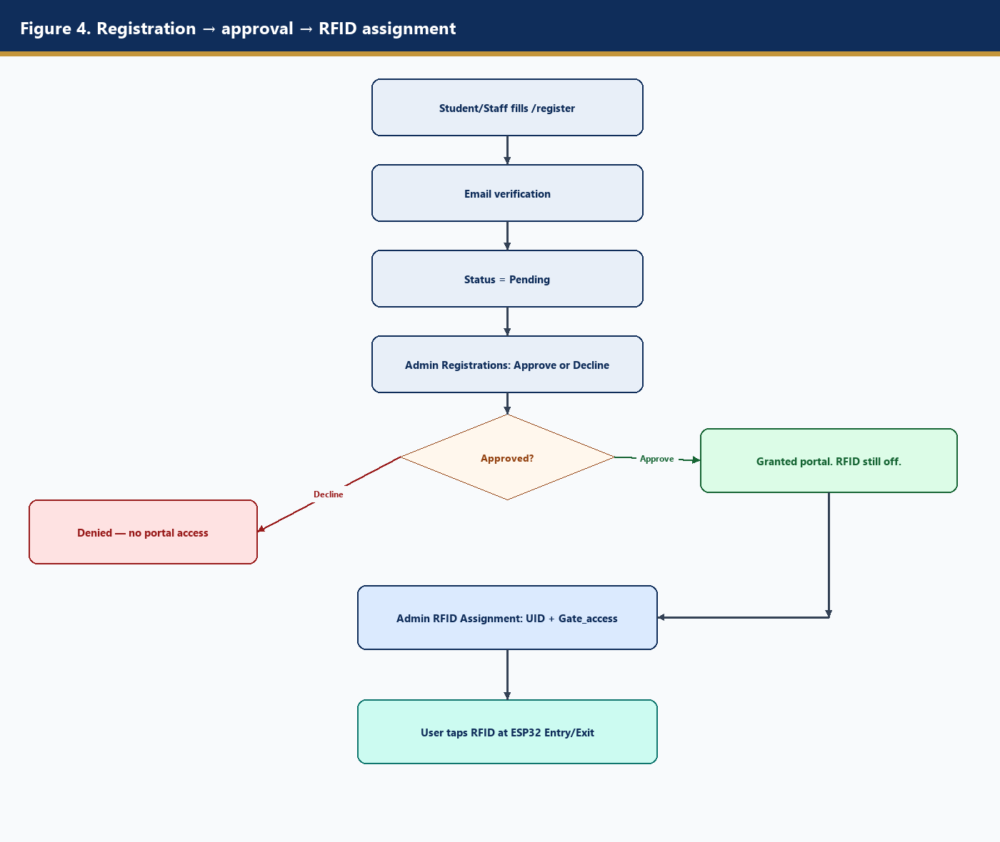
Figure 4. From public registration to RFID-enabled gate access.

4.4 User Management, visitors, violations, logs
User Management audits documents and strikes. Admin visitor pages are oversight only. Violations are read-only evidence. Access Logs are the searchable gate_logs feed (Reverb live).

4.5 Parking, cameras, reports, settings
Parking edits parking_areas / parking_slots and zone allowed_roles. Live Cameras show AI streams. Reports export analytics. Settings write parking_rules, general_informations, violation_types, and system_settings.

5. Guard portal

5.1 Guard Dashboard (/guard)
Duty-officer home: vehicles inside, today’s entries, active violations, free slots, visitor RFID pool, shortcuts to Live Gate and Report Violation, recent gate_logs and citations.
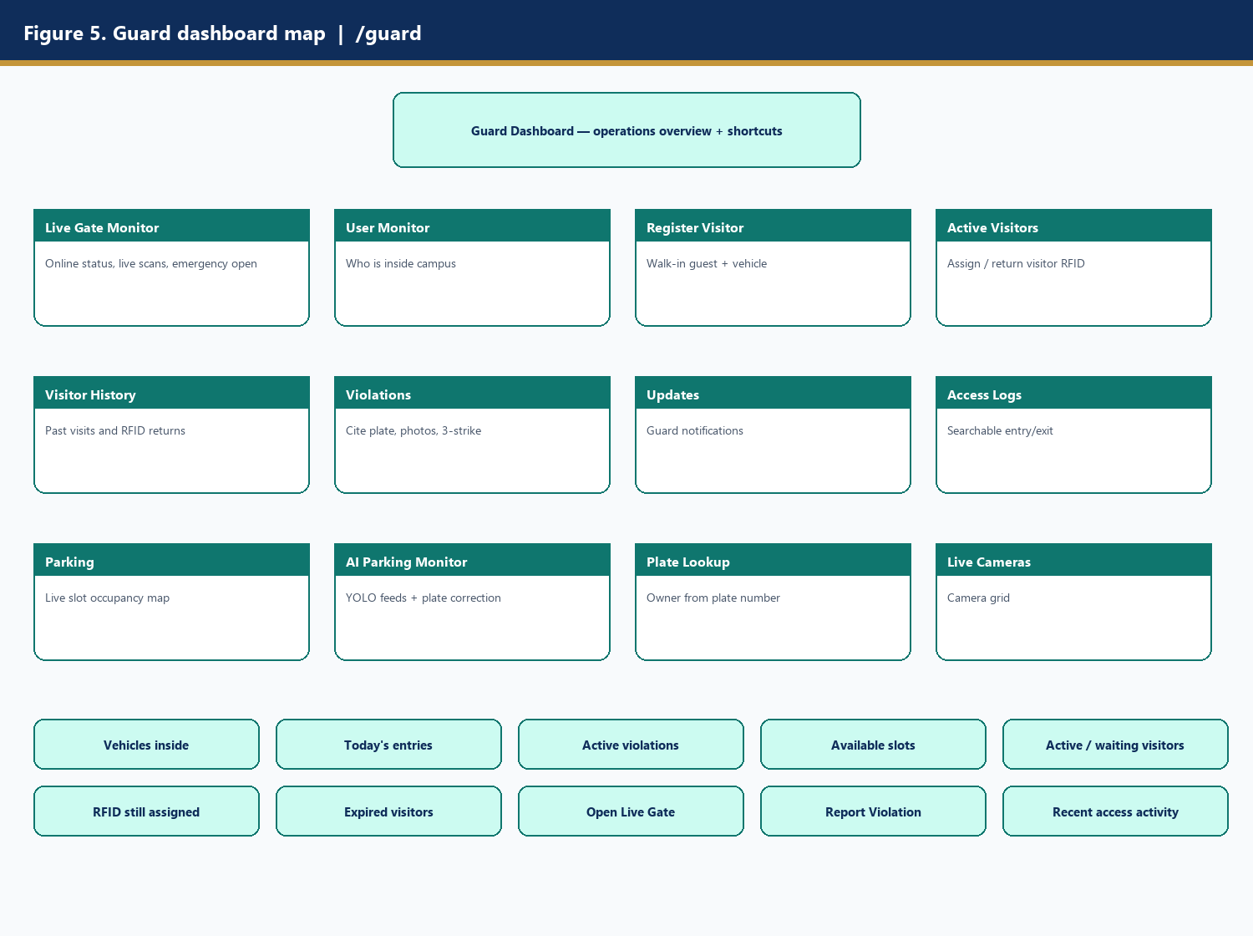
Figure 5. Guard dashboard widgets and module map.

5.2 Live Gate Monitor (/guard/gate)
ESP32 heartbeat = online. Scans arrive on Reverb gate.scans. Emergency Open queues the Entry servo (GPIO 14). Exit grants open the same shared boom.
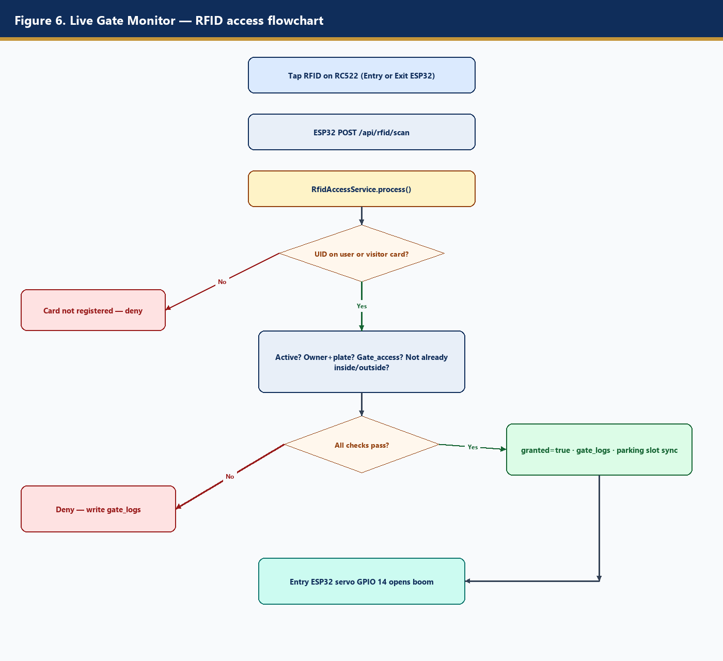
Figure 6. RFID tap decision flowchart.

5.3 Visitors
Register Visitor → assign visitor_rfid_cards → gate tap writes gate_logs.visitor_id → return card → history.
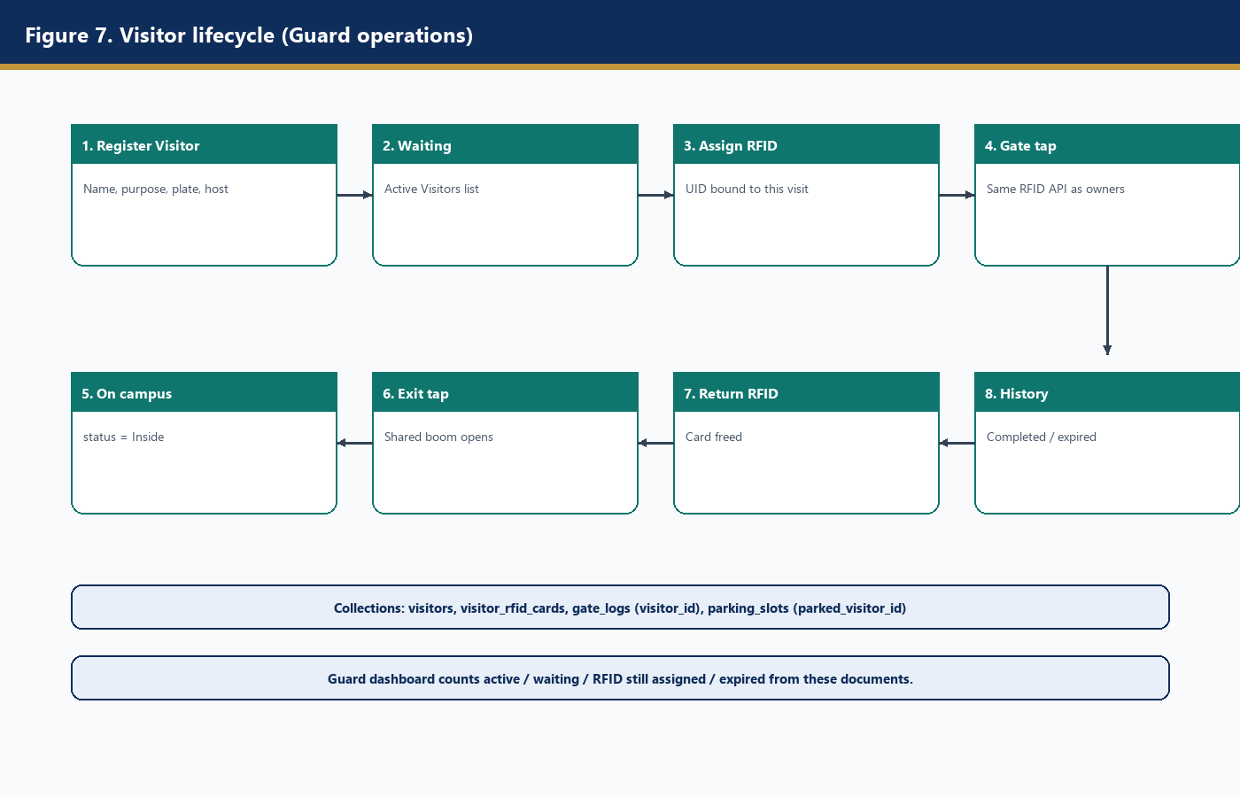
Figure 7. Visitor lifecycle.

5.4 Violations, AI parking, plate lookup
Citations insert violations_log and increment users.strike_count. AI Parking Monitor corrects plates and may auto-cite. Plate Lookup resolves users or visitors by plate.

6. Student / Staff portal
Personal portal only. Dashboard shows plate, Gate_access, strike_count, parking_rules, general_informations, recent own gate_logs and violations. Notifications, My Violations, Entry/Exit History, and Parking (allowed zones) are read-oriented. This role cannot open the boom or cite others.
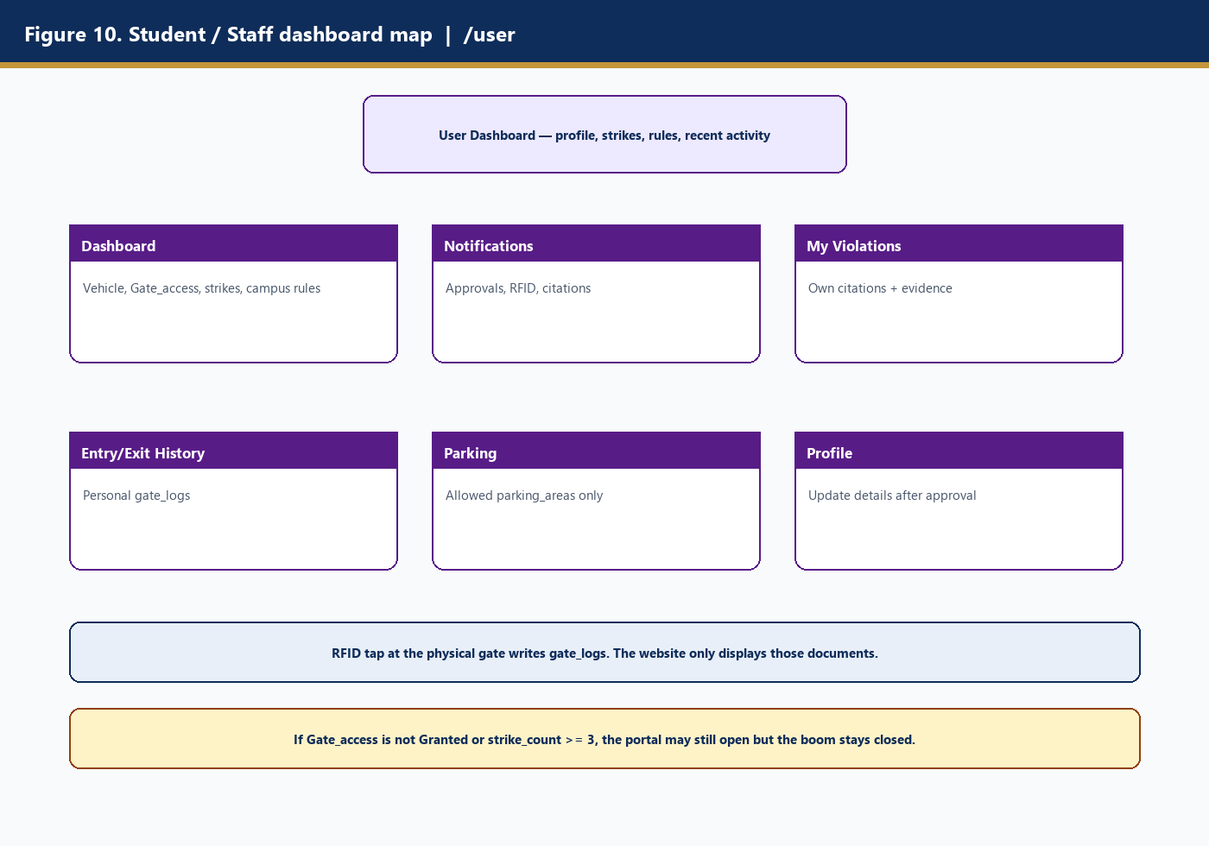
Figure 10. Student/Staff dashboard and modules.

7. Cross-cutting process flows
RFID: Entry ESP32 has the servo; Exit has RFID only. Fail-closed on network errors. Three-strike: strike 2 alerts Admin; strike 3 locks login and RFID. AI parking posts occupancy into parking_slots and optional events into violations_log.
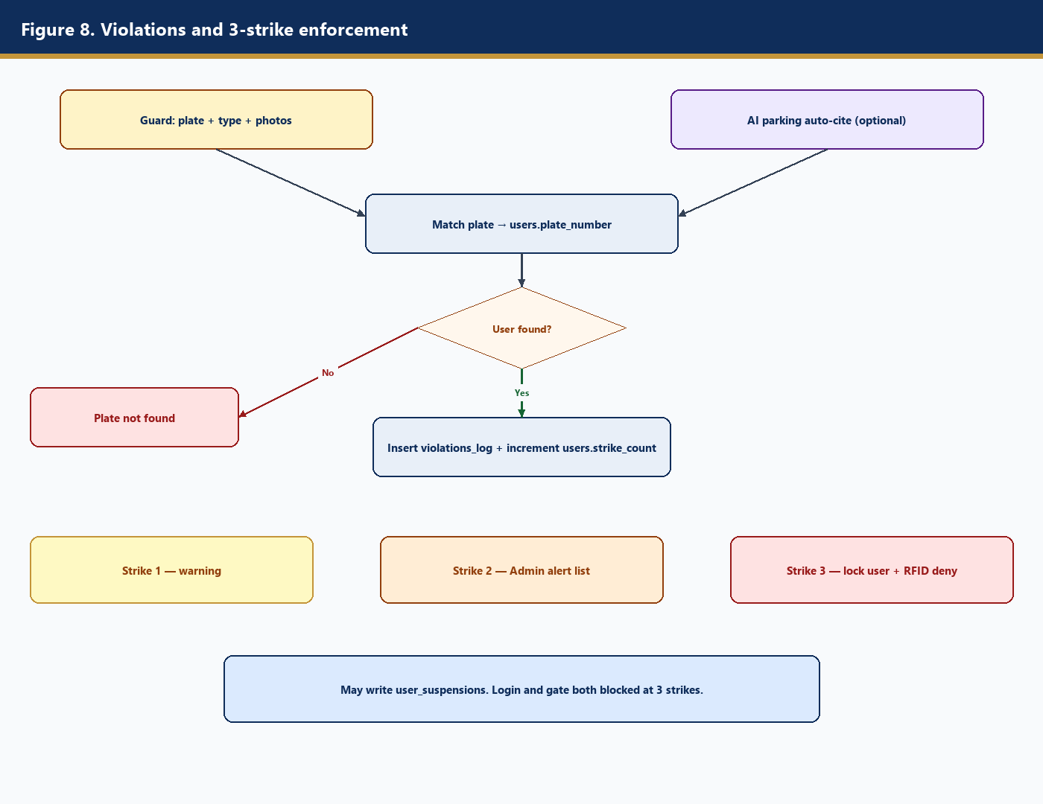
Figure 8. Violation recording and strike escalation.
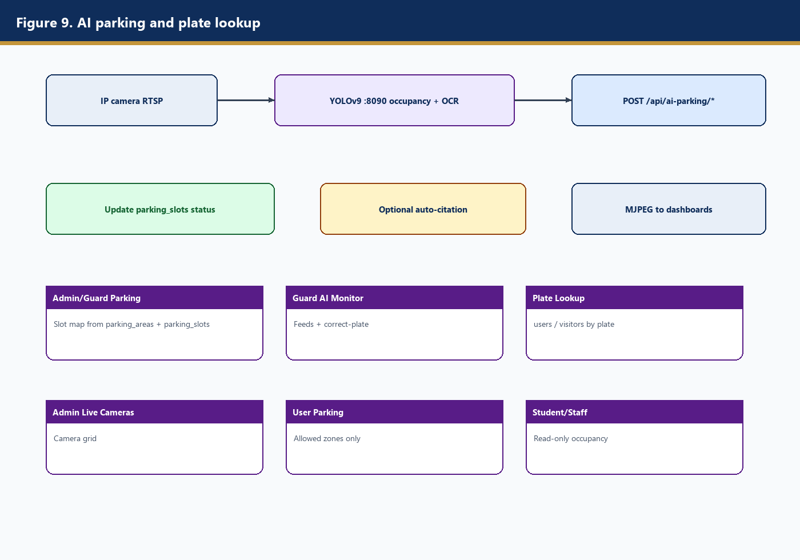
Figure 9. Camera → YOLOv9 → Laravel occupancy → dashboards.

8. URL summary by role
Role | URL | Page
Admin | /admin | Dashboard
Admin | /admin/registrations | Registrations
Admin | /admin/rfid | RFID Assignment
Admin | /admin/users | User Management
Admin | /admin/parking | Parking + zones
Admin | /admin/reports | Reports
Admin | /admin/settings | Settings
Guard | /guard | Dashboard
Guard | /guard/gate | Live Gate Monitor
Guard | /guard/visitors/register | Register Visitor
Guard | /guard/violations | Violations
Guard | /guard/ai-parking | AI Parking Monitor
Guard | /guard/plate-lookup | Plate Lookup
Student/Staff | /user | Dashboard
Student/Staff | /user/notifications | Notifications
Student/Staff | /user/violations | My Violations
Student/Staff | /user/entry-exit | Entry/Exit History
Student/Staff | /user/parking | Parking

APIs: POST /api/rfid/scan, POST /api/rfid/heartbeat, POST /api/ai-parking/occupancy, POST /api/ai-parking/events, POST /api/ai-parking/plate-lookup.
Generated from Laravel models and routes. MongoDB does not enforce FKs; integer ids are application-level keys.

