Purpose and Scope

To describe the procedure for testing product assay cartridges that are produced on ROBAL (Reagents On Board Assembly Line).

This procedure is intended to assess the function of ROBAL during a manufacturing run and to yield product-related data to support final product release.
NOTE: Within the context of this document, “ROBAL” refers to either first generation ROBAL (ROBAL I), second generation ROBAL (ROBAL II), or Jidoka ROBAL (JROBAL), unless otherwise specified.

Reference Documents
  - D0108 Identification, Evaluation, Disposition and Documentation of Nonconforming Product
  - D6254 Laboratory Failure Investigation Procedure
  - D7885 Software Version for QC/WIP Testing & LSP
  - D9050 Cartridge Seal Integrity Vacuum Test Method
  - D10552 Cartridge Seal Integrity Vacuum Test Worksheet
  - D10643 Attachment 4: List of Omni Products
  - D12959 Sampling Plan for GeneXpert Assays
  - D13152 Lot Performance and Acceptance Criteria Summary Sheet for In-Process and QC Testing
  - D16903 GBS ROBAL Testing Procedure
  - D18056 Supplementary Acceptance Criteria for HPV Assay
  - D22580 In Process Testing Signature List
  - D29273 Attachment 2 IPT Checklist US Sites
  - D23998 ROBAL Product Testing Resample Worksheet
  - D29447 Visual Aid for Cartridge Inspection
  - D33211 Standard Work for Reacting to a Seal Test Failure (STF) on ROBAL Tools
  - D43357 Work Instructions for testing on GeneXpert Omni system in Manufacturing Operations
  - D45644 Failure Analysis for ROBAL Abort Criteria
  - D55862 Failure Analysis for JROBAL Abort Criteria
  - D57723 QC Resampling Inspection Form
  - D73609 Labguru LIMS PQC Work Instructions
  - D23998 - ROBAL Product Testing Resample Worksheet
NOTE: See BOM of D12547 for assay specific ROBAL Product Testing Procedures/Product QC Testing Procedures

Responsibility

Quality is responsible for executing this procedure.

Background

ROBAL-processed cartridges will be sampled throughout a manufacturing run, which is defined by a lot number (RRRLL).

Actual sampling time points may vary based on the estimated total run time and to take into account downtimes that may occur during a run.

Cartridges will be sampled from among the ROBAL-accepted pool.

Cartridges excluded from sampling include the following:
- Cartridges rejected automatically by ROBAL
- Cartridges rejected manually by the Operator

Cartridges should be sampled evenly from each time point.

Sampled cartridges intended for ROBAL in-process testing do not require packaging.

These cartridges should be stored at room temperature in the dry room.

Sampled cartridges intended for QC testing do require packaging, if applicable to the product.

After packaging, these cartridges should be stored according to temperature condition specified on the product label. Store QC samples at room temperature if the product label specifies 2-28°C. Store QC samples in the cold room if the product label specifies 2-8°C.

Sample size and acceptance criteria are justified in D12959.

ROBAL in-process functional testing will require test materials, including those listed in assay specific SOP

Labguru LIMS eDHR System Overview:
      - There is an electronic DHR which manages Cepheid’s DHRs. This system is validated and implemented to Sunnyvale and Lodi sites only.
      - Refer to D73609 Labguru LIMS PQC Work Instructions for details on how to use the Labguru LIMS application.

Procedure

Sampling

Sample cartridges evenly from both channels (“+”, “x”) for each time point. If multiple open cartridge lots are used in a time point, sample a minimum of 5 cartridges per open cartridge lot.
NOTE: Channel-dependent sampling does not apply to ROBAL Jidoka.

Refer to Table 2 in assay specific SOP.

If at the end of the manufacturing run, fewer than the required Minimum Total Sample Size of cartridges were sampled in total, pull additional parts at random from the manufactured lot to satisfy the Minimum Total Sample Size requirement.

These cartridges should be recorded in Section 2 under the "Cartridge Data" tab of the assay specific worksheet.
NOTE: Record information on the Cartridge Data tab if applicable.

If applicable (see Table 2 in assay specific SOP), sample an additional 10 cartridges (5 from each channel) off the line as part of the first sampling time point.

NOTE: This sampling is included to identify potential catastrophic failures in production.

Separate (from the main lot), package (if applicable), and store the sampled cartridges in appropriate containers that clearly identify the sampling time point (see table 3a in assay specific SOP).

NOTE: For QC sampling of pouched products, 10-kit parts will be pulled by whole kits, and 50-kit and 120-kit parts will be pulled by flow-wrapped bricks (10 cart pouch) if applicable.

Refer to Table 2 in assay specific SOP, for guidance and details.

Each operator who performs testing on a lot must sign, initial, and date the In Process Signature List D22580 for that lot. A digital signature list may be used in place of D22580 for eDHR in MES.
NOTE: For Production Order (PO) with multiple batches, enter all batch numbers. At the completion of testing attach document to the lot’s worksheet.

A signature list is not required for lots submitted through Labguru LIMS.

(For US Sites) At the completion of testing D29273 Attachment 2 IPT Checklist US Sites must be completed and attached to the lot’s worksheet.

Attachment 2 is not required for lots submitted through Labguru LIMS. The checklist is integrated into the protocols.

Functional Test – First 10 Cartridges (only if applicable per Table 3b in assay specific SOP)

Perform this test as soon as possible after these cartridges have been sampled from the line.

NOTE: For Production Order (PO) with multiple batches, enter all batch numbers.

For these cartridges only:

Conduct Sampling Verification per Section 5.3.

Conduct Visual Inspection per Section 5.4.

Do not perform Seal Test.

Conduct Functional Test per assay specific SOP.

Evaluate Maximum Pressure Test per Section 5.7.

Determine and record Valid Test Replicate per Section 5.8.

Do not perform Statistical Process Control.

Record the results in the first 10 rows of Section 2 under the "Cartridge Data" tab of the assay specific worksheet if applicable.

Notify the Supervisor if 1 or more of the Cartridge Test Results is "FAIL" or "NA" according to the assay specific worksheet.

Sampling Verification

NOTE: Record information on the Cartridge Data tab if applicable.

Assign a Cartridge ID and enter it under the "Cartridge Data" tab of the assay specific worksheet.

Assign a Sample Type to each sampled cartridge and enter its code under the "Cartridge Data" tab of the assay specific worksheet. The code and the number of cartridges to assign each code are defined in Table 3b, in the assay specific SOP.
NOTE: The cell adjacent to the Sample Type cell may not automatically populate until after it is recorded whether the test replicate is considered "valid" (ref Section 5.8)

Inspection

NOTE: Record information on the Cartridge Data tab if applicable.

NOTE: Visual Inspection is performed in two steps. First the exterior of the cartridge is inspected before seal testing (section 5.5) and then the interior of the cartridge is inspected after seal test but before sample is added.

Visually inspect the cartridge per D29447.
If outer film seal coverage is 90–99%, record as Pass ("P") and document as an observation in the worksheet comments. Then perform the following actions in sequence:
(For US sites) Immediately call and email ROBAL to stop the line and send an email to M.E with details of the finding.
(For Solna) Notify ROBAL and technicians of the finding. Request technical action and that ROBAL should be paused.

If any type of film delamination/separation or misaligned film seal is observed on the cartridge film seal or chimney (blockage), then perform the following actions in sequence:

(For US sites) Immediately call and email ROBAL to stop the line and send an email to M.E with details of the failure if 2 delaminations are observed within 3 sampling points.

(For Solna) Notify ROBAL and technicians of failures. Request technical action and that ROBAL should be paused if 2 delaminations/separations, misaligned film seals or 2 identical visual failures are observed within 3 sampling points. On sampling point 00-06, pause for 2 identical failures no matter on which sampling point the error occurred.

(For BA-4plex ONLY) inspect the top film seal for missing center perforation. If the top film seal center perforation is missing, the cartridge fails visual inspection. Segregate the cartridge and do not run functional testing. Immediately call and email Calvary to stop the line and send an email to ME with details of the failure.
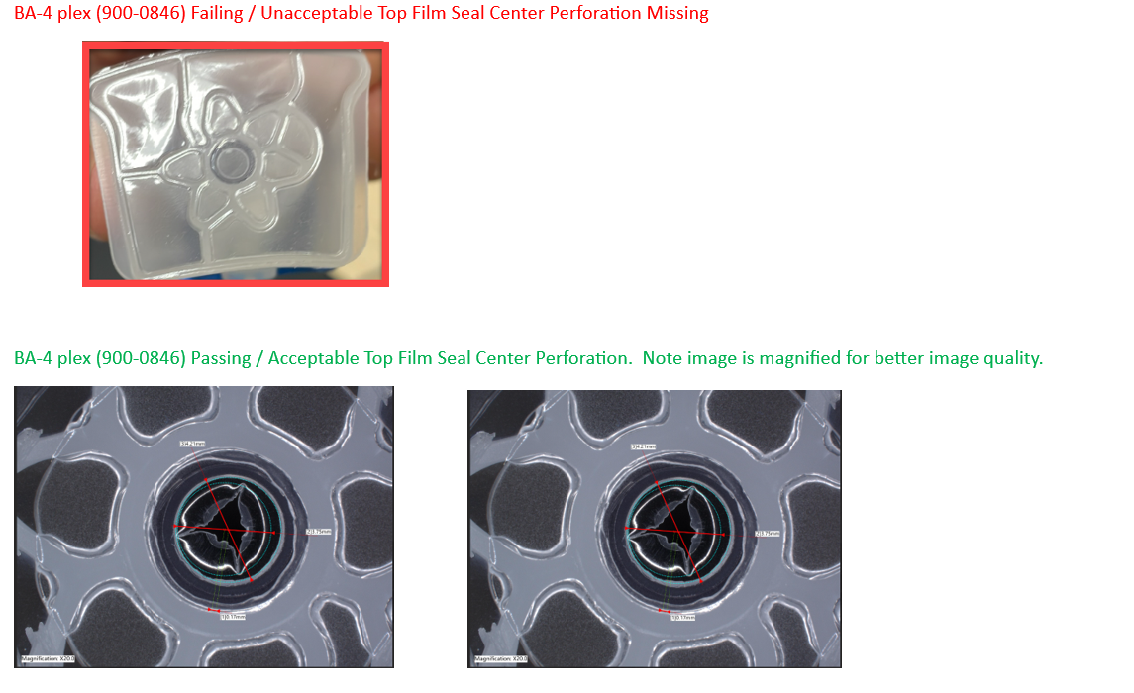

If visual failures are observed (excluding outer film seal coverage 90–99% observations recorded as Pass) then segregate the cartridge and do not run functional testing. See section 5.6.1.

If delamination is observed the cartridge should be functionally tested and whether the replicate should be classified as a delamination depends on the functional result, see 5.6.7-8. Specific naming conventions apply, see table 1.

Enter the result of the visual inspection under the applicable "Cartridge Data" tab of the assay specific worksheet (“P” for pass, “F” for minor visual and “FX” for major visual) and explain the failure (in comments box in worksheet).
NOTE: Outer film seal coverage 90–99% shall be recorded as Pass ("P") and documented as an observation in the worksheet comments. Escalation/line action for this observation is defined in section 5.4.2.2.

If a cartridge fails visual inspection it should not be functionally tested (excluding 5.4.2.5).

Seal Test (only if applicable per Table 4, in assay specific SOP)

NOTE: Record information on the Cartridge Data tab if applicable.

NOTE: In D9050, this is referred to as “Inverted Seal Testing (ROBAL IPT and PQC)”.

If applicable, label the cartridges.

Execute this section only after visual inspection has been performed for a given bag.

Perform the cartridge seal integrity vacuum test according to D9050.

NOTE: For Production Order (PO) with multiple batches, enter all batch numbers.

NOTE: Wipe off any residue from cartridges and wipe the surface of the trays dry before weighing and loading cartridges into the oven.

Record the result (P(ass)/F(ail)) of the seal test under the "Cartridge Data" or “Vacuum Seal Data” tab of the assay specific worksheet if applicable.

If there is a seal test failure, enter “F” for fail and enter “N” in Valid Test Replicate column to indicate there will be a replacement cartridge for functional data.

Enter "N" if the seal test is not applicable or if QC was not responsible for performing the seal testing for functionally tested cartridges.

In addition, record the number of seal test failures (STFs) on the Seal Test Failure Count tab if applicable.

(For US sites) Record the number of seal test failures (STFs) in Labguru LIMS if applicable

If there are seal test failures, count them as seal test failures (STFs) and request re-test cartridge(s) from Manufacturing for Functional Testing (see section 5.9 for more information).

(For Solna) In the event of 2 STF within 3 sampling points, contact ROBAL and technicians and request technical action and that ROBAL should be paused. On sampling point 00-06, pause for 2 STF no matter on which sampling point the error occurred.

(For US sites) In the event of at least one STF per bag, follow Appendix A – the STF reaction workflow.

Functional Test
NOTE: See assay specific SOP for Testing Procedure.
NOTE: Do not start executing this section unless the intent is to run the GX assay.
NOTE: Refer to D7885 for instrument software requirements.
NOTE: Functional testing should be conducted as soon as possible after the seal test (if applicable).
NOTE: Record information on the Cartridge Data tab if applicable.
NOTE: For Production Order (PO) with multiple batches, enter all batch numbers. Open the cartridge.
    - Perform visual inspection according to D29447 and enter result according to 5.4.3-5.4.4.

Create test

For non-Omni GeneXpert products, select Create Test in the GeneXpert software.

For Omni products (see D10643 attachment 4), refer to “start a test” section of D43357 Work Instructions.
NOTE: Omni products have orange NFC symbol on cartridge barcode label.

Enter the following information, see table 1:
Table 1
Field | Information to be Entered (example only)
Sample ID | - Control Material Lot No._Sampling Time Point (Subgroup) No._Sample Type Code _Subgroup Sample No. Lid Welder Laser Cut Pattern  NOTE: Lid Welder Laser Cut Pattern will be the same for all cartridges manufactured on Jidoka ROBAL.  Cartridge Lid – Lid Welder Laser Cut Pattern  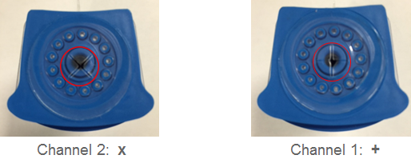  - For example, 052313MR_5_1_10+ would indicate cartridge number 10 from Sampling Time Point (Subgroup) number 5 tested with Sample Type 1 using control material lot 052313MR and + lid welder laser cut pattern. Do not use hyphen "-" or slash "/" because this causes format problems in the GX test summary reports.  - For replacement/re-test cartridges, add an alpha suffix to the Sample ID of the original cartridge. For example, 052313MR_5_1_10A+ would indicate a replacement/re-test cartridge for cartridge 052313MR_5_1_10+.  - For a cartridge with delamination, add “_DXX” (where XX=the chimney location) to the SAMPLE ID. For example,  - 052313_5_1_10+_D01 would indicate delamination on chimney 01  - 052313_5_1_10+_D2A,05 would indicate delamination on chimney 2A and 05  - 052313_5_1_10A+_D8A would indicate a replacement/re-test cartridge with delamination on chimney 8A  - Enter “NEG” as the Control Material Lot No. in cases of Negative testing (Sample Type 0) where only reagent is added as sample input (no cells or virus used) or when multiple control materials (different part numbers) are required to make the negative sample per the assay specific SOP.  - Enter “POS” as the Control Material Lot No. in cases of positive testing (Sample Type 1) where multiple control materials (different part numbers) are required to make up the positive sample per the assay specific SOP.  - Enter 0 for Sampling Time Point (Subgroup) No. if it is not defined, including for the First 10 Cartridges.  - The full Sample ID (e.g. 052313MR_5_1_10) is required only when entering information in the GeneXpert software when starting the run. The Sample ID used in the DHR worksheets may be truncated (e.g. 5_1_10) to remove the Control Material Lot No and will be considered equivalent to the full Sample ID.  - Exceptions to this naming convention will be documented in assay specific SOPs.

For non-Omni GeneXpert products, select Scan Cartridge Barcode in GeneXpert software.

Scan the barcode label to initiate the test. Go to Section 5.6.4.7 if the barcode does not scan properly.

Select the module for cartridge being tested or keep the module the software has selected automatically and move on to 5.6.4.3

Click on "Start Test".

Place the cartridges into a Production GeneXpert module.

When green light is flashing on module, close module door completely.

Repeat the above steps (Sections 5.6.4.1 – 5.6.4.5) for each cartridge.

Record the result (P(ass)/F(ail)) of barcode scanning under the "Cartridge Data" tab of the assay specific worksheet if applicable. Enter "N" if barcode scanning is not applicable.

Segregate and save the cartridges that fail the barcode scanning for further investigation and contact Manufacturing Engineering and/or Failure Investigation.

For Omni Products:

Scan the NFC cartridge label when requested on the mobile device

Record any failures of NFC scanning as a barcode failure (refer to instructions in section5.12).
NOTE: record as a barcode failure if the tag cannot be read, even after restarting the phone and rebooting the instrument.
NOTE: the NFC tag will not be detected if the NFC antenna/chip is damaged (label rejected with a punch hole during NFC Manufacturing Process or if the chip is broken)
NOTE: The NFC tag may be undetected on the instrument if the label is misplaced (a label applied too low on cartridge will result into the NFC cartridge being too far from the instrument NFC antenna). In that case, since the labels for in-process are printed before ROBAL and applied manually by ROBAL operators, the label can be repositioned on the cartridge (see D29447 for correct placement) and the cartridge inserted again in the instrument. If the label cannot be read, then the failure should be recorded.

Segregate and save the cartridges that fail the NFC scanning for further investigation and contact Manufacturing Engineering and/or Failure Investigation

If the cartridge fails CIT (error 2037), segregate and save the cartridge. Record “F” for “Minor Fail” in “GeneXpert Testing” column under the "Cartridge Data" tab of the assay specific worksheet if applicable.

If a cartridge with delamination has been functionally tested according to 5.4.2.5 and the replicate passes functional testing (see assay specific SOP for criteria) then the replicate is considered PASS and the delamination should only be documented as an observation. The functional data for the replicate should be saved in the appropriate data section of the worksheet or Labguru LIMS (“Data – First 10” or “Data – Sample Type”).

If a cartridge with delamination has been functionally tested according to 5.4.2.5 and the replicate fails functional testing (see assay specific SOP for criteria) then the replicate is considered FAIL and should be reported as a delamination. The specific failure that caused the replicate to fail functional testing should be reported as an observation and the functional data should be saved in the “Data – Replaced” section of the worksheet or Labguru LIMS.

Record the result of GX testing under the "Cartridge Data" tab of the assay specific worksheet if applicable. Enter "N" if GX testing is not applicable.

Refer to the assay specific SOP for details of the pass/fail criteria.

Maximum Pressure

NOTE: Record information on the Cartridge Data tab if applicable.

Check the maximum pressure for each cartridge from the functional results obtained in Section 5.6.

Record the result (P(ass)/F(ail)) of the pressure test under the "Cartridge Data" tab of the assay specific worksheet. Enter "N" if the pressure test is not applicable. The maximum pressure is considered a pass if < 90.0.
NOTE: Record F(ail) even if the test replicate automatically failed due to high pressure (Error 2008).
NOTE: if the cartridge failed Maximum Pressure and has another failure (e.g. E5007 or E2008) then record the cartridge as failing both on the cartridge data tab. Comment on both the cartridge data tab and the results summary tab that the cartridge has two failures.

Valid Test Replicate

NOTE: Record information on the Cartridge Data tab if applicable.

Record whether the test replicate should be considered valid (Y(es)/N(o)) under the "Cartridge Data" tab of the assay specific worksheet.
      - Enter "N(o)" if the cartridge fails GeneXpert testing but is subject to re-test per Section 5.9
      - Enter "N(o)" if the cartridge fails GeneXpert testing or a test result is not available due to operator or other non-cartridge-related error (e.g., dropped cartridge, error in loading sample and/or liquid reagents, power outage, etc.). Such occurrences should be recorded in the assay specific worksheet.

A failed cartridge is not subject to re-test and is considered a true functional failure for the errors listed below:
- False Result (False Negative or False Positive)
- Cartridge Integrity Failure (E2037)
- Probe Check (E5007, E5006, E5017, E5018 & E5019)
- Signal Loss Detection (E5011)
- Pressure Errors (E2008, E2009, Max P > 90 PSI etc)
- Assay Specific Termination Errors (E2096 & E2097)
- Sample Adequacy (E2125)
- Invalid
- Curve Fit Error (E5001, E5002, E5003, E5004, E5005, E5015 & E5016)
- Any additional failures listed in the Assay Specific SOP
- Delamination

However, an LFI (per D6254) may be initiated to investigate the failure and ultimately justify a re-test.

All other unexpected results or errors are subject to re-test (applies to all sampling points, including First 10).
      - For E2005 (Syringe Stall Error)/ E2025 (Failed to find the plunger home position) or “Unloadable” cartridges, operator will look for blocked in syringe tube, such as large retain ball or desiccant/ desiccant particles or if the plunger is missing. If particles are seen in syringe tube, DO NOT replace cartridge, call the error a Minor Visual Failure.
      - For BA-4 plex ONLY: For E2005 (Syringe Stall Error)/ E2025 (Failed to find the plunger home position) or “Unloadable” cartridges, operator will look for missing cartridge top film seal center perforation. DO NOT replace cartridge, call the error a Major Visual Failure.

  - Re-test
    - A re-test could be required due to STF, instrument error, handling error, LFI, PCR tube film fuse, etc.
    - If the run is subject to re-test, sample a replacement cartridge at random from the manufactured lot.
    - Depending on the reason for re-test different steps should be performed.
      - Re-test due to STF: Document the replicate with STF in “Data – Replaced”. Perform all steps in this SOP except seal test on the re-test cartridge. Paste functional data for the re-test in the applicable “Data”-tab.
      - Re-test due to instrument error, missing result or handling error during functional test: Paste functional data for the replicate in “Data – Replaced” (if applicable). Perform all steps in this SOP except seal test on the re-test cartridge. Paste functional data for the re-test in the applicable “Data”-tab.
      - Re-test due to PCR tube film fuse (also sometimes referred to as PCR tube doughnut/donut): A cartridge may be functionally re-tested if it resulted in an error caused by PCR tube film fuse artifact if fulfilling all of the following conditions:
(1) The same cartridge was used for seal test and functional test; AND
(2) The cartridge resulted in one of the following errors: Invalid, Curve Fit or Background Validation errors with or without Invalid (E5001, E5002, E5003, E5004, E5005, E5015, E5016), E5007; AND
(3) The Error cartridge was visually inspected post-run and a PCR tube film fuse (doughnut/donut) was observed. Refer to D29447 Visual Aid for Cartridge Inspection for guidance.
If “PCR tube film fuse” per above criteria was determined, perform all steps in this SOP except seal test on the re-test cartridge. Paste functional data for the re-test in the applicable “Data”-tab.
      - Re-test due to invalid seal test (e.g. bags scrapped during the run), missing seal test or handling error during seal test: Paste functional data for original replicate in applicable “Data”-tab. Perform seal test only on the re-test cartridge.
      - If both 5.9.3.2 and 5.9.3.3 are applicable then all steps outlined in this SOP should be performed.

NOTE: For assays where “Cartridge Data” is applicable “valid test replicate” should be marked as “Y” for the replicate (original or re-test) with valid functional result or visual error.

Statistical Process Control

NOTE: This does not apply to the first 10 samples from Section 5.2.

As soon as possible after the results from all the cartridges from a Sampling Time Point are available, enter the requested values under the "Statistical Process Control" tab of the assay specific worksheet or Labguru LIMS. For examples see Table 2
Table 2
Example  # | Description | Value to Enter for "Sample Size of Subgroup" | Value to Enter for "Defects in Subgroup"
1 | - 25 cartridges were sampled from ROBAL.  - 24 cartridges passed Cartridge Test Result.  - 1 cartridge failed Cartridge Test Result. | 25 | 1
2 | - 25 cartridges were sampled from ROBAL.  - 23 cartridges passed Cartridge Test Result.  - 1 cartridge failed Cartridge Test Result.  - 1 cartridge was NA Cartridge Test Result because the test was not valid. | 24 | 1
3 | - 25 cartridges were sampled from ROBAL.  - 1 additional cartridge was sampled from ROBAL for a retest.  - 25 cartridges passed Cartridge Test Result  - 1 cartridge failed Cartridge Test Result | 26 | 1

Follow the instructions defined under the "Statistical Process Control" tab of the assay specific worksheet or Labguru LIMS to determine whether immediate actions are required.

If the supervisor was notified and action was taken, document in the comments section of the “Statistical Process Control” tab of the assay specific worksheet or Labguru LIMS.

After completing testing and all data have been recorded:

NOTE: Record information on the Cartridge Data tab if applicable.

Verify that all rows in Section 1 and first 10 rows of Section 2 under the "Cartridge Data" tab of the assay specific worksheet have been filled in.

Enter the following information (see Table 3) for any empty rows in Sections 1 or 2 under the "Cartridge Data" tab of the assay specific worksheet:
Table 3
Sample Type | N
Visual Inspection (P/F/FX/N) | N
Seal Test (P/F/N) | N
Barcode Scanning (P/F/N) | N
GeneXpert Testing (P/F/FX/N) | N
Maximum Pressure (P/F/N) | N
Valid Test Replicate? (Y/N) | N

Alternatively, the empty rows maybe N/A-ed manually.

Enter "Y" in cell G299 under the "Cartridge Data" tab of the assay specific worksheet.

Select the appropriate product catalog/part number from the pull-down menu in cell L299.
NOTE: For catalog/part numbers starting with a number include a "PN" prefix. In addition, any punctuation marks (e.g., hyphens, slashes) are removed. For example, "900-0487" would be listed as "PN9000487".

The results of ROBAL in-process testing will be displayed at the bottom of the "Cartridge Data" tab of the assay specific worksheet.

If the Overall Test Result is not "PASS", check for and correct data entry errors.

If no data entry errors are apparent and the Overall Test Result is "RESAMPLE", perform additional testing as described in Section7.

If no data entry errors are apparent and the Overall Test Result is "FAIL", initiate an NCR (per D0108).

If no data entry errors are apparent and the Overall Test Result is "Perform Supplementary Analysis", enter the required data in the "Supplementary Analysis" tab.
NOTE: Do not fill out the "Supplementary Analysis" tab if not required.

After the Overall Test Result in this tab is determined, follow the instructions in Sections 5.12.

Data Summary
NOTE: This section may be performed after completion of all testing.

Generate GX Test Summary Data for all runs performed. Cut-and-paste the data and place under the appropriate "Data" tab of the assay specific worksheet or in Labguru LIMS.

Make sure that the pasted data matches the Data Description, as defined in the table 4 below. For Labguru LIMS, refer to D73609 Labguru LIMS PQC Work Instructions.
Table 4
Data Description | Where to Paste the Data (if applicable)
First 10 Cartridges | "Data - First 10" Tab
Sample Type 0 Cartridges | "Data - Sample Type 0" Tab
Sample Type 1 Cartridges | "Data - Sample Type 1" Tab
Sample Type 2 Cartridges | “Data - Sample Type 2” Tab
Replaced Cartridges  Seal Test Failures (STFs) | "Data - Replaced" Tab
Replaced Cartridges from Resample Data | "Data – Resample Replaced" Tab
NOTE: Data where "Valid Test Replicate?" is "N(o)" must not be pasted in the "Data - First 10", "Data - Sample Type 0", "Data - Sample Type 1" tab or “Data – Sample Type 2” tab. These data should be pasted in the "Data - Replaced" tab.
NOTE: The "Data - Replaced" tab is the location for recording the replicate assay testing results that are excluded from the overall data set used to compare against the Acceptance Criteria. Except for Seal Test Failures (STFs), which are evaluated against their own acceptance criteria separate from major and minor failures acceptance.

For any valid test replicate for which GX test summary is not available or applicable manually add a line item in the appropriate data tab with the following information in Table 5A and 5B:
Table 5A
Description of Information | Worksheet Column ID | Information to Enter
Assay Name | A | [Appropriate Assay Name]
Assay Version No. | B | [Appropriate Assay Version No.]
Sample ID | C | [Appropriate Sample ID]
Serial No. | D | 0  (the number zero)
Lot Number | E | [Appropriate Lot Number]
Failure Designation | L | See Table 5B
Table 5B
Failure Type | Designation  (To be entered in Column L)
Seal Test Failure | S
Minor Visual Failure | V
Major Visual Failure | M
Barcode or NFC Scanning Failure | B
LRB Insertion Error | L
Delamination | D

After all the data are pasted, enter the appropriate lot number under the "Results Summary" or “Test Summary” tab of the assay specific worksheet.
NOTE: Leading zeros should be omitted from the lot number. For example, "00801" should be entered as "801".

The assay specific worksheet will perform an analysis, including determining whether the pasted data are consistent with the information input and calculated under the "Cartridge Data" tab of the assay specific worksheet.

This analysis will be output in the "Results Summary" or “Test Summary” tab of the assay specific worksheet or Labguru LIMS.

If the Overall Result is not "VALID", check for and correct data entry errors.

If no data entry errors are apparent and the Overall Result is "ND", write comment “Due to Worksheet Error, the Check Sum and Overall Result should be “VALID” (problem known)

File the records generated under this procedure with the product manufacturing batch record.

Fill out the ROBAL in-process testing section of the Lot Performance and Acceptance Criteria Summary Sheet D13152 for the product tested. Refer to the product BOM for the appropriate document.
NOTE: Lot Performance and Acceptance Criteria Summary Sheet D13152 is not required for RBCR-ABL or BCR-ABL Ultra/Version 2 or BCR-ABL Ultra p190.

For Product QC Testing assays where D13152 is not listed on Product BOM, do not use D13152.
        - If “Resample Consolidated Data” tab and “Resample Single Minor Fail Mode” tab are present in the Product QC Testing worksheet, complete these tabs if resampling is performed.

        - If Product QC Testing Worksheet does not contain “Resample Consolidated Data” tab and “Resample Single Minor Fail Mode” tab, then original and resample results will be summarized on “Test Summary” tab.

Acceptance/Resampling Criteria and Failure Handling

Table 6 shows the general acceptance criteria that the majority of GeneXpert assays must conform to after initial testing. Exceptions to these criteria are listed below, in product specific SOPs and D13152.
Table 6
 | Pass | Resample | Fail
Total No. of Errors (excluding STF) | ≤9 | N/A | >9
Total No. of STF | ≤9 | N/A | >9
Total No. of Major Errors | ≤1 | 2-3 | >3
Max Count of Single Minor Failure Mode | ≤4 | >4 | N/A

All criteria for “Pass” must be met in order for the lot to pass IPT testing.

Resample/Fail is triggered if a single criteria in the respective columns are met.

If both Resample and Fail criteria are met then the result for the lot is “Fail” and the lot is rejected.

For US sites ONLY. If “Fail” criteria is met for Total number of Errors, and the lot has ≥4 E2008 and/or Max Pressure ≥90 PSI failures present in the lot, follow resample procedure outlined in D12547 Attachment 1.

For FIIFV and HEMOSIL the criteria for major errors are listed in the assay-specific sheet in D13152.

HPV has assay-specific criteria for major errors. Refer to D18056 for more information.

If GBS requires Resampling OR Fails, see D16903 for supplementary instructions
  - All viral load assays (HIV VL, HCV VL, HBV VL, HCV VL FS and HIV VL XC) are exempt from these criteria and their acceptance criteria can instead be found in their assay specific testing procedures.
  - Xpert GI Panel has assay-specific criteria for major errors. Refer to D55989 for more information.
  - Upload completed worksheet into MES if MES is available. If the completed worksheet is scanned and uploaded to MES, retain the physical copy of the completed worksheet for a minimum of 14 days after the batch is released. (For Solna): No physical copy of the worksheet needs to be retained.
  - (For US Sites) Submit completed eDHR through Labguru LIMS if applicable.
  - (For Sunnyvale) (if applicable) If there is a mean Ct failure, follow D45644. If D45644 cannot be applied (e.g. ROBAL line has completed), initiate a LFI and retest the failing sample types with a double sample. When retesting the double sample, each set should be tested with its own newly prepared sample.

Resampling Procedure

NOTE: When resampling is required, record resample data and attach to the batch record. Record resample data in the assay-specific resample tab or resample worksheet attachment if applicable, otherwise use D23998 to record the resample data. For Production Order (PO) with multiple batches, enter all batch numbers.

NOTE: See supplemental instructions in D16903 prior to performing resampling for GBS.

NOTE: If Major Functional Failure is a False Positive Result, perform decontamination of work area before performing resampling per procedures outlined in D0235 or UMP0029.

After initial testing, the possible scenarios that trigger resampling are in Table 7:

Table 7
Resampling due to Functional and/or Visual Failures
Resample Type | Scenarios
Functional and Visual Resample | - Resampling triggered by single minor failure mode (excluding delamination)  - Resampling triggered by Major Errors where at least 1 Error is a Major Functional
Visual Resample | - Resampling triggered by Major Errors where all Errors are Major Visuals
Delamination and Visual Resample | - Resampling triggered by Delamination in single minor failure mode

If an HPV lot does not fall into one of these scenarios, supplementary resampling requirements may apply. Refer to D18056 for more information.

If GBS requires resampling, see D16903 for supplementary instructions.

All viral load assays (HIV VL, HCV VL, HBV VL, HCV VL FS and HIV VL XC) are exempt from these scenarios and their resampling scenarios can instead be found in their assay specific testing procedures.
NOTE: The Acceptance Criteria defined below are based on these scenarios.

Go to Section 7.8, if resampling requires Visual Inspection Only.

Go to section 7.9, if resampling requires Delamination check and Visual Inspection.

Go to Section 7.10, if resampling requires Visual Inspection and Functional Testing

Visual Inspection Only:

Sample 200 cartridges at random from the manufactured lot.

NOTE: For Production Order (PO) with multiple batches, enter all batch numbers.

If applicable, open the packaging.

For non-Omni products, scan the cartridge barcode into D57723 QC Resampling Inspection Form.

If a barcode does not scan, count the cartridge as a major failure, and continue with visual inspection.

Visually inspect the cartridge as described in D29447, except that the assay specific worksheet does not apply.
NOTE: Do not check for delamination since that is a functional error and not visual.

Record whether the cartridge passed or failed inspection, including whether a failure is Major or Minor (ref D29447).

Print out the completed D57723 form as a record of this inspection, comment as to the results of the inspection, and file with the batch record.

(For US Sites) If using Labguru LIMS, upload completed D57723 to the eDHR.

See section 7.11 for Resample Acceptance criteria.
  - Delamination and Visual Inspection

Sample 200 cartridges at random from the manufactured lot.
NOTE: For Production Order (PO) with multiple batches, enter all batch numbers.

If applicable, open the packaging.

For non-Omni products, scan the cartridge barcode into D57723 QC Resampling Inspection Form.

If a barcode does not scan, count the cartridge as a major failure, and continue with visual inspection.

Check for Delamination and visually inspect the cartridge per D29447, except that the assay specific worksheet does not apply.

If delamination is observed on the cartridge, then functional testing should be performed according to section 5.6. The result of the functional test determines whether the replicate should be classified as a delamination, see 5.6.7-8. Regardless of the result the functional data should be saved in the “Data – Resample Replaced” section of the worksheet (if applicable).

Record whether the cartridge passed or failed inspection, including whether a failure is minor or major (see D29447).

Print out the completed D57723 form as a record of this inspection, comment as to the results of the inspection, and file with the batch record
      - (For US Sites) If using Labguru LIMS, upload completed D57723 to the eDHR.

See section 7.11 for resample acceptance criteria

Visual Inspection and Functional Testing

Sample 200 cartridges at random from the manufactured lot.

NOTE: For Production Order (PO) with multiple batches, enter all batch numbers.

Prepare for functional testing according to the assay. Refer to Table 1 and Table 3a in assay specific SOP.

If necessary, inspection/testing may be performed in batches.

If applicable, open the packaging.

Visually inspect the cartridge as described in D29447, except that the assay specific worksheet does not apply.

Delamination should be handled according to section 5.4.2.5.

Record whether the cartridge passed or failed inspection, including whether a failure is Major or Minor.

Functionally test the cartridge as described in Section 5.6, if it passes visual inspection (special conditions apply to delamination) except that the assay specific worksheet does not apply.

Record whether the cartridge passed barcode scanning.

Replicates with delamination that are functionally tested should be handled according to section 5.6.7-8.

Record whether the cartridge passed or failed testing, including whether a failure is Major or Minor.

Record whether the cartridge passed maximum pressure as described in Section 5.7, except that the assay specific worksheet does not apply.

Replace any failed cartridges that are subject to re-test based on the information in Section 5.8.

Generate and print out the summarized GX data as a record of this inspection/testing, comment as to the results of the inspection/testing, and file with the batch record.

See section 7.11 for Resample Acceptance criteria.
  - Acceptance Criteria for Resample

Table 8 shows the general acceptance criteria that the majority of GeneXpert assays must conform to after resample. Exceptions to these criteria are listed below, in product specific SOPs and D13152.
Table 8
Error Type | Pass | Fail
Total No. of Errors (Resample only) | ≤10 | >10
Total No. of Major Errors (Original + Resample) | ≤5 | >5
Single Minor Failure Mode (Original + Resample) | ≤10 | >10
    - Single Minor Failure Mode Acceptance Criteria does not apply to Visual Resample.
    - All criteria for “Pass” must be met in order for the lot to pass Resample testing.

If any criteria for “Fail” is met the lot is rejected.

HPV has assay-specific criteria for major errors. See D18056 for more information.

If GBS requires Resampling, see D16903 for supplementary instructions.
    - For FIIFV and HEMOSIL the criteria for major errors are listed in the assay-specific sheet in D13152.
    - All viral load assays (HIV VL, HCV VL, HBV VL, HCV VL FS and HIV VL XC) are exempt from these criteria and their resampling criteria can be found in their assay specific testing procedures.

Upload completed worksheet into MES if MES is available. If the completed worksheet is scanned and uploaded to MES, retain the physical copy of the completed worksheet for a minimum of 14 days after the batch is released. (For Solna): No physical copy of the worksheet needs to be retained.
    - (For US Sites) Submit completed eDHR through Labguru LIMS if applicable.

Grouping of Single Minor Failure Mode

Certain minor error codes or failures have similar causes so it is desirable to place them into same “Failure Mode” for the purpose of counting numbers of single minor failure mode.

Initial ROBAL IPT data and the re-sampled IPT data (if applicable) should be reviewed against Table 9 to determine the numbers of each of the failure mode. The resampling data should be entered into D23998, the Assay Specific Product QC Testing Worksheet, or Labguru LIMS and the results summarized in D13152, the Assay Specific Product QC Testing Worksheet, or Labguru LIMS.
Table 9 Minor Failure Modes
Single Minor Failure Mode Grouping | Error Codes/Calls
Invalid (w/o error code) | SPC Ct=0  Invalid (w/o error code)
Curve Fit Error (results equal to Invalid) | 5001  5002  5003  5004  5005  5015  5016
Probe Check Low | 5007  5017  5019
Probe Check High | 5006  5018
CIT and SLD | 2037 (CIT)  5011 (SLD)
Pressure Abort  High Max Pressure | 2008  Max Pressure > 90 PSI
Sample Volume Adequacy | 2096  2097  2125
Delamination | Delamination

Aborting a Build

If you have ≥3 major failures or total failures (minor + major) according to Table 13 and the lot is still running on the line, hold the line and notify the Supervisor. NOTE: Table 13 is only for minor and major failures excluding seal test failures.
    - FOR GBS ONLY: Notify Failure investigation before aborting a build if there are ≥2 False Positives in the lot.
    - FOR MTB 700-4006 fill pack workorder ONLY:
If you have ≥3 major failures or total failure (minor + major) according to Table 14.
    - For Sunnyvale or other US Sites (except Newark): If you have ≥3 major failures or total failures (minor + major) according to Table 13 and the lot is still running on the line, hold the line and follow D45644 and the instructions provided below. NOTE: Table 13 is only for minor and major failures excluding seal test failures.
    - For Newark and MII Bengaluru: If you have ≥3 major failures or total failures (minor + major) according to Table 13 and the lot is still running on the line, hold the line and follow D55862 and the instructions provided below. NOTE: Table 13 is only for minor and major failures excluding seal test failures.
  - (For Solna) For assays that perform inverted seal testing only: Abort the build per the dynamic abort criteria in Table 15 for total STFs only. Do not complete visual inspection, seal testing, and functional testing. For Sunnyvale or other US sites, there is no abort criteria for seal test failures and the dynamic abort criteria is not applicable.

Enter the failures (defects in subgroup) into the statistical process control tab on the assay specific worksheet or Labguru LIMS as results are received for each bag. If the blue data line goes above or lands on the red control line and the lot is still running on the line then abort the build and notify the Supervisor. See below for example.
NOTE: The example below shows that the build would have been aborted at bag 6 with this rule applied.
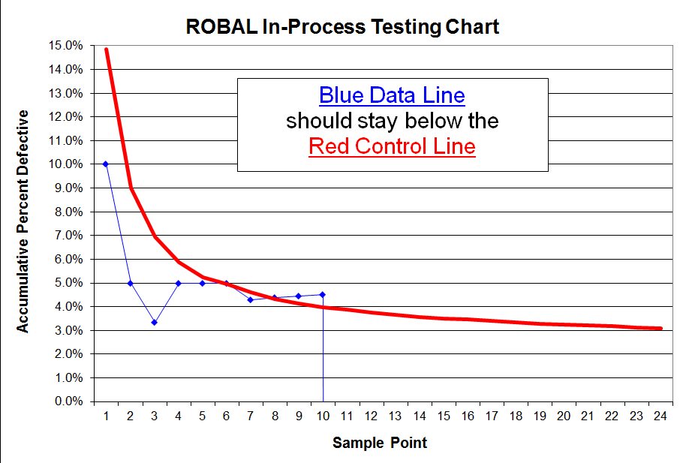
    - FOR GBS ONLY: Notify Failure investigation before aborting a build

Enter failures (defects in subgroup) into the statistical process control tab on the assay specific worksheet or in Labguru LIMS as results are received for each bag. If the blue data line goes above or lands on the red control line and the lot is still running on the line (or Table 13 criteria is met, whichever occurs first), do not abort the build.

For Sunnyvale or other US Sites (except Newark): Follow instructions provided in Table 10a below for next steps and notify Supervisor. See below for example.

For Newark and MII Bengaluru: Follow instructions provided in Table 10b below for next steps and notify Supervisor. See below for example.
Do not Abort the build and follow Table below for next steps
        - Refer to the table below and verify if the major and minor failures seen on the line are any of the failures listed in the table below.
        - For Sunnyvale or other US Sites: If the type of Failures and the total number of failure types matches any of the categories specified in the table below, do not abort the build and follow the instructions provided in procedure D45644 to proceed with lot build.
        - For Newark and MII Bengaluru : If the type of Failures and the total number of failure types matches any of the categories specified in the table below, do not abort the build and follow the instructions provided in procedure D55862 to proceed with lot build.

Table 10a For Sunnyvale / other US Sites

ROBAL ABORT criteria (Functional Failures)
 | Failures | Number of Failures | Potential Cause of Failure | Action Taken
1 | E5007/E5017 | ≥ 4 in one bag  Or  ≥ 6 in two consecutive bags | Incorrect Bead Dispense  Missing Beads  Incorrect Liquid Dispense  Incorrect Sample Addition | Refer to procedure D45644 and follow checklist
1 | Invalid | ≥ 4 in one bag  Or  ≥ 6 in two consecutive bags |  | Refer to procedure D45644 and follow checklist
1 | E5006 | ≥ 4 in one bag  Or  ≥ 6 in two consecutive bags |  | Refer to procedure D45644 and follow checklist
1 | Ct=0 | ≥ 4 in one bag  Or  ≥ 6 in two consecutive bags |  | Refer to procedure D45644 and follow checklist
2 | False Positive/False Negative | ≥ 3 in one bag  Or  ≥ 4 in two consecutive bags | Sample Preparation Error | Refer to procedure D45644 and follow checklist
3 | Mean Ct Failure | In one bag  Or  Two consecutive bags | Sample Preparation Error | Refer to procedure D45644 and follow checklist
4 | E2005 | ≥ 4 in one bag | Debris in Syringe tube  Retaining ball/Beads in Syringe Tube | Refer to procedure D45644 and follow checklist
5 | Delamination | ≥ 3 in one bag  Or  ≥ 5 in two consecutive bags | ROBAL | Refer to procedure D45644 and follow checklist

Table 10b For Newark and MII Bengaluru

JROBAL ABORT criteria (Functional Failures)
 | Failures | Number of Failures | Potential Cause of Failure | Action Taken
1 | E5007/E5017 | ≥ 3 in one bag  Or  ≥ 5 in two consecutive bags | Incorrect Bead Dispense  Missing Beads  Incorrect Liquid Dispense  Incorrect Sample Addition | Refer to procedure D55862 and follow checklist
1 | Invalid | ≥ 3 in one bag  Or  ≥ 5 in two consecutive bags |  | Refer to procedure D55862 and follow checklist
1 | E5006 | ≥ 3 in one bag  Or  ≥ 5 in two consecutive bags |  | Refer to procedure D55862 and follow checklist
1 | Ct=0 | ≥ 3 in one bag  Or  ≥ 5 in two consecutive bags |  | Refer to procedure D55862 and follow checklist
1 | E2125 | ≥ 3 in one bag  Or  ≥ 5 in two consecutive bags |  | Refer to procedure D55862 and follow checklist
2 | False Positive/False Negative | ≥ 3 in one bag  Or  ≥ 4 in two consecutive bags | Sample Preparation Error | Refer to procedure D55862 and follow checklist
3 | Mean Ct Failure | In one bag  Or  Two consecutive bags | Sample Preparation Error | Refer to procedure D55862 and follow checklist
4 | E2005 | ≥ 4 in one bag | Debris in Syringe tube  Retaining ball/Beads in Syringe Tube | Refer to procedure D55862 and follow checklist
5 | Delamination  Beads/Desiccant/Retain  balls in other chambers  Liquid on top of lid | ≥ 3 in one bag  Or  ≥ 5 in two consecutive bags | JROBAL | Refer to procedure D55862 and follow checklist
        - If failures match any of the categories listed in Table 10a or 10b, complete the checklist and proceed with instructions provided in checklist during ROBAL build.
        - If the failures do not match with criteria specified in table above, then abort the build and notify the supervisor.

9.3.2.3 For Solna site only: Refer to the tables below and verify if the failures seen on the ROBAL line are any of the failures listed.

9.3.2.3.1 If the total number of failures and type of failure correspond with Table 11:
- For STF, visual failures or delamination: Pause ROBAL and notify technicians. For every failure received, proceed to contact ROBAL and technicians.
For outer film seal coverage 90–99% observations: Pause ROBAL and notify technicians (no count threshold).
- For functional failures: pause ROBAL, notify technicians, and follow Table 12 for additional actions. If pause criteria is not triggered IPT does not need to contact technicians, proceed to contact ROBAL.
Table 11 For Solna only

ROBAL pause criteria
NOTE: If the failures reach abort criteria follow pause criteria before aborting if 1) failures also trigger pause criteria, or 2) pause criteria is not met but half or more of the errors are from the same failure group.
NOTE: If pause criteria is met when lot is finished on ROBAL, follow pause criteria unless a different assay has already started on the same line.
NOTE: SP00 and 01 should be counted as separate bags.
Failure mode groups  (All errors in the same group are counted together) | Number of Failures | Action Taken
E5006 (Probe check high) | ≥ 3 in one bag  or  ≥ 4 in two consecutive bags  or  ≥ 5 across the lot | See Table 12
Invalid (w/o error code) /FN/SPC Ct=0/HIV-1 Ct outliers/SPC validity fail |  | See Table 12
E2008/Max pressure >90 (Max Pressure failure)  E5001-E5005, E5015, E5016 (Curve Fit failure)  E2037 (CIT) / E5011 (SLD)  Misaligned VBA |  | See Table 12
E5007/E5017 (Probe check low) |  | See Table 12
Mean CT failure  (HxV assay specific procedures takes precedent) | One bag failing | See Table 12
STF | ≥ 2 in three consecutive bags  or  ≥ 2 within SP 00-06 | See 5.5.6  (STF)  See 5.4.2.2  (Visual failures and delamination)
Identical Visual failures (excluding misaligned VBA) / Delamination | ≥ 2 in three consecutive bags  or  ≥ 2 within SP 00-06
Outer film seal coverage 90–99% (observation) | Any occurrence (≥ 1) | See 5.4.2.2 (Visual Inspection)

Table 12 For Solna only
Action Matrix for ROBAL pause criteria
NOTE: If root cause (RC) is found and mitigated. IPT may allow the lot to keep running past abort criteria (NOT fail criteria), see section 9.3.2.4
*** If all errors are from only one ROBAL side DO NOT initiate NC for the OC.
Failures | Most likely potential causes | First action | Second action | Third action
E5006  (Probe Check High) | Beads  Liquid | Contact tech for troubleshooting.  If techs found RC: proceed according to normal procedure.  If techs did not identify RC: proceed to second action. | Proceed according to normal process, call FI during daytime and send FI request.
Invalid (w/o error code) /  False Negative (FN) /  SPC Ct=0 /  HIV-1 Ct outliers /  SPC validity fail / | Liquid  Beads  OC  Sample handling | Contact Tech for troubleshooting.  If techs found RC: proceed according to normal procedure.  If techs did not identify RC: proceed to second action. | PQC key action (only if multiple OCs were used): Check if all errors occurred after OC change.  If yes***: initiate NC for the OC with errors, send containment email and call ROBAL line.  If no/only one OC**:  Do LFI re-test according to D6254 and call FI during daytime and send FI request.  If LFI re-test passed: resume production.  If LFI re-test fails:  proceed to third action.  **If all errors are Invalid (w/o error code) and/or SPC Ct=0, LFI is not needed. Proceed to third action. | Proceed according to normal process, call FI during daytime and send FI request.
E2008 / Max pressure >90  (Max pressure failure)  E5001-E5005, E5015, E5016  (Curve Fit Error)  E2037 / E5011  (CIT) / (SLD)  Misaligned VBA  (Visual failure) | OC | PQC key action:  Check each OC used if it is triggering the pause criteria.  If any OC trigger the criteria***: Initiate NC for the OC with errors, send containment email and call ROBAL line.  If no OC trigger the criteria: proceed to second action. | Unpause ROBAL line and continue to normal process. Failure is not severe enough for action.
E5007/E5017  (Probe check low) | Bead  Liquid  OC | PQC key action: Perform visual inspection: If PCR tube is empty, then the E5007/E5017 is caused by the OC.  Only if PCR tube is empty: check each OC used if it is triggering the pause criteria.  If any OC trigger the criteria***: Initiate NC for the OC with errors, send containment email and call ROBAL line.  If no OC trigger the criteria/PCR tube is not empty: proceed to second action. | Contact Tech for troubleshooting  If techs found RC: proceed according to normal procedure.  If techs did not identify RC: proceed to third action. | Proceed according to normal process, call FI during daytime and send FI request.
Mean CT failure | Sample prep  OC | PQC key action: If a laboratory assignable root cause is suspected, initiate LFI according to D6254.  If LFI is initiated and original data will be replaced: resume production.  If LFI is not initiated or original data will not be replaced: proceed to second action. | PQC key action (only if multiple OCs were used): Check if all errors occurred after OC change.  If yes***: initiate NC for the OC with errors, send containment email and call ROBAL line.  If no/only one OC: RC not found procced to third action | Proceed according to normal process, call FI during daytime and send FI request.

If the failures do not match with criteria specified in table above, then abort the lot if aborting criteria in Table 13 are met and notify Supervisor.

9.3.2.4 For Solna site only: If IPT can confirm that the error that triggers the abort is no longer present in the lot, IPT may allow the lot to keep running past abort criteria. Lot may be kept running past fail criteria with agreement of FI. The serial number of the first non-faulty cartridge after TA (technical action) must be documented in the DHR and no occurrence of the error may be present after that serial number.
  - Failure Investigation or their designee can call off the abort if they determine that continuing the run presents no added risk.
  - Refer to D16199 and D8148 for sampling procedure after a run is aborted.
  - For Solna only: When the lot reach abort criteria, table 13, follow table 11.

Table 13
Bag | Number of Cartridges in bag | Abort at number of total failures (major +minor)
00 | 10 | 4
01 | 20 | 4
02 | 20 | 4
03 | 20 | 5
04 | 20 | 5
05 | 20 | 6
06 | 20 | 6
07 | 20 | 7
08 | 20 | 9
09 | 20 | 9
10 | 20 | N/A

Table 14
MTB 700-4006 Separate fill pack workorder sampling/abort plan
Bag | Number of Cartridges in bag | Abort at number of total failures (major +minor)
01 | 20 | 3
02 | 20 | 3
03 | 10 | 3
04 | 10 | 5
05 | 20 | 5
06 | 20 | 5
07 | 20 | 7
08 | 20 | 7
09 | 10 | 7
10 | 10 | 9
11 | 20 | 9
12 | 20 | 9

Table 15*
Bag | Number of Cartridges in bag | Abort at number of total seal test failures (STFs)
00 | 10 | 4
01 | 20 | 4
02 | 20 | 4
03 | 20 | 5
04 | 20 | 5
05 | 20 | 6
06 | 20 | 6
07 | 20 | 7
08 | 20 | 9
09 | 20 | 9
10 | 20 | N/A
*Applies to Solna only
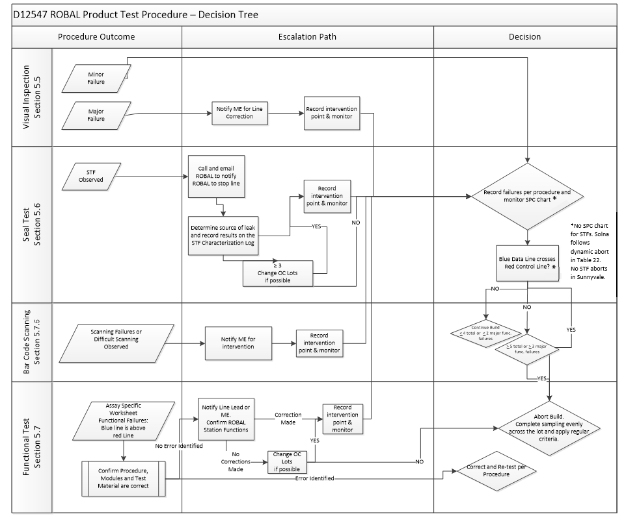

- Appendix A: STF Reaction Workflow (For US sites)

In the event of (3) three or more STFs in one IPT bag or (5) five or more STFs in bag 0-5, perform the following actions in sequence:

When the acceptance criteria are not met in Section 10.1. Manufacturing associate will initiate a BMRAM and notify M.E for intervention on the tool. Sunnyvale or other US sites.

Check the external features of the cartridge to determine the source of the leak (do not open the lid)

Categorize the failure into one or more of the following failure modes and record observation in D10552:

Film seal

Liquid and / or crystallization may be present underneath the film seal
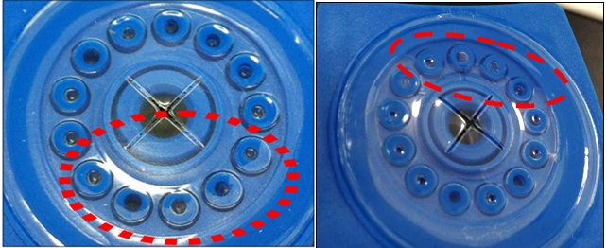

Lid weld

Liquid and / or crystallization may be present at the lid / cartridge body interface
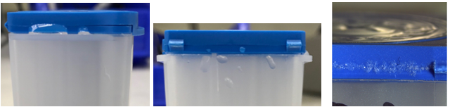

Foot leak

Liquid and / or crystallization may be present on the cartridge foot or in the foot snaps

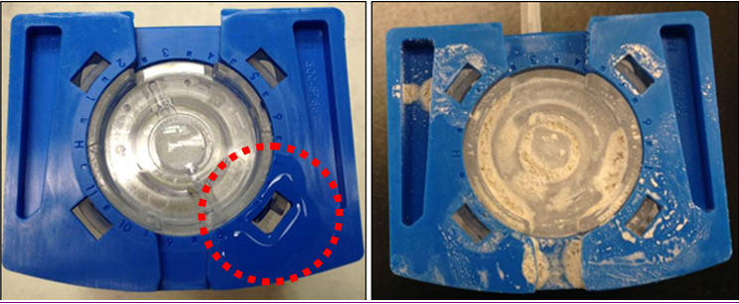

Undetermined

If none of the above characteristics are observed, classify the D9050 failure as Undetermined

Submit email to M.E. group and fill pack group with information from the D10552 Observation

Put failed D9050 samples in the “pass through” area for M.E. pickup

- Document Revision History
Rev | Effective | Description of Changes
FL | Current | No changes to the document or attachments. Added D83056 HIV-1 Qual XC CN Product QC Testing Procedure and Worksheet to the BOM of D12547.
FK.1 | 10/30/2025 | No changes to the document. Remove D24336 from the BOM, as it is being obsoleted in AWF-15190.

