Background

700-6646 filled cartridges of GXHIV-VL-XC-CE-10 lot 1001491877/30202 were manufactured on 2nd August, 2025, on ROBAL 12. The lot passed PQC testing with 1x STF and 4x minor functional errors (2x E5017, 1x Invalid, 1x E2008). However, FI identified a deviation from the PQC sampling plan for sampling point 02 where cartridges were collected between trays 18-20 instead of trays 2-20 per MES input. This corresponds to a sampling gap encompassing approximately 3,000 cartridges with potential impact on the overall lot performance and risk for failures at the customer site, given the multiple technical interventions done at the beginning of the batch.
Per FI recommendation, the lot was placed on NC for further evaluation.

Investigation

Data analysis
Dotplot of cartridge S/N between SP 00 and 05 clearly shows the deviation from the sampling plan with cartridges not being picked between S/Ns 1200368297 and 1200371290 corresponding to trays 2 and 18 (Figure 1).

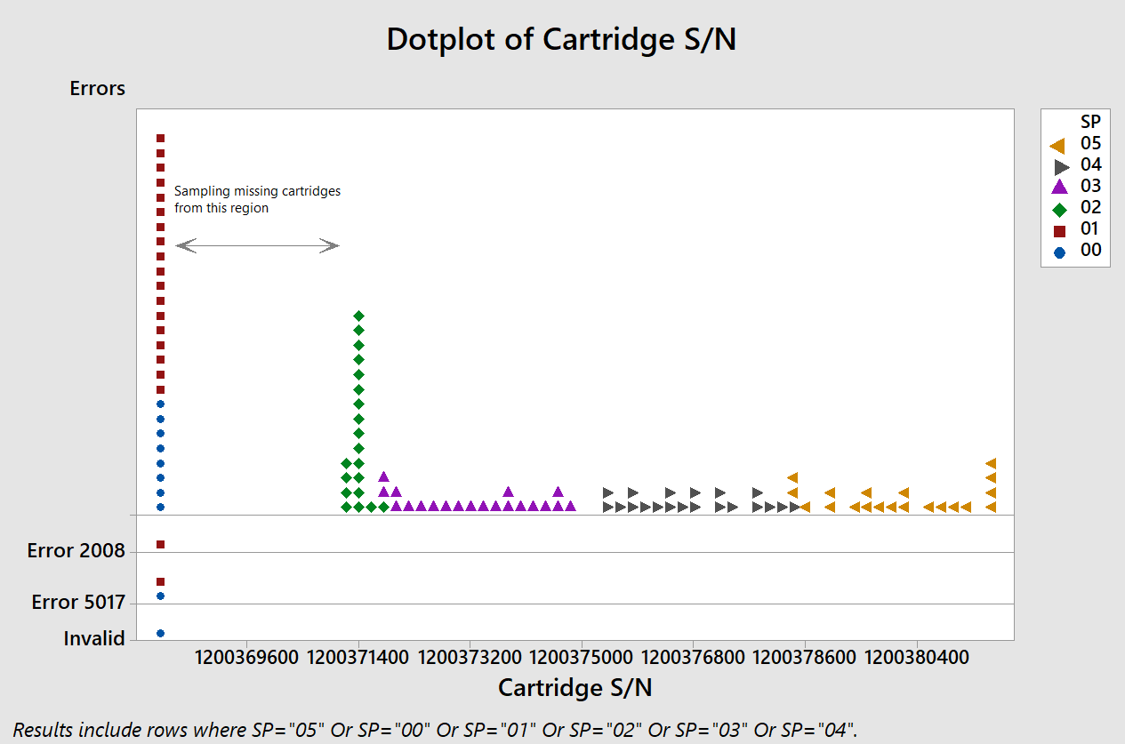
Figure 1: Distribution of cartridge S/N and functional errors between SPs 00 and 05 during the PQC testing of the lot 1001491877/30202.

Comparing MES scanned cartridge data (which records each cartridge sampled for PQC as well as last cartridge per tray) and actual PQC data, a discrepancy can be observed between originally picked for PQC samples and samples that were actually received at PQC based on PQC data where cartridges for SP02 from trays 2-17 did were not received for PQC testing and instead SP02 received 17 extra cartridges from a narrow SN range additionally by the 3 cartridges registered in MES for SP01, see Table 1:

Table 1: SNs of cartridges scanned by ROBAL/saved in MES, sorted by SN, compared to which cartridges were actually received at PQC accoridng to PQC data, for SP01-02 (SP00 is not registered in MES)

Tray | SP | ROBAL scanned | PQC data replicate | SN
1 | 1 | Sample 6 | 082724MOWA_01_2_20+ | 1200368157
1 | 1 | Sample 7 | 082724MOWA_01_2_19X | 1200368162
1 | 1 | Sample 8 | 090424ELIF_01_1_17+ | 1200368163
1 | 1 | Sample 5 | 090424ELIF_01_1_14X | 1200368164
1 | 1 | Sample 9 | 090424ELIF_01_1_13X | 1200368166
1 | 1 | Sample 10 | 090424ELIF_01_1_18+ | 1200368167
1 | 1 | Sample 4 | 090424ELIF_01_1_12X | 1200368168
1 | 1 | Sample 2 | 090424ELIF_01_1_11X | 1200368170
1 | 1 | Sample 3 | 090424ELIF_01_1_15+ | 1200368171
1 | 1 | Last Cartridge |  | 1200368172
1 | 1 | Sample 20 | 010825ELLA_01_0_09+ | 1200368173
1 | 1 | Sample 19 | 010825ELLA_01_0_05X | 1200368174
1 | 1 | Sample 1 | 090424ELIF_01_1_16+ | 1200368175
1 | 1 | Sample 17 | 010825ELLA_01_0_03X | 1200368176
1 | 1 | Sample 18 | 010825ELLA_01_0_10+ | 1200368177
1 | 1 | Sample 15 | 010825ELLA_01_0_04X | 1200368178
1 | 1 | Sample 16 | 010825ELLA_01_0_08+ | 1200368179
1 | 1 | Sample 13 | 010825ELLA_01_0_01X | 1200368182
1 | 1 | Sample 14 | 010825ELLA_01_0_07+ | 1200368183
1 | 1 | Sample 11 | 010825ELLA_01_0_02X | 1200368184
1 | 1 | Sample 12 | 010825ELLA_01_0_06+ | 1200368185
2 | 2 | Sample 2 | not in PQC data | 1200368422
2 | 2 | Sample 1 | not in PQC data | 1200368427
2 | 2 | Last Cartridge |  | 1200368502
3 | 2 | Sample 1 | not in PQC data | 1200368590
3 | 2 | Last Cartridge |  | 1200368647
4 | 2 | Sample 1 | not in PQC data | 1200368747
4 | 2 | Last Cartridge |  | 1200368815
5 | 2 | Sample 1 | not in PQC data | 1200368901
5 | 2 | Last Cartridge |  | 1200368971
6 | 2 | Sample 1 | not in PQC data | 1200369069
6 | 2 | Last Cartridge |  | 1200369125
7 | 2 | Sample 1 | not in PQC data | 1200369220
7 | 2 | Last Cartridge |  | 1200369281
8 | 2 | Sample 1 | not in PQC data | 1200369511
8 | 2 | Last Cartridge |  | 1200369513
9 | 2 | Sample 1 | not in PQC data | 1200369656
9 | 2 | Last Cartridge |  | 1200369658
10 | 2 | Last Cartridge |  | 1200369837
10 | 2 | Sample 1 | not in PQC data | 1200369838
11 | 2 | Last Cartridge |  | 1200369985
11 | 2 | Sample 1 | not in PQC data | 1200369997
12 | 2 | Last Cartridge |  | 1200370141
12 | 2 | Sample 1 | not in PQC data | 1200370143
13 | 2 | Sample 1 | not in PQC data | 1200370336
13 | 2 | Last Cartridge |  | 1200370348
14 | 2 | Sample 1 | not in PQC data | 1200370545
14 | 2 | Last Cartridge |  | 1200370560
15 | 2 | Sample 1 | not in PQC data | 1200370644
15 | 2 | Last Cartridge |  | 1200370764
16 | 2 | Sample 1 | not in PQC data | 1200370948
16 | 2 | Last Cartridge |  | 1200370953
17 | 2 | Sample 1 | not in PQC data | 1200371138
17 | 2 | Last Cartridge |  | 1200371141
17 | 2 | not scanned in MES | 090424ELIF_02_1_12X | 1200371290
17 | 2 | not scanned in MES | 090424ELIF_02_1_17+ | 1200371293
17 | 2 | not scanned in MES | 010825ELLA_02_0_02X | 1200371298
17 | 2 | not scanned in MES | 082724MOWA_02_2_20+ | 1200371299
17 | 2 | not scanned in MES | 082724MOWA_02_2_19X | 1200371302
17 | 2 | not scanned in MES | 090424ELIF_02_1_14+ | 1200371303
17 | 2 | not scanned in MES | 090424ELIF_02_1_15+ | 1200371307
17 | 2 | not scanned in MES | 090424ELIF_02_1_11X | 1200371308
17 | 2 | not scanned in MES | 090424ELIF_02_1_18+ | 1200371309
17 | 2 | not scanned in MES | 090424ELIF_02_1_16+ | 1200371317
17 | 2 | not scanned in MES | 090424ELIF_02_1_13X | 1200371318
17 | 2 | not scanned in MES | 010825ELLA_02_0_01X | 1200371324
17 | 2 | not scanned in MES | 010825ELLA_02_0_03X | 1200371330
18 | 2 | Sample 1 | 010825ELLA_02_0_05X | 1200371334
18 | 2 | not scanned in MES | 010825ELLA_02_0_04X | 1200371336
18 | 2 | not scanned in MES | 010825ELLA_02_0_10+ | 1200371337
18 | 2 | Last Cartridge |  | 1200371340
18 | 2 | not scanned in MES | 010825ELLA_02_0_07+ | 1200371345
18 | 2 | not scanned in MES | 010825ELLA_02_0_09+ | 1200371349
19 | 2 | Sample 1 | 010825ELLA_02_0_08+ | 1200371531
19 | 2 | Last Cartridge |  | 1200371546
20 | 2 | Last Cartridge |  | 1200371742
20 | 2 | Sample 1 | 010825ELLA_02_0_06+ | 1200371743

Figure 2: Individual value plot of Ct for the analytes showing similar trend between SP 02 and others. (b)Distribution of cartridge S/N and functional errors between SPs 00 and 05 during FI comp testing for the lot 1001491877/30202. The green box highlights the region corresponding to the trays 2-18.

Root cause analysis/Process investigation performed together with Mfg:
MES instructs ROBAL operators to sample a certain number of cartridges per tray (depending on expected lot size) and to scan them to be registered in MES. Based on MES records for this lot, see Table 1, it can be observed that sampling originally was performed correctly for trays 2-17 for SP02. However, those samples were later on not send to PQC for testing but instead new samples were collected that have not been registered in MES.
In MES, operators have noted at tray 20 that SP02 was replaced after the technical action (however logging only 1 cartridge for tray 20) logged at a timestamp corresponding to the end of the technical action and end of SP02 sampling where SP02 should have been sent to PQC but did at that time point not contain sufficient samples and thus needed to be filled up, see DHR screenshot in Picture 1:

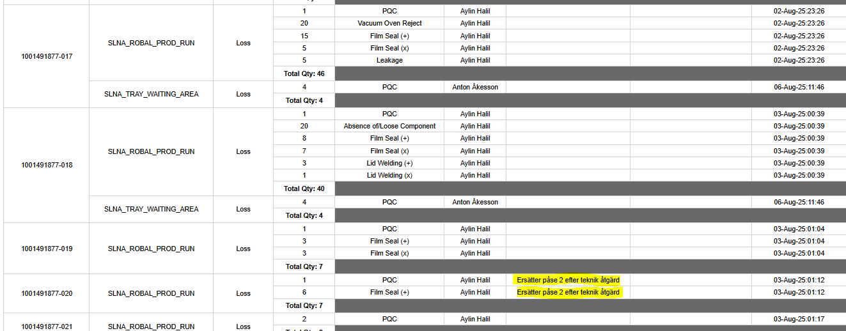
Picture 1: Screenshot from DHR showing quantity report/removed cartridges per tray, including a comment at tray 20 that SP02 was replaced after the technical action.

This shows that the replacement was done purposefully by ROBAL operators before sending SP02 to PQC for testing. Such a replacement of collected cartridges is not within established processes and changes the QC testing of the lot as intended by D12547 Rev FK and implemented by MES process controls to be no longer be representative of the actual lot.
FI interviewed PQC, ROBAL supervisors and technician involved in the production of the lot to determine the cause of the deviation. The lot met the ROBAL pause criteria after SP 01 and was close to abort criteria when the technician was called in to take corrective actions (around tray 18). Technicians and ROBAL operators then supposedly were aiming to prevent abort of the lot due to expecting more errors to be received on the cartirdges originally sampled for SP02 before technical action and thus purged and replaced samples. This is considered a man error caused due to lack of training and understanding of the consequences of incorrect sampling on product quality, compliance, and possible risk to customers.
Note that this issue due to the compliance risks has recently been raised to 25-CAPA-0484 with the current example being a representative example of the non-conformance being investigated in the CAPA. The CAPA owner has been informed and the current NC will be attached to the CAPA.

