

9B17A006

**SHIVA TOURIST DHABA: MANAGING CUSTOMER LOYALTY**

Madhurima Deb and Gautam Sinha wrote this case solely to provide material for class discussion. The authors do not intend to illustrate either effective or ineffective handling of a managerial situation. The authors may have disguised certain names and other identifying information to protect confidentiality.

*This publication may not be transmitted, photocopied, digitized, or otherwise reproduced in any form or by any means without the permission of the copyright holder. Reproduction of this material is not covered under authorization by any reproduction rights organization. To order copies or request permission to reproduce materials, contact Ivey Publishing, Ivey Business School, Western University, London, Ontario, Canada, N6G 0N1; (t) 519.661.3208; (e)* [*cases@ivey.ca*](mailto:cases@ivey.ca)*;* [*www.iveycases.com*](http://www.iveycases.com)*.*

Copyright © 2017, Richard Ivey School of Business Foundation Version: 2017-01-31

On April 23, 2014, Mama Yadav found himself thinking about how his highway restaurant, Shiva Tourist Dhaba, had grown as a result of his experience and the attention he had paid to market transformations through his network of friends and media channels, particularly newspapers. The highway restaurant was located 50 kilometres (km) from Gajraula in the state of Uttar Pradesh, India. Since the restaurant’s inception, Yadav had continued to update his business and adopt relevant practices, such as restaurant patronage schemes, an online presence, and renovations. For many years, Yadav had worked hard to establish and create momentum for his business, which had paid off well.

When he started his business in 1995, most of the nearby restaurants had catered to truck drivers, who regularly travelled on National Highway 24 (NH24). Back then, his highway restaurant faced little competition, as his customer base was totally different, catering instead to those who travelled by car with family and friends. Since opening the restaurant, the area where the restaurant was situated had become a hot spot and one of the area’s most popular eating locations. Market competition had intensified over the years, and as a result, Yadav now faced intense competition. One of his major concerns was how to decide on the appropriate positioning of his highway restaurant to combat growing competition and garner customer loyalty.

The restaurant was promoted in the style of a typical highway restaurant, with the name of the brand on its print advertising, alongside a picture of the proprietor, much like a KFC (Kentucky Fried Chicken) advertisement. Yadav also used several other promotional strategies to promote his highway restaurant. However, he was unsure whether these value propositions (in the form of various marketing mixes such as promotion, product, place, and price) had a positive impact on his loyal customers. He was aware that the future of his business depended on the answers to these questions, so he decided to find some.

In 2014, Yadav hired a marketing research team, briefed them about the situation, and asked them to help him find answers to all his queries. The team started their task by learning about the industry and the firm (including the history of Shiva Tourist Dhaba, its operations and marketing activities, and its competitors). Based on the team’s understanding of the existing positioning strategies employed by Shiva Tourist Dhaba, they conducted a study to better understand the profile of the restaurant’s user base. The specific objective was to gain insight into customer loyalty and to recommend a positioning strategy for Shiva Tourist Dhaba.

The marketing research team began by conducting a survey at the restaurant, among customers who visited for a meal. The team then needed to apply the survey data they had collected to help Yadav decide about his restaurant’s positioning. Yadav’s scientific, relevant, and appropriate decision making depended on the proper use of the survey data, and using appropriate market research tools and techniques. The team was considering which market research tool would be most suitable when the data on customer loyalty were qualitative and the data on positioning variables were quantitative. The team needed to decide on the appropriate market research technique and start analyzing the data.

THE FOOD AND BEVERAGES INDUSTRY

Traditionally, *dhabas*, as roadside restaurants were called in India, served tired truck drivers on a break from their long journeys. Often described as rural India’s fast-food joints, dhabas were located at the side of the street, at truck stops, and along highways. They typically served spicy Indian food and snacks, *lassi* (buttermilk), and *chai* (tea). These restaurants were outfitted with pit ovens, and the seating consisted of wooden cots with seating made of jute strings that had been knit together. Dhabas offered a raw, yet authentic, Indian experience. Over time, the restaurants came to define a culture centred on providing good food with local flavour. They catered not only to truck drivers but also to Indian and foreign tourists travelling on the highways. Shiva Tourist Dhaba was unlike most dhabas in that it was established to address the requirements of car travellers, not truck drivers.

SHIVA TOURIST DHABA—THE HIGHWAY RESTAURANT

After graduating with an arts degree, Yadav had started a wide search for a good job in India. He came from a big family that included two sisters and four brothers. Yadav was married and had two sons and a daughter. Although he was a college graduate who could not get a government or white-collar job, it did not deter him from sending his children to school. He was aware of the importance of education, not only for getting a job but also for earning a decent livelihood. He wanted his sons to earn master’s degrees in business administration and run his business in a more formal, professional way.

One day while eating at a restaurant, Yadav was captivated with the idea of starting his own food business, as he felt he would be able to run it much better than the restaurant he was at. This idea was the beginning of Shiva Tourist Dhaba. However, at that time, during the 1990s, he faced two major hurdles: selecting a good location and acquiring the start-up capital. Like many entrepreneurs, Yadav had limited resources available to him. Despite these odds, he put together his resources and started Shiva Tourist Dhaba, after which there was no looking back.

After evaluating various locations in states such as Bihar and Uttarakhand, he decided on a site that was 50 km from Gajraula in Uttar Pradesh, India. In the beginning, he ran a very modest business, using a small investment of ₹3,000.[1] He opened his restaurant in 1995 with a partner, but the partnership dissolved after its first six months, during which time the entire venture had operated at a huge loss. Despite the end of the partnership, Yadav did not give up; instead, he restructured and renovated the business to make it more attractive to passing travellers. He lacked sufficient capital, so he borrowed ₹14,000 from a relative. He also employed 15 people from nearby localities. Although it took some time, the business eventually picked up, and Yadav was able to realize the dream he had once conceptualized.

OPERATIONS AND MARKETING

To run the entire operation, Yadav employed 25 to 30 labourers from nearby areas, who were paid an average of ₹20,000–25,000 per month. His total monthly expenditure on his staff was ₹500,000–750,000 (see Exhibit 1), and the raw material cost per day was ₹100,000. As the menu was exclusively vegetarian, the most costly items were milk and milk products. Among the most popular dishes were Shiva Tourist Dhaba’s signature dal makhni (lentils cooked with spices and butter), which was typically ordered with stuffed paratha (Indian bread). This signature dish was cooked in a different style from how it was normally prepared in India, and according to Yadav, the twist in the recipe was a spark of his creativity. Every time Yadav introduced an innovation on his menu or new vegetarian items such as paneer chilli kaleji fry (cottage cheese chilli, which was similar to chili chicken), customers were eager to experiment and ordered these new items. To ensure quality, with the help of the staff, he personally procured the raw material for making the food, and he tasted all the food every day. According to him, these small efforts on his part not only had impact on customer satisfaction but also provided him with satisfaction.

The restaurant’s menu included local preparations, such as *paratha* (Indian bread), *dal* (lentils), *chole* (chickpeas), *kadi* (made with curds and gram flour), paneer (cheese), and rice; Chinese dishes, such as noodles; and Indian and Chinese fried foods. The menu prices ranged from ₹6–170. The signature *dal makhni* was priced at ₹100, stuffed parathas at ₹35–40, and tea at ₹10. Tea, which was served in earthen pots, was consumed by nearly all customers. The taste and presentation of the tea was so authentic that customers sometimes consumed more than a cup. The restaurant ran nearly 24 hours a day, opening at 6 a.m. and closing at 3 a.m. the next day for cleaning. The prices were revised based on any increase in costs, which happened twice in 2013, due to the high inflation rate and the resulting increases in the prices of commodities. The major item that drove the price increase at that time was the rise in the price of onions in India. The average bill for each customer was ₹100, and on average, 1,600 customers visited the restaurant each day. The food charges were nominal, and the business was profitable (see Exhibit 1).

Shiva Tourist Dhaba consistently attracted steady traffic from the surrounding areas and from long-distance travellers. The restaurant maintained specific norms regarding the types of customers who were allowed to enter. According to Yadav, highway restaurants could be classified broadly into two categories: truck restaurants and car restaurants. He was very particular about not allowing truck drivers or the consumption of alcohol in the restaurant. He wanted his restaurant to have an image that would encourage families to stop and enjoy a meal while travelling. His restaurant also had a spacious parking facility, with five rows that could each accommodate up to eight or nine vehicles. The average time a vehicle was parked at the restaurant was two hours. On average, 450 vehicles stopped at the restaurant daily. Only 30 per cent of the customers were Hindu, and as manyas, 70 per cent were Muslim. Of all customers, 60 per cent were male and 40 per cent were female or children.

Yadav’s passion for his restaurant was also evident in his personal interactions and involvement with customers. He would sometimes indulge in a bit of mystery shopping by seating himself at a restaurant table and eating as if he were a customer. He would also speak to customers on a random basis to understand how satisfied they were with the food and service, and he even encouraged direct feedback regarding improvements that they would like to see. Yadav also believed in corporate social responsibility. He was a religious person and an ardent devotee of Lord Shiva (a Hindu God). His restaurant was visited not only by regular customers but also by devotees who had renounced worldly life and materialism in search of peace and God. As these devotees had no source of income other than charity, Yadav made it a policy to feed them in an area adjacent to his main restaurant. These activities generated goodwill through word of mouth among customers.

Yadav’s business acumen was also visible in the amount of money he spent on advertisements, which amounted to nearly ₹360,000 every year. He actively promoted his restaurant among car drivers, who drove their families to his highway restaurant or recommended eating there to other drivers. He maintained accurate and updated records of where the drivers came from, the frequency of their visits, and other relevant details. Drivers were also given a free meal when they brought passengers to the restaurants, which was a strong incentive for them to return to Shiva Tourist Dhaba. In addition, each visit that drivers made was entered in the restaurant’s customer loyalty records; based on the frequency of the visits, they were occasionally offered gifts such as mobile phones. Yadav also used relationship marketing practices to encourage patronage to his restaurant by maintaining records of his customers. Some of his competitors (both branded and non-branded) offered drivers ₹50 for every visit and did not provide any incentive based on their frequency of visit, and the competitors’ incentives normally lacked continuity. In contrast, the quality food provided quickly to drivers and offers of future incentives motivated drivers to stop at Shiva Tourist Dhaba instead of other nearby outlets.

The communication strategies that Yadav employed included different forms of print advertising, such as banners and neon lighting. Advertising was done through unipoles, five large and five small (see Exhibit 2). The large ones were 10 × 30 feet (3 metres × 9 metres) and cost ₹5,000 each per month, while the small ones were 10 × 20 feet (3 metres × 6 metres) and cost ₹1,000 each per month, for a total of ₹30,000 per month. Historically, the brand was advertised as a typical restaurant with the name of the brand alongside a picture of the proprietor, much like a KFC advertisement. The colour red was prominently displayed on the banner to attract the attention of customers.

Yadav had started his business with an investment of ₹3,000, but as of April 23, 2014, with the increase in prices and soaring real estate values, it would have cost ₹20,000,000–30,000,000 to open a restaurant in such a prime area. Huge investments in capital-intensive items would also be a big barrier to entering this sector. Despite these barriers, many restaurants were located in and around the same area (see Exhibit 3). As the proprietor of the restaurant, Yadav used the restaurant facilities under a 10‑year renewal lease.

COMPETITION

Shiva Tourist Dhaba offered both quick services and casual dining facilities. Quick service restaurants (QSRs) were also popularly called fast-food restaurants, as they offered fast delivery at low prices. Some of the branded QSRs in India were McDonald’s, KFC, Kaati Zone, Pizza Hut, Domino’s Pizza, Haldiram’s, Papa John’s, Subway, Bikanervala, and Faasos. The QSRs on NH24 that were in competition with Shiva Tourist Dhaba included Haldiram’s, Bikanervala, McDonald’s, Pizza Hut, and KFC (see Exhibit 3).

Casual dining restaurants (CDRs), in comparison to QSRs, offered moderate pricing and provided a casual atmosphere and prompt services to customers. Some also provided takeaway and home delivery. Branded CDRs in India included Saravana Bhavan, Udupi, T.G.I. Friday’s, Punjab Grill, Bombay Blue, and Copper Chimney. The branded and non-branded CDRs on NH24 that were in competition with Shiva Tourist Dhaba included Udupiwala, Punjabi Moga Restaurant, and Skylark Restaurant.

When travelling from Delhi, clusters of eating options were available on both sides of the road near Shiva Tourist Dhaba, including good restaurants and dhabas (see Exhibit 3). These branded outlets had good brand identity and enjoyed steady traffic. Among these clusters, Shiva Tourist Dhaba was positioned as a low-cost, high-quality restaurant, with prompt service and a variety of shops within it (see Exhibit 4), much like a hypermarket, with the restaurant as the anchor shop and the small nearby shops as the other tenants. Shiva Tourist Dhaba had approximately 10 stalls, with an average size of 10 × 10 feet (3 × 3 metres) each. The average rental charged for these stores was ₹10,000 a month. Another surprising insight provided by Yadav was that some of these shops had seasonal businesses. For example, the store selling shikanjiwala (a carbonated soft drink) did well during the summer, but during the winter, the business nearly ceased to operate. Yadav provided this business owner with an alternative business idea. During the off-season, he ran a milk counter, offering varieties of flavoured milk and shakes. This option ensured not only continuity for the seasonal vendor but also monthly rental income for Yadav. For health-conscious customers, a fruit shop in front offered a wide variety of fruits (see Exhibit 4).

DINING AND PARTY SPACE

The restaurant had facilities for dining both inside and outside. The outside dining space was a square space alongside the snack counter. Glass walls provided enclosed dining facilities and space for parties (see Exhibit 4). The party hall and the inside dining spaces were also separated by glass walls. The restaurant’s party hall could accommodate 100 guests. It was preferable to book the space in advance; however, it could be booked on the spot if there were no prior reservations.

Sometimes, schools took children on a tour of nearby sites, such as Jim Corbett National Park and Nainital, and they needed to ensure that the students remained under supervision at all times, even while eating. In response to this need, Yadav created this separate section, which could host parties and provided a single, private space to travellers who booked in advance. For parties, the charges for advance bookings were ₹200 per plate, and a special menu could be pre-ordered. For other bookings, including for children, the charges were ₹100 per plate. This section of the restaurant was booked an average of 50 to 60 times a year.

CHALLENGES

From October to November, the restaurant was in demand from Muslims travelling to Mecca and Medina. In May and June, traffic consisted of people travelled to nearby hill stations, such as Nainital and Char Dham (Hindu pilgrims travelling to places such as Yamunotri, Gangotri, Kedarnath, and Badrinath). Between April and July, schools closed for summer vacations, and parents travelled with their children on holidays, creating a demand from this segment of travellers.

For six months of the year (April to July and then October and November), business was booming. Drawing in traffic during the other six months, when demand slackened, was difficult due to low tourist inflow. Peak-season profits were used to survive the off-peak season. An occasional challenge was the poaching of trained staff and cooks by existing branded and non-branded players in the area. However, with his business acumen and passion, Yadav ran the business well and minimized poaching. Poaching was not his concern, and neither was seasonal business, which was the normal situation with all the existing players in that cluster. Instead, Yadav’s concern was maximizing the traffic during peak season by garnering customers’ loyalty.

Yadav attributed his success to his constant involvement. He was aware that the business was volatile, and his experience had taught him that most restaurants failed due to a lack of the owner’s personal involvement in running the business. At such restaurants, as evidence of a lack of regular monitoring, staff spent their time in leisure activities, which negatively affected the service delivery. The most important challenge for a restaurant was to deliver quality food promptly; failing that meant that customers were likely to leave angry and disappointed. Yadav was alert at all times, and personally monitored the business. Recently, he had also launched a website to create an online presence and increase the restaurant’s visibility.

Despite all these efforts, Yadav worried, as he was undecided about how he could position his restaurant ahead of his competitors and successfully garner customer loyalty. So with the help of a small marketing research team, Yadav conducted a study to better understand the profile of the user base of Shiva Tourist Dhaba. The specific objective was twofold: to gain insight into customer loyalty and to decide on his restaurant’s positioning strategy.

A survey was conducted among customers who visited the restaurant to eat. Customers were segregated on the basis of the screening question, which asked the number of times they had visited the restaurant in the past. Visitors who had visited 1–3 times were labelled as low loyalty (L) visitors; those who had visited more than 3–5 times were labelled as medium loyalty (M) visitors; and those who had visited more than 5 times were labelled as high loyalty (H) visitors. Data were collected on several positioning variables (developed from the knowledge gained by the marketing research team about various operations and marketing activities practised by Shiva Tourist Dhaba and its nearby competitors). The variables included advertising, price, place, food quality, service quality, variety, servicescape (the total space of the restaurant where services like serving food and displaying food were rendered), parking facilities, and rewards provided to the drivers (see Exhibit 5). From the data collected, Yadav wished to gain insight into his positioning strategies and their impact on customer loyalty.

The biggest challenge for Yadav was how to mine the desired information from the data for the purpose of decision making. He needed to understand how these offerings were perceived by the different groups of customers so that he could make improvements (if any), retain high-loyalty customers, and convert medium-loyalty and low-loyalty customers to high-loyalty customers. However, the data collected by the marketing research team were insufficient for decision making without proper analysis. The marketing research team now needed to use the survey data they had collected to help Yadav to decide about his restaurant’s positioning. Yadav’s scientific, relevant, and appropriate decision making depended on the proper use of the survey data and using appropriate market research tools and techniques. The members of the marketing research team were wondering which market research tool would be most suitable when the data on customer loyalty were categorical (non-metric) and the data on positioning variables were metric in nature. The team needed to immediately decide on the market research technique and start analyzing the data.

Exhibit 1: Shiva Tourist Dhaba Restaurant income statements, 2013 and 2014 (₹)

|  |  |  |
| --- | --- | --- |
| Particulars | 2014 | 2013 |
| Sales: |  |  |
| Food & Beverages | 57,600,000 | 46,800,000 |
| Cost of Sales: |  |  |
| Food & Beverages | 588,000 | 467,000 |
| **Gross Profit** | **57,012,000** | **46,333,000** |
| Operating Expenses: |  |  |
| Direct Operating Expenses | 2,900,000 | 2,050,000 |
| Marketing Expenses | 360,000 | 360,000 |
| Utilities | 10,000 | 10,000 |
| General & Administrative Service Expenses | 750,000 | 700,000 |
| Repair & Maintenance | 5,000 | 5,000 |
| Occupational Cost | 20,000 | 20,000 |
| Depreciation | 10,000 | 10,000 |
| **Total Operating Expenses** | **4,055,000** | **3,155,000** |
| **Operating Income** | **52,957,000** | **43,178,000** |
| Interest | 30,000 | 30,000 |
| **Net Profit Before Tax** | **52,927,000** | **43,148,000** |

Source: Company documents.

Exhibit 2: Big and Small Unipol AdvertisementS

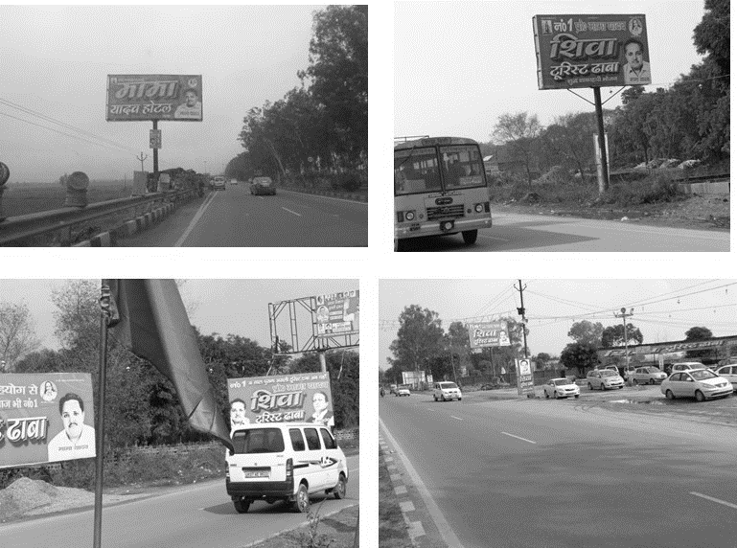

Source: Provided by the authors.

exhibit 3: Clusters of Highway Restaurants on National Highway 24

**3**

Shiva Tourist Dhaba, Shiva Punjabi Tadka, Tourist Dhaba,

Shiva Tourist Dhaba

(3 dhabas owned by others)

Big and Large Hoardings of Shiva Tourist Dhaba

Lee Grand Handi Restaurant,

Skylark Restaurant, Skylark Dhaba

Shiva Punjabi Tadka Dhaba,

Shivam Tourist Dhaba, Haryana Tourist Dhaba, Haryana Dhaba No. 1, Sai Suddha Tourist Dhaba

Sri Balaji Bainov Dhaba, Haryana Mutthal Dhaba, GovardhanaaratisarovarDhaba

Arati Rajasthan Tourist Dhaba, Mahendra Tourist Dhaba,

Sri Krishna Tourist Dhaba

NH24

IM Tourist Dhaba,

Maaganga Tourist Dhaba, Shiva Shakti Tourist Dhaba, Ram Hotel & Restaurant

Tirupatibalaji Hariyanawale Dhaba,

Chotiwale Suddha Bhojnalaya, 2ndTirupatibalaji Hariyanawale Dhaba

DesiJat Bhai Dhaba, Durga Tourist Dhaba

Paradise Hotel & Restaurant

Moga Tourist Dhaba,

Akashdeep Tourist Dhaba

Punjab Restaurant

Ganapati Dhaba,

Shivganga Tourist Dhaba, Radhe S.T. Dhaba

First Small Hoarding of Shiva Tourist Dhaba

**2**

McDonald’s,

KFC,

Domino’s Pizza,

CCD,

Baskin-Robbins,

Tadka Dhaba,

Moga Punjabi Tadka, Bikanerwala,

Meriton Restaurant

**1**

Udupiwala Restaurant,

Sanjha Chulha Restaurant, Green Valley Restaurant, Bholebaba Vaisnavdhaba, Sagar Ratna Veg Restaurant, Sugandh Family Restaurant, Punjabi Tadka,

Sardarjika Dhaba,

Muskan Dhaba

Sher-e-Punjab Tourist Dhaba,

Guruji Tourist Dhaba

Note: 1. This cluster included small dhabas (restaurants) and casual dining restaurants, which were all unbranded except for Udupiwala. 2. This cluster included branded quick service restaurants and casual dining restaurants and only one fine dining restaurant (i.e., Meriton Restaurant). 3. This cluster consisted of Shiva Tourist Dhaba, operated by Yadav, and other tourist dhabas with similar names (i.e., Shiva Tourist Dhaba). The dhabas were owned by Jitendra Chaudhary, Avinash Sharma, and Mama (Direndra) Yadav. 4. NH24 was National Highway 24.These restaurants existed along the highway in different formats.

Source: Based on data collected by authors, May 23, 2014.

Exhibit 4: View of the Shops within the Highway Restaurant

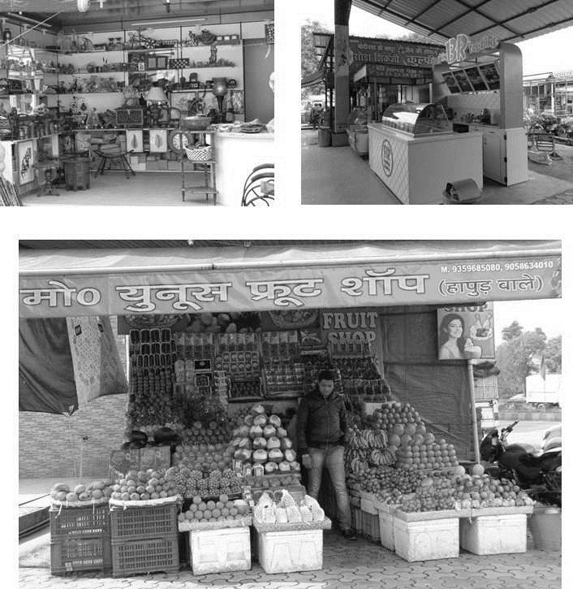

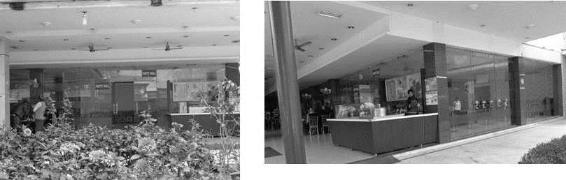

Source: Provided by the authors.

View of the Party Hall

Exhibit 5: Data collected on various variables

|  |  |  |  |
| --- | --- | --- | --- |
| **Serial No** | **Variables** | **Codes** | **Scale** |
| 1 | Number of Times Visited (Loyalty) | Visited | 1. 1–3 (L) 2. >3–5 (M) 3. >5 (H) |
| 2 | Rate Shiva Dhaba’s advertisements using unipoles | Ads | 5-point Likert Scale |
| 3 | Your perception about the pricing at Shiva Dhaba | Price | 5-point Likert Scale |
| 4 | Your perception about the place, Shiva Dhaba | Place | 5-point Likert Scale |
| 5 | Your perception about food quality | F_Quali | 5-point Likert Scale |
| 6 | Your perception about service quality | S_Quali | 5-point Likert Scale |
| 7 | Your perception about variety | Varie | 5-point Likert Scale |
| 8 | Your perception about servicescape | S_scape | 5-point Likert Scale |
| 9 | Your perception about the parking facility | P_Faci | 5-point Likert Scale |
| 10 | Your perception about the rewards provided to drivers | Gifts | 5-point Likert Scale |

Note: L = low-loyalty customers; M = medium-loyalty customers; H = high-loyalty customers

Source: Primary data collected by authors, August 23, 2014.

1. ₹= INR = Indian rupee; all currency amounts are in ₹ unless otherwise indicated; US$1 = ₹60.6636 on April 28, 2014.