

9B17A017

K9FuelBar: AN ENERGY TREAT FOR DOGS

Thomas Funk and Carol Hutchinson wrote this case solely to provide material for class discussion. The authors do not intend to illustrate either effective or ineffective handling of a managerial situation. The authors may have disguised certain names and other identifying information to protect confidentiality.

*This publication may not be transmitted, photocopied, digitized, or otherwise reproduced in any form or by any means without the permission of the copyright holder. Reproduction of this material is not covered under authorization by any reproduction rights organization. To order copies or request permission to reproduce materials, contact Ivey Publishing, Ivey Business School, Western University, London, Ontario, Canada, N6G 0N1; (t) 519.661.3208; (e)* [*cases@ivey.ca*](mailto:cases@ivey.ca)*;* [*www.iveycases.com*](http://www.iveycases.com)*.*

Copyright © 2017, Richard Ivey School of Business Foundation Version: 2017-06-16

In early 2015, Carol Hutchinson and her beloved dog, Oli, were out for one of their long walks on the Niagara Escarpment. Hutchinson really enjoyed these outings when she and her friends would walk up to 15 kilometres. After a couple of hours, the hiking group decided to take a snack break before tackling a large hill in front of them. Hutchinson reached into her backpack for an energy bar. As she started to eat her snack, she noticed Oli looking at her longingly, also wanting a snack. In the bottom of her backpack, Hutchinson found a couple of old dog treats that were broken into several pieces; heaven knew how long they had been there. Although Oli seemed to enjoy these, Hutchinson felt a little guilty that she had a nutritious energy boost and Oli did not. This moment was the beginning of a new product concept that ultimately would become K9FuelBar.

Hutchinson was a culinary nutritionist with several years’ experience in the Canadian food industry. She was a pioneer in the field of sport nutrition and wellness, so with her love of animals, it was a natural step for her to think about energy treats for dogs.

Armed with the basic concept, Hutchinson set about researching the specific dietary needs of dogs. With this research, she was able to formulate a new product that was composed of all-natural ingredients with known energy qualities. She called this product “K9FuelBar.” After some initial success with the product, she considered making it available in the market; however, before Hutchinson could do this, there were a number of things she needed to consider.

Dogs in Canada

The dog population in Canada was large and growing. In 2014, 34 per cent of Canadian households owned one or more dogs, for a total population of nearly 6.5 million dogs (see Exhibit 1).[1] This number had been growing steadily over the years and was expected to continue growing in the future. The dog market could be segmented into groups based on the size of the dog.

Not only was the number of dogs large, the involvement of dogs in family life was also substantial. Hutchinson located a report from the Alberta government, *Canadian Pet Market Outlook*,[2] that stated nearly 90 per cent of dog owners considered their pets to be part of their family. Pet owners believed their dogs and cats offered them improved physical and mental health.

Pet owners were generally in line with national averages in terms of health-related psychographics and behaviour, but were slightly more likely to gravitate toward products that offered natural formulations and enhanced health benefits. Pet owners agreed that natural ingredients meant healthier foods, and they preferred foods that were less processed and had fewer ingredients. Because pet owners were more likely to eat healthfully and get their nutrition from foods rather than supplements, they were more likely to purchase nutritionally enhanced foods for their pets.

The Alberta report went on to say that nearly one-quarter of dog owners were willing to spend significantly more to get healthier, higher-quality foods for their dogs. They agreed that natural and organic products were better than standard national brands, and they would buy more if they were available. Pet owners were also concerned about food safety. The report also stated that pets were more likely to be found in households with higher incomes (i.e., greater than CA$100,000).[3] This group of dog owners were more attentive to value-added health claims and more likely to read labels before purchasing products.

the Canadian Dog Treat Market

Hutchinson had no idea how large the market in Canada might be for high-energy dog snacks. Statistics Canada estimated that annual sales of dog treats were about $250 million in 2014. The vast majority of these were sold in grocery and pet food stores and were not intended to provide an energy boost.[4]

To get a handle on the market size for canine energy snacks, Hutchinson started with the assumption that people who bought energy snacks for themselves would be the most likely to purchase energy snacks for their pets. Hutchinson could not find Canadian data on sales of human energy snacks, but she did find data for the United States that indicated the market there was approximately $1.7 billion in 2014.[5] Because Canada had roughly 10 per cent of the U.S. population, a good estimate of market size in Canada would be $170 million.

If 34 per cent of the population owned a dog, the market size for canine energy snacks would be reduced further to about $58 million. In conversations with veterinarians, Hutchinson found that most believed roughly 5 per cent of their clients were involved in outdoor activities where an energy treat would be desirable, so this reduced Hutchinson’s market size estimate further to a maximum of $2.9 million annually. Of course, it would take time to develop this market so early market size was undoubtedly lower.

Market Segments

Having estimated the size of the market, Hutchinson then wondered if this market was fairly homogeneous or if there were further segments. She thought there might be two ways to segment the market: size of dog and purchase occasion. The dog market could be segmented into three groups based on the size of animal: large, medium, and small (see Exhibit 1). Because large dogs were the most likely to be involved in outdoor adventure activities, Hutchinson felt this was a very attractive segment. She also felt the segment could be further subdivided into dog owners who actually participated in outdoor adventure activities and those who aspired to this type of activity. Although outdoor adventure encompassed many activities, hiking, snowshoeing, swimming, biking, running, and hunting were probably the most common.

Hutchinson did not totally discount owners of medium and small dogs as possible segments. Even though they were less likely to participate in all of the above activities, she noticed that many people who were runners were accompanied by medium and small dogs. Also, owners of these dogs were especially attentive to the needs of their animal friends and, therefore, might be very willing to purchase canine energy snacks.

A third possible segment was people who might purchase a canine energy snack as a gift. She felt K9FuelBar could be the type of product someone would purchase for a friend or relative for a holiday gift or for some other special occasion. Although this might be a hard segment to reach, Hutchinson thought it could be of significant size and contribute in a meaningful way to the success of her new product.

Competition

After an exhaustive search, Hutchinson concluded there was no current direct competitor for K9FuelBar in Canada, but there was a company in the United States with a very similar product that could enter Canada at any time. This company was TurboPUP, which offered outdoor adventure bars in two flavours, bacon and peanut butter.[6] TurboPUP’s bars were made from American ingredients. They were positioned as a complete meal, whereas K9FuelBar was positioned as either a treat or refuel snack. One TurboPUP treat sold at retail for US$2.99.

TurboPUP was launched in 2013, with good U.S. market penetration of about 60 retail locations. They appeared to focus on outdoor adventure stores, including the large retailer Recreation Equipment, Inc. (REI). Later, TurboPUP started to move into more upscale pet supply stores. The product was attractively packaged. Launched in Pine, Oregon, the start-up appeared in January 2015 on *Shark Tank*, a U.S. television show featuring hopeful entrepreneurs. TurboPUP attracted a US$100,000 investment in return for a 35 per cent stake in the company. Later in 2015, TurboPUP was awarded “Start Up of the Year” and its products were picked up and sold by PetSmart throughout the United States.[7]

While TurboPUP could certainly be a significant competitor, Hutchinson felt the product had a few distinct weaknesses in relation to K9FuelBar. First, TurboPUP’s brand position stemmed almost entirely from “product usage” and “American-made” platforms, and not from a canine health perspective. Second, there were no third-party affiliations that added credibility to sustainable practices and canine health (see Exhibit 2).

The Product

Given her estimate of market size and the general importance of dogs in many households, Hutchinson was encouraged to pursue her idea further. Accordingly, she first turned her attention to developing a suitable product. Being a certified nutritionist, she was familiar with the nutritional value and palatability of various ingredients both individually and when combined, and being a dog owner herself, she knew the flavours that were enticing to most dogs.

After considerable research and trial and error, Hutchinson formulated a product that was 100 per cent natural and featured two flavours, peanut butter and liver. Limited taste testing revealed that both products were well liked by dogs in all three size categories.

The actual product featured mostly organic whole food ingredients, none of which were corn- or wheat-based. Each ingredient was non-genetically modified and the bars were hand baked locally. Each 31-gram square pack contained two Canadian-made bars. Because 31 grams was the optimal size snack for a large dog, both bars would be used for one treat. For smaller dogs, just one of the two bars would be used for a single treat.

The K9FuelBar wrapper was both recyclable and biodegradable to minimize impact on the environment. The shelf life of the product was long—at least nine months. Although initially sold separately, Hutchinson anticipated packaging them in boxes of 10 as demand for the product started to grow.

In 2015, Hutchinson contracted production of the bars to a local bakery company that had experience in this type of product. They charged Hutchinson $0.85 per pack of two treats; this included the treat itself and the packaging.

Pricing the Product

A major decision facing Hutchinson was how to price the product. She felt the absolute highest price was $2.99, which was about the current price for a TurboPUP bar. Although she felt her product was better than TurboPUP’s in several ways, K9FuelBar was a snack and not a complete meal. Hutchinson felt realistic pricing options were $2.99, $2.79, and $2.59. All of these were in Canadian dollars and for a 31-gram single serving pack.

As mentioned, the $2.99 price would put the product at the same level as TurboPUP’s. This price level would provide a sizeable contribution margin to support a high level of introductory marketing costs. The price would also support a high-quality image for K9FuelBar. On the other hand, it might eliminate a significant number of buyers who were somewhat price sensitive.

A price of $2.79 had some logic because it was comparable to most human energy bars on the market. Moreover, it would still lead to a sizeable contribution margin to support introductory marketing costs, and could be used to underscore a strong value proposition.

A price of $2.59 would provide the most value to consumers, but reduce the contribution margin significantly. A lower initial price would make it difficult to increase price in the future and to provide volume discounts if this were desirable.

Distribution

There were a number of distribution options open to Hutchinson. The first and most immediate option was to sell K9FuelBar through her own website (see Exhibit 3).[8] This website was built and fully operational. She would receive orders and ship the product to customers using Canada Post. Customers would pay the cost of shipping. Hutchinson’s goal would be to get the product to customers as quickly as possible, but certainly within a week.

A second option was to sell through selected outdoor sports stores such as Mountain Equipment Co-op (MEC). In 2016, MEC had 20 retail outlets in all parts of Canada and a substantial online presence. The retailer sold apparel and equipment for climbing, hiking, camping, hunting, running, snow sports, and water sports. It seemed to Hutchinson that the type of person who shopped at MEC was exactly the group she was targeting. To date, MEC carried a limited line of food items, which included energy snacks for human consumption.[9]

Hutchinson had little experience dealing with large retailers so she got in touch with her good friend, Jason Williams, who worked in this sector. Williams explained to Hutchinson that there were two issues she would have to be aware of: margin requirements and slotting allowance.[10] Although he did not have exact information, he felt a retailer like MEC would demand a margin of 40 per cent and a slotting allowance of $5,000 for this type of product. Once MEC had committed to carrying a product, it required all retail stores to stock it, which meant that Hutchinson would be dealing only with headquarters and would not need to call on individual stores. Any MEC product also appeared in the retailer’s online store.

A third option was to sell through veterinarians. Most veterinary clinics carried one or two lines of high-quality dog food so this was a product category they were familiar with. However, this would be a more complicated option for distribution because there were approximately 3,000 clinics in the country that specialized in companion animals. Generally, vet clinics obtained resale items through purchasing co-operatives they belonged to. A good example of this was Vet Alliance in Fredericton, New Brunswick. This organization served a large number of Canadian clinics by providing them access to most of the resale products and supplies they needed, such as pet food, supplies, and medications. These purchasing co-operatives required a 10 per cent margin on products they carried. For the most part, they performed logistic functions and did not push specific products. Vet clinics themselves required a 40 per cent margin on this type of product. Although Hutchinson liked the vet clinic option, she wondered how much and what type of promotion she would need to get individual clinics to order and display the product.

A fourth option was to sell through pet supply stores such as PetSmart. As noted earlier, this was an option chosen by TurboPUP in the United States. This approach would result in very widespread distribution if the proper retail organization were chosen. Although PetSmart was by far the largest company in terms of number of Canadian stores, there were several others that had good market coverage. One option that was particularly attractive to Hutchinson was Ren’s Pets Depot (Ren’s). Although Ren’s had only two retail outlets, both were very large, with one located in Guelph and the other in Kitchener, Ontario, close to Hutchinson’s home. She thought Ren’s could serve as a kind of test market for this method of distribution. Pet supply retailers required a margin of 40 per cent on this type of product. A small retailer like Ren’s required a modest $1,000 slotting allowance.

A fifth option was to sell through online retailers such as Orvis Company Inc. (Orvis) and Amazon. Orvis was a large online retailer that specialized in outdoor gear for hunting and fishing and carried an extensive line of dog supplies, including out-of-the-ordinary dog treats. Hutchinson felt this option would put her in touch with her highest priority target and allow her to access an international market. Amazon, of course, was the largest online retailer in the world; it carried a very broad range of products, including an extensive line of dog treats. Williams thought margin requirements for this type of retailer were usually in the range of 40 per cent. These retailers also wanted assurance that the product had a sizeable market and would insist on slotting allowances starting at $7,500.

A sixth option was to use various trade shows as a method of distribution. Hutchinson had some experience with this approach in earlier years. There were a number of trade shows that might be appropriate for her product. The three most promising were the One of a Kind Show & Sale, the Canadian Outdoor Adventure Show, and the Royal Agricultural Winter Fair. She thought all of these were frequented by people who might be interested in K9FuelBar for various reasons. Exhibiting at these shows was not inexpensive. For example, a small booth at the Outdoor Adventure Show cost $1,495 for the three days of the show. In addition, there would be other costs, such as insurance, parking, and hotel accommodations, which could easily add $1,000 to the cost. One possible way to reduce costs might be to share a booth with another vendor selling complementary products.

Promotion

Hutchinson knew she had a formidable task in coming up with a promotional program to support the launch and growth of K9FuelBar. Her years of experience in marketing consumer goods underscored the necessity of effective market communications. This project, however, was different from her past experience in two significant ways. First, she had a very limited budget to spend on promotion so she would have to maximize every dollar spent. Second, she was dealing with small niches that would require a very targeted approach. Hutchinson also knew that the type of promotion she engaged in would have to be consistent with her target market and method of distribution.

Because of budget limitations, Hutchinson could not see traditional advertising playing a role in this project. Early on, she thought her best approach was to maximize the use of social media. Facebook and Twitter were possibilities. Both could be used to create awareness and interest, and get people to visit her website to learn more about the product and perhaps place an order. Using these platforms would not be expensive, but would be time consuming because it would require Hutchinson or others to be online for large periods of time, seeking followers and following all relevant players—organizations, retailers, and individual dog owners.

Hutchinson thought there could be some public relations possibilities. One area she wanted to pursue was a partnership with Veterinarians without Borders. Her idea was to donate 1 per cent of gross revenue to this charitable organization; this would allow her to reproduce the Veterinarians without Borders logo on each page of her website, and perhaps on the package of each energy treat.

Hutchinson also wondered about some highly targeted, direct marketing activities aimed at selected groups of consumers or retail partners. She thought it might be possible to purchase lists from certain publications specializing in outdoor adventure and then follow up with direct mail. The same could be true for vet clinics. To reach selected consumers would probably cost $0.05 a name for a list, and a minimum of $2 to send a postcard promotion. For retailers, the cost would be significantly higher for the promotional piece, probably in the range of $5 per mailing.

Sampling was also a possible promotional activity, but seemed difficult to do given the niche nature of her market. Hutchinson also wondered if there might be opportunities for novel sales promotion activities.

What To Do?

This was not the first start-up Hutchinson had managed, so she was realistic about the financial realities of the new venture. Her goal in the first year was to generate revenue of $15,000 and a gross margin of $9,000. This would allow her to cover fixed start-up costs, not including the value of her own time, which she was willing to contribute to the business in year one.

In the second year, Hutchinson wanted to reach a sales goal of $75,000 and a gross margin of $45,000. This would allow her to pay herself a modest salary and have funds to facilitate further sales expansion in year three and beyond. It would also demonstrate the viability of her business to help in attracting other investors, and a possible appearance on *Dragons’ Den*, Canada’s reality television show featuring entrepreneurs.

By the third year, Hutchinson’s goal was sales revenue of $150,000 and a gross margin of $90,000. If this target were achieved, she would be able to pay herself a good salary and have funds for the future expansion of K9FuelBar, and to expand her product line into new, related items.

Hutchinson certainly had a lot to think about in launching K9FuelBar to the Canadian market. Who should be targeted? How should the product be priced? What was the best method of distribution in the short run and longer run? And what type of promotion should be used? With these questions in mind, Hutchinson set about formulating her three-year marketing plan.

Exhibit 1: Dogs in Canada—Top Ten Breeds (2014)

|  |  |  |
| --- | --- | --- |
| **Breed** | **Size Category** | **Estimated Number** |
| Labrador Retriever | Large | 600,000 |
| German Shepard | Large | 580,000 |
| Golden Retriever | Large | 540,000 |
| Poodle | Medium | 530,000 |
| Shetland Sheep Dog | Large | 480,000 |
| Yorkshire Terrier | Small | 450,000 |
| Bernese Mountain Dog | Large | 420,000 |
| Havanese | Small | 380,000 |
| Bulldog | Medium | 320,000 |
| French Bulldog | Small | 300,000 |
| **Total** |  | **4,600,000** |

Source: Sarah Oliveira, *Canadian Pet Market Outlook, 2014*, no. 28 (Edmonton: Alberta Agriculture and Rural Development, June 2014).

Exhibit 2: Turbopup bar features

|  |  |
| --- | --- |
| Ingredients | Grain free, all natural |
| Flavours | Bacon and peanut butter |
| Package Sizes | Sold in packages of six |
| Price | US$17.99 per package of six, or US$2.99 per individual serving |
| Distribution | Company website  Outdoor sporting goods stores in many U.S. states  Selected independent pet stores  PetSmart |

Source: “Products,” TurboPUP, accessed January 9, 2017, www.turbopup.com/products.

Exhibit 3: K9FUELBAR WEBSITE

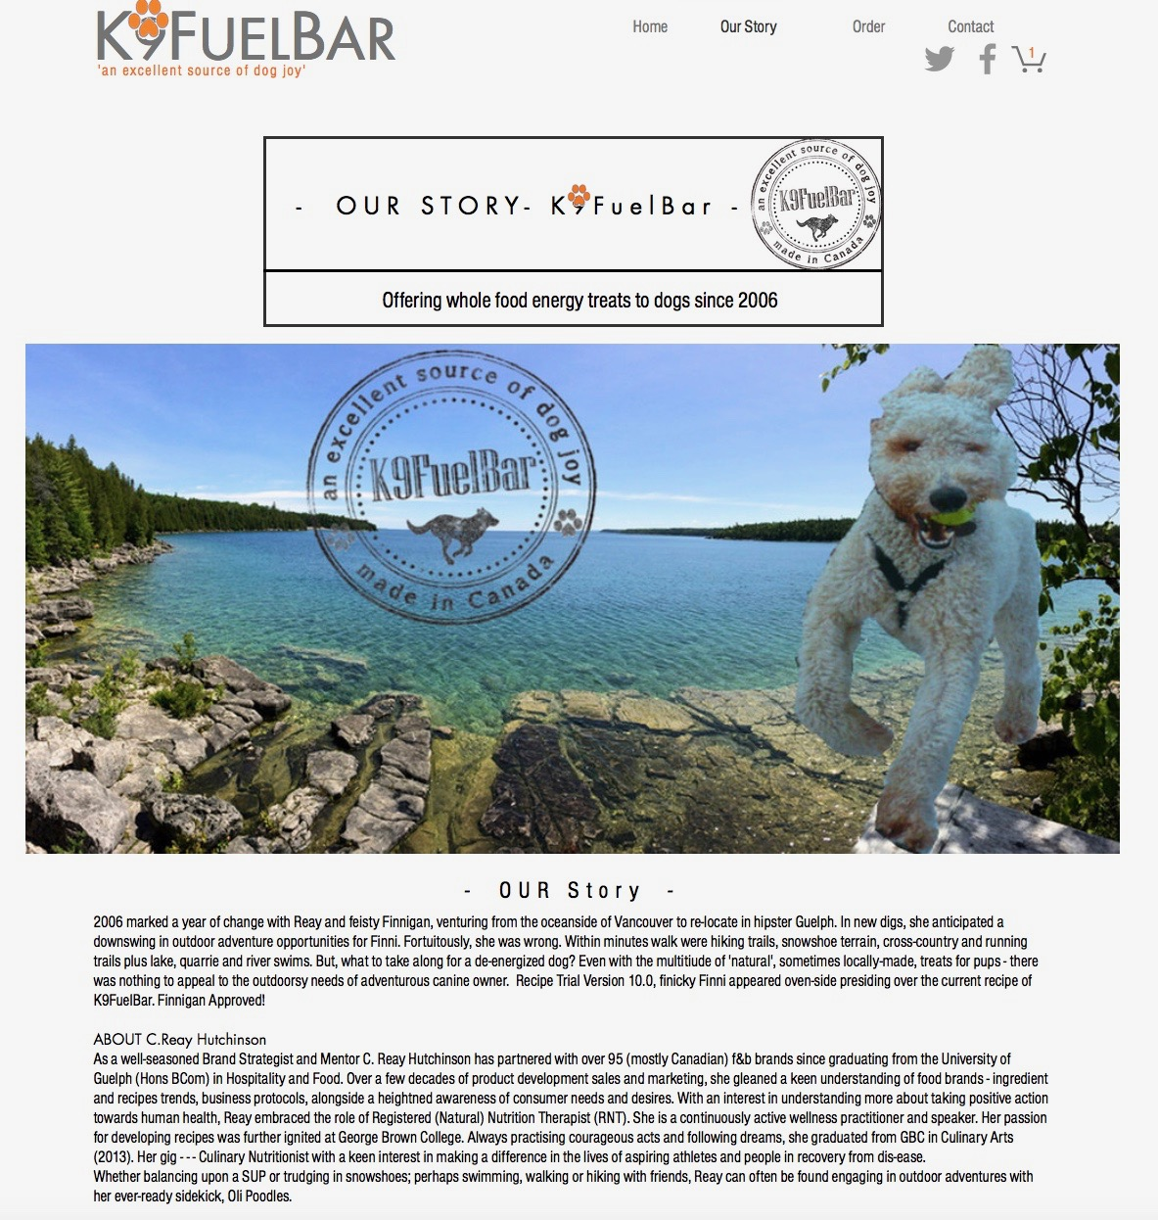

EXHIBIT 3 (CONTINUED)

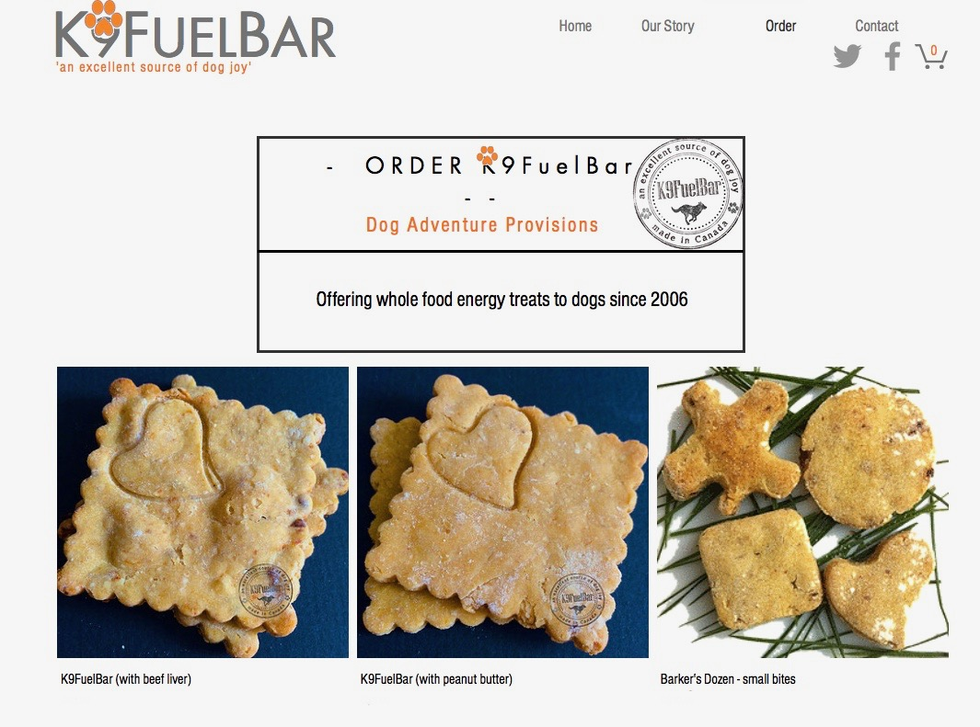

EXHIBIT 3 (CONTINUED)

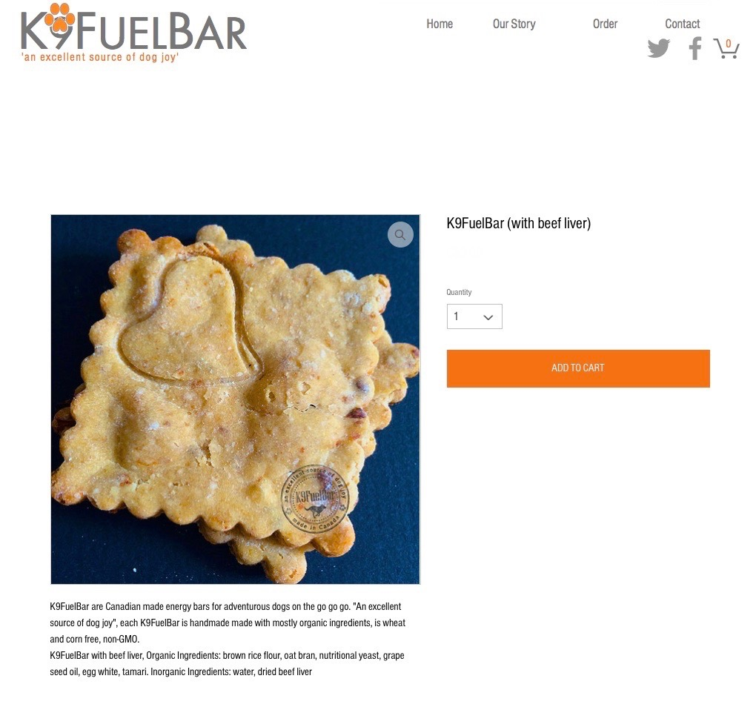

Source: Company website.

1. Sarah Oliveira, *Canadian Pet Market Outlook, 2014*, no. 28 (Edmonton, AB: Alberta Agriculture and Rural Development, June 2014).
2. Ibid.
3. All currency amounts are in CA$ unless otherwise specified; CA$1=US$0.91.
4. “Consumer Trends: Pet Food in Canada,” Agriculture and Agri-Food Canada, accessed January 29, 2017, www5.agr.gc.ca/resources/prod/Internet-Internet/MISB-DGSIM/ATS-SEA/PDF/6245-eng.pdf.
5. “Nutrition and Energy Bars—US–February 2012,” Mintel, accessed February 8, 2017, http://store.mintel.com/nutrition-and-energy-bars-us-february-2012.
6. TurboPUP, accessed January 9, 2017, www.turbopup.com.
7. “Women of the Year Awards Recap,” BEND Chamber, accessed February 8, 2017, http://bendchamber.org/misc/women-of-the-year-awards-recap.
8. K9FuelBar, accessed January 9, 2017, www.k9fuelbar.com.
9. Mountain Equipment Co-op, accessed January 9, 2017, www.mec.ca.
10. Slotting allowances were common in retailing. They represented a one-time fee paid by a manufacturer to a retailer, purportedly to cover retailer costs and risks in introducing new products. The allowances ranged from a low of $5,000 for minor products to as much as $250,000 for major products that required a significant amount of shelf space and risk.