

9B17A019

PAILLASSE International SA: Global MARKET SELECTION

Marc Fetscherin and Tim Pett wrote this case solely to provide material for class discussion. The authors do not intend to illustrate either effective or ineffective handling of a managerial situation. The authors may have disguised certain names and other identifying information to protect confidentiality.

*This publication may not be transmitted, photocopied, digitized, or otherwise reproduced in any form or by any means without the permission of the copyright holder. Reproduction of this material is not covered under authorization by any reproduction rights organization. To order copies or request permission to reproduce materials, contact Ivey Publishing, Ivey Business School, Western University, London, Ontario, Canada, N6G 0N1; (t) 519.661.3208; (e)* [*cases@ivey.ca*](mailto:cases@ivey.ca)*;* [*www.iveycases.com*](http://www.iveycases.com)*.*

Copyright © 2017, Richard Ivey School of Business Foundation Version: 2017-03-29

Urs May hung up the phone on a cold day in Geneva in December 2016. He sat back in his chair and drank his tea. May was chief executive officer of Paillasse International SA (Paillasse), a Swiss bakery. He had just returned from a business trip to Spain, where he signed a licensing agreement with one of the major retail chains, which would begin selling Paillasse’s bread in 2017. May shared the good news on the phone with the company owner, Sindy Pouly, daughter of the company’s founder, Aimé Pouly. May’s telephone conversation ended with Sindy asking, “Where do we go next?”

Sindy asked May to prepare a presentation for the next board meeting identifying major European markets and outlining the company’s internationalization strategy for the next few years. She also asked him to explore North American markets as a possible avenue for growth. This was not an easy task; the company was already present in 15 European countries, including Switzerland. The challenge for May was to come up with a solid recommendation for expanding even further internationally.

COMPANY HISTORY

Aimé Pouly, founder of Paillasse, was a far-sighted and intelligent baker who was passionate about baking and the baking business. He started working for a baker at the age of 13, making bread deliveries. Later, Pouly did a baking apprenticeship in Biel, a little town of about 50,000 people in the French part of Switzerland. His apprenticeship was with a master baker who happened to also be the president of the Swiss Bakers’ Association. It was at that time that Pouly learned and developed his commitment to and appreciation for the taste of quality bread. Pouly finished second-best of all the apprentices of the Canton (state) of Bern in 1972.

At the age of 24, Pouly opened his first bakery in Geneva. Over the next few years, he opened 10 additional bakeries. He and his wife, Catherine, who was his business partner, built their bakery business, growing to 80 bakeries by 2016. While opening new bakeries, Pouly also developed a new type of bread, Pain Paillasse, which was first introduced to the Swiss market in 1993. In 1994, Pouly registered the trademark “Pain Paillasse” in Switzerland and patented the recipe for making the bread (see Exhibit 1). In 2004, Pouly and his wife acquired the Novafood bake house in the little Swiss town of Satigny. The acquisition added nearly 100 people to the business, bringing the total number of employees to 450 by 2016. Awards followed, and in 2009, Pouly won the prestigious prize of Swiss “Master Entrepreneur” of the year. Pouly died suddenly in 2011, at the young age of 62. Since then, his daughter, Sindy, and her brother had been running the Pouly family business to ensure the future of one of Switzerland’s flagship bakery companies.

THE PATENT

The method of producing Pain Paillasse was based on years of research and development to achieve a bread that released no fewer than 80 flavours. This traditional bread with a rustic look was made with wheat flour, natural leaven, and pure water, which were left for a long fermentation process, then twisted by hand before being baked to obtain a golden and crunchy crust and a light open crumb. The main ingredients were a specific blend of flour and a confidential premix, prepared with a unique production method. The premix and production method were both protected by patent (see Exhibit 1). The company had been considering launching a new Pain Paillasse product in 2017—the “Paillasse Tritordeum,” with low levels of gluten to facilitate digestion.

INTERNATIOnAL EXPANSION

Four years after Pain Paillasse was introduced to the Swiss market, the first Pain Paillasse license was signed in Germany in 1998. In the following years, the company executed licensing agreements with bakers in Italy, Belgium, the Netherlands, Luxembourg, and Denmark. In 2006, Pain Paillasse continued its international expansion by entering Austria, Hungary, and France.

Sindy wanted to continue with her father’s vision for their bakery, including the internationalization strategy. In 2013, Paillasse celebrated its 20th anniversary and, with its latest license agreements, began sales in Russia and the Czech Republic. In 2016, the company obtained the prestigious International Certification Award for innovation of its bread. By the end of 2016, Paillasse had signed an agreement in Spain, which brought the total number of points of sale to over 1,400 globally (see Exhibit 2).

BUSINESS MODEL

To support internationalization, Pouly had created a separate company, Paillasse Marketing SA.[1] This increased the business units in Groupe Aimé Pouly to three: Boulangerie A. Pouly (bakeries), Le Fournil Romand SA (bread and pastry manufacturing), and Paillasse Marketing SA. In 2016, the marketing unit generated about US$10 million[2] in sales in the Swiss market alone.

Paillasse served two primary market segments: domestic and global. In Switzerland, the company either sold its bread in its own Paillasse bakeries or offered the premix under license to traditional bakeries. The business model Paillasse used in Switzerland was based on “pure licensing” with no additional investments needed for production or distribution. A key factor for success was finding licensees—producing partners such as a miller, artisan bakery, or industrial partner—that paid a start-up licensing fee of $3,500 and a unit-based price for the premix (including a royalty fee) of $0.75 per kilogram. The Pain Paillasse premix—the secret and patented bread concentrate—could only be bought by licensees under contract with Paillasse Marketing. The licensee mixed the concentrate with regular flour, or had a milling partner do it, to produce the bread for market.

Paillasse worked with about 600 partner bakeries throughout Switzerland. Once they paid their licensing fees, Paillasse provided the licensed bakeries with the training necessary to make the bread properly, and granted the bakeries the right to use the brand name “Pain Paillasse” (see Exhibit 3). Licensees also had access to marketing and communication materials provided by Paillasse (see Exhibit 4).

The second market segment was international partnerships, also built on the licensing agreements Paillasse had developed in the local markets. Paillasse normally designated one partner per country that was allowed to produce either fresh or frozen bakery products. The partner had to have its own network, which varied between artisanal, industrial, and retail clients. The cost of the license in the international market included start-up fees between $10,000 and $200,000, depending on the market size and the partner’s network. The partner was also required to purchase the premix and pay the included royalty fees. As in the domestic market, Paillasse provided international licensees with the necessary training and marketing support.

GLOBAL BAKERY INDUSTRY

Industry Supply

The global bakery industry grew about 2 per cent to $415.7 billion in 2016.[3] The majority of industry growth was led by rising demand from emerging markets, particularly in Latin America, Asia, and Eastern Europe. In the developed markets of North America, Australia, and Western Europe, consumption was expected to be relatively stagnant (see Exhibit 5).

While demand for traditional baked goods was expected to stagnate in mature markets globally, a number of producers focused on introducing a greater variety of premium products in Western Europe’s and North America’s markets to offset the declining demand. The main growth in these markets was a result of manufacturers introducing a variety of new and innovative products meant to appeal to health-conscious consumers. These new products were generally in the areas of organic, reduced-fat, sprouted, and gluten-free breads.

Different types of flour were better suited for different products. Wheat flour was one of the main inputs used to produce bread. Any fluctuation in the price of wheat shifted the costs to the producers, who often had to either accept the higher costs of doing business or pass on the additional cost to customers in the form of higher prices. It was expected that wheat prices would continue to decrease over the next few years.

Due to the global nature of this industry, the products manufactured by industry participants varied drastically from region to region, depending on the local culture. The main products manufactured by the industry were generally classified into four segments: fresh and frozen bread and rolls; cookies, crackers, and pretzels; fresh and frozen cakes, pies, and other pastries; and tortillas and flatbreads (see Exhibit 6). Revenues in the tortilla and flatbreads sector increased over the previous five years, with sales from North America leading that growth. In contrast, sales of cookies, crackers, and pretzels continued to decline, in part because of growing health concerns among consumers around the world.

Global Demand

The demand for bakery goods depended on a number of factors, including consumer taste, which varied by country, price levels, per capita disposable income, and product innovation. Producers in regions where bread represented a staple food item benefited from the steady demand for bread and other bakery goods. However, in regions where consumers primarily made their own bread and baked desserts at home, including the Middle East and Central Asia, the demand for industrially produced goods remained relatively low. Moreover, consumers around the world were becoming increasingly health-conscious and busy, therefore demanding healthy and convenient, yet tasty, products.

The emphasis on health and nutrition had adversely affected the demand for a variety of goods in the developed world. These included white bread, cookies, pastries, and other products. In response to these consumer trends, producers had introduced a variety of healthier and more nutritious products, including whole-wheat bread and nutrient-enhanced bread, to drive demand in wealthy countries.

Bakery goods were sold in various distribution channels, ranking from supermarkets (35 per cent), convenience stores and other grocers (27 per cent), food service and hospitality industries (22 per cent), and grocery wholesalers (16 per cent).

Global Competition

The bakery industry was very fragmented, with the three largest competitors accounting for less than 10 per cent of the global market. These market leaders included food manufacturing giants such as Grupo Bimbo, SAB de CV, based in Mexico (4 per cent), Mondelez International, Inc., based in the United States (3 per cent), and Yamazaki Baking Co., Ltd., based in Japan (2 per cent). Most competitors were characterized as small commercial bakeries operating in a highly mature and fragmented market. Roughly 120,000 establishments operated worldwide, most of them as single entities.

Price and quality were the two most important bases of competition. The industry was large with a number of small operators that specialized in generic products, which were priced significantly lower than branded goods. The price sensitivity of consumers also varied between product segments. Consumer loyalty was strong, but there was a high level of price sensitivity, and buyers easily shifted to lower-priced substitutes. With the increase of affordable, higher-quality private label brands, competition for consumers continued to intensify significantly.

As with any market, the perceived quality of a particular product or brand in the bread industry influenced the price of a product. The higher the quality, the higher the price. With regard to bread and bakery goods, quality was considered the most important attribute, followed closely by such factors as freshness and taste. Taken together, these ultimately determined the competitiveness of the industry. Craft and artisanal bakeries were recognized for producing fresher products than supermarkets or convenience stores.

Cost structures varied widely among industry players, depending on the size or scale of production, supply chain relationships, and level of technology and capital investments. Typically, larger manufacturers benefited from a lower per-unit cost of production because of their greater purchasing power and economies of scale. A typical cost breakdown consisted of 50 per cent for purchase of ingredients; 15 per cent for wages; 10 per cent for rent, utilities, and depreciation; 15 per cent for other costs; and 10 per cent for earnings before interest and taxes (EBIT).[4]

WHERE TO GO NEXT

Earlier in 2016, May had hired Faustine Kesilber, a young and enthusiastic business development manager, and placed her in charge of international expansion. With the artisan bakery market in Switzerland decreasing at an average of 3 per cent annually, Kesilber was tasked with conducting market research, identifying opportunities for international growth, and preparing an analysis that May could present at the next board meeting. Specifically, May asked Kesilber to identify the top three countries the company should enter next (see Exhibit 7).

Getting the market selection right was critical, but there was another question May wanted to consider: Should licensing continue to be Paillasse’s mode of entry for internationalization or should the company use other modes such as franchising, joint ventures, or company-owned stores in certain markets?

EXHIBIT 1: Bread-Making Methods

|  |  |  |
| --- | --- | --- |
|  | **Pain Paillasse, Patented Method (example)** | **Traditional Bread** |
| Hydration rate | 90% or 100 kg flour:100 L water | 65% or 150 kg flour:100 L water |
| Baking powder | 1% | 15%–20% |
| Nature of dough | Very liquid | Thick |
| Kneading | Two-step duration: 15, then 30 minutes | Two-step duration: 5, then 7 minutes |
| Adding salt | Between the kneading stages | At the end of both kneading stages |
| Fermentation | 12–24 hours | 2–6 hours |
| Shaping | By hand, without reworking | By hand or machine |
| Baking | Immediately, without a second fermentation | After standing 1.5–2.0 hours for a second fermentation |

Notes: Hydration, the weight of liquids to flour in bread dough, governed the texture of the final bread crumb; kg = kilogram, L = litre.

Source: Aimé Pouly, Method for Making Bread, European Patent EP 0886472 B1, filed March 21, 1996, issued March 6, 2002, accessed December 2, 2016, https://google.com/patents/EP0886472B1; and Aimé Pouly, Method for Making Bread, Swiss Patent CH20110000478 20110321, issued October 31, 2012, accessed December 2, 2016, https://worldwide.espacenet.com.

EXHIBIT 2: PAILLASSE International SA, INTERNATIONALIZATION

|  |  |  |
| --- | --- | --- |
| **Country** | **Year** | **Number of Bakeries (POS) 2016** |
| Germany | 1998 | 514 |
| Italy | 2000 | 347 |
| Belgium | 2002 | 13 |
| Netherlands | 2003 | 22 |
| Luxembourg | 2003 | 6 |
| Denmark | 2005 | 20 |
| Austria | 2006 | 50 |
| Hungary | 2006 | 139 |
| France | 2006 | 220 |
| Russia | 2013 | 3 |
| Czech Republic | 2013 | 106 |
| Spain | 2017 | Future launch |
| Total |  | 1,440 |

Notes: POS = points of sale.

Source: Paillasse International SA documents.

EXHIBIT 3: COMPANY LOGO

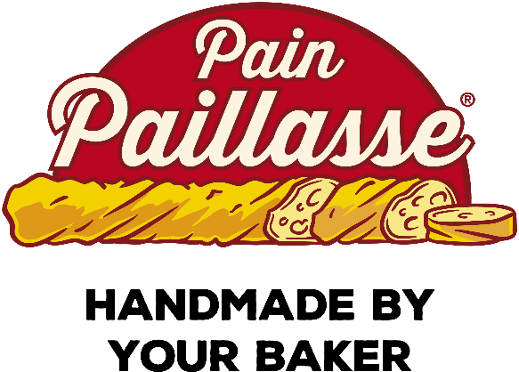

Source: Paillasse International SA documents.

EXHIBIT 4: Sample ADvertisementS FOR SWITZERLAND AND SPAIN

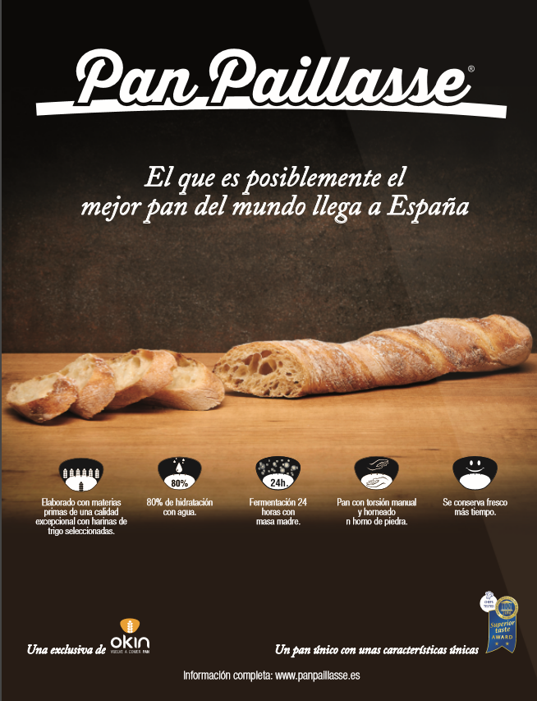

Source: Paillasse International SA documents.

EXHIBIT 5: SALES BREAKDOWN BY REGION

Source: Adapted from “Global Bakery Goods Manufacturing,” IBISWorld Industry Report, 2016, 16.

EXHIBIT 6: GLOBAL PRODUCT AND MARKET SEGMENT DESCRIPTIONs

|  |  |  |
| --- | --- | --- |
| **Market Segment** | **Market Share** | **Segment Description** |
| Fresh and frozen bread and rolls | 13% | Fresh, frozen, and packaged bread, bread rolls, and other fresh bakery products (such as baguettes and naan); varieties of bread-based rolls include hamburger buns, hot dog buns, bagels, and croissants |
| Cookies, crackers, and pretzels | 56% | Sweet cookies, biscuits, wafers, different varieties of crackers and pretzels, and others; flavours and ingredients vary drastically from region to region |
| Fresh and frozen cakes, pies, and other pastries and desserts | 23% | Fresh, packaged, and frozen bakery products; e.g., soft cakes, pies, doughnuts, pastries, cream puffs, and muffins |
| Tortillas and flatbreads | 8% | Very thin flatbread made from either corn (maize) or wheat; corn tortillas were the dominant variety, typically consumed in Mexico and Central America |

Source: Adapted from “Global Bakery Goods Manufacturing,” IBISWorld Industry Report, 2016, 11–12.

EXHIBIT 7: MARKET DATA TABLE, 2015

|  |  |  |  |  |  |  |  |
| --- | --- | --- | --- | --- | --- | --- | --- |
| **Country (values 2015)** | **GDP ($ billion)** | **GDP ($ per capita)** | **Spending on Bread  ($ per capita)** | **Disposable Income  ($ per capita)** | **Population (’000)** | **Urban Population (’000)** | **Ease of Doing Business (ranking)** |
| Belarus | 55 | 5,768 | 145 | 3,620 | 9,481 | 7,329 | 43 |
| Bosnia-Herzegovina | 16 | 4,182 | 140 | 3,514 | 3,824 | 1,982 | 82 |
| Bulgaria | 50 | 6,976 | 156 | 4,126 | 7,202 | 5,268 | 36 |
| Croatia | 49 | 11,511 | 399 | 7,461 | 4,234 | 2,497 | 39 |
| Estonia | 22 | 17,638 | 288 | 9,427 | 1,273 | 890 | 16 |
| Latvia | 27 | 13,585 | 229 | 7,941 | 1,988 | 1,349 | 22 |
| Lithuania | 41 | 14,173 | 352 | 8,905 | 2,921 | 1,963 | 21 |
| Macedonia | 10 | 4,885 | 201 | 3,429 | 2,067 | 1,236 | 14 |
| Poland | 475 | 12,333 | 201 | 7,219 | 38,479 | 23,216 | 28 |
| Romania | 178 | 8,956 | 314 | 5,064 | 19,871 | 10,699 | 37 |
| Servia | 37 | 5,135 | 179 | 3,701 | 7,111 | 4,108 | 68 |
| Slovakia | 87 | 15,976 | 286 | 9,603 | 5,420 | 2,941 | 29 |
| Slovenia | 43 | 20,736 | 282 | 12,361 | 2,063 | 1,028 | 35 |
| Ukraine | 91 | 2,010 | 82 | 1,565 | 45,090 | 30,998 | 87 |
| Finland | 232 | 42,392 | 427 | 24,034 | 5,472 | 4,608 | 10 |
| Greece | 195 | 17,790 | 266 | 12,190 | 10,974 | 6,853 | 58 |
| Ireland | 284 | 61,301 | 350 | 21,017 | 4,628 | 2,945 | 19 |
| Norway | 387 | 74,839 | 453 | 33,585 | 5,166 | 4,157 | 8 |
| Portugal | 199 | 19,203 | 380 | 13,233 | 10,369 | 6,551 | 23 |
| Sweden | 493 | 50,591 | 390 | 24,851 | 9,747 | 8,365 | 9 |
| United Kingdom | 2,813 | 44,148 | 324 | 27,700 | 63,708 | 51,861 | 6 |
| Canada | 1,550 | 43,192 | 321 | 24,466 | 35,898 | 29,415 | 13 |
| United States | 18,037 | 56,083 | 415 | 41,447 | 321,607 | 268,053 | 7 |

Source: Adapted from “Consumer Expenditure on Bread (and Cereals),” “Disposable Income,” “Ease of Doing Business Ranking,” “GDP,” “Total Population/Urban Population,” Euromonitor International (reporting data from the United Nations, country-specific national statistics, World Bank, International Monetary Fund, International Financial Statistics, and Organisation for Economic Co-Operation and Development), accessed November 17, 2016.

1. SA was an acronym for Société Anonyme, a designation in civil law countries that was roughly equivalent to “incorporation.”
2. All currency amounts are in US$ unless otherwise specified.
3. “Global Bakery Goods Manufacturing,” IBISWorld Industry Report, accessed August 7, 2016.
4. “Global Bakery Goods Manufacturing,” IBISWorld Industry Report, accessed August 19, 2016.