

9B17A024

MY KIND OF CAKES: AN EXPANSION DILEMMA

Shalini Kalia and Sandeep Puri wrote this case solely to provide material for class discussion. The authors do not intend to illustrate either effective or ineffective handling of a managerial situation. The authors may have disguised certain names and other identifying information to protect confidentiality.

*This publication may not be transmitted, photocopied, digitized, or otherwise reproduced in any form or by any means without the permission of the copyright holder. Reproduction of this material is not covered under authorization by any reproduction rights organization. To order copies or request permission to reproduce materials, contact Ivey Publishing, Ivey Business School, Western University, London, Ontario, Canada, N6G 0N1; (t) 519.661.3208; (e)* [*cases@ivey.ca*](mailto:cases@ivey.ca)*;* [*www.iveycases.com*](http://www.iveycases.com)*.*

Copyright © 2017, Richard Ivey School of Business Foundation Version: 2017-04-28

A bakery cannot be run if the owner is not a baker at heart!

Sparsh Kapoor

As Sparsh Kapoor, owner of the cake boutique My Kind of Cakes (MKOC), sat down for coffee with his mentor and mother on a January morning in 2017, he thought about his journey over the last five years and felt a mixture of gratitude, satisfaction, regret, and anxiety. He felt grateful for his mother’s unconditional support in his personal and professional life and satisfied because he could overcome business challenges at the young age of 22. At the same time, he regretted having to sacrifice his studies because of the pressures of pursuing his business, and he was anxious about the future of his business. Five years after opening, his business had flourished from a ₹7.2 million[1] establishment in 2012 to one worth ₹19.5 million in 2016 (see Exhibit 1). His target was ₹50 million by 2020.

Because most of his competitors had loyalty programs, Kapoor contemplated launching a loyalty program, which he felt would create a niche for his brand in the local market. But what next? Should he expand geographically and open franchises in nearby towns? Should he increase his product range to include recent trends such as anti-gravity desserts and chandelier cakes? Should he build a digital platform to increase awareness of his brand? Or should he explore a theme photography business to increase his customer base? Faced with so many options, Kapoor needed to choose the one best suited to his business and vision.

MY KIND OF CAKES

MKOC was opened in 2011 with an initial investment of ₹500,000. Kapoor came from a family of bakers. When his grandfather, Lajpat Rai Kapoor, opened Kapoor Bakery in 1954 in Ghaziabad, India, it was the first cake shop in the area. The business was later taken over and managed by Kapoor’s father, Anil Kapoor. Over the years, the shop became known for its quality bakery items.

In the Indian tradition, children in business families grew up dreaming of furthering their family businesses; learning the ropes of the business started in early childhood during leisurely trips with elders to the workplace. Kapoor started learning the nuances of business at an early age, and the first lesson his father taught him was that “a customer should never go unhappy.” Kapoor made this his business mantra.

After Kapoor completed school in 2011, the family decided to open a bakery for him about five kilometres away from the family’s bakery. Kapoor’s mother, who had honed her baking skills by attending various workshops and seminars with renowned chefs, became Kapoor’s first teacher and counselled him at every step in his personal and professional life.

The family considered naming the new shop Kapoor Bakery as an extension of the existing business, but Kapoor and his mother decided to give it a new touch by naming it My Kind of Cakes (MKOC). Although they were aware that keeping the same name would help them capitalize on the established brand image, they decided to target a new segment through innovation. Kapoor did some research and found that teenagers and youngsters were more fascinated than older people by bakery items and that they loved spending time with their friends at restaurants and eating places—hence the name of the cake boutique. Kapoor also used this finding to design his desserts to suit a modern palate and preferences.

A reputed consultant was hired to establish the business, and contemporary equipment was put in place ahead of the launch of MKOC. An expert team of staff and chefs was built with the objective of offering the best and latest-quality products to customers. The business kicked off well; however, after the first year, the chefs left. This was a big jolt to the business, which had to create a new team and re-establish itself. The event initiated a major learning curve for Kapoor, who learned not to rely completely on the staff. He decided instead to use the chefs for standardized jobs, such as creating bases, and to be completely involved by doing other unique tasks by himself.

The staff was composed of eight employees, including two chefs with great service experience who were trained to provide customized dishes. Kapoor trained his employees in soft skills: he trained them to offer superior customer service, encouraged them to remember the names of regular customers, and empowered them to provide the best service possible, even if it required going above and beyond required service. For example, employees were told to change a dish immediately following the smallest of customer complaints. The employees were also trained in hard skills such as using the cash counter and serving food.

THE VALUE PROPOSITION

Uniqueness

Kapoor was a creative person with expertise in arts and design. In addition to standard bakery items, he decided to offer a new range of customized products exclusively baked and decorated to customers’ requirements, including theme cakes that depicted key attributes of storylines shared by the customers. His creativity and expertise in baking and decorating storylines became a hit with his customers (see Exhibit 2). As the customers placed their orders, Kapoor made a note of the information they shared and then used this in the presentation of the cake. Gradually, his customers came looking for him and refused to place an order if he was unavailable at the store. This helped him create a monopoly in this domain in the nearby area.

Kapoor had not taken any professional baking courses, but he used the Internet and television cookery shows as resources to supplement his mother’s lessons in the art of baking. Along with baking, he learned the art of understanding and fulfilling customers’ requirements. If a customer wanted a half-kilogram three-layer cake, most bakeries could not comply; however, Kapoor broke with convention and carved a niche in the market by offering unique designs in small sizes. He experimented, innovated, and attracted customers by offering products in a variety of sizes and designs, which not only made him popular but also made him the indispensable face of MKOC.

Customer Service

Kapoor learned the game of business very well from his elders and from practical experience. He understood the importance of service delivery and customer-experience management in the service industry, and explained that his goal was to “to create a fantastic experience every time a customer places an order.” According to him, his most loyal customers visited the cake boutique as often as 6–8 times a month, which meant that keeping them coming required “something as simple as recognizing them and knowing their choice of bakery products and customizing it the way they like it.”

He was respectful toward his customers and trained his staff to behave in the same manner. Every time a customer visited his cake boutique, Kapoor offered a small portion of some specialty, and never expected payment in return for this gesture. The customers loved this gesture and generally ended up buying the products for their loved ones.

MKOC’s excellent customer service included telephone booking for regular and home-delivery orders: customers with MKOC cards could place orders before they arrived at the cake boutique. This saved time for customers and helped MKOC provide fast customer service. MKOC also offered home delivery within 30 minutes for minimum orders of ₹200. This service became a significant factor in MKOC’s success; because a major competitor in the vicinity had no home-delivery facility, customers gradually started shifting to MKOC, which offered the same or even better quality products at similar pricing, but also provided delivery.

Kapoor connected well with his customers and tried to offer a wholesome experience and service. For example, he made special arrangements for parties. He tracked customer satisfaction related to quality and service delivery by sending customer-satisfaction survey forms to hi regular customers, asking them to rate MKOC on three parameters (see Exhibit 3). Kapoor analyzed the surveys with the help of his friend. He also often called up some of his loyal customers to ask for their feedback, and he made sincere efforts to enhance the quality and services.

MARKETING MIX

Product Portfolio

Apart from standard bakery items such as cakes, pastries, and savouries, MKOC offered specialties like theme-based cakes and dry cakes. It also offered party accessories such as disposable dishes, candles, decorative items, and party favours. The customers found it a one-stop shop for arranging parties and get-togethers.

Kapoor was also passionate about photography. His snapshots became popular with his friends and customers on social media, and this led friends and others to ask him to photograph special occasions such as baby showers and pre-wedding celebrations. Kapoor realized that something he followed as a hobby could open up some exciting professional opportunities. The customers who approached him for theme cakes for an event sometimes asked him to capture the event itself through his photographs, and they were willing to pay for this additional service.

Promotion

MKOC had thrived solely based on word-of-mouth publicity over the last five years. It had made limited use of promotions beyond a Facebook page, which Kapoor updated regularly with posts of designer cakes and other products. Kapoor also included a small MKOC placard with every order that left the store for an event, and these placards helped promote MKOC to the party guests. In addition, MKOC used different customer-relationship strategies for promotional purposes.

Place

While it was located in a tiny lane in Ghaziabad—not in a very prominent place—MKOC became a landmark because of its popularity. The shop had an attractive and cozy ambience, and products were displayed in an appealing manner. A few chairs and tables accommodated the customers who preferred to consume the products in the shop itself (see Exhibit 4). On festive and special days, such as Valentine’s Day, Friendship Day, Christmas, and Mother’s Day, the store became a celebratory centre for people to socialize and celebrate together.

Price

Kapoor’s aim was to offer his customers high-quality products at a reasonable price. His products were competitively priced and provided value for money in terms of service and quality. (He preferred to offer fresh goods, so he worked on items only after an order had been placed.) The minimum cost for two persons was around ₹150.

CUSTOMER RELATIONSHIP MANAGEMENT

MKOC initiated many relationship strengthening activities to retain its regular customers. It was in regular touch with its customers through e-mails, Facebook, and mobile apps such as Whatsapp, and it sent them information about special offers such as discounts, free coupons, and other promotions. Until January 2017, MKOC maintained a customer database of 9,117 customers. The churn rate[2] of customers for 2016 was 14.5 per cent, which was quite low in comparison to competing restaurants; however, the defection rate[3] of its customers was 19 per cent.

Major Clientele

The Institute of Management Technology (IMT), a reputed business school, was located within two kilometres of MKOC in Ghaziabad, and Kapoor endeavoured to capitalize on the student community’s love of bakery items. He collaborated with a cafeteria in the business school premises and started offering bakery items. Kapoor’s excellent product quality and prompt delivery service, as well as his ability to connect with the students who were almost his age, increased Kapoor’s business. IMT, with its population of more than 1,100 students and 200 faculty and staff members, was sufficient to help MKOC’s business thrive. The faculty and staff preferred to buy products from MKOC for birthdays, parties, and various functions and events held at the institute throughout the year, and this contributed to major sales revenue for MKOC. Apart from IMT Ghaziabad, MKOC also connected with leading companies and schools nearby, such as Maruti Suzuki, Honda, and Uttam Toyota.

Birthdays and Anniversaries

MKOC sent birthday and anniversary greetings to nearly 7,000 customers through Whatsapp, and the manager greeted regular MKOC customers with personal calls. The store sent special cakes to select customers on their birthdays and anniversaries. It also offered customers special discounts for parties on those particular days.

MAJOR COMPETITORS

To begin, MKOC targeted the Ghaziabad market and did not aspire to expand across the National Capital Region or to other cities. The following businesses were MKOC’s major competitors in Ghaziabad.

Dunkin’ Donuts

Dunkin’ Donuts (DD)wasa subsidiary of Dunkin’ Brands Group, Inc., which had more than 11,500 DD restaurants worldwide in 2016.[4] It sold many varieties of donuts and more than a dozen coffee beverages as well as an array of bagels, breakfast sandwiches, and other baked goods. DD offered customers a variety of methods to connect, such as online shopping, social media, and the DD Perks reward program. It also offered a mobile app that helped customers view their DD Perks points balance, redeem rewards, receive exclusive offers, and locate the nearest DD store.[5] There was one DD store in Ghaziabad, and the minimum cost for two persons there was around ₹700.[6]

Mr. Brown Bakery

The Mr. Brown Bakery had one outlet in Ghaziabad. This bakery offered pastries that combined classic Asian traditions with modern flavours for the contemporary palate and specialized in wedding dessert creations that used fruits such as apples and strawberries to create mousse cakes, tarts, and a variety of handcrafted Asian pastry specialties.[7] The bakery offered the Mr. Brown Privilege Program, which allowed members to earn privilege points they could redeem for products and other advantages.[8] The minimum cost for two persons here was around ₹500.[9]

Donald’s Pastry Shop

Donald’s Pastry Shop offered desserts and bakery items and was known for customized cakes and bakery items. It was centrally located, with schools, colleges, and government offices nearby. The good quality of products and its location gave it an edge over its competitors. Its products were priced economically, and the cost for two persons here was around ₹300.[10]

Bakes N Cakes

Bakes N Cakes offered bakery products and desserts. It was known for cakes with character designs and photo cakes. It also offered the convenience of online shopping and home delivery. The products were priced reasonably, and the cost for two persons here was around ₹200.[11]

Frequent Bakes

Frequent Bakes had three outlets in Ghaziabad. It offered a wide range of pastries, cakes, and fast-food products. It also offered the convenience of online shopping and home delivery for minimum orders of ₹500.[12] The cost for two persons here was around ₹350.[13]

Sir John Bakery Cafe

Sir John Bakery Cafe had three outlets in Ghaziabad. It offered a wide variety of bakery items, desserts, and fast-food items. It also offered the convenience of online shopping and home delivery. Its express cake delivery service enabled delivery of cakes within hours.[14] The cost for two persons here was around ₹500.[15]

THE WAY FORWARD

While increasing disposable incomes and consumerism had increased consumer spending on bakery products, Kapoor faced a growing threat from competitors who were opening new bakeries. The sale of bakery products was also affected because of rapidly changing customer tastes and preferences, and heightened health awareness, which added to concerns about the consumption of bakery products.

During his discussion with his mother, Kapoor noted that what he had achieved and learned in the last five years had been satisfactory, but it was limited to a very small geographical area. He was also aware that, considering the stiff competition in the market, the journey would not be easy in the future. He pondered strategies for achieving his target revenue of ₹50 million by 2020. He had to decide if expanding geographically and opening franchises in the nearby towns would be the best way to reach that target or if he should increase his product range instead. Kapoor did not have any franchise experience. The cost of opening a new outlet or franchise was ₹3.5 million, and the usual franchise fee in the area was around 20 per cent of the net revenue. Monthly sales of ₹75,000 were required to make franchising a profitable venture.

Kapoor also had to decide whether building a digital platform to increase brand awareness or launching a loyalty program to strengthen his customer base was the best way forward. He would need to invest ₹100,000 to create an appropriate digital platform, which would require another ₹10,000 each month for maintenance.

Kapoor even wondered whether he should indulge in his passion for photography and venture into the theme photography business to capture special occasions like baby showers and pre-wedding shoots, and build a new customer base at such events. With only a few years to make his target revenue, Kapoor was short on time to make a decision.

Exhibit 1: SELECTED FINANCIALS FOR MKOC, 2012–2016

(in ₹ millions)

|  |  |  |  |  |  |
| --- | --- | --- | --- | --- | --- |
|  | **2012** | **2013** | **2014** | **2015** | **2016** |
| Net Revenue | 7.2 | 9.3 | 12.1 | 15.3 | 19.5 |
| Cost of Sales | 3.9 | 5.1 | 6.6 | 8.2 | 10.1 |
| Operating Expenses | 1.8 | 2.3 | 3.1 | 3.8 | 4.7 |
| Other Income (Loss)* | 0.3 | 0.7 | 0.5 | 1.1 | 0.9 |
| Net Income | 1.8 | 2.6 | 2.9 | 4.4 | 5.6 |

Notes: * Includes gain (loss) on equity investments, settlement income, benefit (provision) for income taxes, cumulative effect of changes in accounting principles, and other income; figures have been changed to maintain confidentiality.

Source: Provided by the company.

EXHIBIT 2: FATHER’S DAY THEME CAKE BY MKOC

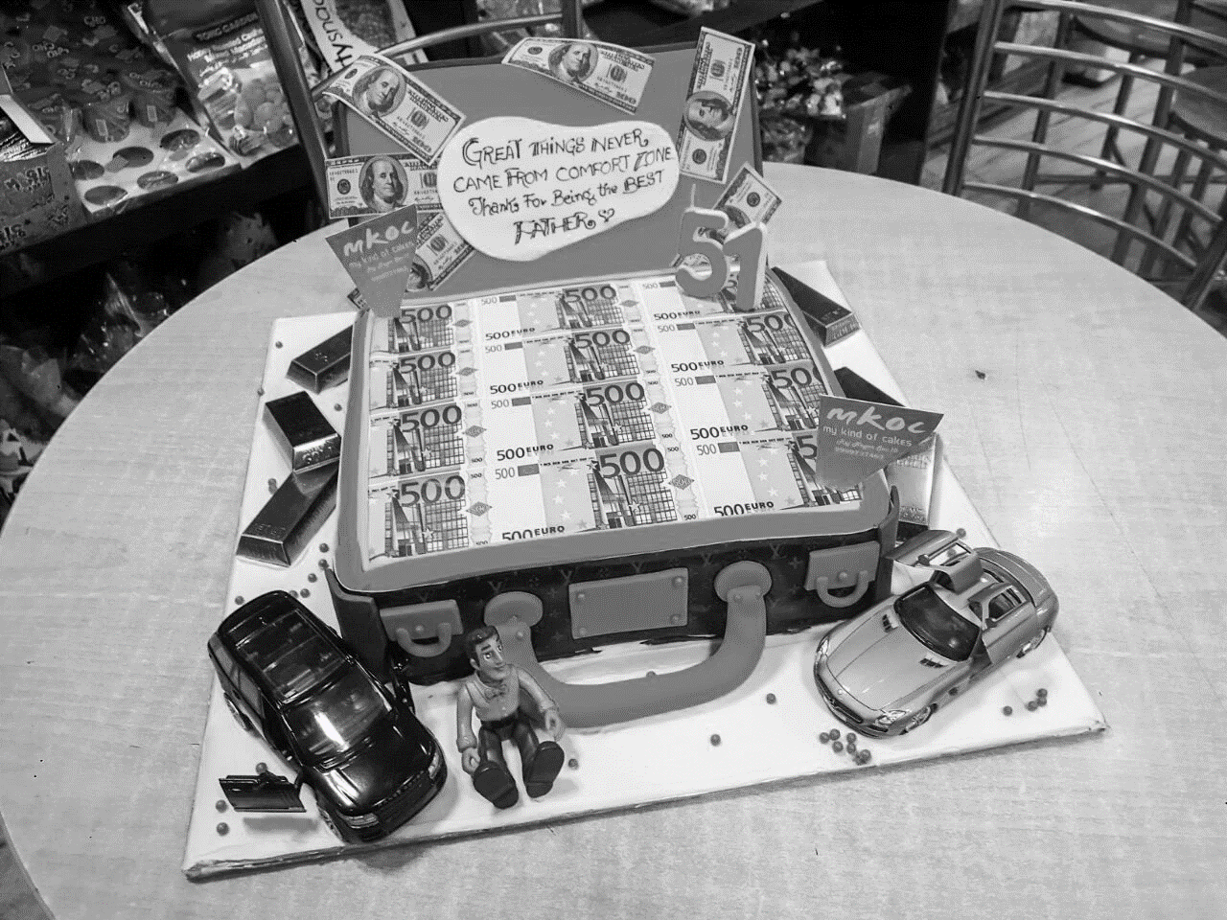

Source: Provided by the company.

Exhibit 3: customer satisfaction survey

**Food Quality**

* Is the order served accurately?
* Is it served fresh?
* Is it presented properly?

**Service**

* Is the customer greeted courteously by the staff?
* How long do the customers have to wait?
* Is the environment comfortable?
* Is the ambience appealing?
* Do staff say “thank you” after the payments?

**Cleanliness**

* Is the restaurant clean?
* Are the tables clean?
* Are the restrooms clean?
* Is the staff wearing clean clothes?

Source: Provided by the company.

EXHIBIT 4: EXTERIOR OF MKOC

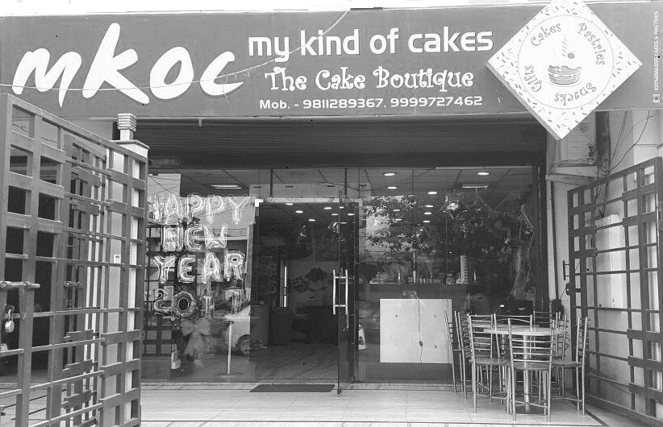

Source: Provided by the company.

1. ₹ = INR = Indian rupee; all currency amounts are in ₹ unless otherwise specified; US$1.00 = ₹67.60 on January 31, 2017.
2. Churn rate was calculated as the number of customers who left a business in a year’s time divided by the number of new customers in the same period.
3. Defection rate was calculated as the percentage of customers who left a business in one year.
4. “About Us,” Dunkin’ Donuts, accessed October 2, 2016, www.dunkinbrands.com/about.
5. John Kell, “You Can Now Use Dunkin’ Donuts Mobile Ordering App Nationwide,” Fortune Retail, June 13, 2016, accessed November 17, 2016, http://fortune.com/2016/06/13/dunkin-donuts-mobile-ordering-app.
6. “Dunkin’ Donuts,” Zomato, accessed October 2, 2016, www.zomato.com/ncr/dunkin-donuts-indirapuram-ghaziabad.
7. “About Us,” Mr. Brown Bakery Food Products, accessed October 2, 2016, www.mrbrownbakery.com/about-us.
8. “Mr. Brown’s Privilege Program,” Mr Brown Bakery Food Products, accessed October 2, 2016, www.mrbrownbakery.com/loyalty-page.
9. “Mr. Brown,” Zomato, accessed October 2, 2016, www.zomato.com/ncr/mr-brown-raj-nagar-ghaziabad.
10. “Donald’s Pastry Shop,” Zomato, accessed October 4, 2016, www.zomato.com/ncr/donalds-pastry-shop-raj-nagar-ghaziabad/info.
11. “Bakes N Cakes,” Zomato, accessed October 4, 2016, www.zomato.com/ncr/bakes-n-cakes-indirapuram-ghaziabad.
12. Frequent Bakes (website), accessed October 4, 2016, www.frequentbakes.com.
13. “Frequent Bakes,” Zomato, accessed October 4, 2016, www.zomato.com/ncr/frequent-bakes-indirapuram-ghaziabad.
14. “About Us,” Sir John Bakery, accessed July 17, 2016, http://sirjohnbakery.in/about-us.
15. “Sir John Bakery Café,” Zomato, accessed July 17, 2016, www.zomato.com/ncr/sir-john-bakery-cafe-1-indirapuram-ghaziabad.