

9B17A035

EAST COAST LIFESTYLE: EXPANDING A REGIONAL APPAREL BRAND

Ethan Pancer, Anna Ferguson, and Maxwell Poole wrote this case solely to provide material for class discussion. The authors do not intend to illustrate either effective or ineffective handling of a managerial situation. The authors may have disguised certain names and other identifying information to protect confidentiality.

*This publication may not be transmitted, photocopied, digitized, or otherwise reproduced in any form or by any means without the permission of the copyright holder. Reproduction of this material is not covered under authorization by any reproduction rights organization. To order copies or request permission to reproduce materials, contact Ivey Publishing, Ivey Business School, Western University, London, Ontario, Canada, N6G 0N1; (t) 519.661.3208; (e)* [*cases@ivey.ca*](mailto:cases@ivey.ca)*;* [*www.iveycases.com*](http://www.iveycases.com)*.*

*Copyright © 2017, Richard Ivey School of Business Foundation*

Version: 2017-06-08

INTRODUCTION

On February 28, 2017, Alex MacLean was wrestling with Stella, his Mastiff Labrador mix puppy, at the flagship retail location of East Coast Lifestyle (ECL). It was 4:00 p.m. on a Tuesday, which meant that it was almost time to meet with his executive leadership team. The atmosphere at the head office was always light and easy-going, and playing with his dog in the office always seemed to help MacLean mull over strategic business issues. His latest struggle was fraught with opportunity and risk—he was considering stretching ECL beyond its regional identity.

In 2013, MacLean founded ECL, a Nova Scotia-based apparel company that sold a range of products from T-shirts and hoodies to dog collars and baby onesies. The company had experienced exponential growth as a small business. Despite having operated for less than four years, ECL had already sold more than 500,000 products.[1]Its product line was now available in 91 retailers across Canada and had been worn by many high-profile celebrities, including singer Ed Sheeran, Nova Scotian hockey star Sidney Crosby, and members of the rap band Wu-Tang Clan.

At 25 years old, MacLean was now the chief executive officer of one of Canada’s fastest-growing business ventures. He had received many accolades for his leadership, including being featured as one of the “Top 30 under 30” in *Marketing Magazine*. For ECL to continue its substantial growth, it needed a market with more space. One option was to invest heavily in extending its brand portfolio. MacLean had recently won a lengthy copyright battle over the rights to West Coast Lifestyle (WCL), a nascent sibling brand to ECL, which had limited current appeal and relatively small sales volumes in British Columbia and Alberta. He had the chance to develop this brand for bicoastal collaboration or friendly competition, but doing so presented the risk of brand cannibalization and identity confusion.

MacLean also had the vision of making ECL a truly global brand by expanding into the United States before launching in Japan and Australia. While the U.S. Eastern Seaboard offered a massive market for lifestyle apparel, and offered synergies with ECL’s current positioning, the logistics of brand-building, distribution, taxes and tariffs, and revising ECL’s organizational structure were roadblocks for getting started. Plus, was it realistic to think that ECL could become an imported regional brand that locals were proud of, or was ECL already too mainstream and corporate to resonate with non-Canadians?

MacLean started the meeting:

Lately, we’ve been trying to do everything—launch new product lines, develop West Coast Lifestyle as a separate brand, and penetrate the U.S. market. I’m not convinced that our divided attention is working because we are not seeing enough progress fast enough. Perhaps we should choose one option for growth and focus on it.

After two hours of protracted debate, MacLean still felt he was in the same position. He wanted to do everything, but he knew that choosing one strategy for the time being was likely the right thing to do. The real question was which one strategy to pursue, and more importantly, how to implement it and roll it out.

COMPANY BACKGROUND

In January 2013, MacLean was a 21-year-old business student at Acadia University in Wolfville, Nova Scotia, a small student town with a population of less than 5,000. Along with eight other students, he was enrolled in a class called Venture Creation, where the goal of the course was to create a business plan for an invention. MacLean, who was rather pragmatic if not rebellious, thought, “Why would I create a business on paper when I can start a real business?” With an $800 loan from his father and the idea that locals wanted to wear their maritime pride, he created East Coast Lifestyle. He bought 30 hoodies and screened them with the phrase “East Coast Lifestyle.” He then became active on social media platforms, including Facebook, Instagram, and Twitter, to create awareness about his start-up. He sold the hoodies on his front lawn—and sold out on the first day. He reinvested the profits to purchase 60 hoodies the following day, and began allowing consumers to pre-order to facilitate inventory management. By the end of the month, he had generated $3,000[2] in revenue. At the end of the semester, his professor was not overwhelmingly impressed with MacLean’s success—it was a business *plan* class, not a business class. MacLean decided to continue with ECL after the class had ended.

During the summer of 2013, MacLean worked part-time at Atlantic Lottery and part-time on ECL, selling about 25 hoodies a week. He hired his first employee, Taylor Northey, as ECL’s creative director. ECL began diversifying its products by also offering T-shirts and tank tops. By late 2013, MacLean was approaching retail chains to carry his product line. Pseudio, a regional apparel retailer with 30 stores, was the first store to sell the ECL brand. One store manager took 10 hoodies initially and told MacLean that if he could sell those 10 hoodies, Pseudio would place them in stores across Canada. Pseudio sold out of the ECL hoodies in 30 minutes. That day, MacLean learned about his consumers’ price elasticity, when he realized that people were willing to pay an extra $10 in the store for the same product he was selling on his lawn. In May 2015, he graduated from Acadia University, and made ECL his full-time job.

THE ECL BRAND

MacLean consistently talked about the distinctive character of ECL as being simple and universal—it was about being proud of where you are from. To understand East Coast pride, it was important to understand some of the history of the region. Historically, the major industries of the region were based on fishing, agriculture, forestry, and coal mining. For myriad reasons, including fiscal policy and investment decisions being driven by the needs of urban centres in Central Canada, the region entered a period of economic malaise in the 20th century. To this date, the Maritime provinces remained one of the poorest regions in Canada, with lower average wages and lower property values relative to the rest of Canada. As a result, Maritimers tended to be rather humble, but still felt a tremendous amount of regional pride. Maclean understood these challenges as opportunities: “I’m proud of being from the East Coast, where oftentimes, we are the underdogs of Canada. People are often required to leave their home to find work.” With ECL, people could share this identity wherever they went, showing others where they came from and connecting with other people from “home.”

competition

The ECL brand transcended traditional apparel categories, being positioned as a true lifestyle brand that encapsulated surf, skate, and snow vibes. While lifestyle branding was unique for the region, it also positioned the brand against a broad array of competitors. The competitive landscape for lifestyle apparel was diverse with varying niches, marketing budgets, and access to capital. Regardless, the lifestyle apparel business was a lucrative one; margins on apparel goods were typically upward of 70 per cent.

In Atlantic Canada, ECL was the market leader in regional lifestyle apparel. Other clothing companies that sold Atlantic Canada-inspired designs, such as Lost Cod, New Scotland, My Home, and Local Legends, generally operated out of one location or solely online. While these brands satisfied the needs of tourists and advocates of buying local, they appeared to lack the resources, distribution, or brand awareness to consider scaling. In addition, the positioning of these brands tended to be predominantly geography-based and not inherently tied to a specific fashion subculture. ECL designs and promotions aligned closely with premium consumers of surf, skate, and snow fashions. This market space was incredibly competitive and saturated, occupied by many large U.S.-based apparel organizations that had substantial financial backing. For example, Zumiez, one of the largest retailers in surf, skate, and snow clothing and accessories, carried more than 400 different brands, from Burton and Vans to Nike and Adidas. More generally, consumers could choose from countless other fashion brands outside of this space, ranging from value brands (e.g., T. J. Maxx) to mid-market brands (e.g., The Gap) to luxury brands (e.g., Tom Ford). According to the 2017 report from McKinsey on “The State of Fashion,”[3] the global apparel industry was characterized by uncertainty, change, and a series of challenges that resulted from volatility in global sales based on geopolitics, the proliferation of city-based strategies instead of country-based strategies, a preference for discounts on fashion, the emergence of new apparel categories based on casualization and active lifestyles (e.g., *athleisure* clothing), digital shopping, and fashion e-commerce.

ECL PRODUCTS

ECL’s product portfolio had diversified to include a broad range of apparel offerings. In February 2017, the most popular products were the hoodies ($69), T-shirts ($34), tank tops ($30), hats ($30), and toques ($30). ECL also sold a variety of eclectic accessories, including baby onesies, flags, anchor-logoed bowties, stickers, duffle bags, and throw pillows. The company even collaborated with a local carpenter to make an ECL gnome door. MacLean wanted to continue launching three to five new products per year. In 2017, the winter plan was to release branded socks, men’s boxers, women’s tall sweaters, and a new style of blankets, while the summer offerings would include beach towels and water bottles. Novel products, in conjunction with the virtually non-existent discounts offered on products, helped rejuvenate and preserve the fresh and premium positioning of the brand.

One key differentiator of ECL products was that many of the products were limited editions. With the exception of the anchor-logoed apparel (see Exhibit 1), all other lines were of a limited run. Once a limited-edition product was sold out, Maclean’s policy was to never reorder or recreate the line. For example, ECL had recently partnered with rapper Ghostface Killah from the rap band Wu-Tang Clan to create a limited-edition Wu-Tang hockey jersey. Only 100 jerseys were produced, each with a number from 1 to 100. As a result of its predominantly limited-edition products, ECL had experience in launching hundreds of logoed items.

PROMOTIONS

ECL continued to promote its products using guerrilla marketing tactics and a very lean budget. MacLean typically relied on social media with happenstance celebrity endorsements, an ambassador program, and cross-promotional initiatives to communicate with prospective customers. Instrumental for ECL in communicating with its customers about new product offerings was ECL’s Instagram account, which now had almost 600,000 followers (see Exhibit 2). Although the products offered varied drastically from year to year, MacLean relished the control of communicating the culture of the brand and was personally responsible for ECL’s social media messaging and customer feedback. ECL typically decided which products to brand based on feedback from customers on social media.

Celebrity support had been perhaps the biggest driver of exposure for ECL. Although MacLean had never paid for an endorsement, he used the social media platform to get gear into the hands of a broad swath of celebrities, including Sidney Crosby (and other National Hockey League players), the rapper Classified, and pop singer Ed Sheeran. Each celebrity “placement” was then actively promoted on ECL’s social media and website. For example, MacLean reached out to a social connection that worked with Ed Sheeran, who then provided the singer with ECL clothing to wear during his concert. After Ed Sheeran wore a branded T-shirt on stage, the item, with the help of a social media push, sold out online.[4]

ECL concurrently ran a brand ambassador program, which offered free promotional items and commission on products sold, in exchange for various local promotional activities for the brand. This influencer program was initiated from a simple Instagram post looking for student brand ambassadors, asking where each prospective brand ambassador was from; ECL received more than 10,000 responses. Over several days, MacLean and his team narrowed the list to 50 students; each had between 5,000 and 150,000 Instagram followers, and regularly posted about ECL. The brand ambassadors also received a discount code to share with their followers, which enabled ECL to track each brand ambassador’s effectiveness. For each sale that brand ambassadors closed, they received between 10 per cent and 15 per cent in discounts.

ECL had also run a series of cross-promotional campaigns. In 2014, MacLean received a call from Alexander Keith’s Brewery (Keith’s), a 200-year-old brewing institution located in Halifax, Nova Scotia, regarding a campaign to target a more youthful demographic with a T-shirt giveaway in specially marked Keith’s bottle packs. Keith’s paid for all of the T-shirts upfront and gave ECL a royalty on each case of beer sold. MacLean went on to secure a cross-promotional deal with Captain Morgan Rum on a probationary three-year term.

ECL also gave back to the local community that had supported the company’s growth by launching special co-branded collections with Wounded Warriors and the Canadian Breast Cancer Foundation, sponsoring local sports teams with apparel, and offering gear to groups aligned with surf, skate, and snow. ECL recognized that to get people to buy into a regional brand, the brand should do something for the region.

DISTRIBUTION

ECL sold its products through three primary venues: four ECL retail locations, an e-commerce-enabled website, and various other retailers. ECL operated a flagship retail store on the Halifax waterfront, which was near the Seaport Farmers’ Market, the Halifax boardwalk, and the disembarkation point of cruise-ship passengers. The flagship store had a staff of four employees. ECL also sold its products at the Halifax Stanfield International Airport, in a shop run by six staff members, to reach travellers seeking an East Coast souvenir. ECL had recently set up a kiosk that employed four people at Dartmouth’s Mic Mac Mall, Atlantic Canada’s largest shopping mall. ECL even used a “pop-up” shop—a truck and trailer containing a broad array of merchandise—that travelled around the Maritimes with a team of four employees, and sold its products at various festivals from May to November.

ECL’s e-commerce platform accounted for 30 per cent of annual sales. Online customers were primarily Canadians, with sales from every province. What MacLean always found interesting was that the majority of online sales were not from the Atlantic region, but rather from Alberta and Ontario—a not-so-subtle nod to the East Coasters who worked far from home.

ECL used various manufacturers to satisfy customer demand and outsourced the majority of its products to fulfil bulk retailer orders. However, some products maintained their Canadian roots. For example, the classic hoodies were made in Toronto, while many of the T-shirts were screen-printed in Halifax.

Although ECL had been expanding its own retail operations, the ECL stores still comprised a small portion of the overall retail sales. ECL relied heavily on its retail partnerships to maintain the majority of its sales volume without having to deal with traditional retail management issues and costs. MacLean ensured that all products sold—whether online or in partner-retailer locations—were priced identically to mitigate potential channel conflict.

When ECL was first launched, it stocked its product for any Canadian retailer that was interested in carrying it. However, with many small retailers concurrently selling knock-off lifestyle products (e.g., “Cape Breton Lifestyle”), ECL made the strategic decision to withdraw all products from the hodgepodge of retailers and to sell through only two retailers: Pseudio (in Atlantic Canada) and Below the Belt (in Central and Western Canada), which meant that ECL had its products in 91 stores. While the Canadian retail operation followed a specific structure, the three small U.S. retailers—two in Rhode Island and one in Florida—received product only because they explicitly asked for it. All three had discovered ECL through Instagram and wanted to try out their inventory. However, by October 2016, when each store received 50 more units to sell, they had moved only one or two units per week, and all U.S. stores still had inventory from their original shipment.

THE GROWTH OPTIONS

West Coast Lifestlye

From day one, MacLean wanted to make people proud of where they were from on a worldwide scale. This insight led to the development of a sibling brand in 2014 for Canadians in British Columbia and Alberta: West Coast Lifestyle. At the time of launching the start-up, MacLean could not afford to trademark both ECL and WCL, so other businesses blossomed in the region with a similar name and aesthetic to ECL. MacLean had to fight trademark issues for a year and was ultimately successful with his lawsuit, making him the rightful owner of WCL. In 2017, WCL was relaunched with new logos, through both online and in-store locations of Below the Belt. While WCL products were now carried in 35 stores in Western and Central Canada, the resources available to invest in ECL were not available for WCL. MacLean explained that, to this point, he worked on WCL only 10 per cent of the time. One of the primary challenges with WCL was that the same formula used by ECL had not “unlocked” the region’s potential. Products moved at a glacial pace, relative to their Atlantic counterparts. In addition, West Coasters were potentially less inclined to identify with the coast as a region. Albertans, for example, did not typically see themselves as being on the coast, because they lived in a landlocked province. MacLean felt that WCL had tremendous potential in terms brand development. However, simply using a boilerplate or standardized ECL model, by substituting mountains for anchors, was unlikely to do the job.

Geographic Expansion

Besides brand development and new product launches, MacLean grappled with geographic expansion ideas. He wanted ECL to become a global player in the lifestyle apparel category. The most logical step was the U.S. Eastern Seaboard, whose population of more than 115 million dwarfed Atlantic Canada’s population of less than 5 million. He had grand plans to eventually capture the hearts and minds of consumers in other countries that had rich surf, skate, and snow subcultures and were located on a seacoast, including the east coasts of Japan (with a population of 10 million) and Australia (with a population of 15 million). While ECL had shipped to 55 countries to date through its online store, the logistics of stocking suppliers and brand-building outside of Canada was truly foreign.

At the time, ECL’s U.S. presence had been built from the requests of a handful of small retailers who had ECL products that were not moving. MacLean had no overarching strategy or rollout in place for expansion. First of all, it was unclear how ECL could develop a deal with an established retail partner. Professional salespeople were available who were trained to approach U.S. retail chains that had brand alignment with companies such as ECL, including Zumiez, PacSun, and Urban Outfitters, and these salespeople did not cost much upfront. However, for every chain that the salesperson signed, the salesperson received a rather hefty percentage (10–15 per cent) of all products that were sold through the chain. This commission was on top of the 60 per cent margin that retailers often demanded to justify carrying the product. At that point, it would be very difficult for ECL to be profitable at launch, considering the import taxes it would need to pay to take product into the United States.

While ECL might have hit the ceiling on Atlantic Canada, other domestic growth opportunities were available. For example, ECL could develop its retailer presence itself, opening a series of small stores and kiosk locations to earn full margins on its products. MacLean was unsure how this idea might affect his existing retail partners and was leery of investing in assets that were not the traditional strength of ECL. ECL could also make its products available to other retailers in Canada—the demand was certainly there. The trade-off was the cost of potentially mainstreaming the brand too much, and thereby diluting the uniqueness of ECL and what it meant to offer limited-edition apparel. MacLean could also make other global decisions, such as expanding the brand ambassadors network to a global scale and using a social media influencer network and online sales to sell directly to consumers without brand building.

Another international option had recently presented itself. An organization in South Korea, which had a rich surf, skate, and snow culture with coastal identification, had approached ECL with the opportunity to license the brand on a one-year contract trial basis. In this scenario, ECL would mitigate much of the expansion risk and cost to access a new consumer base, in exchange for even lower margins and less brand control online. This option did lead MacLean to consider a hybrid of leveraging the brand ambassadors program as a franchise initiative to mitigate risk and grow quickly, but he was skeptical of the implications of a novel business model.

MOVING FORWARD

MacLean’s quandary came down to one question: How should ECL strategically expand? The ECL and WCL brands were trademarked and incorporated globally, and both were assets with broad appeal and public relations momentum. The perspective that ECL could grow in many different directions was exciting for MacLean, but also concerning, given ECL’s lean organizational structure (see Exhibit 3). Because he had invested so much of his own time and resources into the business and felt that he truly understood his customers, the prospect of risk and giving up control was daunting.

Around his office, MacLean kept free promotional items from Hurley and from Burton, American West Coast companies that thrived after their expansion into Canada. MacLean wanted to reverse that trend, bringing some Canada to the world in a way similar to what Herschel had done for bags and what Westbeach had done for snowboard apparel. Could an Atlantic Canadian brand resonate in a city such as Los Angeles with WCL or in Miami with ECL? Americans clearly had a sense of pride that MacLean could tap into, but he wondered whether a Canadian brand could authentically fill that void. MacLean wondered whether East Coast states such as Maine, Massachusetts, New Hampshire, New York, Florida, Georgia, and the Carolinas would react favourably to the brand. ECL had always been an Atlantic Canadian signal of strength, humility, and warmth that could easily start conversations about where people were from. It was exciting to think about what this lifestyle business could evolve into.

EXHIBIT 1: EAST COAST LIFESTYLE APPAREL—THE CLASSIC ANCHOR LOGO

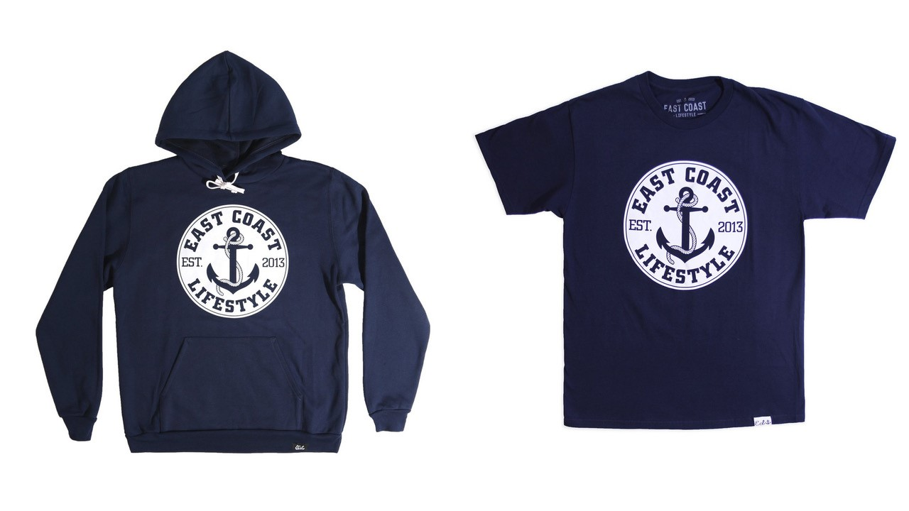

Limited-edition apparel

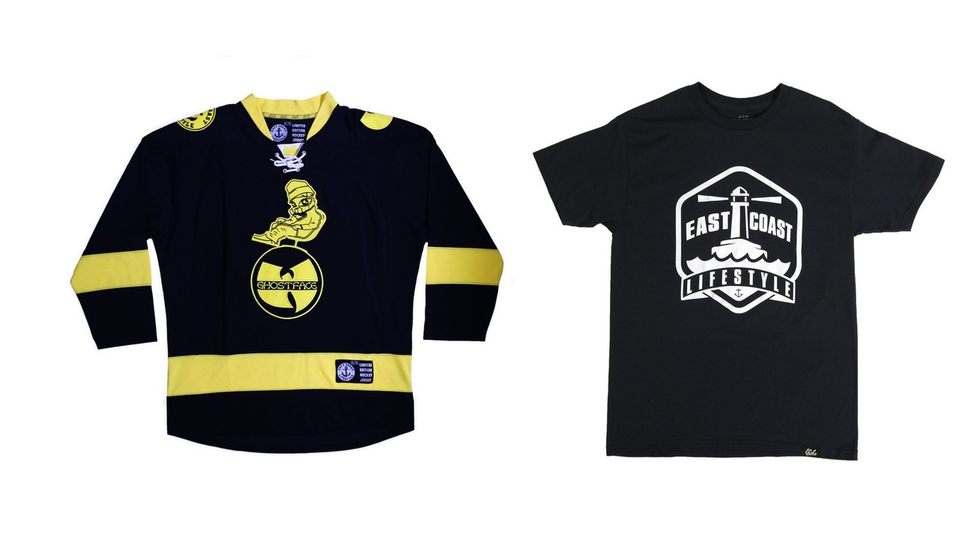

Source: “All,” East Coast Lifestyle website, accessed May 24, 2017, www.eastcoastlifestyle.com/collections/all.

Exhibit 2: East Coast Lifestyle’s Instagram page

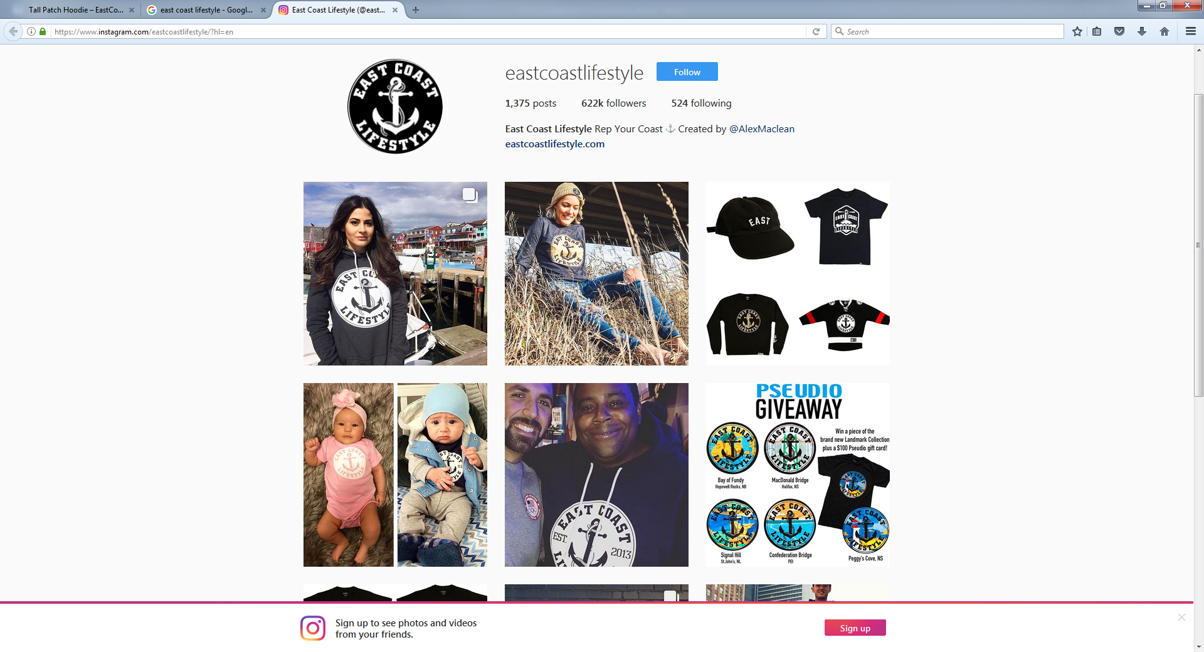

Source: “East Coast Lifestyle,” Instagram, accessed May 24, 2017, www.instagram.com/eastcoastlifestyle.

Exhibit 3: East Coast Lifestyle’s ORGANIZATIONAL Structure—Corporate Headquarters

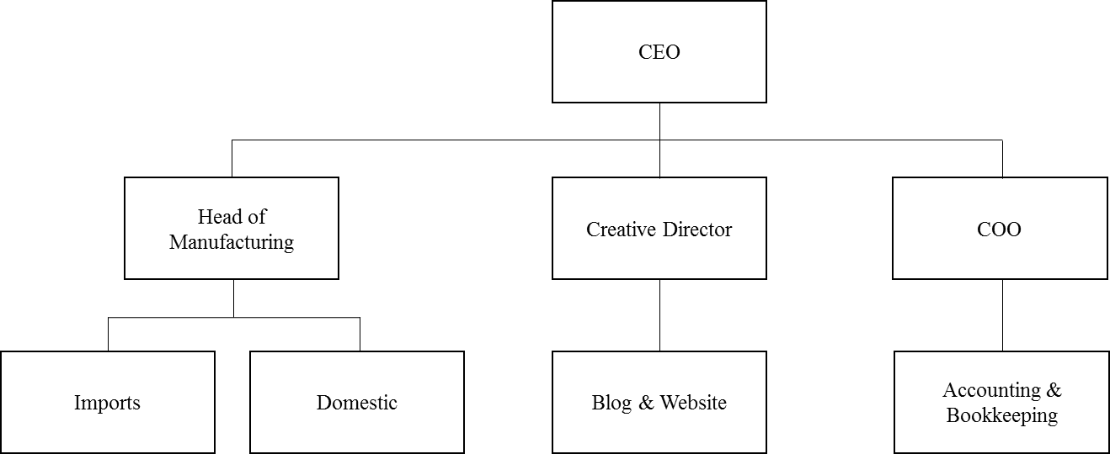

Note: CEO = chief executive officer; COO = chief operating officer

Source: Created by authors based on interview with Alex MacLean.

1. A product, in this sense, represented the weighted average sale price from all products sold and typically reflected the retail price of an ECL T-shirt, tank top, hat, or toque.
2. All currency amounts are in Canadian dollars unless otherwise noted.
3. Imran Amed, Achim Berg, Leonie Brantberg, and Saskia Hedrich, “The State of Fashion,” Mckinsey & Company,December 2016, accessed May 24, 2017, www.mckinsey.com/industries/retail/our-insights/the-state-of-fashion.
4. Russ Martin, “30 under 30: Alex MacLean,” *Marketing Magazine*, October 5, 2015, accessed May 1, 2015, http://marketingmag.ca/brands/30-under-30-alex-maclean-157406/.