

9B17A036

AUDIO ADVICE: FROM RETAIL TO E-TAIL

Michael A. Stanko wrote this case solely to provide material for class discussion. The author does not intend to illustrate either effective or ineffective handling of a managerial situation. The author may have disguised certain names and other identifying information to protect confidentiality.

*This publication may not be transmitted, photocopied, digitized, or otherwise reproduced in any form or by any means without the permission of the copyright holder. Reproduction of this material is not covered under authorization by any reproduction rights organization. To order copies or request permission to reproduce materials, contact Ivey Publishing, Ivey Business School, Western University, London, Ontario, Canada, N6G 0N1; (t) 519.661.3208; (e)* [*cases@ivey.ca*](mailto:cases@ivey.ca)*;* [*www.iveycases.com*](http://www.iveycases.com)*.*

Copyright © 2017, Richard Ivey School of Business Foundation Version: 2017-06-29

On a Friday afternoon in January 2016, Jonathan Stephens took a break from the tedious task of entering product information into his Amazon.com seller account. His tranquility was short lived; his thoughts were drawn to upcoming deadlines and the branding decision that he and his colleagues at Audio Advice faced as they planned their e-commerce site. Stephens knew he needed to devote some time to thinking about branding, but it was getting late and he had to stop at the FedEx store to send a carton of unexpectedly fast-selling headphones to Amazon before heading home for the weekend.

While managing an online retailer was a dream come true for Stephens, it was hard to feel self-indulgent as he hauled the cardboard box out of his car’s trunk. Standing in line, he had a rare few moments to ponder his time at Audio Advice and think about the next steps he and his colleagues needed to take.

Audio Advice was a brick-and-mortar retailer that Stephens was trying to treat as a start-up; his challenge was to take this long established retailer online as soon as possible. During his short time at Audio Advice, they had already experienced some success online as an Amazon Marketplace seller, but Stephens and the rest of Audio Advice’s management had a bigger vision for online retailing. Their ambitious e-commerce plans called for site development to begin in February, with a goal of launching on June 1, 2016, but many important questions still remained unanswered.

BRIEF HISTORY OF AUDIO ADVICE

Leon Shaw put his passions for technology, music, and delighting customers to use in founding Audio Advice in Raleigh, North Carolina in 1978 (see Exhibit 1). The original showroom focused on high-end audio equipment, representing several upscale brands. Some brands, such as Denon, Mirage, and conrad-johnson, were still relevant almost 40 years later. In its early years, Audio Advice sold plenty of record players while they were still a mainstream technology. In the past decade, they also played a role in the “vinyl revival” as a growing number of enthusiasts discovered (or rediscovered) the joys of vinyl records.

While vinyl had come, gone, and come again, Audio Advice had also introduced customers to emerging audio technologies such as compact discs (first commercialized in 1982), MP3 players (first commercialized in 1997), and home surround sound systems. At Audio Advice’s showroom, customers could experience a US$100,000[1] home theatre or select from several loudspeakers priced at over $10,000. Of course, there were also more modestly priced offerings available, such as headphones starting at $100.

Through the years, Shaw had consistently been active in industry associations, such as the Home Technology Specialists of America. This helped to ensure that Audio Advice stayed informed of technological developments and competitive activities.

In 2007, Scott Newnam invested in Audio Advice and took the role of president and chief executive officer. (Shaw remained very active within Audio Advice as chair of the board of directors.) Prior to this, Newnam had founded a media technology company while an MBA student at Harvard Business School. When that company was acquired, Newnam returned to his home state of North Carolina and invested in Audio Advice. He was looking for a more balanced life in this new role, but had ambitions for Audio Advice, believing it could reach a larger audience.

Soon after Newnam became involved in Audio Advice, they opened a second showroom in Charlotte. This was the first step in growing Audio Advice’s reach. The second store continued Audio Advice’s history of steady revenue growth. Both stores proved to be reasonably recession-proof, even through the great recession of the late 2000s. By 2015, Audio Advice’s annual in-store revenues surpassed $10 million. Despite this growth, it gnawed at Newnam that Audio Advice’s reach was still limited to the two largest cities in North Carolina, the ninth largest U.S. state by population. Industry wide, sales had shown steady growth over the previous four years after recovering from a significant drop during the recession (see Exhibit 2).

In terms of culture, one constant at Audio Advice was a strong emphasis on delighting customers. Newnam put it this way:

From the day I got here, everyone at Audio Advice had a passion for audio and electronics, but I think the key thing to understand in thinking about why we do things the way we do is that everybody in the company loves the smile on a customer’s face. When we interview prospective employees, we are looking to see them derive enjoyment from the happiness of customers. *That* is what’s required to make sure [employees will] go above and beyond.

This culture had led to numerous awards from local and national publications, including being named *This Week in Consumer Electronics* (*TWICE*) magazine’s Best Audio Video Specialty Retailer in the United States.

Over the previous five years, Newnam had gotten to know Stephens, a graduate of North Carolina State University’s MBA program with experience managing online sales of technology products. In October 2015—as conversations within Audio Advice about selling online became serious—Newnam hired Stephens as general manager for online sales.

Audio Advice’s management felt sure that there was room for profitable growth through online selling, but they were also certain that there would be concerns from all corners of the organization. Audio Advice’s organization was dominated by sales staff who were pragmatically oriented toward the customers walking through the doors of their retail locations. While the sales staff were not closely involved in the early discussions regarding online strategy, Shaw and Newnam were aware that these employees would be sensitive about funnelling marketing efforts to online, rather than in-store sales, especially because the sales staff earned commissions on their in-store sales. Some believed that online selling could benefit the sales staff with online orders leading to phone calls and store visits to discuss upgrades, but it was clear these issues needed to be thought through. For instance, what would happen when technical support was needed for an online sale? The sales staff typically supported their own customers as part of the sales process, but they clearly wouldn’t love the idea of supporting customers who had bypassed sales staff by buying online.

Audio Advice had long had a website and had used email marketing to promote its products and in-store events; however, audioadvice.com had been exclusively focused on directing potential customers to the two store locations. There was some sentiment that a tool that had been previously used to the benefit of sales staff might end up competing with these same people.

THE CHANGING AUDIO RETAIL LANDSCAPE

The higher performance (and often higher priced) portion of the audio equipment business was often referred to as the “audiophile” segment. Components such as turntables, home theatre receivers, headphones, speakers, and subwoofers were typically sold individually to consumers who thought of themselves as audio enthusiasts, and enjoyed the process of experiencing and learning about new products and technology. Audio Advice targeted these audiophiles, engaging their desire for high performance products and their interest in learning about emerging technologies.

Many of the brands Audio Advice sold in their stores had traditionally prohibited online selling. Indeed, many audiophile components were only sold in specialty audio stores (such as Audio Advice), in which customers could try the products for themselves. This was part of a long-held, but changing, industry practice known as channel protection: to build strong partnerships with traditional audio retailers, manufacturers severely restricted (or eliminated) online selling and sales through other types of retailers, such as big-box electronics stores. The retailers rewarded the manufacturers for this exclusivity by stocking and promoting brands that couldn’t be found in other channels. However, this practice was shifting as consumers showed increasing interest in buying more products online. A few years ago, customers would never have thought to shop for diamonds or mortgages online, but both of these were now big businesses.

Audiophile brands generally offered a great deal of pricing protection to their retailers through minimum advertised price (MAP) agreements, meaning that prices in the audiophile segment were typically consistent across retailers with very little discounting. In the recession of the late 2000s, some traditional audiophile brands, facing slumping sales, widened their distribution to big-box outlets and/or online retailers. They sometimes sold at prices below those offered by specialty audio stores, leaving some uncertainty in audio retailers’ relationships with manufacturers.

As in other areas of retail, audiophile customers began taking advantage of high-touch channels to see and hear products, then purchased from lower priced sources online. This “showrooming” trend was a major concern. While some traditional audiophile brands (e.g., Sennheiser, KEF, Audio-Technica, Klipsch, and Denon) were selling more product through online retailers, other brands (e.g., Linn, Mark Levinson, and Classé) remained devoted to distributing through specialty audio retailers. Still other audiophile brands had taken halfway approaches, distributing some products through online channels and big-box stores while attempting to keep distribution of their highest performance products exclusive to specialty retailers. Some large retailers stretched to take advantage of this approach; for example, Best Buy created Magnolia sections in some stores to carry “premium” audio components, some of which were drawn from traditional audiophile brands. As of 2016, approximately eight per cent of audio equipment sales took place online, though this percentage was expected to nearly double in the next five years (see Exhibit 3).

In the audiophile segment, older customers tended to be very valuable due to their higher earnings, with consumers aged 55 and older spending substantially more on audio equipment than those under 34. This was consistent with Audio Advice’s in-store clientele profile. However, online retailing was expected to skew toward a younger demographic since some older customers in this segment preferred not to browse for products online.[2]

Just as Stephens was starting to learn these industry norms, he headed to Las Vegas for the Consumer Electronics Show (CES), the largest tradeshow for consumer electronics, including audio products. Some of the fast growing brands with digital music products at the show (for instance, Sonos) felt no need to protect the traditional audio specialty channel, since online retailers allowed manufacturers to reach a large group of customers faster. Some manufacturers sold products directly from their own websites—a change from a few years ago when direct sales from audio manufacturers to consumers were nearly unheard of (with a few exceptions, such as Bose). Sales of digital products such as Bluetooth speakers (which had dramatically shifted sales of traditional alarm clocks) were growing very quickly, mainly through big-box and online retailers where price protection hadn’t been as well established. Some of these products were available from a wide range of retailers, from Bed Bath & Beyond to Walmart, as well as from electronics retailers.

In some ways, the lower performance portion of the audio equipment market behaved similarly to markets for some of the newer digital music products: items were available in a range of on- and offline outlets and little attention was paid to service. Bundled products, like home theatres in a box, filled demand for lower performance, lower priced equipment. While Audio Advice needed to be able to provide its in-store customers with newly developed high performance digital products, it wasn’t trying to compete in this price-sensitive, limited-service portion of the audio equipment market.

DIPPING A TOE INTO ONLINE SELLING

Amazon Marketplace

In 2016, Amazon was the largest online retailer in the U.S., selling media (such as books and music), electronics, and other merchandise. In recent years, media sales had become a less prominent and slower growing part of Amazon’s portfolio, while sales of electronics and related products were growing quickly. Amazon reported 32 per cent annual growth in this category.[3]

Some customers were unaware that Amazon, through the Amazon Marketplace, acted as an e-commerce platform for partner companies to sell products alongside Amazon’s own offerings. This allowed independent resellers to reach potential customers through Amazon.com, and allowed Amazon to offer an almost infinite selection of products without having to invest in inventory or risk product obsolescence.[4] The Marketplace let Amazon profitably delegate sales of lower volume products to other firms, while constantly monitoring sales trends and attempting to stock the best-selling products themselves.

Amazon’s Marketplace partners were responsible for approximately 40 per cent of all Amazon.com sales,[5] with numerous partners focusing on electronics and selling $1 million or more worth of merchandise. Many Amazon Marketplace partners also had a presence with other large online retailers, such as eBay; a smaller portion also had their own e-commerce sites.[6]

Many Marketplace sellers used the “Fulfilled by Amazon” (FBA) service, in which products were shipped to Amazon warehouses before customers purchased them. Once a FBA product was sold, Amazon shipped the product directly to the customer. The speed and lower logistical costs that Amazon was capable of were used to the benefit of the Marketplace seller. Amazon charged Marketplace sellers for warehouse space, meaning that when inventory went unsold, it compounded the financial implications for Marketplace sellers. But many Marketplace partners believed that using FBA helped their online reviews, since Amazon’s fulfillment was fast and dependable.

Audio Advice on the Amazon Marketplace

In November 2015, to quickly establish online sales without first needing to invest in their own e-commerce site, Stephens began selling a few products through the Amazon Marketplace. The products Audio Advice’s manufacturers were comfortable selling through this channel were primarily newer digital music products and accessories (such as cleaning kits for vinyl records) for which channel protection was not as prevalent as with traditional audiophile components.

When looking at reports of which products were selling through the Marketplace, it was clear that this channel tended to sell lower priced merchandise, with an average order value that was much lower than the average paid by Audio Advice’s in-store customers. In their early days as a Marketplace seller, Audio Advice almost exclusively used FBA, mainly due to their inexperience handling large numbers of individual shipments to customers. Very recently, when it made sense for individual products, Audio Advice had begun to fulfill some orders direct to the customer (“fulfilled by merchant” or FBM). Recent renovations to their own warehouse and improvements in their inventory management had put Audio Advice in a better position to deal with the logistics of selling online.

In operating as a Marketplace partner, Audio Advice tried to emulate their in-store dedication to customers. From the beginning, Stephens knew that online reviews were crucial to establishing an online reputation. Audio Advice’s attentiveness to their Amazon customers’ needs was rewarded with 100 per cent positive reviews on amazon.com (more than 50 online reviews, all five star, had popped up by January 2016). “We were able to execute pretty well right out of the gate,” said Stephens.

Customer satisfaction was rewarded by Amazon, which ranked established, well-reviewed sellers first to its online customers. This was sometimes referred to as “getting the buy box”—being the first purchase option that most Amazon customers defaulted to⎯since many customers did not care to manually inspect other potential sellers once they had chosen a product. Making use of FBA also helped win the buy box, since Amazon was more assured in shipping product already housed in its warehouses rather than having sellers handle this.

Initial success selling through Amazon gave Stephens greater clout within Audio Advice as online sales materialized just weeks after he started in his new role. Results from November and December 2015 gave Stephens confidence that a goal of $1 million in Amazon Marketplace sales in 2016 was attainable.

Selling through the Amazon Marketplace provided access to a large pool of potential customers quickly, yet there was concern that this channel did not allow Audio Advice to continue its tradition of delighting and retaining customers beyond a single transaction. Customers tended to begin their search for products on Amazon and end by buying through an Amazon Marketplace partner, some even unaware that they were buying through a partner. This made it nearly impossible to establish lasting customer relationships through the Marketplace.

Selling through the Marketplace was perceived by many as being a tenuous business model for another reason: if a product sold well through a Marketplace seller, there typically was nothing stopping Amazon from approaching the product’s manufacturer directly and offering a more attractive margin to the manufacturer, effectively cutting out the Marketplace seller and potentially saddling them with investments in inventory. This was a common concern, reported by nearly two-thirds of large Amazon Marketplace partners (i.e., those with over $1 million in sales).[7] On the bright side, working as a Marketplace seller helped Audio Advice rapidly learn the ins and outs of online customer service and logistics.

Originally, there had been some thinking within Audio Advice that establishing themselves as an Amazon Marketplace seller might generate enough profit to fund development of their own e-commerce site a few years down the road. However, early successes through the Marketplace and a view that now was the time to use Audio Advice’s relationships with manufacturers to launch their own e-commerce site led to increased urgency. Newnam and Stephens agreed that, with a growing portion of audio equipment sales happening online, retail brands needed to establish themselves online now. In a few years, the online market would be too crowded (see Exhibit 3). Despite this palpable rush to establish their own e-commerce site, the path forward for Audio Advice was anything but clear.

TO SUB-BRAND OR NOT TO SUB-BRAND?

Everyone at Audio Advice was aware that their in-store business was reliable and steadily growing. The last thing Shaw and Newnam wanted to do was have online initiatives confuse or alienate existing store customers. For this reason, the idea of using a sub-brand for online selling was discussed in several meetings. If a sub-brand were used, existing store customers wouldn’t be confused (for instance, by a visit to the store’s website encouraging them to buy online) and concerns about cannibalizing in-store sales would be lessened. Sub-branding might also stop impending concerns from sales staff. Audio Advice’s brand wasn’t established outside of North Carolina, so whatever brand they used for e-commerce, the daunting reality was that they would launch their e-commerce site with virtually no national brand awareness.

Audio Advice’s relationships with manufacturers were perceived as crucial to allowing the retailer to sell online products that other online retailers wouldn’t be able to carry. For that reason, some thought it was important to use a sub-brand that was closely integrated with Audio Advice. Two ideas for sub-brands emerged from internal discussions. For years, Audio Advice had used an online customer newsletter, playfully named “Earsay.” Thus, the first branding possibility that emerged was “Earsay by Audio Advice.” Earsay by Audio Advice would be a distinct online site, but would use the Audio Advice parent brand to engender credibility for the online start-up. Gramophone, a brick-and-mortar audio equipment retailer based in Maryland, had recently launched their own e-commerce site, branded “Sky by Gramophone” (skybygramophone.com), presumably for these same reasons.

The second branding option wouldn’t include the Audio Advice parent brand, but would instead be a completely distinct online brand based on the nickname of their home city of Raleigh: “Oak City Sound.” While building a completely new brand provided tremendous creative leeway, there were concerns about whether Audio Advice’s manufacturers would allow their products to be sold online through a new site with a completely unfamiliar brand.

With both of these branding options, some of top management were concerned that they would be investing heavily to build brands other than Audio Advice. Audio Advice wasn’t a huge company; could they support multiple brands? Of course, there was always the option to use the existing in-store brand (i.e., Audio Advice) for the online business as well, but, as mentioned, there were concerns there too.

GO BIG OR GO HOME

As Audio Advice saw it, the advantage that their in-store experience gave them was the relationships with audiophile brands. They hoped to leverage these relationships to fill their e-commerce product line-up with destination brands, that is, brands that weren’t widely available elsewhere online. The question was whether their relationships with the manufacturers were strong enough to carry over to online retailing. Newnam put it this way:

The real bet in this whole thing is *can we get the brands*? The risk is that we build an expensive site and the manufacturers say, “We don’t need another online retailer” *. . . If* they want to sell online, they’ll go to Crutchfield, they’ll go directly to Amazon. Getting the manufacturers on board will be the biggest issue for the first year.

There was not yet consensus on several important decisions for the e-commerce site (for instance, even the domain name depended on the branding decision), though early discussions among Stephens, Newnam, Shaw, and others generated agreement on a few key issues. Their agreement stemmed from the perception that the e-commerce business should take advantage of Audio Advice’s traditional focus on customer delight, and bring this to the online experience. Whichever branding option they pursued, they planned to:

* curate their online product selection and select products that would exceed customer expectations in terms of craftsmanship, design, technology, and performance;
* deeply educate both novice and experienced customers; and,
* provide customized advice and recommendations to customers based on their interests and tastes.

There were precedents for this emphasis on education and long-term connections with customers in other areas of e-tail. For instance, Sweetwater (sweetwater.com) was a long-established online retailer of musical instruments that coupled a depth of online product information with an unexpected level of customer service attention, such as personal follow-up messages after purchase. In a very different product category, Indochino (indochino.com) delighted customers by delivering made-to-measure menswear that customers felt they had a part in designing through a fun, simple, online interface.

There weren’t yet large-scale, successful examples of these sorts of progressive, personalized tactics in online audio equipment retailing, in which the focus so far had largely been on one-time transactions and price-based promotions where possible. While some of the larger online retailers let shoppers access technical product details quickly, little emphasis was placed on educating the customer about what these specifications meant for their personal experience. The idea of better understanding online customers’ needs and presenting products tailored to their tastes was novel to the audio equipment space, at least for now.

The planned online product line-up would not be as broad as Audio Advice carried in-store. Given consumer trends and the need to establish exclusive content on products (e.g., videos, specifications, and educational editorials) before launching the e-commerce site, the thinking was that a focus on headphones, turntables, and digital music players made sense as a starting point. Of course, this hinged on convincing brands in these categories to come on-board.

There would be substantial costs associated with getting an e-commerce site up and running. After talking with website developers, initial cost estimates ranged from $30,000 for a plain, transaction-oriented site to between $200,000 and $300,000 for development of a multimedia-rich site that was built on the notion of personalization to customer tastes. Stephens thought it would be possible to create demand with exclusive content, such as in-depth multimedia profiles of products that weren’t available elsewhere. Newnam’s primary concern remained getting the brands: “We’ve got to build a better e-commerce site. We need cutting-edge functionality, we need better videos and better pictures. It’s the only way to convince audiophile brands that they need to be online with us. You can’t play and be successful here being small. The $30,000 site isn’t even an option.”

Financially, the projected margin structure for direct e-tail sales looked substantially better than for Marketplace sales (see Exhibit 4). Potentially, the customer lifetime value (CLV) of direct e-tail customers could be even higher than these margins indicated. Stephens and Newnam hoped for a retention rate more in line with their in-store experience. They hoped for increased ability to sell higher priced products through the customized advice and proprietary content on their own e-commerce site (see notes to Exhibit 4). If they could pull this off, it would mean a much higher CLV when compared to their Marketplace customers. However, the costs involved in establishing a direct e-commerce presence were substantial. With web development, personnel costs, and inventory costs, the first year funding commitment to pursue direct e-tail would likely exceed $1 million—a very substantial risk for a company of Audio Advice’s size. If sales failed to materialize, this could cripple the organization’s cash flow, which was critically important to supporting Audio Advice’s in-store operations.

Finished with shipping his package, Stephens headed home, knowing he was presenting his vision for the e-commerce site to the rest of the leadership team on Monday. How should they brand their e-commerce site? How could their e-commerce site generate traffic, drive conversions, and help retain customers? How could they convince their audiophile brands to allow online selling? Could they manage any conflict this new channel might create with their in-store business or, better yet, find synergies? Or, should they be content with selling online through the Amazon Marketplace?

Exhibit 1: audio advice Senior Management



President and chief executive officer, Scott Newnam, left, and founder and chairman, Leon Shaw, in one of Audio Advice’s home theatre demonstration rooms.

Source: Company files.

Exhibit 2: Growth in Audio Equipment Retailing in the United States

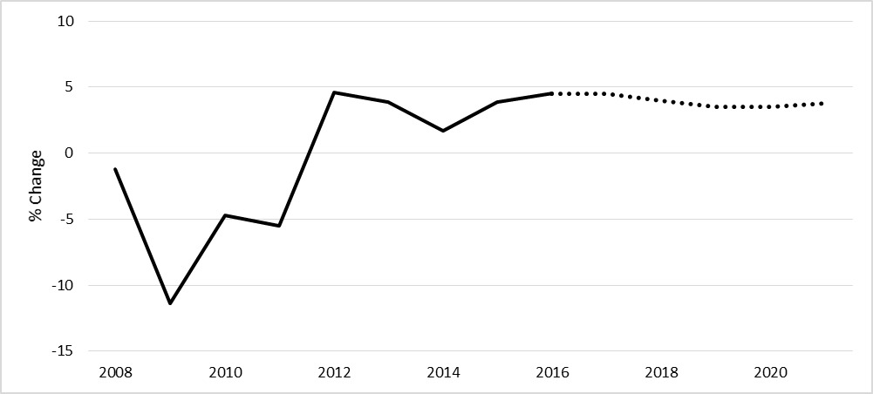

Growth in recent years

Projected growth

Source: Prepared by the author based on IBISWorld, “The Retail Market for Audio Equipment: Market Research Report,” Industry Report OD6122, September 2016, accessed March 21 2017, www.ibisworld.com/industry/the-retail-market-for-audio-equipment.html.

Exhibit 3: PERCENTAGE OF AUDIO EQUIPMENT rEVENUE through ONLINE channels in the United States

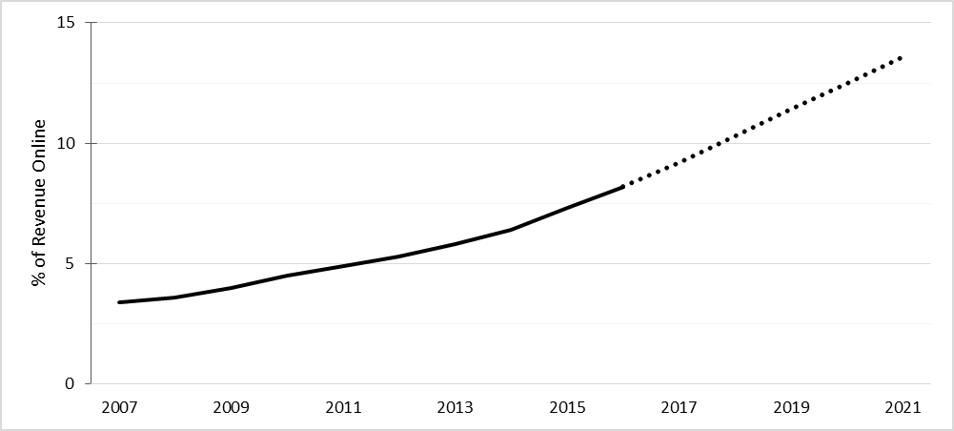

Recent years

Projected

Source: Prepared by the author based on IBISWorld, “The Retail Market for Audio Equipment: Market Research Report,” Industry Report OD6122, September 2016, accessed March 21 2017, www.ibisworld.com/industry/the-retail-market-for-audio-equipment.html.

Exhibit 4: McKinsey’s Waterfall Charts: Marketplace vs. Projected Direct E-tail

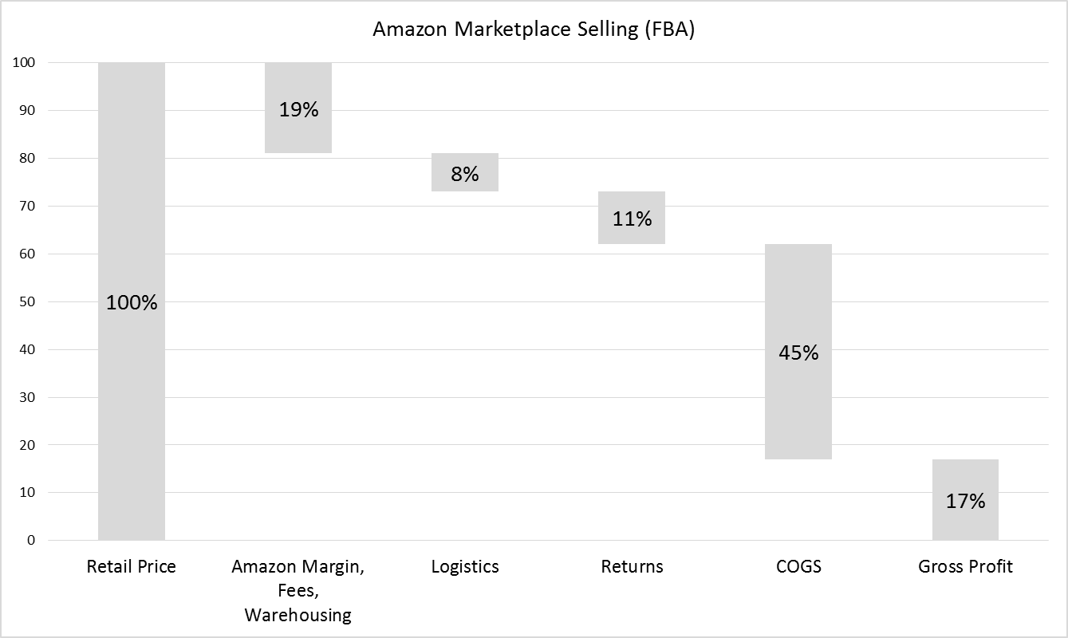

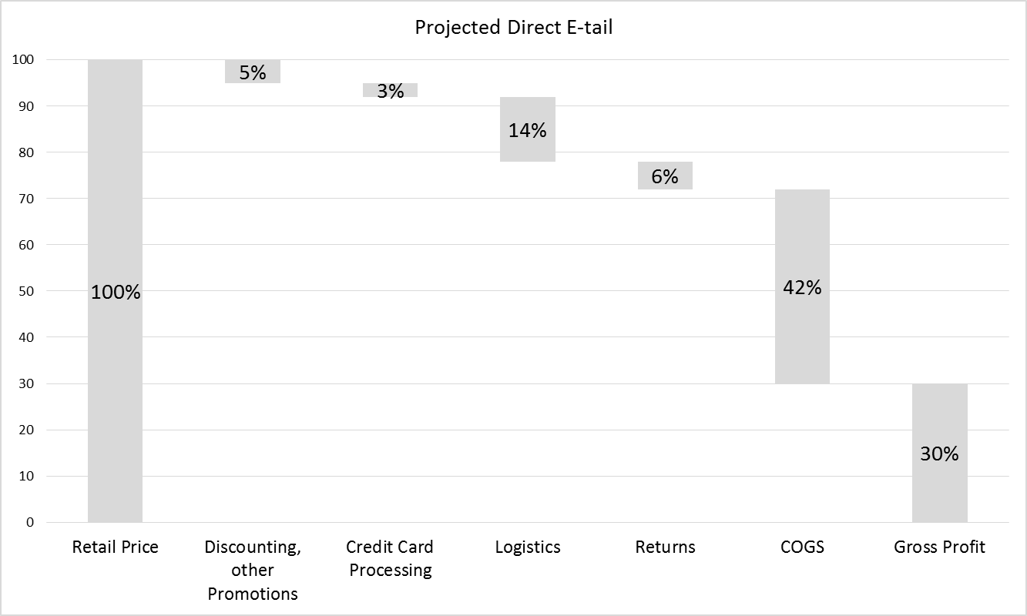Exhibit 4 (Continued)

Notes: FBA = fulfilment by Amazon; COGS = cost of goods sold.

All figures are disguised for competitive reasons. Marketplace partners report a wide range of margins achieved; these figures are for demonstration purposes only.

Amazon margin, fees, and warehousing includes credit card processing.

Logistics includes all shipping and handling costs not incurred by the customer, manufacturers, or Amazon (e.g., moving product from the manufacturer to Audio Advice’s warehouse, shipping to Amazon warehouses, and providing free shipping to direct e-tail customers).

Customer acquisition costs are not included in the charts above. Marketplace customer acquisition costs are relatively small (approximately $1.50 per customer). This was to promote products through Amazon as “sponsored products.” Direct e-tail acquisition costs for online promotional tactics (e.g., cost per click advertising) were expected to be more substantial (approximately $12.00 per new customer addition).

Average order value (AOV) through the Marketplace was approximately $160.00, with negligible customer retention through this channel. Goals for direct e-tail included average annual revenue per customer of $700.00 with 40 per cent annual customer retention.

Audio Advice used a 10 per cent interest rate for decision-making.

Source: Prepared by the author based on disguised company information and “Amazon Sellers Survey 2016: The Results,” WebRetailer, January 12, 2016, accessed May 25, 2017, www.webretailer.com/lean-commerce/amazon-sellers-survey-2016/#/.

1. All currency amounts are shown in U.S. dollars unless otherwise specified.
2. IBISWorld, “The Retail Market for Audio Equipment: Market Research Report,” Industry Report OD6122, September 2016, accessed March 21 2017, www.ibisworld.com/industry/the-retail-market-for-audio-equipment.html.
3. Amazon, “Q1 2016 Financial Results: Amazon.com Announces First Quarter Sales Up 28% to $29.1 Billion,” press release, April 28, 2016, accessed May 25, 2017, http://phx.corporate-ir.net/phoenix.zhtml?c=97664&p=irol-reportsother.
4. Retailgeek, “Jason & Scot Show Episode 24: Amazon Deep Dive,” podcast, May 1, 2016, accessed May 25, 2017, www.retailgeek.com/jason-scot-show-episode-24-amazon-deep-dive.
5. Christian Martin, “5 Myths about Selling on Amazon,” Entrepreneur, September 15, 2015, accessed May 25, 2017, www.entrepreneur.com/article/248775.
6. “Amazon Sellers Survey 2016: The Results,” WebRetailer, January 12, 2016, accessed May 25, 2017, www.webretailer.com/lean-commerce/amazon-sellers-survey-2016/#/.
7. “Amazon Sellers Survey 2016: The Results,” WebRetailer, January 12, 2016, accessed May 25, 2017, www.webretailer.com/lean-commerce/amazon-sellers-survey-2016/#/.