

9B17A037

KITKAT IN JAPAN (A): Sparking a cultural revolution

Philip Sugai and Adrian Sossna wrote this case solely to provide material for class discussion. The authors do not intend to illustrate either effective or ineffective handling of a managerial situation. The authors may have disguised certain names and other identifying information to protect confidentiality.

*This publication may not be transmitted, photocopied, digitized, or otherwise reproduced in any form or by any means without the permission of the copyright holder. Reproduction of this material is not covered under authorization by any reproduction rights organization. To order copies or request permission to reproduce materials, contact Ivey Publishing, Ivey Business School, Western University, London, Ontario, Canada, N6G 0N1; (t) 519.661.3208; (e)* [*cases@ivey.ca*](mailto:cases@ivey.ca)*;* [*www.iveycases.com*](http://www.iveycases.com)*.*

*Copyright © 2017, Richard Ivey School of Business Foundation* *Version: 2017-07-14*

In 2008, Masafumi Ishibashi, marketing manager for Nestlé Japan Co. Ltd.’s (Nestlé Japan) confectionery business, headquartered in Kobe City, in Hyōgo Prefecture, was wondering how he and his colleagues could continue to deepen the appeal and meaningfulness of KITKAT within the fabric of Japanese culture. Nestlé Japan was known for its popular KITKAT chocolate wafers. With competitors not only in Japan’s overcrowded confectionery market but also across a wide range of other packaged goods categories looking to capitalize on Nestlé’s successful KITKAT rebranding efforts, the prospects for another big step forward seemed difficult, if not impossible.

Ishibashi briefly wondered if the prospects were worsening for KITKAT’s continued growth. An optimistic person by nature, however, he had a hunch that KITKAT’s prospects were good. His review meeting with his marketing team would begin in an hour. It was time to review the final strategic options that would guide how Nestlé Japan would move forward with its classic KITKAT brand and usher in a new frontier for KITKAT in Japan.

DIFFERENT WORLDS, DIFFERENT TASTES

Japan was distinct from almost all markets in the West and East. With a total gross domestic product of more than US$4.8 trillion[1] in 2008 and an economy largely relying on household consumption and services, it remained one of the world’s most profitable markets for domestic and foreign brands alike.

At the same time, Japanese customers had been called the toughest in the world to satisfy.[2] This was clearly evident in the Japanese confectionery market, which was valued at $7.7 billion in 2008[3] and where more than 200 competitors were vying for a dominant position within the chocolate confectionery category. Indeed, there were so many within the sugar confectionery market that it was impossible to count. According to Datamonitor, within this $7.7 billion industry, $4 billion of sales (52 per cent) were driven by chocolate, followed by $2.47 billion (32.1 per cent) from sugar confectionery, $1.13 billion (14.7 per cent) from gum, and $0.77 billion (1 per cent) from cereal bars. It should be noted that global consulting companies consistently undervalued the size of Japan’s confectionery market, as Japan’s traditional *kashi* sweets were excluded from these analyses to match with measurement practices from other countries. Nestlé S.A.’s (Nestlé) KITKAT competed within the largest confectionery category against some of Japan’s, and the region’s, most powerful consumer brands, including Korea’s Lotte Co. Ltd. (Lotte), Japan’s Meiji Seika Kaisha Ltd., and Japan’s Ezaki Glico Co. Ltd. (Ezaki Glico).

Within Japan’s chocolate confectionery market, the Japanese palate called for less sweet chocolates and much smaller serving sizes than were preferred in the West. Overseas visitors were often surprised both by the general lack of foreign brands as well as the small sizes of packages found on sale. Nestlé Japan’s marketing research had concluded that chocolates in Japan sold best when packaged in ways that were “tiny, neat, and clean.”

While the Japanese chocolate market had grown exponentially after the Second World War, Japanese citizens ate considerably less chocolate than their Western counterparts, consuming less than two kilograms per capita per year (in Switzerland, the home of Nestlé’s headquarters, consumption was nearly five times that amount). This consumption pattern had been stable since the 1980s, with yearly consumption ranging between 1.5 and 1.9 kilograms. Such stable market conditions resulted in fierce competition for market share between newcomers and classic brands and products alike, as Japanese consumers did not increase their intake even as more products were introduced each year.

Occasions that internationally sparked seasonal peaks in chocolate sales such as Christmas, Halloween, and Easter did not have the same effect in Japan. The reason for this was that chocolate typically was not considered the appropriate gift in Japan. For example, chocolate sales did show a spike on Valentine’s Day (where women generally gave gifts to men), but this was mostly for branded boxed chocolate such as Godiva or its local equivalents and not for chocolate bars such as KITKAT. Also, it was still considered more appropriate to offer handmade chocolates as gifts instead. Men had the chance to reciprocate with gifts on White Day, a day manufactured by confectionery companies to boost overall confectionery sales.[4]

Overall, such holiday sales were laden with complicated and unfavorable terms for manufacturers such as Nestlé Japan. This was because manufacturers needed to allow for extremely high margins for retailers in order to make up for the loss of “dumping” sales after a specific holiday was over. This was not possible for a mass manufacturer like Nestlé Japan, as it could not increase the price point to double or triple its level without adding certain costs to consumers to cover the retailer’s margin. Because of this, many major confectionery producers avoided participating in such practices.

THE COMPETITION: CONFECTIONERY IN JAPAN

According to Datamonitor’s report on confectionery sales in Japan for 2008 (see Exhibits 1 and 2), chocolate sales accounted for more than 50 per cent of overall sales: [5]

Chocolate sales proved the most important for the Japanese confectionery market in 2008, generating total revenues of $4 billion, equivalent to 52.2 per cent of the market’s overall value. In comparison, sugar confectionery generated revenues of $2.5 billion in 2008, equating to 32.1 per cent of the market’s aggregate revenues.

Japan’s aging population crisis also influenced the slow confectionery market growth. However, analysts at Datamonitor projected an increase in future growth even in light of such market forces:

The Japanese confectionery market generated total revenues of $7.7 billion in 2008, representing a compound annual growth rate [CAGR] of 0.9 per cent for the period spanning 2004–2008. The performance of the market is forecast to accelerate, with an anticipated CAGR of 1.1 per cent for the five-year period 2008–2013, which is expected to drive the market to a value of $8.1 billion by the end of 2013.

As of 2008, only three manufacturers held a market share above 10 per cent. Lotte, Korea’s largest chocolate maker, held 19.6 per cent of the market; Japan’s Meiji Holdings, Co. Ltd. (Meiji), held 16.1 per cent; and Japan’s Ezaki Glico held 12.5 per cent. The remaining 51.8 per cent of the market was divided between nearly 200 other companies, each holding a relatively small percentage of the market.

Despite these harsh conditions and with a market share of a mere 3.1 per cent in 2003, Nestlé Japan had managed the feat of making the KITKAT brand the second most popular individual chocolate brand in terms of market share. As Ishibashi was preparing for his strategy-setting meeting, he and his team were weighing different options for reaching the number-one position.

THE HISTORY OF KITKAT IN JAPAN

Originally launched in 1935 in the United Kingdom by Rowntree Mackintosh Confectionary (Rowntree Makintosh), KITKAT had a long life as a classic British snack before being launched in Japan in 1973 under a license agreement with a local Japanese manufacturer named Fujiya Co. Ltd. (Fujiya). At that time, British products commanded a positive, upscale brand image, and based on this fact, the initial KITKAT brand story was built upon KITKAT’s British heritage. The global slogan, “Have a break, have a KITKAT” was used for its initial launch and was still being used in 2008 (see Exhibit 3).

In the 1970s and 1980s, the Japanese KITKAT advertising campaigns were heavily product-oriented, showing British people in distinctly British environments enjoying a KITKAT break between action-packed activities. The 1980s saw a gradual translation of this message into one that showed female Japanese celebrities interacting with and being in British environments. Where the previous communication focused on how foreign the product was, the 1980s message shifted to revolve around how Japanese people could enjoy life within the British context.

The biggest shift for KITKAT in Japan during the 1980s came through the change in packaging. In addition to the two- and four-finger bars, a new concept was introduced: the fun-size pack, which included smaller two-finger wafers in one large bag (see Exhibit 4).

In 1989, the Fujiya license agreement with Rowntree Mackintosh expired, and in that same year, Nestlé Japan created a joint company with Fujiya to continue bringing KITKAT to the country.

By the end of the millennium, KITKAT had come to serve as a staple product in the weekly grocery shopping at large supermarkets for mothers wanting simple and easy chocolate snacks for their children. “KITKAT was the chocolate that moms bought to give to their children,” Ishibashi remembered.

The fun-size packs were a mixed blessing for Nestlé Japan. While they bolstered sales in terms of gross volume, they also drove down earnings per kilogram of chocolate sold, and saw retail prices drop from ¥398 ($3.98)[6] to ¥298 ($2.98) a bag, significantly reducing Nestlé Japan’s margins.

THE RISE OF CONVENIENCE, THE SLOW DECLINE OF SUPERMARKETS

The 1960s ushered in the rapid expansion of Western-style supermarkets in Japan. This shift had a positive impact on the ability of manufacturers like Nestlé Japan to sell and advertise goods in bulk, with complex logistics systems reducing costs and providing an efficient way to reach customers.[7] By the early 2000s, the mismatch between the behaviors of shoppers and this economy-of-scale approach was becoming apparent.[8] A smaller, nimbler, logistically superior style of retailing was quickly gaining a foothold and taking precious customers from the traditional supermarkets—the convenience stores.

The convenience store, or *conbini* in Japanese, offered shoppers something that supermarkets could not—accessibility. What convenience stores lost in selection due to their smaller size, they made up for in terms of location, operating hours, and ease of shopping. While fun-size packs worked well in driving overall unit sales in larger supermarkets, shelf space and slotting fees would not accommodate such bulky, oversized packs in the *conbini* sales channel.

As the Nestlé Japan team reviewed the data on retail shopping trends and, especially, the increasingly important *conbini* channel in Japan, it could clearly see that shoppers were looking for easily consumable snacks during breaks within their busy schedules. This seemed to match well with the existing brand equity that Nestlé Japan had built for the KITKAT brand. Because the demographics of *conbini* shoppers skewed much younger than supermarket shoppers, Ishibashi and his team wondered exactly how this younger generation, especially high school and college students, thought about the breaks that they took in their increasingly hectic schedules.

Kentaro Fuji, the assistant marketing manager for the KITKAT brand, explained the *conbini* experience and its customers as follows:

The convenience store was a place that students, company workers, and pedestrians in cities across Japan could visit to buy most essentials. While mothers and their children would also shop in *conbini*, the mindset they had upon entering these shops was completely different than when they entered a supermarket. The fun-size pack didn’t fit with the *conbini*-inspired mindset, and the costs for placing these packs there were impossible to justify. It was doubly clear that if Nestlé wanted KITKAT sales to continue to grow at this time, we needed a new strategy.

After reviewing the retail sales figures and projections prepared by their advertising agency, Ishibashi and his team agreed that an entirely new marketing strategy was needed. While they had the capabilities to make, package, and distribute KITKAT through nearly all possible retail channels in Japan, they needed to find a new specific target customer segment. Nestlé Japan commissioned extensive customer research in search of this new segment and its needs, and was excited by the possibilities offered by an entirely different lightning rod target customer (LRTC)[9] segment—students.

THE PATH TO THE NEW LIGHTNING ROD TARGET CUSTOMER

To explore this new segment's needs, market research was conducted by asking high school students to use instant cameras to document what they perceived as “a break.” Without interference from interviewers or predefined survey questions, the students were allowed to create their own photo portfolios and collages. Students took photos with themes ranging from hot baths to sleeping on desks at school (see Exhibit 5). They defined a break as something that served as an escape from the stress of school, after-school sports, private school outside of normal school hours (*juku* in Japanese) and, most of all, the much-dreaded exam period (called *juken* in Japanese) that all third-year high school and junior high school students had to pass to be admitted into college and high school. The Nestlé Japan team came to define the breaks that these students took as “a break for both the body and the heart (or spirit).” Ishibashi recalled that

The most important insight that we obtained from our initial research was that an ordinary break in between everyday activities, such as a break between classes or short break during work time, was not perceived as “a good break” by respondents. Instead, they felt that “a good break” was one where they could accomplish something with no need to return back to their work or their studies. We learned that for years our TV commercials had been showing what our customers considered to be “bad breaks.” These were incredibly important and ironic findings. But after learning this, we began to consider what a KITKAT break should be and what sort of problems our consumers could solve during these breaks. After many long discussions, we concluded that a KITKAT break should be a “release from stress” so that a consumer doesn’t have to return to work. Finally, in our research, we also learned that the biggest sources of stress for our target consumers were studying, friendship, and dating.

THE CALL FROM KYUSHU

Yoshiki Sato, the president of one of the biggest chain-stores in Kyushu, was listening to mothers and their friends who would come into his small supermarket during the winter months of December, January, and February talking about the challenges that their children were facing during the *juken* season. He also knew that KITKAT sales were at their highest during these winter months. One day, he decided to ask some of these customers why they were buying KITKAT at this time of year, and the answer to this simple question set off a chain of events that would lead to a change in the very culture of Japan. Sato said,

The Japanese language is made up of a syllabary of specific sounds that limit the ability to pronounce foreign names exactly as they were intended—KITKAT is no exception. This customer explained to me that the name KITKAT sounded a lot like *kitto katsu*, which in the Kyushu dialect means “to surely win.” I knew that this would powerfully resonate with shoppers in my stores.

Sato immediately contacted the Nestlé Japan branch manager Kenji Suganami in Kyushu to discuss how to promote KITKAT by taking advantage of the phrase *kitto katsu*. Suganami then called Nestlé Japan’s headquarters in Kobe to ask them to create point-of-sales materials to promote KITKAT using this phrase. The KITKAT brand manager who received this call immediately declined this request, as he thought it was inappropriate to play with the KITKAT brand in this way.

However, Suganami was not someone who gave up easily, and the following year he again called the Kobe-based KITKAT team, this time asking to talk directly to Kohzoh Takaoka, the marketing director of Nestlé Japan’s confectionery business. Takaoka said,

When I received the phone call from Kyushu and heard the idea, I immediately thought that this was it! The research that the KITKAT team was doing had clearly found that students were under heavy stress because of the challenges they faced with their studies. And if we could develop KITKAT as a lucky charm, then that would become the real KITKAT “break” that we were searching for.

To transform KITKAT into a vehicle for breaks from stress and studying for exams, the team set out to create an entirely new experience, building upon the fundamental story about what KITKAT was and how the KITKAT message could be conveyed. Its next challenge was how to develop the most appropriate copy to accompany the “surely win” message. It was impossible for the team to completely change the brand, but slight modifications were feasible. The question was exactly where such modifications could be made without changing the fundamentals of the KITKAT brand.

*OMAMORI* AND *SAKURA*

Japanese culture was filled with rich metaphors and symbols, as the native Shintō religion emphasized relationships between human beings, nature, and various deities. One cultural outcome of the infusion of this philosophy into daily life in Japan was the *omamori* or good-luck charm. This was available at almost every Shintō shrine in Japan, where prayers for health, happiness, wealth, perseverance, and a wide array of other hopes and aspirations were standard. Each shrine offered more specialized charms for specific afflictions or hopes. These *omamori* were typically small and were meant to be carried by the owner in order for them to experience the positive effects.

For example, one of Kyoto’s most famous Shintō shrines was Kitano Tenmangū, in which a deity of education was enshrined. Each year, thousands of junior high school and high school students across Japan flocked to Kyoto to offer prayers and purchase *omamori* or even lucky pencils that had been infused with prayers from the Kitano Tenmangūshrine priests. Good-luck charms were in fact big business in Japan, and while official *omamori* were the original source of the cultural practice of carrying good-luck charms, in modern Japan even goods that had not been infused with prayers from a Shintō shrine were widely diffused and readily accepted.

The idea, then, that a box of KITKAT could be used as a good-luck charm to offer a student a wish of “winning without fail” was appropriate and offered a unique opportunity for an otherwise traditional chocolate-covered biscuit to evolve into a cultural icon.

Another cultural icon within Japan was the image of cherry blossoms. Although the chrysanthemum was the official flower of Japan, the cherry blossom, which bloomed briefly in the spring, served as one of the most popular and symbolic flowers in Japan. It was considered the harbinger of spring, and in fact, blossoming cherry trees were lit up at night so that families, couples, and even company teams could go out to the park or by a riverside with blooming cherry trees to enjoy a picnic and the fleeting beauty of the cherry blossoms each year.

Because of this revered position that the cherry blossom season held in Japan, blooming cherry trees were also equated with abundance and success. In fact, for years, telegrams had been used to announce if a student had passed or failed the entrance exam of a university. Often the expression “the cherry blossoms have bloomed” was used to accompany the news of a positive entrance exam result.

Eventually the team hit upon the idea of using the phrase “surely the cherry blossoms will bloom.” Once they had this basic idea, it was easy for the team to develop a key visual, which was a full cherry blossom with a KITKAT logo in the middle with the copy “the cherry blossoms have bloomed for you.” This key visual imagery became the icon for the entire KITKAT *juken* campaign.

With the new brand story, messaging, and designs ready to go, the Nestlé Japan team implemented its strategy across all of Japan in the winter of 2002–2003 (see Exhibit 6). It provided display support to retail stores across Japan (see Exhibit 7) and bought nation-wide advertising, and its focus gained the attention of news organizations across the country. In January 2003, Internet portal goo conducted a survey of its users regarding the best gift to give students who were studying for tests, who were called *jukensei*. *Omamori* received 45 per cent of the votes, taking the number-one position, followed by KITKAT, with 34 per cent of all votes.

DEEPENING THE IMPACT OF THE STORY

In both 2001 and 2002, Nestlé Japan held a steady 5.6 per cent share within Japan’s chocolate confectionery market, but winter 2002–2003 sales well exceeded previous sales figures, boosting Nestlé Japan’s overall market share to 6.1 per cent within this category. These results proved to the Nestlé Japan team that it had a winner on its hands, and Nestlé Japan was continuously on the lookout for ways to enhance this story and deepen the impact that it was having. Over the following four years, Nestlé Japan continued to promote KITKAT as the vehicle through which loved ones, family members, and friends could wish *jukensei* warm wishes and good luck as they struggled with the rigors of test-taking.

To further enhance this story, Nestlé Japan worked with regional hotels surrounding test-taking facilities and campuses, recommending that front-desk staff say “good luck on your exam” to stressed out and tired test-takers while giving them a *sakura*-themed KITKAT and a postcard with a special message that “the *sakura* [cherry blossoms] are sure to bloom” as they checked out of the hotel (see Exhibit 8). As Ishibashi explained,

The students who were traveling far from home in order to sit for the entrance exams were over-stressed for a number of reasons. And the hotel staff, although they could clearly notice that these students were struggling and tired, didn’t have anything beyond warm wishes or a smile that they could comfortably give to these young hotel guests. We decided to offer these hotels something a little different, and by allowing them to give KITKATs to these student guests as they checked out, together with a postcard that conveyed the message that “the *sakura* will surely bloom,” we created a win–win–win situation for the hotel, for the student, and for the KITKAT brand.

Between 2004 and 2008, the Nestlé Japan team also worked with local governments, train stations, and even community districts to create environments and messages that would support student test-takers. The team created KITKAT message opportunities on trains, buses, taxis, and train stations; even the famous Tokyo Tower was turned pink to celebrate the KITKAT “surely win” messaging (see Exhibit 9).

Throughout all of these efforts, the emphasis was on the symbol of luck that KITKAT was, not the chocolate inside—in effect, the Nestlé Japan team had managed to transform a chocolate bar into a vessel for offering support to someone who was facing a major life challenge. KITKAT had reached such widespread success in transforming into such a symbol that friends and family members were observed by the Nestlé Japan team to be writing messages around the theme of “relax and be prepared” on the boxes of KITKAT and then giving these boxes with such handwritten messages to test-takers. In some cases, friends or family members from afar would affix postage stamps on these message-laden boxes and send these through the mail to the student test-takers. However, as the box was not designed to be sent via postal mail, well-wishing friends and family members needed to purchase an extra envelope and pay a more expensive shipping fee because these KITKAT boxes and the bars inside were not optimized for being sent through the mail.

THE COMPETITION REGROUPS

As Nestlé Japan had now created this new brand story for KITKAT and found a previously untapped customer segment within Japan’s confectionery market, the success of its strategy led to a 150 per cent increase in year-on-year KITKAT sales between 2002 and 2007. However, this success unleashed copycat products not only within the chocolate and confectionery markets, but across other food and beverage categories as well.

For example, Meiji, Japan’s largest domestic chocolate manufacturer, also manufactured a wide variety of food-related products. One of these was a puffed potato snack called Karu. While Nestlé Japan never considered changing the name of the KITKAT brand, executives at Meiji went so far as to modify the name of their brand from Karu to Ukaru,[10] which in Japanese meant “to pass, be accepted, or admitted into a school.”

On one hand, this type of mimicry was an enormous compliment to the cultural shift that the Nestlé Japan KITKAT team had been able to accomplish. Far bigger rivals were attempting to use similar messaging and stories in their own advertising and promotional campaigns. However, the negative impact that these competitive messages could have on overall KITKAT sales and the brand story that Ishibashi and his team had worked so hard to create were significant and a potent threat to future growth.

Ishibashi and his team were convinced that something needed to be done to further develop the KITKAT brand. The question that remained was exactly what that should be.

Philip Sugai is a professor of marketing at Doshisha University, Graduate School of Business, Kyoto, Japan.

Adrian Sossna is the Marketing Manager at Trillium Incorporated, Tokyo, Japan.

EXHIBIT 1: OVERALL CONFECTIONERY SALES (VALUE-BASED) (2004–2008)

Source: “Confectionery Industry Profile: Japan,” Datamonitor, 2009, accessed April 7, 2017.

EXHIBIT 2: OVERALL JAPAN CONFECTIONERY SALES (VOLUME-BASED) (2004–2008)

Source: “Confectionery Industry Profile: Japan,” Datamonitor, 2009, accessed April 7, 2017.

EXHIBIT 3: “HAVE A BREAK, HAVE A KITKAT” ORIGINAL COMMERCIAL

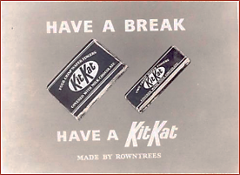

Source: Company documents.

EXHIBIT 4: KITKAT “FUN-size PACK” FOR GROCERY STORES

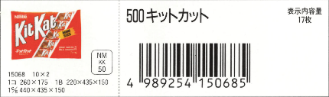

Source: Company documents.

EXHIBIT 5: HAVING A BREAK, NEW RESEARCH INSIGHTS

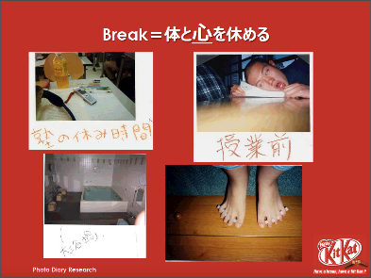

Source: Company documents.

**EXHIBIT 6: THE LAUNCH OF THE *JUKEN* KITTO KATSU CAMPAIGN, WINTER 2002–2003**

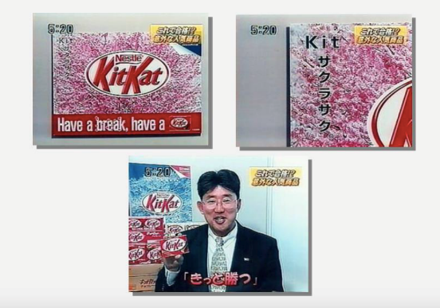

Source: Company documents.

**EXHIBIT 7: KITKAT IN-STORE DISPLAYS: KITTO KATSU (WIN WITHOUT FAIL!)**

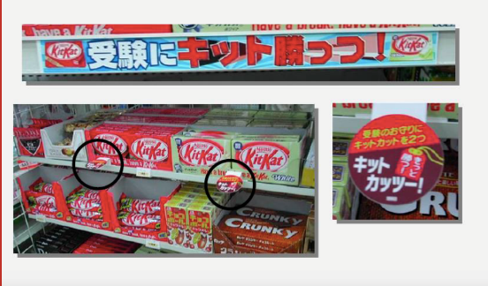

Source: Company documents.

EXHIBIT 8: “THE SAKURA WILL SURELY BLOOM” CARD AND KITKAT AT Hotel FRONT DESKs

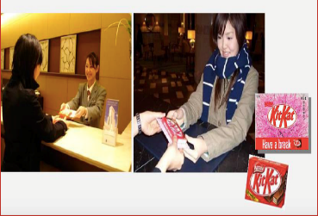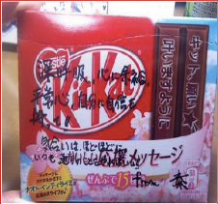

Source: Company documents.

**EXHIBIT 9: THE MANY COMMUNICATION CHANNELS FOR KITKAT**

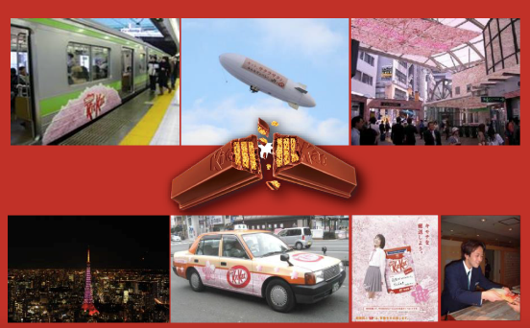

Source: Company documents.

1. Currency amounts are in U.S. dollars unless otherwise specified; “Japan GDP,” Trading Economics, accessed March 27, 2017, www.tradingeconomics.com/japan/gdp.
2. ToshihikoMiura, *Are Japanese Consumers Tough Consumers? Their Cultural and Modernistic Attributes and Marketing Strategy* (Tokyo: Yuhikaku Publishing, 2013), 43–69.
3. “Confectionery Industry Profile: Japan,” Datamonitor, 2009, accessed April 7, 2017.
4. “Valentine’s Day & White Day in Japan,” *Only in Japan*, accessed April 7, 2017, http://us.jnto.go.jp/blog/valentines-day-white-day-in-japan.
5. “Confectionery Industry Profile: Japan,” op. cit.
6. ¥ = JPY = Japanese yen; JP¥1 = US$0.10 on March 31, 2008.
7. Mikio Sumiya, ed., *A History of Japanese Trade and Industry Policy* (Oxford: Oxford University Press, 2000).
8. Chang-Ran Kim, “Sales Decline at Supermarkets and Department Stores in Japan,” *The* *Wall Street Journal*, January 26, 2000, accessed March 28, 2017, www.wsj.com/articles/SB948825501332595131.
9. The term “lightning rod target customer” was based on the concept presented in Mike Moser, *United We Brand*: *How to Create a Cohesive Brand That Is Seen, Heard, and Remembered* (Boston, MA: Harvard Business School Press, 2003).
10. Mynavi News, “今年も明治が受験シーズン限定特別版「ウカール」で受験生を応援! [Meiji cheers students for the examination season with limited special edition ‘Ukaru’]” December 18, 2012, accessed May 13, 2017, http://news.mynavi.jp/news/2012/12/18/061/.