

9B17A040

KITKAT IN JAPAN (D): A TRAJECTORY FOR FUTURE GROWTH

Philip Sugai wrote this case solely to provide material for class discussion. The author does not intend to illustrate either effective or ineffective handling of a managerial situation. The author may have disguised certain names and other identifying information to protect confidentiality.

*This publication may not be transmitted, photocopied, digitized, or otherwise reproduced in any form or by any means without the permission of the copyright holder. Reproduction of this material is not covered under authorization by any reproduction rights organization. To order copies or request permission to reproduce materials, contact Ivey Publishing, Ivey Business School, Western University, London, Ontario, Canada, N6G 0N1; (t) 519.661.3208; (e)* [*cases@ivey.ca*](mailto:cases@ivey.ca)*;* [*www.iveycases.com*](http://www.iveycases.com)*.*

*Copyright © 2017, Richard Ivey School of Business Foundation* *Version: 2017-07-07*

It was 2017 and the future of the KITKAT brand in Japan was at a critical juncture. Masafumi Ishibashi and Ryoji Maki sat down for a special meeting to review how Nestlé Japan Co. Ltd. (Nestlé Japan) had been able to instill deep meaning and create value not only for their customers but also for their employees, partners, and Japanese society as a whole. However, as they began to discuss their options for the future growth of the KITKAT brand, they needed to make some difficult decisions: Should they look to export the flavor variations that had become such big hits in Japan to overseas markets such as China, the European Union, or the United States, as travelers from these countries regularly bought a wide range of KITKAT flavor varieties during their trips to Japan to bring home? Should they focus on expanding the e-commerce sales of premium KITKAT flavors? Or was there another level to the overall KITKAT brand that they had overlooked and needed to evaluate for future growth? As they each considered how best to answer these questions, they kept in mind the events that had unfolded in the last few years.

Sweetness for Adults

Maki was promoted to manager of the KITKAT marketing department in 2010, and his first major initiative was to solve the issue of adults feeling that KITKAT was too sweet. Towards this end, Maki and his team conducted extensive research with KITKAT consumers and non-consumers, focusing especially on women aged 20–32, who they believed were their most important consumer segment. As Maki recalled:

Once our younger female consumers moved beyond the feeling of being a student, our early research showed that they would question their childhood sweets and look for more adult or sophisticated ones instead. If we could understand their views of KITKAT, we were confident that we could find a way to help KITKAT “grow up” together with them.

What they learned through subsequent research was surprising. Instead of having a preference for either a sweeter or less sweet KITKAT, they found that these young women were interested in both a sweeter KITKAT at one time and a darker, more adult KITKAT at others. Based on this feedback, Maki and his team decided that they would use their manufacturing capabilities to create a dark chocolate KITKAT with a lower amount of sugar so that it tasted less sweet and, together with a creative packaging design, looked more sophisticated. He and his team decided to call this lower sweetness level “sweet for the adult palate,” or in Japanese, “*Otona No Amasa*,” and to promote it equally alongside traditional KITKAT.

To help increase the impact of this new extension of the KITKAT brand, Maki together with Nestlé Japan’s’s advertising agency, J. Walter Thompson Japan, signed top talent Meisa Kuroki. Kuroki, one of Japan’s top female actors and television personalities, was the spokesperson for a new branding campaign focused on highlighting the two colors, flavors, and “moods” related to KITKAT, called the Red and Black campaign. Kuroki was able to portray characters both younger and older than her actual age, which made her perfectly suited to convey the “sometimes young, sometimes adult” message of the two different KITKAT flavor variations (see Exhibit 1).

With Kuroki officially signed, Maki and his team then developed a diverse, multi-channel integrated marketing campaign that conveyed a consistent message through television, print, radio, the Internet, and in-store displays (see Exhibit 2).

Launched on September 24, 2010, sales of the Otona No Amasa brand were positive and, together with all other marketing efforts across Nestlé Japan’s confectionery brands, helped to overcome the flat sales trends that the Nestlé Japan’s confectionery business faced in 2009. In fact, with the launch of KITKAT Otona No Amasa, KITKAT surpassed Ezaki Glico Co., Ltd.’s Pocky as Japan’s top-selling chocolate brand.

THE TōHOKU EARTHQUAKE: OVERCOMING HUGE CHALLENGES

On March 11, 2011, northern Japan was rocked by one of the highest-magnitude tremblors in modern history. Registering an astounding 9.1 on the Richter scale, and at the top level (7) on the Japanese rating of earthquakes, the earthquake unleashed devastation that day that shook the entire nation of Japan to its very core. While the world was captivated by the nuclear meltdown at TEPCO’s Fukushima nuclear plant, the devastating effects of the earthquake and tsunami had flattened entire cities and towns along Japan’s northeastern seaboard.

As KITKAT had become a symbol of good luck for those facing adversity, soon after basic public services were reinstated, boxes of KITKAT with handwritten messages of hope and encouragement were sent from people across Japan to those who were suffering (see Exhibit 3).

Ishibashi, Maki, and the entire Nestlé Japan team, whose headquarters in Kobe had also faced a devastating earthquake two decades earlier, understood that Nestlé Japan could not promote a brand that encouraged others to overcome challenges without committing their own company’s resources to doing the same during a time of crisis. They considered many options, but they ultimately chose to help rebuild the Sanriku Railway line that operated along the coast of the Iwate Prefecture. The tracks for this train line had been heavily damaged, knocking out transportation services throughout the Iwate coastal corridor. But in line with KITKAT’s message of overcoming difficult challenges, Sanriku Railway was also “seen as an icon of recovery, in that they re-started their operation on nearly 30 per cent of their tracks within just a few weeks of the disaster,” explained Maki.

By offering ongoing financial and moral support, Nestlé Japan helped rebuild the railroad tracks. It also chose to decorate the train cars with a cherry blossom motif and messages of hope and support for overcoming difficulty as part of an ongoing effort to bring cheer and hope to all residents in the area who were striving to return to normalcy (see Exhibit 4). During the launch of the renewed train service, riders could purchase a special KITKAT box called “Kippu KAT” (*kippu* meant “ticket” in Japanese), which, in lieu of an actual ticket, allowed them to board the train (see Exhibit 5).

Another project that Nestlé Japan chose to support was the rebuilding of a sports stadium that had also been destroyed on March 11 and that was central to the communities between Kuji City and Miyako City in Iwate Prefecture. With ongoing support, the baseball team supported by Nestlé Japan began playing in November 2014, and in 2016, the completely rebuilt stadium was opened to widespread positive media coverage. Most important from these activities was the demonstration of Nestlé Japan’s commitment to its core values, to helping people and entire communities overcome adversity, and to developing new hope and a new perspective.

KITKAT AS A PLATFORM FOR COMMUNICATIONS

As Japan began to return to normal in 2012, Maki and his team revisited the theme of enhancing interpersonal communications using KITKAT as the platform. High on his list was the Japanese workplace, which was notoriously subdued and where communications between colleagues, supervisors, and subordinates were difficult. Maki and his team decided to extend KITKAT’s power to serve as a communications platform within the Japanese workplace, and to do so it launched “Biz Choco,” which was sold as a boxed set of three smaller, two-finger KITKAT bars wrapped within plastic packaging that had an open space on the back to allow for a small message of cheer or challenge to be written.

As such efforts helped the KITKAT brand evolve and become a chocolate that adults enjoyed by themselves or shared with others, Ishibashi, who had now become the chief marketing officer for Nestlé Japan, wondered if it was now possible to bring KITKAT fully into the luxury category to compete with luxury chocolate manufacturers like Godiva and other imported chocolate brands. The reasons for this thinking lay within the underlying dynamics influencing Japan’s confectionery market and its projected levels of growth going forward.

According to Marketline’s 2015 Japanese confectionery market report[1], total confectionery market revenues reached US$9,432 million by 2014,[2] having grown at a compound annual growth rate (CAGR) of 0.6 per cent from 2010 (see Exhibit 6), with a total consumption volume of 498.7 million kilograms (see Exhibit 7). Japanese consumption of overall confectionery products grew at a compound annual rate of 0.5 per cent between 2010 and 2014 (see Exhibit 7). Marketline estimated in its 2015 report that growth in volume and revenue would remain sluggish for the coming five-year period at a 0.5 per cent CAGR through 2019 (see Exhibit 8). Finally, while chocolate confectionery made up 54.7 per cent of the total revenues within the confectionery market as of 2014, analysts at Marketline also predicted relative stability in chocolate sales versus other confectionery categories through 2019.

With the continued decline and aging of Japan’s overall population and an increase in the number of competitors within Japan’s chocolate confectionery market, Nestlé Japan could expect competition within the chocolate confectionery market only to become more severe. If volume and revenue were projected to remain flat, a move upwards into the premium category now seemed vital for Nestlé Japan’s future. But could the Japanese market truly accept a premium KITKAT?

RAMPING UP THE PREMIUMIZATION STRATEGY

Because KITKAT had already been successful in creating the local *meibutsu*-flavor variants, the KITKAT marketing team had come to understand how to effectively sell KITKAT to travelers across Japan. Railway stations in major hubs such as Tokyo, Shibuya, Shinjuku, and Osaka saw hundreds of thousands of travelers pass through each day. Railway station owners such as Japan Railways (JR) leased out small pop-up shops inside these stations to makers of sweets, snacks, and souvenirs.

Extending its collaboration with chef Takagi, Nestlé Japan decided to invest in pop-up shops in JR stations that would showcase the highest-quality, highest-priced KITKAT creations that chef Takagi could make. While the exposure was high and the feedback was positive from consumers, because the investment in these pop-up shops was also high, they were unfortunately not profitable. Ishibashi explained:

What we were missing was the ability for consumers to actually have a premium experience within a more luxury-themed environment. While the pop-up shops served as small storefronts, they didn’t allow for an experience of luxury. Just as Japanese KITKAT consumers had wanted to have a green-colored KITKAT to match the green tea ingredients and flavors, we saw very quickly that they also wanted to have the ability to see and experience luxury when purchasing a truly premium KITKAT.

Based on these insights, Nestlé Japan made the decision to move away from pop-up shops to a larger but more luxurious storefront within a high-end department store. As Maki explained,

Mr. Ishibashi and Mr. Takaoka first considered opportunities within the luxury, department store segment for the KITKAT brand even before the launch of Otona No Amasa (in 2010) or Biz-Choc (in 2012). As far back as 2006 or 2007, we experimented with the pop-up shop format. And after these trials, they sought avenues into department stores and actually held a number of meetings with executives there. Unfortunately, at that time, the response was not so positive because the department store industry at that time still hadn’t fallen into the sales abyss; they were not comfortable offering space to a mainstream brand like KITKAT. A few years later, the situation completely changed. The industry lost 40 per cent of total revenue and was strongly urged to revamp its business model. As part of these attempts to deliver new shopping experiences to their customers, department store executives finally became interested in the idea of opening a permanent KITKAT store.

After months of planning, the world’s first luxury KITKAT store, called the KITKAT Chocolatory, opened in the Seibu Department Store near Tokyo’s busy Ikebukuro Station on January 17, 2014. With the success of this first launch, seven more Chocolatory locations opened across Japan between January 2014 and December 2016.

These shops served as the foundation for the upscale image of Nestlé Japan’s premium KITKAT brand, which sold at ¥41,400 per kilogram, or at 28 times the price of a traditional KITKAT (see Exhibit 9). Deluxe flavors such as sublime raspberry and orange cocktail could be found in these shops wrapped in specialized packaging and with pastry chefs in uniform handling sales. To expand the sales reach of these premium Chocolatory outlets beyond these eight retail stores, rather than expensive pop-up shops in train stations, the Nestlé Japan team opened online e-commerce shops on Japan’s largest retailing websites, including Rakuten and Lohaco. But as of late 2016, sales of the higher-end KITKAT remained small compared to the other KITKAT product lines: In thinking about the future trajectory of the KITKAT brand, Masafumi Ishibashi commented on what he saw as the main challenge ahead:

We see the eight Chocolatory locations as showcases for premium ingredients and the approach that we take in creating the luxury KITKAT products we sell there. We believed that through these showcases, our consumers would like what they saw and then choose to continue to buy these premium KITKAT products through our e-commerce sites. However, as of December 2016, we have yet to see such a strong correlation emerge between the two. The head of our confectionery business is under extreme pressure to grow the e-commerce channel; although we have tried many approaches to date, we have yet to find a solution that resonates in a way that “Kitto Katsu” or KITKAT Mail have consistently done since their introduction. Our biggest challenge today is to figure this out.

As Ishibashi and Maki, who had been promoted to manager of the Nestlé Japan confectionery division in 2013, sat down to review their 2017 strategic options for KITKAT, they began their meeting by reviewing Nestlé Japan’s past successes. At the top of both Ishibashi’s and Maki’s minds was the stark reality that, because KITKAT in 2017 held the top position for an individual chocolate brand, many competitors were vying to unseat Nestlé from this position. New innovations such as chocolate infused with yoghurt cultures, the import and use of cacao beans from faraway exotic countries, and an ongoing interest in the new and unique by Japanese consumers meant that there was no guarantee that Nestlé Japan’s past successes would continue to pay dividends in the future.

As they began to review their options for the future growth of the KITKAT brand, they now needed to make some difficult decisions: Should they look to export the flavor variations that had become such big hits in Japan to overseas markets such as China, the European Union, or the United States, as travelers from these countries regularly bought a wide range of KITKAT flavor varieties during their trips to Japan to bring home? Should they focus on expanding the e-commerce sales of premium KITKAT flavors? Or was there another level to the overall KITKAT brand that they had overlooked and needed to evaluate for future growth?

Given that Marketline predicted that chocolate sales would grow at a meagre 0.5 per cent over the coming five years, Ishibashi, Maki, and the entire Nestlé Japan confectionery team were sure that these competitive challenges would only increase over time. The questions that they needed to answer revolved around how they should approach the coming five years to further enhance the value that the KITKAT brand could create and what strategy would enable such developments to unfold.

Could KITKAT truly continue to win without fail?

Philip Sugai is a professor of marketing at Doshisha University Graduate School of Business, Kyoto, Japan.

**EXHIBIT 1: MEISA KUROKI IN THE DEBUT RED AND BLACK ADVERTISING CAMPAIGN**



Source: Company documents.

**EXHIBIT 2: EXAMPLES OF THE RED AND BLACK INTEGRATED ADVERTISING CAMPAIGN**

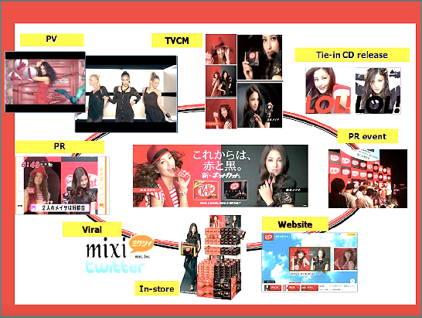

Source: Company documents.

**EXHIBIT 3: BOXES OF KITKAT SHIPPED TO DISASTER AREAS WITH MESSAGES OF SUPPORT**

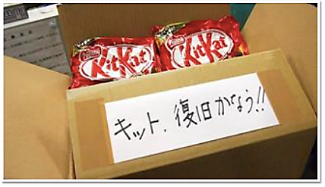

Source: Company documents.

**EXHIBIT 4: THE SANRIKU RAILWAY IN PARTNERSHIP WITH KITKAT**

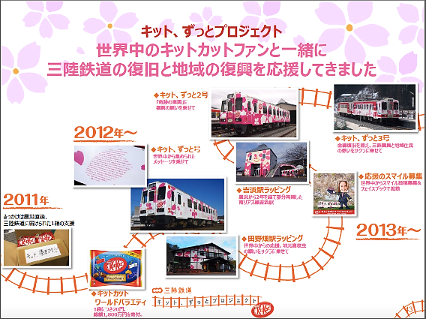

Source: Company documents.

**EXHIBIT 5: “KIPPU KAT” OR TRAIN TICKET KITKAT**

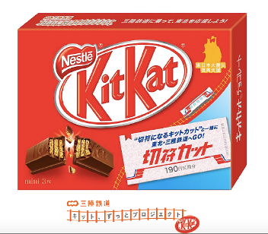

Source: Company documents.

**EXHIBIT 6: JAPAN CONFECTIONERY MARKET SALES (in $ Million), 2010–2014**

Source: “Confectionery in Japan, 2015,*”* Marketline industry report, accessed May 13, 2017, https://store.marketline.com /report/ohme5535--confectionery-in-japan/.

**EXHIBIT 7: JAPAN CONFECTIONERY MARKET VOLUME SALES (2010–2014)**

Source: “Confectionery in Japan, 2015,*”* Marketline industry report, accessed May 13, 2017, https://store.marketline.com /report/ohme5535--confectionery-in-japan/.

**EXHIBIT 8: JAPAN CONFECTIONERY MARKET SALES PROJECTIONS**

Source: “Confectionery in Japan, 2015,*”* Marketline industry report, accessed May 13, 2017, https://store.marketline.com /report/ohme5535--confectionery-in-japan/.

**EXHIBIT 9: PREMIUMIZATION PRICE POINTS**

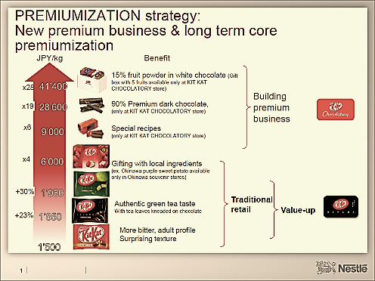

Source: Company documents.

1. “Confectionery Industry Profile: Japan. 2015,” Marketline, accessed April 7, 2017.
2. All currency amounts are in US$ unless otherwise specified; US$1 = JP¥101.88 on March 31, 2014.