

9B17A042

yalla momos: targeting the expatriate

Vimi Jham and Anupam Mehta wrote this case solely to provide material for class discussion. The authors do not intend to illustrate either effective or ineffective handling of a managerial situation. The authors may have disguised certain names and other identifying information to protect confidentiality.

*This publication may not be transmitted, photocopied, digitized, or otherwise reproduced in any form or by any means without the permission of the copyright holder. Reproduction of this material is not covered under authorization by any reproduction rights organization. To order copies or request permission to reproduce materials, contact Ivey Publishing, Ivey Business School, Western University, London, Ontario, Canada, N6G 0N1; (t) 519.661.3208; (e) cases@ivey.ca; www.iveycases.com.*

Copyright © 2017, Richard Ivey School of Business Foundation Version: 2017-07-25

On a Monday morning in April 2016, Prashant Goel and Ishan Goel, founders of a family-run Asian restaurant called Yalla Momos, walked the streets of Al Karama, a residential area in an older part of Dubai. As the two brothers strolled together, they reflected on when they had embarked on their entrepreneurial journey within the food industry four years ago in 2012, and discussed various ways of taking their business forward.

Yalla Momos was the first momo restaurant in the United Arab Emirates (UAE or the Emirates), serving the needs of expatriates (expats).[1] The Goel brothers specialized in making momos, a type of South Asian dumpling native to Tibet, Nepal, Bhutan, Sikkim state, and the Darjeeling district of India. Momos were similar to Chinese *baozi* and *jiaozi*, Mongolian *buuz*, Japanese *gyoza*, and Korean *mandu*. They were steamed and served with a rich, fiery orange curry sauce that excited the taste buds.

The Goels were struggling with mapping out a plan for the expansion of their business, deliberating what strategy to follow. How should they communicate the benefits of healthy, nutritious food to a wider target audience? Should they open more outlets? Would diversifying the menu bring them more customers or cause them to lose their core competitive advantage?

Humble Beginnings

Yalla Momos was located in Al Karama, an area of Dubai that was known as a gourmet’s playground. One could barely walk a block without seeing something enticing to eat, with the various stalls engaged in a competition for customers. In 2012, the Goel brothers started making and selling momos—Nepal’s answer to the Chinese dumpling—in this area. Their love for momos began on the streets of Nainital in India during the Goels’ boarding school days in the 1990s. Then, they devoured momos as an exciting treat that offered them a break from the endlessly bland meals of rice and lentils served at the boarding school.

The Goel brothers were originally from India, from a family whose main business was in the tobacco industry. Prashant moved to Dubai to undertake a master’s degree in business administration from the Institute of Management Technology. After completing his degree, he wanted to do something different from the family business and ventured into business in the food sector. Looking at the growth of the food industry in the UAE, Prashant started Yalla Momos. Ishan joined his brother in the business and they took it forward together. As long-time fans of this epicurean delight, they could not wait to bring momos to Dubai through their new restaurant, Yalla Momos.

YALLA MOMOS

Yalla Momos occupied a small corner café plot just across the road from the much larger Bikanervala restaurant in Al Karama and was popularly known as the first momo restaurant in the Emirates. The Goels bought the space from an Egyptian who had previously operated a food outlet there. This aspect of the deal helped the Goels avoid some of the hassles associated with licensing and other regulations that went along with running a restaurant in Dubai.

Yalla Momos started out with a basic kitchen and a sitting area with only four small tables and a dozen or so chairs. On the restaurant’s very first day of operations, the brothers sold 50 plates of momos within two hours, and Yalla Momos soon became a favourite place for people who were looking for healthy food options when eating out. After 10 months of operation, the Goels revamped Yalla Momos’ kitchen and eating area, increased its prices, and introduced four new varieties of vegetarian and non-vegetarian momos.

As a result of this early success, two years later, in 2014, the brothers opened a second outlet in Dubai’s International City district. The menu was simple and the price for momos ranged from AED 10 to AED 14.[2] Yalla Momos offered vegetarian and non-vegetarian selections, and customers had the choice of adding beverages and other items to their order (see Exhibit 1). Variants like Tandoori momo and Afgani momo were added at a later point. The restaurant’s selling point was simple and nutritious food, and doing it all well. The Goels used a central kitchen at their International City outlet from where the momos were distributed to the Al Karama outlet and other temporary locations.

Dubai’s Food Sector

In 2014, the UAE food and beverage sector was in a growth phase. KPMG (Klynveld Peat Marwick Goerdeler), a professional auditing company, estimated that 1,600 food and beverage outlets would open in the Emirates by 2019. KPMG also estimated in 2012 that the sector would grow at an average of 4 per cent per annum over the next four years. Statistics showed that people in the Emirates ate out at least once a week, and word-of-mouth reviews and social media were primarily what influenced people’s decision to dine in a particular restaurant.[3] Research in the UAE market suggested that people were looking for healthy dining options.[4]

Dubai was a sought-after destination for people around the world to come to live and work. Factors such as good infrastructure, safety, and a tax-free economy were the major attractions for expats. Of the total UAE population, more than 80 per cent were expats, and of this group, over 50 per cent were South Asians.[5] More than 1.5 million Indian nationals lived in the Emirates, which made the Indian nationals the single largest expat community in Dubai.[6]

A 2016 survey of the Dubai market examining food consumption of the expat population in the Emirates suggested that one in three expats included fresh fruits and vegetables in their everyday diet. Having healthy, nutritious food was the choice of the target audience. As well, UAE’s Ministry of Health had launched a “Healthy Restaurant Inititaive” in 2016.[7] The time was right for Yalla Momos to step into the market and achieve success.

The Emirates did not lack opportunity; however, what it *did* lack was originality and variety in the middle- to high-end dining market. International restaurant chains may have dominated the market through spaces such as shopping mall food courts, but nearly every one of the 200 expat communities in the country could choose from at least one restaurant that served their home country’s cuisine, usually at bargain prices.[8] If some of these small, community-based cafés could expand to offer their fare to a wider audience, they would not only help to grow the small business sector but they would also ensure that all restaurant-goers in the Emirates would have a distinct and enjoyable restaurant experience whenever they went out to dine.

In 2015, the total market size of all food service activities in the Emirates reached AED 57.8 billion, placing the UAE among the top 20 countries in the world.[9] This thriving market offered a golden opportunity for medium-sized Yalla Momos to provide nutritious offerings with affordable prices and great taste for diners who were bored with the mainstream restaurants in the expat community.

THE SOUTH ASIAN EXPATriate

The Goels identified some consumer attributes that they needed to consider when developing their marketing strategy. For example, among South Asian women, 16.7 per cent of those who had lived in the Emirates for 10 years had developed Type 2 diabetes due to an easily accessible and affordable high-calorie diet and a lack of regular physical exercise.

The expats who migrated from low-income, developing countries also experienced a change in their nutrition and in their physical activity. Since it was easy to access public transportation in the Emirates (i.e., buses, the metro, and taxis), the physical activity of this group decreased, which led to the expats preferring fewer carbohydrates and more proteins, fruits, and vegetables; they also exercised and walked after a meal.[10] In addition, these expats wanted to follow a healthy diet since falling ill caused a huge financial burden for them.

The government organized ongoing health awareness campaigns, which affected consumers. A study in the UAE revealed that children in that country were 1.8 times more obese than children in the United States, and for that reason, parents had begun to seek out healthy food options for their children, both at home and when eating out. According to a survey by KPMG, 66 per cent of residents in the Emirates ate out at least once a week due to the fast-paced national lifestyle.[11]

The Goels had identified these demographic factors as an opportunity to provide momos as a healthy food option that would also alleviate the boredom that expats faced when eating traditional country-specific food.

While examining the food market, the Goels concluded that there was a young expat population who enjoyed having momos at the end of their workday. The school-aged and university-going children of the expats also relished momos; both segments were in an experimental frame of mind and were looking for healthy and tasty options. Many of the young, working expats were unmarried and often visited the outlet with their friends to eat or celebrate certain occasions. They, too, were looking for a nutritious snack.

The Goels believed that the young working expats, children, and teenagers represented the most lucrative customer segment. They understood the needs of their target segment and therefore added masala fries to Yalla Momos’ menu. This addition offered clients a food selection that was mostly comprised of healthy food, but offered a few indulgent options, and it boosted Yalla Momos’ ability to reach out to its target audience.

The Journey to success

In Dubai, momos had rapidly grown in popularity as a nutritious and affordable snack, and since momos were not on the menu at any of the branded restaurants, the Goels saw an opportunity for Yalla Momos to expand. They believed in providing freshly cooked food, using high-quality cooking ingredients, and offering good value for the consumer’s money. Yalla Momos’ competition came from Chinese-styled dim sum, Ping Pong (a dumpling restaurant), Nepalese and Indo-Chinese restaurants (see Exhibit 2), and neighbouring fast-food outlets such as Burger King and Kentucky Fried Chicken. The brothers realized they could differentiate their own food offering by educating people on the nutritional value of momos and providing excellent service.

Prashant gathered feedback from customers on a regular basis, and his findings suggested that customers wanted a high standard of service, minimum wait times, and promotional offers. At Yalla Momos, the food was served fresh and hot, the nutritional value was high, and the environment was relaxing. Prashant knew that emphasizing these factors would assist in fostering a positive mindset in his customers and would help the business to grow. Cleanliness, health, and hygiene were also priorities for the customers.

Dubai’s food market was on a path of expansion for niche products, and Yalla Momos was able to make the most of this situation by capitalizing on its ability to satisfy consumers’ desire for a nutritious product with affordable pricing and great taste. Yalla Momos had shown constant growth since its inception, with sales increasing from AED 55,000 in 2012 to AED 150,800 in 2015 (see Exhibits 3 and 4).The brothers started out with a staff of three, and that number had increased to eight by 2015.

MARKETING STRATEGY

The Goels’ marketing strategy was based on creating a memorable experience for every customer who visited the restaurant. The brothers relied on social media and referrals to penetrate the market and reach their target audience.

Creating a Positive Customer Experience

Momos were steamed, not fried, and they were favourites of people who sought a quick, healthy meal. Yalla Momos targeted young Asian expats who were leaving work at the end of the day, feeling hungry and looking for a healthy option to satisfy their hunger. The restaurant’s menu offered momos for both vegetarians and non-vegetarians, along with the highly popular option of Maggi noodles (i.e., instant noodles).

From the outset, the pricing at Yalla Momos was reasonable, with the brothers employing a markup pricing strategy. In this model, pricing was calculated by adding all fixed and variable expenses.[12] In pricing their products, the Goels took into account raw material, salaries, rent, and a markup of 30 per cent. With this pricing strategy, Yalla Momos was able to turn a profit while remaining true to its overall mission of making momos a convenient, affordable, and nutritious snack.

The Goels provided an environment where customers could relax and enjoy their food. Inside the restaurant, the walls featured quotations that enhanced the brand and created an ambience that aligned with the exclusive offerings on the menu (see Exhibits 5 and 6). Customers could relate the momos to these quotations, creating an impact that ensured the product stayed present in their minds. The customers’ beliefs and perceptions regarding the brand were reinforced by the product, the ambience, and the high quality of the overall dining experience. Wait times were kept to a minimum, with the food being served within a maximum of 15 minutes. The customers had the option of sitting inside, or outside where the Goels had set up comfortable seating and large umbrellas to provide shade.

Eventually, the Goels introduced home delivery service and online ordering, giving their customers the convenient option of enjoying momos at home. Yalla Momos took care to ensure that the food reached the take-out customer just as steamy, hot, and fresh as it was when the consumer dined at the outlet. In accordance with this strategy, Prashant and Ishan oversaw a Facebook campaign that was later accompanied by listings on Zomato (a site with social media listings and restaurant ratings), and they supplied momos for various events and fairs, such as concerts at Wonderland (a theme park). Yalla Momos was even featured in a few magazine articles in 2015. Other initiatives for gaining exposure included a kiosk at the government’s Project Glow Garden (an entertainment garden) and a call centre module (customers called a toll free number), both of which were initiated later in 2015. Overall, the business depended on referrals and word-of-mouth marketing.

Social Media Use in the United Arab Emirates

According to a study of social media use, 88 per cent of the Middle Eastern population used social networking sites on a daily basis. For business purposes, social media helped to establish brands and respond to customers’ concerns, improving business performance. Products received recommendations from social channels, and buying decisions were influenced by different social media platforms. For these reasons, results-oriented social media engagement was important for business development.[13]

Social media was used strategically for business development in the Emirates, with 30 per cent of the Middle Eastern population ranging between the ages of 15 and 29 years. This age group represented the most common users of social media, and engaging with this target audience would benefit any business.[14]

Zomato was launched in 2012 in the UAE, and it soon became consumers’ method of choice for ordering food. Over 600 calls were made and recorded every month to restaurants that used Zomato’s app and website. Zomato listed 16,000 restaurants in the UAE and featured 400,000 ratings and 150,000 reviews by users.[15]

The Goels discovered that teenagers, when they came into the restaurant to dine, were interested in taking pictures of their food when it was served and sharing the pictures with friends on Instagram. The Goels saw this behaviour of young consumers as an opportunity to make Yalla Momos “go viral” on social media, followed by immediate reviews. More than 40 per cent of consumers read reviews online before visiting a restaurant for the first time.[16]

Harnessing the Power of Social Media

Yalla Momos employed a combination of social media and interpersonal communication messages to promote the tangible and intangible aspects of its brand. In this way, a great sense of anticipation was built for the consumer. Yalla Momos received more than 7,000 Facebook “likes,” and more than 2,000 people had checked in on the Facebook page by January 2016. Zomato gave Yalla Momos the “Most Pocket Friendly Award,” and Timeout Dubai rated it as “the best dim sum restaurant” in Dubai. Average reviews on Facebook stood at 4.4 (out of five) stars. Customer reviews for Yalla Momos on Zomato and TripAdvisor were largely positive, with five star ratings (see Exhibit 7).

However, not all reviews were positive, with one reviewer saying that “the filling was too garlicy and nothing else. Had been there with a lot of expectations but was hugely disappointed.” After receiving that negative review, the team at Yalla Momos immediately responded:

First of all, thanks for visiting us. It really breaks our heart that we couldn’t live up to your expectations. This really is rare when our popular momos have let our guest down. To make up for it, we extend an invitation to you to drop by any day [in the] coming week to help us fix what you found missing. For us, every guest matters and we would like to address the concern [as soon as possible].

The Goels addressed customer reviews on social media on a priority basis, and every effort was made to satisfy the client. Based on these reviews, Yalla Momos started a program called “Momos Monday,” when two plates of momos were given free to the first three people who posted on Facebook on a given Monday. Tastecapade, the first online booking website in the UAE, featured Yalla Momos as one of the top 10 pocket-friendly eateries in Dubai. The restaurant posted a variety of pictures on its Instagram account to let customers know about its latest offers (see Exhibit 8).

The future of Yalla momos

Yalla Momos had succeeded with its expat customers in Dubai with its high-quality food offerings and an ambiance that revived patrons’ nostalgic feelings of being at home. The restaurant reported an increase in sales from 2012 to 2015, but the owners still felt the heat of the competition, especially from new restaurants like Momos Magic and Moshi, which had kiosks installed in food courts in malls throughout Dubai (see Exhibit 2).

The brothers had an option to reinvest their earnings in a kitchen remodeling, which would allow them to introduce a new menu with even greater variety. Additionally, they felt a need to invest in the overall branding of their business in order to harness consumer loyalty and encourage repeat purchases. The Goels had been successful in their efforts to introduce a distinctive and nutritious food option to Dubai’s restaurant market. With that challenge met, they wondered what their next step should be. Should they expand the menu by adding a different variety of momos or diversify it by adding food items besides momos? Whatever course of action they chose, both partners felt strongly that their core offering of nutritious and affordable food should remain the same.

Exhibit 1: menu optionS at yalla momos

|  |  |  |  |
| --- | --- | --- | --- |
| **Vegetarian Momos** | **Non-Vegetarian Momos** | **Additions** | **Beverages** |
| Vegetarian | Chicken | Homemade Masala Fries | Oreo Shake |
| Spinach and Cottage Cheese | Shrimp | Masala Maggi | Hot Coffee |
| Nutri Cheese Mushroom | Beef | Wai Wai | Cold Coffee |
| Cottage Cheese | Mutton | Wai Wai Chat | Water |
|  | Chicken 3C | Apple Pie Momos | Soft Drink |
|  |  | Limca |

Source: Company documents.

Exhibit 2: the Competition

|  |  |
| --- | --- |
| **Restaurant Name** | **Price Range for Two People (in AED)** |
| Moshi Momo: Offered a fusion of Nepalese and Japanese delicacies | 110 |
| Momo Magic: Specialized in street food and fast food | 50 |
| Momo Restaurant: Fast food, Arabian, Middle East, Indian, Chinese | 60 |
| Real Momos: Nepalese fast food | 50 |
| Yak & Yeti: Nepalese food | 200 |

Source: Created by the author.

Exhibit 3: Yalla momos’ Monthly Average Sales since inception

|  |  |
| --- | --- |
| **Year** | **Sales (in AED)** |
| 2012 | 55,000 |
| 2013 | 117,282 |
| 2014 | 141,136 |
| 2015 | 150,800 |

Source: Company documents.

EXHIBIT 4: yalla momos INCOME STATEMENT (in AED, except where indicated)

|  |  |  |  |
| --- | --- | --- | --- |
| **Variables** | **For the year ending 2015** | **Projected Income Statement 2016** | |
|  |  | (without expansion) | (with expansion) |
| Net revenue | 504,000 | 554,400 | 727,200 |
| Cost of revenue | 231,800 | 254,480 | 332,240 |
| Raw material | 138,600 | 181,800 | 181,800 |
| Direct labour | 83,160 | 109,080 | 109,080 |
| Other expenses (cooking gas, utilities, etc.) | 32,720 | 41,360 | 41,360 |
| Gross profit | 272,200 | 299,920 | 394,960 |
| Operating expenses |  | | |
| Rent | 68,000 | 75,000 | 80,000 |
| Salaries | 24,000 | 30,000 | 33,000 |
| Administrative costs | 20,000 | 28,000 | 34,000 |
| Depreciation | 12,000 | 14,000 | 19,000 |
| Advertisement cost | 0 | 8,000 | 12,000 |
| Operating profit | 132,400 | 127,860 | 194,780 |
| Interest | 15,000 | 15,000 | 22,000 |
| Net profit | 117,400 | 112,860 | 172,780 |
| Operating profit margin (%) | 26.00 | 23.00 | 27.00 |
| Gross profit margin (%) | 54.01 | 54.10 | 54.31 |
| Net profit margin (%) | 23.00 | 20.00 | 24.00 |

Source: Company documents.

Exhibit 5: YALLA mOMO outlet interiors

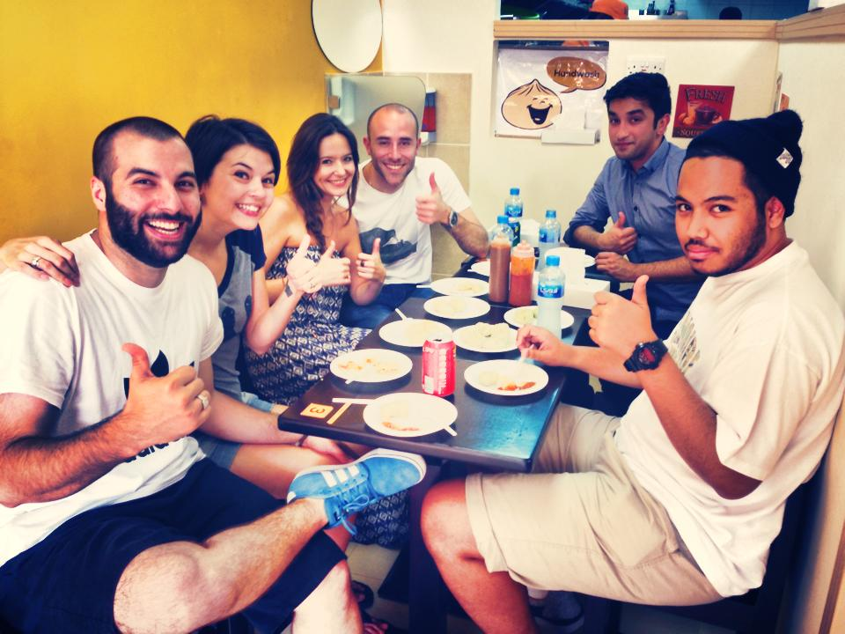

Source: Company documents.

EXHIBIT 6: QUOTations ON THE WALLs at Yalla Momos



Source: Company documents.

Exhibit 7: CUSTOMER REVIEWs ON ZOMATO AND TRIPADVISOR

|  |
| --- |
| * For the first time I stepped into this cafe and everything was yum....from the tandoor spicy chicken momos, shrimp momos, masala fries, chocolate brownie momos and limca masala. The kids loved the cupcakes since they were displayed for Christmas. Would surely come back here again. Prices are worth the quality of food. * Love coming here for a quick casual bite, their cheese and mushroom momos are by far my favourite! I have tried the prawn and veg mix momo but it wasn't as delicious as the cheese. With a side of masala fries and hot chai my meal is complete. I enjoy their chai when I have a flu it's rich with ginger a great detox. I have tried their brownie momo and I would only recommend that to those who have a sweet tooth as it might be too rich for someone not too fond of sweet/sugar. * Good food and quick delivery. Loved the vegetable and chicken momos. The masala maggi was pretty good as well. Perfect place for a quick hunger pang fix and easy on the pocket as well. * If you are a fan of momos then this is a place for you. Very small eatery with outdoor seating. Serves variety of Veg and Non Veg momos with some sides as well. They also have Tandoori Momos which we did not try but would that too some other time. |

Source: “Yalla Momos Reviews,” Zomato, accessed February 2, 2017, www.zomato.com/dubai/yalla-momos-al-karama/reviews; “Review of Yalla Momos,” TripAdvisor, accessed February 2, 2017, www.tripadvisor.co.za/ShowUserReviews-g295424-d5888648-r430994392-Yalla_Momos-Dubai_Emirate_of_Dubai.html.

Exhibit 8: Instagram feeds



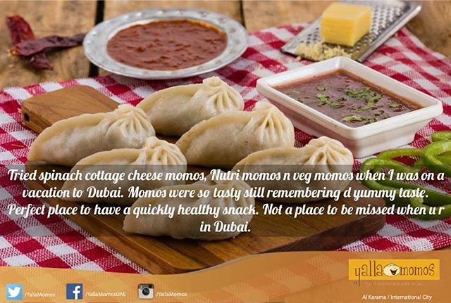



Source*:* Yalla Momos’ Facebook page, accessed July 5, 2017, www.facebook.com/YallaMomosUAE*.*

1. “Welcome to Yalla Momos,” Yalla Momos, accessed February 2, 2017, www.yallamomos.ae*.*
2. AED = Arab Emirates dirham; US$1 = AED 3.66 on March 12, 2016.
3. “UAE Food and Beverage Survey,” KPMG News and Media, accessed December 18, 2016, https://home.kpmg.com/ae/en/home/.../06/2015-uae-food-and-beverage-survey.html*.*
4. Sajila Saseendran, “Dubai Plans Rules to Offer Healthier Food Options,” Gulf News, October 24, 2016, accessed December 16, 2016, http://gulfnews.com/news/uae/health/dubai-plans-rules-to-offer-healthier-food-options-1.1918033*.*
5. “Dubai Population and Nationalities,” Guide 2 Dubai, accessed December 8, 2016, www.guide2dubai.com/visiting/tourist-information/uae-population*.* 
6. Ibid*.*
7. “Healthy Eating Habits Are Increasing for the UAE Expats—Survey,” AME Info, January 21, 2016, accessed February 2, 2017, http://ameinfo.com/money/economy/healthy-eating-habits-among-uae-expats-increasing-survey*.*
8. “Food for Thought for Entrepreneurs,” *The National*, May 19, 2015, accessed March 2, 2016, www.thenational.ae/opinion/editorial/food-for-thought-for-entrepreneurs*.*
9. “Dubai Chamber Reviews the Status of the Food and Beverages Sector,” *Dubai Chamber*, September 2, 2015, accessed February 26, 2016, www.dubaichamber.com/en/news/dubai-chamber-reviews-the-status-of-the-food-and-beverages-sector*.* 
10. “South Asian Women Who Live in UAE More at Risk for Diabetes, Study Finds,” *The National*, February 24, 2017, accessed April 12, 2017, www.thenational.ae/uae/south-asian-women-who-live-in-uae-more-at-risk-for-diabetes-study-finds*.*
11. “One in Three UAE Expats Follow ‘Healthy Diet,’” Gulf News, January 24, 2016, April 12, 2017, http://gulfnews.com/news/uae/health/one-in-three-uae-expats-follow-healthy-diet-1,1659134*.* 
12. Philip Kotler and Kevin Lane Keller, “Developing Pricing Strategies and Programs,” in *Marketing Management*, 13th ed. (Upper Saddle River, NJ: Pearson/Prentice Hall, 2008), accessed July 5, 2017, www.mktgsensei.com/MKTG478/kotler_mm13e_media_14.ppt.
13. “Social Media Usage in Middle East: Statistics and Trends,” GO Gulf, June 4, 2013, accessed April 17, 2017, www.go-gulf.ae/blog/social-media-middle-east*.* 
14. Ibid*.*
15. “Zomato Launches Online Ordering in UAE to Move Its Massive Call Ordering Volume to Its App,” Thomson Reuters, Zawya, September 3, 2015, accessed April 17, 2017, www.zawya.com/mena/en/story/Zomato_launches_online_ordering_in_UAE_to

    _move_its_massive_call_ordering_volume_to_its_app-ZAWYA20150903125218*.*
16. Rohit Nair and Nivriti Butalia “Eating Out is on Everyone’s Menu in the UAE,” *Khaleej Times*, January 14, 2016, accessed April 18, 2017, www.khaleejtimes.com/lifestyle/food/eating-out-is-on-everyones-menu-in-the-uae.