

**9B17A043**

NewStar marine & scooter: Growing a family business

Spencer Wiechert wrote this case under the supervision of Ethan Pancer solely to provide material for class discussion. The authors do not intend to illustrate either effective or ineffective handling of a managerial situation. The authors may have disguised certain names and other identifying information to protect confidentiality.

*This publication may not be transmitted, photocopied, digitized, or otherwise reproduced in any form or by any means without the permission of the copyright holder. Reproduction of this material is not covered under authorization by any reproduction rights organization. To order copies or request permission to reproduce materials, contact Ivey Publishing, Ivey Business School, Western University, London, Ontario, Canada, N6G 0N1; (t) 519.661.3208; (e)* [*cases@ivey.ca*](mailto:cases@ivey.ca)*;* [*www.iveycases.com*](http://www.iveycases.com)*.*

*Copyright © 2017, Richard Ivey School of Business Foundation* *Version: 2017-07-26*

It was early morning on February 28, 2017. Norman Wiechert, owner of NewStar Marine & Scooter Inc. (NMS), sat at his kitchen table reviewing the end-of-year financial statements for 2016. He and his wife, Dalyce Mallion, were aging entrepreneurs who operated a unique family business in Eastern Passage, Nova Scotia. As a retail shop, NMS offered a diverse range of products, including a line of inflatable boats, aluminum boats, outboard motors, and trailers, as well as a line of electric bikes, scooters, and mobility scooters. In its three years of business, sales had tripled from CA$198,000[1] in 2014 to $600,000[2] in 2016. Although the direction for the company had always been positive, near the end of 2016, Wiechert started to struggle with added responsibilities, unhappy employees, a lack of facility space, and poor-quality products. For NMS to continue its remarkable growth, Wiechert needed to rethink his operational and marketing strategies.

Wiechert was considering several ideas, but nothing was concrete. He first considered moving the entire business closer to the city (downtown Halifax was a 30-minute drive away) and transforming a large warehouse into a stunning showroom. He could then split the stock and move the scooter business into a smaller shop downtown. If Wiechert did not move, he could make better use of the current land by redesigning a completely new building or at least an add-on structure that provided more indoor space. Mallion liked this idea because a newer building could reduce future maintenance costs. On the other hand, Wiechert worried about the loss of revenue and customer loyalty while his location was under construction. As Wiechert contemplated a new direction for the business, he began to consider selling the business and harvesting the investment. He and Mallion were nearing retirement, and this could be an opportunity to sell while the business was still growing.

Wiechert left his home office to open the showroom for 10:00 a.m. That day, a married couple stopped in and complimented Wiechert’s great customer service and beautiful seaside location. This comment had him thinking—maybe he didn’t need to make any major changes after all. He was torn. NMS had no well-defined growth plan, which made the implementation of any plan a much more difficult task.

COMPANY BACKGROUND

Wiechert, aged 53, never attended university to study business. He was a tool and die journeyman who had always had an interest in boating as a hobby (see Exhibit 1). His entrepreneurial spirit first led him to real estate as the founder of NewStar Properties. Mallion now operated this 15-year-old property development business, which consisted of three apartment buildings and generated just over $400,000 in annual gross revenue. When Wiechert had completed all major renovations for his property business, he began actively looking for another opportunity to generate additional income. In 2011, he started a small proprietorship, buying and selling a no-frills brand of small outboard motors (i.e., APS outboard motors) out of a rented storage unit. He soon expanded his product line to include an affordable brand of inflatable boats, and eventually added a line of scooters.

NewStar Marine & Scooter Inc. was officially started in September 2013 with the purchase of an acre (0.4 hectares) of property in Eastern Passage, Nova Scotia. The property, a beautiful marine setting facing the protected Halifax harbour, close to a heritage fishing village and boat launch, was ideal for development. It was zoned commercially and had two residential income properties on the premises to offset the initial start-up costs. These homes were renovated and rented at once to produce an annual gross income of $22,000. The main level of one of the homes was separated from the rest of the house and was transformed into a 1,000-square-foot (93-square-metre) showroom for NMS, while the two-door adjacent garage was insulated to become a workshop and storage facility. After investing $290,000[3] to purchase the land and another $70,000 to complete the renovations, landscaping, a parking lot, and signage, the retail shop opened for business on January 1, 2014.

A DIVERSE PRODUCT LINE

Wiechert believed he would attract more profitable consumers by offering more unique products. Each year, he set one primary goal: to sell products no other competitors were offering locally. This goal guided him toward products such as the Toss N’ Save and the Wavewalk—respectively, a foldable rigid inflatable boat and a foldable yacht cycle. Most of these products piqued consumer interest but were largely unsuccessful as they were too new to the market. Over the years, NMS became a dealer for several successful brands, including Daymak, Suzuki, and Tohatsu, which increased the variety and credibility of well-known products. Aside from offering small miscellaneous products, NMS had four major retail categories: boats, motors, scooters, and trailers (see Exhibit 2). Boats consistently attracted the largest sales, while 2016 sales of motors had made a huge leap from 2015 (see Exhibit 3). Each category included multiple sizes, styles, and brands, which contributed to the varying margins (see Exhibit 4).

Boats

NMS offered six brands of boats that incorporated both quality- and price-conscious options. Initially, Wiechert focused on selling inflatable boats, which suited consumers who were searching for either a small dinghy[4] for their much larger vessel or an inexpensive family boat to use on nearby lakes. The sizes offered were between 9 and 12 feet (2.7 and 3.7 metres). The most common size sold was a 9-foot (2.7-metre) tender. An inflatable boat was known for its stability and portability, which were huge selling features for the recreational fishing market, where consumers tended to use only aluminum boats. Typically, boats were purchased during the spring or winter in preparation for the summer.

After multiple requests, NMS began offering aluminum boats and rigid-bottom inflatable boats. These additions offered consumers more durable and higher-end options. These boats were larger and considered more popular in the fishing industry. The aluminum boats typically ranged from 12 to 16 feet (3.7 to 4.9 metres), and the rigid-bottom inflatable boats ranged from 10 to 14 feet (3 to 4.3 metres). As the business began to grow, Wiechert found there was a demand for designer boats that included a steering console or motor package deal. Although these items had better margins, the company was known for only its small marine products. Recently, Wiechert had partnered with MirroCraft and Grand/Gala to offer these bigger options. These brands were advertised in leading magazines, which drove consumer demand. Wiechert also considered selling 14-foot (4.3-metre) pontoon boats in 2017; he would be the only dealer to carry such boats in Atlantic Canada.

Motors

From the beginning, Wiechert had wanted to sell a reliable, no-frills motor for cottage boating. Over time, he had discovered the difficult supplier-to-dealer communication with these unknown brands. Fishers and yacht owners desired smaller motors between 2.6 and 10 horsepower (HP; 1,912 and 7,355 watts), whereas more upscale families tended to be interested in the larger boat packages. The larger the products, the better the margins. Even though Wiechert had the lowest prices, consumers wanted the security and reliability of well-known brands. In 2015 and 2016, NMS partnered with Tohatsu and Suzuki, which boosted the credibility of Wiechert’s business. NMS was almost rid of the leftover APS no-frills motors, and sales trends showed that branded motors were driving significant growth. The small motors, however, did not have healthy margins.

NMS mainly focused on motors ranging from 2.6 to 20 HP (1,912 to 14,710 watts), which weighed approximately 30 to 100 pounds (13.6 to 45.4 kilograms). With the increased interest in designer boat packages, Wiechert hoped to start selling 60- to 140-HP (44,130- to 103,000-watt) motors. These motors took more space in storage and the showroom, and could weigh up to 300 pounds (136 kilograms). This market had less competition, but the demand was unknown. Also, NMS was not recognized as representing large and expensive products.

Scooters

NMS was the exclusive Daymak and Emmo dealer in Atlantic Canada for light electric vehicles. These quiet vehicles required no gas, licence, or registration, and were legal on bike paths. The speed of the vehicles was regulated to a maximum of 32 kilometres per hour. Depending on hills and weight, one $0.25 charge could last nearly 40 kilometres. The scooter market also offered more-attractive margins. Unfortunately, the manufacturers offered little or no marketing support to drive consumer demand and significant sales growth. In Nova Scotia, the electric scooter market was underdeveloped. There was no branding, no branded advertising, no quality control, and the products were inconsistent. Anyone could purchase a trailer load of scooters, put a brand name on the side of the scooters, and sell them. Such a strategy tended to be followed by Costco, Walmart, and Canadian Tire.

Customers typically bought scooters in the summer. This product category included electric bikes, scooters, and mobility scooters. Electric bikes were luxury bicycles that were outfitted with power-assisted lithium batteries. These light vehicles fit the lifestyles of aging, active consumers and urban commuters, as the power-assist option helped on longer distances and steep hills. Scooters, on the other hand, were substantially heavier and were not made to pedal. Many models were originally designed as gas scooters but were stripped of their gas-powered system and installed with electric components. These quiet two-wheel scooters were perfect for mature customers looking for an inexpensive way to travel short distances. Interestingly, Wiechert had discovered a large demand from people who had lost their licence to driving-under-the-influence charges. Mobility scooters were primarily targeted at elderly consumers. After facing many difficulties with the quality of Daymak mobility scooters, Wiechert partnered with other brands to become more competitive in that market. With an aging population and many retirement homes close by, mobility scooters could be a profitable market.

In 2016, Wiechert sold 68 scooters at an average price of $2,332 per unit. An Emmo dealership in Toronto, Ontario, (15 times the market size of Halifax, Nova Scotia) sold between 600 and 700 scooters per year, while a Daymak dealership in Hamilton, Ontario (similar market size to Halifax) sold an average of 200 scooters each year.

Trailers

Galvanized trailers were typically sold with the larger boat packages. Fortunately, this type of product could be stored outside, which usually took up roughly 16 feet (4.9 metres). One of Wiechert’s most popular trailers was the Salter trailer kit. It came in three boxes and was sold unassembled. The versatility of this type of trailer was a huge selling feature. It could be used for construction equipment, outdoor sports equipment, quads (i.e., four-wheeler all-terrain vehicles), boats, or motorbikes, and could be stored in an upright position. The trailer was also affordable. Unfortunately, there was a limitation due to Nova Scotia laws. Only fully assembled trailers could be registered upon purchase, which made it a hassle for consumers to get the product onto the street legally. However, this was not the situation if the dealer sold outside of the province, where the product could be registered when sold.

COMPETITION

Wiechert was consistently one of the first small-dealers in Halifax/Atlantic Canada to represent each product category. Years ago, Zodiac was the only well-known inflatable boat in Nova Scotia. Now the market had over 50 different brands sold by both national chains such as Costco and Walmart, and other smaller dealers such as Freedom, SeaBright Marine, and Highfield. With little marketing effort, a rural location, and no skilled staff, NMS had still tripled in size. In 2016, a Bass Pro megastore outlet opened in Moncton, New Brunswick, which was roughly 2.5 hours from NMS. This opening greatly affected boat and motor sales in the Maritime provinces. Furthermore, Cabela’s, a fishing and hunting outlet store, planned to open nearby (in Dartmouth, Nova Scotia) in 2018. In general, the Halifax area had few marine or scooter stores; the main list included White Water Marine Ltd., Seamasters Services Limited, New Wave Power Products, C Robertson Business Equipment Halifax, and PMV Mobility House. Wiechert believed these shops were relatively small operations and offered poor customer service.

As it was with inflatables, NMS was first into the electric scooter market. Although it was still an underdeveloped market, Wiechert competed with various bike stores such as Canadian Tire, Costco, Walmart, and Lawtons Drugs. Many Halifax stores started to offer electric bikes because NMS did not appear in online searches for “e-bike Halifax.” Wiechert was sure that his poor online presence was having a negative impact on scooter sales growth. Wiechert’s aluminum boats competed with brands that delivered quality or affordable prices, which was also the situation for boat motors. NMS was up against large chain stores and online prices, with Canadian Tire and Costco selling such quality brands as Mercury, Yamaha, Honda, Evinrude, and Shakespeare.

Wiechert was a Halifax/Atlantic Canada dealer for all of his branded products except for Highfield, Daymak, and mobility scooters; thus, NMS had a competitive advantage over big-box stores because it offered higher-end brands. A dealer of a specific brand was typically given exclusivity to a specific territory, but Wiechert continued to compete with other smaller dealerships or manufacturers in every brand category. All brands that offered NMS a dealership had the ability to open more dealerships in the area, which resulted in less exclusivity for Wiechert. Trailers offered by Wiechert had no exclusivity, except for the trailer kits in Atlantic Canada.

The busiest months for NMS were in the summer; however, Wiechert found business remained relativity slow on Thursday afternoons. About 5 per cent of sales were from repeat customers who appreciated the passionate customer service at NMS. Many consumers had trouble learning how to use certain marine and scooter products for the first time. Customers buying online or through the shopping network faced the challenge of “unboxing” their products; this challenge made NMS more consumer-oriented, since Wiechert was always on-site to provide expert advice and hands-on product tutorials.

Pricing was always a concern for Wiechert. European trade tariffs were said to be decreasing later in 2017, but the U.S. dollar continued to increase, which decreased margins on many NMS products.

Newstar marine & Scooter IN 2016

Staffing

Wiechert and Mallion needed to make many intuitive decisions regarding the operations at NMS because they had no training in retail store management or human resources. NMS was open Monday to Friday from 10:00 a.m. to 5:00 p.m., Saturday from 10:00 a.m. to 2:00 p.m., and anytime by appointment. Wiechert had no full-time staff members and two part-time staff members. As the owner, Wiechert was responsible for everything: sales, quotes and invoices, phone calls, graphic design, reorders, inventory counts, and servicing. He extended himself greatly, working most days until 7:00 p.m.

Wiechert hired two part-time staff members near the end of 2016—one to assist with phone calls and the other to help with servicing. These staff members had limited skills, lacked experience, and did not have well-defined jobs. Wiechert also found his staff members were unpredictable in terms of their absences. Wiechert relied on Mallion heavily for organizing paperwork and counting cash every few days when she visited the shop. Usually, Wiechert would rely on family members for help in the boat show. Hiring staff was a difficult task for him. With little margin on products, NMS could not offer high wages and benefits. Thus, Wiechert was paying staff a rate just above minimum wage.

Facilities

Eastern Passage, Nova Scotia, was approximately a 30-minute commute to downtown Halifax. The NMS property included one acre (0.4 hectares) of land, two residential units, and a commercial store. It had a beautiful view of the harbour and a popular boardwalk. Since the store was in a residential/tourist area, there was a pleasant atmosphere for window-shopping (see Exhibit 5). However, Wiechert struggled to use the space effectively. The 1,000 square feet (93 square metres) of display space was inadequate for displaying different styles of boats to attract buyers. The 720 square feet (67 square metres) of storage space in a 24-by-30-foot (7.3-by-9.1-metre) tent was not ideal dry storage since condensation leaked down and could damage cardboard boxes. The 500 square feet (46.5 square metres) of garage space split into storage and service had no room to efficiently service both scooters and motors; nor was it large enough to inspect trailers. The 160 square feet (14.9 square metres) of container space for motors was a good dry storage but was not easy to access with a forklift. The one-half acre (0.2 hectares) of outside storage space was excellent but not fenced in for security.

Limited showroom space had created a challenge for selling a variety of products. Customers could not touch and feel products, and thus had to make purchase decisions based on pictures. A forklift was recently leased at the end of 2016 to assist in storing larger products, but it did not solve the space issue.

Marketing

Industry standards recommended that small businesses with sales revenue of less than $5 million allocate 7 to 8 per cent of sales for a marketing budget. In 2016, NMS contributed only 2.1 per cent to marketing. Wiechert promoted his products through Kijiji, annual appearances at trade shows, and a few small advertisements on a local radio station. Products were mainly advertised by their features. During his free time, Wiechert had managed to create a functional website, but it was not professionally maintained and needed to be upgraded. It also did not offer the ability to purchase products online. Furthermore, Wiechert had created all the brand media; although they were functional, they lacked a professional and consistent theme. In 2015 and 2016, one of Wiechert’s former staff members operated a Facebook company page, but it was not being consistently updated. NMS had a YouTube channel, which presented a collection of national advertisements for some products and some clips of Wiechert using the products.

NMS had below-average scooter sales, which suggested that the brand association with “marine” might be ineffective. However, companies that historically focused only on scooters went bankrupt, such as Super Scooter in Quebec. Other successful businesses such as Gary Chartrand Inc. had diversified into fireplaces and heat pumps in addition to scooters.

Earlier in 2016, NMS increased its participation and booth size at local boat shows and began selling larger aluminum boats on consignment. Later that year, Wiechert decided not to participate in the last two shows (see Exhibit 6). In 2017, Wiechert debated whether to continue such a large investment in boat shows because he could not identify the immediate return. Mallion gathered a list of quotes for other potential marketing investments (see Exhibit 7).

Finances

With a poor point-of-sale (POS) system and inconsistent bookkeeping procedures, it was difficult to accurately depict NMS’s current financial situation. The business had been growing very well, but it was still small. NMS was currently evaluated at only $240,000,[5] excluding assets. The low business value of the company had Wiechert worried about his future retirement. Being an entrepreneur most of his life, Wiechert did not have a pension. He and his wife estimated they would need to sell the business for at least $1,000,000. Would this selling price ever be possible? The family had borrowed $155,000 from a personal line of credit and had an additional $160,000 loan from NewStar Properties, accruing interest rates of 4.2 per cent and 0 per cent, respectively. Mallion estimated that, if necessary, they could take out an additional $105,000 from their line of credit and a $400,000 loan from NewStar Properties with the same interest rates.

Wiechert tried to keep roughly $50,000 in the business bank account, partly due to the high monthly operation costs and inventory purchases (see Exhibit 3). Wiechert had a flooring plan with GE Capital, which financed product with no interest for six months and 7 per cent thereafter. GE Capital provided NMS with a $170,000 line of credit, which gave Wiechert more confidence that the business could remain operational during an expansion.

GROWTH OPTIONS

In 2017, as NMS’s sales continued to grow sharply, Wiechert believed it was time to start thinking about opportunities for growth. The family agreed that there was no clear option. They could move, build, sell, or make small adjustments, and there was much to consider.

Wiechert believed a location closer to the city would increase foot traffic. It would make it easier for customers to reach the shop either by bus or car. He estimated that his retail business would need at least 4,000 square feet (372 square metres) of indoor showroom space with high ceilings. A property fitting his requirements was being offered for $705,000. This warehouse would need a lot of work before becoming showroom-ready, but it had potential. Realistically, Wiechert could acquire the property for $650,000 and then make renovations over the next few years for an additional $200,000. He estimated that his business would be operational at the new location within one to two months. In addition, moving into this large commercial building would allow NMS to become a Honda dealership.

An opportunity with Daymak also required extra space. Just recently, Wiechert had been approached by Daymak, one of NMS’s scooter suppliers, who was interested in expanding dealerships across Canada with the name “E-Bike Universe.” The Nova Scotia region was offered to NMS as an official dealership, but it would require at least 1,500 square feet (139 square metres) of display space and 400 square feet (37 square metres) of service space in a strong retail location for developing business. Daymak offered stronger margins and marketing benefits for a committed exclusive dealership for Nova Scotia. Daymak believed this national expansion would help generate awareness for its products and branded stores.

Wiechert negotiated the terms so that he could offer other brands of scooters, but this opportunity did raise an interesting point: Should he separate the marine and scooter businesses? Wiechert could rent a smaller location in Halifax for scooters and keep the marine business in Eastern Passage. A leasing location in downtown Halifax was offering 975 square feet (91 square metres) for $32,000 per year (see Exhibit 8). Wiechert would need to commit to a five-year lease, but there was an exit clause if the business did not reach its expected sales. Wiechert estimated he would need an additional $40,000 per year to cover other fixed costs.

Another possibility was expanding the current location, but “closed for construction” was not what Wiechert visualized for the future. The idea of building a new shop may have been his dream, but it was a rocky path to get there. Wiechert was quoted $100 per square foot (0.9 square metres) for a metal shell with 20-foot (6-metre) ceilings. He would need to invest a net amount of $50,000, which included the cost and earnings from moving the bungalows off the property. This process would take up to six months—much of which would be during the winter. Wiechert would need to find a storage unit to keep operating throughout the construction. A 24-by-30-foot (7.3-by-9.1-metre) tent cost $6,000, and a 20-by-8-foot (6-by-2.4-metre) container cost $4,000. The family agreed that building new was in many ways riskier than the Dartmouth expansion. It simply could not guarantee that Wiechert would keep his customers and reputation as his competition continued to grow. NMS owned much land, but it was limited, due to the rental properties.

Wiechert also considered selling the business and harvesting the investment. Neither he nor his wife was particularly keen to sell the business right away, but they also didn’t want to be naive. The primary goal of building the business was to provide for their retirement. As the two of them moved into their sixties, their energy would naturally decrease. Could a stressful expansion be healthy? What else could Wiechert do? He was not ready to retire. The land itself would be worth at least $400,000, but there was no interest in the business at this time.

These options were drastic, but smaller adjustments could also have a large effect. Capacity had been an issue, but Wiechert had been successful with the business thus far.

THE DECISION

Both Wiechert and Mallion understood the risks, which made the decision even harder. Each consideration had advantages and disadvantages. Did the family have enough money to invest? Was Wiechert’s brand distinct enough to compete on a larger scale?

This was the family’s last push at a healthy retirement. Could NMS achieve this push? Wiechert knew he would have to revisit his overall company strategy before he could implement any plan. What should he sell? Who were his customers? How could he reach them? And finally, would NMS’s facility allow him to satisfy his customers’ demands?

EXHIBIT 1: BACKGROUND OF ENTREPRENEURS norman wiechert and dalyce mallion

**Norman Wiechert, Owner**

* Education: Attended high school in Scarborough, Ontario; completed a tool and die apprenticeship program in 1982 with Magna International in Toronto; obtained a teaching certificate in 1996 for teaching a community college-level technical course.
* Previous Work Experience: Worked as a tool and die journeyman for nine years in Toronto until relocating to Nova Scotia in 1992 with his wife, who was given a two-year transfer to manage an Atlantic territory. Wiechert took the opportunity to develop his passion and skills in video production, working part-time with the CBC until landing a teaching position at the Nova Scotia Community College in Truro. He worked as a teacher for three years until the government closed several colleges in Nova Scotia and he lost his job. This experience inspired Norman to want to control his own destiny, and he embarked on several entrepreneurial endeavours. He purchased a TV Facts franchise and sold advertising for three years, then saw an opportunity in real estate development. He then purchased and renovated his first of three apartment buildings. He purchased a commercial mall in 2009, which he sold in 2013 when he began his own retail business, focusing on his passion for boating.
* Most Recent Role: manager/owner operator of retail marine and scooter shop, ordering product, selling and servicing product, and overseeing staff.
* Top Three Skills: self-motivated, visionary, mechanically minded.

**Dalyce Mallion, Wife and Business Partner**

* Education: Received a bachelor of arts degree from the University of Toronto, minoring in philosophy; entered the advertising industry and attended a three-year advertising agency practitioner course, receiving a diploma from Ryerson University.
* Previous Work Experience: Left an advertising agency to move to the client side in 1984, becoming a brand manager for Ault Foods Limited. Looking to hone her marketing skills, Mallion accepted a brand management position with Sandoz Canada Inc., where she remained for nine years until being transferred for cross-training in regional sales management in the Atlantic region. When Sandoz merged with Ciba-Geigy in 1994, Mallion took a separation packaged and remained in Nova Scotia. She became a marketing manager for Ronahan Food Brokers Limited, helping to take the company from $2 million to $5 million in sales. She left the company in 2009 to manage the administration and bookkeeping for NewStar Properties, which had reached $620,000 in revenue.
* Most Recent Role: resident manager/bookkeeper for NewStar Properties, as well as administration and bookkeeper for NewStar Marine & Scooter Inc.
* Top Three Skills: creative, organized, writer.

Source: Company files.

EXHIBIT 2: Newstar Marine & Scooter Inc.’s PRODUCT LINE

|  |  |  |
| --- | --- | --- |
| Product | Brands | Picture |
|  |  |  |
| Inflatable Boats | * Salter (Chinese, low end) * Plastimo * Grand (European, high end) * Gala (European, high end) * Highfield (high end) |  |
|  |  | *10-foot rigid hulled inflatable boat with console* |
| Aluminum Boats | * MirroCraft (U.S.) * Polar Kraft |  |
|  |  | *12-foot aluminum boat* |
| Motors | * APS/Berkley (low end) * Suzuki (U.S., high end) * Tohatsu (U.S.) | *../Dropbox/Dropbox%20Doc./*University/UniClasses/3rd%20Year/Y3S3/MKTG4878.1DS/NMS%20Pics/DSC00065.JPG* |
|  |  | *9.9 HP, 2.5 HP, and 6 HP motors* |
| Scooters | * Daymak (Chinese) * Emmo (Chinese) * GNX mobility * Mobicab | *../Dropbox/Dropbox%20Doc./*University/UniClasses/3rd%20Year/Y3S3/MKTG4878.1DS/NMS%20Pics/DSC00067.JPG* |
|  |  | *Bicycle-style e-bike, mobility scooter, and scooter-style e‑bike* |
| Trailers | * Easy Haul * Karavan * Salter trailer kits | *../Dropbox/Dropbox%20Doc./*University/UniClasses/3rd%20Year/Y3S3/MKTG4878.1DS/NMS%20Pics/DSC00071.JPG* |
|  |  | *Six stacked 14-foot galvanized trailers* |

Note: 10 feet = 3 metres; 12 feet = 3.7 metres; 9.9 HP = 7,281 watts; 2.5 HP = 1,839 watts; 6 HP = 4,413 watts; 14 feet = 4.3 metres

Source: Company files.

**EXHIBIT 3: Newstar Marine & Scooter Inc.’s ANNUAL COMPARITIVE STATEMENT OF EARNINGS, JANUARY 1 TO DECEMBER 31, 2014 and 2016 (in CA$)**

|  |  |  |  |
| --- | --- | --- | --- |
|  |  | **2015** | **2016** |
| REVENUE | |  |  |
|  | Boat Sales | 145,970 | 190,514 |
|  | Motor Sales | 41,097 | 166,244 |
|  | Scooter Sales | 111,240 | 158,565 |
|  | Trailer Sales | 32,471 | 57,264 |
|  | Service Revenue | 4,155 | 24,576 |
|  | Tenant Revenue | 22,500 | 22,920 |
|  |  | 357,433 | 620,083 |
| COST OF GOODS SOLD | |  |  |
|  | Boat Costs | 126,870 | 149,990 |
|  | Motor Costs | 38,428 | 153,191 |
|  | Scooter Costs | 61,384 | 76,431 |
|  | Trailer Costs | 18,996 | 29,288 |
|  | Freight | 6,315 | 16,314 |
|  |  | 251,993 | 425,214 |
| EXPENSES | |  |  |
|  | Wages and Benefits | 32,540 | 28,098 |
|  | Accounting and Legal | 8,774 | 6,500 |
|  | Advertising and Promotions | 14,881 | 13,176 |
|  | Business Fees and Licences | 1,886 | 846 |
|  | Equipment Lease | – | 4,398 |
|  | Courier and Postage | 606 | 283 |
|  | Insurance | 4,903 | 5,676 |
|  | Interest and Bank Charges | 7,212 | 10,977 |
|  | Transaction Fees | 3,126 | 2,633 |
|  | Meals and Entertainment | 739 | 465 |
|  | Office Supplies | 7,416 | 1,640 |
|  | Property Taxes | 4,603 | 4,580 |
|  | Repairs and Maintenance | 7,765 | 2,906 |
|  | Telephone and Internet | 1,366 | 1,299 |
|  | Travel | 1,691 | 1,276 |
|  | Utilities | 5,162 | 5,587 |
|  | Vehicle | 1,601 | 1,524 |
|  | Amortization Expense | 5,831 | (4,112) |
|  | (Gain) Loss on Sale of Asset | – | (4,840) |
|  |  | 110,100 | 82,912 |
|  |  |  |  |
| NET INCOME | |  |  |
|  | | (4,660) | 111,957 |

EXHIBIT 3 (CONTINUED)

|  |  |  |  |  |
| --- | --- | --- | --- | --- |
|  |  |  | **2016** | **2017** |
| ASSETS | |  |  |  |
|  | Current Assets | |  |  |
|  |  | Cash | 18,791 | 49,209 |
|  |  | Accounts Receivable | 14,975 | 11,652 |
|  |  | Prepaid Expenses | 9,058 | 4,839 |
|  |  | Inventory—Boats | 52,131 | 84,550 |
|  |  | Inventory—Motors | 63,036 | 67,564 |
|  |  | Inventory—Scooters | 76,629 | 36,241 |
|  |  | Inventory—Trailers | 5,882 | 14,409 |
|  |  |  | 240,502 | 268,464 |
|  | Non-Current Assets | |  |  |
|  |  | (Net) Computer Equipment | 1,151 | 2,750 |
|  |  | (Net) Appliances | 2,806 | 3,867 |
|  |  | (Net) Signage | 223 | 223 |
|  |  | (Net) Paving | 7,757 | 7,757 |
|  |  | (Net) Office Furniture and Equipment | 10,560 | 10,560 |
|  |  | (Net) Vehicle | 6,045 | – |
|  |  | (Net) Building | 208,531 | 208,531 |
|  |  | Land | 121,750 | 121,750 |
|  |  |  | 358,823 | 355,437 |
| TOTAL ASSETS | | | 599,325 | 623,902 |
|  |  |  |  |  |
| LIABILITIES | | |  |  |
|  | Current Liabilities | |  |  |
|  |  | Accounts Payable | 46,245 | 17,402 |
|  |  | Accrued Liabilities | 2,000 | 2,325 |
|  |  | HST Owing/(Refund) | (11,264) | 10,801 |
|  |  |  | 36,981 | 30,528 |
|  | Long-Term Liabilities | |  |  |
|  |  | Line of Credit | 197,143 | 126,370 |
|  |  | GE Capital | 42,531 | 31,346 |
|  |  | Loan Payable | 330,000 | 351,020 |
|  |  |  | 569,673 | 508,736 |
| TOTAL LIABILITIES | | | 606,654 | 539,263 |
|  |  |  |  |  |
| EQUITY | |  |  |  |
|  | Share Capital | | 10 | 20 |
|  | Retained Earnings | | (7,339) | 84,618 |
| TOTAL EQUITY | | | (7,329) | 84,638 |
| TOTAL LIABILITIES AND EQUITY | | | 599,325 | 623,902 |

Source: Adapted from company files.

EXHIBIT 4: Newstar Marine & SCooter Inc.’s CONTRIBUTION MARGIN INCOME STATEMENT, january 1 TO DECEMBER 31, 2016 (in CA$)

|  |  |  |  |  |  |  |  |
| --- | --- | --- | --- | --- | --- | --- | --- |
|  | **Boats** | **Motors** | **Scooters** | **Trailers** | **Service** | **Tenant** | **Total** |
| Sales | 190,514 | 166,244 | 158,565 | 57,264 | 24,576 | 22,920 | 620,083 |
| Variable cost of goods sold | 149,990 | 153,191 | 76,431 | 29,288 | – | – | 408,900 |
| Variable allocated freight expenses | 7,272 | 2,970 | 3,705 | 2,367 | – | – | 16,314 |
| Gross contribution margin | 33,252 | 10,083 | 78,429 | 25,609 | 24,576 | 22,920 | 194,869 |
| Variable marketing and administrative expenses | 1,602 | 1,398 | 1,333 | 482 | 8,881 | 193 | 13,889 |
| Contribution margin | 31,650 | 8,685 | 77,096 | 25,127 | 15,695 | 22,727 | 180,980 |
| Total fixed expenses |  |  |  |  |  |  | 69,023 |
| Net operating income |  |  |  |  |  |  | 111,957 |

Source: Adapted from company files.

EXHIBIT 5: Newstar Marine & Scooter inc.’s RETAIL LOCATION, EASTERN PASSAGE, Nova Scotia

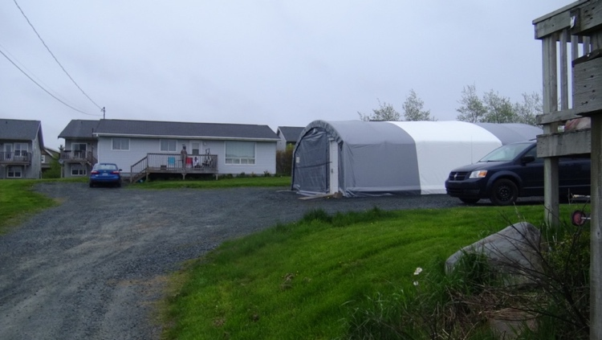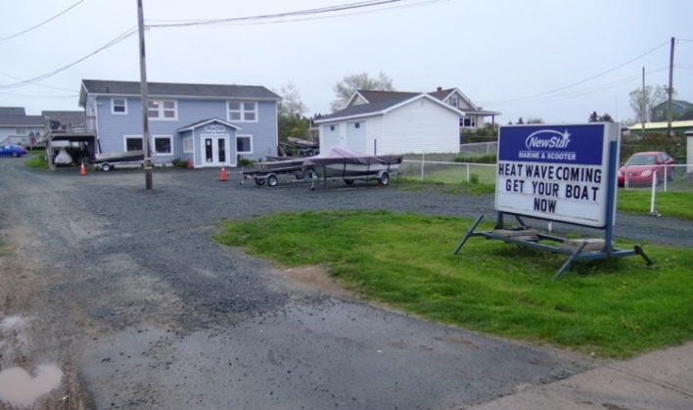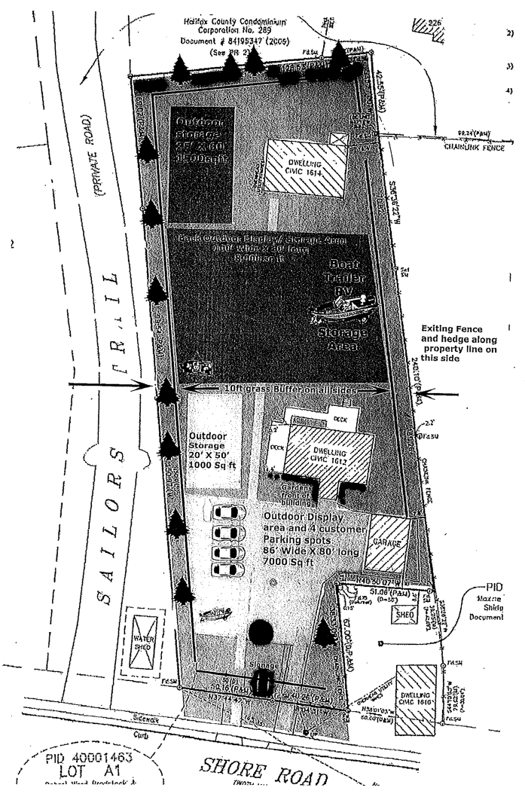

*Front*

*Back*

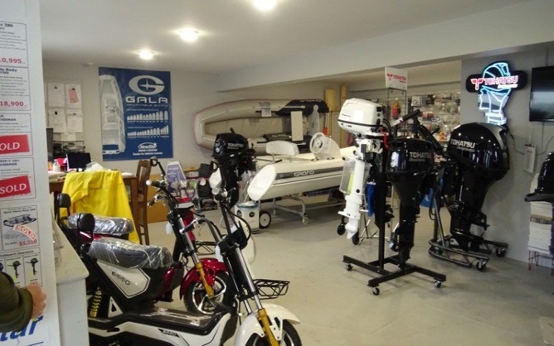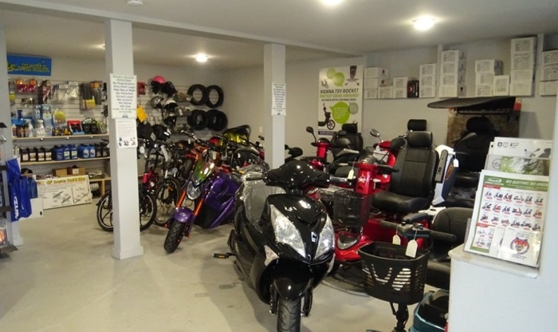

*Showroom, left side*

*Showroom, right side*

Source: Company files.

EXHIBIT 6: newstar marine & scooter inc.’s ADVERTISING and PROMOTIONS EXPENSEs, 2014–2017 (in CA$)

|  |  |  |  |  |  |
| --- | --- | --- | --- | --- | --- |
| **Activity** | **Date** | **2014** | **2015** | **2016** | **2017 (Projected)** |
| RV show | January 28–29 | – | – | 300 | 400 |
| Halifax boat show | February 9–12 | 1,451 | 2,380 | 4,680 | 2,940 |
| Sports & RV show | March 10–12 | 1,007 | 3,540 | 4,071 | 1,500 |
| Moncton boat show | April 1–3 | 1,345 | – | 2,300 | – |
| Guys show | September 15 | – | 2,665 | – | – |
| Sports & RV show | October 15 | 2,800 | 2,800 | – | – |
| a) Show subtotal | – | 6,603 | 11,385 | 11,351 | 4,840 |
| b) Radio advertising | May–June | 1,173 | 1,150 | 1,150 | 2,300 |
| c) Kijiji advertising | January–December | 2,093 | 1,665 | 674 | 2,000 |
| d) Signage | – | – | 681 | – | – |
| TOTALS |  | 9,869 | 14,881 | 13,175 | 9,140 |

Source: Company files.

EXHIBIT 7: newstar marine & scooter inc.’s AVAILABLE MARKETING INVESTMENTS

|  |  |
| --- | --- |
| **Activity** | **Estimated Cost**  **(in CA$)** |
| Website remodel and maintenance | $3,500 + $200 per month |
| 4 professional videos (3 x 0.5 min, 1 x 1.5 min) | $45,000 |
| 3 window prints (including design) | $450 |
| 1,000 direct mail (4- x 6-inch) postcards | $1,500 |
| Radio advertisement | $90 to $120 per week |
| Online search engine advertisements | $300 per month |

Note: 4 inches = 10 centimetres; 6 inches = 15 centimetres

Source: Adapted from company files.

EXHIBIT 8: newstar marine & scooter inc.’s EXPANSION PROJECT

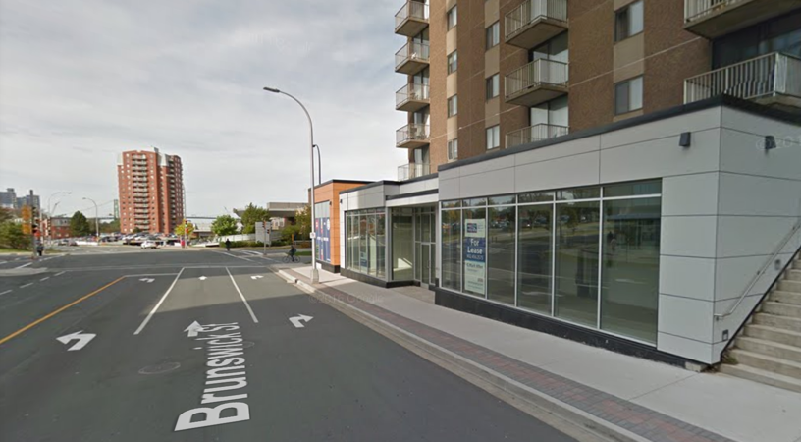

For Lease:

* Downtown Halifax
* 975 square feet
* $32,000 per year

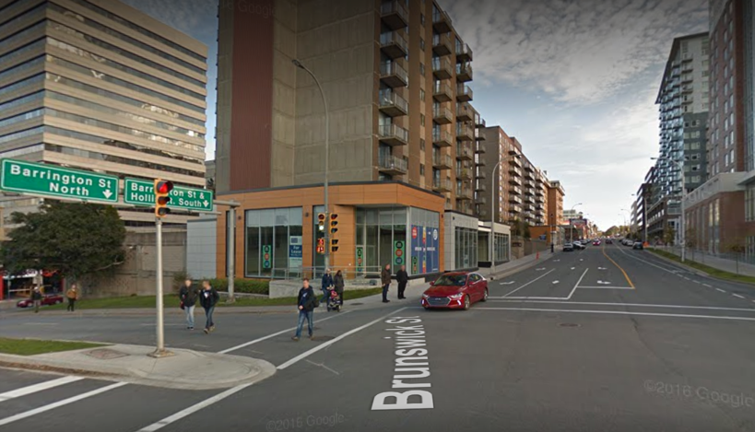

Note: 975 square feet = 91 square metres

Source: Adapted from company files.

1. All currency amounts are in Canadian dollars (CA$); CA$1.00 = US$0.86 on December 31, 2014.
2. CA$1.00 = US$0.74 on December 31, 2016.
3. CA$1.00 = US$0.97 on September 13, 2013.
4. A dinghy was a small, light, inflatable boat designed to be dragged by much larger boats and used in shallow waters to transport passengers to the shore.
5. CA$1.00 = US$0.75 on February 28, 2017.