

9B17A049

TELUS: The Public Mobile Brand Acquisition Decision

Brooke Cooper and Sarah Dickson wrote this case under the supervision of Professor Michael Taylor solely to provide material for class discussion. The authors do not intend to illustrate either effective or ineffective handling of a managerial situation. The authors may have disguised certain names and other identifying information to protect confidentiality.

This publication may not be transmitted, photocopied, digitized, or otherwise reproduced in any form or by any means without the permission of the copyright holder. Reproduction of this material is not covered under authorization by any reproduction rights organization. To order copies or request permission to reproduce materials, contact Ivey Publishing, Ivey Business School, Western University, London, Ontario, Canada, N6G 0N1; (t) 519.661.3208; (e) [cases@ivey.ca](mailto:cases@ivey.ca); [www.iveycases.com](http://www.iveycases.com).

Copyright © 2017, Richard Ivey School of Business Foundation Version: 2018-01-12

It was January 1, 2014, a couple of months after TELUS Communications (TELUS) had publicly announced that it would acquire Public Mobile Holdings Inc. (Public), a prepaid, low-cost wireless telecommunications company. Officially, TELUS acquired Public on December 31, 2013, for CA$229 million[1] net of cash acquired. At the time of the acquisition, Public was losing money and had a poor financial outlook. Despite this, TELUS saw many benefits to the acquisition, including operational synergies, as well as access to a new customer segment and to storefronts outside of TELUS’ more traditional mall locations.

David MacLean, director of Mobility Marketing at TELUS, was contemplating the future of Public and how it would fit into TELUS’ overall portfolio.[2] As the team lead for Public’s integration into TELUS, MacLean, along with his team, was tasked with the challenge of determining Public’s future. He saw that he had three primary options, each presenting its own pros and cons.

1. Option one was to shut down the Public brand. Once the acquisition was complete, TELUS could migrate Public customers over to one of TELUS’ three other brands. Government constraints stipulated that the migration could happen no sooner than January 1, 2015. This option required the least amount of resources to execute and was favoured by many top executives, who did not believe that TELUS needed a fourth mobility brand.
2. Option two was to continue operating Public under the same brand and value proposition that existed before the acquisition. Public had grown quickly over the years and had secured a number of store locations in higher traffic areas that appealed to a demographic TELUS had never focused on.
3. Option three was to refresh Public’s brand and change its value proposition. Although this option presented the most amount of risk, MacLean wondered if it was the best way to enhance TELUS’ financials.

MacLean needed to provide a recommendation to TELUS’ chief marketing officer, David Fuller, in May. To gain approval for his plan, MacLean needed to present a strong case for his recommendation for the Public brand and its 222,000 existing prepaid customers. The recommendation needed to consider the intensely competitive nature of the telecommunications industry, the consumer dynamics in the market, and the effects on key financials metrics for TELUS; in particular, the average revenue per user (ARPU)[3] and the churn rate[4] (see Exhibit 1).

Public Mobile holdings inc. at the Time of Acquisition

Public, a start-up Canadian wireless telecommunications provider, was launched on March 18, 2010, with the purpose of making wireless telecommunications more affordable and accessible for Canadians. Public had made its first spectrum[5] purchase at the 2008 Industry Canada Spectrum auction, where it purchased G band[6] spectrum in Toronto and Montreal. At the time, this spectrum was supported by only select low-tier phone devices, which fit well into Public’s prepaid value proposition (see Exhibit 2).

As a prepaid carrier with limited coverage, Public appealed to individuals who had tight budgets, skewed older (between 35 and 70 years old), were not tech-savvy, and required high-touch support. Public’s customer base was so budget restrained that only 30 per cent of customers paid on a regular basis, with the remaining 70 per cent paying on a more sporadic basis. Furthermore, of those who discontinued their service with Public, 40 per cent reported that they were not planning to use a mobile phone in the near future because they could not afford it. This high level of price sensitivity resulted in an average tenure of about 13 months, with 35 per cent of customers reporting a tenure of six months or less, significantly lower than the industry average of 85 months, or just above seven years.

Knowing that price was the main decision factor for its target segment, Public offered a simple prepaid rate plan structure made up of five core plans starting at $19 per month (see Exhibit 3).

Due to its G band frequency limitations and its focus on value, Public offered a narrow selection of low-tier phones, which customers could purchase outright in stores. These low-tier phones were manufactured by companies such as Kyocera Corporation and ZTE Corporation, and were lagging several years in respect to technological advancement behind the leading phones in the market, such as the devices of Apple Inc. and Samsung Group.

Understanding its customers’ need for high-touch support, Public grew its number of storefronts to 400 over the course of three years. It focused on opening convenient, street-front stores (see Exhibit 4) in the higher foot traffic areas of Toronto and Montreal. To keep costs low and to be as accessible as possible, 88 per cent of Public’s outlets were through dealers[7] and third-party retailers such as Loblaws, Money Mart, and Walmart. These dealers and third-party retailers were chosen based on their ability to connect with Public’s target consumers. For example, they employed store staff who could fluently speak the prominent second language of the surrounding area. Using this method of distribution meant that Public had less control regarding customers’ in-store experience; however, this allowed them to connect more deeply with the local community and save on the capital expenditures of building company-owned stores.

The benefits of an inexpensive, prepaid service offering coupled with accessible stores was a great combination for certain customer segments, especially the low-income segment, recent immigrants, and parents purchasing a phone plan for their children. This combination, however, led Public to struggle with profitability. The company constantly faced a high churn rate and low ARPU, two key financial metrics in the industry. Public’s ARPU at the time of the TELUS acquisition was around $26, while the churn rate was over 6 per cent. These metrics paled in comparison to those of incumbent Canadian telecommunications providers, such as Bell Canada Enterprises (Bell), Rogers Communications Inc. (Rogers), and TELUS, which regularly reported an ARPU of around $60 and a churn rate of under 2 per cent (see Exhibit 5).

Public was able to continue to grow its customer base; however, after three years of operations, it was still unprofitable, reporting a loss of $55 million in 2013. Given Public’s poor financial outlook, the primary shareholders agreed to sell Public to TELUS.

In order to receive acquisition approval, the federal government mandated that TELUS continue to offer Public’s $19 per month unlimited provincial calling plan until at least December 31, 2014. While this plan had to be available for the remainder of 2014, TELUS did have the option to send out promotional communications to incentivize these customers to switch to other TELUS brands before that date. Upon agreeing to these stipulations, TELUS officially received approval to acquire Public on November 29, 2013, and the transaction closed on December 31, 2013.

TELUS inherited 222,000 Public customers, 140 management employees, and 325 retail team members. TELUS also became the owner of Public’s wireless network. Compared to Public’s network, TELUS had a far superior High Speed Packet Access (HSPA)[8] network, which operated nationwide using reliable and fast fourth generation (4G) Long Term Evolution (LTE) technology. Given this information, MacLean and team determined that it was in the best interest of both the customers and the business to migrate the existing Public customer base to TELUS’s HSPA network and shut down Public’s network. This meant that, upon network transition, Public customers would benefit from national coverage, as opposed to the coverage in the greater Toronto and Montreal areas that they had originally signed up for.

Industry Overview

The Canadian wireless telecommunications industry was mature, with a 2 per cent annual growth rate, and quickly reaching saturation, with approximately 80 per cent of Canadians owning a phone at the time of the case.

Bell, Rogers, and TELUS—also known as the “Big Three”—were the incumbent service providers, who continued to benefit from first mover’s advantage and who collectively held 90 per cent market share in 2013. Launched in the late 1980s, these three companies were able to grow quickly in terms of both services offered and number of customers. Over time, initiatives such as loyalty discounts and bundling products (e.g., home phone, Internet, and television) became effective ways to not only protect their customer bases from churning, but also grow the base by cross-selling products.

Acquiring customers in this competitive environment required spending a lot of money upfront to pull customers away from their current carrier. These incentives typically were in the form of device discounts, credits, or gifts with purchase and were measured under the cost of acquisition (COA)[9] umbrella. While this expense was relatively manageable for national companies with strong balance sheets and economies of scale, it was difficult for new entrants to gain market share and maintain profitability. These barriers to entry were somewhat offset by the intervention of the Canadian Radio-television and Telecommunication (CRTC) in the industry. For example, the CRTC helped to spur competition through initiatives such as allocating specific spectrums in auctions to new entrants or to smaller discount carriers.

Within each segment, most of the offerings such as rate plan pricing and phone line-ups were similar, making it important for competition to differentiate on other factors such as network and customer service. While it might have been difficult for new entrants to gain a profitable foothold in the industry, there was definitely an opportunity for them to disrupt the market and enhance the level of differentiation. Smaller discount wireless providers, notably Mobilicity and Wind Mobile (Wind), benefited from the CRTC’s interventions and recognized an opportunity to focus on specific regions and target markets to gain share from the Big Three (see Exhibit 6).

Industry Trends

In 2013, there were 28 million wireless subscribers in Canada, of which approximately 83 per cent were postpaid and the remaining 17 per cent were prepaid. Of those Canadians who did not own a mobile phone, some (children, people living in remote areas, people with lower income) were unable to and others chose not to.

Growth in postpaid users was slowing. The net growth of incremental new users in the postpaid segment was projected to decline by approximately 1 per cent per quarter over the following couple of years and reach a point of stagnant growth by 2015.

The prepaid segment, on the other hand, was expected to continue to experience a net decline in users (i.e., losing more customers than acquiring), but was expected to show some improvement over the next couple of years. The prepaid space was projected to experience a net growth of new users at a rate of 2 per cent per quarter. Unlike the postpaid segment, the prepaid segment was expected to grow beyond 2015.

The lack of postpaid growth was partly attributed to a declining number of customers migrating from prepaid to postpaid plans. In previous years, upselling customers to switch to a postpaid plan had been a major area of focus. It showed high returns and significant financial benefits as migrating customers typically resulted in an increased ARPU and decreased churn, along with a reduced COA. Yet, this strategy had diminishing returns. With a lot of the opportunity previously captured, the same level of growth from this tactic was no longer available.

Industry Customer Segments

The mature telecommunications industry in Canada tended to be divided into three value-oriented segments: premium, mid-market, and price-sensitive. The premium segment consisted of customers who appreciated services that offered value well beyond the level offered by the basic services, and who were willing to pay an associated premium cost. Examples of these services included support offered 24 hours a day, seven days a week; access to the latest devices; and an array of rate plan add-ons to suit their needs, such as roaming and long distance packages. Consumers in this group were typically between the ages of 35 and 55, had children, and were affluent. Many consumers within this category were early adopters of technology and used it regularly in their day-to-day lives.

The mid-market segment encompassed people who were willing to pay for some additional conveniences. These consumers tended to be between the ages of 18 and 34, were anxious about price, and were generally less educated than customers in the premium segment. Consumers within this group used technology often but were not overly tech-savvy.

The price-sensitive segment included consumers who valued price above all else. While they wanted a good, working product, they were also willing to make trade-offs to get discounts. These consumers tended to use a prepaid service model, because it provided them with increased cost certainty. Prepaid customers could be further segmented based on their usage.

Prepaid Customer Profiles

Prepaid customers traditionally fell into one of eight segments (see Exhibit 7). These customers were evaluated based on the importance of price to their purchase and the added value they required of their carrier. Carrier value-add was typically determined by four factors: (1) the availability and location of its retail stores, (2) the selection of phones it carried, (3) the customer service support it offered, and (4) the size and quality of its network.

TELUS, Bell, and Rogers had many retail locations, provided in-store and call centre support, and had a national network. Therefore, these premium, prepaid brands lent themselves to targeting sponsored youth and seniors, safety users, and basic users—all users who required a great deal from their carrier and were less price sensitive.

Koodo Mobile (Koodo), Virgin Mobile (Virgin), and Fido Solutions (Fido) had fewer kiosks to provide support to customers and less expensive rate plans. Therefore, these mid-market brands offered simple services that lent themselves to targeting unsponsored youth and basic users. Sponsored youth and unsponsored youth also tended to have the highest propensity to switch to postpaid plans over time, which had significant financial benefits for these brands.

The discount carriers Wind, Chatr Mobile (Chatr), Mobilicity, and Public all competed to attract new immigrants, deal seekers, and consumers who were frugal by necessity. These segments were the most price-sensitive and had the same value expectations as the target market of the premium carriers. This made it challenging for the discount carriers to compete profitably. One segment that no carrier had successfully attracted was life hackers. These customers ranked price at medium-high importance, but required the least value-add from their carrier (see Exhibit 8).

Competition: Premium Segment

Three companies competed in the premium space: Bell, Rogers, and TELUS. These carriers catered to individuals who were willing to pay more to have access to full-service customer support and high-tier devices, such as the latest iPhone or Samsung phone. These customers also expected excellent service coverage while in Canada and other coverage options while travelling outside the country.

To provide full-service customer support, each carrier had corporate-owned stores in high foot traffic malls and large call centres. Through this structure, these carriers had customer service representatives available to assist new and existing customers at any time of the day.

Bell

Bell was Canada’s second-largest wireless telecommunications company, reporting a market share of 28 per cent in 2013, equating to 7.8 million subscribers. Of its customer base, 86 per cent were postpaid customers and 14 per cent were prepaid customers.

The primary message Bell advertised was that the company operated on Canada’s largest network. Along these lines, Bell highlighted the speed, reliability, and extensive coverage of its 4G LTE network.

Rogers

Rogers, founded in 1960, was Canada’s largest wireless voice and data telecommunications services provider, capturing 34 per cent of wireless market share in 2013. In order to differentiate from its direct competitors, Rogers continued to invest heavily in its network and systems to enable improvements for customers travelling abroad. Similar to Bell’s subscriber breakdown, 85 per cent of Rogers’ customer base was on a postpaid plan and 15 per cent was on a prepaid plan.

Competition: Mid-Market Segment

Three carriers competed in the mid-market space: Fido, Virgin, and Koodo. These carriers offered less expensive rate plans than the premium service parent brands,[10] while accessing the same network. These flanker brands[11] were able to support lower prices by offering a smaller selection of higher-tier devices and keeping marketing spend and customer support investments low. These brands also focused on smaller concept stores, such as mall kiosks, to save costs. While these brands offered a combination of both prepaid and postpaid services, the majority of their consumers were postpaid.

Virgin Mobile

Bell acquired full ownership of Virgin on July 1, 2009. Virgin differentiated itself through its Member Benefits program. This program was available to all its customers—Virgin referred to them as members—and allowed them to take advantage of exclusive discounts at other retailers (e.g., Goodlife Fitness, J.Crew) and VIP experiences (e.g., first access to concert tickets).

Fido

Fido was acquired by Rogers in November 2004, making it the first flanker brand in Canada. One unique aspect of Fido was its loyalty rewards program, known as FidoDOLLARS. The program awarded customers who paid their monthly bills or made prepaid top-ups by giving them 4–5 per cent back in FidoDOLLARS, which could then be put toward the purchase of a new device or add-ons such as premium voicemail, name display, or auto-forwarding.

Competition: Price-Sensitive Segment

Canada also had several regional wireless carriers, including Wind, Mobilicity, Chatr, Saskatchewan Telecommunications Holding Corporation, Vidéotron, EastLink, Tbaytel, and MTS Mobility. At the time of Public’s acquisition, Wind, Mobilicity, and Chatr were Public’s three biggest competitors, who were vying for a similar target market in overlapping coverage areas.

To reach their objective of providing Canadians with simple and affordable wireless service, these three carriers typically used a prepaid structure, lower-tier devices, and a smaller, less advanced network. Accordingly, these discount regional carriers catered to individuals who were budget conscious and willing to make trade-offs, such as regional instead of nationwide coverage, to save money. Public, Wind, Mobilicity, and Chatr all utilized a community-based retail strategy, which allowed consumers to easily access stores on foot or by using public transportation. In addition to the expensive network of storefronts that these discount carriers maintained, customers were also able to receive support by contacting a call centre.

Compared to the business models of national premium brands and their flanker brands, the independent discount carriers’ business models of high fixed costs and cheap rate plans had a very small profit margin. This was further amplified by a smaller subscriber base, low ARPU, and high churn rate. Finding the right balance between acquiring customers, meeting the needs of this target market, and balancing costs had proven difficult for these companies, forcing some of them to nearly go bankrupt.

Wind Mobile

Wind began as a privately owned carrier in December 2009, with the goal of providing its customers with low, simple, and fair pricing. Customers could access Wind’s network in Canada’s major cities and suburbs and on its highways, where the majority of Canadians spent their time. When customers left their coverage area, they had the option to roam on Wind’s Canadian and U.S. partner carriers’ networks for an incremental cost, a fee that varied depending on the customer’s location and the services used. Wind also differentiated itself from its direct competitors by providing access to more mid-tier devices and providing device subsidies for those who signed a postpaid contract. Wind offered a rate plan line-up that included unlimited talk, text, and data for a much lower price than any other postpaid carrier. Although Wind’s coverage was limited, with customers reporting frequent losses of signal and dropped calls, and it throttled[12] data speeds after a certain amount of data usage, the low cost, high data rate plans resonated well with its target market.

Mobilicity

Mobilicity began in February 2010 as a prepaid-only mobile provider, with coverage initially in Toronto and then expanding to Edmonton, Vancouver, and the Ottawa region throughout the remainder of the year. The last network expansion was in Calgary in April 2011.

Chatr Mobile

Chatr began in July 2010, with coverage in Toronto, Ottawa, Calgary, Edmonton, Vancouver, Quebec City, and Montreal. Chatr was owned by Rogers. It provided its customers with a simple mobile solution by allowing them to choose unlimited plans within a certain coverage area, referred to by Chatr as the customer’s “Chatr zone.” When customers were outside of their Chatr zone, their services were available on a pay-per-use basis. Customers were only able to identify when they were outside of their Chatr zone by either entering a code to view a coverage map or checking their account balance after making a phone call.

TELUS Corporation’s Portfolio

TELUS was Canada’s fastest-growing national telecommunications company, reporting $11.4 billion of annual revenue and 13.3 million customer connections in 2013. These connections included 7.8 million wireless subscribers across three wireless brands: TELUS, Koodo, and PC Mobile. The remainder of TELUS’s revenue came from the company’s wireline business, including home phone, Internet, television and health.

Unlike Rogers and Bell, TELUS decided not to pursue investments into the media industry. Instead, it focused on healthcare and, in 2013, TELUS Health became Canada’s largest electronic medical records provider. This health solution, empowered people living with chronic conditions to better manage their own health and made possible more sustainable and affordable care, among other benefits. Additionally, TELUS focused on giving back to the communities in which it served and on being environmentally friendly. Between 2000 and 2013, through the philosophy of “we give where we live,” TELUS and its team members contributed more than $350 million to charitable and not-for-profit organizations, and volunteered 5.4 million hours of service.

TELUS differentiated itself in the market by delivering exceptional customer experiences across all lines of business, with the objective of being the most recommended company in Canadian communities. One way that TELUS was able to quantify the success of this approach was through the metrics reported by the Commissioner for Complaints for Telecommunications Services (CCTS).[13] The CCTS released an annual report on all reported customer complaints directed at telecommunications companies. Despite customer complaints to the CCTS growing on aggregate by 26 per cent year-over-year, complaints about TELUS decreased by 27 per cent in 2013. Its focus on providing exceptional customer experiences also benefitted TELUS financially, as it posted an industry-leading average monthly churn rate of 1.03 per cent in 2013. Another indicator of the company’s success in delivering superior customer experiences was the Likelihood to Recommend metric,[14] a key measure in the telecommunications industry and one on which TELUS prided itself (see Exhibit 9).

TELUS Wireless

The wireless segment drove $6.13 billion of TELUS’s overall revenue in 2013, with 87 per cent of the customer base composed of postpaid subscribers. Revenue was up 5 per cent from the previous year, reflecting 307,000 subscriber net additions and a 1.6 per cent increase in ARPU. Furthermore, TELUS generated an industry-leading lifetime revenue per customer[15] of more than $4,350.

Prior to the acquisition of Public, TELUS’s wireless business consisted of three brands: TELUS Mobility, Koodo, and PC Mobile. Each brand had a unique service offering and structure supporting TELUS’s overall strategy.

TELUS Mobility

TELUS Mobility was TELUS’s full-service, premium brand, with the majority of activations coming from postpaid customers. The brand’s target market consisted of customers who were highly educated, family-oriented, had disposable income, and used technology to make their lives easier.

With a network that covered 99 per cent of Canada and operated on leading 4G LTE technology, TELUS offered Canadians speed and reliability of service wherever they were in the country. TELUS’s flexible SharePlus rate plan suite also made it easy for families to share data across multiple devices. Additional offerings such as roaming and long distance packages made TELUS a great choice for those who travelled frequently or had family abroad.

To complement its breadth of services, TELUS also offered the latest and greatest devices. Working with brands such as Apple and Samsung, TELUS focused on curating an enticing selection of premium devices. Beyond device selection, the company focused on high-quality accessories that added to the device experience, including portable chargers, fitness trackers, and wireless headphones.

TELUS’ focus on enhancing customers’ device experience led to a new corporate store layout, which focused on displaying accessories and creating a relaxed environment. To maintain control over the customer experience, TELUS focused mainly on corporate-owned stores and dealers for distributing products, with a portion of their distribution going through third-party retailers.[16]

In line with TELUS’s focus on customer experience, maintaining a strong customer support network was also a pillar of its service offering. This network included call centres, social media channels, and websites, namely telus.com and the TELUS Neighbourhood.

Koodo

Koodo was started by TELUS in 2008 and was considered its flanker, mid-market brand. The Koodo brand was launched with the intent of disrupting the Canadian wireless market and tapping into a younger demographic than TELUS’s target market.

Unlike other companies, Koodo focused on promoting self-serve, lower-cost support channels for customers to receive support, such as social media sites (Facebook and Twitter) and Koodo’s unique community forum, run by Koodo Ambassadors—a loyal group of passionate customers who voluntarily answered other customers’ questions they posted on the forum. While Koodo focused on self-service, it recognized that online support was not for everyone and so established partnerships with call centres worldwide.

For carefully crafting this culture of support, Koodo was ranked highest in Satisfaction with Customer Care for three consecutive years by J.D. Power.

Koodo’s target market skewed younger, consisting of young adults in college or university. These customers were primarily value seekers who may not have fully trusted telecommunications or were dissatisfied with traditional customer service. They were used to trading their time to save money, and relied heavily on the Internet for information and making purchasing decisions. To attract this target segment, Koodo offered a simple, transparent suite of rate plans and took a “no hidden fees” approach toward billing. Hidden fees were a key pain point in the industry.

Leveraging the TELUS network, Koodo offered customers national LTE coverage. With a simple postpaid rate plan suite, Koodo attracted customers shopping for themselves and looking to save on their monthly bill. To keep things simple, Koodo maintained a lean line-up of additional offerings, including extended device warranty, call forwarding, and long distance add-ons for select countries. Koodo also offered prepaid services, although the majority of its customer base was postpaid.

While Koodo had some premium phones in its line-up, the majority were mid-tier to low-tier devices. Koodo appealed to its target consumers—who valued price over the latest technology—by offering a selection of older generation Android and iPhone models.

In terms of distribution, Koodo leveraged a hybrid strategy whereby phones and rate plans were sold both by third-party retail partners, such as Walmart and Best Buy, and at corporate-owned kiosks in malls.

Its focus on customer support and transparent service offering earned Koodo the highest Likelihood to Recommend score, of 85 per cent, across all national carriers in 2013.

PC Mobile

TELUS owned and managed the postpaid segment of Loblaws’ PC Mobile brand, while Bell managed the prepaid segment. PC Mobile postpaid was launched in the summer of 2013 and, leveraging the well-established brand of Loblaws and TELUS’ expansive network, it grew quickly. The brand attracted a mix of deal-seeking generation X[17] families that religiously collected PC points (part of a rewards program offered by Loblaw Companies), lower income baby boomers[18] who were empty nesters and did not need anything beyond the basics, and millennials[19] who were looking for an alternative to the major telecom players in Canada.

Offering an array of four smartphones and three nationwide plans, PC Mobile prided itself on being clear and simple. It offered a suite of rate plans that protected customers from large, unexpected bills. Subscribers were notified when they approached their monthly voice or data limits, and were then given the choice to either cut off their service for the rest of the billing period or add more minutes or data to their plans.

Distribution was managed out of Loblaws’s wireless storefront, The Mobile Shop, located in local grocery stores. The Mobile Shop also carried other brands, including Koodo and TELUS Mobility. This multi-carrier distribution method made it easier for customers to compare carriers’ phones and plans.

The Decision

As MacLean considered what to do with the Public brand, he was struck by not only the importance but also the breadth of decisions to be made. Could Public be successful in this competitive marketplace without cannibalizing TELUS Mobility, Koodo, or PC Mobile’s current sales? Would it be better to shut down the brand and migrate those customers to either TELUS, Koodo, or PC Mobile’s customer bases? Besides migrating existing Public customers to one of TELUS’ existing brands, shutting down the brand would involve halting all new customer acquisition efforts. Given that Public’s coverage would be upgraded to a national network, MacLean’s team would also need to determine whether Public’s current rate plan pricing should remain the same, keeping in mind that the $19 plan would need to be maintained under the Public brand until December 31, 2014, to meet the acquisition approval requirements. Furthermore, existing customers could not be migrated to internal brands until January 1, 2015.

If Public were able to compete in the marketplace, should the company continue focusing on the same target market and value proposition, and determine ways to reduce costs or increase revenue without jeopardizing churn? With many current customers being budget-conscious by necessity, it would be important to find the appropriate balance between which revenues could be increased and which expenses could be reduced, while still meeting consumers’ wireless needs.

Alternatively, should Public be repositioned and launched with a new brand image and a new value proposition? If so, which customer segments should Public target, and how might this affect Public’s existing customers? Would it be possible to re-brand without alienating current customers? TELUS knew it would be important to maintain a low churn rate with its newly acquired Public customers to achieve value for their acquisition. If Public were to make a big change to its brand, how could it invoke confidence in its existing customers that the company was here to stay?

MacLean knew that regardless of which option he chose, a strategic marketing plan was required to convince the leadership team that it was the right decision. Keeping in mind how each option would affect ARPU and churn would be an integral part of earning decision buy-in. With no time to spare, MacLean got to work.

Exhibit 1: TELUS communications’ Financial and Operating Highlights, 2013

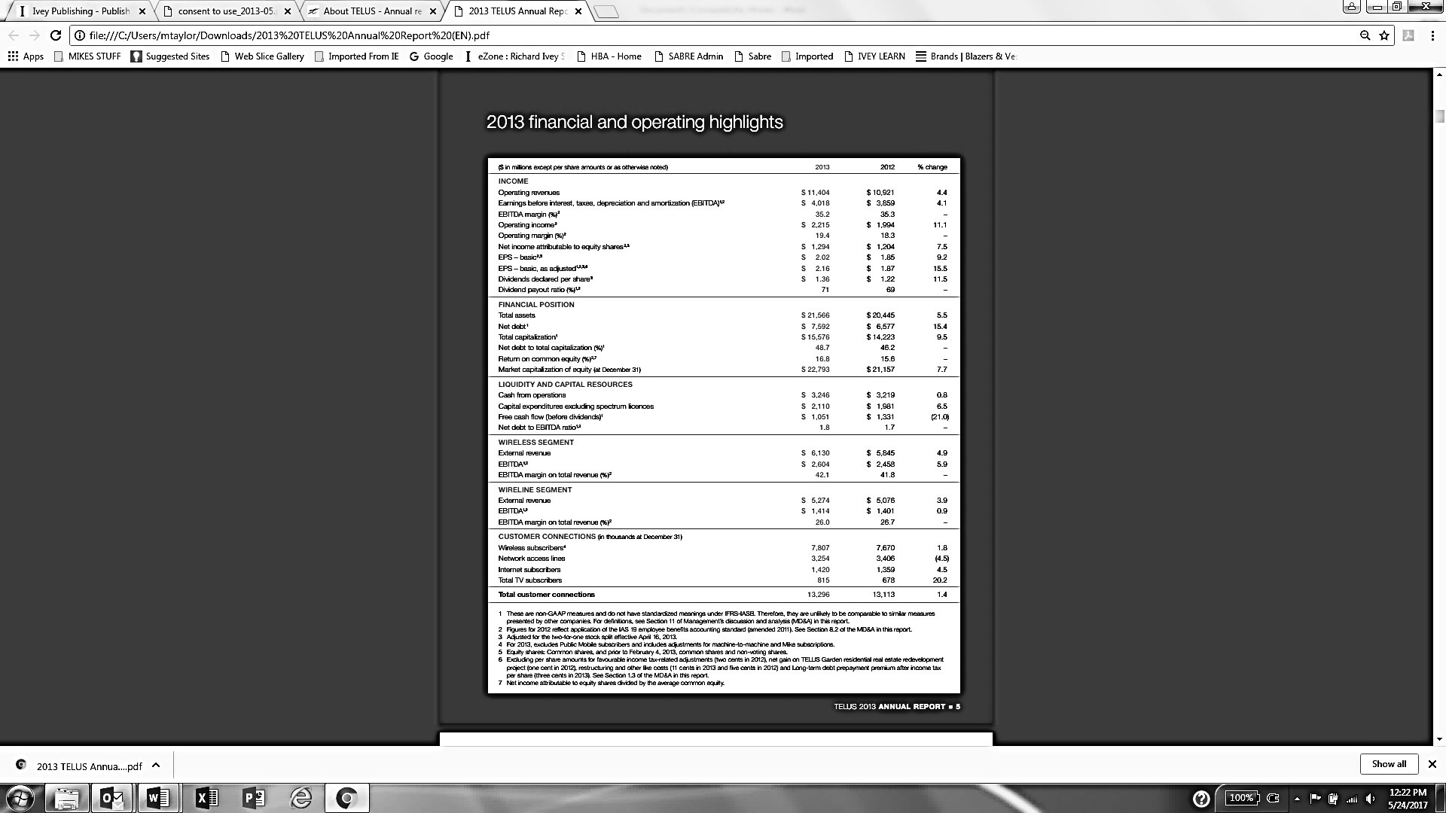

Note: EBITDA = earnings before interest, tax, depreciation, and amortization; EPS = earnings per share; GAAP = generally accepted accounting principles

Source: TELUS Communications, *TELUS* *2013 Annual Report*, accessed May 24, 2017, http://about.telus.com/investors/annualreport2013/files/pdf/en/ar.pdf.

Exhibit 2: Postpaid Versus Prepaid Wireless Business

The concept of prepaid relates to how customers pay for their plan. When on a prepaid plan, customers pay the total amount, which is determined by how much service (i.e., talk, text, and data) they need for a given amount of time, upfront. This means that once the plan’s services are used in full, the customer is without service until another service purchase is made, creating cost certainty. Prepaid plans also provide both accessibility—because customers do not need to pass a credit check when activating the plan—and the flexibility of no required contract.

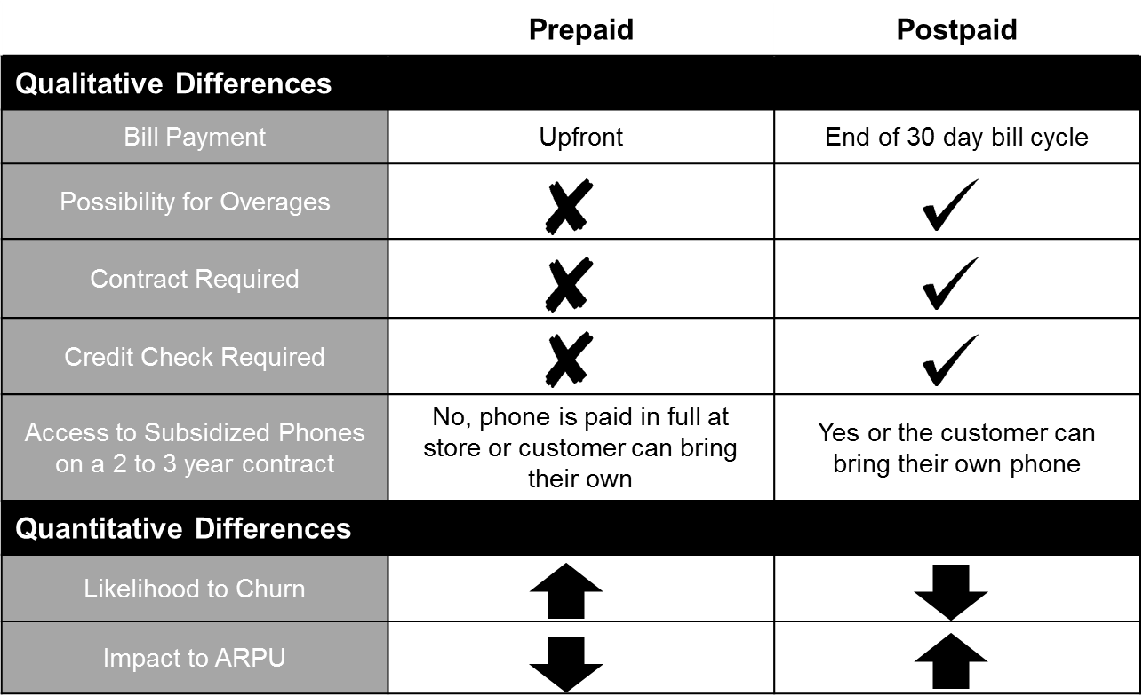

Note: ARPU = average revenue per user

Source: Company files.

Exhibit 3: Public Monthly Rate Plan Distribution

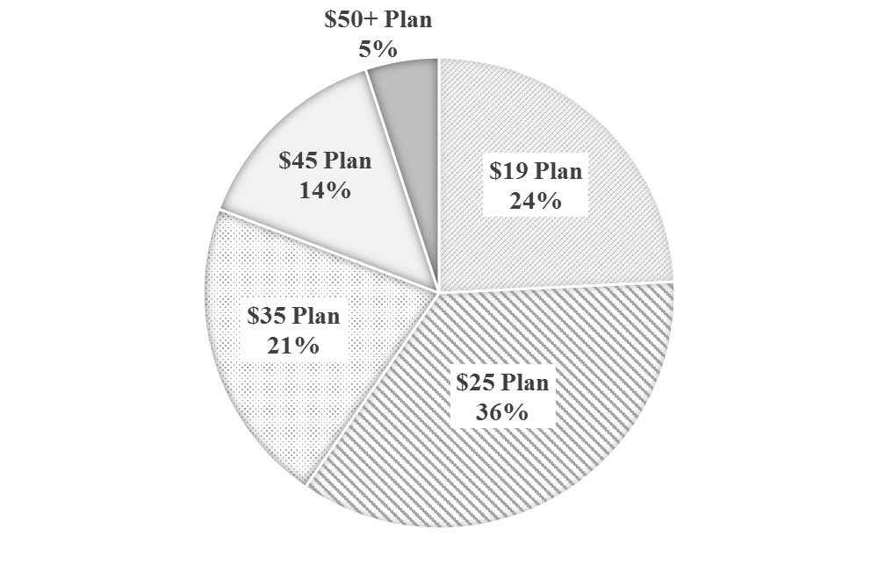

Source: Company files.

Exhibit 4: Public Mobile Store Front

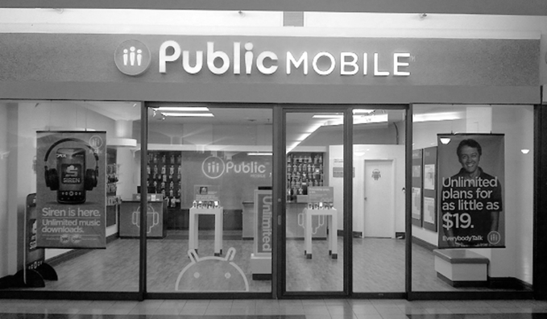

Source: Company files.

Exhibit 5: Select Financial Metrics from the Big Three* Wireless Carrier’s 2013 Financials







Note: Big Three = Bell Canada Enterprises, Rogers Communications Inc., and TELUS Communications; EBITDA = earnings before interest, tax, depreciation, and amortization; ARPU = average revenue per user; COA = cost of acquisition

Source: TELUS Communications, *2013 Annual Report*, accessed August 17, 2017, http://about.telus.com/investors/annualreport2013/files/pdf/en/ar.pdf; Bell Canada Enterprises, *BCE Inc.* *2013 Annual Report*, accessed August 17, 2017, www.bce.ca/investors/annual-report/2013-annual-report.pdf; Rogers Communications Inc., *Rogers Communications Inc.* *2013 Annual Report*, accessed August 17, 2017, www.rogers.com/cms/investors/pdf/annual-reports/2013_Annual-Report.pdf.

Exhibit 6: Canadian Wireless Industry Competitive Landscape

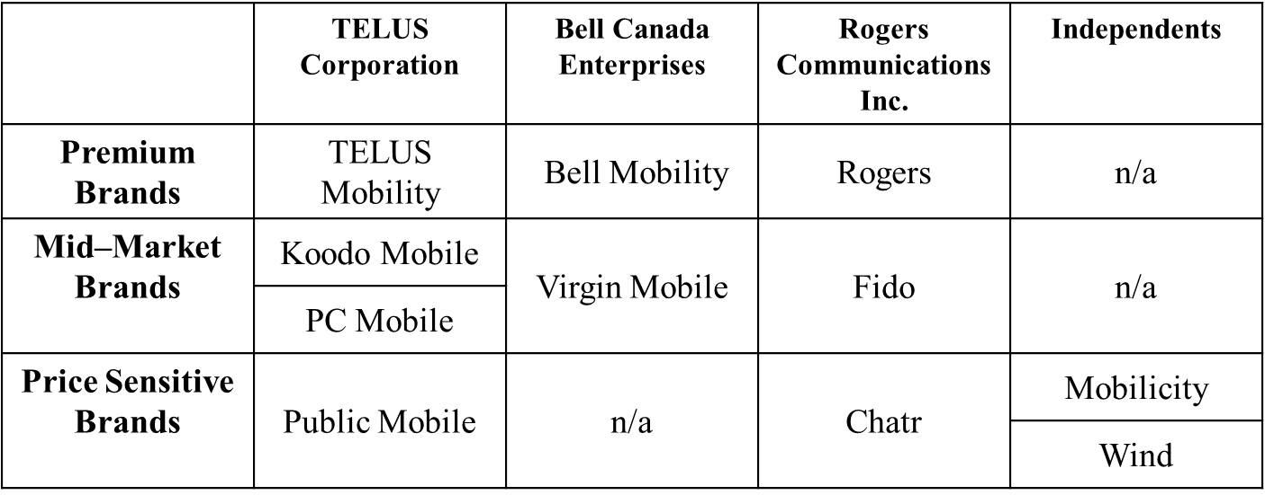

Source: Company files.

Exhibit 7: Prepaid Customer Usage Profiles

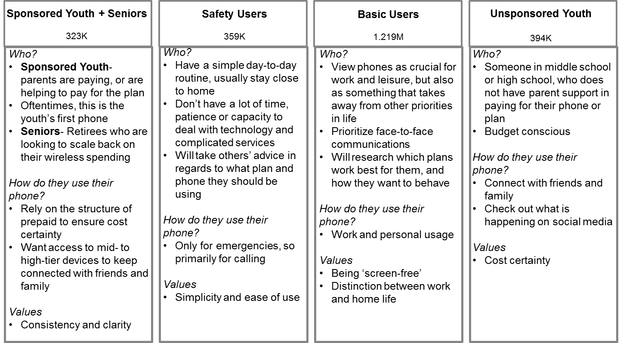

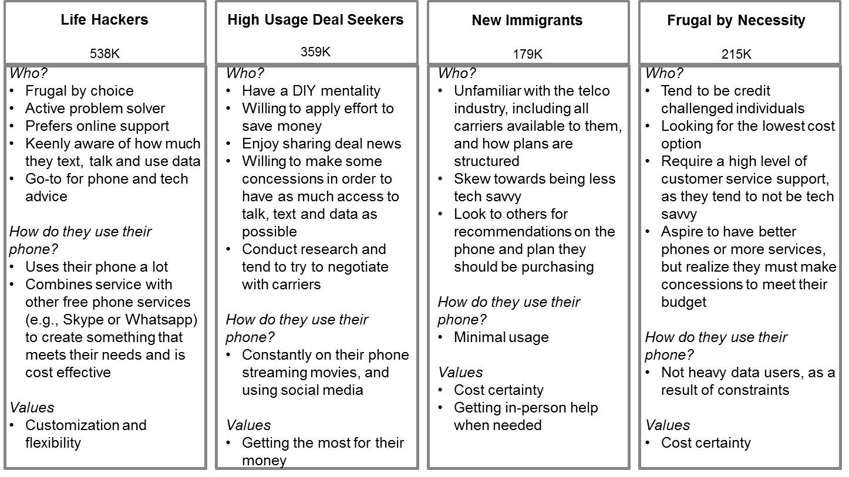Note: The number in each segment is the estimated market size in number of users, e.g., there are 359,000 “Safety Users”; K = thousand; M = million; DIY = do-it-yourself

Source: Company files.

Exhibit 8: Prepaid Customer Segments

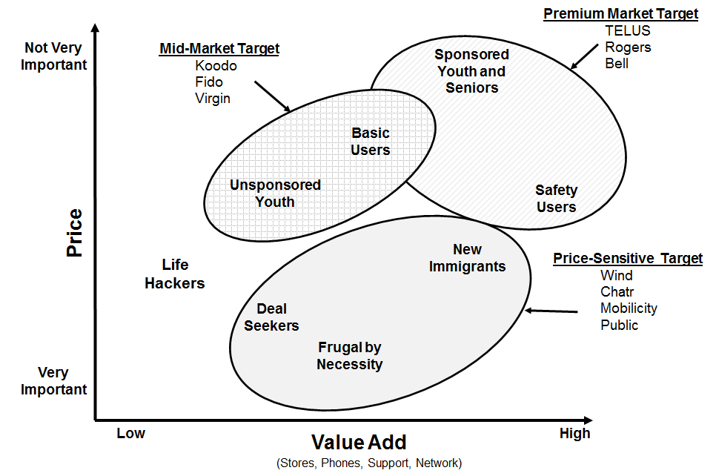

Source: Company files.

Exhibit 9: 2013 Wireless Service Provider L2R Results



Note: L2R = likelihood to recommend

Source: Company files.

1. All currency amounts are in Canadian dollars unless otherwise specified.
2. TELUS owned TELUS Mobility, Koodo Mobile, and PC Mobile Postpaid.
3. ARPU was calculated by dividing total revenue by total number of subscribers in a given month.
4. Churn rate was the monthly percentage rate at which customers discontinued service with their service provider.
5. Spectrum referred to the radio frequencies used in the telecommunications industry. In Canada, spectrum allocation was managed by the federal government through the Canadian Radio-television and Telecommunications Commission.
6. G Band spectrum consisted of frequencies used nowhere else in the world and was compatible with a limited number of devices available in the market at the time.
7. Dealers were independent stores that owned rights to sell a brand’s products and services.
8. High Speed Packet Access was an evolved version of the third generation (3G) mobile network, featuring faster speeds and improved reliability.
9. Cost of acquisition consisted of the total of the device subsidy (the device cost to TELUS less the initial charge to the customer), commissions, and advertising and promotion expenses related to the initial subscriber acquisition during a given period.
10. These are the case author’s observations. Rate plans for mid-market flanker brands were typically $48 to $60 per month, compared to top-tier plans by the Big Three, which were typically over $70 per month.
11. A flanker brand was an extension of an existing brand created to target another segment of the market.
12. Throttling involved reducing data transfer speeds on the network, affecting the speed at which customers could browse the Internet and use their applications.
13. The Commissioner for Complaints for Telecommunications Services was an independent body that helped customers to resolve issues they had with their telecommunications provider.
14. Likelihood to Recommend was measured by dividing the number of people who responded “Probably” or “Definitely” when asked if they would recommend a service by the total number of survey respondents.
15. TELUS calculated customer lifetime revenue by dividing ARPU by the churn rate.
16. A third-party retailer was a partner (e.g., Walmart or Best Buy) that sold TELUS products and services alongside other carriers’ products and services.
17. Generation X was the name given to the generation born between roughly 1961 and 1980; it followed the baby boomer generation and preceded the millennial generation.
18. Baby boomer was the name given to people born between roughly 1946 and 1964, when birth rates across the world spiked.
19. Millennial was the name given to the generation born between roughly 1981 and 2004; also known as generation Y.