

9B17A051

wrist & rye: curING the Naked wrist syndrome

Brent Winston wrote this case under the supervision of Professors Michael Taylor and Colin McDougall solely to provide material for class discussion. The authors do not intend to illustrate either effective or ineffective handling of a managerial situation. The authors may have disguised certain names and other identifying information to protect confidentiality.

*This publication may not be transmitted, photocopied, digitized, or otherwise reproduced in any form or by any means without the permission of the copyright holder. Reproduction of this material is not covered under authorization by any reproduction rights organization. To order copies or request permission to reproduce materials, contact Ivey Publishing, Ivey Business School, Western University, London, Ontario, Canada, N6G 0N1; (t) 519.661.3208; (e)* [*cases@ivey.ca*](mailto:cases@ivey.ca)*;* [*www.iveycases.com*](http://www.iveycases.com)*.*

Copyright © 2017, Richard Ivey School of Business Foundation Version: 2017-09-28

In October 2016, tensions were running high between the co-founders of Wrist & Rye Inc. (W&R), a men’s fashion and accessories company. Brent Winston, chief financial officer and co-founder of W&R, was caught in the middle of a heated debate between two partners. The debate about how W&R’s business model should be structured was weighing on the founders. The two options were for W&R to continue with its current business model of generating sales mainly through its online website and platform or to begin selling its products at wholesale prices through sales teams to high-end, well-known retail stores.

Changing the company’s business model was not the only issue at hand though. Brennan de Langley, chief marketing officer and co-founder, was adamant that W&R start developing new products that consumers could identify with. He believed that in order for W&R to succeed, the company needed to continue selling online and develop new products. If the switch to wholesale was going to be made, he would no longer be a part of the W&R team. De Langley’s stance on W&R’s business model was in direct opposition to that of Travis McKenna, chief executive officer (CEO). To make matters even more stressful, the W&R team had a connection in the fashion industry who had had great success with his own fashion start-up by selling his products through the wholesale avenue. He would be willing to come on board and help grow W&R’s sales using his impressive wholesale connections.

The clock was ticking. Winston knew that he was the mediator in this situation. Winston had been in constant talks with Thomas Mirmotahari, the chief operating officer and co-founder, about how to proceed with W&R. Mirmotahari was just as unsure as Winston about what the right direction would be for W&R. With de Langley and McKenna on opposite sides of the issue, and business taking a hit as a result of the standstill regarding what W&R’s business model should be in the future, Winston knew he had to get the team to agree.

The holiday season was right around the corner, and historically, that was W&R’s most profitable quarter. A decision needed to be made, and fast, so that W&R could capitalize on the holiday spirit and not lose any more of the traction it had built up in the previous year.

**COMPANY BACKGROUND**

Late in 2015 at Western University, undergraduates de Langley and Winston were taking a break from conducting countless hours of research on their strategy 48-hour report topic: the Lego expansion. De Langley and Winston were in talks about a rather common topic at the Ivey Business School: fashion. “Brent, you seem like you care about fashion, right?” de Langley asked Winston. “Ya, I guess so. Why do you ask?” Winston replied. “My buddy Thomas just brought back all these beads from Thailand, and we’ve started beading some bracelets. This one on my wrist is an example of some of the designs we’ve come up with. What do you think? How much would you pay for one of these?” de Langley asked. “I’m not sure, probably somewhere around CA$60-$70,[1]” Winston said. “I’d love to meet Thomas and get involved, you know, if you guys are down to have me.” From there, the rest was history. Winston met with de Langley and Mirmotahari to discuss what was at the time called Old Boys Society, and how they would start their men’s accessories company.

Old Boys Society was the original name that de Langley, Mirmotahari, and Winston had come up with for their company. As they started selling their products to friends and family, they realized that this name would not be suitable if and when they began to sell to the general public. The company’s name was ultimately changed to Wrist & Rye, which in turn helped W&R create a more cohesive brand. Whether you were at the office, the local pub, or on the golf course, if you were purchasing a W&R bracelet, you were the type of person who liked to have a good time and look great while doing so. The company had named its bracelets after different types of alcoholic beverages and described the different types of personalities that would wear those bracelets. The descriptions and product names were an absolute hit. De Langley, Mirmotahari, and Winston realized that they might be on to something and so pushed the idea further.

That cohesive brand that the three founders put together began to sell W&R’s products rapidly around the Ivey Business School. De Langley, Mirmotahari, and Winston were making more money than they knew what to do with, so they built a website to prevent the three founders from spending all of the money they had been earning. Once the website had been put together, and a professional photographer captured the beauty of W&R’s bracelets, the product names and descriptions (which were created predominantly by de Langley) were uploaded, and W&R became a fully functional online retailer. W&R started promoting its website launch in late March and within a couple of weeks, sales started to roll in.

Over the course of the summer in their HBA1 program, de Langley, Mirmotahari, and Winston spent time finding a jeweller who could meet their manufacturing needs, a bead supplier who had the highest quality beads, and the string they would need to ensure that their bracelets were sturdy and not susceptible to breaking. After spending the entire summer conducting product testing, curating media content to further promote the brand, networking with prominent social media icons, and designing new products, the W&R team prepared to bring on its first full-time employee, Travis McKenna, to help the team manage its first full year in operation while de Langley and Mirmotahari started HBA2, and Winston began his first year of law school.[2]

McKenna helped the team through the first four months of sales where W&R brought in close to $25,000 in online sales, with about $10,000 of those sales coming between the final week of November and the second week of December. McKenna continued to grow with the W&R team and gradually saw his role expand. By April 2016, Winston and Mirmotahari decided they were going to focus more on their respective legal and technology careers, reduce their roles, and become advisors to W&R on all matters. McKenna and de Langley decided they would pursue the venture in a full-time capacity, starting with being accepted to and partaking in Western University’s Propel Summer Incubator program, beginning in May 2016.

After McKenna and de Langley had spent the summer working together in the program, each was convinced that his own idea of how W&R should continue to grow was the right one. De Langley stated that W&R should pursue what had worked so far—working with notable social media icons to promote W&R through online channels and thereby driving sales to the online store. Additionally, W&R should continue developing new products to sell through its online store so customers did not get bored with the company. McKenna, on the other hand, felt that perhaps researching the wholesale market for men’s accessories might serve W&R better. Sales had decreased over the summer months, but this could have been attributed to the lack of focus that was paid to the online market. Winston and Mirmotahari were much more involved with W&R over the summer than they had anticipated, and as a result, McKenna and de Langley were looking to the two other partners to assist in making a decision on W&R’s business model.

THE WRIST & RYE BRAND

De Langley had graduated from St. Andrew’s College (SAC), a high school in Aurora, Ontario, known for its academics and extracurricular activities, predominantly its sports teams. SAC had a certain culture surrounding it. This culture focused on students becoming outstanding members of society, whether playing sports or working at a desk job. Each student was to be a “stud” at whatever he was doing. De Langley had grown up with this culture, and as a result, he carried it with him to Western University.

When de Langley had begun to tell Winston about the brand, Winston was able to pick up on the SAC culture rather quickly. He knew it was something that would sell. When Winston finally met with Mirmotahari and de Langley together for the first time, the three founders knew they had to develop a brand that would sell to its consumers, but at the same time would not cross the line of being politically incorrect. After a couple weeks of receiving feedback from friends, family, professors, and random strangers by way of surveys, the founders agreed on a lifestyle brand that was centred on being a “gem,” day in and day out. The tag line they had come up with for W&R was, “From the boardroom, the golf course, to the local pub, Wrist & Rye will be holding your hand wherever your lifestyle takes you.”

W&R wanted to help people incite conversations with one another, and so branded the company as a “social lubricant company.” Since the company’s product names were named after different types of both alcoholic and non-alcoholic beverages, the founders thought this was a fitting description for their company. Because seeing is believing, the W&R team began to enlist the services of professional photographers and athletes to capture the company’s brand in the lifestyle that the founders envisioned (see Exhibit 1).[3]

Within the first year, W&R had successfully created a lifestyle brand that catered to young working-class individuals aged 17–27 who were in touch with fashion. To further engage its clientele, W&R created the concept of the naked wrist syndrome. W&R was continually trying to encourage fashion-conscious men to become more comfortable wearing jewellery (see Exhibit 2). As a result, W&R would point out that many men were suffering from naked wrist syndrome, and that the best way to cure it was with a dose of W&R. The company’s brand had developed into what the founders described as “educated frat” and was backed by professional athletes and musicians.

THE MEN’S FASHION ACCESSORY INDUSTRY

The jewellery industry was a vast and far-reaching industry that covered hundreds of sub-industries. While this industry itself was established thousands of years ago, significant change and growth opportunities were available, derived from changes in technology, consumer preferences, and an increasing social media presence. The McKinsey Article “A Multifaceted Future: The Jewelry Industry in 2020”[4] outlined five of these changing trends presenting themselves in the industry. These trends included internationalization and consolidation, the growth of branded products, a reconfigured channel landscape, hybrid consumption, and fast fashion. Underlying these five areas was the development of a much more sophisticated buyer. Jewellery was beginning to represent more than a statement piece or accessory; jewellery was beginning to also convey an individual’s values, beliefs, and character. As such, jewellery brands that developed a unique personality were becoming increasingly popular.

All of these factors indicated that attitudes toward jewellery were shifting. Men were becoming progressively more accepting of jewellery and interested in it, as it was no longer just a representation of wealth; it was evolving into a statement piece that spoke to the wearer’s personality. Furthermore, men were willing to spend more money per piece of jewellery. As Michael Saiger, the founder and creative director of Miansai,[5] a Miami-based bracelet company, said, “With all the attention to the category, the perception has really changed. Men see jewellery as an extension to their style, like a watch, so they are willing to pay more for the right pieces.”[6] The result of these factors was a projected 5–6 per cent annual growth in the industry, amounting to €250 billion[7] in 2020.[8]

Part of this growth was attributable to bracelet sales. Robert Tateossian, chief executive officer of London-based jewellery brand Tateossian, explained: “If you measure the growth of bracelet sales in the market . . . you would see it growing by 5 to 7 per cent per year. . . . The bracelet has become a different thing; it is a lot more emotional, it means something, it is not just about the value of what you are wearing on your wrist.”[9]

However, at the time, within the men’s bracelet fashion industry, major retailers were not offering a varying selection of precious stone beaded bracelets. As a result, a gap in the market had been created. Over the last two years, there had been substantial growth in men’s accessories, from leather straps to metal bangles. Along with what was a growing accessory trend, it had become a fashion statement and trend to stack several different products on a single wrist. W&R planned to exploit the fact that accessibility to this style of bracelet was limited, and that no dominant household fashion brands offered beaded jewellery in North America. There was a substantial opportunity for a dominant first mover.

The market overview presented a unique opportunity for W&R, as the landscape had changed and consumer habits had evolved from the previous decade. W&R had the potential to capitalize on these developing trends and, in turn, become a dominant player in an area of the market that was currently underserved.

WRIST & RYE’S TARGET MARKET

W&R’s target customer was the sophisticated male between the ages of 17–27 who was conscious of his image and style. When W&R surveyed over 300 people, it was discovered that approximately 60 per cent of the male respondents wore bracelets to some degree. These males were from financially comfortable families or had significant disposable income, therefore allowing them to spend premium prices on fashion items. Specifically, the majority of these customers used their parents’ credit cards when making a purchase. These individuals’ fashion choices were highly influenced by their friends, celebrities, and social media. Furthermore, they quickly bought into a brand that aligned with their lifestyle.

A major part of this market’s lifestyle was going out to bars at night, where they made an effort to look their best in order to show that they were fashion forward individuals. The main driver in motivating this group to look good was to attract the opposite sex. Through analyzing customers’ use of its products, W&R found that its consumers were always wearing W&R bracelets when attending a bar and using the bracelet(s) as a conversation starter with the opposite sex. The bracelets had almost become their social lubricant, breaking any awkward barriers that would normally be overcome by drinking at the bar.

This target segment fit well with W&R’s marketing plan because the target market was quick adopters who were easily influenced in their fashion choices by notable celebrities. These customers’ trends changed very quickly through their huge exposure to the online market and social media. W&R lacked a unique product offering, so at launch, W&R had to flood the market and create strong brand awareness through its celebrity brand ambassadors in order to leverage W&R’s first mover advantage.

THE ALTERNATIVES

Wholesale Distribution to Brick and Mortar Retailers

Expanding into retail distribution was arguably W&R’s most important aspect for future growth, according to McKenna. Although W&R was predominantly an e-commerce company, generating wholesale orders and consignment agreements with retail stores was believed to be necessary if W&R intended to expand its sales opportunities. Quite simply, the more places people could buy W&R products, the faster W&R would grow, McKenna believed. Because the company was not yet an established or well-known brand, W&R could not rely on its target market coming to its products unprompted through its website. Instead, W&R debated whether it had to place itself in areas where its target market already visited. Consequently, the company had to aim to partner with retail locations that attracted the same target demographic that W&R did (affluent males between the ages of 17–27). Some current retail locations that had been targeted as potential partners included Over the Rainbow and Tozzi Boutique in Toronto. W&R had already secured a consignment agreement with a well-known high-end men’s fashion retailer, TNT[10] (The New Trend), located in Yorkville, Toronto, a fashion hub in Toronto. Sales at TNT had been exceptional and had actually outsold a prominent and well-known men’s accessories company that W&R had replaced at TNT.

In order for W&R to be able to reach and partner with new retailers, the company had to leverage its brand ambassadors, network, and provide incentives for these ambassadors to connect W&R with different locations. This was not going to be easy. W&R was potentially going away from the consumer base it had already established and risking having no interest from retailers who did not need W&R’s products in their stores. Starting out, most of W&R’s retail sales would likely be on a consignment basis, as the company would have to have consistent sales or a proven track record to move to wholesale. This dilemma raised the question of whether or not it made sense to pursue the wholesale avenue. W&R was not guaranteed any money from a consignment agreement. W&R bore all the risk.

Beyond the issue of whether or not to pursue wholesale, the question of how to pursue wholesale arose. The company had no experience selling wholesale to retailers and had few connections in the fashion industry that would allow them to do so. As a result, W&R questioned whether it made sense to try to sell to retailers themselves or to take up the offer made by McKenna’s friend to help W&R grow via the wholesale route using a sales team. McKenna’s friend’s company was now at a point where it was clearing $1 million in revenue per year. If W&R did take McKenna’s friend’s help, it would likely be using a sales team and giving up 10–20 per cent of each sale to the sales team pushing W&R’s products. This meant that on top of already selling its products at discounted prices for wholesale purposes, it would be losing an additional 10–20 per cent off the top. Was this option even feasible? Maybe if W&R were successful enough via this wholesale method, it would be able to raise its prices later on. Additionally, would W&R be able to meet the demand required to put its products in retail stores across Canada if the partners could secure wholesale contracts? After all, they were a team of only four. Could they find enough talented bracelet makers who put the same care into the products resulting in the same quality? Could McKenna’s friend bring the same success to W&R that he had to his own company?

Winston had no idea if it made sense for the company to take a loss to get its foot in the door with the sales team or if the team should try to reach out to retailers on its own and spend its time accordingly. Moreover, W&R had the opportunity to sell its products through school bookstores as a wholesale partner as well. Winston also knew that if W&R moved to wholesale, it would have to alter its brand that was centred around drinking and social nightlife culture. The company would tone down the brand’s association with nightlife culture while donating money to anti-drunk driving causes to show that it acknowledged its corporate social responsibility because it associated itself with nightlife culture. The reason for this was that W&R’s products would now be sold in retail stores where impressionable young children would potentially be purchasing these products. Parents definitely did not want their younger children learning about alcohol and activities associated with it earlier than they had to.

Winston weighed the potential issues with wholesale—managing a wholesale team, meeting potential demand, and shifting brand focus—against the theoretically large upside of becoming exposed to retailers across Canada through McKenna’s friend.

Online Marketing Campaigns to Grow e-Commerce Sales

Customers had continually chosen W&R for three reasons: its brand, price, and quality (not necessarily in that order). The brand aligned with the consumers’ lifestyles, the price fit within their budgetary constraints, and the quality exceeded expectations at the given price point. Since the company’s inception in March 2015, W&R had sold over 200 bracelets just online and generated over $40,000 in revenue. The company had not yet promoted itself through strong or well thought-out social media campaigns, but it had been fairly successful for a start-up bracelet company. Because of this early success, de Langley hoped that if W&R could put together strong social media campaigns in association with its celebrity connections, it would be able to continue to grow sales to $100,000 in revenue by fiscal year 2017, but this seemed to be a generous projection.

In September 2015, W&R’s site had attracted over 6,500 unique visitors. To date, sales were driven by word of mouth and modest Instagram and Facebook advertisements. W&R felt it was important to hold off on heavy promotions until it was completely confident in its product, packaging, and ability to handle demand (in the event demand exceeded operational capabilities).

Improving brand awareness was going to be especially important for growing online sales considering the W&R brand was its greatest competitive advantage within the market. Specific ways in which the company intended to improve brand awareness included social media contests, creating a brand personality or character, and storytelling (about either a bracelet or the brand personality). De Langley believed that an easy way to create brand awareness was through contests and giveaways on social media. For example, W&R could hold a contest where customers would post a picture to Instagram showing their most creative use for their bracelets. Winners would win a free bracelet or a discount on their next purchase; this initiative would leverage the company’s existing customers to create further exposure for the brand.

Additionally, de Langley believed that creating a brand personality was something that had proven quite successful for many multi-national brands in the past: Mr. Clean, the big and strong bald man; McDonalds; and everyone’s favourite redhead—Ronald McDonald. W&R could use these strategies to create a character that represented the W&R brand—the Rye Guy.

Moreover, incorporating storytelling into the brand media campaign was a great way to improve brand awareness. Having short videos or stories about the company on its website or on social media was a great way to generate awareness in a fun and creative way; it also provided an easier way to inform consumers about the brand besides simply having them read a description of the company and its products. These stories would be either about a bracelet or about a brand personality (the Rye Guy). De Langley also thought that through the celebrity connections it had established with the likes of National Hockey League players and professional disc jockeys, W&R would be able to drive a fair amount of attention to its website by means of these individuals posting from their social media accounts. Some of these accounts had more than 200,000 Instagram followers and more than 1 million Facebook followers. Creating entertaining content that informed consumers and built brand awareness through these celebrities would be an invaluable way for W&R to attract new customers.

Finally, if this option were not pursued, de Langley did not want to move forward with the company. This was potentially a huge issue. De Langley had predominantly curated the W&R brand by himself. Although Winston and Mirmotahari had been a part of making the brand what it was, they played a background role to de Langley in this area of the business. Winston and Mirmotahari focused on operational and financial management while de Langley was the sole marketing genius behind W&R. Could the company afford to lose that kind of creativity and still thrive? Would this new marketing campaign and content creation really be enough to drive revenue to a sustainable amount year after year? Winston knew losing de Langley could be the end of W&R, but was not sure if de Langley’s growth strategy was the right one.

THE DECISION

Winston knew that the longer this debate between McKenna and de Langley dragged on, the more W&R would suffer. Not only was the company suffering, but the relationship between the partners was also being affected. The options were clearly outlined, and Winston was starting to become overwhelmed with all the meetings he had mediated. He was at the same time in the process of recruiting for summer law positions and had to dedicate time to preparing for his interviews. Winston knew a decision had to be made by the end of the week. W&R would either go with the wholesale avenue and pivot both its brand and business models, or stay the course and continue to beef up its already successful online sales avenue. Winston felt uneasy about losing de Langley to the wholesale option and also worried about how his personal relationship with de Langley might suffer as a result. Winston knew that if de Langley did leave, McKenna’s friend with the successful wholesale business would be coming on board. However, it seemed as if McKenna’s friend was a little overly optimistic about W&R’s potential success.

Winston called Mirmotahari to discuss the strengths and weaknesses of each option one last time. Both of them knew that a decision had to be made, and they hoped this phone call would render a solution to how W&R would pursue solving the naked wrist syndrome.

Exhibit 1: Website Layout

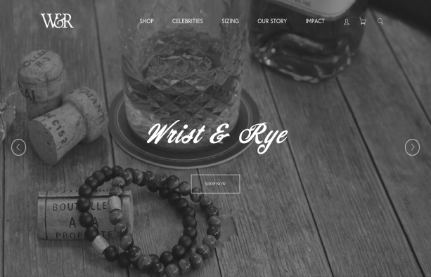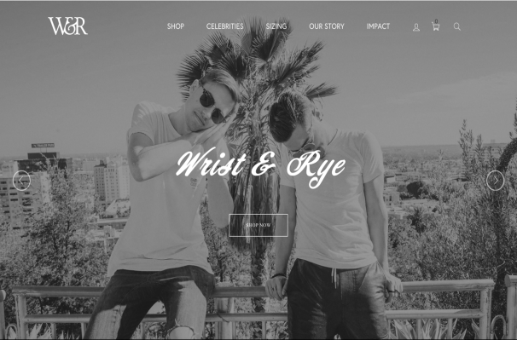

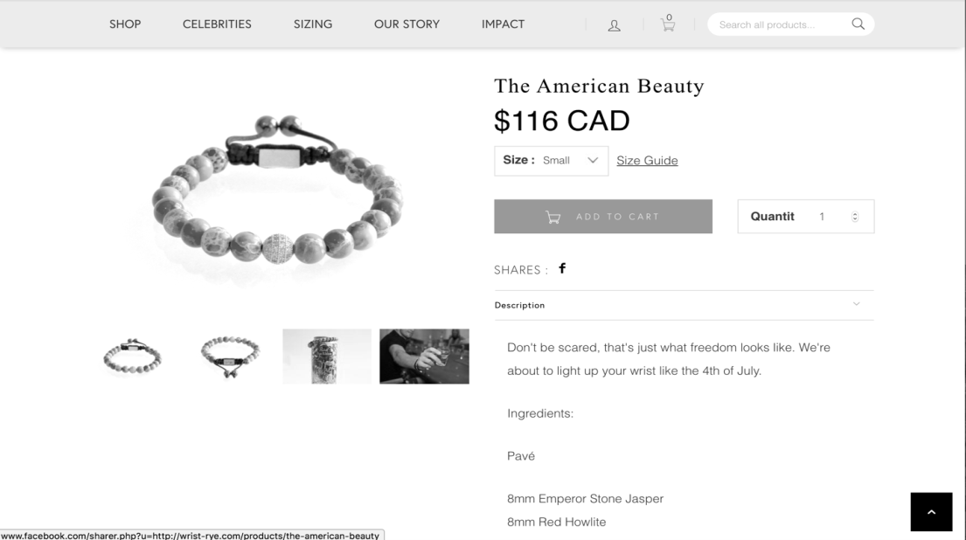

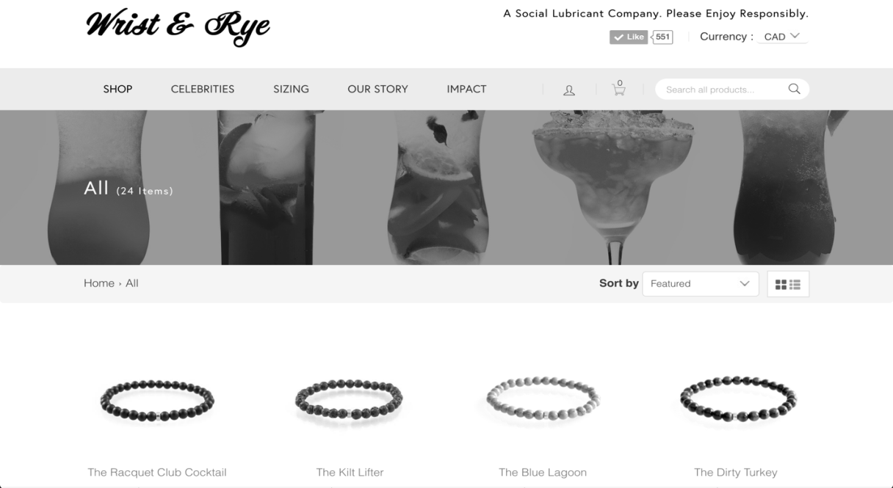

Source: Company files.

Exhibit 2: Wrist & Rye Sales Pitch

“Looking around and seeing so many bare and neglected wrists, it was evident that we had just identified an epidemic—a disease affecting the lives of millions each year called ‘Naked Wrist Syndrome’ (or NWS for short). We sought to remedy this situation by providing the masses with silky smooth wrist-wear, without the inflated price tag. The way we see it, the jewelry you choose to wear is an expression of your personality. Each piece we manufacture is built with a set of values and lifestyles in mind. The wrist revolution is real. Our bracelets will be the best thing to hug your wrists since, well, ever.”

Source: Company files.

1. All currency amounts are in Canadian dollars unless specified otherwise.
2. Winston was registered in the dual HBA/JD program.
3. For a complete explanation of W&R’s brand, go to www.wrist-rye.com.
4. Linda Dauriz, Nathalie Remy, and Thomas Thochtermann, “A Multifaceted Future: The Jewelry Industry in 2020,” McKinsey & Company, February 2014, accessed July 20, 2017, www.mckinsey.com/industries/retail/our-insights/a-multifaceted-future-the-jewelry-industry-in-2020.
5. “About,” Miansai, 2017, accessed, July 20, 2017, www.miansai.com/about/.
6. Robin Mellery-Pratt, “As Attitudes Shift, Men’s Jewellery Grows,” BoF, October 31, 2014, accessed July 20, 2017, www.businessoffashion.com/articles/intelligence/attitudes-shift-mens-jewellery-grows.
7. € = EUR = euro; CA$1 = €0.6793 on October 31, 2016.
8. Dauriz, Remy, and Tochtermann, op. cit.
9. Robin Mellery-Pratt, op. cit.
10. “About,” TNT, 2012, accessed July 20, 2017, http://tntfashion.ca/company-information/.