

9B17A055

MYMUESLI: new markets for customized breakfast cereal

Marc Fetscherin and Elena Kasper wrote this case solely to provide material for class discussion. The authors do not intend to illustrate either effective or ineffective handling of a managerial situation. The authors may have disguised certain names and other identifying information to protect confidentiality.

*This publication may not be transmitted, photocopied, digitized, or otherwise reproduced in any form or by any means without the permission of the copyright holder. Reproduction of this material is not covered under authorization by any reproduction rights organization. To order copies or request permission to reproduce materials, contact Ivey Publishing, Ivey Business School, Western University, London, Ontario, Canada, N6G 0N1; (t) 519.661.3208; (e)* [*cases@ivey.ca*](mailto:cases@ivey.ca)*;* [*www.iveycases.com*](http://www.iveycases.com)*.*

Copyright © 2017, Richard Ivey School of Business Foundation Version: 2017-10-25

In early 2017, the three founders of mymuesli GmbH (mymuesli) spent a week of vacation in Sweden after celebrating the successful opening of a new mymuesli store in Täby, close to Stockholm. At their hotel, they observed other guests engaged in an excited discussion in front of the breakfast buffet. The breakfast buffet allowed hotel guests to add several ingredients to their breakfast cereals, such as raisins, special seeds, and chocolate chips. Curious about what the guests were discussing, the young entrepreneurs decided to talk to them, and discovered that the guests were from different European countries. The guests told them that they enjoyed having such a great variety of breakfast items. They especially appreciated having the option to choose the ingredients for their breakfast cereals. When Hubertus Bessau, the chief marketing officer of mymuesli, explained that their company focused on customization, the guests were excited and wanted to know where they could buy products from mymuesli.

On their trip back to Germany, Bessau convinced his co-founders, Max Wittrock and Philipp Kraiss, that entering new markets would be a great opportunity for mymuesli to grow, although it might be a challenging step for the young company. Bessau suggested working on an internationalization strategy over the next few years. Having confidence in Bessau’s expertise and feeling validated by the hotel guests’ excitement about mymuesli, Kraiss and Wittrock asked him to prepare for the next board meeting a plan of where to go next with the company.

COMPANY BACKGROUND

In 2005, three German students, Wittrock, Bessau, and Kraiss, had the idea of starting their own breakfast cereal company. They were on their way to a lake to go swimming and heard a radio advertisement for a well-known German breakfast cereal manufacturer. The students wanted to seize the opportunity to be pioneers in online mass customization for breakfast cereals, which they believed should also be organic and sugar-free. In 2007, mymuesli went online for the first time, and the business started by distributing breakfast cereals in Germany (see Exhibit 1). The popularity of this concept and of their products allowed the founders to grow their business quickly. At the outset, they mixed the customized breakfast cereals that were ordered online in their small kitchen in Passau. After two weeks, they were already sold out. Therefore, at the end of 2007, they moved to a new production site in Passau.

In its second year of operation, mymuesli began to expand to nearby countries such as Austria and Switzerland, as well as to the United Kingdom. In Switzerland, the founders built a second office and production site in order to increase production capacity. In 2009, they entered the Dutch market with mymuesli, and in early 2017, they opened a store in Sweden. A milestone was met in 2010, when mymuesli’s unique mixing machine began to be used, allowing for the preparation of over 566 quadrillion different breakfast cereal varieties.[1]

Mymuesli offered more than 88 versions of pre-mixed breakfast cereal. These versions were chosen according to the most popular customer choices from the mass customization concept, and were sold in mymuesli’s own stores in multiple cities. In 2009, mymuesli tested the store concept in Passau by selling its products in physical stores in the city (see Exhibit 2). The popularity of this store encouraged the founders to open more stores across Germany. In the following years, mymuesli proceeded with its international expansion by opening stores in Austria, Switzerland, the Netherlands, and Sweden. As of summer 2017, mymuesli owned 58 stores across Germany, Switzerland, and Austria; two in Sweden; and one in the Netherlands (see Exhibit 3).

The company continuously grew, emerging from a three-man start-up, and expanding to a company with more than 800 employees by 2017. Mymuesli won several start-up awards, including the German Founders’ Award granted by Germany’s *Financial Times*, and in 2016, the German Marketing Award.

MASS CUSTOMIZATION

Most of the time, consumers of breakfast cereals found an ingredient in their cereal bowl that they did not like, or missed an ingredient that they liked. The three mymuesli founders wanted to tackle this issue by implementing the concept of mass customization, which would allow customers to mix their own individual breakfast cereals out of more than 80 ingredients on mymuesli’s website. In total, over 566 quadrillion mixtures were possible, ensuring that every customer received his or her preferred product by adding individually chosen ingredients. In five easy steps, the virtual mixer allowed customers to choose their preferred ingredients, all of which were organic and—if possible—locally sourced (see Exhibit 4). Besides mixing individual breakfast cereals, the customer could also create customized labels. To fulfill customer wishes as much as possible and to attract new customers, mymuesli continued adding new ingredients to its list of choices, and adapted its offerings to new trends in health and lifestyle. For instance, it created a special “Yoga-Muesli” in reaction to the popularity of yoga, and added chia seeds to the ingredient list because of the increasing demand for the healthy seeds.

ONLINE AND OFFLINE DISTRIBUTION

In Germany and abroad, mymuesli distributed its products through three channels: its website (online), and its own stores and selected supermarkets (offline). In the online store, customers could mix their own breakfast cereal. Besides this, customers could place orders 24 hours a day, seven days a week, avoiding bottlenecks such as queues and unavailable staff. The products were then shipped to customers’ homes. However, customers had to pay shipping costs of €3.90[2] if the order amount was less than €40, and had to wait two to three days for their products owing to delivery time. If they wanted to avoid these additional costs, customers could pick up their products at hotspots. While such hotspots were located primarily in mymuesli stores, there were a few external hotspots in major cities. For mymuesli, online direct sales were a quick and inexpensive method to connect with customers and to sell its products. The website could be adapted to suit newly entered markets. Moreover, its online stores allowed the company to collect data that was used to analyze customer behaviour and that optimized sales. However, online sales limited customer interactions, and required a great deal of overhead, such as updating product descriptions, adding pictures, and for packaging and delivering the products.

In mymuesli’s own stores, customers could buy pre-mixed versions of cereal. These stores allowed customers to get a “muesli experience” by tasting different products. They could also buy a bowl of freshly prepared breakfast cereal and take it to go. The stores were located primarily in city centres in high-density foot traffic areas, which gave them further exposure to non-customers and offered the possibility of benefitting from people’s impulse buying habits. New customers, who often visited an online store only if they were specifically looking for something, were attracted to mymuesli’s stores. However, for mymuesli, opening its own stores required huge capital investment and involved greater risks.

GLOBAL BREAKFAST CEREAL INDUSTRY

Supply and Demand

According to forecasts, the global breakfast cereal industry was expected to grow at a compound annual growth rate of about 4 per cent between 2013 and 2019. The industry’s value totalled €29 billion in 2012, and it was expected to reach €38.6 billion by the end of 2019.[3] Key growth drivers in the industry were the rising demand for natural and organic food, the increasing number of health-conscious consumers, and consumers’ increased disposable income. In 2014, North America accounted for the largest market share, of about 34 per cent, followed by Europe.[4] However, while the demand for breakfast cereals in North America and Europe was anticipated to be stagnant or even decline, Asia Pacific was expected to emerge as the fastest growing breakfast cereals market, with a forecasted global market share of 13 per cent by the end of 2019.

Companies operating in the industry made use of innovative marketing and promotion strategies to attract more customers. Moreover, they adapted the promotion of their products according to region-specific breakfast habits, and introduced innovative flavours in breakfast cereals to appeal to customers with different taste preferences.

The breakfast cereal industry could be split into several segments (see Exhibit 5). Taking figures from the United States’ breakfast cereal market, the largest market in the world, the segmentation looked as follows in 2016: with about 93 per cent of total sales, ready-to-eat breakfast cereals that could be consumed without further preparation had the largest portion of the market. However, as growth in demand was anticipated for the Asia Pacific, where a majority of consumers preferred hot cereals, the hot cereal segment was expected to increase its share to about 18 per cent of the global industry market share by 2019, and thus to drive overall market growth. In 2016, ready-to-eat corn breakfast foods (e.g., corn flakes) made up the largest segment in the United States with 27.9 per cent of total industry revenue. The increasing number of consumers choosing gluten-free products, as well as relatively low production costs, led to an increase in revenue for this segment. The revenue of the second-largest segment, ready-to-eat wheat breakfast foods (e.g., wheat flakes), decreased to 16.8 per cent because of shifts in dietary preferences. The segment of other ready-to-eat grain breakfast foods (e.g., granola or oats) grew to 48.2 per cent of total revenue in the United States in 2016, thanks to consumers’ increasing preference for healthy cereal foods and gluten-free grains. Last, with 7.1 per cent of the United States’ industry revenue, hot cereals (e.g., oatmeal) accounted for the smallest percentage in 2016. Their consumption was seasonal, and revenue share had declined over recent years due to consumers’ increasing shift to convenience food.[5]

The demand for breakfast cereals was influenced by multiple factors, including household disposable income, changing consumer lifestyles, product pricing, and the presence of substitutes. The demand in developed countries had declined due to changing consumer trends and economic recovery. While the rise in income per capita allowed customers to buy more expensive or branded products, it also enabled them to buy costly alternative breakfast products, such as yogourt, sandwiches, snack bars, and fruits. However, most of these substitutes did not provide the same nutritional benefits as some breakfast cereals, which were nutrient-dense thanks to the many vitamins, minerals, and fibre they contained. Additionally, consumers were tending to dine out at cafés and coffee shops more frequently, and busy consumers increasingly preferred fast and portable foods. Moreover, the trend toward healthy diets such as low-carb diets limited the demand for breakfast cereals.

The demand from supermarkets and convenience stores for breakfast cereals was a key external driver of industry performance. Looking at the U.S. industry as a proxy, this segment accounted for 53.8 per cent of total industry revenue in 2016. It was followed by grocery wholesalers with 33.4 per cent. Mass merchandisers were able to sell products at a lower price because of their purchasing power. Moreover, they had a huge choice of different brands to select from, and sold their own private label products. The private label products were also adapted to consumer needs and were sold for a lower price (around 35 per cent lower). Supermarkets mostly sold the brands that enjoyed the highest brand loyalty, as end costumers tended to buy brands they knew from their childhood. Although distribution through food service providers contributed the smallest revenue share in the United States in 2016 (6.5 per cent), food service providers that catered to hotels and schools, for instance, were crucial because their segment reported a growing revenue share thanks to the increasing trend of having breakfast outside of home. Additionally, 6.3 per cent of industry revenue in the United States in 2016 was generated through exports.

Industry Costs and Pricing

Cost structures in the breakfast cereal industry varied depending on various factors, such as the size and scale of production, marketing expenses, and supply chain relationships. The cost structure in the U.S. breakfast cereal industry serves as an example. While profit was estimated at 5.4 per cent of revenue, the remaining 94.6 per cent was costs, broken down as follows: 53.2 per cent was purchasing costs, 7.6 per cent was the cost of wages, marketing made up 5.6 per cent of costs, 1.6 per cent was depreciation, and the costs for rent and utilities totalled 1.5 per cent. The remaining 25.1 per cent included various other costs such as; overhead expenses, logistics and distribution, and research and development.

Profit in the industry had been volatile over the past few years because of fluctuations in commodity prices of corn, wheat, and grains. The prices of corn and wheat, which were both important inputs for breakfast cereals, significantly influenced profitability. When these prices rose, industry profitability decreased. Moreover, the changing availability of grains resulted in volatile prices. Suppliers, who were mostly independent, were carefully chosen to control costs and supply volatility of these raw materials. Mymuesli mainly purchased its supplies from local farmers and grain traders. An increase in the number of organic farmers in recent years had led to a decrease in prices for organic supplies. Companies offering supplies for packaging were numerous, and they set relatively stable prices.

The price sensitivity of customers varied among product segments. Customers’ willingness to pay a higher price depended on the perceived quality of the products. Strong brands were able to command a premium price thanks to their good reputation and brand-loyal customer base. Producers of healthy products perceived as high quality were able to charge higher prices. However, during the past five years, the growing segment of low-priced, private-label brands led to an increase in price-based competition.

Mymuesli positioned its products as organic, premium products for which its customers were willing to pay a higher price. The large, pre-mixed cans (400, 500, or 575 grams) could be purchased at prices from €3.90 to €14.39, while the “2go” cups (40 or 85 grams) cost approximately €1.90. If customers chose to mix their own breakfast cereals, €3.90–€4.90 was charged for the base, and €0.20–€1.25 was added for each additional ingredient.

Global Competition

The global breakfast cereal industry was mature and somewhat concentrated. Major players with well-established brands benefited from their customers’ brand loyalty, and accounted for the large majority of industry revenue. The biggest global players, fiercely competing for market share, were Kellogg Company, PepsiCo Inc., Nestlé S.A., General Mills Inc., and Weetabix Ltd. In the United States, General Mills Inc. had a market share of 23.8 per cent, followed by Kellogg Company with 23.3 per cent, Post Holdings with 11.9 per cent, and PepsiCo Inc. with 6.3 per cent.[6] Yet, there were also country-specific industry players, such as Dr. Oetker Ltd. in Germany and Valsoia SpA in Italy. The industry was expected in the near future to become even more concentrated. Since breakfast cereals were facing increased competition from substitutes, major players were likely to acquire niche companies in order to increase their product offerings, market share, and market power.

The ability of new players to enter and compete in the industry was limited by some barriers to entry, such as the high capital intensity, heavy industry regulations and policies, and strong positioning of existing players who enjoyed favourable contracts with media outlets and positive supply chain relationships. Economies of scale and scope were favourable in the industry. However, companies that specialized in niche products could become new players in the industry. In mymuesli’s home market of Germany, start-ups such as Muesli Muehle and Cereal Club, which emulated mymuesli’s organic and customized breakfast cereal concept, entered the market.[7] Players in the breakfast cereal industry mainly competed on quality, relationships with buyers, price, product innovation, and differentiation. The ability to adapt to shifts in consumer preferences and to differentiate from other players was a key success factor for companies, whose growth was limited. In response to the consumer trend toward healthier diets and to an increase in disposable income, companies adapted their product lines to spur demand by introducing healthy, premium products.

WHERE TO GO NEXT

Although their company had grown significantly in terms of number of employees from a start-up to a medium-sized company, the three founders were eager to determine into which market to introduce mymuesli. Bessau met with his marketing team to discuss how to proceed with the internationalization plan. He specifically wanted his team to conduct an analysis to identify the top three most attractive markets in Europe based on data he had gathered (see Exhibit 6).

EXHIBIT 1: COMPANY LOGO

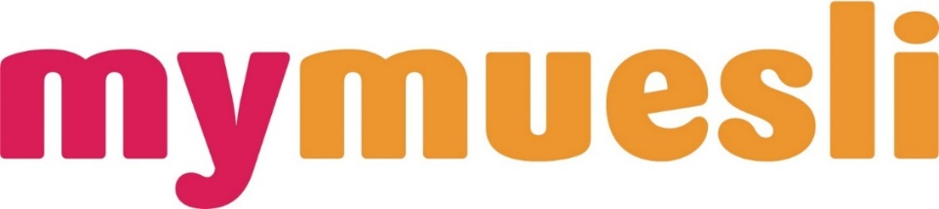

Source: Company documents.

EXHIBIT 2: mymuesli STORES AND PRODUCTS

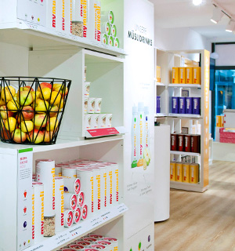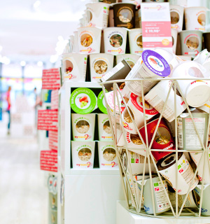



Source: Company documents.

EXHIBIT 3: MYMUESLI INTERNATIONALIZATION

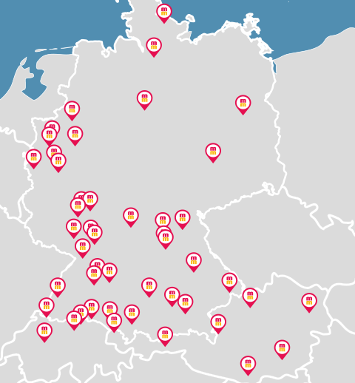

**Location of mymuesli Stores in German-speaking Countries\***

|  |  |  |  |  |
| --- | --- | --- | --- | --- |
| **Country** | **Year** | **Online** | **Offline** | **Number of Stores (2017)** |
| Germany | 2007 | x | x | 39 |
| Switzerland | 2008 | x | x | 6 |
| United Kingdom | 2008 | x |  | 0 |
| Austria | 2007 | x | x | 10 |
| The Netherlands | 2009 | x | x | 1 |
| Sweden | 2017 | x | x | 2 |

Note: * In addition, mymuesli owned two stores in Sweden and one store in the Netherlands.

Source: Created by the authors based on company documents.

EXHIBIT 4: mymuesli’s CUSTOMIZATION PROCESS

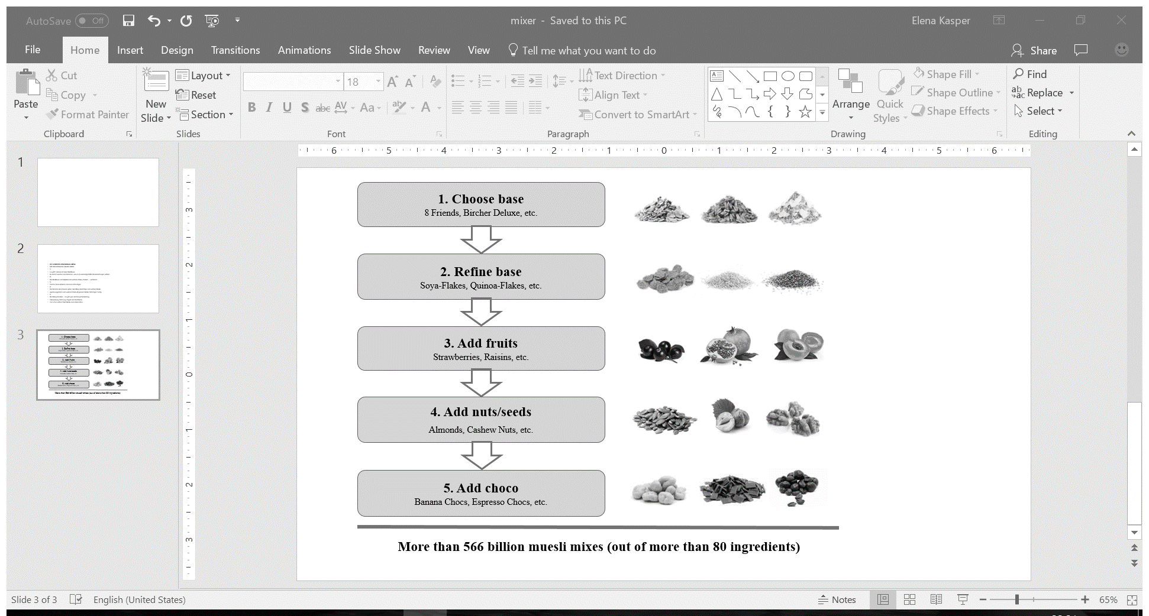

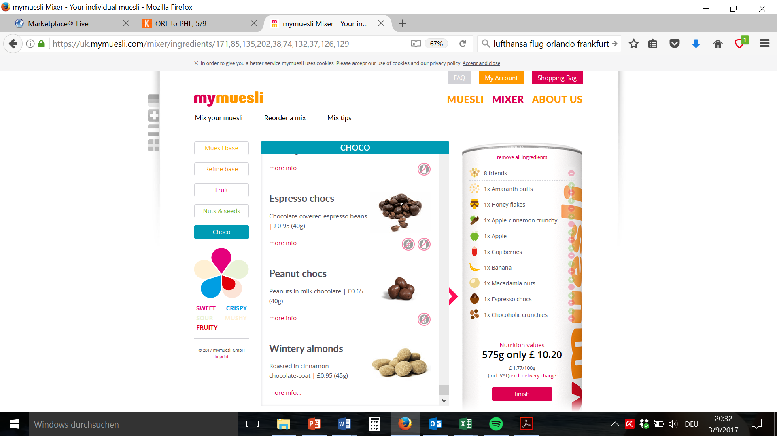

Note: choco = chocolate; chocs = chocolates

Source: Company documents; “Mixer,” mymuesli, accessed March 15, 2017, https://uk.mymuesli.com/mixer/.

EXHIBIT 5: GLOBAL MARKET SEGEMENT DESCRIPTION

|  |  |  |
| --- | --- | --- |
| **Market Segment** | **Percentage of U.S. Industry Revenue (2016)** | **Segment Description** |
| Ready-to-eat *corn* breakfast foods | 27.9% | Products in this segment included cold cereals made of corn, such as corn flakes |
| Ready-to-eat *wheat* breakfast foods | 16.8% | Products in this segment included cold cereals made of wheat, such as wheat flakes |
| Ready-to-eat *grain* breakfast foods | 48.2% | Products in this segment included cold cereals made of grains (oats, quinoa, rice, etc.), such as granola |
| Hot cereals | 7.1% | Products in this segment included breakfast cereal products that were consumed hot, such as oatmeal |

Source: Created by the authors based on “IBISWorld Industry Report 31123 Cereal Production in the US,” IBISWorld Rory Masterson, July 2016, accessed March 2, 2017.

EXHIBIT 6: MARKET DATA TABLE

|  |  |  |  |  |  |  |  |
| --- | --- | --- | --- | --- | --- | --- | --- |
| **Country**  **(Values 2016)** | **Total GDP in Billion US$** | **GDP per Capita in US$** | **Consumer Expenditure on Cereals per Capita**  **in US$** | **Disposable Income per Capita in US$** | **Total Population in '000** | **Urban Population in '000** | **Ease of Doing Business (Ranking)** |
| Belarus | 48 | 5,013.50 | 102.30 | 2,987.70 | 9,487.50 | 7,379.30 | 37 |
| Belgium | 466 | 41,348.90 | 437.20 | 23,115.60 | 11,267.90 | 11,030.80 | 42 |
| Bosnia-Herzegovina | 16 | 4,281.00 | 141.30 | 3,554.50 | 3,816.20 | 2,004.70 | 81 |
| Bulgaria | 52 | 7,285.60 | 154.80 | 4,126.50 | 7,153.80 | 5,227.20 | 39 |
| Croatia | 50 | 12,004.40 | 338.90 | 7,658.30 | 4,190.70 | 2,484.70 | 43 |
| Czech Republic | 194 | 18,342.10 | 216.10 | 9,481.90 | 10,553.20 | 7,727.30 | 27 |
| Denmark | 306 | 53,838.50 | 362.50 | 25,780.70 | 5,687.60 | 5,004.70 | 3 |
| Estonia | 23 | 18,136.00 | 297.80 | 9,888.90 | 1,267.70 | 888.60 | 12 |
| Finland | 237 | 43,124.90 | 429.50 | 24,565.20 | 5,487.30 | 4,629.00 | 13 |
| France | 2,460 | 38,137.80 | 423.60 | 23,658.20 | 64,496.20 | 56,988.90 | 29 |
| Georgia | 14 | 3,810.90 | 239.30 | 2,643.90 | 3,720.40 | 2,148.10 | 16 |
| Greece | 195 | 18,080.50 | 268.60 | 12,523.20 | 10,793.50 | 8,454.00 | 61 |
| Hungary | 125 | 12,673.50 | 166.10 | 6,566.20 | 9,830.50 | 6,929.80 | 41 |
| Ireland | 21 | 62,426.60 | 359.30 | 21,722.20 | 331.80 | 2,978.50 | 18 |
| Italy | 1,854 | 30,406.70 | 464.50 | 19,709.60 | 60,986.80 | 42,556.50 | 50 |
| Latvia | 27 | 13,917.50 | 236.00 | 8,332.60 | 1,969.00 | 1,339.70 | 14 |
| Lithuania | 43 | 14,766.00 | 375.50 | 9,387.30 | 2,888.60 | 1,943.20 | 21 |
| Macedonia | 11 | 5,225.00 | 208.00 | 3,523.40 | 2,067.90 | 1,240.90 | 10 |
| Montenegro | 4 | 6,888.10 | 188.90 | 4,631.50* | 617.20 | 409.70 | 51 |
| Norway | 367 | 70,294.40 | 452.20 | 34,640.40 | 5,214.00 | 4,209.30 | 6 |
| Poland | 470 | 12,228.70 | 194.10 | 7,144.60 | 38,437.20 | 23,166.40 | 24 |
| Portugal | 204 | 19,755.90 | 393.70 | 13,240.50 | 10,341.30 | 6,619.50 | 25 |
| Romania | 187 | 9,469.80 | 330.30 | 5,482.50 | 19,774.90 | 10,683.60 | 36 |
| Russia | 1,244 | 8,627.00 | 175.60 | 4,778.90 | 144,218.20 | 107,290.30 | 40 |
| Serbia | 38 | 5,328.10 | 181.50 | 3,794.10 | 7,074.10 | 4,112.00 | 47 |
| Slovakia | 90 | 16,514.20 | 287.70 | 9,532.90 | 5,423.20 | 2,944.00 | 33 |
| Slovenia | 44 | 21,294.70 | 288.30 | 12,761.70 | 2,064.30 | 1,029.20 | 30 |
| Spain | 1,233 | 26,578.50 | 338.10 | 16,474.00 | 46,374.40 | 36,251.20 | 32 |
| Turkey | 834 | 10,617.80 | 337.60 | 6,806.00 | 78,505.10 | 56,806.50 | 69 |
| Ukraine | 91 | 2,032.50 | 82.10 | 1,566.00 | 44,934.10 | 30,956.00 | 80 |

Note: *Estimated; countries ordered alphabetically; GDP = gross domestic product

Source: “Consumer Expenditure on Cereals,” Euromonitor International from National Statistics/Eurostat/United Nations (UN)/Organisation for Economic Co-operation and Development (OECD); “Disposable Income,” Euromonitor International from National Statistics; “Ease of Doing Business Ranking,” Euromonitor International from World Bank; “GDP: Euromonitor International from National Statistics/Eurostat/OECD/UN/International Monetary Fund, International Financial Statistics; “Total Population/Urban Population,” Euromonitor International from National Statistics/UN; “Urban Population,” Euromonitor International from National Statistics/UN, Euromonitor International, accessed April 3, 2017.

1. Calculations can be found at mymuesli, “566 Billiarden Müslis: Der Rechenweg [566 Billion Cereals: The Calculation Method],” May 1, 2007, accessed April 4, 2017, https://www.mymuesli.com/blog/2007/05/01/566-billiarden-muslis-der-rechenweg/.
2. € = EUR = euro; all currency amounts are in € unless otherwise stated; €1 = US$1.12 on May 20, 2017.
3. “Breakfast Cereals Market (Product Type—Hot Cereals and Ready to Eat Cereals)—Global Industry Analysis, Size, Share, Growth, Trends and Forecast 2013–2019,” Transparency Market Research, February 14, 2014, accessed March 6, 2017, www.transparencymarketresearch.com/breakfast-cereals-industry.html.
4. “Global Breakfast Cereal Market—Market Research Report 2015–2019,” technavio, October 2015, accessed March 6, 2017, https://www.technavio.com/report/breakfast-cereal-market.
5. “IBISWorld Industry Report 31123 Cereal Production in the US,” IBISWorld Rory Masterson, July 2016, accessed March 2, 2017.
6. Ibid.
7. “Müsli Muhle [Muesli Mill],” accessed March 5, 2017, www.muesli-muehle.de; “The Cereal Club,” accessed March 5, 2017, www.cereal-club.de.