

9B17A058

True Fruits: A Juiced-up internationalization strategy

Professor Marc Fetscherin and Patrick Sell wrote this case solely to provide material for class discussion. The authors do not intend to illustrate either effective or ineffective handling of a managerial situation. The authors may have disguised certain names and other identifying information to protect confidentiality.

This publication may not be transmitted, photocopied, digitized, or otherwise reproduced in any form or by any means without the permission of the copyright holder. Reproduction of this material is not covered under authorization by any reproduction rights organization. To order copies or request permission to reproduce materials, contact Ivey Publishing, Ivey Business School, Western University, London, Ontario, Canada, N6G 0N1; (t) 519.661.3208; (e) cases@ivey.ca; www.iveycases.com.

Copyright © 2017, Richard Ivey School of Business Foundation Version: 2018-03-22

Marco Knauf was driving back on the Autobahn from his ski trip in Switzerland. It was a late and snowy Sunday in March 2017. Skiing in Switzerland had shown him the interest of customers in health and lifestyle products. While in Switzerland, Knauf had visited some of the stores that had just begun selling the products of his company, True Fruits. While talking to the store managers, he learned that sales of True Fruits’ products had grown over 75 per cent. This assured Knauf that the company’s products were in great demand.

Caught by an idea to increase sales in other countries, Knauf had texted his good friends and co-founders, Nicolas Lecloux and Inga Koster, about his idea. The following morning, the three agreed that Knauf would prepare a presentation for the next board meeting, outlining their internationalization strategy for the next few years by identifying major European markets to enter. Despite being a mid-size German company and already having a presence in three European countries, Knauf faced the challenge of coming up with a sound international expansion plan to exploit growth opportunities.

Company Background

True Fruits was founded on June 26, 2006, in Bonn, Germany. The three founders, Koster, Knauf, and Lecloux, had successfully competed in an innovation competition that attracted investors and enabled the launch of their first four smoothie products. The idea to produce smoothies had been generated during a semester abroad in Scotland. Between nights out, rainy trips to the Highlands, and convoluted lectures, they discovered smoothies at local supermarkets. At that time, smoothies did not exist in Germany. The founders’ launch of four different smoothie flavours in November 2006 made them the first German smoothie producer (see Exhibit 1 for company logo). Their products were first available at cafés, bars, gyms, and the Petit Bistro shop from Aral (a German gas station).

True Fruits’ sales were approximately US$40 million[1] in 2016, and they employed 25 employees at their headquarters in Bonn. Knauf was managing director of sales and chief executive officer; Koster was chief financial officer and responsible for product development; and Lecloux was chief marketing officer. Although Knauf was chief executive officer in name, all three founders shared those tasks. Even though the founders held the major positions, True Fruits had a very flat hierarchy.

The Marketing Secret

True Fruits’ marketing department was innovative when it came to attracting customers’ attention. In 2012, True Fruits successfully launched an initiative to refurbish used bottles, and applied creative ideas for this through an online competition called Upcycling. Two years later, the company took the initiative a step further by developing stainless steel bottle toppers. These could be used for a variety of storage options (see Exhibit 2)*.*

True Fruits offered limited editions of bottle designs for special occasions and thereby tried to incorporate new marketing strategies with tested products. Limited editions were launched in 2010 with the “düstere Burlesque-Flasche” (gloomy burlesque bottle), and the “Strenesse” (named after a local fashion brand) in 2011. One year later, a special edition was launched for the company’s fifth anniversary: a bottle showing the company’s history. In 2013, True Fruits launched the first limited edition to come as a double; Limited no. 4.1 and 4.2 were designed by Mago Dovjenko, a young designer from Cologne. In the same year, True Fruits designed another limited edition—the measuring jug for the 750-millilitre (ml) bottle. True Fruits waited two years before releasing another limited edition, the black edition. The Indian design no. 7 introduced the curcuma root. In 2016, True Fruits celebrated its 10th birthday with another limited edition, a bottle painted in gold. The latest limited edition, the camouflage, was launched in April 2017—the first time True Fruits had produced a limited edition for a green smoothie.

True Fruits’ philosophy suggested the use of catch phrases instead of “standard” labelling in order to attract customers’ attention, engage them, and create for them an entirely new experience. In 2016, True Fruits encountered some criticism for a billboard campaign introducing its new seed juices, owing to ambiguous content potentially suggesting something improper. Two cities (Munich and Stuttgart) prohibited the use of particular billboards. However, True Fruits simply replaced Stuttgart with another city that allowed the billboard campaign. Because Munich was one of the biggest cities in Germany, the company did not want to renounce its billboards there. True Fruits printed the censored text on their billboards and hung these censored posters all over Munich. Overall, approximately 50 million people—more than 60 per cent of Germany’s population—were reached during the 10-day period by 4,000 billboards.[2] The campaign was not only supported through social media, but also enforced through active public relations efforts (see Exhibit 3).

International Presence

By the end of 2016, True Fruits was the market leader for smoothies in Germany. Premium grocery stores and high-end restaurants in Austria and Switzerland distributed and sold True Fruits’ smoothies; however, those two countries together accounted for only about 3 per cent of total revenues (see Exhibit 4). Austria was considered a very favourable market, as the consumption of smoothies had doubled there in the past four years.[3]

Corporate Strategy

True Fruits’ mission had always been to make healthy living a style of life rather than an obligation. The three founders had built their brand from the perspective of consumers, combining the best ingredients with the best packaging. Therefore, they used glass bottles for sustainability and differentiation, and printed directly on the glass bottle to avoid paper labelling. The company had decided to use glass as its packaging material because it was dense, safe, and neutral in taste, and it maintained the colour and stability of the product. Furthermore, glass had proven to increase the perceived value, and it was recognized as a premium product, making it a favourable packaging material—though it was also costlier.

True Fruits emphasized simplicity, quality, and purity of ingredients for all of its smoothie products. In fact, its glass bottles were filled with 100 per cent natural ingredients. Even though the glass bottles were completely recyclable, upcycling, as previously described, was still used for creative ideas.

True Fruits extended its offering to include nine different smoothies, named according to their colour: yellow, purple, orange, pink, white, green smoothie no. 1, green smoothie no. 2, white smoothie strawberry, and white smoothie matcha. It also offered two chia seed juices: chia yellow and chia red. The green smoothies were made out of vegetables and supplemented by green plants and fruits; the white smoothies were made out of fruits and nuts (see Exhibit 5). Some of the company’s products were available in 250 millilitre (ml) (8.5 ounces) and 750 ml (25.4 ounces) sizes. The price for a 250 ml smoothie was $2.80, and the price for a 750 ml smoothie was $4.50.

The company used a selective distribution strategy by selling to retailers who represented themselves as “high end” to their customers, indicating these retailers strove for the pull effect, which was in line with True Fruits’ mission and vision. True Fruits’ consumers were quality conscious, healthy, lifestyle-oriented people who were willing to pay a premium for a high-end product. Its target segment could be further characterized as being assertive in terms of the design—both optic and haptic—of the products they purchased, as well as having a consciousness of the importance of purchasing a healthy and sustainable product.

True Fruits’ statement “true fruits—no tricks” was a common theme the company applied to all of its activities. This included its minimalistic product design, and its honest, direct communication. These related to the company’s goal to produce a premium product in terms of a selection of high-quality ingredients, the product itself, and corporate design. The founders’ opinion was that the product labels would most likely be boring, which was why the company decided to print amusing and provocative phrases on the glass bottles. This became part of its marketing strategy. Exclusive ingredients rarely sold in Germany, such as acerola, pitaya, cupuaçu, and goji berry, justified the product’s high price.

True Fruitschose only the best quality ingredients, which were picked from the tree or shrub when they were ripe. The ingredients were mashed, packaged aseptically, and shock-frosted in order to preserve all of their vitamins and minerals. Further, True Fruits developed and implemented a gentle production method, “flash pasteurization,” through which the smoothie ingredients were heated for a very short period, giving the product its distinct taste. True Fruits received multiple national awards for this process, including the Bundesehrenpreis für Fruchtgetränke (a federal award for fruit juices)[4] in 2008, and the Land der Ideen Auszeichnung (Country of Ideas Award) in 2011.

Because True Fruits consistently offered a premium product, its marketing approach was connected to its mission of making healthy food part of a lifestyle, which was translated through its product offering. Its communication channels suggested a minimalistic, functional product design, which included an honest and transparent sales approach. Therefore, corporate design was an essential element supporting the brand’s image. The company’s four major communication channels were social media, public relations, bottle labelling, and its website.

GLOBAL SMOOTHIE INDUSTRY

Industry Overview

Taking the United States as an example, the juice industry consisted of the following main market segments: orange juice, the largest market segment with 52.2 per cent; fruit drinks and blended smoothies (33.8 per cent); lemonade (8.2 per cent); vegetable juice (1.2 per cent); and other juices such as apple, tomato, and pineapple (4.6 per cent). In contrast to juice production, mostly the entire fruit, including shell and seeds, was used in the production process for smoothies, so that all of the minerals and vitamins ended up in the smoothie.

The world market for smoothies was estimated to be around $9 billion in 2015,[5] and was projected to grow to $15.8 billion in 2022.[6] The largest smoothie market in the world was the United States, which had grown by 2.8 per cent between 2011 and 2016 to $2.3 billion in revenue.[7] The continuous growth was ascribed to factors such as the health consciousness of consumers, convenience, taste, and portability. The demographics for smoothie consumption tended to show a long-term perspective, with 18–24 year-olds composing the largest group (26.1 per cent), and people aged 55 and over representing the smallest group (3.6 per cent) (see Exhibit 6).[8] The major distribution channels for smoothies and fruit juices were grocery stores and supermarkets (41 per cent), convenience stores and gas stations (21 per cent), warehouses and superstores (18.5 per cent), vending machines (8.5 per cent), and others (11 per cent).[9]

Determining Demand Factors

The demand for smoothies depended on consumer preferences, and on per capita disposable income because this determined the consumer’s ability to make discretionary purchases such as smoothies. Overall smoothie consumption was expected to grow around 2 per cent between 2016 and 2020, according to an IBISWorld Industry Report.[10]

A consumer trend towards increased health consciousness was indicated by such measures as an increase in the healthy eating index. Another factor determining demand for smoothies was geographic region. The report suggested that more smoothies were consumed in places with favourable climatic conditions such as higher temperature, proximity to the sea or to a lake, and average sunshine duration.

Next to that, the day of the week also played a major role in determining smoothie demand. According to market research company Vivonet,[11] the majority of smoothies in North America were consumed on Fridays (17.5 per cent), followed by Thursdays (15.2 per cent) and Saturdays (14.8 per cent). Sunday tended to be the day when smoothies were consumed the least (11.2 per cent). The overall trend was that smoothie sales increased every day from Monday until Friday. Smoothie chains could use this knowledge to their advantage by implementing menu placements and promotions on certain days.

Market research showed that strawberry was the most popular smoothie ingredient among consumers, with 21 per cent of the ingredients used, followed by acai berry (see Exhibit 7). In contrast, the five least favourable ingredients were guava, papaya, marion berry, passion fruit, and lemon.

The most important driver for demand of smoothies was their price. The high price sensitivity of smoothie customers created the risk that they would quickly switch to substitutes. Further, it was possible that a limited and repetitive product choice might decrease smoothie consumption. It was therefore crucial for companies within the industry to maintain a high quality of ingredients and thereby differentiate from other companies—evidence of the demanding challenges smoothie producers faced with consumers’ continuously changing preferences.

Concentration of the Industry

The industry showed an increase in the consumption of smoothies since 2007. Globally, the industry was projected to grow at a compounded annual growth rate (CAGR) of 7.1 per cent until 2020.[12] In 2016, the United States represented the biggest market of the global smoothie market, in terms of sales and revenue. Asia-Pacific was expected to grow by a CAGR of 9.1 per cent until 2022.[13] This was attributed to a growth in the middle class, the Westernization of food consumption, and growing health consciousness stemming from rising levels of obesity. The consumption of fruit juice was regarded as an effective way to lose weight.

Because fruit juices were favoured in warmer climatic conditions, countries in Asia with a close proximity to the equator were projected to incur significant increases in the consumption of fruit juice in the years following 2016. When applying the climatic concept to the United States, the smoothie industry would be concentrated mainly in the southeast and the southwest. With daily weather volatility, the climate made the industry highly seasonal. In general, a warmer environment fostered the sale of smoothies. California, Florida, and Texas were the top three regions in terms of number of smoothie industry locations in the United States, with 20.1 per cent, 16.1 per cent, and 10.4 per cent of locations, respectively. In Europe, southern countries featured the ideal climatic conditions; however, as mentioned, climate was not the only factor determining smoothie consumption.

Competition

The existence of thousands of smoothie companies globally was due to low capital intensity in the industry, which decreased switching costs for consumers. Among the largest players were Barfresh Food Group, Bolthouse Farms, Boost Juice Bars, Crush Juice Bars, Freshens, Innocent, Jamba Juice, and Smoothie King. For example, in the U.S. market, the two major players, Jamba Juice (23.6 per cent market share) and Smoothie King (10.3 per cent market share), made up roughly one-third of the U.S. smoothie industry.[14]

Jamba Juice was the only publicly traded corporation within the industry. The corporation had over 800 locations worldwide, most of which were franchises. The firm operated two types of stores in the United States: traditional stores, which were located in major urban centres, and non-traditional stores, which were based within another business or institution. On the other hand, Smoothie King had a more international presence, with 100 locations outside the United States, in addition to the 700 stores it had within the United States. The company intended to expand mainly into developing countries within Asia, with the intention of using the growth of these nations to the company’s advantage. The third-largest company was Maui Wowi Hawaiian Coffees & Smoothies, with an estimated 3.2 per cent market share, followed by Robeks, with an estimated market share of 1.6 per cent. The remaining 61.3 per cent of the market was shared by smaller players, which suggested a low market concentration.[15]

The majority of smoothie stores were independently owned in a local geographic market. Therefore, a key to success for smoothie companies was ease of access for the customer. Highly populated areas had the greatest number of customers, as well as the greatest number of new stores, owing to new trends in healthy lifestyles, such as eating organic foods. For a company with limited resources for its own franchise, becoming a franchisee suggested a relatively low risk and was an easy option to enter markets. Lastly, efficient inventory management was a factor in helping a smoothie bar stock supplies properly and thereby maximize its margins and revenue. Longevity and loyalty were competitive advantages for the big companies; however, these values did not have an impact on the competition between local players. Customers were willing to pay higher prices for premium products.

Cost structures varied widely among industry players, depending on the number of locations they had, their ownership structure, and the number of customers the business location attracted. In general, firms with regular clients tended to be more profitable. A typical cost breakdown was 38.8 per cent—costs of goods sold; 23.1 per cent—wages; 12.5 per cent—rent and utilities; and 19 per cent—other costs, including marketing expenses, depreciation, and insurance costs, leaving an estimated 6.6 per cent earnings before interest and taxes.[16] Noteworthy was the fluctuation of fruit and vegetables prices, which could not be passed on to the consumer, and waste generated as a result of inefficient inventory management. It was, therefore, essential for companies to monitor their menus and other food inputs continuously. Developments in technology enhanced communication with suppliers and enabled greater efficiency in supply chain management. In contrast to the fluctuation in prices for ingredients, prices for packaging materials were constant; there were a large number of suppliers and they produced very similar products.

The increase in global demand for fresh fruits and vegetables raised smoothie producers’ prices, but they managed to slightly increase their margins between 2011 and 2016 by about 6.6 per cent.[17] Nevertheless, consumers were likely to substitute the high-cost product for low-cost drinks, or make their own smoothies when the price increased too much. An increase in external competition—from retailers and coffee shops, for example—added a tremendous threat of new entrants to the smoothie industry. Not only did cold-pressed juices become more popular because of their longer shelf lives, but Starbucks Corporation also entered the market, beginning with its acquisition of Evolution Fresh for $30 million in 2011.[18]

Globally, franchising had been the major source of expansion for leading smoothie companies. A company’s networks provided special assistance based on the franchisee’s location; for example, stores located in close proximity to fitness centres could adapt their products by adding healthy options containing protein supplements. This made it easier for companies to expand into new venues such as grocery stores, colleges, airports, and many other locations. Local stores were expected to face increased competition from major players in the smoothie industry due to the latter’s supply chain advantages in minimizing costs.

Future Trends

Industry analysis suggested that juices and smoothies with high sugar content would become less favourable to consumers. For example, orange juice and lemonade had seen decreases in consumption in recent years due to consumers’ increased health consciousness and awareness of childhood obesity. Companies producing exotic drinks and smoothies benefited from this, and it sparked a new subcategory, namely cold-pressed juice. This niche segment used technology that yielded a higher nutritional content without the addition of any supplemental products. Because a higher quality of fruit was needed for cold-pressed juice, the demand was expected to lead to an increase in the price of fruits in the next few years.

Non-genetically modified organisms, high-fibre, and organic smoothies had increased in popularity during recent years and were projected to continue doing so in the future.[19] Smoothie industry projections could be taken even a step further: green juices were being used as a meal replacement and for cleansing diets, and it was expected that many smoothie producers would capitalize on this trend in developed markets, offering smoothie bowls as a substitute for ice cream or breakfast cereals. This trend could potentially open an entirely new market, and it had shown tremendous future expansion potential.

WHERE TO GO NEXT

Against this background, Knauf, Koster, and Lecloux moved forward with their plans for international expansion and hired Daniel Aminati Bilzerian,a young and enthusiastic strategic manager, in the second quarter of 2017. Bilzerian was placed in charge of international expansion under the supervision of Lecloux. Due to increasing competition and rising fruit prices in Germany, Bilzerian’s task was to conduct an analysis for growing True Fruits internationally, which he was asked to prepare for the next board meeting. Of a short list of 32 potential markets, he had to identify the top three countries where the company should expand next (see Exhibit 8). Using the correct factors to identify these countries was critical, but Bilzerian had to consider another question: Was direct exporting the most efficient international mode of entry for True Fruits, or should the company consider using other methods such as licensing, franchising, joint ventures, or company-owned stores in certain markets?

EXHIBIT 1: COMPANY LOGO



Source: Company documents.

EXHIBIT 2: UPCYCLING EXAMPLES

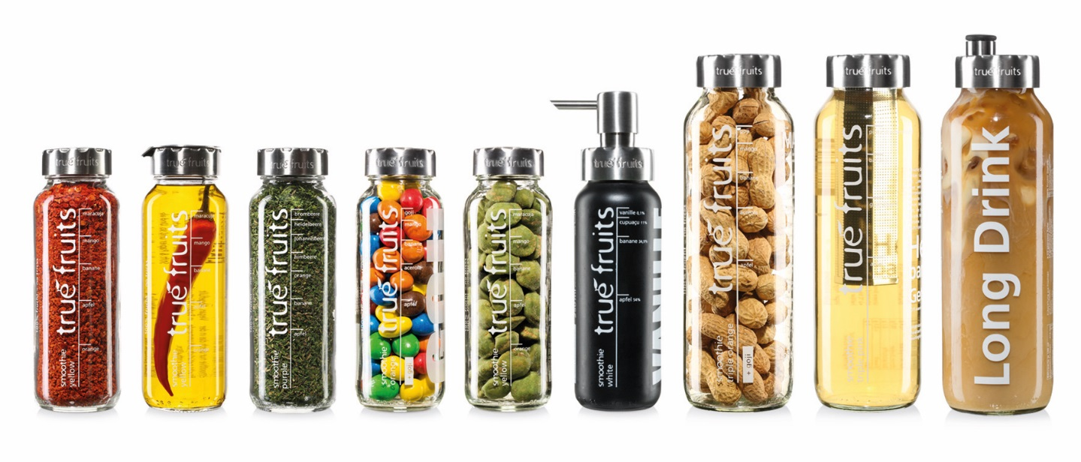

Source: Company documents.

EXHIBIT 3: true fruits BILLBOARD CAMPAIGN

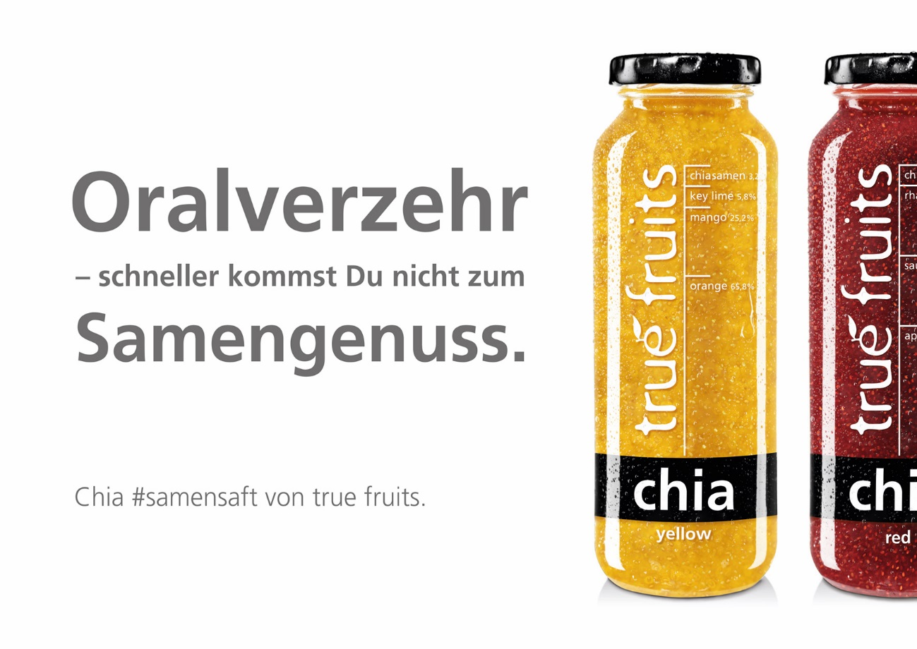

English translation: “Oral consumption- you won’t get a faster semen pleasure”

Source: Company documents.

EXHIBIT 4: TRUE FRUITS INTERNATIONALIZATION

|  |  |  |
| --- | --- | --- |
| Country | Year | Revenue Generated (%) |
| Germany | 2006 | 97 |
| Austria | 2008 | 2 |
| Switzerland | 2016 | 1 |
| Total |  | 100 |

Source: Company documents.

EXHIBIT 5: PRODUCT LINE EXAMPLES WITH INGREDIENTS

|  |  |
| --- | --- |
| True Fruits Smoothie Yellow, 250 ml | |
|  | 3/4 squeezed orange  2/3 squeezed apple  3/5 pureed banana  1/3 pureed mango  1 2/3 pureed maracuja |
| True Fruits Smoothie Purple, 250 ml | |
|  | 1 squeezed apple  1/2 pureed banana  9 pureed raspberries  19 pureed blueberries  7 pureed blackberries  20 pureed red currants  26 pureed black currants |
| True Fruits Smoothie Orange, 250 ml | |
|  | 1 1/2 squeezed apple  18 pureed acerolas  2/5 pureed banana  1/5 pureed mango  7 squeezed goji berries  1 dash yuzu  1 pureed slice of curcuma |

Note: ml = millilitres

Source: Company documents.

EXHIBIT 6: DEMOGRAPHIC FOR SMOOTHIE CONSUMPTION (age/market share)

|  |  |
| --- | --- |
| Age Group in Years | Total Smoothie Consumption (%) |
| <18 | 13.00 |
| 18–24 | 26.10 |
| 25–34 | 25.60 |
| 35–44 | 19.40 |
| 45–54 | 12.60 |
| >55 | 3.60 |

Source: “How Big is the Smoothie Industry?,” Planet Smoothie*,* accessed October 4, 2017, http://planetsmoothiefranchise.com/learn-planet-smoothie/big-smoothie-industry.

EXHIBIT 7: FAVOuRed SMOOTHIE INGREDIENTS IN NORTH AMERICA

|  |  |
| --- | --- |
| Ingredient | Favoured (%) |
| Strawberry | 21 |
| Acai berry | 12 |
| Tropical fruit | 11 |
| Mango | 10 |
| Mixed berry | 9 |
| Banana | 9 |
| Orange | 6 |
| Cranberry | 5 |
| Pomegranate | 4 |
| Matcha green tea | 4 |

Source: Richard Lazazzera, “Infographic: The Most Popular Smoothie in North America,” Vivonet, October 3, 2012, accessed October 4, 2017, www.vivonet.com/blog/bid/159764/infographic-the-most-popular-smoothie-in-north-america.

EXHIBIT 8: MARKET DATA TABLE (2016)

|  |  |  |  |  |  |  |  |  |
| --- | --- | --- | --- | --- | --- | --- | --- | --- |
| **Country** | **Ease of Doing Business Ranking** | **GDP per Capita**  **(in $)** | **GDP**  **(in $ billions)** | **Consumer Expenditure on Fruits per Capita (in $)** | **Consumer Expenditure on Fruit and Vegetable Juices per Capita**  **(in $)** | **Disposable Income per Capita (in $)** | **Total Population (in ‘000)** | **Urban Population (in ‘000)** |
| Belarus | 37 | 5,013.50 | 48 | 61.90 | 8.00 | 2,987.70 | 9,487.50 | 7,379.30 |
| Belgium | 42 | 41,348.90 | 466 | 194.80 | 180.50 | 23,115.60 | 11,267.90 | 11,030.80 |
| Bosnia-Herzegovina | 81 | 4,281.00 | 16 | 84.70 | 80.80 | 3,554.50 | 3,816.20 | 2,004.70 |
| Bulgaria | 39 | 7,285.60 | 52 | 46.00 | 86.70 | 4,126.50 | 7,153.80 | 5,227.20 |
| Croatia | 43 | 12,004.40 | 50 | 137.70 | 89.30 | 7,658.30 | 4,190.70 | 2,484.70 |
| Czech Republic | 27 | 18,342.10 | 194 | 135.00 | 89.10 | 9,481.90 | 10,553.20 | 7,727.30 |
| Denmark | 3 | 53,838.50 | 306 | 157.60 | 180.30 | 25,780.70 | 5,687.60 | 5,004.70 |
| Estonia | 12 | 18,136.00 | 23 | 121.30 | 106.20 | 9,888.90 | 1,267.70 | 888.60 |
| Finland | 13 | 43,124.90 | 237 | 280.50 | 194.10 | 24,565.20 | 5,487.30 | 4,629.00 |
| France | 29 | 38,137.80 | 2,460 | 172.30 | 165.00 | 23,658.20 | 64,496.20 | 56,988.90 |
| Georgia | 16 | 3,810.90 | 14 | 23.30 | 14.30 | 2,643.90 | 3,720.40 | 2,148.10 |
| Greece | 61 | 18,080.50 | 195 | 174.90 | 90.70 | 12,523.20 | 10,793.50 | 8,454.00 |
| Hungary | 41 | 12,673.50 | 125 | 69.40 | 105.10 | 6,566.20 | 9,830.50 | 6,929.80 |
| Italy | 50 | 30,406.70 | 1,854 | 227.20 | 126.70 | 19,709.60 | 60,986.80 | 42,556.50 |
| Latvia | 14 | 13,917.50 | 27 | 126.10 | 79.60 | 8,332.60 | 1,969.00 | 1,339.70 |
| Lithuania | 21 | 14,766.00 | 43 | 149.80 | 88.80 | 9,387.30 | 2,888.60 | 1,943.20 |
| Macedonia | 10 | 5,225.00 | 11 | 55.60 | 81.90 | 3,523.40 | 2,067.90 | 1,240.90 |
| Montenegro | 51 | 6,888.10 | 4 | 64.80 | 39.00 | 4,631.50 | 617.20 | 409.70 |
| Netherlands | 28 | 45,402.20 | 771 | 151.40 | 128.80 | 21,618.00 | 16,978.00 | 14,422.80 |
| Norway | 6 | 70,294.40 | 367 | 244.00 | 379.80 | 34,640.40 | 5,214.00 | 4,209.30 |
| Poland | 24 | 12,228.70 | 470 | 57.00 | 66.20 | 7,144.60 | 38,437.20 | 23,166.40 |
| Portugal | 25 | 19,755.90 | 204 | 182.80 | 62.90 | 13,240.50 | 10,341.30 | 6,619.50 |
| Romania | 36 | 9,469.80 | 187 | 90.30 | 76.90 | 5,482.50 | 19,774.90 | 10,683.60 |

Exhibit 8 (Continued)

|  |  |  |  |  |  |  |  |  |
| --- | --- | --- | --- | --- | --- | --- | --- | --- |
| **Country** | **Ease of Doing Business Ranking** | **GDP per Capita (in $)** | **GDP (in $ billions)** | **Consumer Expenditure on Fruits per Capita (in $)** | **Consumer Expenditure on Fruit and Vegetable Juices per Capita (in $)** | **Disposable Income per Capita**  **(in $)** | **Total Population (in ‘000)** | **Urban Population**  **(in ‘000)** |
| Russia | 40 | 8,627.00 | 1,244 | 116.20 | 80.20 | 4,778.90 | 144,218.20 | 107,290.30 |
| Serbia | 47 | 5,328.10 | 38 | 51.90 | 69.10 | 3,794.10 | 7,074.10 | 4,112.00 |
| Slovakia | 33 | 16,514.20 | 90 | 83.10 | 72.90 | 9,532.90 | 5,423.20 | 2,944.00 |
| Slovenia | 30 | 21,294.70 | 44 | 126.60 | 103.20 | 12,761.70 | 2,064.30 | 1,029.20 |
| Spain | 32 | 26,578.50 | 1,233 | 170.10 | 117.10 | 16,474.00 | 46,374.40 | 36,251.20 |
| Sweden | 9 | 51,833.80 | 511 | 210.60 | 197.70 | 25,055.80 | 9,851.00 | 8,468.30 |
| Turkey | 69 | 10,617.80 | 834 | 164.90 | 85.70 | 6,806.00 | 78,505.10 | 56,806.50 |
| Ukraine | 80 | 2,032.50 | 91 | 32.50 | 29.00 | 1,566.00 | 44,934.10 | 30,956.00 |
| United Kingdom | 7 | 39,988.10 | 2,615 | 173.30 | 171.30 | 25,467.10 | 65,382.60 | 52,495.00 |

Note: GDP = gross domestic product.

Source: Euromonitor International, “Countries Ordered A to Z,” Passport, accessed March 4, 2017.

1. All currency amounts are in US$ unless otherwise specified.
2. “Bei Samenstau schütteln: ‘Für ihre Chiasamen-Saft-Kampagne setzen die “Einhornkotze’-Experten von True Fruits auf anzügliche Sprüche,” [Shake in case of seminal congestion: The unicornvomit-experts of True Fruits are using raunchy patterns for their chia seeds campaign] Meedia Redaktion, August 29, 2016, accessed October 4, 2017, http://meedia.de/2016/08/29/bei-samenstau-schuetteln-fuer-ihre-chiasamen-saft-kampagne-setzen-die-einhornkotze-experten-von-true-fruits-auf-anzuegliche-sprueche.
3. “Consumption of Smoothies in Austria from 2008 to 2016 (in Million Liters),” Statista, accessed October 4, 2017,www.statista.com/statistics/425627/consumption-of-smoothies-austria.
4. Percy Bongers, “Nur das Beste in der Flasche [Only the best in the bottle],” besserhaushalten, January 2017, accessed October 4, 2017, www.besserhaushalten.news/essen-leben/gourmet-genuss/true-fruits-100-frucht-no-tricks.html.
5. “Global Smoothies Market to Reach $9.0 Billion by 2015, According to New Report by Global Industry Analysts, Inc.,” prweb*,* April 5, 2010, accessed October 4, 2017, www.prweb.com/releases/smoothies_market/frozen_mix_smoothie/prweb3808804.htm.
6. Global Industry Analysts, Inc., “Evergreen Consumer Preference for Nutrient Loaded Blended Juices Sustains the Undying Popularity of Smoothies,” strategy.com, August 2016, accessed October 4, 2017, www.strategyr.com/MarketResearch/Smoothies_Market_Trends.asp.
7. Andrew Alvarez, “Juice & Smoothie Bars: Market Research Report,” IBISWorld, September 2016, accessed October 4, 2017, www.ibisworld.com/industry-trends/specialized-market-research-reports/consumer-goods-services/food-service-drinking-places/juice-smoothie-bars.html.
8. “How Big is the Smoothie Industry?,” Planet Smoothie,accessed March 2017, http://planetsmoothiefranchise.com/learn-planet-smoothie/big-smoothie-industry.
9. Andrew Alvarez, op. cit.
10. Alvarez,op. cit.
11. Richard Lazazzera, “Infographic: The Most Popular Smoothie in North America,” Vivonet*,* October 3, 2012, accessed October 4, 2017, www.vivonet.com/blog/bid/159764/infographic-the-most-popular-smoothie-in-north-america.
12. Laura Wood, “Global Smoothies Market Growth of 7.1% CAGR by 2020—Analysis, Technologies & Forecasts Report 2016–2020—Key Vendors: Bolthouse Farms, Innocent Drinks, Suja Juice—Research and Markets,” Business Wire, July 5, 2016, accessed October 4, 2017, www.businesswire.com/news/home/20160705005722/en/Global-Smoothies-Market-Growth-7.1-CAGR-2020.
13. Global Industry Analysts, op. cit.
14. Andrew Alvarez, “Juice & Smoothie Bars: Market Research Report,” IBISWorld, September 2016, accessed October 4, 2017, www.ibisworld.com/industry-trends/specialized-market-research-reports/consumer-goods-services/food-service-drinking-places/juice-smoothie-bars.html.
15. Ibid.
16. Ibid.
17. Ibid.
18. Andrew Alvarez, op. cit.
19. Global Industry Analysts, op. cit.