

9B17A061

TATA GLUCO PLUS: BUILDING THE BRAND IDENTITY

Neena Sondhi wrote this case solely to provide material for class discussion. The author does not intend to illustrate either effective or ineffective handling of a managerial situation. The author may have disguised certain names and other identifying information to protect confidentiality.

*This publication may not be transmitted, photocopied, digitized, or otherwise reproduced in any form or by any means without the permission of the copyright holder. Reproduction of this material is not covered under authorization by any reproduction rights organization. To order copies or request permission to reproduce materials, contact Ivey Publishing, Ivey Business School, Western University, London, Ontario, Canada, N6G 0N1; (t) 519.661.3208; (e)* [*cases@ivey.ca*](mailto:cases@ivey.ca)*;* [*www.iveycases.com*](http://www.iveycases.com)*.*

Copyright © 2017, Richard Ivey School of Business Foundation Version: 2017-11-27

Energy! The word resonated with K.S. Kuttiah, the vice-president of marketing and innovations at NourishCo Beverages Ltd. (NourishCo). Kuttiah was admiring a poster of the non-caffeinated water beverage Tata Gluco Plus, which occupied the entire wall behind his desk at the company’s headquarters in Gurugram, Haryana, India. Kuttiah had been managing the innovative, ready-to-drink offering since 2015. Tata Gluco Plus was a unique blend of health and taste. It offered energy and wellness through a balance of dextrose, electrolytes, and iron. The brand was part of the product portfolio of NourishCo, a joint venture between Tata Global Beverages Limited (Tata) and PepsiCo India Holdings (PepsiCo).

In its fourth year since its inception, the product was enjoying adequate sales, but the brand had not been able to create a clear image for consumers. The NourishCo team felt that the brand had great potential. However, an expert was needed to define the product’s clear positioning, so Kuttiah was brought in from Tata for the task. NourishCo’s chief executive officer and managing director Harsh K. Rai had categorically and emphatically told Kuttiah that “with Tata Gluco Plus, we want to own energy in this market,” which was a very ambitious goal in a country as diverse as India, with complex consumer nuances, and where the national culture had to coexist with regional customs.

Extensive in-depth consumer insights and field research from the sales force had gone into creating a new brand identity for Tata Gluco Plus. Kuttiah had spearheaded a well-constructed and sharp branding strategy for the beverage, which had increased the brand’s consumer awareness and had earned it a trial run in Tamil Nadu and Andhra Pradesh. Recognizing the great potential of the new brand, NourishCo had given it the lead role of establishing the company’s national presence. Formal approval for the plan was given by the NourishCo board of directors in May 2016, so the company was all set to go ahead with executing the plan.

NourishCo’s business model had always emphasized operational efficiency and cost-effective strategies. A complex challenge like giving the brand a national presence became further complicated when the company philosophy was to keep costs to a stringent minimum. It was the onset of summer in most of the Indian states, and Kuttiah needed to give Rai a blueprint of the roadmap for Tata Gluco Plus’s branding strategy. This had to be complemented and closely synchronized with the NourishCo national launch strategy for the brand. Kuttiah had a meeting scheduled for Monday morning, so he still had the weekend to work out the plan’s direction and resolve any issues.

The branding exercise had begun the previous year in the southern states through a series of traditional and contemporary contests, allowing the brand to gain visibility. Kuttiah looked down at the dossier for the brand results for 2015 versus 2016. The results were positive and encouraging, showing clear progress. However, they were mixed in terms of the brand’s recognition. Consumer trials and repurchase had also increased, but for the key attributes on which Kuttiah wanted the brand to excel, progress was either slow or inexistent.

His mandate for the brand had been to garner healthier consumer acceptance and to create a clear brand positioning. Looking at the indices, Kuttiah wondered if the brand would be able to move in the right direction to meet its goals. Should energy, the key differentiator, be further enhanced so that the brand would be recognized as a healthy, affordable energy brand? Would this be a good or a counterproductive strategy? Would the brand be seen as having functional benefits, but no longer as a preferred beverage? Affordability and taste were not resonating with the Tata Gluco Plus customer as attributes of the product. How could the brand endear itself to consumers in new territories, where both niche and large beverage competitors already occupied the preferred brand space? Kuttiah needed to establish a promising new image for Tata Gluco Plus. The question was how to achieve that goal.

NOURISHCO BEVERAGES: A hydrating solution for a healthy India

NourishCo was an equal partnership between Tata (part of the Tata Group of companies) and PepsiCo. The company was created in 2010 to fill the gap in India’s health and wellness beverage market, offering a range of beverages. “NourishCo—the joint venture with PepsiCo India—helps us leverage the trust invested in the Tata name and PepsiCo’s unique sales and distribution expertise,” said R.K. Krishna Kumar, Tata’s vice-president.[1] The company opened business in 2011 and offered three different brands[2] by 2016. Kuttiah explained the need for three brands as follows:

Marketing or brand portfolios have to be assessed for [their] synergistic effect. So, let’s step back a bit. NourishCo, as a company, talks about *good for you* beverages, and that’s a large platform [that] straddles three segments. Right at the bottom, it is about insufficient *nutrition*;from there it moves to *fortification*; and right at the top, people seek *holistic wellness*. So, we will have the *wellness brand* with Himalayan, and the Tata brand with Gluco Plus, and Water Plus will be the *functional delivery*. So those are the buckets that we see and that [tie] up with the larger company objective.

Himalayan

Himalayan wasan untouched, unprocessed, pure, natural mineral water—the epitome of purity. The water percolated through layers of Himalayan rock and collected natural organic minerals on its path, and then finally reached an underground aquifer beneath land owned by the company. Every bottle was packed at the source and transported to various parts of the country for discerning Indians who sought the very best nature had to offer. The product came in transparent polyethylene terephthalate (PET) bottles in three different sizes, and it was priced at ₹55[3] per litre. The bottle came with a unique fuchsia-pink cap that gave it instant recognition among other packaged water brands available in recyclable bottles, which came with mostly white or blue caps.

The brand was available across the country. It was also available at Starbucks outlets in India and Singapore.[4] The company was exploring new global territories, having launched a sparkling water brand to compete directly with global brands such as Perrier and San Pellegrino. Rai explained the pricing strategy as follows:

Sparkling [Himalayan](http://www.business-standard.com/search?type=news&q=Himalayan)will be priced at over ₹220 per litre. Typically, a 330-ml [millilitre] imported sparkling water brand costs around ₹200 to ₹300. We are using the PepsiCo distribution network to push [regular] Himalayan into modern as well as traditional trade and into hotels [and] restaurants. Sparkling [Himalayan](http://www.business-standard.com/search?type=news&q=Himalayan) will also be pushed into modern and traditional trade, but the accent will be on targeting premium outlets, such as high-end traditional trade outlets where imported products are stocked. For sparkling Himalayan, we will target upscale hotels [and] fine-dining restaurants as part of its distribution push. We will launch the product in Mumbai, Bangalore, and Delhi before taking it to other markets.[5]

Tata Water Plus

Tata Water Plus was created for the Indian market after a considerable study was conducted. Zinc was identified as a micronutrient deficient among Indians, yet essential for maintaining the human body’s immunity. In fact, most Indian governmental agencies recommended zinc during an outbreak of diarrhea. The second element identified by the research was copper, which was known to support overall body functions. The key challenge was to develop a beverage that tasted and looked just like normal water but delivered zinc and copper in a bioavailable manner. Tata Water Plus managed to do just that. The research results led to an invention that that boasted the following qualities:

It would provide a hydrating supplement fortified with the micronutrients to supplement [any] deficiencies. Further, the object of the present invention . . . is to provide a beverage fortified with zinc and copper to reduce the deficiency diseases in humans … [and] to provide an inexpensive source and additional dietary nutrients such as zinc and copper in a treated water beverage.[6]

To support and adhere to the larger vision of the company, the product was made available for an affordable price of ₹2 in a pouch (200 ml) format. Later, it was also made available in PET bottles, in 500-ml and 1-litre sizes. The brand came with the tag line Pyaas bujhao health se, which roughly translated to “thirst quench health.”

The pouch format and the PET bottle both featured a copper colour on the labels and on the bottle’s cap. This represented the presence of copper in the water. “Most Indian families keep water in copper vessels overnight. Thus, copper has a strong perception of delivering goodness, and it is something that most Indian customers can connect with,” said Rai.

Tata Gluco Plus

Tata Gluco Plus was the other product developed by NourishCo. It was launched in 2012 with the proposition of *Instant Energy Anytime Anywhere* in the state of Tamil Nadu. The product was the result of extensive consumer research and insights. According to Rai, the findings clearly indicated several assumptions:

In a hot and humid country like India, where a substantial number of people work outdoors, there is a constant need for energy. Secondly, alongside energy depletion in tropical climates, one loses body salts because of sweat. So, electrolytes were another loss. [The] third issue was our deficiency—and a national concern as well—of iron. And while many carbonated beverage brands deliver on imagery benefits, there was no brand that delivered on real energy to the consumer. While there are a number of global energy brands like Red Bull, Monster, etc., available in the Indian market, they are largely caffeine-based. You see, caffeine based drinks are only a stimulant, while Tata Gluco plus is composed of glucose, electrolytes, and iron; thus, it provides you energy with no side-effects of caffeine. Thus, the drink was designed to satisfy this clear energy gap that existed in the Indian beverage space.

The company also tested flavours, which had to have a universal appeal for the Indian consumer. The flavours that met this criterion were lemon, orange, mango, and apple. Of these, lemon was the safest in terms of likability and was chosen as the introductory flavour. The other challenge was to deliver this drink packed with glucose, electrolytes, and iron in an appealing flavour at a price lower than other soft drinks on the market. The company used innovative packaging, but managed to keep production costs low.

According to Kuttiah, the struggle was to develop the right blend of the supplements as well as flavour, because “taste was the [core benefit] factor.” The company’s other major decision involved the package size and design. Because the product was intended to provide “energy on the go,” the package size had to be suitable for individual use and convenience, so a 200-ml plastic cup was chosen. This option served two purposes. It would reduce the unit manufacturing price of the offering and it would offer differentiation, because no other carbonated or energy drink was available in this format at the time. The peelable cup container was the first package of its kind. It was a key factor in generating curiosity among consumers in a trial run. In 2016, the product was priced at ₹10 and was available in a 200-ml cup format in six flavours, offered in the states of Andhra Pradesh, Tamil Nadu, Maharashtra, Karnataka, Jammu, and Gujarat (see Exhibit 1).

In 2015, the company decided to adopt a localized approach. The company conducted extensive research that included local consumer insights, and then launched one popular local flavour for each territory. As market analysis clearly showed, some local brands built up large businesses with this strategy. According to Kuttiah, “our hypothesis is that local preference plus energy should be a winning combination.”

Having established acceptability of the concept and product for both Tata Water Plus and Tata Gluco Plus in select Indian states (especially Andhra Pradesh and Tamil Nadu), the beverage company was able to develop a distinct, cost-effective business model. NourishCo now needed a strong contributor to the bottom line to meet the company objective of breaking even in the next couple of years (see Exhibit 2A and 2B). Therefore, it prepared to increase its customer base and establish a national footprint. Although the company already had one product (i.e., Himalayan) that was available across the country, it planned to offer its value-based offerings nationally as well. The company identified Tata Gluco Plus for this purpose. The expansion plan was presented to the NourishCo board, and approval was received in May 2016. It was time to plan for the next stage.

TATA GLUCO PLUS: evolution of the brand

Tata Gluco Plus was a unique product and brand, offering energy without caffeine. As Kuttiah noted, “Tata Gluco Plus hit a sweet spot, if you ask me. Energy is definitely a need and consumers recognize it. But to stay true to our larger objective of wanting to deliver wellness for the country, we also fortified it with iron.” In the initial years, the brand performed well and gained market share rapidly, despite a low marketing investment. However, by the end of 2013, the brand’s rise had slowed down. By the end of 2014, sales were stagnating in some regions and dropping in others.

Assessing the Market

To assess consumer sentiments regarding the product, an exploratory market-level feedback survey was conducted, of both consumers and retailers, to gauge how the product’s acceptance had fared. The survey indicated the product had reached very high acceptance among consumers. In fact, most customers indicated they were delighted by the drink (see Exhibit 3).

Working out the Solution

It was clear the company had a great product. People loved it and the level of repeat purchases was satisfactory. The consumer need for quenching thirst was squarely addressed and the product delivered a delightful taste, which was a non-negotiable benefit. However, the brand did not convince consumers that it was the only brand to deliver energy. The core target group identified for the brand was young and aspirational, as Kuttiah explained:

Typically, [it is] an 18- to 30-year-old male, who spends a significant amount of time outside the home and one who aspires to get ahead in life. For this person, an offering like [Tata Gluco Plus] can play a significant role to give him an instant boost of energy whenever his energy wanes, and keeps him going, particularly in a hot country like India, when one gets physically sapped due to heat and loss of salts in the body.

The product’s association with energy, however, needed a complete revamp. As well, the brand’s image had to be raised. The low-cost drink had caught the attention of many small and regional players, who were coming up with similar flavoured drinks in the same format. As competition intensified, the need to establish the first mover advantage became very important, as Kuttiah explained:

We picked out the single largest benefit—energy—and we repositioned the brand around it. What was critical was that it had to be communicated in a manner that was seen to be cool and fun, as the category is driven a lot by imagery. The brand couldn’t risk being seen as a boring, functional brand. Consumer insights told us that Tata Gluco Plus had a lot in terms of health cues and that plus sign, but semiotically it was very dairy—you know, like a milk-based product.

In addition, the source of gain in market share for the brand was within the larger soft drink category, of which carbonated drinks formed the major portion. This finding became a concern for Kuttiah:

It was less likely for a consumer to choose Tata Gluco Plus at ₹10 for 200 ml as a replacement for his water; he gets a litre of safe drinking water at ₹20 per litre. We knew that attempting to outspend the large soft drink brands . . . to gain share would have been futile, and so it was decided to do it by telling the consumer in the sharpest possible manner what the benefit of Tata Gluco Plus was in relation to the alternatives he consumed currently.

Therefore, the marketing team designed a new tag line that read *Gas Minus—Energy Plus*, which used four words to tell consumers that Tata Gluco Plus was a non-carbonated energy drink that delivered instant energy*.* Once the positioning was decided, it was further tested and validated by a leading brand research firm. The brand was thus all set for a complete makeover and a new communication strategy.

Building and communicating the new avatar

The repositioning for Tata Gluco Plus was done holistically, through changes in branding and packaging, as well as through communication.

Branding and Packaging

The first change was carried out in the names of the flavours, which were changed to convey the fact that the brand had energy as a benefit at its core. The new flavour names were Mangoey Rush, Lemony Zing, Orangey Burst, Applez Cinnamon, and Rosey Surge (in Tamil Nadu). The change in packaging moved away from a design with a lot of information and a look that was too similar to a milk-based yogourt cup. The old design did not visually communicate the benefits of the brand sufficiently. Therefore, the new design would shift from the semiotics of the dairy category to a look that emphasized the delightful taste of an energy drink. The new cup came with the following changes:

* The fortification and ingredient details were shifted to the lid, and the colours on the sides of the cup were changed to match the flavours.
* The Tata Gluco Plus name was made more prominent on the cup, and the brim was given waves to denote energy.
* The cup pack was designed to retain its balance, even when placed upside down, the way it was often stored (see Exhibit 4).

Kuttiah explained the focus behind the packaging design changes:

A brand that wishes to speak to its consumer has to have everything completely linked with the central thought. Even in a poster that is printed, if energy is the core message, then it needs to reflect that—bright active splash, bright colours. We also tell our sales force that when you approach a new market/retailer, open the pack and give it to the guy to taste it before you say anything. So, the sales people are required to say, “This is Gluco Plus, this is energy, please taste it.” That is all he is asked to say.

Television Communication—A Story Full of “Gas”

A new television commercial advertising the product delivered its message through storytelling. Kuttiah explained the message in the advertising commercial as follows:

We decided to tell a story full of “gas” [exaggeration] to tell consumers that Tata Gluco Plus was not “gas” but full of real energy, and the idea was to cause re-evaluation of Tata Gluco Plus in relation to carbonated soft drinks. What helped was the fact that carbonated drinks have a perception increasingly of being unhealthy, hence this worked to the brand’s advantage.

Created by India’s J. Walter Thompson marketing agency, the commercial made use of local Tamilian nuances and two famous comedians from Tamil cinema—Badava Gopi and Chaams.[7] The story borrowed the background score from the television series *Malgudi Days*. Kuttiah explained the familiar nuances in the advertising commercial as follows:

We wanted to use cultural nuances, which the Tamilian will relate strongly to, so that even though the film uses extreme exaggeration, it is hugely enjoyable and has the ability to beat the clutter and deliver the brand message. So, even though it was a story full of gas, it cannot afford to alienate the target group. Part of the laughability is because it was a familiar tune, a familiar face, a familiar behaviour of putting my handkerchief or my shopping basket to reserve my seat; of course, exaggerated, but all cues are to bring familiarity and context.

Sampling and Point of Sales Activation

In support of the packaging and communication, a series of point of sales activities, along with sampling, were carried out. This was done through Mycollegefest, a venture by Graphene Media, a digital media and technology company. Mycollegefesthad an inventory of over 2,500 colleges in 300 Indian cities and specialized in creating student engagement with brands across college festivals.

For Tata Gluco Plus, an augmented reality game called *Energy Dash* (along the lines of *Temple Run*) was created. It used state-of-the-art gaming and Kinect technology to create a challenge in which the player had to control his virtual avatar by running, dodging, and clearing obstacles. While playing, the player had to collect Tata Gluco Plus “Energy Booster” points (see Exhibit 5). Every obstacle in the race caused the player to lose points, and every Tata Gluco Plus pack gave the player points to run farther. The activity was conducted at 76 college festivals covering 18 cities in Tamil Nadu, and engaged with more than 90,000 students. The activation also offered participants an opportunity to win attractive prizes for themselves and their college. Individual participants with the highest scores at the end of each week could win cash prizes of ₹10,000, and the college with the highest score at the end of the campaign could win ₹1 million from Tata Gluco Plus and an upgrade for the winner’s college sports infrastructure.

Digital Campaign

A Tata Gluco Plus Facebook page was created to emphasize the energy engagement between the brand and the consumer. The page further supported the *Energy Dash* experience. Digital videos were also created and made available on YouTube; these videos delivered the energy message before the five-second skip. The digital team also ensured regular social engagement with *Gas Minus—Energy Plus* content (see Exhibit 6).

Looking into the future: The DECISION dilemma

The non-alcoholic beverage market was a category with low involvement and little differentiation. Therefore, beverage companies relied considerably on their communication. Company size and financial resources varied, although most companies spent approximately 10 per cent of their annual sales on advertising. NourishCo had to reach a fine balance point for its communication budget, as it moved towards the second stage of its business operations and prepared to launch nationally. The company needed its communication budget to be supported by the product’s sales. The new brand did not yet have an established presence, and sales were proportionately low. However, with a conservative budget of ₹30 million and faith in the brand, Kuttiah managed to achieve volume growth up to 80 per cent after the product’s repositioning—a considerable leap from negative growth of 11 per cent in the pre-campaign period.

The four-year-old brand seemed to have finally mastered all aspects of its marketing mix. The product had the right blend of taste and health benefits, an affordable price, and a-200 ml convenient single-serve drink, all of which resonated with its targeted audience. The new brand’s promise was recognized by NourishCo’s management, who decided to build a national presence using the Tata Gluco Plus brand. This meant that brand building needed to be accelerated so that it could entice consumers across the country. Rai and Kuttiah were unified in their vision for the brand. “We would like Tata Gluco Plus to own energy in this country,” stated Kuttiah. The challenge, however, was howto“replicate a two-state success very rapidly into an all-India-basis victory.”

The company realized that speed and success were equally critical. Tata Gluco Plus’s journey had been well paced in the last couple of years. The company had taken two to three years to establish the brand in Andhra Pradesh and Tamil Nadu, and the national imperative meant the time was short—maybe just one or two years to make a national footprint. The speed of replication would be a great challenge. The fragile packaging required a dedicated manufacturing unit that could manage supply of the product for a 300-kilometre area. The second challenge would be to reach threshold distribution, which created the dilemma of which should come first. To communicate nationally, threshold distribution was needed; and yet, to achieve threshold distribution, investment was required in communication and brand building.

The new trade partners in new territories would expect to see strong communication andtelevision commercial support to give Tata Gluco Plus the boost it needed. Timing was also critical, so the efforts between the product launch and the brand communication would need to be synchronized. Acting too early would lead to wasted efforts; acting too late would not allow the brand to register with the customer. Added to these strategic complications was the fact that NourishCo had always worked with limited budgets. Although sales for NourishCo brands had improved, there was a limited area of operations, so budgets would not rise above ₹10–15 million in the current year.

What Next?

In the 12 months since the branding exercise had been initiated, the following metrics had been tracked, which was the usual process for new brands:

* Awareness and consumption were measured for the three-year period from 2014 to 2016 (see Exhibit 7). This period was chosen because sales were low in 2014.
* The brand perception score across various attributes was also measured. This metric was established as an important factor for a consumer when choosing a beverage option. The brand (i.e., Tata Gluco Plus) was compared with other product options in the beverage space to assess how it performed on selected attributes. The comparison was conducted before and after the advertising campaign, to assess the change in consumer perception. Because the branding exercise was conducted in Andhra Pradesh and Tamil Nadu, the cities of Hyderabad and Chennai were chosen as the test locations (see Exhibit 8).

All the results had been formulated, and Kutiah examined the dossier carefully. The national branding strategy he had to present to the NourishCo team on Monday was going to be based on this information.

The awareness metric showed the brand had excellent recognition. The increase and results from recent consumer trials were also good. This was good news because it meant the consumer was converting product awareness into product purchase. The question remained, however, of whether Tata Gluco Plus was a substitute for the consumer’s preferred drink, or simply a novelty factor. For this question, the perception data was critical.

Although the brand had achieved recognition as an “anytime, anywhere” summer drink (see Exhibit 8A), it had failed on affordability. Compared to other drinks (see Exhibit 8B), however, it had gained over other brands. Consumers seemed to recognize the variety that the brand offered, but the brand failed to score high on taste. It was perceived to be healthy, but had only average recognition as an energy drink, although it fared a little better in Andhra Pradesh than Tamil Nadu.

The comparative scores (see Exhibit 8B) offered mixed results. Consumers trusted the brand, and it was found to be affordable for young people. It offered something different than other brands did. But the brand scored low on all evaluations regarding energy—and for a brand that wanted to own the energy market, this was not good news.

Kuttiah had to submit a brand proposition for Tata Gluco Plus. The question, however, was how to present it. Should the brand continue on its storytelling route, emphasizing energy with its *Gas Minus—Energy Plus* tag line? Storytelling had resonated for its local nuances, but would localization work on a national scale? Would the young consumer see the brand as an energy drink? Or should the brand focus more on taste? If so, how would it stand out from the innumerable clutter of similar flavours from regional, national, and international brands?

Kuttiah re-examined the comparative matrix to determine which attribute to focus on—should it be energy, or something else? Kuttiah had great faith in this new brand, but could he make the brand be both unique and strong?

The author would like to acknowledge the help received in the preparation of this case from Mr. Harsh. K. Rai, chief executive officer and managing director, Nourish Co. Beverages Limited and Mr. K.S. Kuttiah, vice-president, marketing and innovations, Nourish Co. Beverages limited.

EXHIBIT 1: The Tata Gluco Plus journey, 2011 to 2016

|  |  |
| --- | --- |
| 2011 | * Manufacturing plant is set up in Aurangabad (Maharashtra) to produce the beverage. * Lehar Gluco Plus, a lemon flavoured non-carbonated rehydration drink is test marketed (February). * Lehar Gluco Plus is re-named Tata Gluco Plus. |
| 2012 | * Tata Gluco Plus is launched in two new variants—orange and mango. |
| 2013 | * Tata Gluco Plus launches a new variant—grape. |
| 2014 | * Tata Gluco Plus launches two new flavours—apple and cinnamon. |
| 2015 | * Tata Gluco Plus changes packaging. * The first television advertisement airs for Tata Gluco Plus as part of the *Gas Minus—Energy Plus* campaign. * The campaign is supported by a series of contests and events. * Tata Gluco Plus re-names its flavours. |
| 2016 | * NourishCo plans to expand nationally with Tata Gluco Plus. * Tata Gluco Plus launches the new flavour variant Paneer Soda in Tamil Nadu. |

Source: Prepared by the authors.

EXHIBIT 2a: NourishCo Balance Sheet, 2012 to 2015 (in ₹)

|  |  |  |  |  |
| --- | --- | --- | --- | --- |
|  | **March 2015** | **March 2014** | **March 2013** | **March 2012** |
| Share capital | 1,550,000 | 1,250,000 | 700,000 | 350,500 |
| Reserves and surplus | –1,377,640 | –1,014,760 | –621,004 | –231,900 |
| Total shareholders’ funds | 172,360 | 235,240 | 78,996 | 118,600 |
| Other long-term liabilities | 843 | 4,828 | 3,372 | 1,335 |
| Long-term provisions | 988 | 585 | 260 | 121 |
| Total non-current liabilities | 1,831 | 5,413 | 3,632 | 1,456 |
| Trade payables | 198,382 | 183,538 | 183,707 | 142,350 |
| Other current liabilities | 37,447 | 31,983 | 33,442 | 23,544 |
| Short-term provisions | 67 | 15,371 | 1 | 1 |
| Total current liabilities | 235,896 | 230,892 | 217,150 | 165,895 |
| **Total equity and liabilities** | **410,087** | **471,545** | **299,778** | **285,951** |
|  | | | | |
| Tangible assets | 66,535 | 4,455 | 2,256 | 468 |
| Tangible assets capital work-in-progress | 3,468 | 50,493 | 1,454 | - |
| Total fixed assets | 70,003 | 54,948 | 3,710 | 468 |
| Long-term loans and advances | 883 | 31,607 | 64,589 | 10,302 |
| Other non-current assets | 505 | 495 | - | - |
| Total non-current assets | 71,391 | 87,050 | 68,299 | 10,770 |
| Inventories | 63,319 | 41,553 | 31,583 | 25,582 |
| Trade receivables | 25,918 | 27,080 | 16,675 | 16,850 |
| Cash and bank balances | 159,436 | 284,430 | 124,090 | 186,181 |
| Short-term loans and advances | 88,659 | 30,743 | 58,851 | 43,855 |
| Other current assets | 1,364 | 1,184 | 280 | 2,713 |
| Total current assets | 338,696 | 384,990 | 231,479 | 275,181 |
| **Total assets** | **410,087** | **471,545** | **299,778** | **285,951** |

EXHIBIT 2b: NourishCo Profit and Loss Statement, 2012 to 2015 (in ₹)

|  |  |  |  |  |
| --- | --- | --- | --- | --- |
|  | **March 2015** | **March 2014** | **March 2013** | **March 2012** |
| Revenue from sale of products | 866,312 | 754,810 | 497,031 | 196,244 |
| Other operating revenues | 13 | 56 | 134 | 122 |
| Total revenue from operations other than finance company | 866,325 | 754,866 | 497,165 | 196,366 |
| Total revenue from operations | 866,325 | 754,866 | 497,165 | 196,366 |
| Other income* | 203,808 | 23,336 | 7,154 | 7,239 |
| Total revenue | 1,070,133 | 778,202 | 504,319 | 203,605 |
| Cost of materials consumed | 76,955 | 30,327 | 37,644 | 26,458 |
| Purchases of stock-in-trade | 662,127 | 635,834 | 450,152 | 202,699 |
| Changes in inventories of finished goods, work-in-progress, and stock-in-trade | –6,673 | –7,254 | –2,990 | –22,346 |
| Employee benefit expense | 52,798 | 40,144 | 13,040 | 9,638 |
| Depreciation expense | 2,005 | 480 | 172 | 72 |
| Total depreciation, depletion, and amortization expense | 2,005 | 480 | 172 | 72 |
| Other expenses** | 645,801 | 585,727 | 484,999 | 302,284 |
| Total expenses | 1,433,013 | 1,285,258 | 983,017 | 518,805 |
| Exceptional items before tax | - | 113,300 | 89,594 | 83,300 |
| Total profit before extraordinary items and tax | –362,880 | –393,756 | –389,104 | –231,900 |
| Total profit before tax | –362,880 | –393,756 | –389,104 | –231,900 |
| Total profit (loss) for period before minority interest | –362,880 | –393,756 | –389,104 | –231,900 |

Note: ₹ = INR = Indian rupee; US$1 = ₹66 on May 1, 2016; *Other income reflects financial support from partnership; **Other expenses include sales, distribution, advertising, and promotional expenses.

Source: Company files.

EXHIBIT 3: KEY CATEGORY and CONSUMER INSIGHTS

|  |  |
| --- | --- |
| **Insight** | **Inference** |
| Carbonated soft drinks were the largest non-alcoholic beverage category. No other brand had appropriated the real energy space to date. | It was difficult to win in this category with health and functional messaging, given the fun attitude quotient of the soft drink brands. |
| Non-carbonated beverages were perceived to be healthier than carbonated beverages. | Tata Gluco Plus was a non-carbonated beverage, so it had an advantage over carbonated beverages in delivering functional benefits. |
| The Indian youth were seeking energy to break away from the past into a better future, but there was always a shortage of energy offerings to do so. This segment found the urban youth an aspirational image. | Tata Gluco Plus could aim to use energy as its core benefit. |
| Tata Gluco Plus was priced at ₹8 for a 200-ml cup, while the carbonated soft drink category was priced at ₹10. | The margin percentage would increase, but at the cost of growth. |
| The peelable cup format was a differentiator and an advantage, but it did not stand out in the crowd. | The packaging had to be redesigned to better communicate the brand message. |

Source: Company files.

EXHIBIT 4: old (a) and new (b) packaging

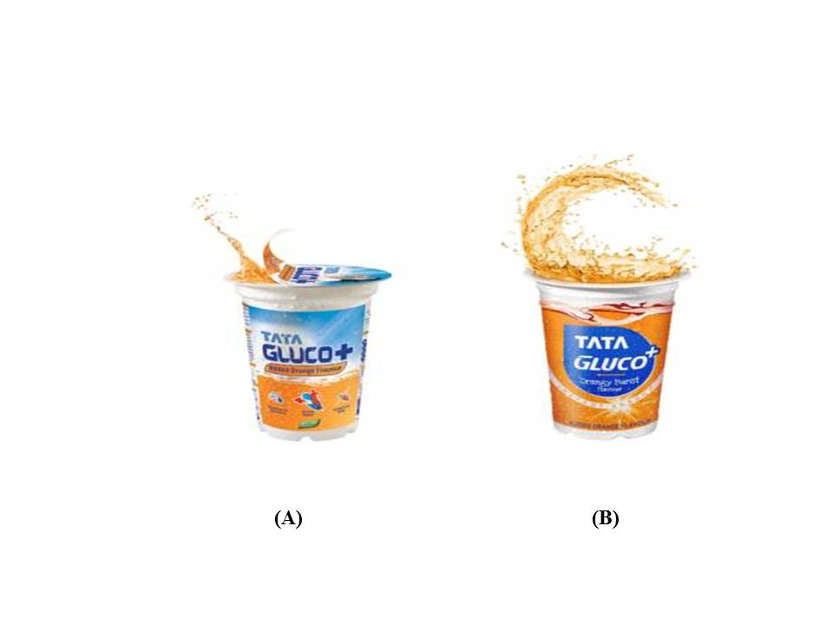

Source: Company files.

EXHIBIT 5: College event by Mycollegefest for Tata Gluco Plus

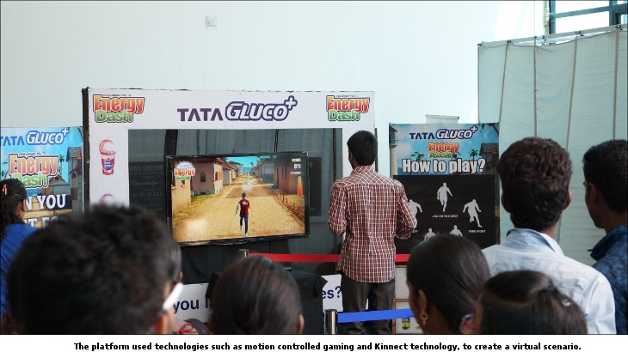

Note: The platform used technologies such as motion-controlled gaming and Kinect technology to create a virtual scenario.

Source: Company files.

Exhibit 6: snapshots of digital media content

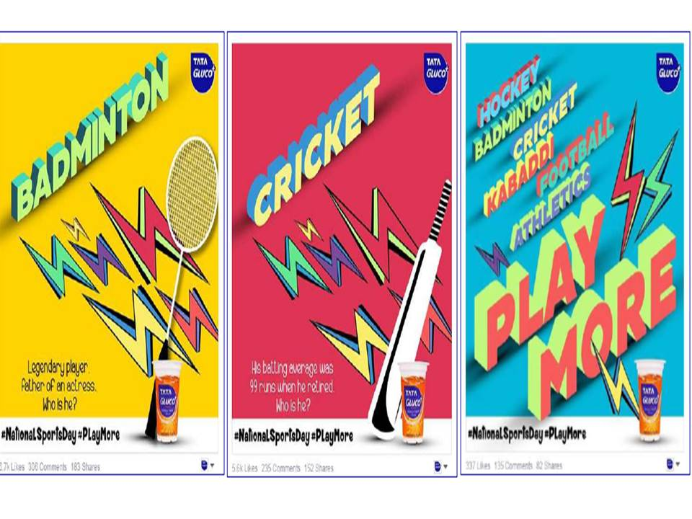

Source: Company files.

Exhibit 7: Awareness and consumption patterns for Tata Gluco Plus,

2014 to 2016 (by percentage)

|  |  |  |  |  |  |  |
| --- | --- | --- | --- | --- | --- | --- |
| **Segment Awareness and Consumption** | **Tamil Nadu  (Sample City: Chennai)** | | | **Andhra Pradesh (Sample City: Hyderabad)** | | |
|  | 2014  (n = 408) | 2015  (n = 608) | 2016  (n = 500) | 2014  (n = 409) | 2015  ( n= 596) | 2016  (n = 495) |
| Tried in the past month | 23 | 37 | 39 | 14 | 16 | 23 |
| Tried in the past three months | 28 | 44 | 60 | 18 | 23 | 40 |
| Ever tried | 37 | 66 | 71 | 22 | 43 | 43 |
| Total awareness | 80 | 93 | 97 | 60 | 73 | 73 |

Source: Company files.

Exhibit 8: Brand perception analysis for Tata Gluco Plus

The brand perception scores for Tata Gluco Plus were calculated by looking at the association data for various beverage options and Tata Gluco Plus on a set of attributes. Respondents were asked to rate all the brands on these sets of attributes. Each attribute statement was read out one by one to respondents, and respondents were asked to endorse the brands that they associated with that particular attribute. The association scale, therefore, generated data in the form of number of endorsements for each brand, as well as for each attribute. This endorsement data could then be read as a percentage of the total aware respondents, for each attribute. The base is taken in the form of respondents who are aware of all brands. Based on the data obtained from the study, two levels of analysis were carried out.

Exhibit 8a: Brand Perception Scores for Tata Gluco Plus, 2015–16



**Note:** The above table looks at the preliminary analysis of the association data. The percentage association on the attribute is a good way to read trends in terms of perception changes for a particular brand. The trend data identifies the consumers’ perceptions on which Tata Gluco Plus is performing better or worse compared to a previous period (2015 versus 2016). The data presented for 2016 data is from after the branding campaign. The data can also be used to compare performance across the two different locations. Therefore, the table presents a time comparison for Tata Gluco Plus for Tamil Nadu (sample city: Chennai) and Andhra Pradesh (sample city: Hyderabad).

**Legend:** Shaded cells represent endorsement scores of Tata Gluco Plus for that attribute that are significantly higher or lower than the overall average.

 = The brand scored average for this attribute, so it was not a differentiator. For example, for the attribute “Easily available,” the brand scored average across locations and time lines.

 = The brand was differentiated on this attribute, so it was a differentiator. For example, for the attribute “Trend-setting,” the brand was considered trendy by the respondent group, following the advertising campaign.

Exhibit 8b: Brand imagery comparisons of Tata Gluco Plus with others



Note: The second set of analysis assesses the brand strength of Tata Gluco Plus relative to other beverage brands in the market. Here, the method followed is data normalization. The endorsement scores are biased by the size of the brand. Therefore, the bigger the brand in terms of its aware base, the higher the endorsement score would be across all the attributes. The endorsement scores are therefore normalized across both rows and columns to obtain brand image scores. Positive scores indicate the attributes on which the brand is stronger. Significant positive scores are those above a threshold (depending on the sample size, +3 in this case). The number indicated at the cross-tab point (for brand attribute) indicates the evaluation of the brand with respect to the attribute as well as its relationship with the index across all the categories. For example, in the illustration above, “Is the most popular brand” and “Has an appealing advertising” are core strengths of carbonated soft drinks relative to other beverages; similarly, “Is a brand I trust” stands out for Tata Gluco Plus.

Source: Company files.

1. “NourishCo, the Tata Global Beverages and PepsiCo India JV Launches India’s First Nutrient Water—Tata Water Plus,” Tata Global Beverages, press release, February 9, 2012, accessed September 9, 2016, www.tataglobalbeverages.com/media/news/detailed-news/2015/02/25/nourishco-the-tata-global-beverages-and-pepsico-india-jv-launches-india-s-first-nutrient-water-tata-water-plus.
2. “Home,” NourishCo, accessed September 10, 2017, www.nourishco.com/home.html.
3. ₹ = INR = Indian rupee; all currency amounts are in ₹ unless otherwise specified; ₹1 = US$0.0151 on May 1, 2016.
4. Tata global beverages and Starbucks created a 50–50 partnership for opening and operating Starbucks outlets in the country. The partnership was called “Starbucks, a Tata alliance.” Later, in 2016, the two partners decided to expand the relationship to select global locations, including Singapore.
5. Viveat Susan Pinto, “Himalayan Climbs up the Price Ladder,” *Business Standard,* July 29, 2014, accessed September 9, 2016, www.business-standard.com/article/management/himalayan-climbs-up-the-price-ladder-114072901219_1.html.
6. “Electrolyte Fortifying Composition for Recharge, a Hydrating Supplement, and Process for Preparing the Same (Patent: WO 2012038988 A2),” Google Patents, accessed September 9, 2016, www.google.com/patents/WO2012038988A2?cl=en.
7. “Tata Gluco Plus—Plane Starting TVC,” YouTube video, 1:38, posted by Mark Manuel, April 27, 2015, accessed September 10, 2017, www.youtube.com/watch?v=JUZzrXFJxFY.