

9B17A069

Santé Au Naturel: Healthy to the Core

Robert Mackalski and Marc Ducusin wrote this case solely to provide material for class discussion. The authors do not intend to illustrate either effective or ineffective handling of a managerial situation. The authors may have disguised certain names and other identifying information to protect confidentiality.

This publication may not be transmitted, photocopied, digitized, or otherwise reproduced in any form or by any means without the permission of the copyright holder. Reproduction of this material is not covered under authorization by any reproduction rights organization. To order copies or request permission to reproduce materials, contact Ivey Publishing, Ivey Business School, Western University, London, Ontario, Canada, N6G 0N1; (t) 519.661.3208; (e) cases@ivey.ca; www.iveycases.com.

Copyright © 2017, Richard Ivey School of Business Foundation Version: 2020-01-27

A passion for health and wellness led 23-year-old entrepreneur Lauren Mathers on a mission. Mathers saw the rising demand for alternative health products in the downtown core of Montreal and established the Santé Au Naturel boutique as a one-stop shop for superior-quality foods, vitamins, supplements, natural cosmetics, homeopathic remedies, and other items for the health-conscious buyer. Such goods had surged in popularity as public awareness of alternative and holistic health increased, and her business thrived. The circulation of knowledge about natural solutions for an ever-growing array of health and dietary needs fostered a growing and lucrative market (see Exhibit 1). However, while widening awareness of the specialty health industry had benefited Mathers’s business, it also meant that supermarkets and drug stores began to offer products that were similar to many of those stocked on Santé Au Naturel’s shelves. While the store had flourished since its opening in 2013 thanks to the growth of the health-conscious market in the city, it faced growing margin pressures (see Exhibit 2) as her top sellers were picked up by supermarket chains and drugstores. As Santé Au Naturel entered 2017, Mathers reflected on the optimal way to differentiate her offering and considered how to improve her marketing mix to protect margins and grow sales.

PRODUCT OFFERINGs

Mathers promoted her store as “your local natural health boutique.” The 1,500-square-foot shop specialized in health-conscious, fast-moving consumer goods, healthy foods (including vegan, gluten-free, lactose-free, and organic options), professional-quality vitamins, supplements, and natural medicinals. Nestled among vegetarian and vegan restaurants, the Santé Au Naturel store was within walking distance of downtown businesses, two universities, and one college.

Santé Au Naturel prided itself on having well-stocked shelves. The store carried more than 5,000 different stock keeping units: 3,000 supplements, 900 natural personal care products, and 1,000 food and beverage items. Supplements generated approximately 50 per cent of revenue, cosmetics around 10 per cent, and foods 40 per cent. Supplements (including vitamins) yielded the highest gross margins of all products, with the average price over $45 per unit.[1] To support this category, the store employed naturopaths to provide consultations and product recommendations. The all-natural cosmetic and beauty products ranged in price from $6 to $45 per unit. Foods and beverages catered to dietary needs and restrictions. The median product in this segment, which had the lowest margins, was $7 per unit. Mathers worked hard to stay on top of trends and was frequently the first to introduce new raw and natural products into the market (for example, kombucha, kale chips, vegan cheeses, and broccoli buds).

To further differentiate its offerings, Santé Au Naturel offered free delivery services for all orders over $80. These services were outsourced to a local delivery service provider and were intended to offset the challenges of parking downtown. Deliveries were made the same day, if orders were placed before 2:00 p.m.

Current positioning And CONSUMER SEGMENTATION

Mathers described the Santé Au Naturel experience as having a “friendly and inviting, yet professional vibe.” Management and staff prioritized customer relationships and service to nurture a sense of community around their shared commitment to holistic health. Mathers could identify most of her individual patrons by name. This warm rapport with clientele made it easy for staff to provide personalized service: employees could make relevant and tailored recommendations on new products and categories for each customer.

The Culture of Alternative Health and Wellness

The store’s consumers tended to be busy individuals who led fast-paced, healthy lifestyles and bought products on the go. Spending tended to change with the seasons: The summer season, when many student customers departed, was quiet; this was followed by increased activity in September that built up to a bustling December. Sales increased again in January with the added impetus of health-focused New Year’s resolutions. Operations then continued steadily until early May.

Santé Au Naturel averaged around 1,500 visitors per month, and more than 1,250 of these visitors were paying customers—60 per cent of whom returned more than once a month. Supplement shoppers tended to return once a month. The distance customers travelled varied depending on the products they purchased. For example, residents within a three- or four-block radius tended to make convenience purchases of food and beverages, whereas supplement shoppers came from as far as 20 kilometres away.

Customers

Mathers categorized her customers into three main groups: the casual student, the health-conscious young professional, and the supplement enthusiast.

The Casual Student

As it was located near universities, Santé Au Naturel attracted a modest portion of the student population to its doors. These casual student customers tended to make small purchases and rarely used the naturopathic services. A typical student basket might have included a fresh sandwich, deodorant, a bottle of shampoo, and a packaged drink. Casual student shoppers represented 60 per cent of the total number of Santé Au Naturel’s customers but represented a smaller portion of its dollar sales. Seasonality was an issue, as students tended to leave the city for long periods of the year when school was not in session. In addition, turnover in this segment was high, requiring a continuous investment of time and resources into customer acquisition and retention as students graduated and left Montreal permanently.

The Health-Conscious Young Professional

Many young professionals lived and worked in the area directly surrounding Santé Au Naturel. Their higher disposable income made them a more lucrative source of revenue than students. These customers used Santé Au Naturel as a convenient one-stop shop for purchasing not only food and grocery products but also cosmetics and personal care items. Whereas a student basket usually included only three or four items, a young professional’s basket would likely include items from all areas of the store. A young professional’s basket occasionally included supplements, such as vitamins or omega-3. This segment represented approximately 20 per cent of Santé Au Naturel’s customer base, and basket sizes for this group typically ranged from $30–$80.

The Supplement Enthusiast

Due to the breadth and uniqueness of Santé Au Naturel’s supplement offerings, the store attracted many supplement enthusiasts, who exclusively purchased vitamins and supplements. Whereas younger consumers were more likely to use the occasional vitamin or supplement to deal with localized, temporary deficiencies, these customers were typically older, wealthier individuals who took supplements for serious health-related reasons. These consumers typically purchased two to five supplements and rarely, if ever, accessed the remainder of the store’s product offerings.

Supplement enthusiasts made up approximately 20 per cent of the customer base, but supplement sales accounted for 40 per cent of profits. The average basket size for this segment ranged anywhere from $100–$500 per purchase, depending on the frequency of the purchase (lower-frequency consumers typically spent more per basket), making this group the highest-spending segment of all Santé Au Naturel consumers. Mathers observed that supplement buyers also tended to be more diligent about seeking out specific products.

PROMOTIONAL AND COMMUNICATION EFFORTS

Santé Au Naturel promoted its store with the slogan, “Your natural health boutique.” Mathers’s team developed the store branding to be distinctive and used illustrative decorations (see Exhibit 3) to convey a clean, approachable image that contrasted with the earthier “hippie” image typical of most alternative health stores in Montreal. Mathers said this branding allowed Santé Au Naturel to position itself differently from other specialty businesses that did not appear as inviting because of their “hard-core” atmosphere. The name itself was intended to be fun and non-threatening, and provide a friendly, attractive appeal to an intimidating retail category.

The Santé Au Naturel Customer Loyalty Program

With each purchase at the store, customers could obtain points through a customer loyalty program called Kangaroo Rewards, and these could later be redeemed for in-store discounts. This system allowed Santé Au Naturel to track seasonal purchase patterns in the fickle retail industry and send direct promotions to customers twice a month via e-mail or SMS. The system also acted as a method of collecting phone numbers and e-mail addresses, which were logged when the user signed up in the store. Mathers leveraged this data for direct marketing e-newsletters.

Web and Social Media

The company website featured information on the products and brands offered (including the brands of vitamins and supplements available), directions to the store, and contact information. It also included a YouTube video that provided a tour of the store and its various departments. Online sales were not offered.

Santé Au Naturel maintained pages on Facebook and Instagram. Posts included information about contests, product-specific promotions, and informational health facts. It was sometimes hard to predict which posts would be most popular—such as the “name that cheese” post that captured dozens of comments. The company also used social media to promote other marketing initiatives such as in-store tasting events and gift sales at neighbouring fitness studios.

Sales Promotions

In-store sales promotions included deals offering 10–20 per cent off specific products, “buy one, get one free” (BOGO) promotions, and occasional specials determined by manufacturers and suppliers. For example, a recent promotion on oregano oil included with each purchase a small book about the product. For the most part, in-store staff judged which products should receive sales promotions. In addition, Santé Au Naturel sometimes distributed 10-per-cent store discount flyers at university events to generate in-store traffic and purchases. These flyers had little success; 99 per cent of recipients never used them. The store also established partnerships with yoga, stretching, and fitness studios to give the teachers and staff of these studios year-round 10-per-cent store discounts. It also sponsored frosh week events at a neighbouring university by supplying food in exchange for brand presence and exposure to thousands of first-year students at the school.

COMPETITION: THE MONTREAL HEALTH LANDSCAPE

A health-conscious culture was burgeoning in Montreal, particularly in the Plateau region—a youthful, hip, fashionable neighbourhood. Stores with offerings similar to those of Santé Au Naturel tended to be similarly sized, independently operated, and owned by passionate entrepreneurs. Each store focused on its own local neighbourhood, and there was no specialty store in the immediate competitive vicinity of Santé Au Naturel.

The industry landscape was complicated by competition from large grocery chains like Sobeys Inc. (IGA), Loblaw Companies Limited (Loblaws), and Metro Richelieu Inc. (Metro), which followed the consumer trend towards healthy, all-natural food. Further competition came from pharmacies like The Jean Coutu Group Inc. (Jean Coutu) and Shoppers Drug Mart (Pharmaprix), which began to offer more natural cosmetics and personal care products. These competitors were typically able to dominate the market on a price-based competitive strategy due to their large buying power and economies of scale. They also benefited from having more locations, merchandising, and stronger brand awareness than independent stores. Grocery stores like Metro and IGA also carried fresh produce, a category that health-conscious consumers regularly sought out but could not purchase at Santé Au Naturel. Whenever a product became popular with the independent players, the corporate retailers started carrying it, frustrating the management of independent stores.

In the vitamin and supplement stream, competition was even more intense; it included individual naturopaths who sold their own products, mass-market pharmacies like Pharmaprix and Jean Coutu, and alternative and independent pharmacies around the city. Most competitors in this segment carried only a select portion of the vitamin and supplement catalogue carried by the Santé Au Naturel store, which meant Santé Au Naturel had the most extensive selection of holistic supplements.

Santé Au Naturel faced further competition from online vendors such as Amazon.com Inc. (Amazon), Well.ca, and Vitasave.ca, which intensified price competition. Amazon had demonstrated its commitment to the health and wellness category with its recent acquisition of Whole Foods Market Inc.

OTHER CHALLENGES

Beyond competition, Mathers was concerned about ensuring customers kept coming back. Some clients were disinclined to visit regularly because of the location, where parking was hard to find, while others eventually gave up using Santé Au Naturel’s products after an initial period of enthusiasm. Still others risked going elsewhere to replenish their supplies after initially buying from Santé Au Naturel and procuring the information they needed from the staff.

It was also a concern when the best-selling products in the natural foods category were adopted by the mainstream, making the offerings of alternative health stores like Santé Au Naturel less distinctive. Mathers conjectured that this was because most consumers tended to equate health with food. She also reasoned that the benefits of natural foods were more immediately visible than those of other products offered at her store:

When someone starts eating healthy, they will usually feel a difference in their energy level, and over time, in their weight or skin. . . . However, when switching from chemical to natural cosmetics, it can be more difficult to see a big change, which can be less motivating for consumers who are now spending more money on their natural cosmetics and wondering why they might not feel any benefits.

Despite these limitations, Mathers observed that an initial interest in healthy foods could become a gateway to other holistic health products:

As consumers care more about what they eat, they get involved in the health world and slowly start to realize that what they put *on* their bodies is just as important as what they put *in* them. So, I think people begin with food and diet, and slowly move towards cosmetics once they are already intrigued by the health community.

Mathers believed her store could leverage this gateway to holistic health as a strategy for securing long-term customers.

looking ahead

With a growing market and a developing brand, Mathers had her business off to a promising start. With intensifying competition, she wondered if she had differentiated her business enough. Could she improve her customer targeting and marketing mix? What else could she do with her products and promotions to grow her business and protect against declining margins? One thing was certain: as a passionate entrepreneur, she wanted to ensure Santé Au Naturel’s healthy future.

This case was prepared by Professor Robert Mackalski (McGill University, Desautels Faculty of Management) and Dr. Marc Ducusin (McGill University).

Exhibit 1: Canada’s Growing Natural/Organic Markets (CAD millions)

|  |  |  |  |  |
| --- | --- | --- | --- | --- |
| **Year** | **Natural Healthy Packaged Foods** | **Natural Healthy Beverages** | **Organic Packaged Foods** | **Organic Beverages** |
| 2011 | 3,663 | 4,271 | 835 | 353 |
| 2012 | 3,834 | 4,259 | 870 | 378 |
| 2013 | 3,970 | 4,303 | 903 | 405 |
| 2014 | 4,075 | 4,344 | 944 | 437 |
| 2015 | 4,213 | 4,504 | 999 | 475 |
| 2016 | 4,340 | 4,661 | 1,063 | 514 |
| 2017 | 4,541 | 4,866 | 1,138 | 565 |
| 2018 | 4,745 | 5,100 | 1,217 | 619 |
| 2019 | 4,946 | 5,353 | 1,299 | 676 |
| 2020 | 5,150 | 5,624 | 1,383 | 735 |
| 2021 | 5,353 | 5,912 | 1,457 | 796 |

Source: Euromonitor International. (2017, July 15). *Canada’s growing natural/organic markets* [table]. Retrieved from http://go.euromonitor.com/Passport-Home.

Exhibit 2: Gross margins of Santé Au Naturel, 2013–2017

|  |  |  |  |  |  |
| --- | --- | --- | --- | --- | --- |
|  | **2013** | **2014** | **2015** | **2016** | **2017** |
| **Gross Profit (percentage)** | 46.7 | 45.8 | 45.1 | 44.9 | 44.7* |

Note: *2017 percentage is as of October 1, 2017.

Source: Company documents.

Exhibit 3: Santé Au Naturel store design

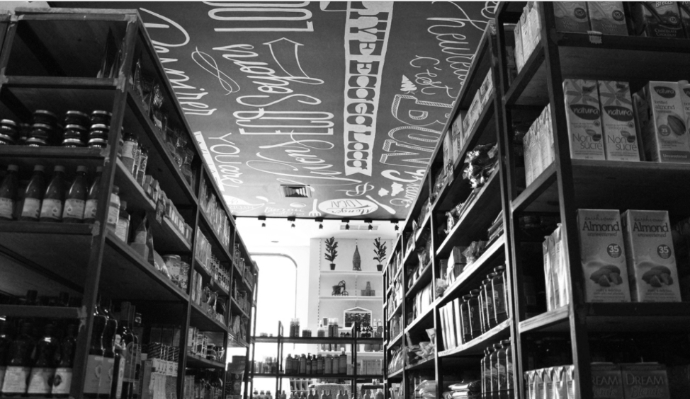

Source: Company documents.

Exhibit 4: Financial statement of Santé Au Naturel, 2016 (CAD)

|  |  |
| --- | --- |
| Sales | 286,419 |
| COGS | 157,817 |
| Gross Profit | 128,602 |
| Labour | 45,576 |
| Shrinkage | 512 |
| Utilities | 4,950 |
| Other | 2,450 |
| Rent | 21,400 |
| Depreciation | 6,390 |
| Insurance | 5,240 |
| Advertising/Promotion | 4,785 |
| Property/Taxes | 4,400 |
| Other | 2,379 |
| Total Operating Expenses | 95,782 |
| Operating Profit | 30,520 |

Note: COGS = cost of goods sold

Source: Company documents.

1. All currency amounts are in Canadian dollars unless specified otherwise.