

9B17B013

AquaSafi Purification Systems: Changing the Operating Model

Ryan Rego wrote this case under the supervision of Elizabeth M. A. Grasby solely to provide material for class discussion. The authors do not intend to illustrate either effective or ineffective handling of a managerial situation. The authors may have disguised certain names and other identifying information to protect confidentiality.

*This publication may not be transmitted, photocopied, digitized, or otherwise reproduced in any form or by any means without the permission of the copyright holder. Reproduction of this material is not covered under authorization by any reproduction rights organization. To order copies or request permission to reproduce materials, contact Ivey Publishing, Ivey Business School, Western University, London, Ontario, Canada, N6G 0N1; (t) 519.661.3208; (e)* [*cases@ivey.ca*](mailto:cases@ivey.ca)*;* [*www.iveycases.com*](http://www.iveycases.com)*.*

Copyright © 2017, Richard Ivey School of Business Foundation Version: 2017-06-08

It was February 2016, and Pavin Pankajan, executive director of AquaSafi Purification Systems Pvt. Ltd. (AquaSafi), faced an important decision. Should AquaSafi change its current operating model as it expanded to new villages in India?

AquaSafi was a social enterprise that aimed to provide clean water to people in the developing world. The organization currently assembled and sold its water purification technology, at cost, to villages and non-governmental organizations (NGO) in rural India. The technology was used in water filtration plants that operated across the state of Karnataka. Before deciding to change the current operating model, Pankajan thought it would be useful to evaluate, through a set of differential analyses, how the company’s cash flow would differ at a new water filtration plant under the current and proposed operating models. Pankajan also wondered whether it made sense for AquaSafi to change its operating model as it expanded its operations, since its current operating model had been well received in the villages.

UNSafe Drinking Water in Rural India

Unsafe drinking water posed a serious problem in India; in fact, more people in rural India had access to mobile phones than to clean drinking water.[1] India’s rural population in 2015, around 70 per cent of India’s total population of 1.326 billion people,[2] lived in 600,000 rural villages throughout the country.[3] Of the 663 million people worldwide who lacked access to safe drinking water,[4] 77 million lived in India.[5]

A 2014 study concluded that 38 million people in India were affected annually by waterborne diseases, and 780,000 deaths each year could be attributed to contaminated water. Of these 780,000 deaths, 400,000 were attributable to diarrhea alone.[6]

In most villages, water was sourced from nearby rivers and wells. This water often contained excess levels of fluoride, as well as nitrate and bacterial contamination, which led to waterborne diseases and other illnesses.[7] In Karnataka, a few small operators sold water purification machinery, but they had limited resources and operated within a limited region, with no plans to expand. Additional market participants included a few global charities, such as WaterHealth International (WHI), that operated in other parts of India with the same goal as AquaSafi. WHI operated over 500 plants in the states of Andhra Pradesh and Gujurat, roughly 500 kilometres west and 1,300 kilometres north of the state of Karnataka, respectively. These international organizations had access to funding but, to date, had been unable to break even using their current technology and operating models.

Another challenge facing many of India’s villages involved the inefficient use of government-provided water storage tanks, which were connected to a local water supply (see Exhibit 1). These tanks served as a reservoir in case of emergency, and they ensured the supply of water during dry seasons. In Karnataka, the government had set up 6,000 water storages, but only 1,000 were currently operating. The government invited companies to bid to purify this water for villagers’ use, but due to high levels of corruption on both sides of the negotiations,[8] the outcome was rarely in the best interest of villagers. Water prices set by these companies were high, often between ₹7 and ₹10[9] per 20 litres, and the machinery was unnecessarily complex, which led to high maintenance costs for the villages. In addition, once these companies recovered their investment, they had no desire to reinvest in new machinery, so they would leave villages with inoperative equipment (i.e., water storages and purification machines).

AQuasafi purification systems pvt. Ltd.

History

AquaSafi was the Indian branch of H2O for Humanity L3C (H2OH). H2OH owned several water purification patents in the United States. It was founded in 2010 by two American engineers, brothers Kevin and Eric Cluff, based on a water purification technology system developed by their father and currently used by AquaSafi. In March 2011, Kevin Cluff incorporated AquaSafi when it operated from the Deshpande Center[10] for Social Entrepreneurship in Hubli, Karnataka.

In November 2013, Pankajan became the executive director of AquaSafi. Previously, he had worked as an operations and maintenance manager at Naandi Community Water Services, a company that offered similar water purification services in 450 villages across five states in India, including Karnataka.[11] If AquaSafi could be successful in Karnataka, Pankajan believed the company could grow to service other regions in India, and to eventually expand into other countries where people lacked access to clean drinking water.

AquaSafi was still in its startup phase and was growing rapidly under its current operating model. In 2014, the organization operated 85 plants, and by February 2016, that number had increased to 130 plants. Since its inception, AquaSafi had been able to raise funding through the Deshpande Foundation. Additional financial support came from former National Football League players John Tait and Rob Morris, who lived in the United States and worked with H2OH.

The Purification Technology

AquaSafi’s water purification systems addressed the concerns of excess levels of fluoride, as well as nitrate and bacterial contamination. The initial process in the organization’s purification system passed river water or groundwater through sand filtration, subjecting it to a process of reverse osmosis, after which the treated water was exposed to ultraviolet light to eliminate bacteria. AquaSafi’s technology was much preferred over most other reverse-osmosis systems because it consumed 30 per cent less electricity and reduced water wastage by 30 per cent. Further, the system was quite compact, requiring only a small space in which to operate (see Exhibit 2).

In the newer plants, AquaSafi had installed modems in the panel boards of the purification systems, which allowed the plants to be monitored remotely. Machine data was forwarded daily via these modems to AquaSafi’s head office to ensure the plants were operating safely and efficiently.

Current Operations

As of February 2016, AquaSafi assembled water purification machines at its head office in Hubli, Karnataka. The company then entered into partnerships with village leaders and NGOs to operate its plants in various villages (see Exhibit 3). AquaSafi provided the water purification technology at cost to the villages and NGOs, and the plants were then operated either by village residents or by operators who were hired by the NGOs. AquaSafi’s main NGO partner was the Shri Kshethra Dharmasthala Rural Development Project (SKDRDP).

Once a plant was in operation, AquaSafi was contracted to provide technical support and maintenance for the plant’s equipment. These contracts constituted AquaSafi’s main source of revenue, generating a monthly income of ₹3,250 per plant. This price was fixed, regardless of the amount of water filtered and sold. AquaSafi extended credit terms of 45 days to the villages.

The villages and NGOs used their water sales[12] to pay for the plant’s utilities, the plant operator salaries, the maintenance fees charged by AquaSafi, and all other plant costs. The remaining profits remained with the villages or the NGO, and SKDRDP often used these funds to provide microfinance loans[13] to the villagers.

The villages and NGOs often had to purchase replacement components from AquaSafi in order to keep their plant equipment in working order. These component sales, equal to 10 per cent of the monthly maintenance charges, offered an additional source of revenue for the company. AquaSafi earned a 10 per cent margin on component sales and maintained 30 days’ worth of components in inventory at all times.

AquaSafi employees provided plant maintenance. Each employee serviced 10 of AquaSafi’s plants monthly and was paid ₹20,000 at the end of every month. Other related technical support and maintenance costs were fixed at ₹1,000 a month and were paid promptly.

AquaSafi’s current operating model was working well, but under this operating model, the NGOs handled the hiring of plant operators and day-to-day operations; AquaSafi was contacted to provide plant maintenance only. Thus, AquaSafi gave up control of the plants’ operations and depended on the NGOs to manage the water purification technology. By altering the current operating model, Pankajan thought there was some potential to increase AquaSafi’s profits.

Proposed Operating Model

For all new plants that would use AquaSafi’s technology, Pankajan proposed a new operating model. Under this model, AquaSafi employees would set up the plants and perform all maintenance, thereby eliminating the need for partnerships with the rural villages and NGOs and allowing AquaSafi to collect revenues from the sale of water. AquaSafi had also begun to automate the selling process at the newer plants, so the work that had previously required a full-time plant operator would be reduced to that of a part-time plant operator. Automating the selling process had other benefits as well: water could be sold outside of the current operating hours, and the part-time plant operator would focus on tasks such as marketing initiatives and educating villagers on the benefits of clean water.

A single AquaSafi technician serviced 10 plant locations, but with the new addition of remote monitoring, it was estimated that one technician could service up to 50 plant locations. Thus, the new model’s time savings would allow AquaSafi employees to handle additional tasks. Although AquaSafi would be taking on more responsibility with the proposed model, since the village leaders and NGOs were currently managing the plants, the company would not require an increase in personnel to handle these responsibilities.

Pankajan projected that an average of 300,000 litres of water would be sold at a single plant each month at the same selling price of ₹2 per 20 litres currently offered by the NGOs and villages.[14] This volume of water could drop by as much as 40 per cent in slower months; however, the total number of slow months would never be more than six months a year.[15]

Most of the costs associated with a single plant would be fixed (see Exhibit 4) and would be paid as incurred, except for the part-time plant operator’s salary and the company’s telephone expense, which would be paid at the end of every month. Utilities expense would be the only variable cost and would amount to ₹15 per 1,000 litres sold. Utility bills would also be paid at the end of every month.

AquaSafi would need to invest three lakhs[16] to cover each plant’s construction and equipment. Pankajan estimated that the plant equipment’s useful life would be five years. The plant itself, which represented 60 per cent of the three-lakh investment, would have an estimated useful life of 20 years. To fund the investment, AquaSafi would need to obtain a loan. Pankajan’s aim was for AquaSafi to repay ₹10,000 each month toward the loan, including any interest.

Under Pankajan’s proposal, plants that operated under the current model would continue to do so; only newly opened plants would operate under the proposed new model. Pankajan also recently learned that SKDRDP was open to the idea of older plants being converted to the new model. The operators at SKDRDP believed that the remote monitoring and reduced need for a full-time plant operator would allow them to allocate resources to other planned developments for the villages.

Conclusion

Although AquaSafi had been quite successful with its current operating model and had grown quickly since its inception, Pankajan wanted to assess the new operating model’s financial potential. To help him make an effective decision, he planned to analyze both operating models using differential analysis. Additionally, Pankajan would perform a breakeven analysis for the new operating model to determine how many customers per village would be needed to cover AquaSafi’s fixed costs. If he decided to go ahead with the new operating model, he would sign a contract with the new villages to lock in AquaSafi’s selling price of ₹2 per 20 litres. He would also need to consider what length of an agreement term AquaSafi should offer to sell water to the villagers.

Exhibit 1: Government-provided WAter Storage

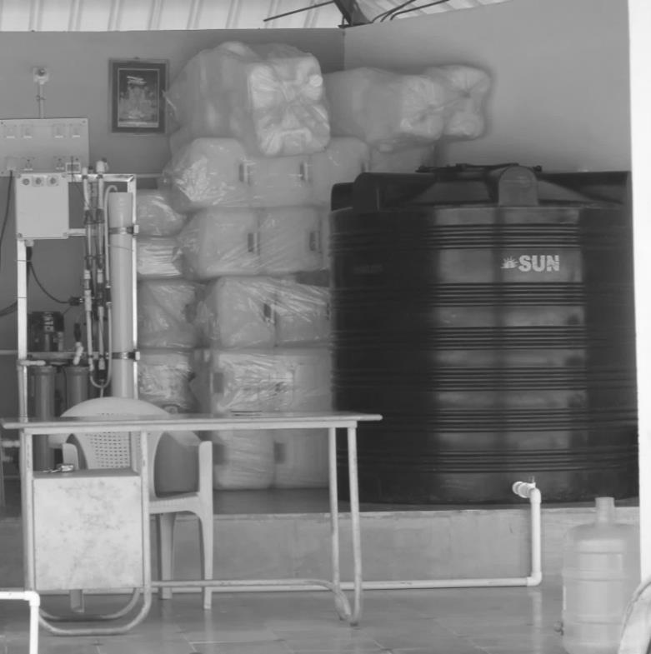

Source: Company files.

Exhibit 2: Aquasafi Purification System

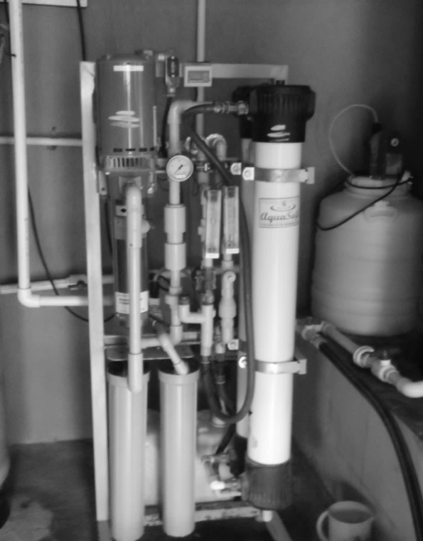

Source: Company files.

Exhibit 3: AquaSafi Plant in Karnataka, india

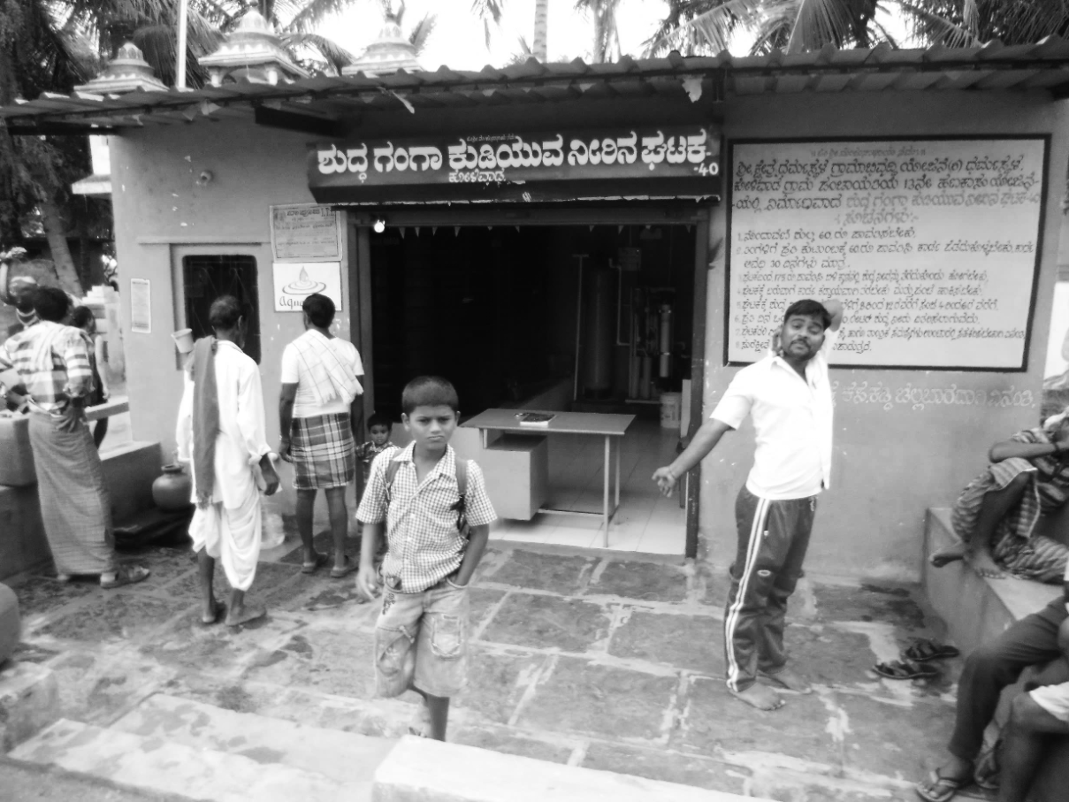

Source: Company files.

Exhibit 4: Other Per Plant Costs for the Proposed Operating Model

|  |  |
| --- | --- |
| Cash Expense | Rupees (₹) per month |
| Administrative expenses | 3,000 |
| Technician wages | 600 |
| Materials | 100 |
| Consumables | 650 |
| Telephone expense | 50 |
| Cleaning expenses | 100 |
| Membrane expense | 300 |
| **Total** | **4,800** |

Note: Included in the administrative expenses was the part-time plant operator’s salary, which amounted to ₹2,000 per month. The training costs for the operator amounted to ₹3,000.

Source: Company files.

1. “Ten Facts about Drinking Water in India That May Make You Sick,” *Forbes India,* July 21, 2015, accessed January 23, 2017, http://forbesindia.com/blog/economy-policy/ten-facts-about-drinking-water-in-india-that-may-make-you-sick/.
2. “India Population (1950–2017),” Worldometers, accessed January 23, 2017, www.worldometers.info/world-population/india-population/.
3. “Number of Villages,” Census India, accessed January 23, 2017, www.censusindia.gov.in/Census_Data_2001/Census_data_finder/A_Series/Number_of_Village.htm.
4. “Facts about Water and Sanitation,” Water.org, accessed January 23, 2017, http://water.org/water-crisis/water-sanitation-facts/.
5. “India’s Water Crisis,” Water.org, accessed January 23, 2017, http://water.org/country/india/.
6. “Ten Facts about Drinking Water in India That May Make You Sick,” op. cit.
7. “About AquaSafi,” AquaSafi, accessed January 23, 2017, www.AquaSafi.com/.
8. Corruption in India often involved bribery or company executives and government officials working together to further their own interests.
9. ₹= INR = Indian rupee; on February 2, 2016, CA$1 = ₹48.
10. The Deshpande Foundation was a non-governmental organization founded in 1996 by Gururaj (Desh) and Jaishree Deshpande with the goal of driving sustainable change through entrepreneurship and innovation. Two other Deshpande centres were located in North America—one in the United States at the Massachusetts Institute of Technology in Boston and one at the University of New Brunswick in Fredericton, New Brunswick, Canada, “Our Story,” Deshpande Foundation, accessed January 23, 2017, www.deshpandefoundation.org/about-us/our-story.
11. India consisted of 29 states and seven union territories. The population of the state of Karnataka was 66 million people in 2016.
12. The average customer purchased 20 litres of water a day.
13. Microfinance loans were small loans that were provided to low-income individuals or groups who had not qualified for normal bank loans; these funds allowed recipients to finance small businesses and become self-sufficient. Because of the specific repayment plans and group-based models for microfinance loans, the default rates were quite low; Amy Newmann, “Microfinance as a Tool to Alleviate Poverty,” *Forbes,* July 24, 2012, accessed January 23, 2017, www.forbes.com/sites/dell/2012/07/24/microfinance-as-a-tool-to-alleviate-poverty/#6b7e135c75e8.
14. No credit terms would be extended, and collection would be immediate.
15. In this low scenario, sales during the other six months of the year were projected to average 200,000 litres a month.
16. A lakh is a unit in the Indian numbering system equal to ₹100,000.