

**9B17B017**

**LOCKBOX SOCIAL INC.: STATUS QUO OR SEO?**

*Jimmy Wang wrote this case under the supervision of* *Elizabeth M.A. Grasby solely to provide material for class discussion. The authors do not intend to illustrate either effective or ineffective handling of a managerial situation. The authors may have disguised certain names and other identifying information to protect confidentiality.*

*This publication may not be transmitted, photocopied, digitized, or otherwise reproduced in any form or by any means without the permission of the copyright holder. Reproduction of this material is not covered under authorization by any reproduction rights organization. To order copies or request permission to reproduce materials, contact Ivey Publishing, Ivey Business School, Western University, London, Ontario, Canada, N6G 0N1; (t) 519.661.3208; (e)* [*cases@ivey.ca*](mailto:cases@ivey.ca)*;* [*www.iveycases.com*](http://www.iveycases.com)*.*

*Copyright ©* *2017, Richard Ivey School of Business Foundation* *Version:* *2017-08-11*

On July 5, 2016, Michael Hetzer, founder and president of Lockbox Social Inc. (Lockbox), a real estate social media management company based in Myrtle Beach, South Carolina, United States, was contemplating the future direction of his business. Since founding the company two years ago, Hetzer had built a strong customer base and had experienced positive net cash flows. He needed to determine what products to offer to potential clients before scaling up the business and promoting the business to a wider audience. Should he remain with social media management or pivot Lockbox’s services to focus on search engine optimization (SEO), or do both? Decisions would also need to be made on how much he should charge for the SEO service and whether the business’s current pricing system for social media management was appropriate.

THE REAL ESTATE SALES AND BROKERAGE INDUSTRY

When buying or selling a property, an individual would typically contact a real estate agent to help facilitate the transaction. Upon completion of the sale, the seller would pay the agent or brokerage a commission, typically around 6 per cent of the selling price of the property upon the closing of the deal. Although it was possible to buy or sell a property without the help of an agent, only approximately 8 per cent of sellers and 12 per cent of buyers chose to do so.[1]

The U.S. real estate sales and brokerage industry was highly cyclical and affected by the country’s economic performance. Real estate sales were driven by property prices, interest rates, and per capita disposable income. Since the 2009 recession and housing collapse, the U.S. economy had grown at an average annual rate of 2.1 per cent, and U.S. real estate prices had rebounded and surpassed pre-recession levels (see Exhibit 1).[2] Dovish monetary policy from the U.S. Federal Reserve had also driven mortgage rates to near all-time lows.[3] The 30-year mortgage rate, an indicator of the cost of borrowing for real estate, averaged 3.43 per cent, down from 4.09 per cent a year prior.[4] However, the continuing improvement in the U.S. economy and the strengthening labour market could force the U.S. Federal Reserve to raise interest rates over the next few years, which would increase the cost of borrowing. The industry was expected to generate $126.9 billion[5] in revenues in 2016 and to grow 2.6 per cent annually over the next five years,[6] with 64.4 per cent of total industry revenues coming from residential sales.

LOCKBOX SOCIAL INC.

Michael Hetzer

Prior to founding Lockbox, Hetzer had graduated university with a degree in electrical engineering. He worked for IBM following graduation and concluded that he did not like the corporate lifestyle. He then moved to Russia to pursue a career in journalism and subsequently wrote a novel based on his experiences. After returning to the United States, he founded his first business, Web Hen Media Inc. (Web Hen), in 2003. Web Hen was an online lead generation business[7] that gave Hetzer extensive experience in the marketing business. His business philosophy was “to provide a solution to someone’s problem at a price they are willing to pay.”

Start-up

Lockbox was founded in July 2014 after Hetzer attended Inman Connect, a conference for real estate agents and executives to network and share new ideas. At the conference, Hetzer saw a strong need for social media and online management, and then founded Lockbox with $80,000 of personal savings. He followed the lean start-up method, which involved starting a company with hypothesis-driven iterative product development cycles to discover the perfect product.

The lean start-up method was proposed by Eric Ries, a Silicon Valley entrepreneur, from his experience working with start-up businesses. The main reason start-ups failed was that they were unable to deliver a quality product before their funding was depleted. Using the lean start-up method allowed companies to maximize the use of their cash reserves by shortening the hypothesis-driven iterative product development process by going through as many product development cycles as possible. New business ventures started by “creating a minimum viable product to test new ideas and run experiments to tune the engine of growth.” The product was then deployed and pivoted[8] based on frequent customer feedback. This approach was contrary to traditional schools of thought that recommended refining the product first and focusing on its quality before introduction to the market. Deciding when to persevere versus pivot was a key challenge to the lean start-up philosophy. While innovation and change were important, pivoting prematurely could also be detrimental.[9]

Ultimately, start-ups needed to leverage both speed and agility to be successful in the Internet era. Once a start-up found a product that customers thought was critical (i.e., they had to have it and could not live without it), it could be mass-marketed to the general public.

The Product

Lockbox’s original product included a website, blog, and social media management solution for real estate agents. Agents were charged $50 a month for daily blog posts on WordPress, which were mirrored on their Facebook business page. They also received individual listings for their properties on Lockbox’s website. Hetzer soon found that Lockbox’s cost to operate this service was approximately $100 a month, and agents were not willing to pay this price. In addition, because of the advertising spend and the sales team having to effectively target individual real estate agents, Lockbox did not have either the financial or human resources to run a business-to-consumer business.

As a result, Hetzer pivoted Lockbox to become a business-to-business company targeting real estate brokerages. Lockbox connected with these brokerages through targeted journals, websites, trade shows, and cold calls. In order to meet the brokerage’s needs, Lockbox provided a hosted website and bundled the website with its social media management service as an additional product. Lockbox did not charge a set-up fee for new customers. Brokerages were charged $400 a month for a hosted website plus an additional $5 a month for each agent who wanted a Facebook and WordPress blog page.[10] The agents were supplied with daily blog and Facebook posts to help incubate leads and generate new business. Lockbox’s part-time employee took half an hour to set up a new agent and six hours a week posting to blogs and Facebook pages. This employee was paid $15 an hour. Hetzer estimated that it would cost $170,000 to develop the software to fully automate Lockbox’s current product.

Current Operations

Although the client-facing side of the business was fully automated, Lockbox’s behind-the-scenes operations were only partially automated. Full automation was a goal Hetzer had for the business; however, he wanted to perfect Lockbox’s product before investing more money into the business. Lockbox currently employed five people, including one in charge of social media management for its customers.

Hetzer had a deep passion for sailing and had plans to take his sailboat around the world. Since sailing sometimes involved days and weeks on the ocean with limited Internet access, the amount of time he could dedicate to running Lockbox was limited. He was planning to take a year-long sailing trip starting late 2016.

CUSTOMERS

Background

Lockbox’s customers consisted of real estate brokerages in the United States that focused on the residential market. Agents had a real estate licence from their respective licensing body. Agents who passed an additional broker’s examination could own and operate their own brokerage. Real estate agents were required to work for a brokerage, but a broker could operate individually or hire agents to work for the brokerage.

The United States had approximately 1.3 million real estate agents in total, 900,000 of whom had completed at least one transaction in the past year. Real estate agents and brokerages depended heavily on their sphere of influence to generate leads and sales. Real estate agents’ earnings were based 100 per cent on commission with no base salary, so it was important to keep overhead expenses low and for brokerages to ensure that their agents were successful. The average age of a real estate agent in the United States was 55 years.[11]

Social Media and the Internet

Social media—computer platforms for people and businesses to connect to their networks through the Internet—also allowed content creators to connect directly with their audience, bypassing the need for traditional media outlets. Due to the increasing popularity of smartphones and improved Internet access, social media and the Internet had changed the way people sought information. Facebook, founded in 2004, was the most popular social media platform with over 1.65 billion global monthly active users as of March 2016.[12] The average Facebook user spent 40 minutes on the website each day.[13] Although using social media and the Internet was intuitive for millennials, individuals aged 50 and older generally found it more difficult to navigate and operate. See Exhibit 2 for a list of social media networks by popularity and Exhibit 3 for Facebook user demographics.

Social media and the Internet had also changed the way real estate agents managed their sphere of influence. Before the Internet, real estate agents had relied on traditional and word-of-mouth advertising to generate leads. The Internet and social media had replaced traditional media, so real estate agents were able to extend their reach and interact with more targeted demographics.

Despite Facebook’s potential, only 77 per cent of real estate agents reported using Facebook for business purposes.[14] According to a 2013 study, the real estate industry ranked second of 14 industries in inbound social media engagement, behind Internet and cable companies.[15] However, the real estate industry ranked 13 out of 14 industries in terms of outbound social media engagements. In addition, 94 per cent of homebuyers started their real estate search online.[16]

A number of online real estate listing directories were available, including the Multiple Listing Service (MLS), Zillow, and Realtor.com. These directories contained databases of properties for sale that could be sorted by price, city, size, and amenities. Homebuyers searched for properties through traditional search engines such as Google, Yahoo, and Bing. Regardless of the platform, a service’s ease of use was a quality agents valued in their selection process.

In Hetzer’s view, the Internet provided tremendous opportunities for real estate agents; however, their listings were difficult to differentiate from those of their competition. As a result, real estate agents found that generating traffic to their own website was an effective way to stand out among their competitors and generate leads for their business. SEO was a service intended to increase online traffic by improving the website’s visibility on search engines. For example, a brokerage operating in Myrtle Beach would want its website to show up as a top result when someone searched for “Arcadian Shores,” a neighbourhood in the area. SEO services took into account how search engines indexed the World Wide Web and optimized websites by including keywords people searched for, creating inbound links, and refining its structure and layout. See Exhibit 4 for a further list of the differences between social media and SEO services.

THE COMPETITION

Real Estate Agent Directory

The Real Estate Agent Directory (READ) was founded in 2011 by HomeASAP LLC (formerly N-Play RE, LLC), a real estate social media platform provider based in Jacksonville, Florida. READ was a directory that connected over 484,000 agents to potential homebuyers and sellers in over 15,000 U.S. cities (see Exhibit 5).[17] READ provided agents with a Facebook page and a listing in a directory that allowed potential customers to search for them based on location and expertise. Although the service was free to use, READ charged a percentage of the agent’s commission in the transactions it helped facilitate. READ also charged users a fee for promoting its page to targeted customer groups.[18] Unlike Lockbox, READ did not provide users with daily content linked to the agent’s website, nor did it promote the agent’s business outside of READ’s platform.

Inbound Marketing Companies

Inbound marketing companies provided solutions to attract customers to businesses by creating content that generated a customer’s interest. Solutions included blogs, social media management, and SEO. The difference between inbound marketing and outbound marketing was that outbound marketing disseminated advertisements to a mass audience without their explicit consent.[19] Some inbound marketing companies offered ghostwriters[20] who managed their customers’ social media platforms and web content. Social media management and SEO services were priced between $100 and $2,500 a month and between $100 and $300 an hour, respectively.[21] Depending on the level of service, some companies supplied original content on blogs and websites, posted on social media platforms, ran online campaigns to raise awareness, and offered SEO. Most companies also charged an initial $100 to $200 set-up fee for new customers. Inbound marketing companies often required websites to be hosted on their platform in order to use their SEO services.

Do-It-Yourself

Some real estate agents chose to self-manage their own social media and website platforms; however, they were not always successful at doing so because of the unpredictable nature of their work schedule and the time it took to manage these platforms. In addition, many real estate agents did not understand how to manage social media and websites properly, and those who wanted to do their own often did not have the technical expertise to design them.

DECISION tIME

Product

Despite positive feedback from Lockbox’s customers, Hetzer noticed that lead incubation through daily social media and blog posts was not working for some real estate agents. It took too long to build an online following before the lead generation tool became effective. In addition, he noticed that agents who did not already have a large personal social network were having difficulty gaining social media exposure solely through daily posts. Since Lockbox did not have access to an agent’s personal Facebook pages, agents who were not already active on Facebook were at a disadvantage.

Recently, Hetzer began receiving requests from clients for SEO services. Although SEO services were not a part of Lockbox’s official product offering, he decided to offer these services to these customers as a pilot program. He wondered how SEO would affect Lockbox’s current product offering and whether adopting SEO as a full-time endeavour replacing social media management was the next “pivot” for Lockbox. A third option would be to offer SEO in addition to Lockbox’s current products.

Price

Since the SEO service was still in its infancy, Hetzer wondered how much he should charge for this service. He currently billed his customers $20 an hour and paid $15 an hour to a part-time employee to perform SEO. His pricing decision would be made independently of whether SEO would be pursued as a new product offering, since this product idea could be revisited in the future. Furthermore, Hetzer wondered whether his current pricing model was appropriate for Lockbox’s social media management. When deciding on the selling price, Hetzer wanted to consider cost, the customer’s willingness to pay, and Lockbox’s competitive pricing. He understood that his customers were budget-conscious.

CONCLUSION

Hetzer sat back on his patio and took a deep breath of the ocean air. When he founded the business two years ago, he did not expect that it would still be running two years later. He split his time between a number of different commitments so he was not in a rush to scale up Lockbox until after he had settled on the right price and product mix. Regardless, he wanted to make this decision before his sailing trip in the next few months.

Exhibit 1: U.S. Housing Price Index, 1996–2016

Index Value

U.S. Real Estate Prices (every 8 months)

Source: “Data: Zillow Data,” Zillow, accessed February 7, 2017, www.zillow.com/research/data/.

Exhibit 2: U.S. Social Media Platforms by Market Share, october 2016

|  |  |
| --- | --- |
| Social Media Platform | Market Share (%) |
| Facebook | 43.20 |
| YouTube | 22.70 |
| Reddit | 5.60 |
| Twitter | 4.90 |
| Instagram | 1.70 |
| Pinterest | 1.70 |
| LinkedIn | 1.50 |
| Tumblr | 1.33 |
| Yahoo! Answers | 1.00 |
| Yelp | 0.90 |

Source: “Most Popular Social Network Websites in the United States in October 2016, Based on Share of Visits,” Statista, accessed January 19, 2017, www.statista.com/statistics/265773/market-share-of-the-most-popular-social-media-websites-in-the-us/.

Exhibit 3: U.S. Facebook Users by Age as of April 2015

|  |  |
| --- | --- |
| Age Group | Percentage of Internet Users |
| 18–29 | 82 |
| 30–49 | 79 |
| 50–64 | 64 |
| 65+ | 48 |

Source: Maeve Duggan, “The Demographics of Social Media Users,” PewResearchCenter: Internet Science & Technology, August 19, 2015, accessed January 19, 2017, www.pewinternet.org/2015/08/19/the-demographics-of-social-media-users/.

Exhibit 4: Social Media versus Search Engine Optimization

|  |  |  |
| --- | --- | --- |
|  | Social Media | Search Engine Optimization (SEO) |
| Speed | Posts appear and can be viewed by audiences instantly. | Content takes time to be found by search engines. |
| Reach | People can share content with their social networks, and peer recommendations can be made easily. | Traffic is limited to people who search for specific terms. |
| Topics | Content can be promoted to create an emotional connection and potentially viral content that is relevant to the target audience. | Content on websites tends to be factual and objective. |
| Formats | Content tends to include more visual graphics and bite-sized segments. | Content tends to be more text-based and informative. |
| Audience Intent | Visitors are less likely to buy but more likely to share and interact. Audience could also become future customers. | Visitors from search engines are typically more serious buyers. SEO also helps businesses target more specific audiences. |
| Effort | Active management is required. | Search traffic is passive and does not require constant monitoring. |
| Metrics | User engagement is easy to measure (e.g., likes, shares, and comments), but traffic is difficult to track. | Web traffic is easy to track, but user engagement is more difficult to measure. |
| Engagement | Businesses are allowed to interact directly with potential customers and respond to criticisms in real time. A social media presence can also help build online credibility. | Direct interaction with customers is limited and rarely happens in real time. |

Sources: Andy Crestodina, “Social vs. Search: 9 Differences between Social Media and SEO [INFOGRAPHIC],” *Orbit Media Studios* (blog), accessed January 19, 2017, www.orbitmedia.com/blog/social-media-seo/; “SEO vs. SMO: What’s the Difference, and Why Should You Care?,” *Wishpond* (blog), accessed January 19, 2017, http://blog.wishpond.com/post/67575277462/seo-vs-smo-whats-the-difference-and-why-should-you.

Exhibit 5: Real Estate Agent Directory (READ) Facebook Page

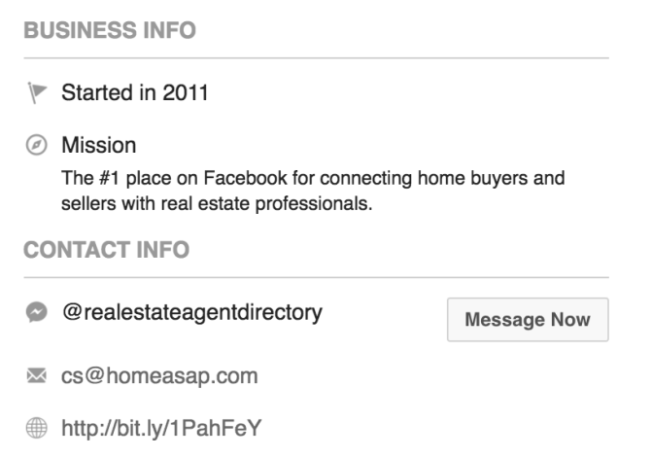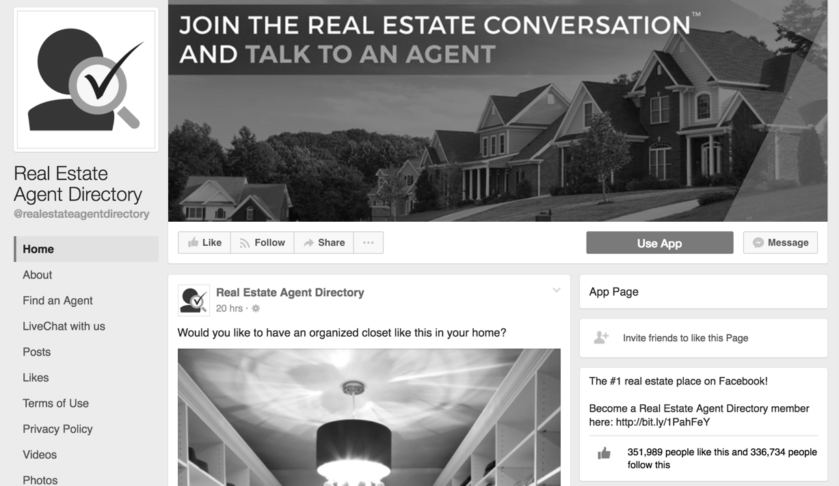

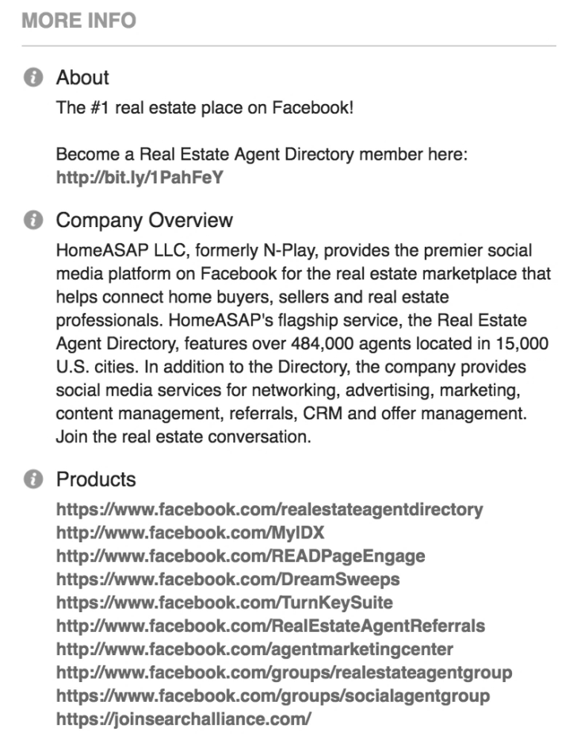

Source: “Home: Join the Real Estate Conversation and Talk to an Agent,” Real Estate Agent Directory, accessed February 8, 2017, www.facebook.com/realestateagentdirectory/. (Used with permission.)

1. Michele Lerner, “How Do Real Estate Agents Get Paid? An Overview for Home Buyers and Sellers,” realtor.com, December 3, 2013, accessed January 19, 2017, www.realtor.com/advice/sell/how-do-real-estate-agents-get-paid/.
2. “Real GDP Growth of the United States from 1990 to 2016,” Statistica: The Statistics Portal, accessed January 19, 2017, www.statista.com/statistics/188165/annual-gdp-growth-of-the-united-states-since-1990/.
3. The U.S. Federal Reserve is the U.S. central bank, which is in charge of monetary policy, including the money supply and interest rates.
4. “Mortgage Rates See Another Significant Decline,” Freddie Mac, accessed January 19, 2017, www.freddiemac.com/pmms/.
5. All currency amounts are in U.S. dollars.
6. “Real Estate Sales & Brokerage in the US: Market Research Report,” IBISWorld, April 2016, accessed July 26, 2016, www.ibisworld.com/industry/default.aspx?indid=1354.
7. In marketing, lead generation referred to the initiation of customer interest in a product or service.
8. Pivoting involved tweaking the product or service to better meet customer needs.
9. Eric Ries, *The Lean Startup: How Constant Innovation Creates Radically Successful Businesses* (New York: Crown Publishing Group, 2011).
10. On average, the real estate brokerages that Lockbox worked with had approximately 100 agents.
11. Company files.
12. Nicholas Carlson, “At Last—The Full Story of How Facebook Was Founded,” Business Insider: Tech Insider, March 5, 2010, accessed January 19, 2017, www.businessinsider.com/how-facebook-was-founded-2010-3#we-can-talk-about-that-after-i-get-all-the-basic-functionality-up-tomorrow-night-1; “Stats,” Facebook Newsroom: Company Info, accessed January 19, 2017; Emil Protalinski, “Facebook Passes 1.65 Billion Monthly Active Users, 54% access the Service Only on Mobile,” VentureBeat, April 27, 2016, accessed May 18, 2017, https://venturebeat.com/2016/04/27/facebook-passes-1-65-billion-monthly-active-users-54-access-the-service-only-on-mobile.
13. Jillian D’Onfro, “Here’s How Much Time People Spend on Facebook per Day,” Business Insider: Tech Insider, July 8, 2015, accessed January 19, 2017, www.businessinsider.com/how-much-time-people-spend-on-facebook-per-day-2015-7.
14. “2013–14 REALTOR Technology Survey Report,” National Association of Realtors, June 24, 2014, accessed January 19, 2017, www.realtor.org/reports/2013-14-realtor-technology-survey.
15. Inbound social media engagement referred to interactions from potential customers that required a response. “The Sprout Social Index: Engagement & Customer Care,” Sproutsocial, December 2013, accessed January 19, 2017, http://downloads.sproutsocial.com/The-Sprout-Social-Index_December-2013.pdf.
16. “Homeasap’s Real Estate Agent Directory Swells to 450,000+ Members on Facebook,” HomeASAP, press release, April 19, 2016, accessed January 19, 2017, https://about.homeasap.com/press-release/homeasaps-real-estate-agent-directory-swells-to-450000-members-on-facebook/.
17. “Homeasap’s Real Estate,” op. cit.
18. Brittany Darwell, “N-Play Creates Facebook Ad Tool for Real Estate Agents but Needs More Transparency,” Adweek: Digital, November 14, 2012, accessed, January 19, 2017, www.adweek.com/socialtimes/n-play-creates-facebook-ad-tool-for-real-estate-agents-but-needs-more-transparency/286710.
19. Zac Gregg, “Inbound vs. Outbound: Why Is Inbound Marketing Better than Outbound Marketing?,” *The Alley* (blog), Vital, accessed January 19, 2017, https://vtldesign.com/inbound-marketing/inbound-marketing-vs-outbound-marketing/.
20. Ghostwriters were people who wrote material on behalf of credited authors.
21. Rand Fishkin, “SEO Pricing: 600+ Agencies Share Costs of Services & Pricing Models,” *Moz Blog*, January 3, 2012, accessed January 19, 2017, https://moz.com/blog/seo-pricing-costs-of-services.