

**9B17C003**

**TOWER FOODS LTD.**

*Eric Cabral wrote this case under the supervision of* *Elizabeth M. A. Grasby solely to provide material for class discussion. The authors do not intend to illustrate either effective or ineffective handling of a managerial situation. The authors may have disguised certain names and other identifying information to protect confidentiality.*

*This publication may not be transmitted, photocopied, digitized or otherwise reproduced in any form or by any means without the permission of the copyright holder. Reproduction of this material is not covered under authorization by any reproduction rights organization. To order copies or request permission to reproduce materials, contact Ivey Publishing, Ivey Business School, Western University, London, Ontario, Canada, N6G 0N1; (t) 519.661.3208; (e)* [*cases@ivey.ca*](mailto:cases@ivey.ca)*;* [*www.iveycases.com*](http://www.iveycases.com)*.*

Copyright © 2017, Richard Ivey School of Business Foundation *Version: 2017-01-18*

“I can’t believe what they’re asking for, it doesn’t make sense!” Adam Jacobs muttered at his desk. It was another late night, and Jacobs, vice-president of client retention for Tower Foods Ltd. (Tower), examined the list of requirements in the request for proposal (RFP) from Flatrock Limited (Flatrock). Flatrock was Tower’s largest customer,[1] and its contract had expired and was now open for suppliers to bid on. If Tower could not keep Flatrock as a client, the future of Tower would be in jeopardy. Negotiations had been going on for months now, and Jacobs was under pressure to close the deal. This deal would be worth hundreds of millions of dollars for Tower, so Jacobs needed to come up with a plan to make this work for both parties. He had all the information from the past few months in front of him, and he settled in for a long night.

Tower Foods

Background

Tower Foods, founded in the 1970s, was the leading food service and facility management provider in Canada. Tower typically provided workers to operate the facilities of various organizations, including schools, leisure facilities, prisons, and mining and oil camp worker villages.[2] Large companies would contract this work to providers such as Tower because these companies lacked either the resources or the expertise to manage their own facilities.

Tower’s values of providing efficient service and emphasizing partnership and shared value for all stakeholders made it an attractive option for companies needing a provider to operate their facilities. Tower used a number of performance indicators to evaluate the facilities it managed, but its priority was client service, which exemplified the company’s focus on partnership and client satisfaction.

Tower recently opened a new head office with an open-concept design. The new space included a billiards room and a video gaming station. Painted throughout the walls of the office were inspirational quotes. As Jacobs described, it was “the perfect space for Tower Foods employees to put their best work forward.” The office was created in the hopes of attracting the best talent and pushing forward Tower’s vision of “great people, great results” (see Exhibit 1).

The Bidding Process

When a potential client was looking for a food service and facility management provider, the client issued an RFP, which outlined what the client was expecting to receive from a supplier and at what cost. The RFP would be issued to multiple potential suppliers, who would each be given an opportunity to make a proposal, also referred to as a bid, for the client’s business.

Adam Jacobs

Jacobs was 55 years old. He had worked in the food service business his entire life, starting as a kitchen manager as a teenager and working his way up to the role of vice-president of client retention for Tower.

Jacobs grew up in a poor family. He often worked 40-hour weeks as a teenager, while going to school, to help pay the family bills. This work ethic was key to his advancement and his current role at Tower. Jacobs was well liked by almost everyone who worked with him. He often walked into meetings with angry clients who wanted to fire Tower and walked out with these same clients patting him on the back and renewing their contracts.

Flatrock limited

Flatrock was one of the largest mining companies in the world. This company promoted a belief that its work should “make the world a better place.” Flatrock’s corporate structure included an executive vice-president and two categories: category management and field logistics (see Exhibit 2). Category management employees dealt with long-term objectives, so they were often analytical and made decisions driven by data. Field logistics employees dealt with the day-to-day operations, so they were much more concerned with tangible results such as employee satisfaction and production levels. The differing nature of these two categories had caused internal conflicts in the past. Decisions affecting the company’s future would often be debated between category management and field logistics teams that had little apparent common ground. This caused many important operational decisions to take longer than necessary.

The high-cost nature of the mining industry demanded that Flatrock continually seek ways to contain costs and improve production levels. To ensure these measures were being achieved, bonuses were often tied to employees’ ability to produce more while lowering costs.

Tower Foods and Flatrock Limited

History

Tower started serving Flatrock 40 years ago, and was Flatrock’s first and only food service and facility management provider. Tower and Flatrock enjoyed a mutually beneficial partnership, and Tower became very profitable serving Flatrock.

With Flatrock’s contract with Tower ending shortly, Flatrock issued an RFP to multiple suppliers (including Tower) and let it be known that Flatrock was planning to potentially replace Tower as its sole supplier.

The Tower operators who managed Flatrock’s facilities had noticed the first sign of trouble in the partnership five years earlier, when Tower started to experience “client nibbling”[3] from Flatrock. Tower’s operators viewed this action as an indication that Flatrock management believed Tower had become too profitable, and Flatrock’s requests for additional services ensured the company earned what they saw as a more reasonable return for this expense. Flatrock believed Tower’s margins were around 30 per cent when they were actually 16 per cent.

Tower provided the additional services requested in an effort to satisfy Flatrock; as a result, Tower’s own profitability began to erode. After a few years of providing these additional services that they had never been contractually obligated to provide, Tower started taking away the additional services (requested by Flatrock) to combat this erosion. Due to unspecific wording in its contract, Flatrock believed that Tower was taking away services that Flatrock was entitled to—that Flatrock was no longer receiving the services identified in the contract. This tension between Flatrock and Tower was exacerbated when Flatrock hired a new director of field logistics, Rusty Clyne.

New Flatrock Director

Clyne was new to Flatrock. He accepted the position of director of field logistics after working for a company that had been acquired by Flatrock. He was passionate about his new job and was known as someone who “wore his emotions on his sleeve.” Clyne tended to hire employees who shared similar views and attitudes to his own; hence, he was fairly well liked by those employees who worked for him. These same employees would often take Clyne’s side during negotiations with suppliers. When Clyne did not get his way, he would often find someone to blame and impose punishment. Clyne appeared to relish making key decisions, including hiring, firing, and disciplining his subordinates. Clyne had recently hired a new culinary manager, Martha Bakes, who had previously worked at Tower. Clyne hoped that Bakes would have inside information on Tower’s financial operating model. He did not know that Bakes’ information was outdated and did not reflect Tower’s current operations.

Tower dealt with the logistics side of Flatrock management, so Tower management dealt with Clyne and his staff. This side of the business tended to employ experiential learners, and Clyne was no exception. Clyne had experience in retail services, so he believed he understood well how Tower should be providing its services; nevertheless, to get a better idea of how Tower had been operating, Clyne hired consultants to investigate how Tower’s lodging services compared against other third-party lodging[4] services used by Flatrock.

First Consultant Report

After receiving audits of all Flatrock’s lodging providers, Clyne discovered that, on an overall weighted basis across the categories audited, Tower ranked lower than Flatrock’s third-party providers. Clyne confronted Tower’s sector president, Jenna Heller, about this in a meeting:

Clyne: Look at these results. How can you justify charging us what you are when you aren’t even doing as well as our third-party providers! What value do you really bring to us if our employees prefer staying at other lodges?

Heller: Listen Rusty, your predecessor understood this. The facilities you audited are all different ages; ours are much older than the third-party providers’, and I’ll remind you that upkeep of those facilities is actually your responsibility. On top of that, you’re paying the third-party providers more on a per-person basis! We’d be happy to provide the same services they are if you’re willing to pay the same rates.

Clyne: Don’t give me that load of bull! You’re just trying to pass the buck and put the blame on us. You’ve been under-producing and, if this is going to work, we need more from you.

Heller: We are not going to keep giving you more without a price increase. We’d be happy to solve this problem with you, but we need to work together on this.

Clyne: Oh, I’ll solve this problem alright!

Clyne stormed out of the boardroom. The next week, Flatrock issued the RFP, wherein it stated that the contract would be awarded to two or more suppliers. To Tower, this meant that Flatrock would definitely be contracting with another competitor as its supplier for the first time. When Clyne was asked why Flatrock would do this, he said that bringing in a competitor was “to keep you guys at Tower honest.” At this juncture, Jacobs was asked to negotiate and to take an arm’s-length approach to Tower’s bid.

The Meeting

After Flatrock’s RFP arrived, Jacobs, Heller, and Tower’s chief executive officer, Ron Potter, penned a response to the RFP in the form of a bid. The three of them then met with Clyne and Flatrock’s executive vice-president, Steve Hart. Jacobs described Hart as “pragmatic, determined, directorial, bottom-line oriented, and a fact-based decision maker. He was unemotional but was committed to partnerships.” Hart had the final say on the decision regarding a service provider but could be swayed by input from either or both of Flatrock’s two different divisions (category management and field logistics).

At the meeting, Hart opened with a promising statement:

Hart: Hello everyone. I want to state before we start this meeting that I do want to collaborate with Tower Foods moving forward. I value the partnership that we’ve fostered over the years and appreciate the relationships you have with your joint-venture partners.[5] That being said, let’s get these negotiations started and see what we can work out.

Potter: I’m glad to hear that Steve. We feel the same way. Now, do any of you have questions about the submission?

Clyne: Yes! Now that my consultants have showed us where you’re shortchanging us, how are you going to fix it?

Jacobs: We’re not shortchanging you Rusty. We were losing money by providing you those extra services.

Heller: And our plan to split more revenues is on page 230 of the submission.

Clyne: Of course. I mean, what are you going to do to make sure our employees like your lodges more than the third-party ones?

Heller: Our plan to have regular audits on all our lodges to ensure your employees’ satisfaction is on page 120. . . . Seriously, have any of you even read our submission?!

Hart: My apologies to all of you. I didn’t have the time to read the submission, but I really expected Rusty would have. I apologize for wasting your time. Rusty, let’s talk outside.

Hart and Clyne left the room. Clyne was red in the face and obviously angry. Jacobs later learned that Clyne had been reprimanded for not reading the submission before the meeting. The next week, Flatrock’s culinary manager, Bakes, met with Jacobs. Clyne was angry about being made a fool of in the meeting, and the situation was escalating. Bakes told Jacobs that Heller had to go or they would not get a deal—and if Jacobs repeated that to anyone, he would have to go as well.

Second Consultant Report

When Clyne wouldn’t listen to reason regarding the results of his first consultant team, Jacobs decided to appeal to the more data-driven side of the organization; he reached out to the director of category management, Allison Biers. Biers had worked on Flatrock’s category management team for a number of years, and she exemplified professionalism. She was impartial and unemotional in her decision making, and she was influenced only by the data and rationale provided to her.

Biers was much more receptive to Jacobs’s explanation of why Tower had fared worse than the third-party lodges. When she was presented with the data behind this, she understood the value Tower was bringing to Flatrock. Biers presented this information to Clyne and explained that she was prepared to tell Hart that the information from Clyne’s consultants showed a biased opinion of Tower and had not taken all the relevant information into account. Clyne reluctantly agreed not to use the results from his consulting team in the negotiations. He immediately fired those consultants and hired a second consulting team, this time with the objective of finding where Tower was making a profit so that Flatrock could share in some of it.

This new team of consultants discovered a revenue stream of Tower’s that they believed Flatrock could share; however, the consultants greatly overestimated the size of this revenue stream, and when Jacobs showed Clyne and Biers how much Tower was actually making from this avenue, Biers agreed with Jacobs that it was far too small to split. This discovery made Clyne angrier: another one of his consulting groups failed to get the result he wanted. After hearing about this, Hart told Clyne that the category management team lead, Albert Wong, would take over negotiations. Wong was directed by Hart to close the deal, but Clyne would still have to be satisfied with the outcome. Wong would also have a direct line to Hart, Biers, and Clyne during these negotiations.

Upcoming Meeting Challenge

The meeting with Wong was to take place in two weeks. Currently, Clyne was asking Tower for 100 per cent success on performance audits, 100 per cent of the time (the industry average was 80 per cent success on performance audits, 85 per cent of the time). Clyne was also asking for complete transparency into Tower’s operating model and costs, along with greater profit sharing. Jacobs looked at these demands and could not believe it. Jacobs muttered to himself: “There’s no way anyone could meet these expectations. Clyne’s trying to make this impossible for us!”

Next Step

Jacobs knew he needed to find a way to get these requirements changed, but Clyne fired the second consulting team and was now angrier than ever, so it was not going to be easy. Tower could find a way to accommodate all Flatrock’s other demands, but it wouldn’t be able to operate with these two additional requirements. In two weeks, Jacobs would have his last chance to negotiate with Wong, and he would have to make every second of that time count.

Exhibit 1: Tower Foods organization chart

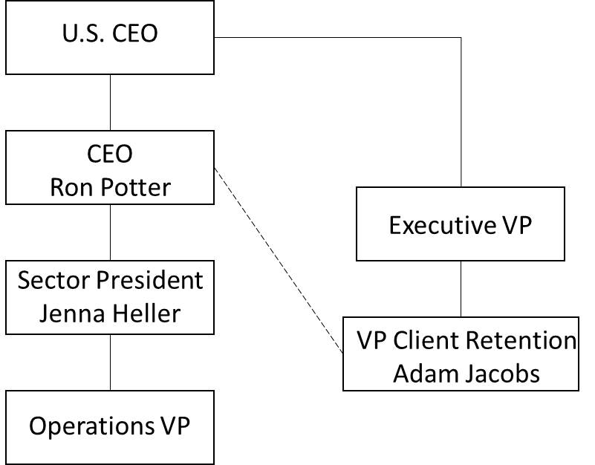

Source: Case author’s notes.

Exhibit 2: Flatrock organization chart

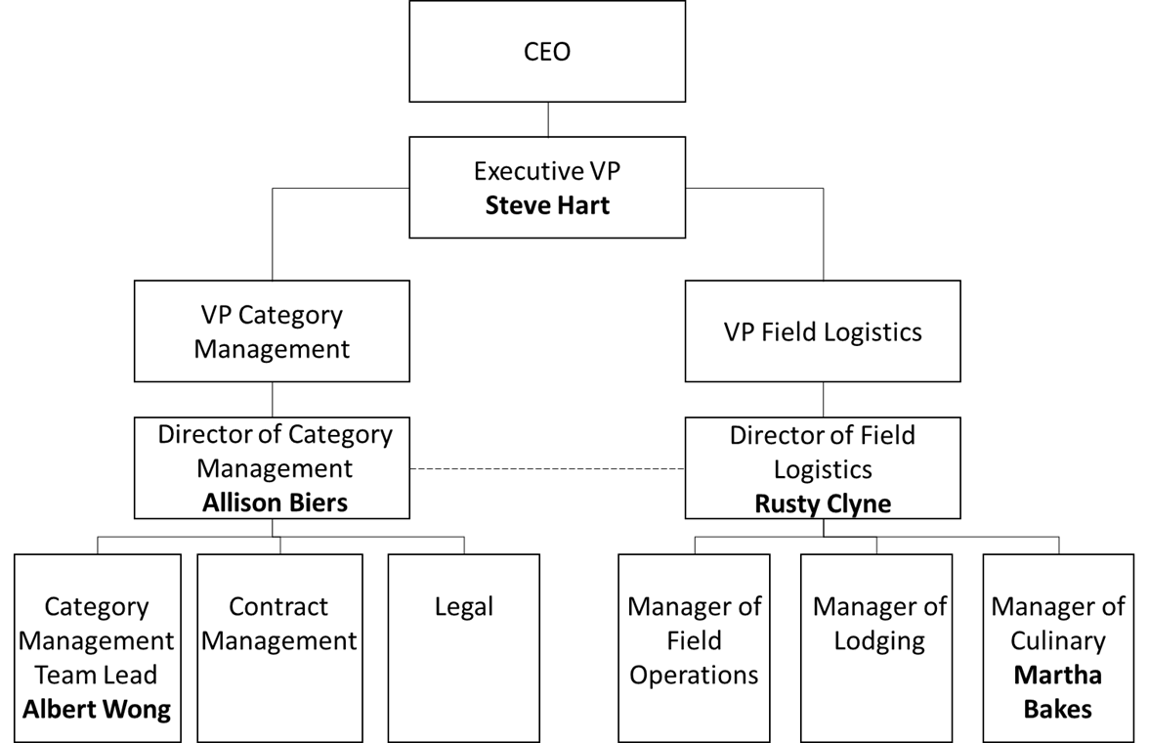

Source: Case author’s notes.

1. Flatrock’s contract accounted for 16 per cent of Tower’s revenues and 20 per cent of Tower’s profits.
2. A worker village was a community set up by mining and oil companies near the worksite, since the remote locations of most worksites made it difficult for workers to commute to them.
3. “Client nibbling” was when a client would ask Tower to supply additional services at no additional cost.
4. Third-party lodging companies provided the same service as Tower but charged on the basis of the number of rooms rented out as opposed to a predetermined rate agreed upon during negotiations.
5. Joint-venture partners were indigenous groups Tower partnered with to add value to its offering.