

9B17C007

GACL: Balancing employee satisfaction and productivity

Kanupriya Katyal and Jagrook Dawra wrote this case solely to provide material for class discussion. The authors do not intend to illustrate either effective or ineffective handling of a managerial situation. The authors may have disguised certain names and other identifying information to protect confidentiality.

*This publication may not be transmitted, photocopied, digitized, or otherwise reproduced in any form or by any means without the permission of the copyright holder. Reproduction of this material is not covered under authorization by any reproduction rights organization. To order copies or request permission to reproduce materials, contact Ivey Publishing, Ivey Business School, Western University, London, Ontario, Canada, N6G 0N1; (t) 519.661.3208; (e)* [*cases@ivey.ca*](mailto:cases@ivey.ca)*;* [*www.iveycases.com*](http://www.iveycases.com)*.*

Copyright © 2017, Richard Ivey School of Business Foundation Version: 2017-03-01

It was August 2016. “What a hectic week,” Venkat Kumar said to himself as he sipped his afternoon tea, waiting for the “unlucky” period of the day—*Rahukalam*[1]—to end. Kumar, the managing director of Gujarat Automotive Corporation Limited (GACL), was mostly a man of science, except for his small superstition regarding *Rahukalam*, when he would avoid meeting anyone or beginning any new task or project.

As he drank his tea, Kumar recalled how much he had achieved in the two years since he had joined GACL, a Tata Motors Limited (Tata Motors) company that built bus bodies. His strict discipline and innovative production practices had paid off, and GACL had emerged from its losses of $570,000[2] in 2009/10 to become a profitable venture, making profits in excess of $3.6 million in 2012/13 (see Exhibit 1).

However, achieving this turnaround had not been an easy task. Kumar recalled the numerous instances when he had clashed with other GACL staff members. “Tough decisions need to be taken,” he had told the board. “Turning a company around is nothing short of waging a war.” He also remembered the last board meeting, at which he was commended for his performance. Yet one of the directors, Peter D’Silva, had not shied away from asking difficult questions: “What about the employees? Are they happy and content?” D’Silva had suggested that the company should conduct a satisfaction survey. “From a long-term perspective, it is important for the company to balance customers, investors, and also employees. Financial gains cannot come at the cost of disgruntled employees,” he asserted. D’Silva’s remarks had interrupted the congratulations, but they were valid. Kumar himself held a similar opinion: with respect to either a nation or a company, “wartime” and “peacetime” required different management styles.

Kumar had instructed Amar Panth, the general manager of the human resources (HR) and administration department, to prepare a satisfaction survey to be administered in May 2014. Panth had suggested that for the survey to be an impartial one, it should be conducted by an external agency. He suggested involving Jia Gupta and Ram Singh from the Gujarat Institute of Management (GIM), whom he had met at his university’s convention. Subsequently, the two professors were contacted and the survey was conducted, taking three months to complete. Armed with the resulting report, Panth, Gupta, and Singh were scheduled to meet with Kumar.

Kumar was curious to know whether employees at GACL were satisfied with their jobs and workplace. He felt that everyone should have been satisfied when they saw their company innovate and grow. With the company back on track, he wanted to develop employee-friendly practices. He needed to know what his focus areas should be, and this survey was his starting point.

GUJARAT AUTOMOTIVE CORPORATION LImited

GACL was established by Tata Motors (formerly known as Tata Engineering and Locomotive Company Ltd.) and EDC Limited (formerly known as the Economic Development Corporation of Goa, Daman & Diu Limited) in 1980. GACL manufactured sheet metal components, assemblies, and bus coaches. Two of its factories were in Kota and Bhumi, in the state of Gujarat, while another was on the border of the neighbouring state (Jejuri, Rajasthan). The sheet metal division was the first to be started, and by March 2016, it had achieved an output of more than 17,620 tonnes. The company was listed on the Bombay Stock Exchange.

In 1987, the company entered into a technical collaboration agreement with Fuji Heavy Industries Ltd., (FHI) Japan, for various models of chassis-mounted bus bodies, which led to the creation of the bus body-building division. GACL reached a further agreement with FHI to build bus bodies for FHI’s luxury line (Monocoque) in 1995. However, Tata Motors was GACL’s biggest client, with over 74 per cent of its sheet metal business and 94 per cent of its bus body business coming from Tata Motors. Tata Motors was the world’s second-largest bus manufacturer by volume.

The most important product that GACL made was the bus body. Each bus chassis would arrive at the GACL plant to be fitted with the bus body. The bus bodies were of two different types—standard and luxury. There were 15 stock keeping units (SKUs) in the luxury segment and six in the standard segment. Apart from these regular-sized buses, GACL also made mini-buses (five SKUs) and ambulances (one SKU). The business was not restricted to Tata Motors’ vehicles; GACL also did business with other bus manufacturers like Ashok Leyland, Swaraj Mazda, and Eicher. Yet business with the latter manufacturers represented a relatively new initiative and was limited in volume. Besides bus bodies, GACL also undertook jobs for sheet metal fabrication of items such as engine cross members, floor panels, and cowl posts.

Tata Motors formed a joint venture with Marcopolo in 2007, setting up facilities in Lucknow and Dharwad. These facilities also produced bus bodies and were therefore in direct conflict with GACL. The Marcopolo plant received 70 per cent of the bus body business. The GACL board had often complained to Tata Motors about this treatment, which GACL saw as neglectful. The entry barriers in the bus body business were very low, and there was further competition from the unorganized sector, which competed based on lower prices.

The bus body and sheet metal components were manufactured in GACL’s plants at Bhumi (Gujarat), Kota (Gujarat), and Jejuri (Rajasthan). The company was functionally divided into nine departments (see Exhibit 2). The Gujarat plant at Bhumi was the largest. It employed a total of 591 employees, of which 332 were associates and 259 were staff members.[3] Of the 591 employees, 547 were employed at the main plant in Bhumi, 44 in Kota, and three in Jejuri (see Exhibit 3).

EMPLOYEE UNREST in 2009

The early part of 2009 was sluggish for GACL, and the Gujarat plant was shut down due to low levels of demand. The plant was reopened in June, but the capacity utilization was low. The situation was saved by a few large orders from Tata Motors, and the demand peaked in the last quarter. However, GACL could not take advantage of the situation because of an unfortunate labour unrest over the issue of wages.

Workers at GACL (as in several other Indian companies) were organized into worker unions. These unions looked after the rights of the workers, who elected the union leaders. Each union met with management periodically to negotiate salaries and other terms. The union also handled workers’ grievances and communicated these to the management. Forming a union was a legal right given to workers under the Trade Unions Act of 1923, but many companies had criticized the trade unions for associating themselves with political parties.

Companies such as GACL worked around the legal system and the unions by employing contract labour for low-end jobs. Contract labourers were not covered by unions, and their numbers could be “managed” depending on the demand. In addition, contract workers helped companies build temporary capacity as required.

It was noteworthy that most workers had been working with GACL since its inception. In 2009, the labour unrest brought production to a standstill, leaving the company unable to fulfil its commitment to supply over 1,100 buses to clients in the Middle East and to the Maharashtra State Road Transport Corporation. The contract with the latter organization involved a penalty clause of ₹20,000[4] per day if orders were not fulfilled in time. The overall situation pushed GACL to the brink of bankruptcy.

Firm steps taken by GACL’s management, as well as support from the government and promoters, helped the union and the company to reach a three-year settlement that was effective from April 1, 2009. Even so, only 2,373 buses were sold in 2009, compared to 4,509 sold the previous year.

CHANGE IN LEADERSHIP AND IMPROVED PRODUCTIVITY

In 2010, Kumar took over from his predecessor as the managing director of GACL. While orders from Tata Motors had started coming in, the plant was struggling with low levels of productivity and a lack of discipline after the strike. The incumbent director and his team embarked upon a sustained endeavour to get additional business from private customers, eliminate waste, and carry out a massive cost-reduction drive. The focus was on improving the overall efficiency of the plant (see Exhibit 4).

Kumar had remarked once that he was able achieve higher efficiency without any considerable investment. As soon as Kumar joined GACL, he realized that productivity was suffering for two reasons: poor planning and a lack of discipline. Improvement in these two areas would be his main objective. Kumar observed that the workforce deployment at the bus body plant was lopsided. There were days when the plant operated just one shift, while on other days, the plant operated three shifts. This lack of a consistent schedule was inefficient. The company also paid special incentives to encourage workers to take night shifts and offered additional overtime pay to employees working two shifts.

The production staff identified erratic orders as another problem. Orders from Tata Motors would arrive as a group, and the chassis would arrive in groups as well. The process of building the bus bodies could not begin until the chassis arrived. A simple innovation changed this situation. Kumar met with representatives from Tata Motors and urged the company to inform GACL of future orders in advance. Tata Motors maintained that while it could inform GACL of the next month’s order with 100 per cent certainty, that level of certainty would decrease for subsequent months. Under a new arrangement with Tata Motors, the latter promised to inform GACL of the next month’s production schedule and to provide a tentative schedule for the next two months. Over time, Kumar realized that the tentative schedule was sufficiently accurate (within a margin of about 10 per cent) to allow him to plan GACL’s production in advance.

Moreover, Kumar changed the system of production in the plant. Instead of waiting for the chassis to arrive, he directed his staff to build each body on fixed platforms that resembled a bus chassis. Once the chassis arrived, the ready-made body was simply fitted on top of it. Better planning ensured that the work would be distributed evenly over the month. The number of shifts was reduced, and the system of overtime was discontinued.

The second—and more challenging—problem that Kumar identified was that of discipline. Several changes were made, such as instituting a policy of zero tolerance against disruptive behaviour. While these measures proved effective, they made Kumar somewhat unpopular among the workers. Kumar hoped to mitigate some of this unpleasant feeling by initiating sound HR practices.

For instance, the training and development of employees had been shown to improve employees’ knowledge and skills, as well as their attitude and motivation. GACL had always emphasized the need to develop HR. Training programs for employees continued, even during the strike of 2009. Kumar continued the company’s emphasis on training and development, acknowledging it as a sound practice.

Another initiative that Kumar emphasized was standardization of parts. Before his tenure, different bus designs used different parts, but Kumar initiated a standardization drive with the help of associates and staff. All of the parts that did not contribute towards differentiating a model were standardized. As a result, inventory levels came down drastically, which resulted in huge savings.

Kumar’s predecessor had already reached a wage agreement with the workers’ union in 2009, and this agreement would remain in force until 2012. However, Kumar sought to revise staff salaries and bring them on par with industry standards. Because Kumar believed in treating individuals with fairness and respect, the use of the term “worker” was discontinued and was replaced with the term “associate.” Professional uniforms were provided to both staff and associates, and a common dining area was established for both groups. Kumar instituted a grievance-handling system, as well as a system for recognizing and rewarding outstanding employees on a monthly basis.

SATISFACTION SURVEY

At a board meeting in February 2014, GACL’s directors stressed the fact that too much focus on productivity and discipline may have led to employee stress and lower levels of employee satisfaction. The board recommended that an independent body should be engaged to measure employee satisfaction and that appropriate measures should be taken to create a harmonious work environment at GACL.

Consequently, Panth invited Gupta and Singh to discuss the issue. After a brief conversation, Gupta remarked that there were two important factors to consider when measuring employee satisfaction:

First, employee satisfaction is not one-dimensional but multidimensional. Dissatisfaction in a job may arise from several factors, like compensation, advancement, relationships with coworkers, relationships with supervisors, and recognition [for performance]. There are 20 such factors listed in theory, and these factors may change from culture to culture and industry to industry.[5]

Gupta also stressed the need to measure employee “trust” towards GACL and whether or not employees considered GACL to be a “fair” employer. “These are related issues,” Gupta explained. “If employees perceive an organization to be fair, they trust it, and this increases employee satisfaction.”

Both GIM professors stressed the need to customize the satisfaction factors to suit the requirements of a manufacturing firm like GACL. They also emphasized the need for administering the questionnaire in the local languages—Gujarati and Hindi—apart from English.

Subsequent to these discussions, the two professors met with Panth a few more times to finalize the questionnaire. While most of the questions were standard, a few changes had to be made. The questionnaire was then presented in English and translated into the local languages (see Exhibit 5).

A team of five representatives from GIM took one week to conduct the survey. On the first day, they encountered initial resistance from the unionized workers, who viewed the exercise with substantial skepticism and expressed a fear of persecution. It was only after Singh assured the union members of complete confidentiality that they agreed to let the survey proceed.

RESULTS OF THE SURVEY

It took about two months for the team from GIM to present its findings (see Exhibit 6). As Kumar reviewed these findings, he heaved a sigh of relief and considered: “It’s not as bad as I thought. There is a difference between the staff members’ and the associates’ levels of satisfaction, but some of the results are as expected. After all, how many people are completely satisfied with their salary?”

Kumar also wondered whether it made sense to work towards satisfying potentially incompetent and low-performing employees: “Is this exercise enough? Would I have gained more insight if I knew who, exactly, was satisfied? Why should I care about the satisfaction of an unproductive employee?”

Finally, Kumar considered the practical value of the report, musing, “What I have is a report card. Now what? The report does not say anything about how I improve satisfaction. Can I do so without compromising the levels of productivity that I have achieved through so much hard work?” What should the next step be?

EXHIBIT 1: Financial Performance (in $ Millions)

|  |  |  |  |  |
| --- | --- | --- | --- | --- |
|  | **2009/10** | **2010/11** | **2011/12** | **2012/13** |
| Net Sales | 35.90 | 56.90 | 51.19 | 40.52 |
| Total Expenditure | 36.50 | 50.90 | 46.06 | 37.39 |
| Operating Profit/(Loss) | −0.60 | 6.01 | 5.10 | 3.13 |
| Other Income | 0.71 | 0.94 | 1.28 | 1.32 |
| Earnings before Interest, Tax, Depreciation and Amortization | 0.12 | 6.95 | 6.41 | 4.44 |
| Interest | 0.04 | 0.02 | 0.02 | 0.02 |
| Cash Profit | 0.08 | 6.93 | 6.39 | 4.43 |
| Provision for Depreciation and Amortization | 0.65 | 0.71 | 0.73 | 0.83 |
| Profit/(Loss) before Tax | −0.57 | 6.21 | 5.66 | 3.60 |
| Provision for Tax (Net) | −0.24 | 2.02 | 1.84 | 1.19 |
| Balance in Profit and Loss Brought Forward from the Previous Year | 5.89 | 5.45 | 3.82 | 2.41 |
| Profit Available for Appropriation | 5.56 | 9.65 | 7.50 | 9.21 |
| **Appropriations:** |  |  |  |  |
| Equity Dividend |  |  |  |  |
| Interim | – | 0.25 | 0.25 | 0.25 |
| Final | 0.10 | 1.23 | 1.23 | 0.99 |
| Corporate Dividend Tax | 0.02 | 0.25 | 0.24 | 0.21 |
| Transfer to General Reserve | – | 0.42 | 0.38 | 0.24 |
| Balance Carried to Balance Sheet | 5.45 | 7.50 | 9.21 | 9.94 |

Source: Created by authors using company files.

EXHIBIT 2: ORGANIZATION STRUCTURE

Source: Created by authors using company files.

Exhibit 3: EMPLOYEE DISTRIBUTION ACROSS PLANTS

|  |  |  |  |  |  |
| --- | --- | --- | --- | --- | --- |
| **Designation** | **Bhumi Unit** | **Kota Unit** | **Jejuri Unit** |  | **Total** |
| Associates | 323 | 9 | 0 |  | 332 |
| **Total A** | **323** | **9** | **0** |  | **332** |
| Diploma Engineer | 1 |  |  |  | 1 |
| Graduate Engineers | 2 |  |  |  | 2 |
| Staff | 9 |  |  |  | 9 |
| Supervisors | 25 |  |  |  | 25 |
| Officers | 58 | 5 |  |  | 63 |
| Senior Officers | 62 | 12 | 2 |  | 74 |
| Deputy Managers | 31 | 12 | 1 |  | 43 |
| Managers | 19 | 4 |  |  | 23 |
| Senior Managers | 5 | 1 |  |  | 6 |
| Asst. General Managers | 5 |  |  |  | 5 |
| Deputy General Managers | 3 | 1 |  |  | 4 |
| Chief Operating Officer | 1 |  |  |  | 1 |
| General Managers | 2 |  |  |  | 2 |
| Senior General Manager | 1 |  |  |  | 1 |
| **Total B** | **224** | **35** | **3** |  | 259 |
| **Grand Total A+B** | **547** | **44** | **3** |  | **591** |

Source: Created by authors using company files.

EXHIBIT 4: GACL PERFORMANCE OVER TIME

EXHIBIT 4 (continued)

EXHIBIT 4 (continued)

Exhibit 4 (continued)

Source: Created by authors using company files.

EXHIBIT 5: QUESTIONNAIRE—BASIC STRUCTURE

Confidentiality and Informed Consent

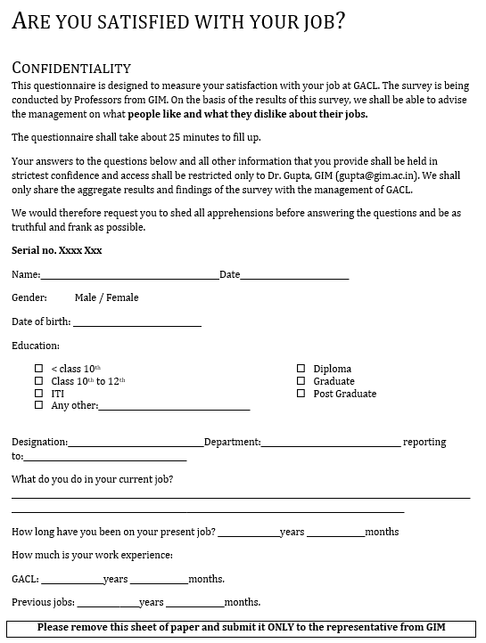

Demographic details

Instructions to remove this page leaving no markers on the rest of the pages

Serial number that connects this page with the rest after this page has been removed

EXHIBIT 5 (contined)

Serial number

Instructions for filling out the questionnaire

Questions on Satisfaction, trust, and fairness

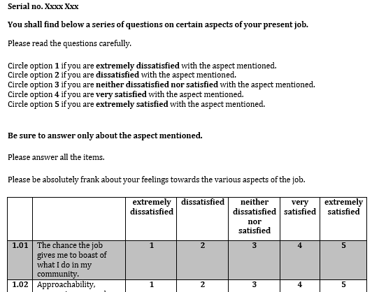

Figure : Pages 2–10

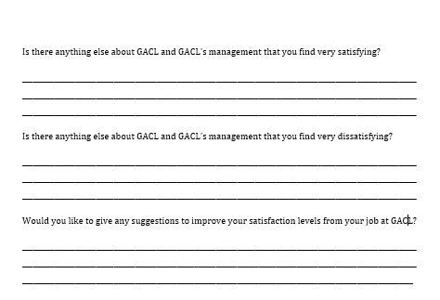

Open-ended questions

Figure : Last page

Source: Created by authors using company files.

EXHIBIT 6: RESULTS OF THE SURVEY

Results of Satisfaction. A score of 1 indicates “extremely dissatisfied” and 5 indicates “extremely satisfied”

|  |  |  |  |  |
| --- | --- | --- | --- | --- |
|  | **Associates** | | **Staff** | |
| **Component** | **Mean** | **Standard deviation** | **Mean** | **Standard deviation** |
| Contribution | 4.14 | 0.55 | 4.14 | 0.42 |
| Activity | 4.00 | 0.86 | 4.10 | 0.59 |
| Co-workers | 3.87 | 0.59 | 4.04 | 0.44 |
| Achievement | 3.86 | 0.64 | 3.73 | 0.63 |
| Social Status | 3.67 | 0.64 | 3.70 | 0.58 |
| Independence | 3.57 | 0.94 | 3.70 | 0.77 |
| Ability Utilization | 3.47 | 0.64 | 3.80 | 0.47 |
| Recognition | 3.39 | 0.80 | 3.67 | 0.70 |
| Responsibility | 3.38 | 0.78 | 3.87 | 0.55 |
| Creativity | 3.27 | 0.91 | 3.72 | 0.62 |
| Supervisor—Technical Knowledge | 3.27 | 0.86 | 3.92 | 0.62 |
| Company Policies & Practices | 3.26 | 0.62 | 3.70 | 0.55 |
| Authority | 3.23 | 0.93 | 3.77 | 0.52 |
| Supervisor—Human Relations | 3.14 | 0.78 | 3.79 | 0.57 |
| Security | 3.12 | 0.93 | 3.47 | 0.80 |
| Advancement | 3.09 | 0.78 | 3.47 | 0.72 |
| Interdepartmental Relationships | 3.04 | 0.79 | 3.42 | 0.60 |
| Working Conditions | 2.90 | 0.70 | 3.39 | 0.61 |
| Compensation | 2.86 | 0.91 | 3.26 | 0.84 |
| [6]Variety* | – | – | – | – |

Results of Trust. A score of 1 indicates “low trust” and 5 indicates “high trust”

|  |  |  |  |  |
| --- | --- | --- | --- | --- |
|  | Associates | | Staff | |
| **Component** | **Mean** | **Standard deviation** | **Mean** | **Standard deviation** |
| Ability | 3.80 | 0.60 | 4.10 | 0.56 |
| Benevolence | 3.08 | 0.77 | 3.50 | 0.79 |
| Integrity | 2.78 | 0.9 | 3.55 | 0.81 |

Results of Fairness. A score of 1 indicates “unfair” and 5 indicates “fair”

|  |  |  |  |  |  |
| --- | --- | --- | --- | --- | --- |
|  |  | Associates | | Staff | |
| **Rank** | **Component** | **Mean** | **Standard deviation** | **Mean** | **Standard deviation** |
| 1 | Distributive | 2.99 | 0.84 | 3.54 | 0.78 |
| 2 | Procedural | 2.89 | 0.64 | 3.32 | 0.66 |
| 3 | Interactional | 2.79 | 0.75 | 3.48 | 0.66 |

* Note: Variety is not interpreted because it failed the internal consistency test.

Source: Created by authors using company files.

1. In Indian astrology, *Rahukalam*, or the period of *Rahu*, is a certain period of each day deemed inauspicious for any new venture.
2. All currency amounts are in U.S. dollars unless otherwise specified;
3. “Associates” refers to shop-floor employees. “Staff” refers to administrative or managerial employees.
4. ₹ = Indian rupees; US$1 = ₹66 on January 1, 2016.
5. Readers can learn more about the Minnesota Satisfaction Questionnaire at “(MSQ) Minnesota Satisfaction Questionnaire,” University of Minnesota, accessed November 11, 2016, http://vpr.psych.umn.edu/instruments/msq-minnesota-satisfaction-questionnaire.
6.