

9B17C024

AGODA: PEOPLE ANALYTICS AND BUSINESS CULTURE (A)

Ken Mark wrote this case under the supervision of Professor Kenneth T. Goh solely to provide material for class discussion. The authors do not intend to illustrate either effective or ineffective handling of a managerial situation. The authors may have disguised certain names and other identifying information to protect confidentiality.

*This publication may not be transmitted, photocopied, digitized, or otherwise reproduced in any form or by any means without the permission of the copyright holder. Reproduction of this material is not covered under authorization by any reproduction rights organization. To order copies or request permission to reproduce materials, contact Ivey Publishing, Ivey Business School, Western University, London, Ontario, Canada, N6G 0N1; (t) 519.661.3208; (e)* [*cases@ivey.ca*](mailto:cases@ivey.ca)*;* [*www.iveycases.com*](http://www.iveycases.com)*.*

Copyright © 2017, Richard Ivey School of Business Foundation Version: 2017-07-19

**Introduction**

On a typically hot day in Bangkok, Thailand in early March 2016, Robert Rosenstein, chief executive officer (CEO) of Agoda Company Pte. Ltd. (Agoda), was having a morning coffee with Peter Allen, vice-president of People and Organization Development. Agoda, an online accommodation service, was the Asia-based subsidiary of The Priceline Group, Inc. (Priceline). Rosenstein observed to Allen,

We are a global leader in using data and analytics to optimize our e-commerce platform, but how advanced are we in terms of data and analytics in the people function? We know that this is central to the people department mission, but we need to make sure, as we do with our platform, we can correlate investment with outcomes, while also staying true to our culture. How far along are we, Peter?

Allen replied, “We’ve implemented Workday, a human resource (HR) information system that provides a lot of data, which we’ve been studying, and we are investing in customization of that platform so it can serve our specific needs.” The challenge was how incremental investments could—or should—be justified. Allen noted:

In particular, we’re also installing Greenhouse, a new applicant tracking system for recruitment that will provide us with additional insights into how effectively we are recruiting. We are starting to look at the recruiting data much more as we look at conversion on our core platform, finding areas of opportunity and developing best practices.

Helping Allen and his team make this vision a reality was Jeffrey Lee, Agoda’s director of Operations and Compensation. Lee had spent the past year overseeing the development and introduction of a number of software tools to assist managers in compensation and other areas of operations. The next stage of the operation team’s plan was to oversee the implementation of Greenhouse.

Rosenstein challenged Allen:

We need to be sure these tools provide insights for managers to manage talent more effectively. We need managers to own the outcomes of talent management rather than delegate that responsibility to the people team. We need to be very careful about any unforeseen cultural changes: the last thing we want is to put a system in place that moves us in the wrong direction from a management philosophy perspective. If managers think that the people team needs to own more as the result of this new system, we will have done something wrong.

**THE GLOBAL ONLINE TRAVEL AGENCY INDUSTRY**

In 2016, Priceline and Expedia, Inc. dominated the global online travel agency market, serving consumers with millions of properties under contract.[1] Through online sites such as Booking.com, Agoda, Priceline.com, OpenTable, Rentalcars.com, and KAYAK, Priceline was the leader in worldwide online accommodation reservations. Priceline customers could use the group’s services to book hotel stays, rental cars, airline tickets, vacation packages and cruises, and even restaurant reservations. In 2015, Priceline generated US$2.6 billion[2] in net income from $9.2 billion in revenues and $55.5 billion in gross bookings, employing 15,500 people in total.[3] Priceline’s success was remarkable—especially considering that in the early 2000s, it had suffered near-catastrophic losses. Fortunately, the firm had retained enough cash—raised from investors during the dot-com boom of the late 1990s—to reinvent itself.

Priceline’s turning point was a 2002 decision by Jeffery H. Boyd, then the company’s new CEO, to focus on accommodations, offering great terms to hotels—the company’s suppliers—and the strategy of expanding by acquiring strong regional online travel agency brands. Priceline paid $133 million for Netherlands-based Bookings in 2005, and two years later, the renamed Booking.com grew from a small base to account for half of Priceline’s bookings.

A focus on expansion in Asia led Priceline to purchase Agoda in 2007 for $16 million in cash and up to $142 million in performance incentives.

**AGODA BACKGROUND**

Rosenstein had travelled to Southeast Asia as a backpacker in 1991. Returning in 1998, he invested in an online hotel reservation business. Along with a co-founder, in 2002, he formed a partnership that would ultimately launch Agoda in 2005. He led the firm as president and chief operating officer, and managed it through the acquisition by Priceline, becoming CEO in 2010. By 2016, Agoda had grown from a small startup with a handful of employees to a multinational with 40 offices in 31 countries, and over 2,500 employees. Agoda, headquartered in Singapore and with a significant presence in Bangkok, served consumers globally (see Exhibit 1).

With its inventory of more than one million accommodations, Agoda’s business was remarkably complex. For example, for each hotel listing, there were typically at least 10 available room types (e.g., single, double, with or without breakfast, refundable, and non-refundable rates), and each room required its own web page and selling features. To complicate matters further, each page had to be accessible on multiple platforms (desktop and mobile, in particular) and translated into 30 languages, with pricing converted in real time to dozens of different currencies. The technology required to manage this complexity was a core feature of Agoda’s business.

Despite its success, Agoda continually faced threats from new entrants; regulatory changes; competitors that consistently adopted the latest technologies to improve customer experience and operations; and startups like Airbnb, Inc., which sought to disrupt entire business models. To thrive in this rapidly changing and highly competitive landscape, it was crucial for Agoda to remain nimble. It not only had to keep abreast of the latest technological advances that could affect the business, but also attract and retain top talent from around the world.

Explaining the importance of talent, Rosenstein stated,

I like the combination of high natural intelligence, competitiveness, personal humility, and a strong ethical foundation. That’s a winning formula for your most important people. When you find someone who is like this who can add value to your business, be willing to pay up, take less for yourself, or make whatever sacrifice you need to make, because that is how you make a great business.[4]

Rosenstein believed that the relationship between managers and employees was critical to building the strongest company and getting the best out of employees. Agoda was designed to encourage the manager–employee relationship to flourish, with minimal administrative interference. From the CEO’s perspective, traditional HR functions often impeded good management. Consequently, it was not until 2012 that Agoda had a real HR function. Before that, the small number of HR staff had responsibilities only for recruiting and managing payroll, and not staff development.

Rosenstein knew he needed to build recruitment, compensation, performance management, learning and development, and talent management—traditional HR functions—for his rapidly growing company of 1,200 full-time staff. However, he was concerned that an HR bureaucracy would impede or replace good management by taking ownership away from managers and employees. He also worried that it would impose rules and policies that inhibited managers’ ability to make decisions that were best for the company’s business; this was even more of a concern because of the firm’s diversity.

Agoda’s employee population comprised over 70 different nationalities working in a number of very different functions: call centre employees, IT developers, marketing professionals, business development professionals, and staff in finance, legal, and other areas. Rosenstein believed that an overly intrusive HR function would damage the relationship between managers and employees, and reduce the sense of entrepreneurship and flexibility that were core to the company. Yet some form of centralizing and structure was necessary to help the firm operate and grow.

To ensure that his philosophy on managing talent was sustained while Agoda continued to grow, Rosenstein turned to Peter Allen. With a PhD in humanities and MBA from The Wharton School at the University of Pennsylvania, Allen had been a McKinsey & Company consultant in New York, founded Google University, and worked in talent management at Standard Chartered bank. Allen took the job because he wanted to see if he could shape the HR function to make a positive difference to this growing company.

**RE-ENVISIONING THE HR ROLE**

Allen was sympathetic to Rosenstein’s concerns about the dangers of imposing unnecessary bureaucracy. He believed that the relationship between managers and employees was the foundation of a high-functioning organization. As a result, Allen decided to build an HR function that would not add to the bureaucracy, but would instead play an advisory role in supporting and enhancing the role of management—in a sense, an internal consultancy that would help managers become more empowered in managing talent through data and insights.

Allen explained his rationale:

Some tech firms grow out of an engineering culture in which the fundamental belief is that managers are bad, so the less management you do, the better. Such firms prefer to minimize or automate the business of management as much as possible. By contrast, we start with a different fundamental assumption. We believe that the most important relationship at work is the one between [managers and their] employees, so we want to help managers do their jobs well by empowering and supporting them.

One of Allen’s first moves was to rename his department; he replaced the old “Human Resources” name with a new one, “People and Organization Development” (generally known as the “people department”). As Allen explained,

My department’s fundamental goal is to help managers manage better, not to manage on their behalf.

Our approach is based on a few core principles:

* Managers, not HR, should define, live, and develop the company’s leadership.
* Managers, not HR, should do the hard work of managing people—hiring, evaluating, rewarding, and disciplining employees—and managers should be evaluated on their results.
* Employees, not HR, should “manage up” and take responsibility for solving problems directly with their managers.

We’ve also tried to hire the smartest and most talented people we can find, regardless of whether they have traditional HR backgrounds. Results so far have been promising.[5]

Allen’s focus in the people department was to empower frontline managers to make many of the decisions traditionally carried out by HR. Naturally, for a data-driven company, a large part of the empowerment would come from providing those managers with the data to make those frontline decisions. The question was what data to collect, and how to collect, analyze, and present it in a way that empowered managers to make better decisions.

Data of all kinds was core to Agoda’s business. With millions of customers around the world, Agoda needed to keep innovating in its business not by hunches or by intuition, but by solid data wherever possible. Like other information technology (IT) firms, Agoda relied extensively on data to garner insights into its customers. The objective was to do a better job of targeting prospective customers and retaining existing ones.[6]

Allen knew that unless the people department operated in the same way as the rest of the company, it would not have the credibility it needed to help managers make the best possible decisions. However, when he joined the company, he found that most personnel information was kept on hundreds of spreadsheets on the computers of different members of the old HR team. Further, performance reviews were done on paper and kept (though hardly ever consulted) in physical files in the team room. There was no way to stay up to date, aggregate information, protect employee security, build accurate organizational charts, or support good management without the kind of information other departments had at Agoda.

For Allen, improving the way the people department worked with managers and other stakeholders was a priority. His vision was not just about ensuring data could be digitized, centralized, and available in real time; it involved a fundamental change in the organizational role of the HR department—from one that established, monitored, and enforced HR policy to one that empowered managers to manage better.

To initiate this transformation of Agoda’s people department, Allen made a number of changes. One such change was to persuade the company to adopt best-in-class information systems like Greenhouse and Workday, and be in a position to customize where needed. These changes would require technical resources. More importantly, Allen needed to hire great people who would share his philosophy, work within the culture, and be very comfortable with data. In particular, he knew he would need someone to take the lead and demonstrate how this new system could empower managers.

This person was Jeffrey Lee, a former McKinsey & Company consultant whom Allen recruited to be the director of Operations and Compensation. Lee had a wealth of international experience that was relevant to Agoda’s international presence. He grew up in Singapore and joined the U.S. Department of State as an analyst providing coverage of Asia. After completing his MBA at The Wharton School, Lee was recruited by McKinsey & Company, where he consulted on operations strategy with multinational clients around the world. Allen thought that Lee’s consulting experience would place him in a strong position to lead the people department to develop data-driven insights that would empower managers in managing the talent.

**IMPLEMENTING PEOPLE ANALYTICS**

Lee was excited about Allen’s vision of enabling managers with data but realized this was going to be a challenging undertaking. “When I arrived, we were conducting performance evaluations with one-megabyte macro-enabled Excel sheets that were emailed to managers around the world.” In addition to the technical issues of integrating a new human capital management system, Lee had to persuade managers and his team in the people department to rethink how data was collected, analyzed, interpreted, and presented. These changes were necessary to be consistent with Allen’s vision of the people department as an enabler of managers, rather than a policy-setting and compliance-monitoring unit. Allen and Lee worked with their team to bring the firm’s people practices up to speed by focusing on three areas: compensation and benefits; performance evaluation and promotion; and recruitment.

**Compensation and Benefits**

In many organizations, the HR function determined salary bands and compensation policies for different roles and positions. At Agoda, managers were encouraged to make compensation decisions based on their unit’s needs. Allen explained the principle underlying this unconventional approach:

We believe that managers should be able to hire the best people for their roles, without following arbitrary salary limits. Agoda hires employees from all over the world. Without compensation flexibility, it would be impossible to hire, say, senior IT talent from Silicon Valley into Thailand. As a result, giving managers the freedom to compensate employees appropriately was a key to the company’s success.

To empower managers in deciding on compensation, Lee implemented a system to collect real-time market rates on compensation, presenting the information to managers in a user-friendly format. Managers were also shown correlations between performance and bonuses in their departments so they could make informed decisions about allocating bonus payments (see Exhibit 2).

According to Allen, managers were prompted to look at these correlations and see where there were any discrepancies:

These correlations should generally be positive. If they are not, it is possible that the bonus allocations are out of sync. Another possibility is that there could be other reasons for the way bonuses were allocated: sometimes there are specific individual circumstances, or broader changes in market conditions of which managers are aware, which then alerts us to consider adjusting compensation across the organization as a whole. The people team provides data and advice—but does not override or overrule managers, who, after all, are responsible for the performance of their own teams.

As a check, Rosenstein reviewed compensation for all departments at least once a year. The outcome was that while salaries were not consistent, even within a single department, managers were able to hire, reward, and retain the talent they needed most.

Lee also applied analytics to track employee benefit use. As an online travel agency, Agoda provided employees with a travel benefit: 12 times per year they were able to use discounted rates on personal accommodation booked through the Agoda website. While there were guidelines about using these discounts, there were no clear penalties for excessive use. The question was how the company could prevent employees from abusing their benefits without over-policing.

The people department monitored employee behaviour. However, rather than establishing blanket policies for dealing with employees found to have abused their benefits, the department brought each case to managers to resolve. In one case, for example, an employee was found to have used employee discounts for stays worth more than half his salary. The people team presented data around excess bookings and, in some cases, the person’s compensation to make the point that it was highly probable the employee was reselling the discount. The manager then acted to rectify the problem. While the outcome may have been the same as it would have been if HR managed the process, Agoda’s approach required managers to take ownership of the problem and resolve it themselves.

**Performance Evaluation and Promotion**

Performance evaluation at Agoda was conducted through peer evaluations of employees’ work habits, cognitive abilities, and interpersonal skills (see Exhibit 3). Ratings for each employee were collated and shared with the employee, the manager, and the departmental head (see Exhibit 4). In order for this data to empower managers, Lee encouraged his team in the people department to constantly look for ways to identify and collect data that was relevant to managers. Allen explained:

We initially didn’t know where to begin, so we started with a 50-question survey. Then, we ran correlations on the responses to see if there were any key questions that drove the results. Identifying these questions allowed us to pare the survey down to a handful of questions to make it easier for employees completing the surveys and for managers.

From his prior consulting experience, Lee was aware that employees in each department performed different kinds of work and needed to be measured differently. For instance, call centre employees were managed on actual behaviours, such as the number and duration of calls handled. In contrast, employee performance in partner marketing could only be measured after a longer period of time. Therefore, managers in each of these units required different criteria for evaluating employee performance. Rather than simply applying a common set of criteria to evaluate all employees, Lee regularly engaged with managers to refine performance measures so they were the most useful to managers.

With this information, managers could help employees with their developmental needs and deploy them to areas that suited their strengths. By tracking employees’ improvements in developmental needs over time, department heads could use this information as another indication of their managers’ consistency and effectiveness in managing, rather than rely solely on profit and loss numbers. Lee stated, “Many of our departments award bonuses annually. Some want to award them monthly, and we are developing the flexibility to provide these managers the tools with which to assess their employees’ performance, allowing them to use key performance indicators to award bonuses.”

Once again, the people department had to find the right positioning—it wanted to give managers the information required to make and own good management decisions, but it did not want to take over the responsibility of managing from them. The principle remained the same: ask managers what information they needed, get good data, analyze it, provide that data to managers in ways that would help them manage better, and then follow up with them for feedback on the changes.

Lee remarked,

A typical HR department operates like a government monopoly. There’s no competition for its services. You have to take what it provides. Moreover, you have to comply with its rules. We look at our people department in a different way. We want to be useful to managers. We won’t spend time developing tools or processes they don’t want. Managers are thinking about how we can help them immediately. If we want our people department to be relevant, if we want a seat at the table, we’re going to have to earn managers’ trust and give them tools, services, and data that they need. Otherwise, they’ll find other ways to collect and use data and cut us out of the loop.

**Recruitment**

Having made some headway in giving managers the data they needed to manage their staff, Allen and Lee saw the next step as developing Agoda’s analytics capabilities in recruiting talent. To sustain Agoda’s fast pace of growth, there was a constant need for new talent—both local and foreign experts—in critical areas like programming, product management, design, learning and development, and finance. Allen and Lee were convinced that getting recruitment to work, and work well, was critical to the company’s growth and continued success.

Despite a growing recruitment team and a multi-million dollar annual recruitment budget, the company had limited insight into the effectiveness of its recruiting efforts. The people team hoped to gain insights such as the following:

* Which universities, agencies, and other sources were producing the candidates most likely to be hired/successful?
* Were managers interviewing candidates efficiently and effectively?
* Were there managers who could consistently identify top performers?
* How long did the recruiting process typically take? How could Agoda expedite this process?
* Should the recruiting function sit inside the department, reporting directly to the business heads?
* Did candidates’ experience affect the company’s reputation and its ability to attract top talent?
* Was the internal referrals program effective?

Agoda sent out a People Team Survey with the objective of learning about the likelihood of employees referring potential employees (see Exhibit 5). To gain insight into Agoda’s recruitment efforts, Allen and Lee envisioned an applicant tracking system that would enable the people department to track, collate, analyze, and present data about applicants. In addition to ensuring that job applications were reviewed and acted on in a timely manner, such a system could potentially give managers feedback on successful recruitment practices and hiring decisions. However, Lee’s experience in implementing a people analytics platform made him sensitive to some of the challenges and drawbacks that were important to consider.

**CHALLENGES IN IMPLEMENTING ANALYTICS**

First, Allen and Lee recognized that the effective use of analytics for managing talent boiled down to employees’ deeply ingrained beliefs about the role of the HR function in the organization. “The perception of the HR function as adding to the bureaucracy is so ingrained, even within the people department,” remarked Lee. “We’re working hard to change the perception that HR departments serve a ‘command and control’ function. We need to constantly remind ourselves that our job is to deliver value to managers by empowering them with data.”

However, this philosophy was not always easy to embrace. For example, some of Lee’s analysts in the people department were concerned that the constant iteration and customization of surveys for different business units created analytical challenges. Not only was it difficult to track performance over time, but it was also difficult to benchmark performance across units. From Lee’s perspective, this trade-off was very clear: empowering managers with data, even at the cost of consistent benchmarking, was the main role of the people department.

Second, most managers believed themselves to be good at what they did. While providing managers with evidence about their successes reaffirmed these beliefs and would be received positively, their reactions to evidence about their shortcomings were more unpredictable. Managers could become defensive and more resistant to change, or misinterpret the data, resulting in unexpected behaviours.

For example, providing data showing that a longer orientation program resulted in happier, more productive employees could prompt managers to simply lengthen their orientation programs without paying attention to the quality of those programs, or the trade-offs they might require. Similarly, collecting employee feedback on a proposed new change (championed by the manager) could result in managers electing not to share information about new initiatives in the future. Another risk was that managers would “teach to the test” by behaving in ways that might make employees happy in the short term but might not improve their performance.

The opportunity to gain a competitive advantage through data had to be tempered with the fact that many companies still had not become competent at leveraging the data they were collecting. Agoda had advanced systems, including people technology infrastructure, to manage its workforce (see Exhibit 6). However, a recent commentary by Brendan Marr, an author focused on data, analytics, metrics, and improving business performance, caught Allen’s eye:

[I]n the rush to avoid being left behind, I also see that many companies risk becoming data rich but insight poor. They accumulate vast stores of data they have no idea what to do with, and no hope of learning anything useful from.

To add to the problem, a lot of data has a lifespan. At some point in time, it becomes no longer relevant, inaccurate or outdated. But often it is held onto anyway in the mistaken belief that someday it might come in useful.

It is important to remember also that collecting and storing data costs money—data requires storage, electricity to power it, and, if the information is sensitive (including customer records), attention to be spent on security and data compliance.[7]

Third, there were concerns about data collection methods. If employees were being asked for their opinions through online surveys, how could the people department ensure that appropriate questions were being asked? How would it know if the surveys were sent out in the right frequency? Too little data would not be informative, but survey fatigue was a risk, too.

Allen and Lee also expressed concern about how something as subjective as employee performance could be measured accurately. “It’s much more complex and difficult to pin down employee performance than dealing with financial transactions. Money you can count; performance—high or low—is a little more difficult to determine,” said Allen. “How do we decide what makes a good manager and create a program that develops these attributes?”

Fourth, Lee wondered how the information should be presented: “Should we send out our conclusions and back them up by providing managers with the raw data? Or should a summary page be sufficient? And, frankly, what would make managers actually pay attention and act on the information they received?” If the goal was to have managers make decisions based on data, the question was how to encourage managers to pay attention and use the data as a basis for change, rather than just treat it as a report to be perused, or worse, ignored.

Lee toyed with the idea that the people department should implement a “league review” format, comparing the hiring and management performance of managers with each other. “My dream state is that each hiring manager has his or her own ‘baseball card.’ There would be statistics on it, a manager’s scorecard if you will, and managers’ results would be available for all to see.” But what kind of consequences would such a scorecard have? Rating systems had worked before in getting managers to complete performance evaluations; what else could they be extended to?

Fifth, Lee wondered about privacy concerns. Was the overall effort to monitor and track employees too intrusive? How would these efforts at data collection affect Agoda’s organizational culture, productivity, and innovation?

Sixth, Allen and Lee had to overcome practical and technical challenges. The people department managed a significant amount of employee testing, evaluation, performance, and feedback data. There were weekly pulse surveys, a 60-question online employee engagement survey administered annually, and exit interviews. There was semi-annual performance review data, other survey information, and data from a new learning management system on the way. These groups of data were housed in six different datasets.

“We want to have an integrated platform that allows us to collect and analyze employee data. We are aiming to invest in a unified system in the next few months,” said Lee. However, consolidating data would require a significant investment of resources. Was it worth the cost and effort when the team was already overstretched? What additional insights could be gained? How else might managers be empowered, and how might this impact be quantified? How could the people department encourage—not force—managers to behave in ways that would have better outcomes?

**CONCLUSION**

CEO Robert Rosenstein’s questions returned to the fore: How could Agoda correlate data and system investment with outcomes, and what would it take to make this system work? How would the people team persuade managers to use it—and what would be the implications for Agoda culture if they did? This process of shaping the culture and changing behaviour—without creating resentment or taking away managers’ independence—was a crucial one, and both Rosenstein and Allen knew it.

**Exhibit 1: Agoda Growth since 2007**

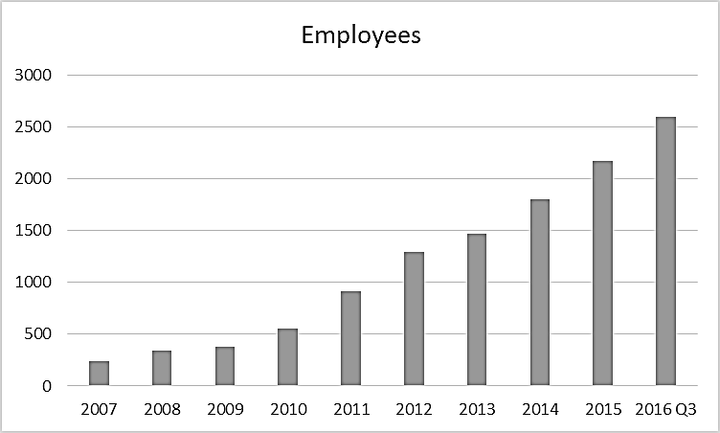

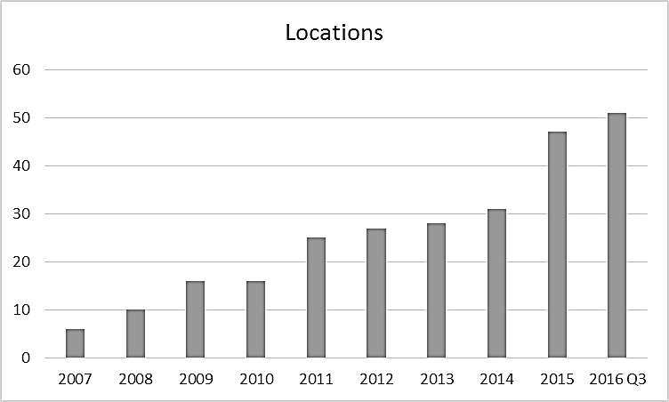

Source: Company files.

**Exhibit 2: correlation between Bonus and performance at agoda**

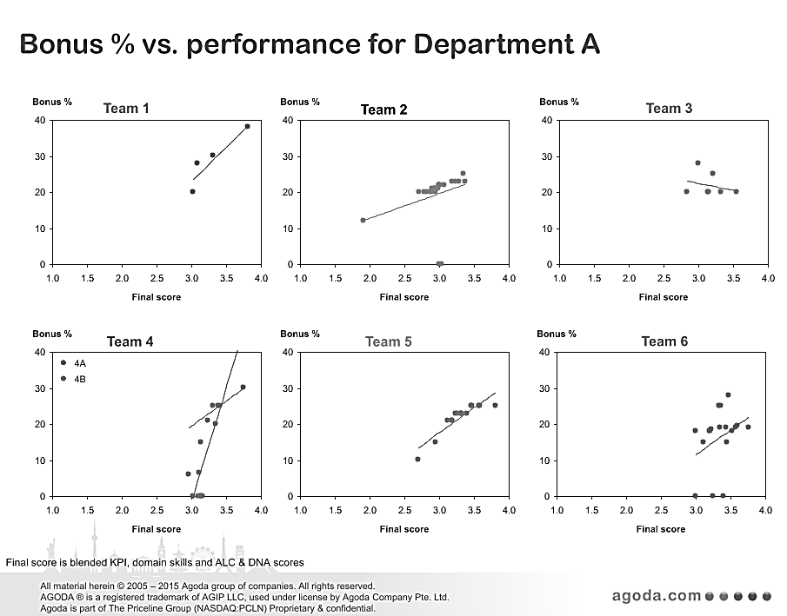

Source: Company files.

**Exhibit 3: Agoda Departmental Evaluation**

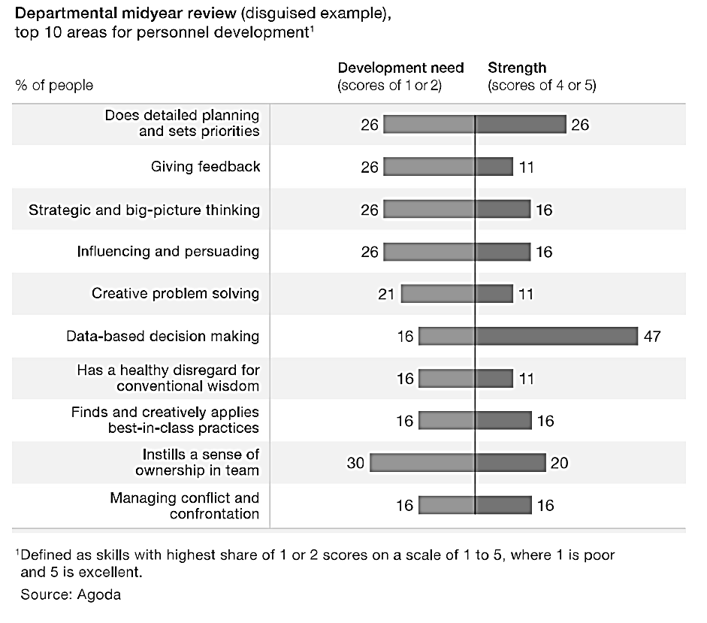

Source: Company files.

**Exhibit 4: Sample report from agoda Employee Engagement Survey 2015**

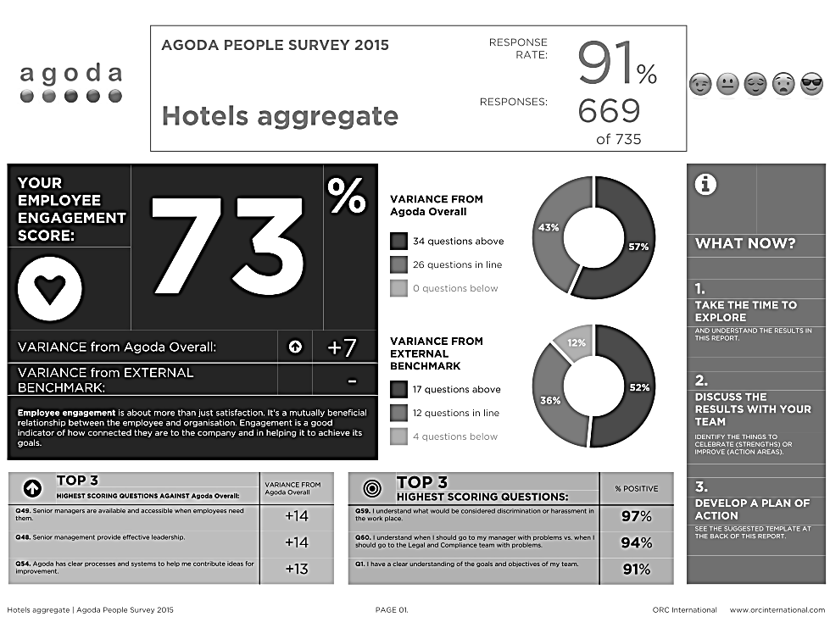

Notes:

**Employee engagement** is about more than just satisfaction. It is a mutually beneficial relationship between the employee and organization. Engagement is a good indicator of how connected employees are to the company and to helping it to achieve its goals.

**Top 3 highest-scoring questions against Agoda overall:**

* Q49. Senior managers are available and accessible when employees need them
* Q48. Senior management provides effective leadership
* Q54. Agoda has clear processes and systems to help me contribute ideas for improvement

**Top 3 highest-scoring questions:**

* Q59. I understand what would be considered discrimination or harassment in the work place
* Q60. I understand when I should go to my manager with problems versus when I should go to the Legal and Compliance team with problems
* Q1. I have a clear understanding of the goals and objectives of my team

Source: Company files.

**Exhibit 5: Agoda People Team Survey (Recruiting)**

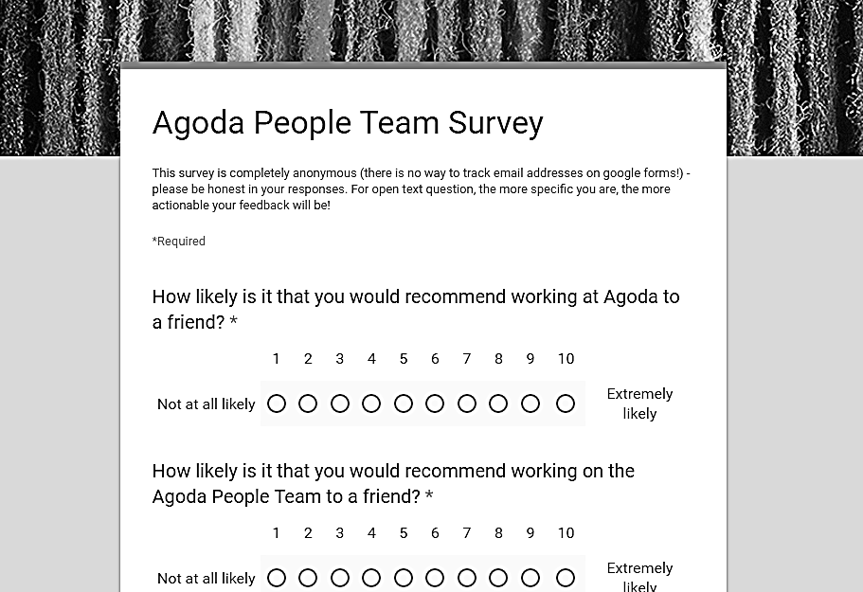

Source: Company files.

**Exhibit 6: Agoda People Technology Infrastructure**

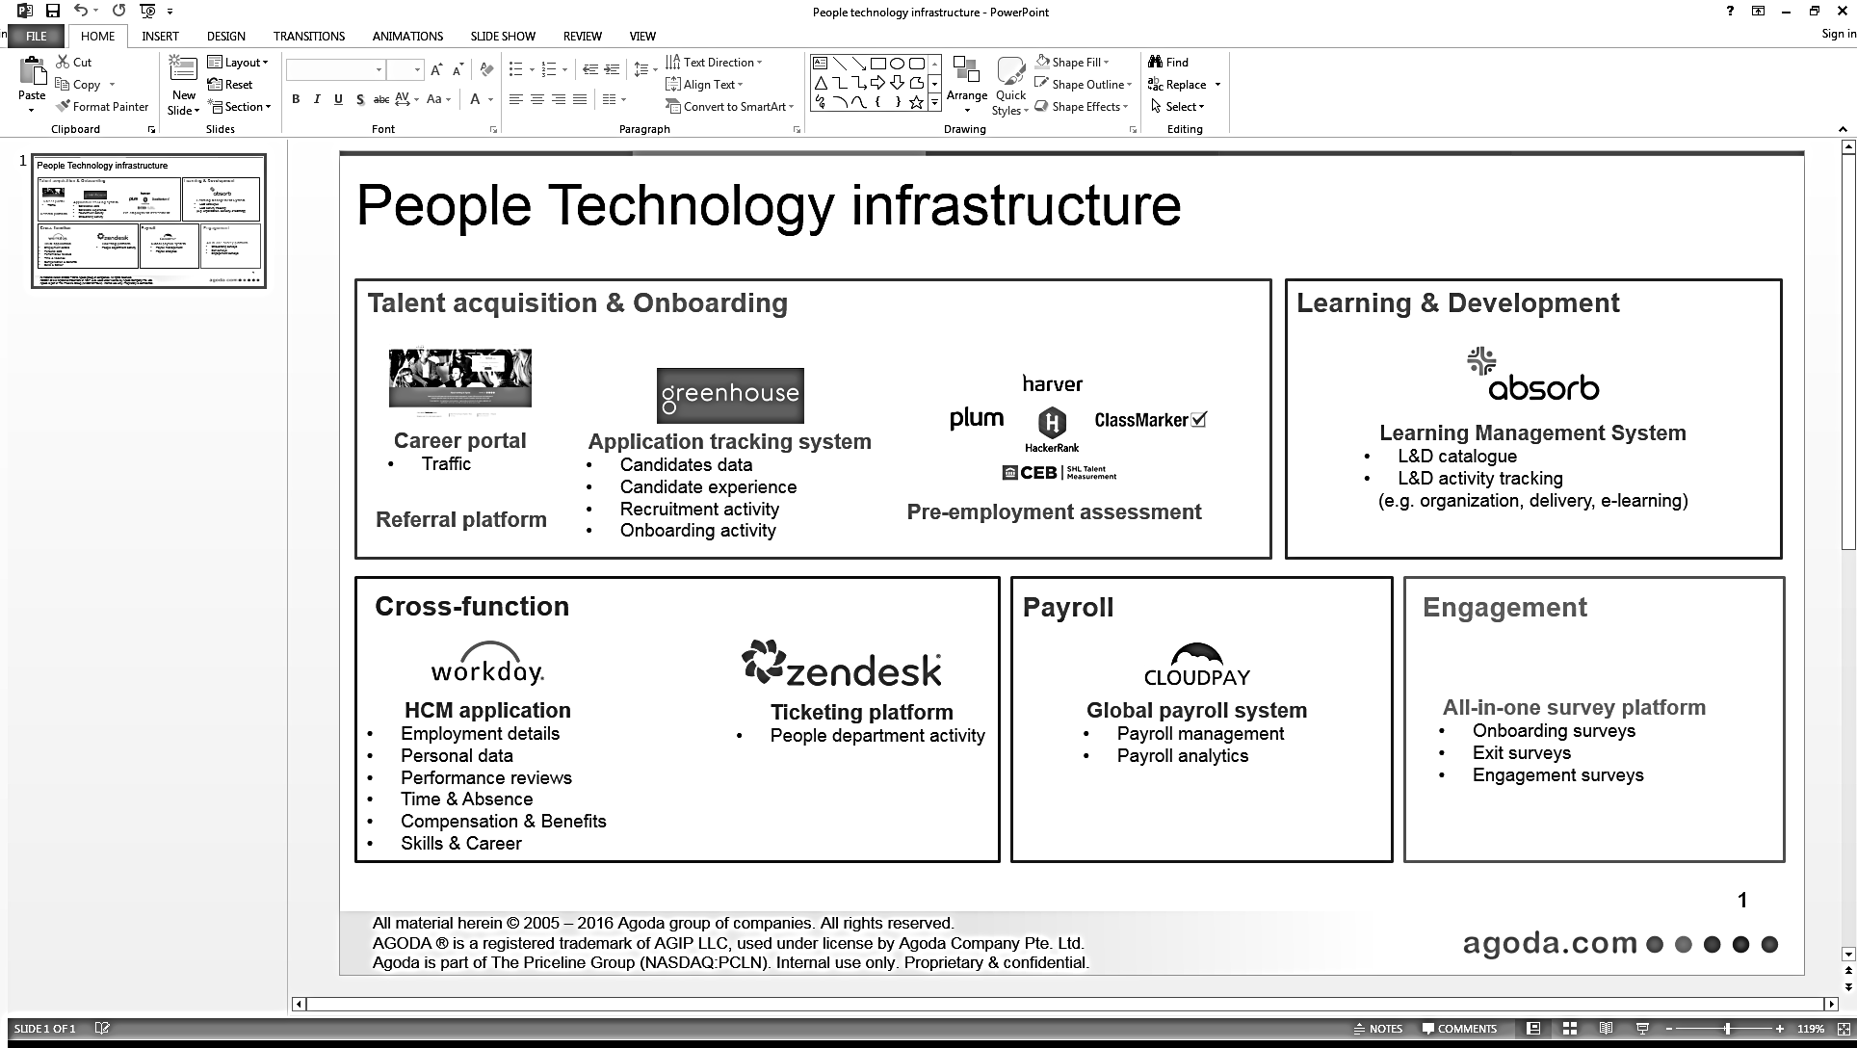

Source: Company files.

1. Dennis Schaal, “Priceline vs Expedia: By the Numbers in First Quarter 2015,” Skift, May 8, 2015, accessed November 1, 2016, https://skift.com/2015/05/08/priceline-vs-expedia-by-the-numbers-in-first-quarter-2015/.
2. All currency amounts are in U.S. dollars unless otherwise specified.
3. EDGAR Online, Inc., Form 10-K (Annual Report), The Priceline Group Inc., 38, accessed November 1, 2016, http://files.shareholder.com/downloads/PCLN/2762914235x0xS1075531-16-84/1075531/filing.pdf; The Priceline Group, accessed November 1, 2016, www.pricelinegroup.com/.
4. Kira M. Newman, “Launch to Acquisition: Interview with CEO of Agoda (Acquired by Priceline),” Tech.Co, February 29, 2012, accessed November 1, 2016, http://tech.co/agoda-2012-02.
5. Peter L. Allen, “Toward a New HR Philosophy,” *McKinsey Quarterly*, April 2015, accessed November 1, 2016, www.mckinsey.com/business-functions/organization/our-insights/toward-a-new-hr-philosophy.
6. Gil Press, “A Very Short History of Big Data,” *Forbes,* May 9, 2013, accessed November 1, 2016, www.forbes.com/sites/gilpress/2013/05/09/a-very-short-history-of-big-data/2/#6dead6a51af0.
7. Barnard Marr, “Big Data Overload: Why Most Companies Can’t Deal with the Data Explosion,” *Forbes*, April 28, 2016, accessed November 23, 2015, www.forbes.com/sites/bernardmarr/2016/04/28/big-data-overload-most-companies-cant-deal-with-the-data-explosion/#383d1b7c3920.