

9B17C025

AGODA: PEOPLE ANALYTICS AND BUSINESS CULTURE (B)

Ken Mark wrote this case under the supervision of Professor Kenneth T. Goh solely to provide material for class discussion. The authors do not intend to illustrate either effective or ineffective handling of a managerial situation. The authors may have disguised certain names and other identifying information to protect confidentiality.

*This publication may not be transmitted, photocopied, digitized, or otherwise reproduced in any form or by any means without the permission of the copyright holder. Reproduction of this material is not covered under authorization by any reproduction rights organization. To order copies or request permission to reproduce materials, contact Ivey Publishing, Ivey Business School, Western University, London, Ontario, Canada, N6G 0N1; (t) 519.661.3208; (e)* [*cases@ivey.ca*](mailto:cases@ivey.ca)*;* [*www.iveycases.com*](http://www.iveycases.com)*.*

Copyright © 2017, Richard Ivey School of Business Foundation Version: 2017-07-19

At the end of 2016, it was still too early to provide definitive answers to the crucial questions about the use of data and analytics in the people department at Agoda Company Pte. Ltd. (Agoda). Yet both data and anecdotes suggested that Agoda was making progress in improving its hiring process through the use of data. As Greenhouse, a new applicant tracking system for recruitment, came into wider use at the company, it became possible to track simple but important behaviours, such as managers’ speed in reviewing resumes. Even the information Greenhouse provided during this process itself (such as giving the number of minutes taken for each review) impressed on managers that efficiency was important and their activities mattered.

Correlating testing and performance was making a difference too. Agoda required most of its applicants to take a variety of tests—such as tests for critical thinking, quantitative skills, and logical thinking—which gave a reasonable indication of overall intelligence and other factors associated with success at Agoda, including a focus on results, people, and quantitative skills. Testing of both candidates and employees showed that employees with greater skills in these areas tended to perform better, even after considering that there were different expectations of employees in different roles (see Exhibit 1). True to its principles, the people team did not make hiring decisions based on these tests. Instead, it shared the results with managers and advised them on what the tests meant. In general, however, the team found that candidates and employees who scored highly in all these areas tended to be more successful at the company; those with lower scores more often did not succeed as well.

Collecting and analyzing recruitment data was beginning to pay off too. For example, it had never been fully clear which channels were the best ones to pursue for hiring. Agencies, job boards, and employee referrals all had their advantages and disadvantages, but without good data, it was not possible to know where the company’s recruitment dollars were best spent. By late 2016, the people team had collected sufficient data so that it was possible to make better decisions. Job boards received thousands of applications, but had the lowest hiring yield at 0.6 per cent. Executive search firms yielded 3.8 per cent, but employee referrals were far and away in the lead, with a 9.1 per cent hire rate (see Exhibit 2). “It was clear from the findings that the company should be investing less in job board advertising. Instead, it should substantially increase its emphasis on referrals,” remarked one manager. This was important news for a company that hired well over 1,000 people each year.

Critical to the success of this approach was a team of people who believed in the principles and had the skills to implement them. Robert Rosenstein (chief executive officer), Peter Allen (vice-president of People and Organization Development), and Jeffrey Lee (director of Operations and Compensation) tested applicants to the people team. The three executives lived by their values, favouring candidates who had both the intellectual and people skills to make the Agoda model work. Harmen Nieuwenhuis, the director of Learning and Leadership Development, was a physicist with a MBA from the University of Oxford and years of consulting experience at McKinsey & Company. José Camacho, the director of Talent Management, was an engineer with a master’s degree in marketing who had run the company’s pay-per-click online advertising division, managing huge amounts of data and many millions of dollars in advertising budgets. Camacho’s status as a certified coach further bolstered his people skills. Other employees had similar skills.

Allen’s belief that he had helped to create a truly differentiated people team was reaffirmed when a manager who left the company to move abroad told him, “You know, it’s quite hard to move from Agoda to another company because most human resource departments aren’t interesting. They don’t really support their company’s business—they just focus on their own goals.” Agoda’s people philosophy helped attract more talented professionals not only to the company as a whole, but to the People team as well.

Gradually, more and more members of senior management were coming around to Rosenstein and Allen’s philosophy. The Information Technology department, which had tended to be independent, was a major proponent of Greenhouse because it wanted the kind of data about manager performance that only Greenhouse seemed to be able to provide. Finance relied heavily on testing in hiring senior people—with an emphasis on prospective employees’ quantitative skills, but also on their ability to consult with other departments. The large Customer Support and Partner Services teams both created and consumed data to help improve—and validate—their hiring, learning and development, and people management.

Rosenstein always noted that the people team was “on a journey”—only at the beginning of meeting its goals. With first-rate people, systems that could collect data and help make it useful, a clear people management philosophy, and a culture on the people team and in the overall company that brought all these factors together, Rosenstein, Allen, and Lee believed that Agoda would continue to innovate and make the same kind of progress on the people front that it was making in technology and many other areas.

Note: Peter Allen and Jeffrey Lee moved to new roles in late 2016. Allen became managing director of Agoda Outside, a new undertaking that worked with external partners to promote travel and tourism. Lee became the head of People Operations & Talent.

**Exhibit 1: Agoda Intelligence quotient and Personality Test Results**

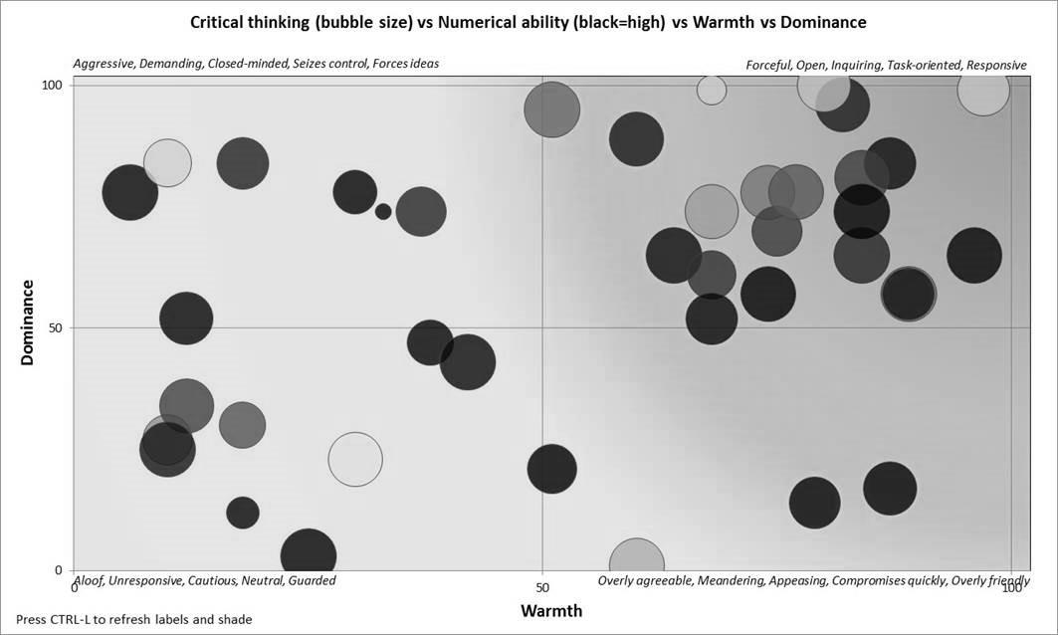

Notes:

* Aggressive, Demanding, Closed-minded, Seizes control, Forces ideas
* Forceful, Open, Inquiring, Task-oriented, Responsive
* Aloof, Unresponsive, Cautious, Neutral, Guarded
* Overly agreeable, Meandering, Appeasing, Compromises quickly, Overly friendly

Source: Company files.

**Exhibit 2: Agoda hiring statistics for 2016**

|  |  |  |  |  |  |
| --- | --- | --- | --- | --- | --- |
| **Channel** | **Apps** | **Offers** | **Hires** | **Offer %** | **Hire %** |
| Referrals | 835 | 96 | 76 | 11.5 | 9.1 |
| Events | 192 | 12 | 9 | 6.3 | 4.7 |
| Executive Search | 1,239 | 67 | 47 | 5.4 | 3.8 |
| Prospecting | 1,813 | 77 | 34 | 4.2 | 1.9 |
| Social Media | 201 | 7 | 2 | 3.5 | 1.0 |
| Company Marketing, including Direct Applications | 7,045 | 58 | 39 | 0.8 | 0.6 |
| Job Boards | 18,589 | 151 | 106 | 0.8 | 0.6 |
| Other | 229 | 18 | 8 | 7.8 | 3.5 |

Source: Company files.