

9B17C028

INGERSOLL RAND: CREATING EFFECTIVE ENGINEERING AND TECHNOLOGY CENTrES (B)

Rahul Sheel and Neharika Vohra wrote this case solely to provide material for class discussion. The authors do not intend to illustrate either effective or ineffective handling of a managerial situation. The authors may have disguised certain names and other identifying information to protect confidentiality.

*This publication may not be transmitted, photocopied, digitized, or otherwise reproduced in any form or by any means without the permission of the copyright holder. Reproduction of this material is not covered under authorization by any reproduction rights organization. To order copies or request permission to reproduce materials, contact Ivey Publishing, Ivey Business School, Western University, London, Ontario, Canada, N6G 0N1; (t) 519.661.3208; (e)* [*cases@ivey.ca*](mailto:cases@ivey.ca)*;* [*www.iveycases.com*](http://www.iveycases.com)*.*

*Copyright © 2017, Richard Ivey School of Business Foundation* *Version: 2017-07-13*

Ravi Madhavan looked back at the initiatives that were taken between 2012 and 2015 to make Ingersoll Rand (IR) India’s engineering and technology centres (ETC) more effective. These initiatives were primarily divided into two categories: initiatives to improve overall processes and initiatives to improve human resource (HR) processes and people practices. There was a sense of relief to find that most of the efforts taken were showing results. However, new challenges emerged. Could the success of ETCs be seen as a threat for the engineering teams of each strategic business unit (SBU)? How would they respond in the future? As small project-based units, the ETCs could not provide employees with continued growth opportunities. The challenge was how to sustain employee motivation without any sign of employee growth in the organization. As he reviewed the results over the previous three years, Madhavan wondered how the success could be sustained.

Changes at Corporate Headquarters

The change initiatives at the ETCs needed to be considered in context of the overall changes at IR over the previous few years. IR companies had been operating as a part of holding company, which meant that each brand had its own infrastructure and data centres. The brands also had their own finance and HR departments. Because almost 60 per cent of IR’s business was established through acquisitions, the result was a conglomerate with non-standard, scattered processes and systems.

Soon after being named chief executive officer in 2010, Michael Lamach aimed for global integration across all IR companies. Lamach introduced an initiative that was later given the title Path to Premier Performance. The initiative comprised three strategic priorities for the entire organization: strategic growth (i.e., growth through innovation, emerging markets, and services); operational excellence; and winning culture (i.e., a progressive, diverse, and inclusive culture). Lamach also introduced five pillars of success,[1] which mainly consisted of behaviours for IR managers across all levels of the organization to uphold. Lamach’s five pillars—model our values, inspire our people, focus on customers, create long-term value, and deliver premier performance—were introduced to 300 of the company’s top executives in February 2012 and then rolled out to employees worldwide.

In 2011–12, IR also launched an enterprise initiative called AGILE to improve the efficiency and effectiveness of support functions (i.e., engineering, finance, HR, information technology, legal, and operations). Functional teams worked with leaders and other stakeholders to make design recommendations in an effort to optimize role clarity and decision-making. As a result, the HR operating model of IR was restructured for better efficiency (see Exhibit 1).

A common process across all business units was assisted by enterprise resource planning architecture, which was implemented in all IR businesses. The new operating model was introduced in India in 2012, and the following three centres of excellence were formed: talent acquisition, talent and organization capability, and compensation and benefits. These changes enabled the HR team to perform more effectively, reduce costs, and provide support as strategic partners in solving previous ETC issues (see Part A of this case).

Initiatives to Improve the ETC Processes

IR Product-Development Process

One reason why the ETCs in India were unable to coordinate effectively with various businesses was the lack of a common product-development process across divisions. This led to confusion when an ETC was developing products for different divisions. However, it would have been futile to change the process in the ETC because the process also needed to change in the other divisions that the ETC served. A common process would facilitate tracking the progress of a project simultaneously by the ETC and the SBU. The introduction of the product-development process was instrumental in solving this issue because it introduced standardization to the product-development life cycle across all business units in India.

The global focus of IR and the respective change in India had a lot of congruence built in to facilitate change. For example, to support innovation across the IR businesses globally, a position of senior vice-president, innovation (also known as chief technology officer) was created in 2011. The responsibilities of this position included accelerating global innovation and technology-led growth strategies and promoting an innovation-centric mindset throughout the organization.A global engineering excellence team was formed in 2011 in the U.S. company that started working closely with the various ETCs and SBUs to improve their processes.

The senior vice-president, innovation visited the India ETCs in early 2012. His visit resulted in a team of cross-functional experts working to initiate a process of aligning product development and people practices. The process was fully developed and implemented in 2012 and 2013.

Introduction of a Program Management Office

A program management office (PMO) was introduced to keep track of all projects. All employees were provided with training on basic project management skills. New employees were required to undergo project management training within their first 90 days. However, it was still difficult for an engineer executing the project to update the progress of the project because of the collaborative nature of the project, which required work to be done at various different locations. Madhavan explained the issue as follows:

If we have 143 project agreements cut across 11 SBUs and their entities, the work involves working with at least four or five different entities for each SBU. Therefore, we may need to manage 11 times (at least) three, which equals 33 locations. Therefore, for many project agreements, it’s hard for an engineer who’s executing (the project) to manage reporting the overall status . . . because many of the deliverables that we’re supposed to do are dependent on multiple functions, which are remotely located—some may be manufacturing or engineering facilities. For example, the vendor, who is probably based somewhere in China, a test-lab, which is somewhere in Malaysia—so these things are all over the place.

As a result, the organization introduced the concept of project agreements, with specific and clear deliverables that the SBU and the ETC were required to agree on before the project was executed. This solved issues arising out of vague project agreements or verbal agreements. After this change, every project required a written contract to start implementation of the project. A phase-gate model helped to refine the expected deliverables. The introduction of the PMO also helped managers assess the load factor for an employee (i.e., the amount of work the employee was currently working on), because each project would be broken down to a micro-schedule. A manager explained the benefits of the program office as follows:

Earlier we had a list of projects, each leader used to communicate to all the counterparts in a separate meeting, and I had to get into multiple things or I had to talk to many individuals to get the status . . . that is a very clear problem that has been fixed with the PMO, so I talk only with PMO person. She, in turn, talks to all the leads and then we sit and have one single presentation that goes out as a weekly summary of all the projects; it also contains Red, Yellow, and Green status of every project in one single dashboard on quality, delivery, and cost. . . . We are getting the tracking of particular milestones, and in case we miss any, we’re tracking multiple reasons why a particular delivery is missed, what is the percentage of deliveries planned versus met, [and] how many unplanned deliveries we’ve met. We’re now being able to see in terms of data. Earlier it was all in people’s heads, never in data form, now I have data to prove. So if my SBU counterpart says you’ve not delivered, I’ll ask where is the data for that? I have data for the last nine months, for example, and I’m tracking this project every week—tell me where did I miss? So it has fixed these communication gaps issues. As the single point of contact, [the] PMO drives the same team with weekly calls. She tracks people located in teams across geographies weekly, and it has eased operations.

The PMO team started conducting monthly meetings with the SBU teams to provide status updates on all projects and to calibrate expectations for the coming month. This ensured open and transparent communication.

Training and Development

The strategic focus on better project management and innovation could not have been achieved without support from all fronts. To facilitate work, many initiatives were taken in the area of people practices. One of the important HR issues in the ETC was the low employee scores on the pulse survey in response to the statement “I received the right kind of training.” After further probing, the HR team realized that employees were concerned about technical training, which was not adequate. The HR team had the option of hiring someone who would report to the head of HR and be responsible for the technical aspects of training. However, the HR team decided instead to form a technical training council with representatives from various ETC teams who were known in the company to be more technically proficient than others. The council would identify needs and identify trainers (both internal and external) to support technical training.

A technical competency framework was also launched with the objective of identifying a list of technical competencies required for the ETC with annual and three-year long-range plans. The framework helped develop a competency evaluation mechanism and helped assess the level of competencies within the ETC. The result was a database with the competency level of each employee assessed by the employee and the manager. The database was useful in development planning and enabled IR to arrive at specific plans to improve the skills of its engineers. It also helped in resource planning and allocation. For example, if a project required an engineer with a particular competency, the database helped allocate the right talent to the team. When there was a work downturn, people moved from one project to another based on their competencies. It became the best practice for other ETCs to follow. Within first year of implementing this initiative, the survey’s training index, captured by the statement “I received the right kind of training”, improved by 19 percentage points; in the following year, it improved by another 10 per cent.

Talent Management and Succession Planning

One of the issues described in Part A of this case was the lack of a proper system to identify talent. The talent discussions with managers were not given adequate attention; therefore, it became difficult to evaluate the competency and potential of employees. The HR team worked with managers to develop a culture of development planning. HR managers started training managers on development planning meetings and made sure that everyone in the organization truly understood why development planning was very critical to them and how they could benefit from it. Once they began speaking to employees about development planning, the HR team faced a series of questions. An HR team member recalled the situation as follows:

Employees started asking this question: “Why is the organization so interested in my development; how is the organization going to benefit?” . . . We were so happy that people were brave enough to put those questions forward. Until they asked the questions, we did not know the messages we should put forward. We were thinking that we all are aware that development plan is critical, and it is important to them, and they have the right understanding. We started talking about why employees should require a good development plan, and what are the specific aspects to be looked at, and what are the other things we could do to kind of infuse awareness—bring in that seriousness of why it is critical to them.

The HR team organized development planning clinics and HR connect sessions to facilitate this process. The development planning clinics allowed employees to see HR with their development plans and seek coaching and guidance on building a robust development plan. Even if employees did not have a development plan, they could just walk in and have a focused discussion with an HR team member to understand how they could come up with a good development plan. Employees were coached to start thinking about their own growth and development. The coaching focus also differentiated between first-time managers and existing managers to better understand distinct needs. The HR connect session’s specific weekly time slots were announced in advance so that any employee could connect with HR to discuss concerns, queries, and aspirations. HR was committed to keeping this time free from any other meeting. Although employees were welcome to connect at any time, keeping this time aside helped ensure that HR was not tied up in any other meeting, and that time was set aside specifically for employees.

The process also resulted in a better identification of people potential; therefore, HR was better able to identify the successors for each role. The organization deployed a 3 × 3 matrix for identifying leadership potential.[2] As described in Part A of this case, the succession-planning index was poorly populated, particularly at the second senior leadership[3] level. The succession strength for this level increased from 49 per cent in 2012, to 80 per cent in 2013 and to more than 90 per cent in 2014 and 2015. The succession index for the first senior leadership level increased from 80 per cent in 2011 to 92 per cent in 2012 and to 100 per cent in 2013.

The process also resulted in the realization that not everyone who worked in ETC would be a good people manager. Promotions would usually force employees into the role of people manager, but some employees preferred the technical aspect of their jobs. This problem was solved by introducing a technical career ladder—an alternate route for employee growth (i.e., promotion) in technology and domain specialization, targeted towards building a technology talent pipeline. The process resulted in employee retention. Employees were no longer limited in ways to grow, and thus started to find preferred avenues of career growth (see Exhibit 2).

In development sessions, managers beyond a certain grade were asked their preference and they were supported towards that route. If managers chose technical careers, 90–95 per cent of their time was spent in technical areas. However, managers who chose to be promoted as people managers spent about 60–70 per cent of their time in people management roles and the remaining time on technical work. This initiative was also given additional attention from HR team members who coached employees to change their traditional mindset of growth. In some cases, managers openly noted that they did not enjoy the people manager role and switched to the technical career path. The initiative meant that all the managers at that level were retained—a result that had been lacking before the introduction of this initiative.

Other Initiatives to Drive a Culture of Growth and Development

Communication was considered the key driver for desirable employee behaviour and understanding of employee issues. There were several key initiatives that were started towards this goal.

Town Hall Meetings

Although town hall meetings had taken place before, the improved after 2012, as Madhavan explained:

We wanted to improve the basic understanding for the engineers as to how they are contributing to the success of the organization. As you are sitting in a remote area and you are working in a sub system of a product, your visibility is restricted to that product or the person with whom you are talking to. But where is the bigger picture? Why are they making this product? How is that going to affect their bottom line or top line? As a business, how are they going to get affected by this? What happens if this gets delayed by a month or two? What is the loss in revenue? . . . With the town halls attended by the senior leadership team, there was better communication that started happening. . . . We started talking about the finance, financial aspects typically for engineers. We started sharing that if you miss a product delivery deadline, how [has] that affected the top line? What is bottom line? How [would] their contribution help us achieve the bottom line? If your manufacturing plant gets only 80 per cent loaded, what is the impact of it on the overall business performance?

Through these town hall meetings, employees developed a better understanding of how their actions affected business performance. This led to more ownership among the employees. Town hall meetings were used to communicate various initiatives undertaken by the organization, as well as the results of the employee survey and the survey response initiatives. Communication activities were introduced, such as intercultural training for both U.S. and Indian employees who worked together. This was an effort to develop better communication between the SBU and the ETC team.

As part of a progressive, diverse, and inclusive strategy, the concept of appreciating culture was introduced, where employees had the opportunity to learn about the rich cultural diversity in India and to appreciate differences. Senior leaders at all locations, along with people managers and employees, participated in celebrating the theme throughout the day by wearing traditional clothes and costumes that depicted various cultures being celebrated. They participated in events and activities showcasing the rich and vibrant tradition and history of the region, architecture, art festivals, and customs, which included dance, music, and food. Traditional food from the various states being celebrated was served across all sites. This encouraged a sense of belonging and promoted interpersonal relationships at the workplace.

Your Ideas Our Future

Employees were asked to contribute to organizational initiatives through a survey called Your Ideas Our Future, which gathered employee feedback and recommendations that were subsequently acted upon. Ideas suggested in the survey were implemented by the organization in two ways. First, the organization identified the themes emerging from the survey and specific suggestions for improvement. It looked for focus areas from the survey and then identified initiatives to pursue in those areas.

Second, the organization reviewed all concerns voiced through the survey and learned from them. For example, the survey responses suggested that promotions were a concern because employees tended to leave the company if overlooked for a promotion. Employees would wait until the next promotion cycle (which occurred twice per year) and would then leave the company if they were not promoted. This insight implied that growth through promotions was important to employees, and that they saw available opportunities to be limited. The leadership team decided that, to influence a change in the employee mindset, promotions were to be done only if there was a role available. Under this change, when a new role became available, the readiness of employees would be evaluated. This meant that employees needed to focus on development, rather than expecting promotions based only on the length of their tenure at the company.

With the new promotion process, the manager proposing a promotion needed to justify the role change and recommendation. This presentation was made to the promotion panel, where healthy discussions on the concerned employee’s potential, development plans, and future growth took place. Promotions were also open throughout the year, rather than only twice per year, as role changes occurred.

Leadership Conferences

Leadership conferences were organized with the director and next level of managers, where leaders reflected on the previous year and talked about successes and failures. These conferences emerged as great knowledge sharing sessions among the company leaders, where the next level in the hierarchy was made aware of the kind of challenges that the leaders faced. Leaders shared their paths to success with other upcoming leaders to emulate, and this served as a road map for growth and development. The conferences emerged as a motivating force for future managers. Initially, when the conferences started, the leaders spoke about successes; later, it was decided that it would be more interesting to hear about failures, struggles, and the learning derived from experience. This change in the conference approach generated great interest throughout the leadership pipeline, as reflected in increased participation, post-event feedback, and engagement during the conferences.

Innovation Reward System

A reward system was introduced to commend employees on their innovation and disclosures achieved every year. To review the intricate process of innovation, an innovation review team was established. It was possible for employees to seek funding for their ideas, which had needed support from the SBU in the past. This practice increased the visibility of the ETC within the SBU engineering community.

Success indicators

IR’s ETC performance showed improvement after the interventions. Over the previous five years, the number of disclosures had increased from 38 in 2011 to 267 in 2015. The employee engagement score had increased from 67 per cent in 2012 to 85 per cent in 2015. Quality, delivery, and cost had increased from 20 per cent in January 2013, when it was first deployed, to almost 100 per cent (see Exhibits 3 and 4). A manager commented on these initiatives as follows:

If the initiatives we took were not taken during that time, we would be in a different state. With the kind of work we were doing, the productivity was good. Because we were doing the lower value chain of work (i.e. [computer aided design] support), if the long-term perspective would not have been taken at that time, we wouldn’t have gone up the value chain, or we wouldn’t have got the credentials and credibility from the external world—the rewards and recognition we got. Neither would we have been a technology centre of choice for our SBU partners.

CHALLENGES

Not all SBUs had adopted IR’s product-development process. Therefore, conflicts still persisted with the SBUs whenever ETCs wanted to work with them for product development. Another challenge was to keep employees motivated for the future of the organization, as Madhavan observed:

Beyond a certain point, you want to keep your employees motivated and engaged. They need to see their future in the organization. They need to see a roadmap of their future, and that’s not something ETCs can do in isolation (without the help of SBUs). Different SBUs have their own roadmaps for the employees of their own engineering organizations. Beyond a point, they may not want to use us.

Employees looking for vertical growth could only be supported if the SBUs provided them with the opportunity. As employees gained experience, providing them with opportunities for growth was a challenge. As ETCs continued to be successful, the in-house engineering units of the respective SBUs could perceive them as a threat. Also, because ETCs had a contractual arrangement with SBUs, the SBUs were free to partner with any other unit to get the job done. Ravi wondered how he could sustain the growth of the ETCs.

Exhibit 1: Human Resources (HR) Operating Model

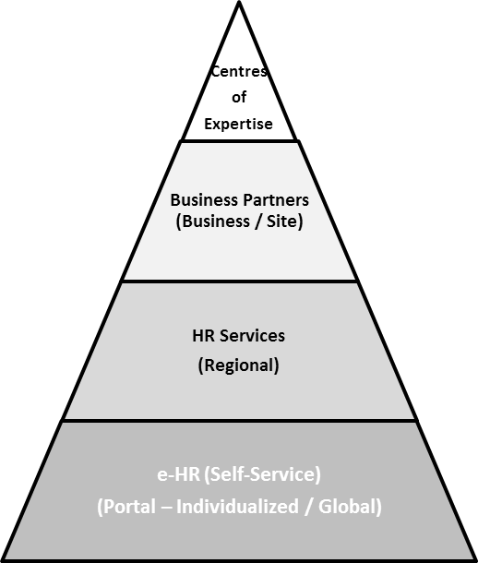

**Cost to serve**

**Higher**

**Lower**

* **Centres of Expertise:** Define and design strategies, policies, processes, & standards.
* **Business Partners:** Business-facing HR organization enable strategic execution by line & functional managers move from transactional & task oriented to strategic value-added capabilities.
* **HR Services:**

**Transactional:** Routine, repeatable, tactical administrative

**Interactional:** Support, guidance, employee questions/issue resolution

* **Self-service:** Fundamental HR/C activities, transactions, and information requests executed via personalized technology

**Greater strategic work**

**Greater operational work**

Notes: HR/C = HR Communication; e-HR = Electronic HR

Source: Company documents.

Exhibit 2: Employee numbers growth

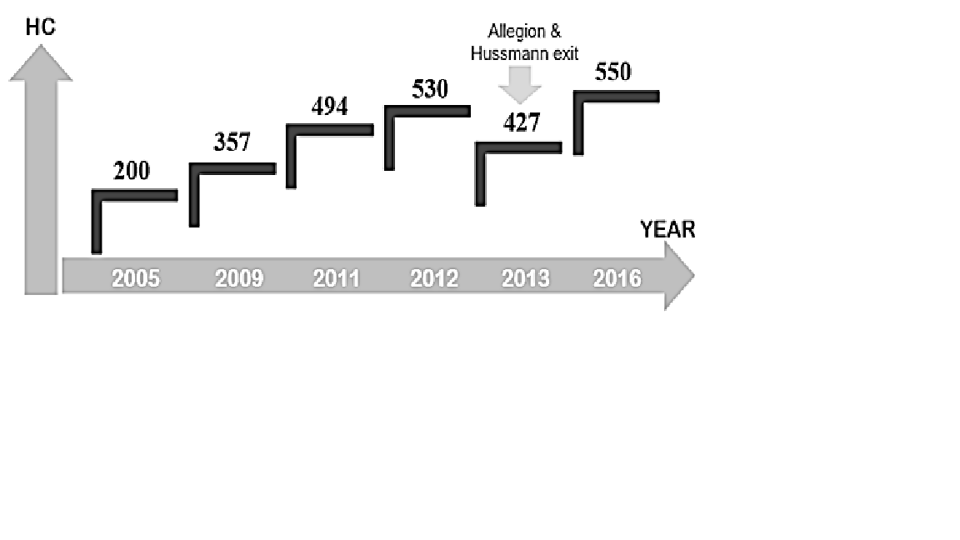

Notes: HC = head count (employee numbers); IR’s commercial and residential security business named Allegion was spun off, and a majority share of the refrigerated display case business named Hussman was sold, leading to a loss in headcount.

Source: Company documents.

Exhibit 3: Quality Delivery and Cost (QDC) for Strategic Projects

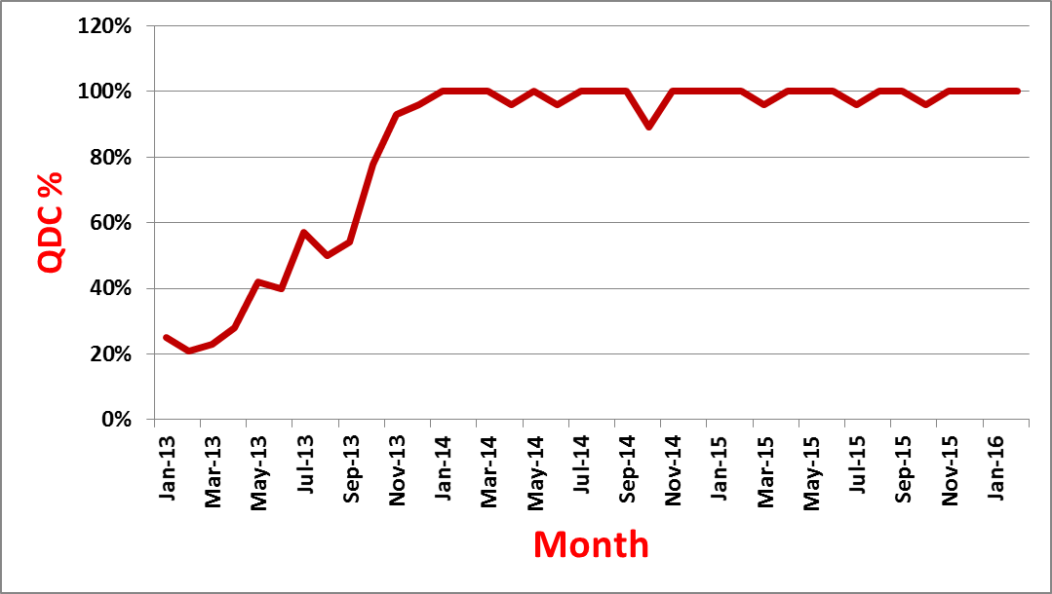

Source: Company documents.

Exhibit 4: Indicators for Engineering and Technology Centres success

|  |  |  |  |  |  |
| --- | --- | --- | --- | --- | --- |
|  | **2011** | **2012** | **2013** | **2014** | **2015** |
| EE Scores | — | 67% | 70% | 78% | 85% |
| Disclosures (Patents) | 38 | 95 | 187 (24) | 130 (8) | 267 (25) |
| Succession/Bench Strength — SLT Ready Now | — | 0% | 100% | 100% | 100% |
| Succession/Bench Strength — SLT-1 Ready Now | — | 80% | 92% | >90% | >90% |
| Succession/Bench Strength — SLT-2 Ready Now | — | 49% | 80% | >90% | >90% |
| Project Agreements | — | — | 120 | 129 | 147 |

Notes: EE = employee engagement; SLT = senior leadership team.

Source: Company documents.

1. Louis Carter, “A Leadership Makeover at Ingersoll Rand,” Chief Learning Officer, November 1, 2013, accessed April 5, 2017, www.clomedia.com/2013/11/01/a-leadership-makeover-at-ingersoll-rand.
2. “Enduring Ideas: The GE-McKinsey Nine-Box Matrix,” *McKinsey Quarterly*, September 2008, accessed June 6, 2017, www.mckinsey.com/business-functions/strategy-and-corporate-finance/our-insights/enduring-ideas-the-ge-and-mckinsey-nine-box-matrix.
3. Senior leadership team level 2 was the second level in hierarchy after the ETC head.