

**9B17C030**

**OLYMPIC SELECTION: CHARACTER, COMPETENCE, AND COMMITMENT**

*Ciaran McGovern wrote this case under the supervision of Professor* *Mary Crossan solely to provide material for class discussion. The authors do not intend to illustrate either effective or ineffective handling of a managerial situation. The authors may have disguised certain names and other identifying information to protect confidentiality.*

*This publication may not be transmitted, photocopied, digitized or otherwise reproduced in any form or by any means without the permission of the copyright holder. Reproduction of this material is not covered under authorization by any reproduction rights organization. To order copies or request permission to reproduce materials, contact Ivey Publishing, Ivey Business School, Western University, London, Ontario, Canada, N6G 0N1; (t) 519.661.3208; (e)* [*cases@ivey.ca*](mailto:cases@ivey.ca)*;* [*www.iveycases.com*](http://www.iveycases.com)*.*

*Copyright ©* *2018, Ivey Business School Foundation* *Version:* *2018-02-22*

Coach Glenn Hoag sat with a scotch, reflecting on both his past 10 years with the Canada’s men’s national volleyball team and his decision on which players to select for Canada’s team entry in the 2016 Summer Olympic Games in Rio de Janeiro, Brazil. After years of Canada’s men’s volleyball team not seeing results on the international stage, Hoag had taken over as head coach in 2006. Much work had been needed to take the team to the Olympics—a feat that had not been accomplished since the 1992 Summer Olympics in Barcelona.

Coach Hoag

Hoag had played on the Canadian men’s national volleyball team from 1981 to 1986. During his tenure, the men’s volleyball team had been the most successful in Canadian history, placing fourth in the 1984 Olympics. Hoag also helped Canada to a gold medal at the 1984 Commonwealth Games. In addition, Hoag played professionally in Europe for nine years (1984–1993), highlighted by three top division titles in France and two Coupe de France crowns.

As a coach, Hoag started his professional career with Paris Volley. In 2001, he coached Paris Volley to a triple crown victory, winning the French Cup, the French Championship, and the European Champions League. Later, he took the Slovenian ACH Ljubljana to the final four tournament of the Champions League (the top four teams in Europe compete for the title), before moving to his most recent club, Arkas Spor Izmir, in Turkey.

Prior to deciding to coach Team Canada, Hoag had been an assistant coach for the French national team. In 2005, France had played Canada twice. Both times, Hoag had been responsible for scouting the opposing Canadian team. From the sidelines, he saw deficiencies in Canada’s style of play and thought about the work that would be needed to get Team Canada competing at the highest level. The next year, the head coach job for Team Canada became available, and Hoag put his name forward.

the Transformation

In Canada, volleyball was not a traditional sport, as hockey was. People were not exposed to the game and did not understand it, often until high school, in contrast to other parts of the world where volleyball received the kind of exposure that hockey received in Canada. Hoag faced many questions: How could volleyball’s public image be changed? Did it need to be changed? Or did Canada need to develop a unique position in the world—perhaps a new style of play that complemented Canadian athletes? Hoag’s task was not simply to work with the current team available in Canada but rather to build volleyball across the country and to develop the sport as a whole. This task involved work both at the grassroots programs all the way up to the national team. His primary focus still needed to be developing players in their early professional career and teaching his new system to the Canadian team (see Exhibit 1).

From day one, Hoag went back to basics with a group of professional athletes. To drive change in the gym, the emphasis was no longer on being better than each other, but rather to compare all team members against the best players in the world and to focus on training to exceed the performance of their international competitors. When Hoag took over the team, the team members had a fundamental lack of belief that their team would be able to accomplish anything in the sport, let alone compete in the Olympics.

Once the Olympic cycle was over in 2008, many athletes left the team. Their exodus created an opportunity to start fresh with a group of younger athletes. Turning the training program around and returning to the pinnacle tournament for the sport required commitment, passion, and buy-in from every athlete. To get the buy-in from athletes, Hoag taught players the philosophy of how and why each action contributed to the overall plan. Hoag knew the transformation would take time, commitment, and ambition from everyone involved.

One of the initial necessities was to grow Canada’s talent pool by getting more athletes training in the gym. In 2006, only 18 volleyball player on the senior roster were competing for Canada. Other countries had numbers closer to 40, with consistent training from youth to senior levels. Having more players with a chance to play tended to breed strong competition in the gym every day. For Hoag, that internal competitiveness was an essential aspect to the external competitiveness he sought, propelling the team forward. In addition, Hoag faced difficult decisions regarding who were the best athletes to train and how each athlete fit within the system that Hoag wanted to create for the team. How did the team stack up against other nations in physical attributes, skill, and volleyball intelligence quotient (IQ)? Hoag knew it would be a long road with plenty of learning, both for himself and for each athlete that walked into the gym.

From day one, the players showed a commitment to relearning the basic skills. By taking a younger core of the team, and older players willing to learn, Hoag found a foundation on which the team could build.

Competence, Character, and Commitment

As a sport, volleyball required a diverse skill set and a high degree of athleticism. Of the six players on the court for indoor volleyball, each player had a specific role. With three players in the front row and three in the back, the players rotated in a clockwise fashion after each rally, thus making any role specialization especially challenging.

The rally started with a serve, and the team’s first contact was typically a pass to the setter who then positioned the ball for an attack. A rally consisted of the ball moving back and forth over the net with a maximum of three touches by a team when the ball was on their side—no player could have two touches in a row. A point was scored at the end of a rally (when the ball touched the ground or when one team committed an error).

While volleyball included many types of systems, most teams operated with one setter whose primary role was to set up the attack. Players specialized in the front row as a receiver/attacker, middle blocker, or opposite. The game had strict substitution rules[1] in terms of the number of substitutions and players, so choosing the right starting line-up was essential. The basic competencies in volleyball included blocking the opposing attack, attacking (sometimes called a spike or hit), defence (defending the opposing attack around the block), ball control (the player’s general control with the ball), setting (setting up the attack with precision, which often required certain specific and rehearsed plays around the height, location, and quickness of the set), passing (the first touch on the ball after the serve was hit), and finally, serving.

Beyond the specific volleyball competencies, volleyball IQ was necessary to be able to read plays and to be in right position, given the speed of the game. Team competencies were essential since the six players needed to shift and move as a unit to provide the coverage needed. While court coverage could be provided in specific ways, depending on the system being used, executing the optimal positions required significant judgment in the midst of the play and substantial communication among team members.

As with other sports, character and commitment were also critical. In part, the development of competency was, to a certain degree, based on character and commitment. Courage, drive, and accountability were perhaps more obvious aspects of character, but humility played a big role, particularly relative to the capacity to learn and develop. Handling stressful situations on and off the court often took temperance (patience and calm), while transcendence (a sense of optimism and future orientation) was critical to help players imagine what was possible. Given the importance of teamwork, looking out for each other on and off the court was fuelled by the character dimensions of humanity and collaboration. Justice and integrity, when highly developed, helped players see beyond their own self-interest to develop a set of principles that served a cause bigger than themselves.

Hoag realized that statistics that were given to teams and players in competitive volleyball were incomplete and failed to represent the importance of skills that led to exceptional performance. Skills needed to be adopted from the top down, and players needed to embrace a sense of urgency with how they trained and competed. Typically, the statistics focused on noting the errors and successes of serves, service receptions, and attacks (see Exhibit 2). Currently, most players looked only at the kills and total points columns, but the raw statistics could be misleading, giving players a false sense of their efficacy on the court. Hoag took a different approach to the quantitative data, by evaluating players in a more holistic way. The new style of evaluation quantified a player’s actions to properly justify a player’s performance, correctly identify weaknesses, and hold players accountable to each other and their actions (see Exhibit 3). When the system was first implemented, players needed to compile the statistics themselves so that they understood how they were evaluated, both as individuals and as a team. This evaluation allowed for open communication of what the team members expected from each other, unified the team goals, and held players accountable.

As more players funnelled into the program, the standards for selection increased. Athletes needed to exhibit not only competence and commitment but also character and sound judgment. One of the biggest drivers when selecting future players was a passion and a love of the game. Canadian players needed to be sent overseas for a large part of the year to earn a living when the national team was not training together. Being away from family and friends for almost the whole year was a large sacrifice so the players’ commitment needed to be rooted in their passion. As more athletes walked into the gym every year, the team culture started forming.

In the beginning, when athletes were first learning from Hoag, he knew he could not allow any complacency or laziness. An example of Hoag’s everyday actions was his handling of a middle blocker who did not get off the net fast enough to transition from his block to be in position to hit the ball. Hoag stopped the practice:

Do you know what your actions just did for this team? Because you did not work hard enough to get off the net and approach to spike the ball, the other team did not need to think about blocking you. You left your teammate vulnerable, and we do not do that in this gym.

Hoag then proceeded to have the player execute getting off the net and hitting five strong balls off his toss to help engrain the action. No player was allowed to take a day off. To get to the highest level, the team needed to be accountable to one another, and Hoag needed to provide the base for how the team would compete on the world stage.

THE 2016 Summer Olympics

Leading up to the 2016 Summer Olympics, some of the players had been with Hoag for the entire 10-year transformation. Others were up-and-coming players who had received great experience in key tournaments with the team. Both the qualification process and the Olympics presented some difficult decisions regarding player selection.

After a steady increase in performance through many tournaments, at the beginning of June 2016 in Japan, the team qualified for the Olympics. A few key members from the team in the past few years had been left off the roster for various reasons, from injury to performance issues. For the Olympic roster, only 12 would be able to compete, although at least 18 capable athletes could be sent. Hoag had coached some of the players for the full 10 years of his tenure. The team members were dedicated and committed to the team—and to volleyball in Canada.

Two positions in particular faced difficult decisions. While the core eight players had already been selected and would play most of the big games, the difficult decisions involved the supporting cast of players. Both the receiver/attacker and middle blocker positions had a wealth of talent. Some players were veterans and had been with Hoag for his entire tenure. Although they may have had diminished athleticism due to age, they compensated for their age through their sharpened volleyball IQ and tremendous experience playing internationally. Others were promising athletes who had proved themselves in important games over the past few seasons. Hoag had a large enough sample size of each athlete’s performance to know what kind of play he could expect.

From a decision point of view, the players that would be selected could serve several roles. Hoag needed to decide how to use his current starting lineup and how each player could fit within a supporting role. International volleyball was a game of inches. In a given set, many games surpassed 25 points and could be decided by a few as two points (see Exhibit 2). It was imperative to have the utmost focus and attention on the task at hand both as a team, and as an individual.

Receivers/Attackers

Of the following four players, two would be selected for the Olympic team.

Craig Oban: 34 Years Old

Oban had been the captain of the team for the past six years and had a quiet leadership style. As he aged, he had played less of a starting role with the team. In his professional career, he was placed in a role where he was the first receiver/attacker off the bench. Hoag described Oban as, “The guy that should have been.” Although Oban was a talented player, he could have been one of the most talented players in the world. Leading up to the Olympic qualifier, Oban was not at the top of his game, weighed in at 20 pounds (9 kilograms) overweight, and did not travel with the team. Hoag felt that Oban did not believe that the team would qualify in Japan. After they did qualify, Oban worked on his fitness and skills to show he could be a valuable asset coming off the bench.

As a younger player, he had been a primary attacker for Canada. As he aged, he became a specialist at passing and ball control with a stable overall skill set. His athleticism had decreased over time, but he was able to execute the basics well. During the game, he was not vocal, but he handled game adjustments well. From his many years of experience to draw on, he had a great sense for the game. Oban had been a part of the team all the way through Hoag’s tenure and had accepted new roles as the team evolved.

Dan Macallan: 41 Years Old

Macallan was one of the key leaders on the team. He had been accountable, hard-working, and one of the most competitive and focused players on the floor. Macallan was older, and for the last six years had played libero (i.e., a defensive specialist) with the team. However, another player had secured that position, although Macallan also had experience as a receiver/attacker. Hoag could use him as a back row specialist to boost the teams passing and give some players a rest. Macallan was always a leader on the road and made sure all the players were focused on the task at hand. He also supported Hoag with some of the coaching decisions and was always dedicated to the task at hand when the team was on the road. His role on the floor was limited; however, Hoag thought Macallan could bring some support to the younger players going to the games.

Marc Morangie: 31 Years Old

Much like Oban, Morangie had been on the team throughout all of Hoag’s tenure. He had been one of the most dedicated and passionate players, but similar to Oban, he had accepted different roles as new players came into the program. His continuous hard work and strong camaraderie with the team had shaped the culture of the team. Morangie could be counted on for a specialized role in blocking, but was not a good option for serving or passing. Generally, Hoag saw Morangie as a front row player, as he was limited in aspects of serving and defending, and Hoag would use him off the bench only in certain situations. If Hoag were to put him in a game, it would be to replace a player for the balance of the match. He was in great physical shape, and brought a lot of energy to the court. He had an admirable ability to grind out and push through tough situations.

Glen Fiddich: 27 Years Old

Fiddich was a newer addition to the team. In 2014, he started travelling consistently with the team and instantly made an impact. He was one of the most versatile players on the roster. On many occasions, he played both opposite and receiver/attacker, and, to qualify for the Olympics, was on the court for some monumental team wins against the United States and China. Although he was a quieter player, he made big plays that could push the team and keep the others focused. His ball control, defence, and athleticism made him useful to the team in many different scenarios. In addition, Fiddich had a great ability to read the game and adapt. Often he would adjust to the game plan to make plays to be in the right position based on a read from the other team.

Middle Blockers

Of the following three players, two would be selected for the Olympic team.

Phil Lagavulin: 32 Years Old

Arguably, Lagavulin had undergone the most radical transformations in skill since joining the team in 2008. He transformed into one of the top blockers in the program; however, a shoulder surgery sidelined him for the 2015 professional season. Reaching the end of his career, Lagavulin dedicated himself to his recovery to be ready for his last push at the Olympics. He was consistently able to adjust in games and was the team’s best read blocker.[2] Although Lagavulin was not the most athletic guy at the position, he was able to command a presence with his intelligence and consistency. Showing the utmost *coachability* and hard work, he had learned well from Hoag so that in 2013 he was the top middle blocker on the team.

John Aberlour: 28 Years Old

When Aberlour was focused and prepared, he was one of the top performers on the team as a middle blocker. Aberlour brought physicality, offence, and athleticism to the floor. He had played consistently with the team for the past six years and had been coached by Hoag in his early professional career in Turkey. During the summer leading up to the Olympics, Aberlour was performing at a high level. Off the court, Aberlour had his struggles. Hoag, through past experiences, had seen an egotistical side of Aberlour over the six years of coaching him. Aberlour had a tendency to shut down mentally when he was not playing. For example, after not being selected to dress for a game, he could be found in his tracksuit, reading a book in the stands, or wandering around the venue.

Terry Laphroaig: 26 Years Old

One of the most promising up-and-coming middle blockers in the past couple of years, Laphroaig had consistently made an impact in big games with his attacking and blocking. When he was at his best, his athleticism and aggression on the court could turn games around. However, he had not progressed through the traditional avenues (see Exhibit 1) with Team Canada and the universal, systematic style that the team had implemented. He was still developing some of the fine nuances and situational plays that would come with experience, but he was a strong presence in the position. He had learned quickly over the past few summers from his teammates and had played a big role in some of the team’s recent successes to qualify for the Olympics.

Hoag’s Decision

Hoag had plenty of competent athletes from which to choose. These two decisions—for two receivers/attackers and two middle blockers—were particularly difficult and needed clarity and sound judgment. It had been a long road to get to this point and had required many course corrections. Now it was time to make a very difficult decision. Each player could execute the role that he needed to at any given time; however, the role of the supporting cast needed to be played to perfection. Doing so required a unique focus that would help the team greatly. The selections needed to provide the right dynamic for the team to be successful.

In making his decision, Hoag needed to remember that the Olympics was a different kind of tournament. Amid plenty of distractions, the players needed to be ultra-focused to be able to perform at their top level. There was no room for any athlete to be self-centred; instead, all players needed to be there for the team and to be accountable for their actions. The funding to support a national team and to attend the Olympics was hard-earned taxpayers’ money, which Hoag had preached and instilled in the players from day one. Hoag now faced a decision that encompassed many complex factors. His decision would directly impact the team’s performance at the Olympics and would also leave an imprint on the organization and what the team represented—in addition to changing the lives of the athletes forever.

The Ivey Business School and the Ian O. Ihnatowycz Institute for Leadership gratefully acknowledge the generous support of Bill and Kathleen Troost in the development of this case.

Exhibit 1: Development Plan for Team canada’s men’s volleyball



Note: TCMV = Team Canada Men’s Volleyball; HP = High Performance; B/FISU = 2nd team/Fédération Internationale du Sport Universitaire (in English, International University Sports Federation); IST Coaching staff; CIS = Canadian Interuniversity Sport

Source: Glenn Hoag

Exhibit 2: Typical competitive volleyball Performance Statistics

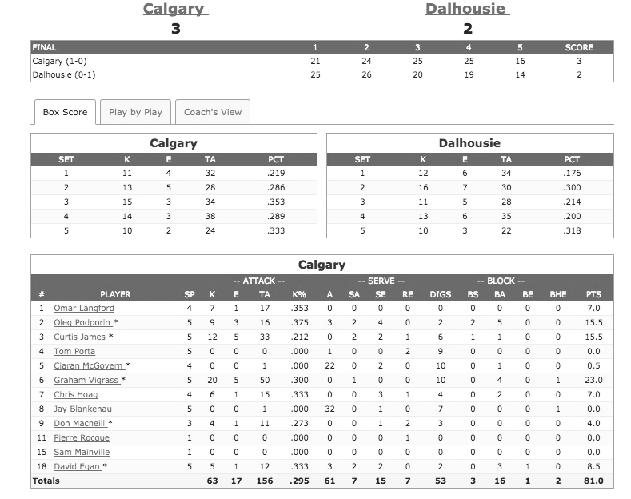

Note: K = kills; E = errors; TA = total attacks; PCT = percentage; SP = Sets played; A = assist; SA = service aces; SE = service errors; RE = reception error; DIGS = digs (successfully defended attacks); BS = block solo; BA = block assists; BE = block errors; BHE = ball handling errors; PTS = points; The starred items are from the Canadian interuniversity Sport Archive.

Source: Glenn Hoag

Exhibit 3: Team Canada’s Performance Statistics for men’s volleyball

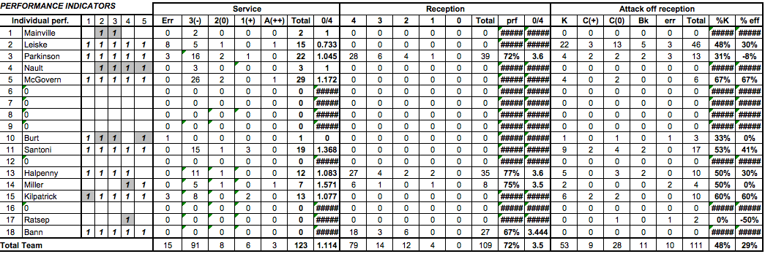

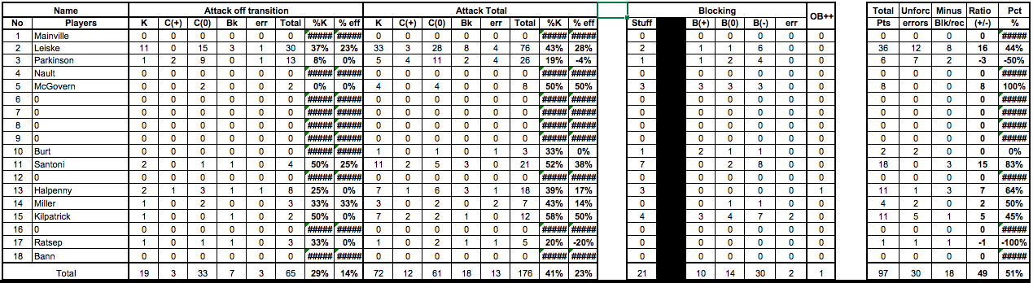

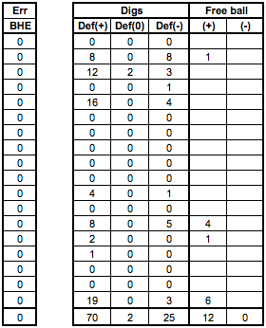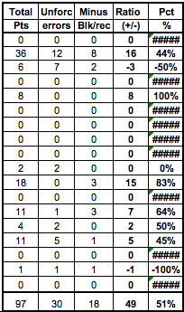

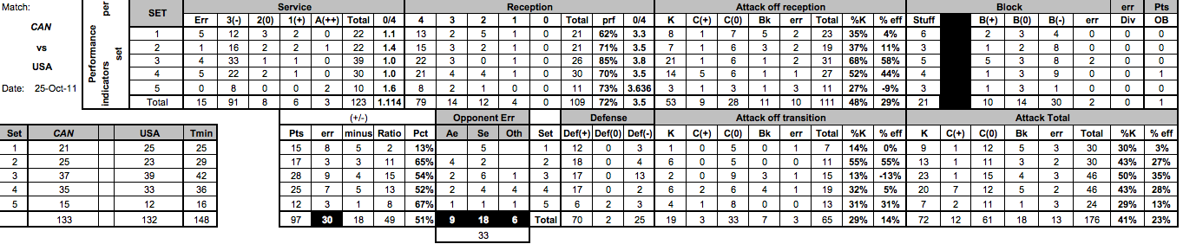

Note: Games are best of five sets; perf. = performance; Err = errors; A = ace; prf = perfect %; K = kills; C = continues; bk = blocks; eff = efficiency; Stuff = blocks for points; B = Blocks; OB = overbumps; Pts = points; Unforc = unforced errors; Blk/rec = block/reception; Pct = percentage; BHE = ball handling errors; Def = defence; Ae = Attack error; Se = service errors; Oth = Others

Source: Glen Hoag

1. A player on the bench could be substituted (subbed) in for one player on the floor only once, and be subbed back out only once.
2. Read blocking was a skill whereby the middle blocker could process information from the opposing team and, instead of guessing, could react to the situation as it happened.