

**9B17C031**

**TTWM ENGINEERING INCORPORATED: RETHINKING A HIRING CHOICE**

*Tessa Weidner wrote this case under the supervision of* *Elizabeth M. A. Grasby solely to provide material for class discussion. The authors do not intend to illustrate either effective or ineffective handling of a managerial situation. The authors may have disguised certain names and other identifying information to protect confidentiality.*

*This publication may not be transmitted, photocopied, digitized, or otherwise reproduced in any form or by any means without the permission of the copyright holder. Reproduction of this material is not covered under authorization by any reproduction rights organization. To order copies or request permission to reproduce materials, contact Ivey Publishing, Ivey Business School, Western University, London, Ontario, Canada, N6G 0N1; (t) 519.661.3208; (e)* [*cases@ivey.ca*](mailto:cases@ivey.ca)*;* [*www.iveycases.com*](http://www.iveycases.com)*.*

*Copyright© 2017, Richard Ivey School of Business Foundation* *Version: 2020-02-12*

Curtis Bruce, a senior engineer at TTWM Engineering Incorporated (TTWM) had left an angry voice mail for TTWM Vice-President Tucker Merlin on his office phone. Bruce, who was clearly upset with Merlin, said, “I was supposed to change TTWM. I was hired to change TTWM!” Merlin, wishing he knew what to say to Bruce in response, quietly hung up the phone and then sat in his chair wondering when it had all gone wrong. How could he have missed the warning signs? A year ago, he had been thrilled to recruit Bruce, a technically strong senior engineer, and now he regretted having hired him. Merlin had to address Bruce’s outburst quickly before it affected the rest of the office staff.

TTWM Engineering Incorporated

Background

TTWM had been established three years earlier. The multidisciplinary engineering firm, which focused on structural engineering, was based in Cambridge, Ontario. TTWM worked mainly on smaller structural, civil, and environmental projects for local clients, and its goal was to be a successful competitor among other small engineering companies. The president aimed to double the size of the business over its first three years, and after two years, TTWM expanded to a second location in Markham, Ontario.[1] Because of this expansion, management designed a new organizational structure (see Exhibit 1). Over the past three years, TTWM had exceeded the president’s expectations and had rapidly grown from five to 120 employees.

TTWM’s mission statement and core values illustrated the company’s team-based culture and “all for one, one for all” attitude (see Exhibit 2). All employees shared in yearly profits.

The company was divided into structural, civil, and environmental business units, which each had some autonomy. All were centrally serviced by the head office departments: information technology, human resources, marketing, and finance. TTWM’s head office distributed projects to team leaders and dictated the projects’ budgets for project managers. Although the centrally controlled company allowed for a consistent cultural message, it did not always provide the creativity and flexibility desired by those working on artistic projects.

Tucker Merlin

Tucker Merlin was a graduate of Western University’s engineering program, where he had specialized in structural building design. After graduation, he worked for four years at a company in the city of London, Ontario, and earned his professional engineering (PEng) license.[2] Merlin then moved to the city of Waterloo, Ontario, to work for a structural firm as a professional engineer. Six years later, the president of TTWM contacted Merlin and offered him an exciting opportunity to help create a company specializing in local client projects. At the time, Merlin held a successful senior associate position, but he was ready for a new challenge and accepted the offer.

Since TTWM’s inception, Merlin had put in hundreds of hours building a foundation for the company. For example, he assisted in designing the original company structure, hiring its employees, and acquiring TTWM’s initial structural clients. Due to his efforts, Merlin had been recently promoted to the position of vice-president of the structural unit for both locations. This position involved hiring senior engineers for the Markham office, acquiring new clients, and monitoring the profit/loss and completion progress on all structural projects at TTWM.

The Markham office

Leadership Recruitment

TTWM’s growth had been so rapid that the Markham structural division was under significant pressure to recruit more senior engineers to lead the junior engineers. Merlin wanted to promote a current employee because this presented a greater chance for a successful transition within TTWM’s team-based culture; however, after a few weeks of interviewing, Merlin had found no suitable candidates. He hired a recruitment agency to locate a more senior engineer who would fit TTWM’s needs, and two weeks later, the recruitment agency contacted Merlin about Bruce, a well-known and highly skilled senior structural engineer from downtown Toronto who was eager to leave his current position. Merlin was determined to hire a technically skilled engineer, and Bruce appeared to be a perfect fit for TTWM. Merlin was ecstatic about meeting with Bruce and decided to interview him after the holiday season.

Curtis Bruce

Curtis Bruce was a well-known and accomplished structural glass engineer employed at TAW Engineering (TAW). Bruce was in his mid-fifties, married with two teenaged children, and had been with TAW for the past 25 years. Bruce’s day-to-day work at TAW focused on high-priority, high-stress, prestigious projects with demanding timelines.

TAW was a stable, 100-year-old business in downtown Toronto that employed over 1,000 people. TAW completed prestigious projects for large global corporations that were globally recognized for their technical expertise. TAW treated each business unit as a profit centre, and business units enjoyed ample flexibility to exercise creativity within each project. TAW also granted considerable autonomy to its client-focused business units. Consequently, employees at TAW operated under an “eat what you kill” mentality—that is, they were expected to be independent experts who faced the entire risk of defeat or potential for reward on their own—and yearly bonuses were tied to individual performance.

TAW had recently been acquired by a well-known Asian engineering company, and dramatic changes to TAW’s organizational structure and culture were being implemented. Because of these changes, Bruce would be demoted from his position as a senior associate engineer to the role of associate engineer. This change was not appealing to Bruce, and he was eager to find a company that would recognize and respect his many years of knowledge and experience.

The Interview

In early January, Merlin set up a lunchtime interview with Bruce at a local Cambridge restaurant. The interview was casual. Merlin was nervous going into the interview because he had never hired anyone who had more professional engineering experience than he did, and he had never managed a more senior engineer outside of the Cambridge location. Merlin and Bruce sat down for lunch to discuss the opportunity of Bruce’s employment at TTWM. Merlin pulled out his notebook, which included some basic facts about TTWM, and began the interview:

Merlin: Curtis, it is an honour to have you interview for TTWM. As you know, TTWM is a multidisciplinary engineering firm that is rapidly expanding, especially in our structural division. Just last year, we opened our second location in Markham, Ontario. I know, with your technical abilities, you would be a perfect fit for our Markham office. I will be working out of the Cambridge office, while you will be our team leader of the structural division in Markham. Your salary will be comparable to your previous [salary] and [the contract] will include a non-compete clause.[3] Do you have any questions for me?

Bruce: Well Tucker, thank you for your time and the offer. I really don’t have any questions at this time. I have a lot of skills that will be valuable for TTWM. Oh, and of course, I am also looking forward to a shorter commute to work, as my family and I currently live in Markham. It will be a nice change from the hour-long commute to downtown Toronto.

Merlin: See, best of both worlds! I have brought along the contract if you are ready to sign, because I would love to bring you on to TTWM, and TTWM would be honoured to learn from you.

Bruce: Sounds like you really need me. I’m looking forward to being a part of TTWM!

The conversation continued with talk about Bruce’s involvement in previous structural projects.

Bruce’s First Day

Bruce started work at the Markham office of TTWM in the middle of January. On his first day, Bruce met Merlin and was introduced to his team and the administration staff. Bruce’s team was made up of four junior structural engineers, who had been with TTWM for a year. Merlin spent the day walking Bruce through computer programs, phone numbers, and introducing him to the rest of the Markham office staff before leaving him to organize his office. Merlin then gave Bruce the client projects that the corporate office had specifically selected based on Bruce’s expertise in structural glass design.

During his first week, Bruce appeared uninterested and did not want to be involved with his new team members. He came in early, left late, and quietly spent the days alone in his office. The staff noticed that Bruce was making many phone calls before and after work and was receiving a number of visitors to his office. At the end of the week, Merlin came back to see how Bruce was transitioning into his new position. When he arrived, there were two men sitting in Bruce’s office. As soon as Bruce noticed Merlin, he waved him into his office:

Bruce: Good afternoon, Tucker. Please meet my two new hires, David Magatha and John Smith. These two men are the best when it comes to structural glass design. David was my junior engineer from my previous firm, and John is a strong technical engineer and my good friend. I can assure you, Merlin, TTWM will benefit from their knowledge. Honestly, the structural employees here are very far behind, and I need more help to bring them up to my clients’ standards.

Merlin: Well, Curtis this is not typically how TTWM hires its employees . . . but since you have a lot of experience, I am sure we can trust your judgment [regarding] our clients’ needs. Next time, please run hiring decisions through me and head office.

Bruce: Well, as you said, I have the experience. I will make sure these two fine gentlemen have desks.

When Merlin left for the day, he questioned his actions: had he handled Bruce correctly? He was worried about whether the new employees would integrate well with TTWM’s current employees. Clearly, Bruce had not consulted or involved human resources personnel when he hired these two employees, but with the constant stress to grow the business, Merlin thought he had to trust Bruce’s 25 years of experience in the industry.

The Next Five Months

Over the next five months, Merlin heard of some divisiveness among the structural staff in the Markham office. Existing staff felt that the two staff members Bruce had recruited were being treated preferentially. One of the four junior structural engineering employees had e-mailed Merlin to say that Bruce was giving his two selected staff members the more technical and interesting tasks, while the other four staff members were constantly being overlooked. Head office had also told Merlin that Bruce was causing them frustration because he was not pleased with being assigned projects by head office and wanted to choose his own projects.

Armed with this knowledge, Merlin decided to spend at least one day a week as an authoritative presence in the Markham office; he would be easily accessible so that staff could speak to him, and he could monitor any issues at the office. Merlin spent the next three weeks going back and forth but did not see or hear anything from the employees.

Because Merlin worked out of the Cambridge office, he did not have the time to be in the Markham office every day, and because profits from Bruce’s division were the highest in the company and no staff had shared any concerns with him, Merlin decided not to worry about the rumours. He decided that the employee who had expressed concerns was likely having a bad work week. Merlin concluded that the Markham office staff were experiencing growing pains, and he trusted that Bruce’s 25 years of experience would resolve any issues.

The Acquisition: Early June

At the beginning of June, TTWM acquired a small family-oriented structural engineering firm, Fusilli’s Engineering (Fusilli), which had eight employees. Fusilli, located in Markham, Ontario, had been in business for five years. The company valued teamwork, had a hands-on client focus, and developed sustainable structures in and around Markham. Fusilli had been one of TTWM’s previous clients, and Merlin had valued Fusilli’s input when they had worked together on previous projects. Merlin was excited about this acquisition because he saw a natural fit with both TTWM’s culture and the firm’s business activities.

Merlin believed that Bruce and Fusilli had complementary strengths and weaknesses and would make a successful leadership team for the Markham office. Dan Fusilli, the owner of Fusilli Engineering, was excited to partner with Bruce to lead the structural division at TTWM Markham. Merlin spent the next week working with Bruce and Fusilli to merge their teams into one 17-person structural group that included eight employees from Fusilli and nine employees from TTWM.

Shortly after Merlin left for Cambridge, Bruce turned to Fusilli:

Bruce: Even though Tucker said we are equal leaders, you do understand I have the most experience and I am still the leader of the structural division. My team [pointing to David and John] clearly has more technical capabilities, so I will delegate the projects. You should just sit back and watch me until you feel more comfortable.

Fusilli looked confused, but agreed because Bruce did have more experience and knowledge that Fusilli hoped he could learn.

July to December

Over the next six months, Bruce pushed Fusilli further away from a leadership position and into a more junior role, where his skills were not showcased. In early December, Fusilli decided to address this situation with Bruce:

Fusilli: Hey Curtis, I feel that I have spent a lot of time being on the sidelines, and as I was hired to be your equal, it is time I were treated as such. I wanted to make a difference to the local community with you and TTWM.

Bruce: Well Dan, as you know, I have far more experience, so I was just giving you time to adjust. I can give you a few small projects, but I need to take the larger ones, you know, to maintain the clients.

Fusilli: I think we need Tucker to be more involved in who gets what project.

Fusilli walked away and phoned Merlin to discuss his conversation with Bruce.

After Fusilli’s phone call, Merlin immediately planned a meeting for the following week with Fusilli and Bruce. At the meeting, Merlin made an executive decision to divide the structural division between Fusilli and Bruce based on client focus: Bruce would focus on all specialized structural designs, and Fusilli would focus on the smaller projects where he could have a more “hands-on” client focus. Fusilli was thrilled with the distinct job roles and the fact that he would have an opportunity to build relationships with more clients. Bruce did not comment on the distinct job roles at the meeting but continued his regular day-to-day activities. For the rest of the month, Merlin received no further communication from either Bruce or Fusilli.

At the end of December, the president announced that TTWM had recorded the highest profits in its history. Employees were thrilled with their bonuses, which were equally distributed,[4] and Bruce’s team received special recognition for being a driving factor in the company’s strong profitability.

After receiving his annual bonus pay, Bruce expressed frustration over his staff’s equal year-end bonus. Bruce believed he deserved a higher bonus because of his success in leading the department. Bruce was becoming increasingly frustrated by the lack of autonomy he was given by head office. As well, he was insulted by Merlin’s decision to make him work with Fusilli. He had 25 years of experience managing teams, and he believed he did not need help from someone with less experience. Bruce knew he had to address “this nonsense,” so on the day the bonuses were announced, Bruce phoned Merlin’s office number and left a voice mail:

Bruce: [shouting] How dare you give me equal bonus pay as everyone else when you know the effort and the time I have given to this company? Do you know who I am, the level of position I left when I moved here, and the opportunities you have missed by having corporate hold me down? I am here to change TTWM. You need my skills. Do you want a successful company? I was supposed to change TTWM; I was hired to change TTWM! You have two days to address my concerns, Tucker.

Client Exit

The next morning, while listening to Bruce’s voicemail, Merlin received an e-mail from one of the Markham office’s administrative employees about a client under Bruce’s supervision: Elizabeth Messi was leaving TTWM for another firm. With TTWM’s goal to grow, the exit of current clients was a major concern. Merlin immediately reviewed the client’s notes to identify the cause of this exit. There had been no complaints filed, TTWM’s best prices were presented, and the client’s projects had always come in under budget. Merlin became curious and decided to speak to the client to see if he could resolve the issue quickly:

Merlin: Good morning Elizabeth. I am calling to see if there was anything TTWM could offer you to keep your business with us. We were very much looking forward to helping with the reconstruction of your local bridge.

Messi: Hello, Tucker. We were quite happy with our previous projects, but our advisor, Curtis (Bruce) recommended another large engineering company that provided us with a better price and service for this project. It was very nice of Curtis to make these suggestions.

Merlin: [speaking nervously and quickly] I am terribly sorry our services were not meeting your requirements. Let me assure you, TTWM will meet the other company’s prices and provide the small-firm services we understand you greatly value. Remember, TTWM specializes in local client projects, such as your business. Please allow us another opportunity to keep your business and support our local clients.

Messi: Well, I am afraid we have already moved forward with this new company. I appreciate the phone call. Thank you for calling. Have a nice day.

Merlin hung up the phone feeling defeated. Merlin could not believe that Bruce was advising TTWM clients to leave. Merlin also knew he did not have any proof that Bruce’s influence had caused this client to move to another engineering company.

the dilemma

Merlin was at a crossroads. Bruce was operating the most profitable division of TTWM, but now a client was leaving. Merlin believed Bruce was also clearly opposed to the company’s “all for one, one for all” approach. Additionally, Merlin had to address Bruce’s outburst over the phone. Bruce would have to respect Merlin’s authority in order for this relationship to move forward. With TTWM’s president pushing Merlin to grow the structural division, what would happen if he let Bruce go (see Exhibit 3)? Merlin would have no one else to lead these specialized structural projects, so TTWM could potentially lose more clients and more money.

EXHIBIT 1: ORGANIZATIONAL STRUCTURE OF TTWM

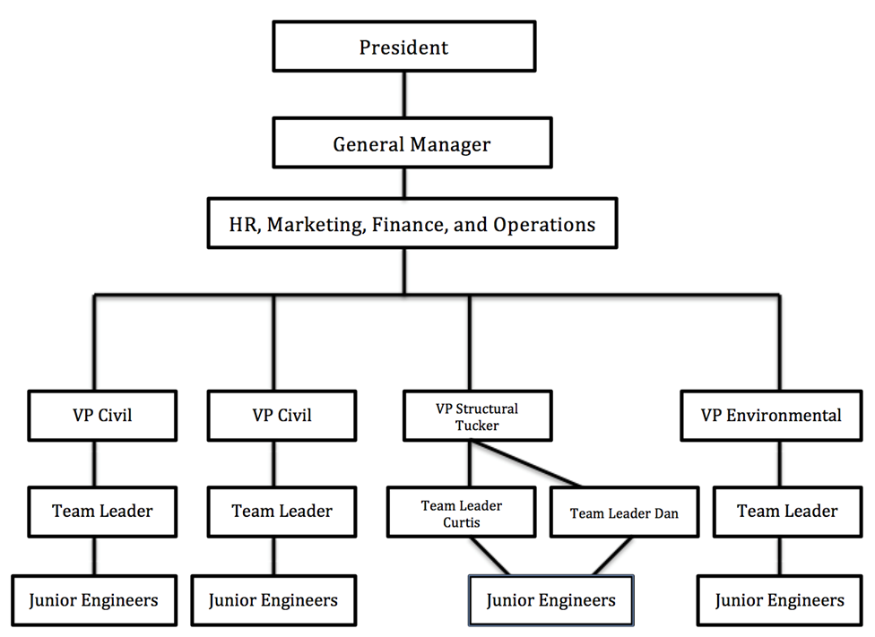

Source: Company files

EXHIBIT 2: MISSION STATEMENT AND CORE VALUES

|  |
| --- |
| **TTWM MISSION STATEMENT & CORE VALUES** |
| Teamwork, Respect, and Small-Town Client Focus  TTWM strives to provide exceptional quality while working in a family-based environment. “All for one, one for all” is the innovative motto TTWM shares between the company and its local clients. With one consistent message and the professional goal of maximizing the productivity and profitability of our customers, we will successfully grow the company.  —TTWM PRESIDENT |

Source: Company files

EXHIBIT 3: TTWM DISCIPLINARY PROCESS

**Justifiable Reasons to Terminate Employees:**

* illegal activity
* failure to meet performance standards
* poor cultural fit

**TTWM Termination Procedure:**

**Probationary Period**

* During the three-month probationary period, a new employee can be fired without cause.

**Written Warning**

* After the probationary period, a written warning must be presented to the employee.
* The written warning is to be presented to the employee in a formal meeting between the employee and HR.
* The written warning must include a documented explanation of the violation and the solution worked out between HR and the employee.

**Verbal Warning**

* The team leader or vice-president and the employee will meet together 24 hours after the incident.

**Termination**

* Vice-president, team leader, and HR representative will hold a meeting with the employee to detail the steps of the termination and clearly outline the violation.
* The HR representative will then walk the employee out and plan a time for the employee to clean out his or her office space.

Source: Company files

1. There was a one-hour drive between the two locations.
2. To be granted a professional engineering license (PEng) in Ontario, an applicant had to be at least 18 years old, be of good character, hold an undergraduate degree from a Canadian Engineering Accreditation Board-accredited program (or possesses equivalent qualifications), successfully complete the Professional Engineers of Ontario professional practice examination, and demonstrate at least 48 months of verifiable engineering experience—at least 12 months of which must have been acquired in a Canadian jurisdiction under a licensed PEng; Professional Engineers Ontario, “Licensing Guide and Application for Licence: How to Apply for a Professional Engineer Licence in Ontario,” Association of Professional Engineers of Ontario, June 2012, accessed April 5, 2017, <http://peo.on.ca/index.php/ci_id/14824/la_id/1.htm>.
3. Non-compete clause restricts employees from competing against their employer if an employee leaves and works at another company. These agreements are used to protect intangible assets (clients, intellectual property, etc.).
4. All employees at all levels of experience received the same bonus.