

**9B17C032**

**NORTH COVE UNIVERSITY**

*Eric Cabral wrote this case under the supervision of* *Elizabeth M. A. Grasby solely to provide material for class discussion. The authors do not intend to illustrate either effective or ineffective handling of a managerial situation. The authors may have disguised certain names and other identifying information to protect confidentiality.*

*This publication may not be transmitted, photocopied, digitized, or otherwise reproduced in any form or by any means without the permission of the copyright holder. Reproduction of this material is not covered under authorization by any reproduction rights organization. To order copies or request permission to reproduce materials, contact Ivey Publishing, Ivey Business School, Western University, London, Ontario, Canada, N6G 0N1; (t) 519.661.3208; (e)* [*cases@ivey.ca*](mailto:cases@ivey.ca)*;* [*www.iveycases.com*](http://www.iveycases.com)*.*

*Copyright © 2017, Richard Ivey School of Business Foundation* *Version: 2017-08-17*

John Roberts, senior vice-president (SVP) of the strategic partnership sector (SPS) of Tower Foods Limited (Tower), hung up the phone. He could not believe what he had just heard. Mike Collins, Tower’s sector president of sales for educational institutions, had just called. Roberts had expected the call to be a typical sector review, in which he received updates on the current status of clients from Collins.

Instead, Collins informed Roberts that he would be sending a termination notice to North Cove University (NCU), stating that NCU’s contract with Tower would end in 30 days. Collins told Roberts: “We’re not making money there, and the client is acting unreasonably! We need to get out, and we need to get out now.” Although Collins had agreed to give Roberts some time to look into the contract to see if Tower could find any middle ground with NCU, his closing comment was: “It would take a miracle for that to happen!” It was mid-August, and Roberts had until the end of the month to see what he could do before Collins issued the termination notice.

North Cove University (NCU)

NCU promoted itself as an elite educational institute, with a student population of more than 40,000. When polled, approximately 90 per cent of students indicated that they were satisfied with their educational experience. The university offered a voluntary meal plan for all students living in residence.[1]

Last year, NCU renewed its foodservice and facility management contract with Tower. Tower had just finished a five-year contract with NCU, and the new contract was set to last for another five years. The previous contract had generated modest returns for Tower, and the contract was viewed by management primarily as a revenue generator although the contract’s margins were extremely small.

During negotiations of the new contract, Patrick Leeland, the director of student services for NCU (and a former Tower employee), had emphasized that partnership and collaboration between the two organizations would lead to greater returns for both. The new contract was negotiated in the summer (July and August) and the employees at NCU were relieved when Tower signed this second contract. Roberts commented:

It was the start of August when we signed the new contract, and it was lucky for NCU that we did. With only a month before classes started, it would have been nearly impossible for the university to find a new provider, negotiate a contract, and get them operating in time for the school year. We really saved them by entering this new contract.

Tower Foods limited

Background

Tower was a foodservice and facility management provider founded in the 1970s. Tower’s business entailed providing foodservices (employees, equipment, and management) to businesses and institutions, including leisure facilities, prisons, and schools. Large companies subcontracted this work to providers such as Tower because they lacked either the resources or the knowledge to manage their own facilities.

Tower was the leading foodservice and facility management provider in the industry, posting revenue of CA$1.8 billion[2] in the previous fiscal year. The company’s organizational chart is provided in Exhibit 1. Tower’s focus on efficient client service, and its emphasis on partnerships and shared value for all stakeholders, had made it an attractive option for companies in need of a foodservice provider. Tower management used a number of performance indicators to evaluate its foodservice operations. The company’s most important indicator was client satisfaction, exemplified by its focus on partnership and client service.

Tower had recently opened a new head office with an open-concept design. The new space included a billiards table and a video game station. Painted on the walls throughout the building were inspirational quotes. Roberts described the new building as: “The perfect space for Tower employees to put their best work forward. This building was designed in the hopes of attracting the best talent and pushing forward Tower’s vision of great people, great results.”

Strategic Partnership Sector

SPS was Tower’s arm’s-length, client relations department. The primary function of SPS was client retention. Both Roberts and Moreen Bishop, the account director, had been involved in the contract negotiations between Tower and NCU. SPS employees operated under a different bonus structure than other employees of Tower. SPS bonuses were based heavily on top-line metrics,[3] the most important of which was revenue growth. At the beginning of the year, Tower set expectations for growth that were agreed to by SPS employees. If those expectations were not met, SPS employees did not receive their bonuses. Due to this bonus structure, SPS employees strove to increase revenues. Employees in the sales and operations sector, managed by Mike Collins, earned bonuses based on profit margins. Employees in the sales and operations sector were rewarded if they met a minimum acceptable profit margin with their clients. These bonuses increased as the profit margins increased on the contracts managed by sales and operations employees.

At times, these differing financial incentives created conflict between the sales and operations team and SPS, and the two teams could be at odds over which clients to pursue. Roberts appreciated that Collins had accepted the previous NCU contract with its low margin, but, in negotiations for the new contract, Roberts assured Collins that he would only sign a contract with more acceptable margins. Roberts had thought that the new contract with NCU would be more lucrative, so it was a shock to hear that Tower had not made a profit. For NCU to have become unprofitable, either Tower was putting more money into the account than originally agreed in the contract or NCU was paying less for services than was negotiated. Either way, it appeared the contract that Roberts had helped negotiate was not being upheld.

The Contract

During negotiations, Leeland had emphasized maintaining and continuing to build upon the partnership and collaboration between NCU and Tower. Given Tower’s corporate focus on partnership and client satisfaction, Roberts thought that the values Leeland identified as the pillars of his offer were appealing. Roberts, nevertheless, had to ensure the new contract would be profitable enough for Collins. In the spirit of collaboration, Roberts and Leeland negotiated a contract wherein Tower would earn marginal profits early on and then, over the course of the contract, the two parties would work together to increase revenues and profits for both NCU and Tower.

The deal that had been agreed upon was that Tower would provide the services specified in the contract, and, each year, NCU would increase the price of the student meal plan by 5 per cent, with the extra revenue going to Tower. This would allow Tower to break even in the first year, and then earn growing profits in subsequent years. The provision for the meal plan price increase was crucial to making the deal work, but Leeland said that he was unable to put these specifics in writing. Roberts described the situation as follows:

Leeland told us that he couldn’t put the meal plan increase in the written contract because he would not be able to gain permission for that increase each year so far in advance. He explained to us that a 5 per cent increase would be very attainable each year and he would ensure that we got the increase we needed, but he would just have to do it on a year-by-year basis. We were both in a hurry to sign the contract and, with Leeland’s continued focus on collaboration and partnership, all of us at Tower Foods felt okay with allowing the meal plan increase to be a verbal commitment. We believed that enough people at both NCU and Tower knew about the verbal commitment NCU had made, so it would be difficult for NCU to deny it if they did try to get out of raising the meal plan prices.

Changes at NCU

Months after negotiations had ended and the university term had started, NCU hired a new vice-president of the board (academics), Mark Byrd, and a new partnership administrator, Michelle Hardy. Byrd’s and Hardy’s predecessors, who were Leeland’s former bosses, had been influential during negotiations, and had assured Tower that the verbal commitments they had made on behalf of NCU would be upheld. Byrd and Hardy, however, were unaware of these verbal commitments. To Roberts’ surprise, Leeland had not passed along this information to them. Collins believed Leeland had purposely not told his superiors so that he could make the deal more profitable for NCU and take advantage of Tower’s trust.

Tensions Building

First Year of the New Contract

In addition to the meal plan price increase, there were a number of other verbal commitments made by NCU that directly affected Tower. NCU had made commitments pending the final student enrolment and meal plan changes. The most important of these commitments was that NCU would move to a mandatory meal plan for all students living in residence. Additional verbal commitments that had been made included NCU allowing Tower to reduce service during exams, as well as to close cafeteria areas on weekends and during holidays in order to lower costs during times of low student traffic. Although not specified in the contract, it was understood that these commitments would be upheld. Tower had based all of its projections and budgeting on these commitments during negotiations. When the school year started, Tower began operating at a loss, and it soon became obvious that NCU management did not intend to honour the promises made during negotiations. After months of losses, Collins decided to take action and scheduled a phone call with Mark Byrd.

Collins: Hi Mark, I’m afraid we need to discuss our contract with you. There were certain commitments   
 your predecessor made that I’m afraid are not being upheld and it’s putting us at Tower Foods in   
 a bad position.

Byrd: I’m sorry Mike but I’m not sure I follow. Verbal commitments? I’m just following what was outlined in the contract you signed.

Collins: I understand that, but, during negotiations we were told you were just waiting on information regarding student population and meal plan rights before you could make anything official. We only signed that contract under the impression that once you had that information you would fulfill your other commitments!

Byrd: I don’t want to accuse you of anything, but it sounds like you’re just trying to get more money out of us. I’ve talked to our director of student services, Patrick, and he seems to believe you should be making a fine profit! With his history working at Tower Foods, I’m sure he can’t be far off.

Collins: A lot has changed since Patrick left us for NCU, Mark. Listen, if you won’t make good on what you promised, we won’t be able to offer the same level of service that you’ve come to expect.

Byrd: I’m sorry you signed a contract that you aren’t happy with now but it’s too bad, you signed it. I expect everything that was promised in writing.

Byrd hung up and Collins wondered what he could do. He decided to do exactly what he had promised and lowered the level of service Tower provided at NCU. Eager to meet his budget requirement, Collins began reducing the cost of Tower’s operations at NCU. He decreased services, labour, and hours of operation. This drop in quality was drastic and, in Collins’s estimation, it needed to be. He had projected that Tower would suffer a net loss of $1 million, while paying an additional $1 million in commissions to NCU.[4]

It did not take long for student complaints to reach Byrd, which alerted him to the overall lower quality of foodservices provided by Tower. When he realized that Tower had not fulfilled its contractual obligations, Byrd immediately phoned Collins.

Byrd: Mike! I’ve had a number of complaints about your services. What’s going on?

Collins: I did exactly what I said I’d do. I’m trying to save any money I can out of this deal.

Byrd: Well, you’d better start offering what you are contractually obligated to or else I’m terminating the contract and letting other companies bid on the business!

Collins: Sure, that sounds great.

Byrd: I’m not kidding!

Collins: Neither am I. If we don’t have this contract, I hit my annual budget expectations. NCU is   
 dragging Tower’s margins down, Mark. If you were to terminate the contract, you’d be doing me   
 a huge favour. Let me know what you decide.

Collins hung up, and hoped that Byrd would make good on his promise to terminate the contract. However, as the months passed and Tower received no notice of termination, it became apparent to Collins that Byrd had made an empty threat. Collins thought that Byrd must have realized how unappealing NCU’s business would be to any other provider and that it would be nearly impossible to get another company to take on a contract similar to the one with Tower, even at the poor service level that was currently being provided. After months of tension between NCU and Tower, the school year came to an end.

Second Year of the Contract

Collins held out hope that, over the summer, NCU might attempt to get the promised meal plan price increase to ease the working relationship between NCU and Tower. When it became apparent that the meal plan price increase was not going to happen, Collins phoned Roberts and let him know his intentions to terminate the contract: “We’re not making money there, and the client is acting unreasonably! We need to get out and we need to get out now.”

Conclusion

Having originally been involved in the negotiations with NCU, Roberts felt compelled to try to salvage the deal. NCU was a $12 million revenue generator. Not only was this revenue critical for meeting his annual bonus expectations, but Roberts also had to ensure that the contract was profitable for Tower (and Collins). Roberts had a tough task ahead of him and only a few weeks available to do it.

Exhibit 1: Tower Foods limited Corporate Hierarchy

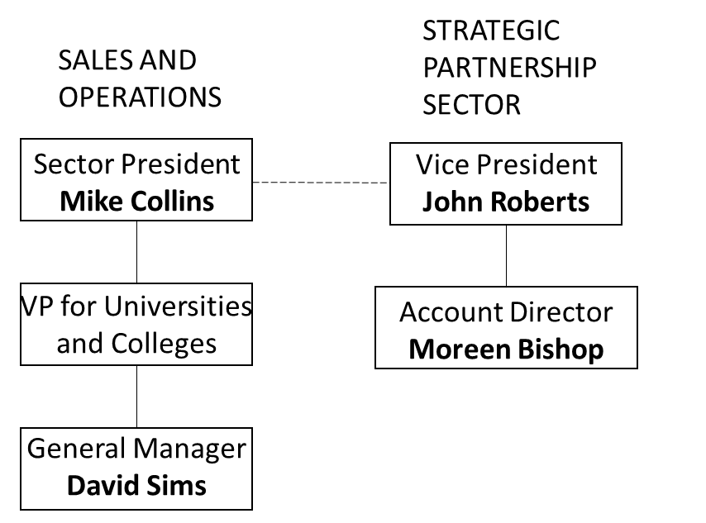

Source: Company files.

Exhibit 2: NCU academic Hierarchy

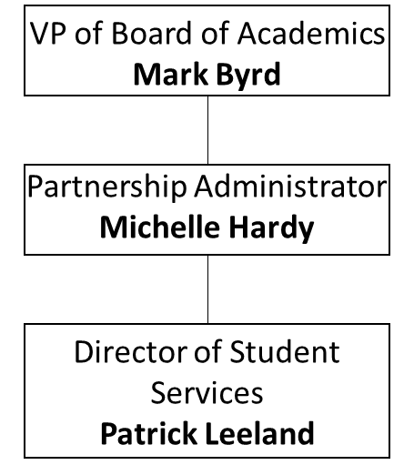

Source: Company files.

1. NCU had approximately 4,000 students living in residence each year.
2. All currency in Canadian dollars unless specified otherwise.
3. Top line metrics refer to the lines at the top of the income statement, such as revenue or gross sales.
4. Tower operated in NCU’s facilities. Since Tower received its revenue directly from the students through meal plans, Tower paid NCU a commission as its contribution to the facilities’ overhead costs.