

9B17D003

1-800-Flowers.com: collaborating with suppliers

Jayashankar Swaminathan wrote this case solely to provide material for class discussion. The author does not intend to illustrate either effective or ineffective handling of a managerial situation. The author may have disguised certain names and other identifying information to protect confidentiality.

*This publication may not be transmitted, photocopied, digitized, or otherwise reproduced in any form or by any means without the permission of the copyright holder. Reproduction of this material is not covered under authorization by any reproduction rights organization. To order copies or request permission to reproduce materials, contact Ivey Publishing, Ivey Business School, Western University, London, Ontario, Canada, N6G 0N1; (t) 519.661.3208; (e)* [*cases@ivey.ca*](mailto:cases@ivey.ca)*;* [*www.iveycases.com*](http://www.iveycases.com)*.*

Copyright © 2017, Richard Ivey School of Business Foundation Version: 2017-04-04

In March 2012, Jim McCann, chief executive officer of 1-800-Flowers.com, a U.S. gifts and flowers enterprise, was faced with a pressing decision. 1-800-Flowers.com had a very good brand in terms of product distribution. However, the online market for flower and gift sales was changing rapidly, presenting new opportunities for efficiencies and market expansion. Jim was joined in a meeting at 1-800-Flowers.com’s headquarters in Carle Place, New York, by his younger brother and chief operating officer, Chris McCann, as well as Joe Pititto, vice president of investor relations and corporate communications. The meeting was called to discuss how 1-800-Flowers.com could gain competitive advantage through collaborations with the extended supply chain.

Chris started the discussion by suggesting that 1-800-Flowers.com should bring more florists into the company’s “BloomNet” network, and introduce more of its non-floral gift products (specifically its gourmet gifts) into the florists’ shops for same-day delivery. He believed that “the best way going forward is to expand our BloomNet network, and get [florists] to carry our gourmet gifts for same-day delivery; this would extend our product offerings and geographical reach, and more importantly, we could be close to the customer with minimal investment.”

Jim agreed with Chris, but only up to a point:

While I agree that we benefit immensely from collaborating with independent florists, and they have the ability to carry other gift items in their shops for same-day delivery, we cannot rely solely on the florists to drive our growth. Our agreements with them are non-exclusive and we do not have any control over their day-to-day operations. [Further,] they have limited capabilities in terms of space and inventory investment bandwidth to carry all the products that we would like to position closer to our customers.

Chris listened to these thoughts and replied:

I think we may be missing a point here. Our supply chain does not stop with the florists. In terms of floral gifts, some of the delivery issues that we have had in the past were due to the non-availability of quality flowers specific to our product designs to meet customer demand. To address this element of our gifting supply chain, I think we need to bring the floral growers into our discussion. Further, as you have pointed out, our business is no longer just about flowers; we also need to look at how we bring synergies through our supply chain, including our own gourmet gift production, warehouse, and delivery facilities.

Jim concurred:

In terms of the floral supply chain, our goal of influencing the availability of key floral varieties and enhancing our ability to help our florists do the best possible job for us must address the supply chain from the farms all the way to the florists. While buying [from] growers or wholesalers is an involved and risky approach—not to mention capital intensive—developing a strategy and an initiative to offer an electronic marketplace for flowers would help us improve availability, lower costs, and improve coordination, thereby providing us with a sustained competitive advantage.

Chris agreed, noting that integration across the value chain could be one important element toward the overall goal of leveraging both owned and partnered assets to bring consistency of supply and expanded range of products closer to the firm’s customers. As they left the room, the three men knew that they needed to consider further some important questions. First, how could 1-800-Flowers.com improve the performance of the floral supply chain in terms of floral designs, costs, and delivery through better information sharing and coordination across the supply chain? Second, how could the company benefit from combining the floral supply chain with the gift supply chain?

Company History

1-800-Flowers.com began operations as Flora Plenty in 1976, when Jim acquired a single retail florist in New York City. He subsequently expanded the business to a 14-store chain. Jim’s younger brother, Chris, joined the company in 1984. In 1986, Flora Plenty acquired a Texas-based florist named 800-Flowers, along with the rights to the toll-free number 1-800-Flowers. At a time when brick-and-mortar retailing was the common practice, Jim made the bold move to adapt telephone commerce as the business model, and renamed the company 1-800-Flowers. This change was a stroke of marketing genius: the innovative and memorable name led to a strong brand recall value among customers. The company was one of the first retailers to use 24/7 toll-free numbers, and it changed the way the floral industry operated. Floral orders over the phone would soon become the norm. Two years later, in 1988, the company launched BloomNet, its own network of independent florists, to facilitate same-day delivery of customer orders. BloomNet would later become a fully owned subsidiary of 1-800-Flowers.com, offering business-to-business florist wire service.

Over the next few years, while the retail industry was riding the “1-800 wave,” 1-800-Flowers was already exploring several new ideas in pursuit of the next big technological innovation that would fundamentally alter the way business was done. As a part of this initiative, the company explored the possibility of selling through the Internet, and had its own website by 1991. The results were not immediate because Internet retailing was practically non-existent at that time due to the lack of supporting infrastructure. However, the launch of several web browsers between 1993 and 1995 kick-started the e-commerce era and 1-800-Flower’s online sales volume increased significantly after 1995. To reflect the changing times and to emphasize the role of the Internet in the company’s business strategy going forward, 1-800-Flowers was re-christened “1-800-Flowers.com” in 1998.

The company was one of the first retailers to directly sell over the Internet, and, as with telephone retailing, the Internet retailing model revolutionized the floral industry landscape. Suddenly, customers had access to the products offered by hundreds of florists across the country through 1-800-Flowers.com’s website. From the company’s standpoint, this meant increased product variety along with the added benefit of reduced investment in inventory and infrastructure. The Internet retailing model pioneered by 1-800-Flowers.com soon became a standard in the floral industry.

Social, Local, and Mobile

1-800-Flowers.com had always been a leader in adopting technology to drive business, and it lived up to its reputation when another wave of change swept the retail industry: mobile and social commerce. 1-800-Flowers.com launched the floral industry’s first mobile gift centre in 2008, and went on to win numerous awards for its innovative applications (apps) in the mobile commerce space. In 2009, the company added one more accomplishment to its list of “firsts” in the floral industry (and the retail industry in general) by partnering with social commerce provider Alvenda.[1] With the partnership, 1-800-Flowers.com became the first retailer ever to open a fully operational store inside Facebook. Customers could purchase and make payments without leaving the social media website. Many other retailers soon followed suit.

1-800-Flowers.com was also a pioneer in social marketing, partnering with Facebook, Twitter, Google+, and many other blogging websites to reach customers directly, and in a cost-effective manner.[2] The company planned to further invest and innovate in the social and mobile media space in line with its social, local, and mobile theme, which recognized the growing importance of mobile commerce and social networking to the firm’s future growth and marketing plans.

Not Just Flowers

While 1-800-Flowers.com had been a leader in the floral industry for almost 30 years, it was no longer just about flowers: the company’s mission was to be the “leading provider of thoughtful gifts” by positioning itself as an everyday gift destination. In line with this mission, 1-800-Flowers.com began offering non-floral products like gourmet cookies and gift baskets in the late 1990s. The diversification gained momentum with the acquisition of The Popcorn Factory in 2002. Since then, the company had invested heavily in the non-floral category to open new businesses, and had also made a series of acquisitions.

As of 2012, in addition to its core floral business and BloomNet wire service, 1-800-Flowers.com had a significant presence in the gourmet foods and gifts industry through its various wholly owned subsidiaries (e.g., The Popcorn Factory, a leading producer of gourmet popcorn and specialty treats; Cheryl’s, offering fresh-baked gifts; Fannie May, offering confections; 1-800-Baskets.com, specializing in gift baskets and towers; and Winetasting.com, offering a collection of more than 700 wines from around the world). To leverage its multi-million customer base and leadership position in the floral industry, 1-800-Flowers.com used a multi-brand website that directed the high traffic flow to 1-800-Flowers.com to the company’s non-floral business as well (see Exhibit 1). In 2011, 53 per cent of the company’s revenues came from the consumer floral business, 11 per cent from BloomNet wire service, and 36 per cent from gourmet food and gift baskets.

1-800-Flowers.com’S Supply Chain

1-800-Flowers.com operated a complex supply chain comprising manufacturers (non-floral); growers (floral); distribution centres; fulfillment centres; and franchised, company-owned, and independent retailers (floral and non-floral) (see Exhibit 2). Typically, orders for all products were placed either online (through 1-800-Flowers.com, 1-800-Baskets.com, etc.) or over the telephone; however, the order fulfillment strategy varied significantly depending on the product type.

Flowers and Plants

1-800-Flowers.com’s floral orders were fulfilled using a hybrid system consisting of (1) the BloomNet network of franchised and independent florists, and (2) the company-owned distribution centres. Customers had the option of choosing from a menu of the following items: hand-crafted floral arrangements, which were delivered in person by the local florist on the same day (representing approximately 80 per cent of the company’s floral sales); a wide variety of “shipped in a box” floral arrangements, which were directly shipped from the distribution centers (no same-day delivery was available for this option); and a select variety of floral products through the firm’s Fresh From Our Growers® program, in which case the flowers were shipped directly from the growers’ fields to the customer.

BloomNet

For nearly a decade after 1-800-Flowers.com began operations in 1976, the company primarily fulfilled its orders through 14 company-operated stores. This system changed in 1988, when 1-800-Flowers.com teamed up with a select network of independent florists to create the BloomNet network. This collaboration with florists opened up new opportunities in terms of product variety, flexible delivery options, and, more importantly, a wider geographical reach. Through its florist partners, 1-800-Flowers.com had the advantage of being close to the customer; for the first time, the company was able to offer same-day delivery nationwide. The florists also benefitted immensely from this partnership because 1-800-Flowers.com’s strong brand value and large customer base provided increased visibility and demand for the florists’ products with little to no additional marketing costs.

Over the years, the nature and scope of the collaboration between 1-800-Flowers.com and the florists increased steadily, culminating in the formal launch of BloomNet as a business-to-business al wire service provider in 2005. BloomNet was no longer just an order fulfillment network; it offered a suite of products and services to help florists grow their businesses profitably (ranging from exclusive, wholesale merchandise to floral design training programs). 1-800-Flowers.com had a quality assurance program for BloomNet florists to guarantee customer satisfaction and maintain high standards for florist-to-florist transactions within the BloomNet network. The company selected retail florists for BloomNet based upon florists’ design and delivery capabilities, and allocated orders to members within a geographical area using a complex algorithm that considered a variety of inputs (e.g., a florist’s historical quality performance and customer satisfaction ratings, its inventory and ability to fulfill orders to the company’s recipes and specifications, and the number of member florists serving the area). The industry standard revenue-sharing agreement for floral orders, as adopted by BloomNet, was as follows: the florist who received the order (i.e., either 1-800-Flowers.com or an independent BloomNet florist) kept approximately 29 per cent of the total order value, while the fulfilling florist received the remaining 71 per cent. The responsibility for the floral inventory and delivery rested with the fulfilling florist.

Gourmet Foods and Gift Baskets

For non-floral products, 1-800-Flowers.com primarily used direct shipment from its manufacturing and distribution facilities to the customers. Further, as of December 2011, the company owned and operated approximately 70 Fannie May and Harry London stores and nine Cheryl’s retail stores, and had a growing number of franchise retail locations for its Fannie May brand. Fannie May chocolates (as well as the company’s Harry London wholesale brand of chocolates) were produced in Canton, Ohio (approximately 10 million pounds of chocolate produced annually). The company’s Cheryl’s brand cookies and other baked gifts were manufactured at its facility in Westerville, Ohio. The Popcorn Factory products were produced in its Lakeville, Illinois plant, and its 1-800-Baskets.com gifts were produced at its facility in Melrose Park, Illinois.

Economic Downturn and Strategic Response

The gift industry was highly discretionary in nature, and performance was heavily subject to the economic climate. The demand for gift products depended on customers’ spending ability, which was, in turn, directly related to factors like the unemployment rate, housing market conditions, and commodity prices. During the 2008 global financial crisis, demand for 1-800-Flowers.com’s products was adversely affected (mainly in the core floral business), resulting in a negative operating income in 2009 and 2010 (see Exhibit 3). The impact of this recession, in terms of net revenue, was worst in fiscal year (FY) 2009/10.

Cost-Cutting Measures

1-800-Flowers.com’s initial response to the reduced demand and lacklustre market conditions was to implement a series of cost-cutting measures. Between June 2008 and June 2009, the company significantly reduced its workforce (including full- and part-time employees). This reduction included an elimination of roughly 15 per cent of full-time jobs. Another 100 employees were laid off in the following year. In addition to downsizing its workforce, 1-800-Flowers.com decided to close its brick-and-mortar customer service centres in order to reduce the fixed costs associated with operating these facilities. The company transferred employees from these centres to its home agent network, and used sophisticated call routing and voice-over-Internet solutions to virtualize its customer service platform. Importantly, this move also served to improve customer satisfaction ratings because home agents proved to be stable and experienced staff who were motivated by their ability to work from home.

As part of the cost-cutting plans, 1-800-Flowers.com also accelerated the initiatives under its Process Enhancement Programs to reach the goal of saving US$50 million[3] in operating costs by the end of FY 2008/09. During the fourth quarter of the same fiscal year, the company made the strategic decision to divest its home and children’s gifts business to better focus on the floral business, BloomNet, and the gourmet foods and gift baskets categories. These measures resulted in lower operating costs (excluding the goodwill and intangible impairment expenses of $85.4 million in 2009), leading to increased gross margin percentages in 2010 and 2011. Furthermore, 1-800-Flowers.com’s operating expense ratios were comparable to pre-recession levels, despite the much lower revenues in 2010 and 2011.

The economic recession impacted 1-800-Flowers.com in several ways. While it emerged leaner and operationally more efficient, the company quickly realized that simply cutting costs and passing on the benefits to the customer (e.g., through discounted pricing, free shipping, etc.) were not sufficient to spur market demand in tough economic times. In the lead-up to Valentine’s Day (February 14) 2010, 1-800-Flowers.com resorted to a combination of steep discounts and increased marketing spending to generate consumer interest for its products. These promotional activities continued all the way to Mother’s Day (in the United States, the second Sunday in May). Although these programs saw an increase in the number of orders and new customers, that increase was insufficient to offset the associated decline in the average value per order, resulting in lower gross margins.

Based on an in-depth analysis of the company’s financial performance in FY 2009/10, top management at 1-800-Flowers.com concluded that the company had to look beyond the existing methods and line of products to return to profitability and support its ambitious growth plans. While staying committed to its efforts to reduce operating costs and increase efficiency, the company decided to invest in developing new and exciting products that would better capture customers’ interest. Products were organized into three categories—good, better, and best—based on their price points. The cost-based approach had led to a focus on the “good” products and did very little to differentiate 1-800-Flowers.com from every other company that offered low-cost gifts. Therefore, 1-800-Flowers.com made the bold decision to focus on the “better” and “best” categories while working closely with the supply chain. A key element of this strategy was the close collaboration with florists at the design stage.

A-DOG-Able® Collection

By June 2010, 1-800-Flowers.com had already decided to invest in developing new and exciting products, but one key question still needed to be answered: how would the company create such radically new designs? The straightforward answer would have been to increase in-house product design efforts by residential floral designers; however, the company was convinced that this was not the solution. The management team felt that it had to look outside the firm for fresh, outside-the-box ideas. It was at this juncture that 1-800-Flowers.com decided to bring a knowledgeable, valuable source of ideas into its product design process—the company’s own BloomNet member florists. Many florists within the network had outstanding design capabilities, and involving them in product design would also be valuable from an operational standpoint because, ultimately, product crafting and delivery were carried out by the florists.

The company employed a variety of strategies to facilitate idea exchange and deepen the design collaboration with the florists. One such initiative was the creation of a magazine, *Floriology*, through which florists could exchange inspiring ideas, marketing strategies, and so on. The magazine regularly featured promising designs by member florists, along with a short narrative of the design concept. Some of these designs might eventually be added to 1-800-Flowers.com’s product offerings. This recognition and visibility encouraged the florists to actively participate in the design process. The company also established the 1-800-Flowers.com Floral Design Council to foster floral design artistry and collaboratively develop new products. The design council routinely conducted design competitions for florists, and winners were rewarded with cash prizes and, in some rare cases, a share of the revenue for designs directly attributed to the winner. The company had even named a floral arrangement, “Dee’s Tropical Paradise™,” after a Boston-based florist who provided inspiration for that particular design.

The increased product design efforts through collaboration with the BloomNet florists resulted in many innovative and exciting products, including the widely popular “a-DOG-able®” collection of products, which featured a set of 11 products for different seasons and reasons (see Exhibit 4). These floral arrangements were hand-crafted by the fulfilling florists in the shape of an adorable dog, complete with eyes, nose, and a pair of long ears. The a-DOG-able® line was an instant hit due to its appeal, unique design, and, more importantly, the value that it offered to customers with a low starting price of $34.99.

Moving Forward

1-800-Flowers.com’s design collaboration with the florists was proving successful, but numerous challenges lay ahead for the company. While the economy remained the single biggest threat, the firm was facing intensifying competition as well. In the floral category, 1-800-Flowers.com’s competitors included retail floral shops, online floral retailers, floral wire services, and supermarkets with floral departments. Improvements in information technology and the convenience of e-commerce had led to a surge in the number of Internet-based floral retailers, some of which also sold their products through traditional channels by collaborating with independent florists. In addition, 1-800-Flowers.com’s partnership with the independent florists and growers was non-exclusive; the service agreement could be terminated by either party with very little notice. The company had no control over the operations of either the independent florists or the growers, which exposed it to a certain level of risk that needed to be carefully managed in terms of quality, timeliness, and reliability of its services in the floral business.

To deepen its relationships with its BloomNet florists, 1-800-Flowers.com decided to expand its franchise program. Prior to 2011, the company had not added a new florist to its small franchise network (part of BloomNet) for more than a decade. However, rising interest from florists after the company’s very positive appearance on the hit television program *Undercover Boss* led to an initiative to allow select BloomNet florists to co-brand, which offered florists the benefit of retaining their local brand recognition while also gaining from 1-800-Flowers.com’s national brand recognition and advertising campaigns. In addition to the expansion of co-branded franchise florists, in FY 2011/12, the company acquired Flowerama, a Waterloo, Iowa-based florist franchise company with more 77 retail stores in more than 25 states. Flowerama stores had already begun to co-brand their retail locations. 1-800-Flowers.com franchise florists became the upper tier of the company’s BloomNet network in terms of their deep relationships with the company.

1-800-Flowers.com was also working on leveraging the company’s existing non-floral supply chains to deliver floral products, while concurrently seeking ways to utilize its unique same-day delivery capability through the BloomNet florist network for many of the company’s non-floral gourmet food gift items. Integrating the floral and non-floral delivery channels offered tremendous potential. The company operated 68 company-owned (and a growing number of franchise) Fannie May and Harry London retail stores as well as the nine Cheryl’s retail stores, all of which could be doubled up as retail outlets for the floral business. This gave 1-800-Flowers.com a cost-effective way to be closer to the customer.

The company had also recently introduced a new product line, Fruit Bouquets, designed to compete with the franchise chain Edible Arrangements. The idea was to refit existing florist locations and company-owned gourmet food gift stores with the ability to craft fruit bouquets, and thereby grow national same-day delivery capability quickly. To achieve this goal, 1-800-Flowers.com needed to invest in employee training as well as significant planning before the floral and non-floral delivery channels could be integrated.

As 1-800-Flowers.com sought ways to address these diverse opportunities, a number of key strategic decisions needed to be made. It was clear that the company needed to leverage and expand the supplier collaboration effort. What was the most effective way to do this? Should the strategy be based primarily on vertical integration, or should it be created along the lines of virtual integration? A second and related question pertained to the level of integration with the growers. One of the firm’s key strategic choices had been to focus on the higher end of the product offerings. Could 1-800-Flowers.com somehow extend the integration back to the growers so that flowers of the right type and quality (including exotic flowers) could be made available as needed, thus providing the firm with sustained competitive advantage? How should the company begin to establish that strategy? What was the optimal supply chain structure: a fully integrated supply chain extending all the way up to the growers, a semi-integrated supply chain involving virtual integration with the growers and vertical integration with the florists, or a completely virtually integrated supply chain?

In 2014, 1-800-Flowers.com’s management had also been evaluating a proposal to develop an electronic marketplace. The marketplace would allow for florist-to-florist transactions, as well as 1-800 Flowers.com-to-florists transactions. The company could procure the most needed flowers from growers and auction them at the electronic marketplace, thereby increasing the availability of critical flowers for local florists. Further, the transaction data could give 1-800-Flowers.com important information about demand patterns for various types of flowers, and the firm could then coordinate planning with growers in advance. This approach could be a middle ground between vertical integration and maintaining the status quo. However, important challenges related to the positioning, planning, and execution of this approach would have to addressed.

This case was prepared by Professor Jayashankar Swaminathan, Kenan-Flagler Business School, University of North Carolina at Chapel Hill, with the help of doctoral student Karthik Natarajan.

Exhibit 1: 1-800-Flowers.com’s multi-brand website

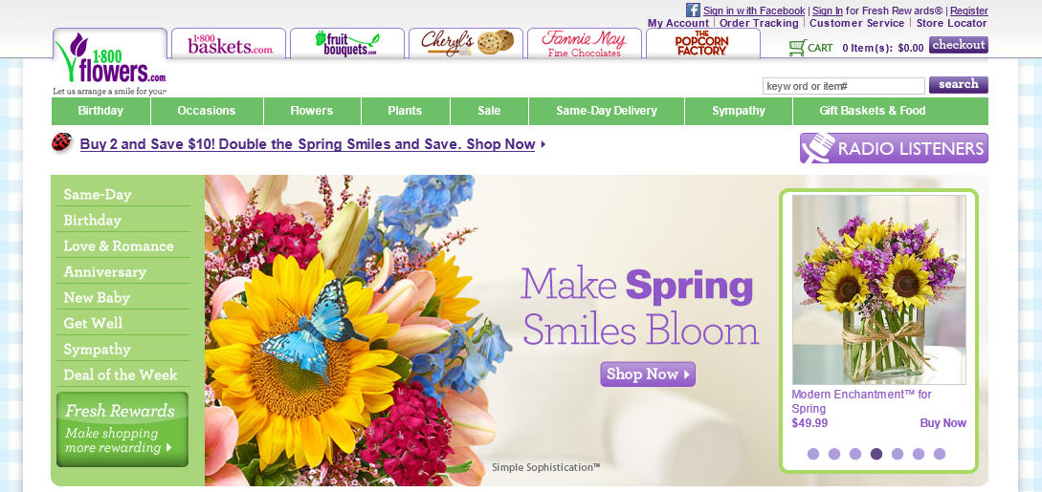

Source: Company files.

Exhibit 2: 1-800-FlowerS.com’s Supply Chain

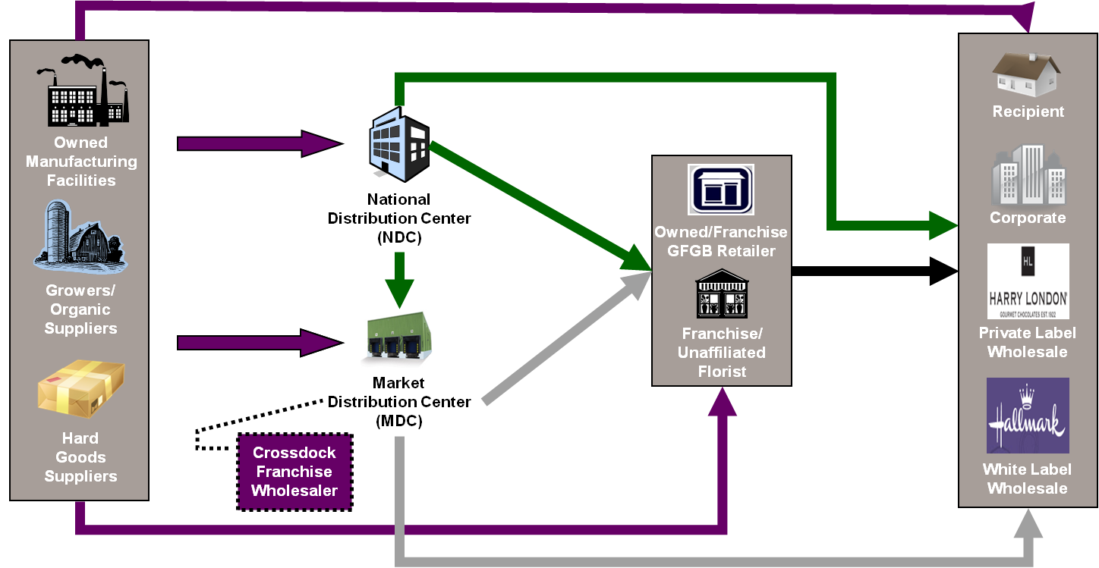

Hallmark

Harry London

Note: GFGB = Gourmet foods and gift baskets

Source: Company files.

Exhibit 3: Consolidated Statement of Operations and Balance Sheet for Fiscal Year 2007–2011 (US$ ‘000)

|  |  |  |  |  |  |
| --- | --- | --- | --- | --- | --- |
| **Years Ended** | | | | | |
|  | **2011-07-03** | **2010-06-27** | **2009-06-28** | **2008-06-29** | **2007-07-01** |
| Total net revenues | 689,787 | 667,710 | 713,950 | 739,211 | 725,650 |
| Cost of revenues | 409,703 | 401,908 | 432,744 | 426,916 | 419,083 |
| Gross profit | 280,084 | 265,802 | 281,206 | 312,295 | 306,567 |
| Total operating expenses | 266,671 | 262,420 | 353,738 | 272,970 | 264,698 |
| Operating income (loss) | 13,413 | 3,382 | (72,532) | 39,325 | 41,869 |
| Other income (expense), net | (4,077) | (5,752) | (9,295) | (4,170) | (6,133) |
| Income (loss) from continuing operations before taxes | 9,336 | (2,370) | (81,827) | 35,155 | 35,736 |
| Income tax expense (benefit) from continuing operations | 3,614 | (282) | (15,326) | 13,126 | 14,755 |
| Income (loss) from discontinued operations before taxes | - | (1,723) | (39,754) | (1,785) | (6,727) |
| Income tax expense (benefit) from discontinued operations | - | 410 | (7,838) | (810) | (2,864) |
| Net income (loss) | $5,722 | $(4,221) | $(98,417) | $21,054 | $17,118 |

Source: Company files.

Exhibit 4: A snapshot of the a-DOG-able line of products from 1-800-Flowers.com’s website

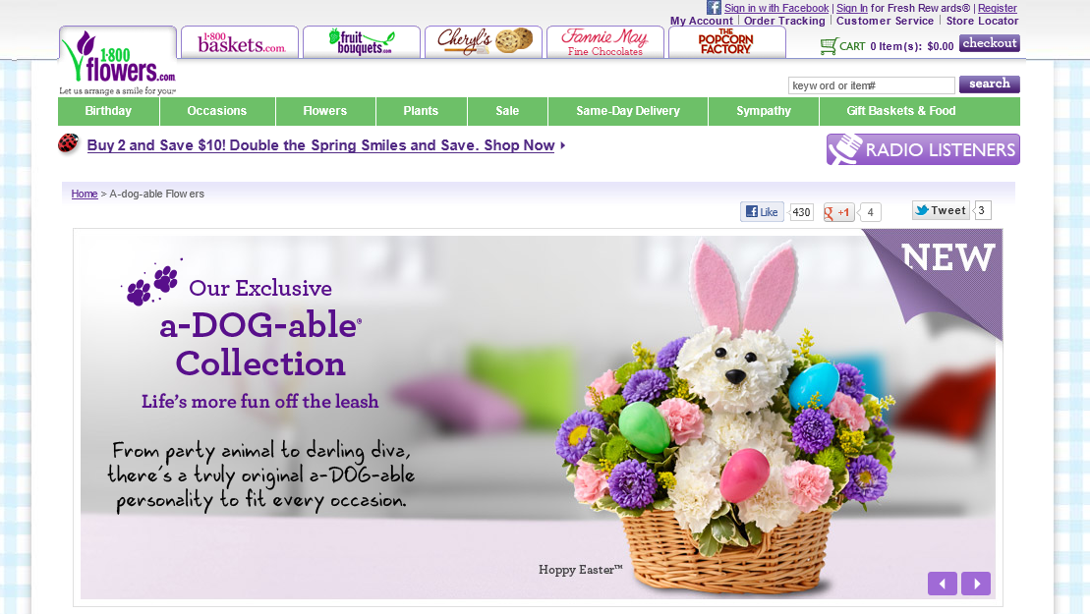

Source: Company files.

1. Alvenda became part of Fluid Inc. after 2014.
2. For example, in fiscal year 2009/10, 1-800-Flowers.com introduced a “Like It” feature on its website, allowing customers to add chosen products to their “wish lists” on the their Facebook pages, making it easy to let family and friends know about their gift preferences.
3. All currency amounts are in US$ unless otherwise specified.