

9B17D007

startech.com: supply chain strategy

Ken Mark wrote this case under the supervision of Professor P. Fraser Johnson solely to provide material for class discussion. The authors do not intend to illustrate either effective or ineffective handling of a managerial situation. The authors may have disguised certain names and other identifying information to protect confidentiality.

*This publication may not be transmitted, photocopied, digitized, or otherwise reproduced in any form or by any means without the permission of the copyright holder. Reproduction of this material is not covered under authorization by any reproduction rights organization. To order copies or request permission to reproduce materials, contact Ivey Publishing, Ivey Business School, Western University, London, Ontario, Canada, N6G 0N1; (t) 519.661.3208; (e)* [*cases@ivey.ca*](mailto:cases@ivey.ca)*;* [*www.iveycases.com*](http://www.iveycases.com)*.*

Copyright © 2017, Richard Ivey School of Business Foundation Version: 2020-01-30

Introduction

Paul Seed, co-founder and chief executive officer of StarTech.com (StarTech), was concluding his meeting with Jeff Brodie, chief operating officer. It was Monday January 23, 2017, and the two were meeting in the board room at the company’s head office in London, Ontario, to review StarTech’s supply chain strategy:

It looks like we hit our growth targets for 2016, reaching $190 million[1] in sales. We are forecasting year-over-year sales growth of 20 per cent for at least the next three years. To support this level of growth, we will need to examine our supply chain strategy.

Sales revenues at StarTech, a manufacturer and distributor of hard-to-find technology products, had grown by almost $70 million in the previous four years. However, the company’s growth had increased the complexity of the business, and Paul wanted to ensure that the aggressive sales targets could be supported through strong operations and an efficient supply chain. Of particular interest was the need to support StarTech’s customer value proposition of product availability within 24 hours with prudent investments in inventory. Paul continued:

We make it easy for information technology professionals to identify, find, get, and use hard-to-find connectivity parts by having the right products, at the right place, at the right time. The key to remaining profitable is balancing product availability with our inventory investments. Conventional inventory management principles do not apply to our unique business model.

You have done a good job improving our working capital utilization, but we need to look at how and where additional improvements can be made to our supply chain. I would like you start with a review of how we are making product available to our customers through one of our distribution partners as a test case. Let’s focus on cable product line for starters. Specifically, what initiatives should we be considering that will ensure high levels of product availability for our end-users? How can StarTech enhance our value proposition to our customer, while simultaneously improving our operating margins and inventory productivity? Get back to me with your preliminary recommendations by the middle of February.

The Global Computer Connectivity Hardware Industry

Information technology (IT) hardware such as smartphones, servers, tablets, laptops, and similar devices had a constantly changing array of ports and connections used to interconnect, charge, and attach to peripherals such as external displays, networks, and electronic storage. StarTech distributed a broad portfolio of products that enabled the IT professional to solve these everyday connectivity challenges.

Original equipment manufacturers (OEMs) such as Apple, HP, and Lenovo created and marketed technology and mobility products and peripheral devices and cables. Large corporations and mass-market retailers, including Best Buy, Walmart, and Target, bought directly from OEMs. Peripherals and connectivity parts supporting these devices were supplied by third-party manufacturers such as StarTech.

Distributors purchased OEM and third-party products in bulk to sell to regional and local resellers and directly to IT professionals and consumers. These distributors operated as “one-stop shops” for consumers and businesses. To maintain a wide range of product offerings, distributors purchased and marketed hundreds of thousands of technology products from thousands of hardware manufacturers and software suppliers, selling these products and services to their network of customers. These customers included local and regional distributors and systems integrators who put together technology equipment services for small- and medium-sized enterprises. Distributors typically operated several warehouses, each with a different product mix depending on historical and forecasted demand. Some distributors provided same-day shipment for product orders, relying on common freight carriers such as the United States Postal Service, United Parcel Service (UPS), and Federal Express. As an added service to manufacturers and resellers, distributors provided supply chain management services: order management, customer and technical support, logistics management, and other services.

For resellers and corporate IT departments, the advantages of relying on a distributor was speed of delivery and the ability to place an order consisting of products from a range of manufacturers. Distributors also allowed downstream customers to reduce inventories, as products could often be ordered on a just-in-time basis. It was typical for distributors to earn a small profit from each sale and to focus on generating high order volume. For example, the gross profit per item sold by distributors could range from 5 to 20 per cent, and a distributor could earn net income on sales of 1–3 per cent.

StarTech.com

After a series of new ventures that included running a coin-operated computer business, offering a word-processing service, and starting a video cassette recorder and movie rental operation, Paul Seed and Ken Kalopsis moved into manufacturing and marketing computer peripherals in 1987. Their first product was a dust cover for computers, followed by an anti-glare mesh and an anti-static mesh. Stationery and office products firms such as Hay Stationery Company Limited, in London, Ontario, and Grand & Toy Limited started carrying their products. The venture, which was later named StarTech.com, achieved revenues of $127,000 in 1988.

In 2017, StarTech’s product portfolio was composed of nearly 3,000 stock keeping units (SKUs) across six product categories, with an average selling price of approximately $13. Gross profit margins varied by category but ranged from 20 to 30 per cent. StarTech’s six main product categories were add-on cards and peripherals (e.g., cards and adaptors, docking stations, and hubs), audio-video connectivity products (e.g., adapters, converters, extenders, and splitters), cables and hard-drive accessories (e.g., external drive enclosures and mobile racks), networking input/output products (e.g., media converters and extenders, network adapter cards, and Ethernet switches), and server management products (e.g., keyboard, video, and mouse switches and rack consoles). Prices for its products ranged from under $1 (e.g., small network adapters) to more than $1,000 (e.g., server racks), and the products supported more than 200 different technologies. Each year, StarTech processed approximately 15 million transactions, and new product introductions ranged between 200 and 300 SKUs.

Exhibit 1 provides an overview of StarTech’s supply chain. Approximately 80 per cent of the company’s products were sold to distributors, such as Ingram Micro Inc., D&H Distributing Co., and SYNNEX Corporation. In most cases, StarTech provided inventory on consignment to its distributor customers. A second segment was online direct marketers, including CDW, Amazon.com Inc., Newegg Inc., and TigerDirect.ca, which sold products to consumers or businesses. This segment accounted for approximately 5 per cent of StarTech’s sales. Value-added resellers were the third segment, accounting for approximately 12 per cent of company sales. Value-added resellers sold products to end-users as part of installation services or through small retail stores. They were usually owner-operated and were called upon to install or repair computer systems. Direct sales to end-consumers accounted for about 3 per cent of StarTech revenues.

Product Lines

StarTech’s product line was split between the latest technology products (commodity items) and hard-to-find products that satisfied niche markets and applications and that had been discontinued by other suppliers. Due to the nature of the products StarTech offered, sales of commodity items generally resulted from the purchase of another related item (an “anchor” product). For example, a customer installing a server might need a rack, power supply, or network cables. The purchaser of a new monitor could require a signal splitter or convertor. Often, an individual connectivity component was a minor but critical element of a larger technology installation or solution, so it was very important that it be available for purchase and delivered to the customer in a timely manner. Ensuring that key connectivity products were available in sufficient quantities through the same sales channel at the time an “anchor” purchase was researched or made was a key element of StarTech’s strategy.

The second major contributor to sales was the wide variety of legacy products stocked by StarTech. Distributors looking to differentiate themselves from their competitors often wanted to carry the broadest possible range of products so that their customers would not need to go elsewhere to complete their purchases. For example, OEM and third-party manufacturers usually capitalized on a three- to four-year window of opportunity for new products. After this window ended and the product had entered the maturity stage, interest turned to developing and launching the next generation of products as demand entered the decline stage. StarTech focused on products during the growth stage (e.g., commodity products) and after they had been discontinued (e.g., hard-to-find products) (see Exhibit 2). Approximately 30 per cent of StarTech’s revenues came from its hard-to-find product line. Generally, average sales volumes for commodity items were higher than for hard-to-find products, but the margins were better for hard-to-find products.

Supply Chain

The company operated a total of 190,000 square feet (more than 17,600 square metres) of warehouse space across three sites: London, Ontario, Canada; Lockbourne, Ohio, United States; and Northampton, United Kingdom. Most products were sourced in Asia and shipped to North American or U.K. warehouses via marine or airfreight (the relatively low weight of StarTech’s products sometimes made airfreight economical). Inventories in company-operated warehouses totalled approximately $30 million. In addition, the company owned approximately $27 million of inventory inbound from suppliers in its pipeline.

StarTech stocked product on consignment at its key distributor partners, referred to in the industry as vendor managed inventory (VMI). Under this arrangement, product was owned by StarTech until it was sold. In January 2017, the company had approximately $17 million of VMI in its supply chain.

VMI levels varied by customer distribution centre (DC) based on projected demand and customer stocking restrictions such as available space. The general policy was to set inventory levels that provided 24-hour service for each SKU at a service level of 97 per cent availability for A items (high demand), 94 per cent for B items (medium demand) and 91 per cent for C items (low demand). Inventory levels at customer distribution centres were reviewed at the end of each month, with a replenishment lead time of one month. Jeff described how StarTech used inventory in its supply chain:

StarTech.com uses inventory as a strategic weapon to grow our market share. Using industry data on the market size, we set stock in the channel to maintain our targeted customer service levels. Consumers expect access to all of the required accessories and peripherals for their purchase. For example, a consumer buying a new laptop may also want to buy a cable to connect it to a printer and a docking station. Availability of our products affects the consumer buying decision and is part of our value proposition. StarTech.com’s objective is to make finding and acquiring required products easy for our customers, and our strategy is to provide the broadest possible availability of SKUs for 24-hour delivery. We monitor market pricing levels to be cost competitive, but customers buy from us because StarTech.com provides availability for a broad range of products.

Working capital utilization was a key metric at StarTech. Before Jeff started with the company in 2013, inventory as a percentage of sales was approximately 50 per cent. Jeff and the operations team had worked hard to improve this metric to 35 per cent, but performance was still short of the target of 30 per cent.

Preparing for the Meeting with Paul Seed

Jeff decided to start his analysis by focusing on cable inventories held on consignment at a key U.S. distributor that operated five DCs. Cables were one of StarTech’s largest product categories, and were regarded as representative of its main product categories. This particular customer carried 34 cable SKUs, with an average selling price from StarTech ranging from $0.90 to $154.92. Examples of StarTech cables can be found in Exhibit 3. Information on each SKU is provided in Exhibits 4 and 5. Jeff commented on the situation:

StarTech.com is a product-focused company. The question is how to balance strategic intent with tactical execution of our supply chain strategy, which provides two challenges. First, how do we capture greater value from our investments in inventory? A significant amount of our inventory is consignment-based, and we can do a better job balancing our stocking strategy with sales potential. We have to balance availability with responsible working capital management. Second, how can we improve our product life-cycle management process? For example, our current approach does not differentiate between commodity and hard-to-find products. We need a strategic approach to product management, supported by our supply chain strategy, as SKUs transition from commodity to hard-to-find categories.

The combination of product offerings that spanned the technology life cycle, a broad SKU count, a strategy of high availability, and a consignment-based distribution model kept inventory management top of mind for Jeff. As revenues continued to grow, StarTech’s supply chain strategy had to evolve to ensure high levels of product availability for end-users, to build on its relationship with distributors, and to simultaneously improve working capital utilization. “Our objective is for sales to continue to grow at a faster rate than our investment in inventory,” said Jeff. “I know we can get better at how we manage our supply chain operations.”

Exhibit 1: StarTech.com Market Channel

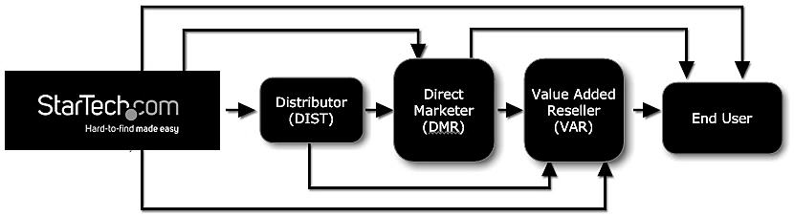

Source: Company files.

Exhibit 2: StarTech.com Product Life-Cycle Position

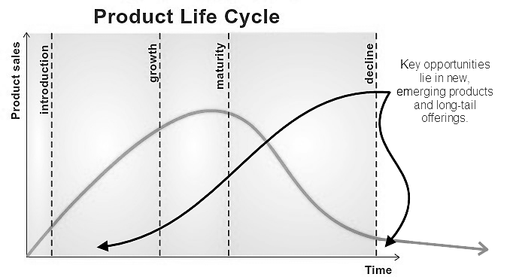

Source: Company files.

Exhibit 3: Examples of StarTech.com Cables

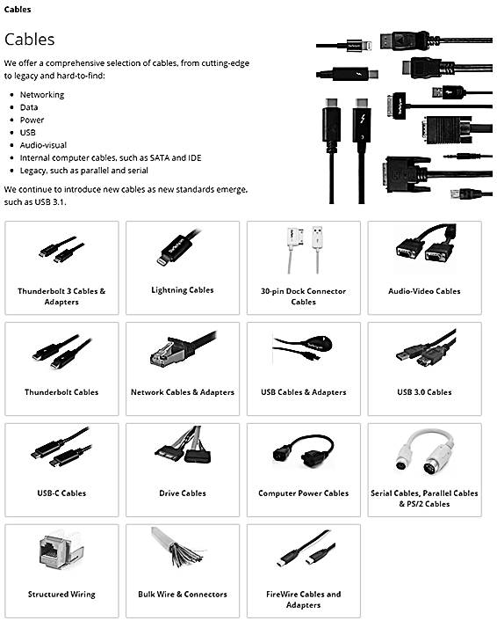

Source: Company files.

Exhibit 4: Cable SKUs at Distributor



Rank: A = high demand; B = medium demand; C = low demand; Y = discontinued.

SKU Category: C = commodity item; S = hard-to-find.

Average inventory levels provided in number of units.

Source: Company files.

Exhibit 5: Monthly Demand



Note: The standard deviation in the total column is based on the total average monthly demand (i.e., it is not the sum of the standard deviation values at the individual warehouses).

Source: Company files.

1. All currency amounts are in Canadian dollars unless otherwise specified.