|  |  |
| --- | --- |
|  |  |

9B17D008

ShopClues: Turning Logistics into a Competitive Advantage

Anupama Prashar wrote this case solely to provide material for class discussion. The author does not intend to illustrate either effective or ineffective handling of a managerial situation. The author may have disguised certain names and other identifying information to protect confidentiality.

*This publication may not be transmitted, photocopied, digitized, or otherwise reproduced in any form or by any means without the permission of the copyright holder. Reproduction of this material is not covered under authorization by any reproduction rights organization. To order copies or request permission to reproduce materials, contact Ivey Publishing, Ivey Business School, Western University, London, Ontario, Canada, N6G 0N1; (t) 519.661.3208; (e)* [*cases@ivey.ca*](mailto:cases@ivey.ca)*;* [*www.iveycases.com*](http://www.iveycases.com)*.*

Copyright © 2017, Management Development Institute, Gurgaon and Richard Ivey School of Business Foundation Version: 2017-06-28

ShopClues has developed a marketplace for the masses by building a technology platform that connects Tier 2 and Tier 3 customers [households with income between $6,000 and $15,000[1] residing in Tier 2 and Tier 3 cities] with regional/local brands.[2]

Sanjay Sethi, chief executive officer and co-founder, ShopClues.com

In March 2016, Ranjit Mayne, senior director of logistics and fulfillment at ShopClues.com (ShopClues), a leading online marketplace headquartered in Gurgaon, India, was reflecting on the company’s positive turnaround in logistics strategy. Until 2014, the company had been dependent on air transport to deliver shipments, which had limited it to Tier 1, Tier 2, and a few Tier 3 cities[3] (covering 8,000 postal index numbers or PIN codes). It was entirely reliant on the few national courier services such as Blue Dart Express Limited, Ecom Express Private Limited, and Gati Ltd. for deliveries. These services had high logistics costs per unit and were not able to reach customers in Tier 3 and 4 cities, which left customers unable to place orders and dissatisfied.

To meet delivery service-level agreements (SLAs), expand its reach, and reduce delivery costs, ShopClues had shifted to a logistics outsourcing strategy, which involved using a combination of national and regional partners. To further optimize logistics costs, the company shifted from an air mode to an express surface mode of transportation. During its mega Diwali sale in November 2015, 70 per cent of orders were delivered by third-party logistics (3PL) partners through express surface delivery covering 19,000 PIN codes. This increased to 95 per cent during the 2016 Diwali sale. By the end of 2016, ShopClues was delivering over two million orders per month across 30,000 PIN codes in the country, using a network of 37 3PL partners (see Exhibit 1). “Our network of logistics partners delivers to nearly 30,000 destinations across India, which is the largest for any e-commerce site in the country,” Mayne noted.

In February 2016, ShopClues became the fourth entrant in the country’s “unicorn club”[4] of e-commerce marketplaces (after Flipkart, Snapdeal, and Paytm) after it successfully secured funds from investors, including Singapore’s sovereign wealth fund, GIC Private Limited. The company was targeting to be profitable and to file an initial public offering (IPO) of its shares on the Nasdaq stock exchange by the first financial quarter of 2018.[5] To achieve the goal to be the first profitable e-commerce company in the country, ShopClues’s logistics and delivery functions had a crucial role to play. As head of the logistics function at ShopClues, Mayne had some tough questions to answer: How would the logistics strategy support the company’s growth strategy? How could it meet evolving expectations of customers from its online marketplace? What would be the merits and demerits of a 3PL strategy? How could ShopClues leverage technology to optimize logistics services?

E-COMMERCE INDUSTRY AND LOGISTICS

The Indian e-commerce industry, growing at a compound annual growth rate (CAGR) of 31 per cent, was expected to reach $80 billion by 2020—up from an estimated $27.5 billion in 2016.[6] According to a recent KPMG report, the online travel segment (i.e., e-ticketing and travel booking) dominated the Indian e‑commerce market at 61 per cent, followed by online retailing. The online retail market was estimated at $12 million in terms of gross merchandise value (GMV). With the presence of both home grown e‑retailers—such as Flipkart, a 10-year-old company with 46 million registered users, and Snapdeal, a six-year-old online marketplace company—and subsidiaries of international e-retailers, such as Amazon India, competition was fierce in this market.

An efficient supply chain (logistics) was a key enabler for the growth of e-commerce in the country. The trend in the e-commerce logistics market saw companies shifting from using in-house logistics infrastructure to outsourcing logistics services to 3PL partners. The 3PL partners included traditional logistics service providers (LSPs), e-commerce–focused logistics providers, and India Post. In terms of the mode of transport, the preference was shifting from air transport to express surface transport, since airline hauls cost four times as much as similar surface hauls. The 3PL companies that focused on e-commerce offered a complete package of services—from procurement and storage to packaging and delivery—to online retailers operating in the marketplace model. This not only allowed retailers to mitigate the risk of transportation delays, damages, and losses, but it also expanded their reach to include Tier 2 and 3 cities, where cash on delivery (COD) was the preferred mode for transactions. The 3PL companies also paved the way for small and medium enterprises (SMEs) spread across different geographical regions to participate in the growth of e-commerce. With the help of 3PL partners, online retailing companies could offer specialized value-added services, such as time-bound deliveries (same day or next day deliveries), card (swipe) on delivery, and parcel lockers.[7] The 3PL partners supported e-commerce players in enhancing customer trust, conversion rates, and repeat purchases on the portals.

SHOPCLUES.COM

ShopClues.com, one of the largest online marketplaces, was headquartered in Gurgaon, India. It was the subsidiary of Clues Network Pvt. Ltd., a U.S. corporation founded by a team of entrepreneurs from Silicon Valley. While the major e-commerce players in India ventured into online retail through an inventory-led model, ShopClues was the first to adopt a zero-inventory (managed-marketplace) model from its inception in June 2011 (see Exhibit 2). The company believed that the next stage of growth in the e-commerce industry would come from smaller cities and non-metropolitan areas, where the average ticket size might be low (around $12–$15), but volumes would be higher.

Therefore, unlike other marketplaces, which focused on selling mobiles, electronics, and high-end fashion brands in major cities, ShopClues brought unstructured product categories such as home and kitchen, appliances, unbranded apparel, auto accessories, and mobile and laptop accessories into smaller cities and rural regions. The platform targeted price-conscious households with low disposable income residing in Tier 2 and 3 Indian cities. These customers preferred online marketplaces not for convenience but for value. Over 70 per cent of ShopClues’s GMV, which grew to $1.2 billion in fiscal year (FY) 2016–17 (see Exhibit 3), was attributed to sales registered in the unstructured categories from smaller towns and cities.[8]

As a marketplace popular for unstructured product categories, ShopClues created an aggregation of over half a million registered sellers (merchants) over a period of five years.[9] This large pool of sellers boosted the availability of offerings in the unstructured category on the platform, leading to high conversion rates. ShopClues’s interface, Indimarket,[10] allowed sellers to showcase region-specific traditional artwork from eight states and 21 cities in India. The company enabled merchants to digitize its businesses by offering support in designing websites and mobile applications (apps), and creating electronic points of sale (EPOS) in its physical stores. ShopClues designed a host of services for its merchant community via partnerships with some of its acquired companies, such as mobile payment app Momoe, and an investment in HeyBiz, a chatting app for merchants. “We treat our 650,000 merchants like our 650,000 warehouses to keep our capital expenditures low,” Mayne explained.

As one of its initiatives to promote SMEs, ShopClues launched the first online wholesale marketplace.[11] Buyers had to register for ShopClues club memberships for a minimal annual fee of $15 to participate in the wholesale deals. These deals were offered in both minimum-order quality and fixed-lot formats. More than 20,000 SMEs became members to take advantage of the benefits of this online marketplace for buying and selling goods.

Through its differentiated approach to e-commerce, the company was able to successfully raise funding to expand its market presence from a series of angel investors. In terms of business growth, the orders processed on the portal increased from 689,000 in 2012 to over 12 million in 2015 (see Exhibit 4). By March 2015, the company had the lowest losses among the e-commerce majors, at $15 million; Snapdeal’s losses were $199 million, Amazon India’s were $259 million, and Flipkart’s were $300 million.[12] The company was aiming for profitable earnings before interest, tax, depreciation, and amortization (EBITDA) by the end of 2017, targeting topline sales of between $2.5 and $3.0 billion by FY 2017–18.[13]

LOGISTICS as a COMPETITIVE ADVANTAGE

ShopClues’s strategy to break even in the next few months relied on high margins, a clear focus on Indian consumers (over 150 million Indians residing in Tier 2 and 3 cities), the country’s vast merchant network, and its lower price points. With an underdeveloped logistics system in the country and a dearth of pan-Indian courier options, cost-effective access to Tier 2 and 3 markets was the biggest challenge for the company. Mayne commented, “Due to the unavailability of digital access, banking, and gateways, and lack of trust in online retail in these deeper pockets of India, building a customer base was challenging.”

Logistics Strategy

The logistics needs of ShopClues were quite different from those of offline retailers and other e-commerce players. With a wide geographical spread in terms of both its sellers (more than 650,000 merchants across the country) and customers (covering 30,000 PIN codes), the company faced a huge challenge in achieving competitive transportation costs (for procurement and delivery of large numbers of small orders) and delivery times (especially for interstate deliveries). The virtual nature of the electronic transactions on the platform further raised customers’ expectations with respect to service quality and speed of delivery. Managing the reverse logistics for sales returns (an average 5 per cent) for the portal was another issue. “Logistics and supply chain have been the key focuses of the company since [they are the] only way of ensuring faster delivery, wider reach, and [of] reducing delivery cost, which in turn will help us to win over the competition,” Mayne expressed.

To overcome these challenges and bring efficiency into its distribution system, ShopClues adopted a logistics outsourcing strategy. It outsourced its logistics for both forward and reverse handling of orders to regional logistics players (see Exhibit 4 and 5). Some of the 3PL partners were The Professional Couriers, Wedib Express Ltd. courier tracking, DNV Logistics, and Beacon Courier and Cargo (India) Pvt. Ltd. The 3PL partners offered services such as express/non-express road transportation, route/delivery planning, real-time tracking, and reliable documentation. “We don’t have any logistics company that covers the length and breadth of the country. That is the reason why we need to partner with regional players to get to the depth of the country,” Mayne added.

Most of these small 3PLs, operating from small cities and rural areas, lacked the financial capability to invest in technology. ShopClues built a plug-and-play (system integration) technology platform for real-time exchange of data between the portal and the 3PLs, facilitating effective communication. This platform also helped in demand management by allocating order volumes based on partners’ capacities and past delivery performance. “We are currently working on integration of individual application program interfaces (APIs) of different logistics partners,” Mayne said. Broadly, the logistics outsourcing strategy had enabled ShopClues to achieve economies of scale by focusing on its core business of driving sales, reducing investment in logistics infrastructure, reducing risk, and ensuring wider market coverage.

ORDER FULFILLMENT CYCLE

ShopClues was operating primarily with a marketplace model, with a mere 3 per cent of the orders processed by company-owned fulfillment centres in major cities; 97 per cent of the orders were processed by the sellers. The logistics operations involved in a typical forward order fulfillment (see Exhibit 5) were as follows.

Order Processing

ShopClues used technology to enhance the efficiency of order processing, a critical aspect with a direct impact on customer satisfaction in e-commerce. Once a customer placed an order for a product on the portal, the inbuilt software checked the prices, taxes, and terms of payment (credit card or cash on delivery) and assigned an order number. The order was then assigned for shipment to a suitable 3PL partner with the help of a back-end decision support system (DSS). The DSS enabled automatic selection of a suitable 3PL partner based on multiple factors such as SLA for pickup, shipping, and last-mile delivery; SLA for return to origin (RTO); and cost of RTO (for reverse orders).

Inventory Management and Order Fulfillment

Honouring delivery commitments to customers was of paramount importance to remain competitive in the e-commerce industry. This required integrating information on orders captured online with the inventory and fulfillment system. ShopClues’s online interface allowed its vast aggregation of sellers to view order status and other delivery details. The APIs and system integration improved the visibility of shipments and helped ascertain shipment status and reasons for any delays.

ShopClues offered three types of fulfillment services to sellers. Under the Velocity Premium (SCVP) service, the company managed the complete fulfillment process, from pickup, quality inspection, packaging (affixing invoice and labels with consignee details, item details, and quantity), and delivery through its 3PL partners. This service was offered through company-owned and outsourced fulfillment centres, which had state-of-the-art facilities for fulfilling high-value, low-volume products such as mobile phones, laptops, and mobile accessories. The Velocity Basics (SCVB) service offered shipment and delivery only, with other fulfillment processes managed by the seller. This service was available in Tier 1 to Tier 4 cities. Under the Merchant Direct Fulfillment (MDF) service, merchants managed the complete fulfillment process without ShopClues intervention. This option was limited to sellers who handled certain special categories that required special attention, such as furniture and sports equipment. A packaging service fee of $0.44 per order and a fulfillment fee of $0.83 per 500 grams of product shipped were charged by the portal for this service.

Shipping

Order-status information flowed to the 3PL partner selected by the DSS through the pickup API. This allowed the 3PL to schedule pickup of the packages that had been previously processed at the seller’s site or the fulfillment centre. Once packages were shipped, the order status was updated as “dispatched” through the connection API. The shipment details (3PL partner name and tracking number) were sent to the customer via e-mail, short message service (SMS), or an order-status link on the portal.

Tracking

Customers could track the status of their in-transit order at the ShopClues portal or the 3PL portal using the order number or airway bill number (referred as a tracking number). Regular updates on the status of orders were also automatically sent to customers via SMS and e-mail. 3PL SLAs were classified based on the destination of order delivery—within a city, within a zone, within a metropolitan area, or in the rest of India. For instance, the SLA for within-city order delivery was three to five days. Although 95 per cent of orders were delivered as per the SLA, in case of delays, non-delivery reason (NDR) updates were sent. These NDR updates were in real time, transmitted within minutes of the event occurring. The ShopClues team followed up with 3PLs on all within-city pending orders that took more than three days.

Order Delivery

The 3PL partner was required to make at least three order delivery attempts before initiating an RTO. An RTO meant that the order delivery was unsuccessful, and the product was sent back to the seller. If an RTO was initiated for a COD order, the product was sent back to the seller. For a paid order, the full amount was refunded to the customer if the customer refused reshipment.

Reverse Material Flow

To protect customer interests, ShopClues had a well-structured return and replacement policy for products that were damaged, unsatisfactory, or the wrong product. The company had a network of reverse 3PL partners, such as Nuvoex and Pikndel, for handling 4,000 reverse orders per day across 14,000 PIN codes (see Exhibit 1). Within 10 days of order delivery, a customer could file a return request on the portal and a pickup would be arranged within two business days, without any additional fee to the customer. Over 95 per cent of customers who returned items received refunds within 12 to 24 hours of pickup. The reverse logistics partners offered both “doorstep-quality-check” and “return-to-seller” services to the company.

In case of self-shipment by customers from cities that were not covered by the reverse 3PLs, ShopClues reimbursed the courier charges in the form of “Cluesbucks,” loyalty points credited to the customer’s account on every purchase. These returns were analyzed based on the reason for return. Products returned due to a mismatch with customer preference were sent back to the sellers. Products returned because of damages were classified as a seller or 3PL liability, costs were recovered, and products were handed over to the sellers or the 3PL. If products were significantly damaged or if the seller or 3PL refused to accept the products, they were scrapped based on confirmation of this refusal.

WAY FORWARD

ShopClues was already a member of the unicorn club, and it was now targeting to be profitable. For an online marketplace connecting 25 million registered customers and over 500,000 sellers spread across Tier 2 and 3 cities, scaling up its logistics capability was the need of the hour. The company had adopted the strategy of outsourcing logistics instead of building its own logistics infrastructure in order to expand reach, reduce logistics costs, and achieve faster order deliveries. It had developed the largest aggregation of regional 3PL partners to achieve effective forward and backward logistics.

Technology had played a pivotal role in improving ShopClues’s logistics services. Investing in a plug-and-play technology platform and integrating individual sellers with the platform using APIs were steps toward improving the flow of information to and from the sellers and reducing the dependence on manual procedures. The company had also worked to develop strategic technology solutions for 3PL partners to improve the tracing of shipments and ensure timely delivery. “We have invested in technology to integrate about 90 per cent of our 3PL partners to ensure faster information flow between our customers and merchants. This will lead to reduced delivery times, integrated tracking, and real-time updates on both forward and backward deliveries,” Mayne said.

To strengthen its logistics services, ShopClues continuously expanded its fulfillment space to offer fulfillment services to its sellers. It planned to invest in over 9,000 square metres of fulfillment space, adding 10 new fulfillment centres to the existing four centres.[14] With stringent competition in the Indian e‑commerce industry, it was yet to be seen if this unicorn could achieve sustainable profits in the near future with its 3PL services.

EXHIBIT 1: SHOPCLUES LOGISTICS FACT SHEET (FY 2016–17)

|  |  |
| --- | --- |
| **Number of Forward Orders per Month** | > 2 million |
| **Number of Reverse Orders per Day** | 3,000 |
| **Number of Forward Couriers** | 37 |
| **Number of Reverse Couriers** | 10 |
| **Number of Forward PIN Codes** | 29,950 |
| **Number of Reverse PIN Codes** | 12,650 |
| **Team Strength** |  |
| ***Fulfillment Ops*** | 19 |
| ***Forward*** | 30 |
| ***Reverse*** | 13 |
| **Merchant Strength** | 650,000 |
| **Customer Base** | 30,000,000 |

Source: Company documents.

EXHIBIT 2: INVENTORY-LED AND MARKETPLACE MODEL

Inventory-Led Model

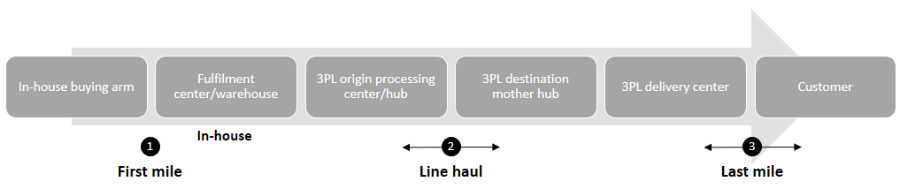

Marketplace Model

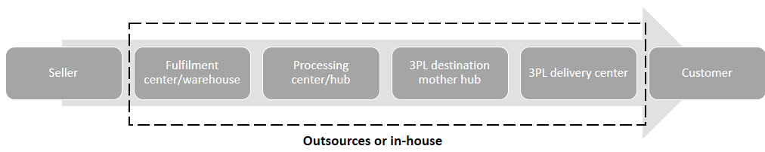

Source: Company documents.

EXHIBIT 3: SHOPCLUES—GROWTH IN GROSS MERCHANDISE VALUE (in US$ millions)

|  |  |
| --- | --- |
| Year | Gross Merchandise Value |
| 2012 | 5 |
| 2013 | 32 |
| 2014 | 110 |
| 2015 | 500 |
| 2016 | 1,100 |

Source: Company documents.

EXHIBIT 4: SHOPCLUES—GROWTH IN number of ORDERS PROCESSED (in millions)

|  |  |
| --- | --- |
| Year | Orders Processed |
| 2012 | 1 |
| 2013 | 3 |
| 2014 | 7 |
| 2015 | 12 |
| 2016 | 18 |

Source: Company documents.

EXHIBIT 5: ORDER FUFILLMENT CYCLE AT SHOPCLUES

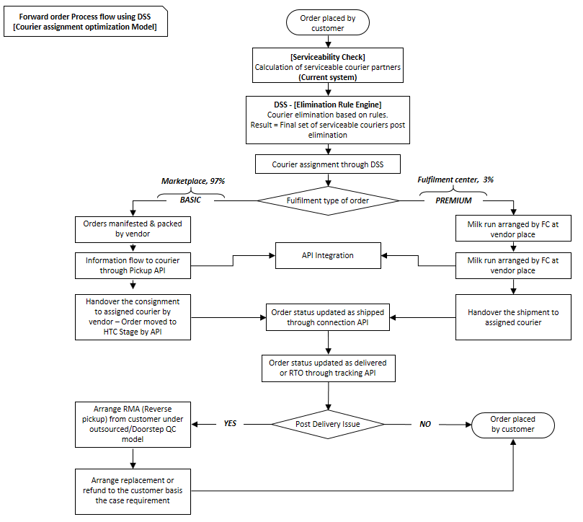

Source: Company documents.

1. Currency amounts are in U.S. dollars, unless otherwise noted.
2. Athira A. Nair, “How ShopClues Joined the Unicorn Club,” YourStory, January 29, 2016, accessed March 3, 2017, https://yourstory.com/2016/01/ShopClues/.
3. Indian cities are classified based on population; Reserve Bank of India, “Section 23 of the Banking Regulation Act, 1949: Relaxations in Branch Authorisation Policy—Annex II (Details of Tier-Wise Classification of Centres Based on Population),” accessed October 28, 2015,https://rbi.org.in/scripts/NotificationUser.aspx.
4. *Unicorn* was a term used to describe a start-up company valued at over US$1 billion.
5. PTI, “ShopClues Plans Nasdaq Listing Next Year, Eyes $2 Billion in Sales,” ET Markets, December 6, 2016, accessed March 4, 2017, http://economictimes.indiatimes.com/articleshow/55836257.cms.
6. KPMG, *Fulfilled! India’s E-Commerce Retail Logistics Growth Story,* August 2016, accessed March 24, 2017, https://assets.kpmg.com/content/dam/kpmg/in/pdf/2016/08/E-commerce-retail-logistics-India.pdf.
7. These were parcel pickup and drop-off centres that allowed buyers to collect or return goods.
8. Jai Vardhan, “550 Employees and Four Years Later, This Is What Shopclues Is up To,” YourStory, March 2, 2015, accessed March 5, 2017, https://yourstory.com/2015/03/ShopClues-cracked-alexa-60/.
9. Rebecca Menezes, “Shopclues Big Business Boom to Boost Festive Sales & Seller Base?” Indianonlineseller.com, October 5, 2016, accessed May 5, 2017, http://indianonlineseller.com/2016/10/shopclues-big-business-boom-to-boost-festive-sales-seller-base/.
10. ANI, “ShopClues to Promote ‘Make in India’ Vision with IndiMarket,” *Times of India*, June 1, 2016, accessed March 26, 2017, http://timesofindia.indiatimes.com/city/delhi/ShopClues-to-promote-Make-in-India-vision-with-IndiMarket/articleshow/52536722.cms.
11. Sugandh Dhawan, “ShopClues Launches India’s First Online WholeSale Marketplace,” Iamwire.com, March 14, 2014, accessed March 25, 2017, www.iamwire.com/2014/03/ShopClues-launches-indias-online-wholesale-marketplace/25885.
12. Karan Choudhury and Nivedita Mookerji, “We’ve Already Toppled Flipkart, Snapdeal: ShopClues CEO,” *Business Standard*, January 26, 2016, accessed March 15, 2017, www.business-standard.com/article/companies/we-ve-already-toppled-flipkart-snapdeal-ShopClues-ceo-116012600002_1.html.
13. Mehak Sharma, “ShopClues on Track to Turn Profitable by FY17; Eyes US$2 Billion in Sales,” IndiaRetailing.com, December 9, 2016, accessed March 15, 2017, www.indiaretailing.com/2016/12/09/retail/ShopClues-on-track-to-turn-profitable-by-fy17-eyes-us-2-billion-in-sales/.
14. Pooja Vishant, “ShopClues to Expand Its Fulfillment Spaces to Strengthen Shipping,” Indian Online Seller, September 10, 2014, accessed March 20, 2017, http://indianonlineseller.com/2014/09/ShopClues-expand-fulfillment-spaces-strengthen-shipping/.