

**9B17D015**

**Safe boat trip ltd.: launching the flying ferries**

Joshin John, Neetha J. Eappen, and Sushil Kumar wrote this case solely to provide material for class discussion. The authors do not intend to illustrate either effective or ineffective handling of a managerial situation. The authors may have disguised certain names and other identifying information to protect confidentiality.

*This publication may not be transmitted, photocopied, digitized, or otherwise reproduced in any form or by any means without the permission of the copyright holder. Reproduction of this material is not covered under authorization by any reproduction rights organization. To order copies or request permission to reproduce materials, contact Ivey Publishing, Ivey Business School, Western University, London, Ontario, Canada, N6G 0N1; (t) 519.661.3208; (e)* [*cases@ivey.ca*](mailto:cases@ivey.ca)*;* [*www.iveycases.com*](http://www.iveycases.com)*.*

*Copyright © 2017, Richard Ivey School of Business Foundation Version: 2017-09-25*

Paul George, principal superintendent at Safe Boat Trip Private Limited (Safe Boat Trip) in Kerala, India, had been recently put in charge of managing the operations for launching two hydrofoils the company had procured from Greece. During a project meeting on July 28, 2016, Varkey Tolin, managing director, presented the idea to commission the boats into service by the time of Onam, the most revered festival in Kerala, set to begin the second week of September that year. Tolin suggested that it would be ideal to launch the boats during the festival of harvest and rain flowers to benefit from the tourism potential of the season in Kerala.

George, an experienced marine engineer and fleet superintendent, was specially entrusted with creating a feasible project plan for commissioning the hydrofoils into service. Management at Safe Boat Trip also wanted to know when the boat service would break even once it was in business. With these challenges before him, George set out to devise a solid plan of action before the company’s next meeting.

COMPANY BACKGROUND

Safe Boat Trip, incorporated on September 1, 2014, was part of the Tolins Group of Companies (Tolins), which had diverse business interests ranging from agricultural products, natural latex rubber production, and tire manufacturing to educational institutions, hotels, resorts, and houseboat cruises in the backwaters of Kerala. Safe Boat Trip was the maiden venture of the Kalady-based Tolins in the regulated and organized sector of coastal shipping and passenger transport. Although Tolins was active in the tourism sector—owning and operating timber houseboats in the sheltered backwaters of Kerala—registering and operating an aluminum-hull coastal vessel (see Exhibits 1 and 2) with classification by the Indian Register of Shipping (IRS) was unchartered territory for the company. Safe Boat Trip was gearing up to launch the first hydrofoil passenger ferry service in India, and filling all statutory requirements necessary for the safety and comfort of passengers.

THE FLYING FERRIES

Hydrofoils were special high-speed crafts with hulls that were lifted out of the water as the boat gained speed. They worked on the same principle of winged aircrafts fitted with airfoils, which lifted from the runway owing to the differential pressure or lift created under the wings when the airplane gained momentum. Hydrofoil crafts were usually strutted with U-shaped surface piercing foils or inverted-T-shaped, fully submerged foils underneath their hull (see Exhibit 3). As the foil-equipped craft increased its speed, the hydrofoil elements under the vessel generated sufficient lift to raise the hull above the water, with the foil skimming over the surface at very high speeds.

At cruise speed, the resistance of the vessel was minimum, as the hull was above the water, significantly reducing drag and providing better fuel efficiency. Hydrofoil crafts could thus be described as flying ferries. The cost of building one was prohibitively expensive, more expensive than building a conventional boat because of the complexity in its design, construction, and maintenance.

Safe Boat Trip procured two sister hydrofoil crafts, constructed at the Volga Shipyard in Russia, from Greece for US$2.3 million[1] per boat. The vessels were shipped from Athens and arrived at the Port of Kochi, India, in late July 2016. During their service life, the hydrofoils had changed registration from the International Association of Classification Services class member Russian Maritime Register of Shipping to Croatian Register of Shipping in 2006. George looked keenly at the details of the crafts (see Exhibit 3), and listed the necessary steps for re-classing the hydrofoils with another reputed International Association of Classification Services member, the IRS.

TECHNICAL MEETING AT SITE

At a site meeting on August 6, 2016, George delivered a briefing on the status of the project’s activities: “In order to commission the hydrofoils,” George began, “we need to list all of the activities required to be completed and approved by the competent authority. As a starting point, we can classify the tasks that have to be performed under three major headings: hull, machinery and outfitting work. Of course, there will be some miscellaneous items, including special inspections and documentations, which we can deal with separately.” George continued,

The hull, inclusive of all shell plates, bulkheads, and deck plating, needs to be gauged in order to satisfy the minimum thickness requirements of the IRS, and the engineering drawings required for re-classification need to be submitted. An endoscopy needs to be done for the main engines, and other auxiliary machinery and equipment are to be overhauled and tested for satisfactory performance. We also need to look at the condition of the outfit components and instrumentation for navigation in the cockpit.

Captain Sivankutty, a master mariner and the nautical superintendent of Safe Boat Trip, added,

That’s right. The vessels were stacked for quite some time before we got them shipped to Kochi. We need to check whether the navigation panels in the bridge are in working condition, and if not, get them repaired or replaced. Besides that, the aluminum hull will need a new coat of anti-fouling paint and sacrificial zinc anodes to protect the hull from being corroded in salt water. But that would be only after the renewal of necessary plates, after the hull gauging report comes in.

The team circled the vessels, which were rigged upright on cradles, inspecting the different areas underneath the boats’ hulls. They walked from the stern of the vessel, ducking under the propellers, to the mid-ship region, and climbed the embarkation ladder that took them to the main deck. “The propellers look alright, but we need to check for propeller shafting and the stern tube alignment for any possible anomalies. But that can run in parallel with the hull work,” George said as he reached the main deck.

The passenger seating area on the main deck was empty; the seats had been removed to be replaced with new ones. A few sample seats from one of the upholstery vendors had been kept for display. K. Shammy, the principal surveyor from the IRS present for the site inspection, remarked,

George, it’s good to see the new seats alright. But they look slightly bulky and wider than the regular ones. We need to be careful about the ergonomics and that the total weight of passenger seats are within the design limits, lest there be a noticeable increase in the lightship weight of the hydrofoils. Also, consider the width of the walkways in the passenger seating area. There should be sufficient space for fire escape and muster plans. But I’m sure you’ll take care of all this before you submit the revised drawings for firefighting and life-saving appliances.

“Sure, sir,” George answered. “We already have the original as-built class drawings from Volga Shipyard. But we will be submitting all necessary drawings and documentation incorporating the ongoing modifications onboard the vessels for re-classification.”

George and Shammy spent some time inspecting the forecastle deck, engine room, wheelhouse, and the void tanks beneath the main deck. The breeze was steady at the quayside at Mattancherry Wharf, where the vessels were stacked for refurbishment. The sky was slightly overcast but not ominous, which was characteristic of the Southwest monsoons. Sivankutty, sitting at the quayside, was busy taking notes about the project in his log (see Exhibit 4). As the team disembarked from the boat, he handed the logbook to George, saying, “I think I got the gist of the work breakdown structure here with the precedence constraints. I’ve also put in some timelines based on discussion with the suppliers and fabricators. Take a look.”

George was delighted to see the notes prepared by his colleague. There was much clarity now about the technicalities of managing the project. Safe Boat Trip management had envisioned starting the ferry service at Kochi and running to the two major coastal port cities in Kerala: Calicut in the North, and Trivandrum in the South. In order to boost coastal shipping and transport, the government of Kerala had recently drafted policies favouring water transport, including a subsidy of ₹1[2] per kilometre. This, they hoped, would take some congestion off the overburdened road network. George had sought the advice of Yohan Lee, a marine consultant, on the business feasibility of the hydrofoil ferry project, including running costs.

The site meeting had gone well. Few major concerns were raised, but a lot of work was needed to renovate the ferries and give them a facelift before the launch. The meeting ended on a high note when the IRS agreed to accept the original as-built drawings from Volga Shipyard for structural zones; the drawings did not have to be modified, with the exception of adding an annotation in English alongside the original Cyrillic script. After the meeting, as George showed the team into the Bristow Lounge of the Merchant Navy Club for lunch, a notification popped up on his mobile phone. It was for an e-mail from Lee, listing the operational costs and other business details related to the hydrofoil ferry project (see Exhibit 5). George could not hide his smile as he said, “Sivankutty, I’ve got mail from Yohan [Lee]. Looks like we’re in business.” Sivankutty let out a hearty laugh and nodded, saying, “Almost, George. Almost.”

Exhibit 1: Classification Schema for Registering HSC and LC with the Indian Register of Shipping

Regime of Application of HSC and LC Rules

No

V ≥ 4.8 Δ1/6

**?**

Class Notation **LC**

Yes

Non-Passenger (Cargo) Vessels

Passenger Vessels

Non-IMO Vessels

GT ≥ 500 and

t < 8 hours

GT < 500

V ≥ 7.16 Δ1/6

**?**

Fast Vessels

Yes

Class Notation **HSC**

Class Notation **HSLC**

Class Notation **HSC**

Class Notation **HSLC**

No

**Legend**

HSC: High-Speed Craft

LC: Light Craft

HSLC: High-Speed Light Craft

GT: Gross Tonnage

V: Velocity in Knots

Δ: Displacement (Tonnes)

IMO: International Maritime Organization

Source: Created by the authors based on information from the Indian Register of Shipping.

Exhibit 2: Scope, Character, and Hull Notation for Classification with IRS

IRS Classification covers a craft’s hull, appendages, and machinery, including electrical systems to the extent specified in the Rules and Regulations for High-Speed Crafts (HSC) and Light Crafts (LC) (section 3.3).

**Character of Classification** (section 3.5)

The following characters and symbols are assigned by the IRS to indicate classification of HSC and LC.

|  |  |
| --- | --- |
| Character | Description |
| SUL | Assigned to seagoing crafts; indicates that the hull, appendages, and equipment (i.e., anchors, chain cables, and hawsers) meet the rule requirements for assignment of the classification character. |
| SU | Assigned to seagoing crafts; indicates that the hull and its appendages meet the rule requirements, but in respect of the equipment, the IRS has agreed that the normal equipment is not necessary in view of their particular service. |
| SU- | Assigned to seagoing crafts; indicates that the hull and its appendages meet the rule requirements. Equipment is not supplied or maintained as per the relevant rules, but is considered by the board of the IRS to be acceptable for their particular service. |
| IY | Assigned to self-propelled seagoing crafts; indicates that the machinery meets the rule requirements for assignment of the classification character. |

**Class Notation—Hull** (section 3.6)

Main Notation: HSC, LC, or HSLC (High-Speed Light Craft)

Service Type Notation (depending on the primary nature of service): Passenger, Cargo, Supply, Workboat, Pilot, Patrol, Rescue

Service Area Restriction Notation: Depending on the sea conditions in the service area for which the craft has been approved and constructed, appropriate service restriction shall be assigned.

|  |  |
| --- | --- |
| **Notation (Service Area Restriction)** | **Design Significant Wave Height [m]** |
| RS0 | Hs ≥ 4.0 m |
| RS1 | 2.5 m ≤ Hs ≤ 4.0 m |
| RS2 | 0.6 m ≤ Hs ≤ 2.5 m |
| RS3 | Hs ≤ 0.6 m |

Note: In addition to the above, crafts may be assigned a service range notation, limiting the distance in nautical miles from the place of refuge or the coast, if requested. For example, “for operation within 20 nm from the coast.” It is predicted with a 95% confidence interval that there is a probability of extreme waves at a height of 4.00 m and 4.14 m for storm return periods of 5 years and 10 years respectively, off the coast of Kerala. However, the proposed route of hydrofoil service is in restricted waters with wave heights in the range of 0.6 m to 2.5 m.

Example of classification assigned to a craft with character and notation: **IY, LC, RS 3, Workboat**

Note: IRS = Indian Register of Shipping; nm = nautical miles; m = metres.

Source: Created by the authors based on information from the Indian Register of Shipping.

Exhibit 3: general arrangement of hydrofoil ferries and foil types

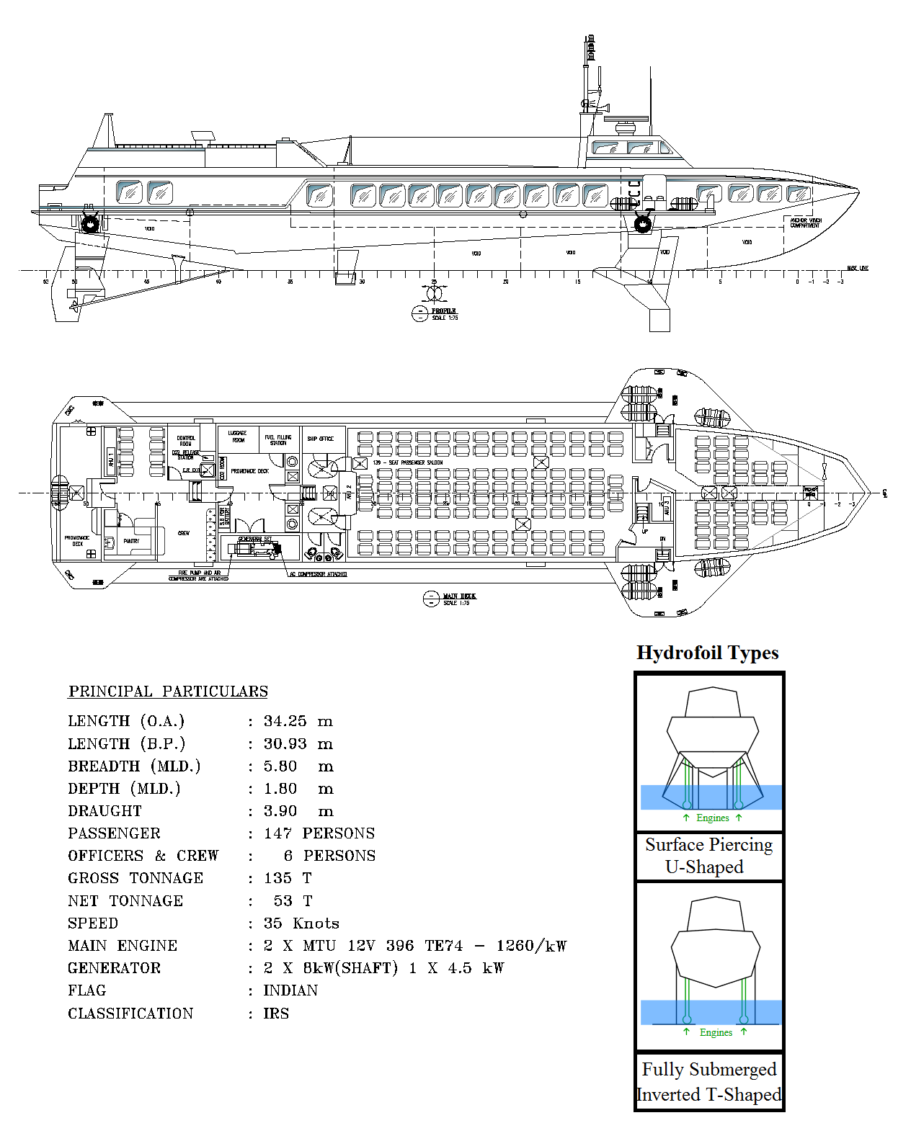

Note: O.A. = Over all; m = metre; B.P. = Between Perpendiculars; MLD. = Moulded; T = Tonnes; MTU = Name of OEM (Original Equipment Manufacturer); TE = This is part of the model number of the engine; kW = kilo Watt; IRS = Indian Register of Shipping

Source: Company documents.

Exhibit 4: Project Notes from Captain Sivankutty—Work Breakdown Structure

|  |  |  |  |  |
| --- | --- | --- | --- | --- |
| Category | # | Activity | Duration | Precedence |
| Hull (Main) | H1 | Hull Survey | 1 week | - |
| H2 | Plate Gauging | 2 weeks | H1 |
| H3 | Plate Renewal | 14 weeks | H2 |
| H4 | Tie Coat | 2 weeks | H3 |
| H5 | Anti-Fouling Paint | 2 weeks | H4 |
| H6 | Stern Tube Repair | 4 weeks | H1 |
| Hull (Appendages) | H7 | Rudder and Rudder Stock | 3 weeks | H1 |
| H8 | Skeg and Support Structure | 2 weeks | H1 |
| H9 | Hydrofoil Structure | 2 weeks | H8 |
| Machinery | M1 | General Machinery Inspection | 2 weeks | - |
| M2 | Main Engine Overhauling | 13 weeks | M1 |
| M3 | DG Set Testing | 5 weeks | M1 |
| M4 | Other Equipment and Pump Tests | 7 weeks | M1 |
| M5 | New Machinery Installation | 8 weeks | M2, M3, M4 |
| M6 | Fuel/Lube/Coolant Check | 2 weeks | M5 |
| M7 | Propeller Shaft Alignment | 3 weeks | H6, M5 |
| Outfit | O1 | Panelling and Woodwork | 8 weeks | H1 |
| O2 | Towing and Mooring Equipment | 4 weeks | M1 |
| O3 | HVAC and Reefer Equipment | 2 weeks | M1 |
| O4 | Navigation Instruments | 3 weeks | H1 |
| O5 | Fire Fighting Equipment | 4 weeks | H1, M1, O8 |
| O6 | Life Saving Appliances | 3 weeks | H1, O8 |
| O7 | Sacrificial Anodes | 2 weeks | H3 |
| O8 | Passenger Seating Arrangement | 6 weeks | H1, O1 |
| Documentation | D1 | Class Drawings | 12 weeks | H3, M5 |
| D2 | Statutory Documentation | 10 weeks | H1, M1, O5, O6 |
| D3 | Approved OEM Certificates | 4 weeks | M5 |
| Miscellaneous | Z1 | Overall Inspection | 4 weeks | H*, M*, O*, D* |
| Z2 | Vessel Launch and Commissioning | 2 weeks | Z1 |

Note1: DG = diesel generator; HVAC = heating, ventilation, and air conditioning; OEM = original equipment manufacturer

Note 2: * indicates all activities under the specified category.

Source: Company documents.

Exhibit 5: Operational Costs and Comparison of Transport Mode Fare and Duration

|  |  |  |  |
| --- | --- | --- | --- |
| **Operational Expenses** |  | **Operational Expenses** |  |
| Repair and Commissioning† | ₹23,000,000 | Administrative Charges |  |
|  |  | Shore Office Expenses | ₹85,000 per month |
| Labour and Overheads |  | Agency Fees | ₹65,000 per month |
| Wages of Crew and Officers | ₹440,000 per month | Insurance Charges | ₹950,000 per year |
| Medical Expenses for Crew | ₹20,000 per year |  |  |
|  |  | Maintenance and Dry Docking |  |
| Running Costs |  | Stores Supply | ₹820,000 per year |
| Port Dues and Handling Charges | Waived by the Government | Spares Supply | ₹650,000 per year |
| Bunkering, Water, and Lube Oil Charges | ₹17,500,000 per year | Workshop | ₹960,000 per year |
| Survey and Certification Charges | ₹1,150,000 per year | Provisions | ₹75,000 per month |
| Lighthouse Charges | ₹20,000 per year | Government Subsidy‡ | ₹1 per kilometre per passenger |

|  |  |  |
| --- | --- | --- |
| **Transport** | **One-Way Fare (Duration)** | |
| **Roadways** | **Kochi–Calicut** | **Kochi–Trivandrum** |
| Bus AC—Govt. | Rs. 330 [5.5 h] | Rs. 350 [5.0 h] |
| Bus AC—Private | Rs. 550 [5.0 h] | Rs. 350 [4.5 h] |
| Taxi AC | Rs. 3,200 [5.0 h] | Rs. 4,200 [5.5 h] |
| **Railways** | **Kochi–Calicut** | **Kochi–Trivandrum** |
| Second Sitting | Rs. 90 [4.5 h] | Rs. 95 [4.8 h] |
| Sleeper Non-AC | Rs. 140 [4.5 h] | Rs. 165 [4.8 h] |
| Chair Car AC | Rs. 330 [4.5 h] | Rs. 350 [4.8 h] |
| 3-Tier AC | Rs. 490 [4.5 h] | Rs. 490 [4.8 h] |
| 2-Tier AC | Rs. 695 [4.5 h] | Rs. 695 [4.8 h] |
| **Waterways** | **Kochi–Calicut** | **Kochi–Trivandrum** |
| Hydrofoil Boat | Rs. 1,000 [2.0 h] | Rs. 1,000 [2.0 h] |
| **Airways** | **Kochi–Calicut** | **Kochi–Trivandrum** |
| Economy Class | Rs. 1,670 [45 min] | Rs. 1,350 [45 min] |
| Business Class | - | Rs. 9,900 [45 min] |

Exhibit 5: continued

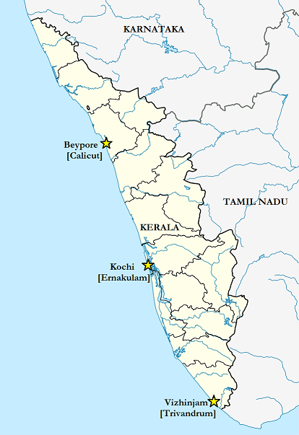Business Brief: Market research shows that there is business potential for hydrofoil ferry service, particularly for intercity commuters who want to save on time. The high-speed ferry service can be an effective substitute for intercity taxi services, premium rail services (Tier 2 AC), and airline passengers, with competitive pricing.

Ferry Service: The hydrofoil, once commissioned into service, shall make a round trip per day. One boat will be dedicated to the northern leg (Kochi–Calicut) while the other will be dedicated to the southern leg (Kochi–Trivandrum).

Operation: The vessels shall ply 5 days a week, year-round (52 weeks) except for 2 weeks of annual downtime for dry docking and repair. The vessels are expected to ply with full passenger capacity, except during the monsoon months (12 weeks, from June to August), during which the capacity use is estimated to fall by 50%.

Note: AC = air conditioned; Rs. = INR = Indian rupee; US$1 = ₹66.96 on July 28, 2016; h = hours; min = minutes.† Repair & Commissioning is a one-time charge incurred to get the vessel in running condition post purchase. ‡The state government provides a subsidy of ₹1 per kilometre per passenger to promote coastal transport. A one-way trip from Kochi to Calicut or from Kochi to Trivandrum is approximately 200 kilometres.

Source: Company documents.

1. All currency amounts in the case are in U.S. dollars unless otherwise specified.
2. ₹ = INR = Indian rupee; US$1 = ₹66.96 on July 28, 2016.