

9b17D023

re-matt inc.: scaling the mattress recycling operations

R. Chandrasekhar wrote this case under the supervision of Professor Stephan Vachon solely to provide material for class discussion. The authors do not intend to illustrate either effective or ineffective handling of a managerial situation. The authors may have disguised certain names and other identifying information to protect confidentiality.

*This publication may not be transmitted, photocopied, digitized, or otherwise reproduced in any form or by any means without the permission of the copyright holder. Reproduction of this material is not covered under authorization by any reproduction rights organization. To order copies or request permission to reproduce materials, contact Ivey Publishing, Ivey Business School, Western University, London, Ontario, Canada, N6G 0N1; (t) 519.661.3208; (e)* [*cases@ivey.ca*](mailto:cases@ivey.ca)*;* [*www.iveycases.com*](http://www.iveycases.com)*.*

Copyright © 2017, Richard Ivey School of Business Foundation Version: 2017-12-05

In January 2017, Shawn Cable was considering the way forward for the mattress recycling operation he had set up in the city of Calgary, Alberta. Since starting with no specific knowledge in November 2014, he had built Re-Matt Inc. (Re-Matt) into a one-of-its-kind enterprise in Alberta where municipalities, both urban and rural, had been categorizing mattresses as waste and sending them to landfills for disposal for decades. In December 2015, the City of Calgary had set a goal of diverting 70 per cent of waste from landfills towards environmentally friendly avenues by 2025.[1] This agenda would affect how used mattresses in Calgary would be disposed of going forward.

Re-Matt’s business was diverting used mattresses from landfills and recycling them by routing their individual components back into the economic streams and recovering value. The company had reached an annual revenue of CA$500,000[2] in two years. Cable was now weighing his options with respect to scaling up Re-Matt’s operations. He was also trying to identify ways of differentiating Re-Matt from its potential competition, which seemed imminent.

WASTE GENERATION IN CANADA

Canada was generating about 25 million tons of solid waste annually—the highest tonnage among members countries in the Organisation for Economic Co-operation and Development (OECD) (see Exhibit 1).[3] The reason for this large amount of waste was that Canada, unlike many other OECD members, was a processor of natural resources. For example, the country’s oil industry was the largest producer of waste followed by mining, livestock, and solid municipal waste.

A provincial ranking based on the index of waste generated per capita placed Nova Scotia at “A grade” (with 386 kilograms of waste per person) and Alberta at “D grade” (with 1,007 kilograms per person). Overall, Canada generated 720 kilograms of waste per capita in 2014.[4]

Managing waste was part of the core customer services that Canadian municipalities were responsible for providing to their residents. This waste management involved four priorities: reduce, reuse, recycle, and recover. Reducing the quantity of waste generated at source was crucial to minimizing its impact on the environment. Reusing the end products of waste, recycling them into secondary markets, and recovering the end products to produce an altogether new output often involved the use of relevant technologies.

Municipal waste was defined as “waste from households, including bulky waste, similar waste from commerce and trade, office buildings, institutions and small businesses, yard and garden waste, street sweepings, contents of litter containers, and market cleansing waste.”[5] In Canada, 95 per cent of municipal waste was sent to designated facilities for disposal into landfills. Some was diverted to recycling facilities for recovery of value in terms of secondary materials, while some was incinerated.[6] Municipalities, in general, had two major limitations in managing municipal waste: lack of access to affordable diversion technologies, and the absence of nearby markets for secondary materials.[7]

MATTRESS RECYCLING

Mattresses were complex products from a sustainability perspective. Although their customer value proposition was clear as providers of rest, relaxation, and sleep, there was ambiguity about their eco-friendliness beyond the products’ end-of-life, which averaged 10.8 years.[8]

Used mattresses were being disposed of in four ways: through reuse, at landfills, via incineration, and via recycling. The most common channel for reuse was charitable institutions. Most municipalities in Canada aggregated mattresses at their solid waste disposal facilities to be buried in landfills or fed into incinerators, both of which also had significant environmental impacts and operational problems.

A mattress was less dense than other solid waste but larger in volume, which was a disincentive for aggregators because the fees they charged for accepting waste (or “tipping fees”) were based on weight, rather than volume. In addition, a mattress was bulky, springy, and had a compaction rate that was 400 per cent lower than regular waste. Each mattress occupied 0.6 to 1.1 cubic metres (23 to 40 cubic feet) of area in a landfill, depleting valuable airspace.[9] Moreover, mattresses could take decades to decompose in landfills, often popping out of the ground long after they were buried.

A mattress was also difficult to incinerate because its springs or coils could be caught in the moving grates of an incinerator or shredding machine, harming the equipment. In any case, even after incineration, 40 per cent of a mattress (by weight) had to be disposed of in a landfill anyway.

A typical mattress was an assembly of steel, polyurethane foam, wood, fibre, and cotton (see Exhibit 2). There were markets for all of these components. Steel components like spring metal and box spring metal, once separated, could be scrapped and reconverted into steel. Polyurethane foam could be turned into carpet underpad. Wood could be chipped and used as animal bedding, mulch, or biomass fuel. Fibre could be recycled into industrial filters or padding materials. Cotton could be used in locomotive oil filters. Although 95 per cent of the components of a mattress were recyclable, only 7 per cent of used mattresses were recycled in Canada; the rest ended up in landfills.

Canadian municipalities had not taken any initiative to establish dedicated facilities for recycling mattresses because of issues related to investment in recycling machinery and plant/labour capacity utilization. Thus, mattress recycling was left to private enterprise. The country’s first mattress recycling operation was set up in Montreal in 2007. Since then, independent recyclers had launched operations in select urban centres in British Columbia, Alberta, Manitoba, Ontario, and Quebec. Many of them had provisions for recycling products in other categories, like soft furniture. These recyclers sourced used mattresses from locations that generated them in bulk (e.g., hotels, hostels, retailers, and hospitals), and created drop-off points for individual residents.

Some large mattress manufacturers and retailers collected used mattresses for recycling when they delivered new ones. They recovered the recycling fee from the buyer at the point of sale and paid it to the recycler. This system was characteristic of the strategy known as extended producer responsibility (EPR), which shifted the responsibility for waste management from a municipality to the individual manufacturer. EPR saved tax dollars and incentivized manufacturers to incorporate environmental considerations right from the stage of product design, though it was voluntary for mattress manufacturers in Canada.

In product categories where EPR was mandatory, like electronics, the strategy had led to increases in recycling rates. The corresponding legislation included performance goals and collection site convenience metrics. The growth in recycling had to be led by new entrepreneurs creating new markets.

Regulatory actions like banning landfills could provide the groundwork for a future EPR program for mattresses. Metro Vancouver, for example, had implemented a mattress landfill ban in 2012. Calgary had set a goal of diverting 70 per cent of its waste (including mattresses) from landfills by 2025. The Province of Ontario had identified mattresses for future EPR programs as part of a drafted waste reduction strategy that it had prepared for its municipalities.

RE-MATT

Company Background

Cable had founded Re-Matt in mid-2014. Before that point, he had worked for three years on the supply chain operations of an oil sands company in Calgary, where he had witnessed first-hand the negative impact that industry could have on the environment. As part of a skills upgrade program, the oil sands company had sent him to attend a course in logistics at Mount Royal University in Calgary. The class was touring a local Sears distribution centre when Cable saw a pile of used mattresses at a warehouse. He learned from the warehouse supervisor that the mattresses were destined for a landfill because there was no mattress recycling facility in the province, and that Sears was willing to provide a fee per mattress to anyone who could dispose of them in another way. Cable immediately spotted a business opportunity.

He enlisted a friend, with whom he had worked earlier at a national restaurant chain for over a decade, as a partner. The two drove along alleys in Calgary, found a few discarded mattresses, took them to their garage, and started taking them apart. It took 15 minutes for each of them to disassemble a mattress. The process seemed akin to peeling layers off of an onion.

The two men spoke to other potential suppliers of used mattresses and put together a business plan (see Exhibit 3). One of the difficulties they faced was ascertaining sources of revenue. The recycling fee that some retailers were charging customers at the point of sale of a new mattress became a benchmark for determining the fee that their company, now called Re-Matt, could charge for recycling a used mattress. The duo set this fee at $13–$15 for non-residential sources and $15 for residential sources. However, when they approached Canada’s main banks for a working capital loan of $150,000, they were turned away because they could not offer any collateral. Fortunately, the Business Development Bank of Canada, which focused on small and medium enterprises, was willing to finance an idea that it recognized as novel in the province. The partners acquired a 10,000-square-foot warehouse on a five-year lease and converted it into their business’s shop floor (see Exhibit 4). Re-Matt was officially in business by November 2014.

Cable and his partner initially learned through trial and error. They trained themselves and their new employees, who joined the company on a part-time basis. The business had no entry barriers but those in related businesses, including mattress manufacturers and retailers, were reticent about revealing their knowledge of the industry tricks of the trade. One such “trade secret” was that the sale of secondary materials could be a source of revenue. Cable and his partner had identified the recycling fee as the main source of income in their business plan. It was only much later, as they settled into the business, that they recognized that the byproducts had a regular market of their own, and that they raised the value of each mattress to $0.80 more than the partners had estimated in their business plan.

Cable had been manager of a restaurant for seven years, and general manager—responsible for the profitability of regional units in the restaurant chain—for five years. The work was paid hourly, rather than daily or weekly, and involved many different skill sets. He applied the lessons and skills gained from his restaurant experience to this new business.

By early 2015, Re-Matt had five full-time and three part-time employees. Cable recognized that in order to break even, the company needed to recycle one mattress every 10 minutes per employee. The need to reach out to part-time workers became a rough measure of how good (or bad) a week was for the business. Recycling seven mattresses an hour became the new performance metric.

The business was not always even. The end of each year (when residents bought furniture for the holiday season) and spring (when many people cleaned out their homes) witnessed heavy inflows of used mattresses. During the summer months, business was usually slow because people were out of town on vacation. Therefore, Cable designated July and August as months when Re-Matt employees could take their leave. There was typically a spike in supplies whenever a large vendor announced a sale.

As Cable soon realized, recycling mattresses “was not the most glamorous work in the world,” but it required skills that could only be developed over time—like understanding what made each mattress unique, identifying quality end products, and getting a feel for the mattress parts by using sight and touch. For example, different types of foam had different flashpoints, and segmenting them on the shop floor was crucial to determining where a foam type could be used (e.g., punching bags, carpet padding, car seats, or bus seats). In addition to dismantling mattresses, the shop floor duties included unloading trucks as they came in, operating forklifts, and loading the recyclable materials when they were ready for dispatch. Cable immediately noticed that maintaining morale on the shop floor would be an issue, and employee retention became a metric for him to monitor.

The disassembly of each mattress was manual at Re-Matt. This process reduced wastage and maximized the quality of the recyclable materials, but it was slower than the mechanized separation that was common in some places, such as California. In mechanized facilities, each mattress would be placed on a conveyor belt and specially designed saws would cut away soft materials on the top and bottom, separating the polyurethane foam and cotton fibre. The metal pieces would be removed magnetically and the remaining fibre materials were then shredded and baled. The process took one individual three to four minutes per mattress.

Scaling up Operations

Ensuring steady sources of used mattresses (on the supply side) and finding established markets for recycled materials (on the demand side) were crucial to building scale for Re-Matt. These actions would enable automation, ultimately driving down costs and, in turn, generating greater efficiencies. Scaling up the business would also ensure better commodity prices for end products. Together, these two agendas would create a virtuous cycle.

By 2016, the disposal fee had stabilized at an average of $12 for large sources and $15 for households. Cable had to work on two streams in enhancing procurement sources: developing new collection systems for large non-residential sources, and providing multiple channels for small and independent residential sources. Some large retailers had their own reverse distribution systems to return used mattresses to their original manufacturers; it was important that Re-Matt integrate its procurement systems with these retailers. For residential customers, Re-Matt’s options included setting up permanent drop-off sites and one-day collection events in neighbourhoods, or regular curbside collection. Mattress quality was an issue with curbside collection, because mattresses left outside for collection were quickly damaged by exposure to the elements. Re-Matt would be in a better position to access large volumes of mattresses if (1) a ban of mattresses from landfills was enacted, and (2) a recycling fee at the point of sale of each mattress was collected.

The original concern with byproducts was their disposal. The tipping fee was about $113 per ton. There were several materials that had to be sent to landfills. For example, the top layer of a mattress was a combination of textile and foam sewn so closely together that separating the two components was a labour-intensive task; however, without being separated, the materials had no value and would have to be sent to a landfill. Similarly, although pocket coils had a metal component, traders in Calgary would not accept them unless the microfibre in which they were wrapped was taken out. Traders in provinces like Ontario, however, saw value in pocket coils. These differences meant that Re-Matt was facing a business location conflict—to scale up the supply side, the company needed to go where the mattresses were; to scale up the demand side, Re-Matt had to go where the end markets were.

Re-Matt’s original business plan was predicated on a conservative income of $0.80 per mattress from the sale of recycled materials. Since then, Cable had developed a better understanding of end markets. The monthly yield from the 4,000 mattresses that Re-Matt recycled in 2016 was 20,000 pounds of metal, 20,000 pounds of foam, and 4,800 pounds of cotton. Metal was sold at a price range of $0.17–$0.28 per pound, foam at $0.25–$0.35 per pound, and cotton at $0.10 per pound.

The five-year lease for Re-Matt’s existing shop floor premises would end in 2019, when the company would need to look for larger premises and pursue increases in plant and staff capacities. Moving into Ontario and Quebec, which had Canada’s largest and the second-largest waste generation by weight, respectively, would scale up operations. Cable wondered whether diversifying beyond mattresses into other recycling-related products (e.g., soft furniture) would be another option for scaling up.

Differentiation

Re-Matt had a first-mover advantage in Alberta, as the first enterprise of its kind. By January 2017, it had diverted 1 million pounds of mattress waste from landfills. Sustaining this position was critical because new players would be drawn to the business in the absence of entry barriers. Re-Matt had to build a differentiation strategy that addressed both the supply and demand sides of the business.

As part of building differentiation, the company had started providing certificates of appreciation to its customers for their commitment to recycling. The certificate mentioned the quantity of waste that Re-Matt diverted in a year (see Exhibit 5).

Further, partnerships could be a way to erect entry barriers. Establishing long-term contracts with large companies (particularly manufacturers and retailers) would enable Re-Matt to lock in supply sources in Alberta. Even if the recycling fee were renegotiated, large volumes would ensure the recovery of fixed costs. However, Cable wondered how Re-Matt could avoid the risk of low-cost positioning. The risk was greater on the demand side, where the end products were already commoditized.

Building a sustainability proposition into its sale of end products would not only differentiate Re-Matt, but generate higher prices as well. Re-Matt could also avoid the secondary markets and route the recycled materials directly to the mattress manufacturers. These companies could then pitch their products to eco-conscious consumers, making an emotive appeal based on the recycled content of the product. Re-Matt had to rebuild its value proposition.

While weighing the options available to him with regard to both scaling up and building differentiation, Cable wondered what would be the best way forward—both for the novel business enterprise he had built and for him personally.

Exhibit 1: WASTE GENERATION IN CANADA BY PROVINCE

|  |  |  |  |  |  |
| --- | --- | --- | --- | --- | --- |
| Province | (in ’000 tons) | | | | |
| 2004 | 2008 | 2010 | 2012 | 2014 |
| Newfoundland and Labrador  Nova Scotia  New Brunswick  Quebec  Ontario  Manitoba  Saskatchewan  Alberta  British Columbia |  | 380  354  479  6,146  9,632  945  903  4,147  2,811 | 394  367  475  5,796  9,247  952  937  3,917  2,658 | 392  365  492  5,584  9,209  1,017  958  3,914  2,604 | 415  364  508  5,715  9,165  1,027  940  4,098  2,721 |
| Canada |  | 25,797 | 24,743 | 24,535 | 24,953 |

Source: Laurie Giroux/Giroux Environmental Consulting, *State of Waste Management in Canada*, 7, 2014, accessed April 5, 2017, www.ccme.ca/files/Resources/waste/wst_mgmt/State_Waste_Mgmt_in_Canada%20April%202015%20revised.pdf; “Disposal and Diversion of Waste by Province and Territory (Total Waste Disposal),” Statistics Canada, September 22, 2016, accessed April 5, 2017, www.statcan.gc.ca/tables-tableaux/sum-som/l01/cst01/envir32a-eng.htm.

Exhibit 2: COMPONENTS OF A MATTRESS

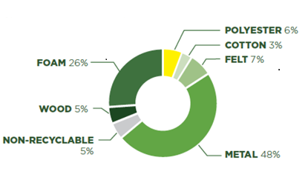

Source: Company documents.

Exhibit 3: RE-MATT BUSINESS PLAN, 2014

|  |  |  |  |  |  |
| --- | --- | --- | --- | --- | --- |
|  | **Monthly** | | **Yearly** | | |
| Number of Mattresses | Value ($) | Number of Mattresses | Value ($) |
| Sleep Country  Sears  The Bay  IKEA  Mattress Mattress  The Brick  Ashley Furniture  Residential Sources  Income from Recycling | 666  400  75  200  28  100  20  1,000  - | 6,660  4,000  750  2,000  280  1,000  200  12,000  2,000 | 8,000  4,800  900  2,000  340  1,200  240  12,000  - | 80,000  48,000  9,000  20,000  3,360  12,000  2,400  144,000  24,000 |
| Total income | 2,489 |  | 29,480 | 342,760 |
| Salaries and Wages  Benefits  Recruitment and Training  Rent  Utilities  Insurance—Assets  Insurance (Errors & Omissions)  Software Maintenance  Advertising  Donations  Meals and Entertainment  Cargo Truck and Pick-Up  Bank Charges  Memberships  Office Expenses  Accounting and Legal  Postage and Courier  Telephone  Travel |  | 11,840  2,000  500  2,500  1,250  417  417  292  1,250  333  417  3,500  417  417  1,250  417  250  583  417 |  | 142,080  24,000  6,000  30,000  15,000  5,000  5,000  3,500  15,000  4,000  5,000  42,000  5,000  5,000  15,000  5,000  3,000  7,000  5,000 |
| Total Expenditure |  |  |  | 92,000 |
| Startup Costs |  | 160,000 |  | - |
| Operating Income |  | 425 |  | 1,170 |

Note: Rent was based on a warehouse space that was approximately 280 square metres (3,000 square feet) in size.

Source: Company documents.

Exhibit 4: RE-MATT—SHOP FLOOR LAYOUT

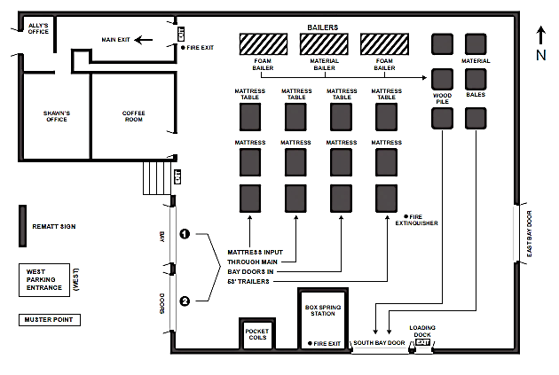

Source: Company documents.

Exhibit 5: Re-Matt CUSTOMER APPRECIATION CERTIFICATE

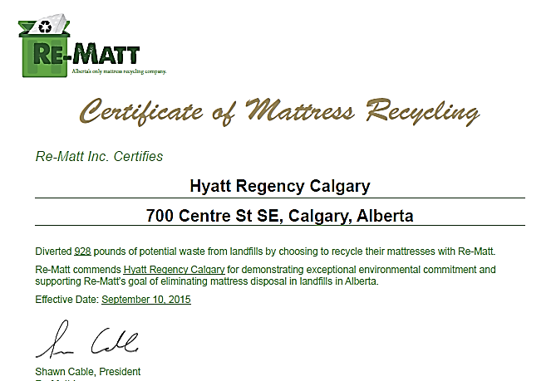

Source: Company documents.

1. “Leading Calgary to Zero Waste,” Calgary, accessed October 10, 2017, www.calgary.ca/UEP/WRS/Pages/About-WRS/Calgary-Waste-Goals.aspx.
2. All currency amounts are in CA$ unless otherwise specified.
3. “International Ranking: Municipal Waste Generation,” The Conference Board of Canada, 2017, accessed April 12, 2017, www.conferenceboard.ca/hcp/details/environment/municipal-waste-generation.aspx.
4. “Provincial and Territorial Ranking: Waste Generation,” The Conference Board of Canada, 2017, accessed April 11, 2017, www.conferenceboard.ca/hcp/provincial/environment/waste.aspx.
5. “International Ranking: Municipal Waste Generation,” op. cit.
6. Statistics Canada, *Human Activity and the Environment: Waste Management in Canada 2012*, 18, accessed May 20, 2017, www.statcan.gc.ca/pub/16-201-x/16-201-x2012000-eng.pdf.
7. *Canada-Wide Action Plan for Extended Producer Responsibility,* Canadian Council of Ministers of the Environment, October 29, 2009, accessed May 10, 2017, www.ccme.ca/en/current_priorities/waste/epr.html.
8. “What’s in a Mattress,” Re-Matt, accessed April 15, 2017, www.re-matt.com/bed-facts/.
9. Ibid.