

9B17E003

CALGARY DROP-IN Centre: Donor information system

Deb Elkink, Michelle Woo, Dennis Dupuis, and Dan Hausermann wrote this case under the supervision of Professor Derrick Neufeld solely to provide material for class discussion. The authors do not intend to illustrate either effective or ineffective handling of a managerial situation. The authors may have disguised certain names and other identifying information to protect confidentiality.

*This publication may not be transmitted, photocopied, digitized or otherwise reproduced in any form or by any means without the permission of the copyright holder. Reproduction of this material is not covered under authorization by any reproduction rights organization. To order copies or request permission to reproduce materials, contact Ivey Publishing, Ivey Business School, Western University, London, Ontario, Canada, N6G 0N1; (t) 519.661.3208; (e)* [*cases@ivey.ca*](mailto:cases@ivey.ca)*;* [*www.iveycases.com*](http://www.iveycases.com)*.*

Copyright © 2017, Richard Ivey School of Business Foundation Version: 2017-02-01

The homeless and marginalized had been paramount in Alan Facey’s mind for the past 15 years. As director of finance and administration for the Calgary Drop-In & Rehab Centre (the DI), he exercised “management by walking around,” leaving his sixth-floor office daily to mingle with staff as well as the street-involved clients who rotated through the facility. He measured success by the DI’s ability to serve others in times of need through offering community and relationship to those suffering or in trauma. “People gravitate towards a safe hub,” he said, “and that’s us.”

By spring of 2016, Facey was becoming frustrated with the DI’s donor and volunteer information system (IS). He had been exploring ways to leverage technology in order to improve operational effectiveness in the non-profit organization, which relied on manual processes to capture information. The DI had not been able to replace the director of information technology (IT), who had retired more than a year before, and Facey had assumed additional responsibilities as a result. The legacy systems built over time by the former IT director were antiquated, and the DI was in desperate need of an overall technology upgrade to support its five business strategies. Communication, fundraising, and stewardship were not operating at optimal levels, and, with the board of trustees watching closely, Facey had a fiduciary duty to marshal limited resources. He cared about each of the clients passing through the DI. As the DI continued to expand its service offerings, and as demand for donor and volunteer stewardship increased—at least 75 homeless Albertans were dying each year due to substance abuse, violence, and suicide[1]—improved technology and operational effectiveness were essential (see Exhibit 1).

**THE CHARITABLE SECTOR IN CANADA**

Charities played a critical role in building and enriching communities across the country. The Canada Revenue Agency (CRA) regulated this sector, granting charitable registration status to organizations operating exclusively for benevolent purposes. All charities were non-profit organizations, but not all non-profit organizations were charities. In order to earn recognition as a registered charity with the ability to issue tax receipts, an organization had to meet certain CRA requirements, such as demonstrating that it benefitted the community through relief of poverty or advancement of education or religion.[2]

Over the past few decades, the landscape of the charitable sector in Canada had become increasingly complex. Charities employed over two million Canadians. When measured as a share of the economically active population, Canada’s charitable and non-profit sector was ranked as the second largest in the world, with the Netherlands leading and the United States in fifth place.[3] Charities and non-profit organizations contributed 8.1 per cent of Canada’s gross domestic product (CA$106 billion), more than either the automotive or manufacturing industries.[4] The value of volunteer work could not be underestimated; more than 13 million people volunteered for charities and non-profit organizations in Canada every year.[5] In 2013, 44 per cent of people aged 15 years and older participated in approximately 1.96 billion hours of volunteer activity, equivalent to about one million full-time jobs. Out of the estimated 170,000 charitable and non-profit organizations in Canada, 85,000 were registered charities recognized by the CRA, and 54 per cent were run entirely by volunteers.[6]

Charities worked relentlessly to address societal issues and improve the outlook of communities, but real investment was required to achieve outcomes. Funding came from many sources, including individual and corporate donations, government programs, foundation grants, and sales of products and services. Administrative costs, a reality of operating a charity, accrued through multiple factors: management, financial systems, insurance, IT, staff and volunteer recruitment, and everyday expenses such as rent, electricity, and salaries. Producing annual reports, financial statements, audits, and program evaluations also came with costs.[7] Despite this, surveys showed that nearly 75 per cent of Canadians believed that charities were spending too much on salaries and administration, while 52 per cent believed that charities spent too much on fundraising.[8] Although low overhead expenses were often seen as a measure of success, research showed that low overhead could limit the effectiveness of non-profit agencies.[9] In fact, while the bottom line might have looked alarming, based on Facey’s business orientation, he knew it was true that a higher budget meant the DI could achieve more good in the community.

To ensure the continuance of the DI’s good works, Facey knew it was important to pay close attention to donors, especially considering the growing competition between Canadian charities for limited government and foundation grants. Well-stewarded benefactors were more likely to give larger or more frequent gifts and to continue relationships with the charity. In fact, the likelihood of existing donors giving again was greater than the likelihood of securing new ones.[10] Facey understood that investment in stewardship was a critical component of sustaining and increasing fundraising capacity in the long term and that it ultimately enabled the organization to realize its mission and carry out its remarkable programs. Positive donor sentiment that was spread by word of mouth enhanced the DI’s reputation within the community and attracted other prospective financial supporters.

The DI was only one of more than 24,000 non-profit organizations and charities in Alberta’s non-profit sector, which had been affected by recent drops in the price of oil and economic uncertainty (see Exhibit 2). According to a survey by the Calgary Chamber of Voluntary Organizations, more than twice as many organizations expected their finances to worsen in the subsequent year. Approximately three-quarters of organizations surveyed took steps to prepare for the fallout from Alberta’s economic downturn, including reviewing or changing existing organizational budgets, creating contingency budget scenarios based on different funding levels, diversifying funding, and increasing fundraising.[11]

**THE CALGARY DROP-IN & REHAB CENTRE**

At the DI, Facey was in full agreement with the social service agency’s mission: to “prevent homelessness where possible, offer care and shelter when needed, and provide opportunities for people to rehabilitate and rebuild their lives.”[12] As an incorporated, non-denominational, non-profit, charitable organization administered by a full-time staff and a board of directors, the DI was the largest organization of its kind in North America and had served the city of Calgary for more than half a century. It offered a complete range of wrap-around community support—from meals and shelter to clothing, medical services, counselling, volunteer opportunities, education, and permanent supportive housing for over 10,000 people each year.

“People think of a homeless shelter as a bed for the night, but that’s one of the least important aspects of the DI,” Facey explained:

Poverty comes upon many people through a snowball effect. A young man loses his roommate and can’t pay the rent. He’s forced to use his limited income for food and then ends up on the street without a job. He can’t get an interview because he can’t afford a haircut; he can’t afford a haircut because he can’t get a job. Our barber gives him a trim, and our employment services staffing sets him up with a new boss—and he’s off and running again.

Donors contributed 46 per cent of the DI’s funding (see Exhibit 3). In 2014, the DI utilized over 30,000 volunteers, assisted 10,965 clients, served 1.2 million meals, distributed 97,382 pieces of clothing, offered 18,572 counselling services, and placed people in 11,574 jobs. The DI had the capacity to shelter 1,100 people per night, with four levels of accommodations to meet the diverse needs of the population: emergency beds, short- and long-term supported living, and affordable housing.[13]

Facey was deeply gratified to associate himself with the DI; a community of kindness focused on providing more than 50 programs and services to Calgarians who were experiencing homelessness, marginalization, and extreme poverty. Coordinating the resources to make these good things happen presented many challenges.

the Existing SYSTEM

Regular communication with volunteers and donors was an important component of fundraising and donor stewardship strategy, and a high-quality database was considered an essential investment for any registered charity. Such systems were typically used to generate statistics and trend analyses, schedule reminders for donor meetings, and create targeted mailing and invitation lists through segmenting. Many non-profit agencies leveraged cloud, mobile, and social media technologies to help deliver better programs and services, engage the community, improve communications, and increase fundraising revenue. The emergence of crowdfunding and multichannel fundraising campaigns that made use of mail, Internet, and telephone made centralized management of data regarding donors and volunteers more necessary than ever.

Facey knew that the DI’s existing IS process for capturing volunteer and donor information was in crisis. With more than 55,000 donors, the organization’s Microsoft Access database hit its limit. A new instance of the database was created for each new capital campaign, and this led to multiple historical versions. The DI staff had tried many times in the past to manually cleanse the data to remove duplicate donors and addresses with limited success. Facey recognized that the mess was due to the sheer number of donors and separate databases.

The existing database structure had been developed more than a decade earlier under the guidance of the former IT director. Small upgrades had improved functionality over time, but changes had been limited because of the DI’s lack of technical expertise. Maintaining multiple discrete databases was challenging and led to many errors. For example, when it came time to create a donor appreciation event, separate databases from every capital campaign had to be exported to spreadsheets and consolidated, which led to duplicated donor names and inconsistent addresses. Donor data could not be easily mined to assist with fundraising campaigns, provide analytics on the effectiveness of existing strategies, or identify the most loyal volunteers and donors for proactive communication. Facey also found it impossible to determine whether volunteering led to donations or vice versa. This translated into a shortfall in fundraising and volunteering, and it meant the organization was unable to truly understand and steward donors. Simply put, donor data were not very accessible.

Open and unrestricted data-entry fields presented a primary source of errors. Staff and volunteers used different techniques and formatting standards when entering data, and this led to inconsistencies, such as four different records for “Talisman”—one referring to an oil and gas company and another to a sports facility (see Exhibit 4). Some donors appeared multiple times, depending on how their first names had been captured (for example, “Michael,” “Mike,” or “M.”); given names were not stored in a separate field from surnames. Errors were sometimes caught by the end-user reviewing the mailing list, but this was a hit-and-miss endeavour. Some donors received multiple copies of an annual report, leading to negative feedback. One donor had recently expressed her frustration over continuing to receive duplicated reports despite having called several times to request that the error be fixed. Why donate money to an organization that squanders it on useless postage?

The leadership team had often discussed replacing the existing legacy system to better capture donor and volunteer information, and the recent retirement of the former IT director had provided the necessary impetus to finally move this project forward.

**POSSIBLE SOLUTIONS**

Selecting an IS system was one of the most significant investments a charity could make in support of its fundraising strategy and activities, and it was critical to make the correct choice. “We want to keep it as simple for entry as possible to take out ambiguity and eliminate error,” Facey said. The DI reviewed the potential options available and took a close look at other comparable organizations’ fundraising in terms of receipted activity, overall revenue, and the systems they were using to capture donor information (see Exhibit 5).

One option open to Facey was to build a new, in-house system to replace the current Microsoft Access database system. This would involve hiring a full-time programmer to create a system around the basic requirements and customize this to the DI’s needs and staff preferences. All donors and volunteers would be captured in one central database, which would allow the organization to identify duplicates and merge records. Lists and reports would be generated based on criteria specific to the needs of the DI. The programmer would be able to ensure the database was connected to existing systems in the DI, such as gift processing through Beanstream Internet Commerce, Inc. (an online payment processing company). The programmer would also be available for ongoing issues, upgrades, and troubleshooting, acting as an on-the-ground resource for the DI. This option would cost approximately $150,000, would take eight to 12 months to implement, and would require servers and security to store the data, at additional costs.

Another option was to purchase software specifically developed for non-profit fundraising and relationship management, such as Raiser’s Edge or DonorPerfect. There were many software options for small, non-profit organizations like the DI, and such software had been used by non-profit groups in health-care, faith-based ministries, foundations, and the arts. The DI would need to review and adjust its current processes to fit an out-of-the-box solution, but it would be able to review data, understand donor retention rates and segmentation, and generate standardized general-purpose reports. Such software would be installed on personal computer desktops, and staff would be trained on the application, which would be integrated with basic, online marketing tools and mobile apps. Technical customer service would be managed by the vendor. Sample pricing in 2013 was US$10,050 for a single-user licence; a non-profit organization requiring three user licences would spend US$20,025 in the first year, then pay ongoing annual maintenance fees of approximately US$3,000, including support.[14] Servers and security to store the data would involve additional costs.

Finally, the DI could adopt a cloud-based fundraising solution, such as Salesforce for Nonprofits or Raiser’s Edge NXT. This solution would allow the DI to store information on a secure, shared platform. For 100,000 records, the standard version of Raiser’s Edge NXT would cost $21,800 per year with a three-year contract, and the professional version with additional modules would cost $32,000 annually with a three-year contract. Through an online-hosted system, the data would be centralized and backed up in a protected environment. This would allow individuals working at the DI sites to access and edit donor and volunteer information online. A range of permission levels would be implemented based on the degree of access reasonable for specific groups. These platforms would be supported by off-site customer services and security experts supplied by the vendor. Implementation would take seven to nine months, and the platform’s open design would allow further customization and integration with other systems and applications.[15]

Facey had recently learned that the Mustard Seed, an organization that also offered services to the homeless population in Calgary, was expected to launch a customer-relationship-management transition project. This project entailed moving from Raiser’s Edge to Salesforce for Nonprofits and recruiting a data analyst to work on predictive modelling and future fundraising initiatives.[16]

**WHAT NEXT?**

Facey thought about the people the DI served, such as the woman born 60 years ago with mental limitations whose mother died when she was 11 years old, and who had lived on the streets for years before ending up at the DI. Success to Facey meant meeting these people at their point of need—a meal for the hungry or a bed for the weary. He surveyed the proposals strewn over his desk. Which option would best set up the DI for future success?

EXHIBIT 1: The Calgary Drop-In & REHAB Centre

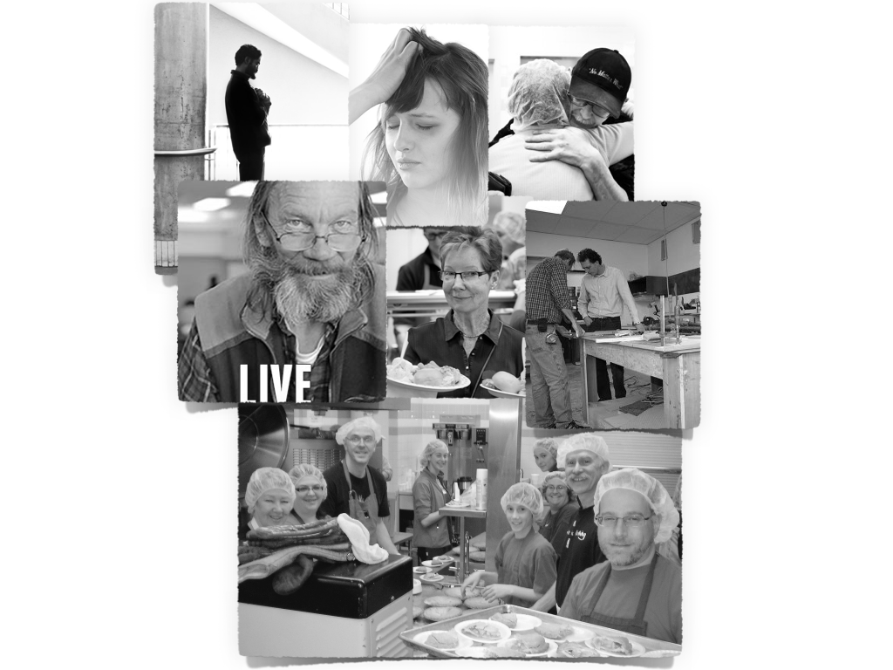

Source: Photo collage by the case authors, from Calgary Drop-In & Rehab Centre files.

EXHIBIT 2: Oil price trends mirror the financing of Alberta’s non-profit sector

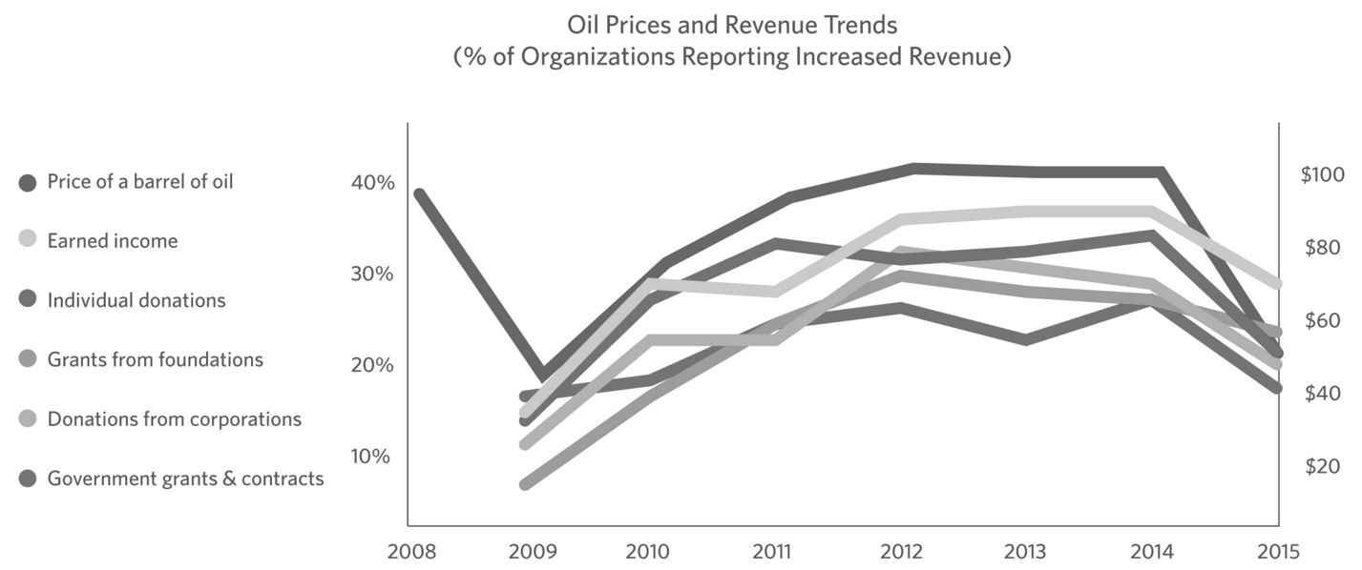

Source: Created by the case authors from Calgary Chamber of Voluntary Organizations, “Section Two: Shifting Context, Shifting Mood,” 2015 Alberta Nonprofit Survey, accessed September 1, 2016, www.calgarycvo.org/2015-alberta-nonprofit-survey-pg2/.

Exhibit 3: THE Calgary Drop-In & REHAB Centre’s SOURCES OF FUNDING

Source: Calgary Drop-In & Rehab Centre, “The DI Today,” accessed September 1, 2016, http://www.thedi.ca/about-the-di/the-di-today/.

Exhibit 4: Screen Shot from The Calgary Drop-In & REHAB Centre’s Current donor database SySTEM

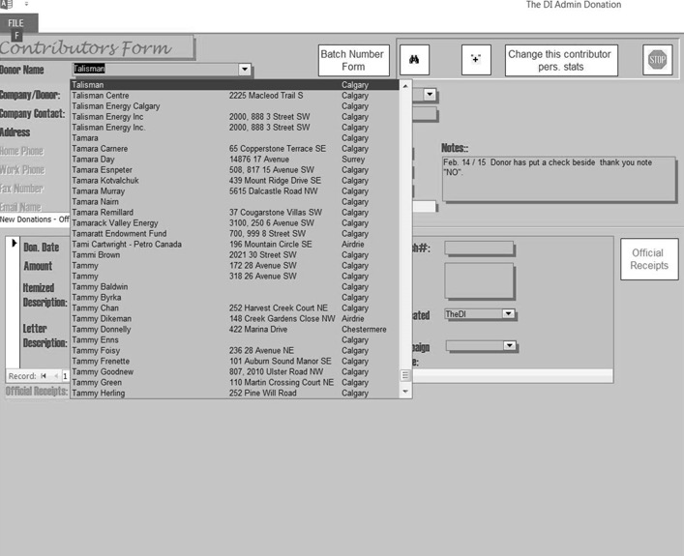

Source: Calgary Drop-In & Rehab Centre.

Exhibit 5: SYSTEMS USED BY OTHER CHARITIES

|  |  |  |  |
| --- | --- | --- | --- |
| **Registered Charity** | **2015 Receipted Donations** | **2015 Total Revenue** | **System Used** |
| Calgary Drop-In & Rehab Centre (The DI) | $1,737,021 | $26,011,348 | In-house Microsoft Access database |
| Hope Mission | $7,469,753 | $18,334,905 | Raiser’s Edge  Volgistics Volunteer Logistics |
| Edmonton City Centre Church Corporation (E4C) | $523,522 | $15,576,397 | Raiser’s Edge |
| The Mustard Seed | $9,631,954 | $15,087,448 | Raiser’s Edge; planned migration to Salesforce for Nonprofits |
| Canadian Red Cross | $65,447,370 | $275,720,312 | Raiser’s Edge |
| University of Calgary | $49,352,091 | $1,248,306,806 | Raiser’s Edge |
| University of British Columbia | $39,628,000 | $2,197,214,000 | Blackbaud Nonprofit CRM (enterprise solution for large charities) |
| SickKids Foundation | $59,685,495 | $261,067,425 | Blackbaud Nonprofit CRM |
| Salvation Army | $92,214,268 | $282,694,074 | Raiser’s Edge |

CRM = constituent relationship management

Source: Created by the case authors, based on information from the “Canada Revenue Agency Charities Listing,” accessed May 31 2016, www.cra-arc.gc.ca/chrts-gvng/lstngs/menu-eng.html, and from organization websites and/or telephone calls.

1. Jason Van Rassel, “Homeless Death Statistics Paint Grim Picture,” Calgary Herald, November 14, 2014, accessed October 12, 2016, http://calgaryherald.com/news/local-news/homeless-death-statistics-paint-grim-picture.
2. Canada Revenue Agency, “What is the Difference between a Registered Charity and a Non-Profit Organization?” accessed May 14, 2016, www.cra-arc.gc.ca/chrts-gvng/dnrs/rgltn/dffrnc-rc-np-eng.html.
3. Michael H. Hall, Cathy W. Barr, M. Easwaramoorthy, S. Wojciech Sokolowski, and Lester M. Salamon, *The Canadian Nonprofit and Voluntary Sector in Comparative Perspective* (Toronto, ON:Imagine Canada, 2005), accessed May 14, 2016, http://sectorsource.ca/sites/default/files/resources/files/jhu_report_en.pdf.
4. All currency amounts are in Canadian dollars unless otherwise specified; Imagine Canada, “Key Facts about Canada’s Charities,” accessed May 14, 2016, www.imaginecanada.ca/resources-and-tools/research-and-facts/key-facts-about-canada%E2%80%99s-charities.
5. Imagine Canada, “Sector Impact: What is the Charitable and Nonprofit Sector?,” accessed May 14, 2016, http://sectorsource.ca/research-and-impact/sector-impact.
6. Martin Turcotte, *Spotlight on Canadians: Results from the General Social Survey—Volunteering and Charitable Giving in Canada*, Statistics Canada, January 30, 2015, accessed May 14, 2016, www.statcan.gc.ca/pub/89-652-x/89-652-x2015001-eng.pdf.
7. Imagine Canada, “Fundraising and Administrative Expenses,” February 19, 2014, accessed May 14, 2016, http://sectorsource.ca/sites/default/files/resources/files/narrative-issue-sheet-expenses-en.pdf.
8. David Lasby and Cathy Barr, *Talking about Charities 2013: Canadians’ Opinions on Charities and Issues Affecting Charities* (Edmonton, AB: The Muttart Foundation, 2013), accessed May 14, 2016, www.muttart.org/wp-content/uploads/2015/11/3.-Talking-About-Charities-Full-Report-2013.pdf.
9. Kennard Wing and Mark A. Hager, *Getting What We Pay For: Low Overhead Limits Nonprofit Effectiveness,* Urban Institute, August 1, 2004, accessed May 14, 2016, www.urban.org/sites/default/files/alfresco/publication-pdfs/311044-Getting-What-We-Pay-For.PDF.
10. Council for Advancement and Support of Education (CASE), “Fundraising Fundamentals, Section 7.10,” accessed May 14, 2016,www.case.org/Publications_and_Products/Fundraising_Fundamentals_Intro/Fundraising_Fundamentals_section_

    7/Fundraising_Fundamentals_section_710.html.
11. Calgary Chamber of Voluntary Organizations, “Section One: Highlights,” *2015 Alberta Nonprofit Survey*, accessed June 5, 2016, www.calgarycvo.org/nonprofitsurvey/.
12. Calgary Drop-In & Rehab Centre, “The DI Today,” accessed June 9, 2016, www.thedi.ca/about-the-di/the-di-today/.
13. Calgary Drop-In & Rehab Centre, “History,” accessed June 9, 2016, www.thedi.ca/about-the-di/di-history/.
14. Elizabeth Pope, Andrea Berry, Laura S. Quinn, and Kyle Andrei, *A Consumers Guide to Donor Management Systems*, (Portland, OR: Nonprofit Technology Network [NTEN], October 29, 2013), accessed June 9, 2016, www.nten.org/NTEN_images/reports/2013idealware_dmguide_october29_0.pdf.
15. “Raiser’s Edge NXT Nonprofit Fundraising Software,” Blackbaud, accessed June 9, 2016, www.blackbaud.com/fundraising-and-relationship-management/raisers-edge-nxt.
16. The Mustard Seed,“Data Analyst,” accessed June 9, 2016, http://theseed.ca/wp-content/uploads/2016/04/201604-06-Data-Analyst.pdf.