

9B17E008

JSW STEEL LTD.: A LOGISTICS DILEMMA

Amol S. Dhaigude, Debmallya Chatterjee, and Vishnukumar wrote this case solely to provide material for class discussion. The authors do not intend to illustrate either effective or ineffective handling of a managerial situation. The authors may have disguised certain names and other identifying information to protect confidentiality.

*This publication may not be transmitted, photocopied, digitized or otherwise reproduced in any form or by any means without the permission of the copyright holder. Reproduction of this material is not covered under authorization by any reproduction rights organization. To order copies or request permission to reproduce materials, contact Ivey Publishing, Ivey Business School, Western University, London, Ontario, Canada, N6G 0N1; (t) 519.661.3208; (e)* [*cases@ivey.ca*](mailto:cases@ivey.ca)*;* [*www.iveycases.com*](http://www.iveycases.com)*.*

*Copyright © 2017, Richard Ivey School of Business Foundation*

Version: 2017-06-15

On a warm Sunday morning at 10 o’clock, Arun Kumar’s intercom suddenly came alive, breaking into his thoughts. It was the last week of September 2014, and the staff at JSW Steel Ltd. (JSW) was frantically focused on last-minute efforts to achieve the company’s quarterly targets. Kumar was the senior customer relationship manager to Jindal SAW Ltd. (JSAW), a long-time client of JSW, and he found himself in a difficult spot because he had only a short window of time to decide whether to transport finished materials to JSAW by barge (sea route) or, instead, use the faster but more expensive method of transporting it by rake (rail route).

On a routine day, Kumar would have had no second thoughts on the matter, but today was an exception because JSAW needed the material urgently, and Kumar certainly did not want to shut down his customer’s production process. The JSW logistics team was putting pressure on Kumar to release the material and send it by rake to JSAW; however, Kumar thought that shipping the materials by barge would still ensure that they reached the client in time, with additional savings for his own company during the crucial quarter-end period. Kumar had less than 12 hours to decide on the mode of transportation and release the material.

The Company

JSW Steel Ltd. was a steel giant that operated five manufacturing units in India. The company generated annual revenues of ₹512,196.2[1] million in 2013–14 (see Exhibit 1) and was the nation’s leading private steel manufacturer. JSW produced a variety of steel products, including hot-rolled (HR) coils, cold-rolled (CR) coils, thermo-mechanically treated sheets, wire rods, galvanized steel, and galvalume sheets. It also manufactured special grades of steel that were used extensively in high-end applications, such as the manufacturing of large-diameter pipes, prefabricated metal structures, and components for auto sectors. The company’s largest plant—the Bellary plant in the village of Toranagallu, Karnataka—was strategically located in south India, close to the ports of Goa, Chennai, and Mumbai.

In terms of its corporate vision, JSW aimed to become a globally respected organization through sustainable industrial and business-development practices. The steelmaker had received several awards for its initiatives in cultivating a green philosophy among its employees, processes, and products. One such initiative involved the operation of a responsible supply chain that assessed the benefits to people, planet, and profit throughout its corporate decision-making. Thus, apart from the regular railway routes, the company made every effort to supply its clients with materials that were shipped by barge to locations that were close to ports (see Exhibit 2). Shipping by barge reduced the time needed to transport material and offered an additional benefit of reducing in the company’s carbon footprint.

SteelMaking and Logistics

JSW manufactured steel using iron ore, coke, and limestone, either in a blast furnace or in a Corex furnace, which was a more environmentally friendly alternative to the blast furnace. The end products of reduction and melting were hot metal and slag. The hot metal was processed further, by blowing it with oxygen to remove the unwanted carbon. Finer elements, such as vanadium, nickel, cobalt, and titanium, were added to enhance the features of the steel and to make it suitable for specific applications. The steel slabs were rolled through a critical method to manufacture HR coils, which were then shipped to customers who manufactured pipes and tubes.

The customer put the HR coils through a flattener and used a special technique called submerged arc welding to manufacture pipes. This process required clean coils to avoid strains on the pipes and tubes produced. The pipes were further processed and used to connect water resources, natural gas, and fuel lines around the world. The timely supply of these HR coils to the customers was obviously an important concern for JSW’s logistics department.

The logistics team used different transportation modes for different locations. The customer—in this case, JSAW—was located in the Mundra region of Gujarat, so the closest port was Mundra, and the closest railway siding was Gandhidham (see Exhibit 3). The material for JSAW products had always been transported by rail route from the time the two companies started doing business together; however, with JSW’s recent focus on a responsible supply chain, the sea route was also considered as a viable alternative. Indian railways charged JSW based on a price list that was approved every year, and JSW’s accounting department shared this price list with all other departments within the company so they could refer to it to make cost-effective shipping decisions (see Exhibit 4).

The Indian railway system classified its rake services based on the number of rail wagons attached. For example, 45 wagons constituted a BOXN rake and 59 a JUMBO rake. A JUMBO rake could carry 3,500 tons (3,175 tonnes),[2] while a BOXN rake could carry 2,500 tons (2,267 tonnes). Indian Railways’ monopoly gave it the authority to sanction the type of rakes it supplied. The chance of attaining a JUMBO rake on request was just 30 per cent since the railway operated only a small number of JUMBO rakes and availability was limited. Prior to 2014, Kumar’s experience had taught him that the railway authorities usually gave permission for the requested number of BOXN rakes 80 per cent of the time, and 20 per cent of the time, the allocation was one BOXN rake less than the number requested. Also from experience, Kumar knew that, for a rail shipment, the odds of late arrival were approximately 30 per cent.

South West Port Ltd., Goa, operated the nearest port to Bellary. This port was mostly used for the export of HR coils, CR coils, steel plates, and steel sheets to international customers; it was also used for the import of raw materials such as coal and iron ore. Gates 1 to 4 were used for exports, gates 6 and 7 for domestic activity, and gates 8 to 10 for imports. Because South West Port Ltd. was owned by JSW Group, Kumar had always enjoyed the availability of the required number of rakes between the plant and the port.

Most of the barges that entered this port for domestic purposes were carrying coal shipments, and thus, a significant amount of coal and iron dust could damage the surfaces of the coils that were being transported. The vendors who supplied barge transportation that offered clean storage space (Class I) charged a premium (₹30 per ton) beyond the normal delivery charges, but the availability of such clean-storage barges was only 30 per cent.

Kumar knew that he could place a request with port officials to have Class II vendors provide clean storage space on their barges. In such a case, the vendors would charge an additional ₹25 per ton, and Kumar estimated only a 75 per cent chance that the cleaning would actually be done. He remembered that Class I vendors had a record of 80 per cent timely delivery, whereas the Class II vendors had a record of only 35 per cent. The combined cost of transporting coils to the port in Goa by rake and then to the Mudra port by barge was approximately 22 per cent cheaper than that of transporting the coils directly by rail. JSW’s past records showed some variation in activity times across both modes of transportation (see Exhibit 5).

Kumar’s problem

The quantity of steel ordered by JSAW was 7,000 tons (6,350 tonnes), of which 5,000 tons (4,535 tonnes) had already been produced; the remaining 2,500 tons (2,267 tonnes) was under production and was scheduled to be ready for dispatch by 10 p.m. that same day, Sunday. The conditions for delivery of the coils were decided through a memorandum of understanding, and a negotiation document had been drawn up between JSW and JSAW. All terms and conditions were clearly defined for every project (see Exhibit 6).

The intricacies of this logistics problem were growing with every minute that passed, and Kumar knew he needed to make his decision in less than 12 hours. He was under tremendous pressure since this was the last week of the quarter. As well, timely delivery to JSAW was high on Kumar’s list of priorities, but the logistics department could not confirm the availability of JUMBO or BOXN rakes until the next day, Monday, at 10 a.m.

As he pondered the situation, several important questions ran through Kumar’s head: Would it be best to wait until Monday morning to get confirmation on the rail rakes? What if he could not obtain the required type or number he needed? Should he talk to the port officials now and at least try to get a confirmation on the availability of a clean barge? JSAW shipments had always been transported by rail. Would it be risky to rely on a recently developed sea route to make a rush delivery for an important customer such as JSAW? Would the final decision affect the goodwill between JSW and JSAW?

As Kumar considered the possible answers to these questions, he felt he could not agree more with the well-known adage, “Too tired to stay up, yet too awake to fall asleep.”

Exhibit 1: Revenue of JSW Steel Ltd., 2008–09 to 2013–14 (IN ₹ Millions)

Note: ₹ = INR = Indian rupee; US$1 = ₹60.53 on September 1, 2014.

Source: Company records.

Exhibit 2: Barge carrying steel coils

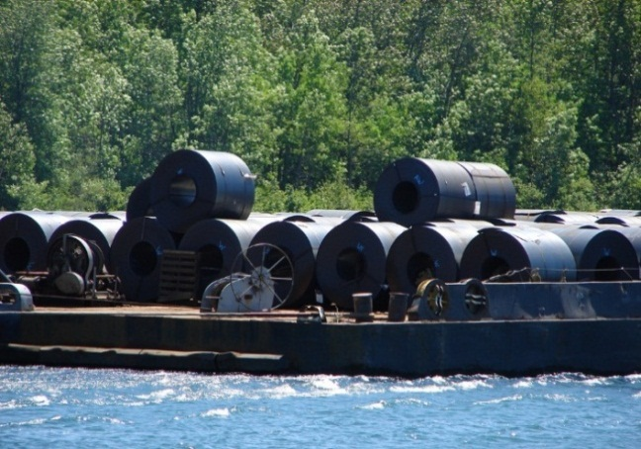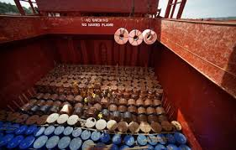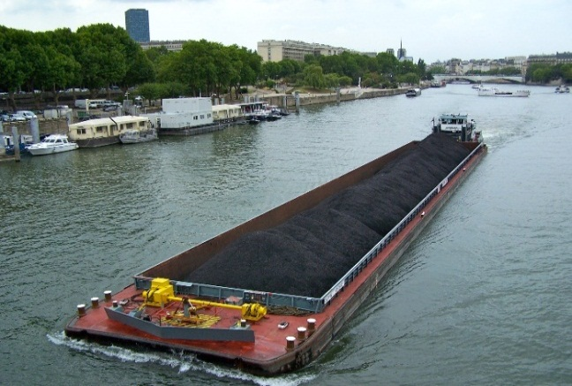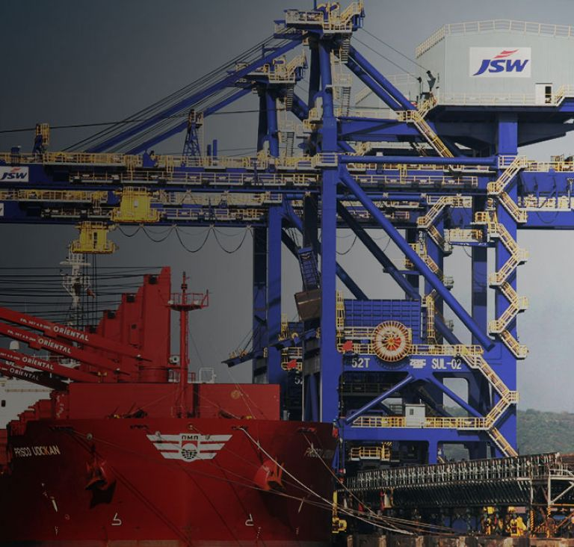

Source: Company records.

Exhibit 3: Location of JSW Steel LTd., Jindal SAW LTd., South West Port ltd. (Goa), Mundra Port, and Gandhidham railway siding (Gujarat)

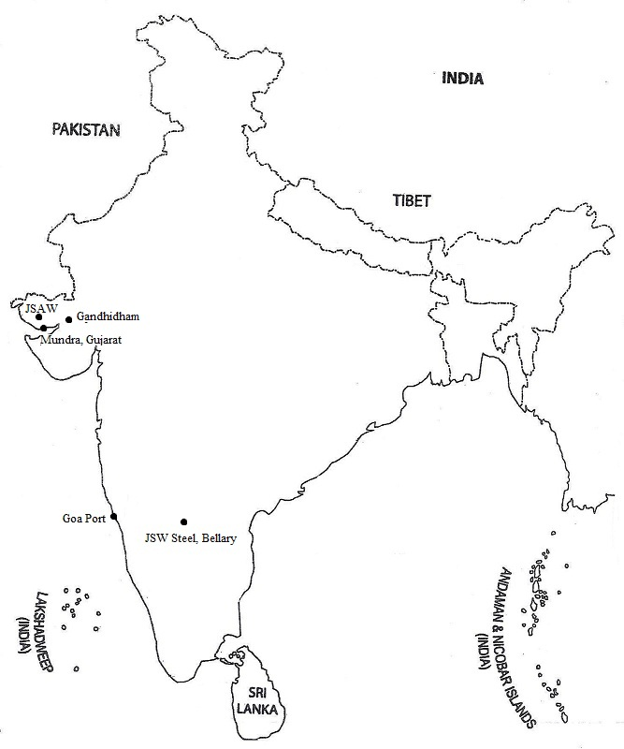

Source: Company information.

Exhibit 4: email with the Indian Railways’ price list, 2014–15

|  |  |  |  |  |  |  |  |  |  |  |  |  |  |  |  |  |  |  |  |  |
| --- | --- | --- | --- | --- | --- | --- | --- | --- | --- | --- | --- | --- | --- | --- | --- | --- | --- | --- | --- | --- |
| **To whomsoever it may concern:**  Railway charges (outgoing rakes) are as mentioned below for the year 2014–15. Under no circumstances will the prices change unless there is a letter issued by the Railways Board and signed by the manager in-charge, which states explicitly regarding the change.  Table i: Prices within state and to Goa and Chennai ports (per ton)   |  |  |  |  | | --- | --- | --- | --- | | Destination | Within State | Goa and Chennai Ports | Rest of India | | Prices | ₹1,078 | ₹1,193 & ₹1,690 respectively | Follow Table 2 |   Table ii: Price for rest of India   |  |  | | --- | --- | | Destination (rest of India) | Price (₹) | | Gurgaon siding | 3,990 | | Himachal region | 4,598 | | Mundra region | 3,180 | | Indore and other parts of Central India | 2,689 | | Eastern region | 3,500 |   The above-mentioned prices are on per-ton basis; kindly update your pricing charts accordingly. A detailed hard copy will soon be delivered to your office.   * G. Warrier, Head of Accounts |

Note: ₹ = INR = Indian rupee; US$1 = ₹60.53 on September 1, 2014.

Source: Company records.

Exhibit 5: Details of activities involved in transporting coils

|  |  |
| --- | --- |
| **Activities by Rake** | **Time in Hours** |
| Coils made ready for dispatch | 12 |
| Waiting for railway office to open | 12 |
| Arrival of JUMBO/BOXN rakes after approval from railway | 0.5 |
| Loading coils into rakes | 8–12 |
| Transporting coils from Bellary to Gandhidham siding | 96–120 |
| Unloading into trucks | 6–8 |
| Transporting coils from Gandhidham siding to Jindal SAW | 8 |

|  |  |
| --- | --- |
| **Activities by Barge** | **Time in Hours** |
| Coils made ready for dispatch | 12 |
| Arrival of rakes for South West Port Ltd., Goa | 0.5 |
| Loading coils into rakes | 8–12 |
| Transporting coils from Bellary to South West Port Ltd., Goa | 30–36 |
| Unloading from rakes and loading into barge | 16–20 |
| Transporting coils: South West Port Ltd., Goa, to Mundra Port, Gujarat, Jindal SAW | 50–60 |
| Clearance and unloading into trucks | 12–16 |
| Transporting coils from Mundra Port to Jindal SAW | 12 |

Source: Company records.

Exhibit 6: Memorandum of Understanding between JSW STeel Ltd.

and Jindal SAW ltd.

|  |  |  |  |  |  |  |  |  |  |  |
| --- | --- | --- | --- | --- | --- | --- | --- | --- | --- | --- |
| This letter is issued by JSAW Ltd. (henceforth mentioned as the first party) to JSW Steel Ltd. (henceforth mentioned as the second party) in order to put forward the terms and conditions for the material supply at the Gandhidham project.  Material to be provided: Hot-Rolled coils (HRC)  Grade of Steel: ASTM A53  Packaging conditions: 2 circumferential and 2 axial steel straps  Labels: 1 on ID (inner diameter) and 1 on OD (outer diameter)  **Clause 1:** The first party will receive the material provided by the second party, adhering to the following conditions only:   |  |  |  |  |  | | --- | --- | --- | --- | --- | | Quantity delivered | Full delivery of ordered quantity | Delivery between 80% to 99% | Delivery between 70% to 79% | Delivery less than 70% | | Price (in ₹) | 30,000/ton | 28,000/ton | 25,000/ton | Nil |   **Clause 2**: First party claims the rights of accepting the material in clean and acceptable conditions throughout the supply for the project. Any deviation may result in deduction of 10% of the original value of the goods paid to the second party.  **Clause 3:** The first party also claims the delivery of material on the mutually accepted dates (12 days from the date of order booking and confirmation from second party via email). Any deviation from the above conditions will result in deduction of 10% of the original value of the goods paid to the second party.  **Clause 4:** The material will be received at the factory premises only, and any handling/transportation charges will be borne by the second party. All the invoices and transit documents should be received by the first party 2 days before the material reaches. This is for discounting of the bills and other financial follow-ups.  **Clause 5:** The first party will pay the second party the entire invoice amount according to the above-mentioned clauses on or before 3 days from the date of material received. |

Note: ₹ = INR = Indian rupee; US$1 = ₹60.53 on September 1, 2014.

Source: Company records.

1. ₹ = INR = Indian rupee; US$1 = ₹60.53 on September 1, 2014.
2. 1 ton = 2,000 pounds, or 0.907 tonnes.