

9B17E009

tech talk: Creating a social media strategy

Arpan Kumar Kar and Reema Aswani wrote this case solely to provide material for class discussion. The authors do not intend to illustrate either effective or ineffective handling of a managerial situation. The authors may have disguised certain names and other identifying information to protect confidentiality.

*This publication may not be transmitted, photocopied, digitized, or otherwise reproduced in any form or by any means without the permission of the copyright holder. Reproduction of this material is not covered under authorization by any reproduction rights organization. To order copies or request permission to reproduce materials, contact Ivey Publishing, Ivey Business School, Western University, London, Ontario, Canada, N6G 0N1; (t) 519.661.3208; (e)* [*cases@ivey.ca*](mailto:cases@ivey.ca)*;* [*www.iveycases.com*](http://www.iveycases.com)*.*

Copyright © 2017, Richard Ivey School of Business Foundation Version: 2017-07-19

In late 2016, Dr. Aditya Khare was trying to decide how he should promote Tech Talk, the content publishing portal he had co-founded in 2012. As of December 1, 2016, the portal was slightly over five years old and had a relatively small social media presence. Khare wanted to change that. He understood that it was impossible to ignore social media in his growth strategy. He wanted Tech Talk to get ample traffic directly through platforms such as Facebook and Twitter. He also wanted it to have a strong presence among special interest groups on social media so that discussions could be initiated and carried forward to enrich the body of knowledge on the web. However, coming up with a strategy that could be implemented by his small team was turning out to be more daunting than he had initially thought. Khare needed to find an answer within the next week, when he would have to present the portal’s annual progress to other governing stakeholders.

One of Khare’s agenda items for the future was fast growth, which needed to be fuelled by capital inflow from investors. A successful social media strategy would play a key role in that initiative. However, Khare did not want to experiment too much. Instead, he wanted to use established strategies for developing a strong presence on social media. How should he strategize the interaction with readers on social media? Which platforms should he focus on? How should he invest in building a presence on these platforms?

Electronic content Publishing Industry

The electronic content publishing industry (often called the electronic publishing industry, or knowledge blogs) was one of the faster growing industries in the digital economy based on year-on-year growth.[1] In October 2016, there were approximately one billion Web 2.0 websites, with approximately 319.8 million content publishing blogs available. Web 2.0-based industries witnessed a number of innovative revenue-generating business models, which targeted a focused yet narrow customer segment but created a lot of returns, especially in the shorter run. This success inspired new entrepreneurs to join and take up new initiatives in the industry. Some of these emerging business models attempted to provide their target customers with unique niche content, while many other business models were repetitive and thus failed to make any significant business impact. In the long run, many of these initiatives failed to sustain their growth and died.

The electronic publishing industry was highly fragmented. Thousands of content publishing websites posted news and content that could be considered generic and that crossed all domains or interest areas, while specialized content publishing companies focused on a niche market. As an alternative, some popular yet small teams of bloggers shared niche, yet highly focused, content with their readers. Added to this mix were content providers who mechanically churned content from existing websites, using article spinning systems. These websites created new content, and kept adding it to the repository of posts and articles. Such spun articles, if checked for similarity, showed original results. However, if the websites were checked for unique contribution, originality of thought, or even synergy of meaning within articles that were published, they failed, since articles were randomly generated using mix and match techniques from synonym-based dictionaries.

All in all, one billion websites provided trillions of pages of digital content, often with little differentiation for the not so well-versed consumer.[2] These websites faced a major challenge in creating a niche to attract readers, retain them, and generate revenue effectively. Innovative business models and pricing schemes were therefore required for sustenance and growth.

**Search Engine Optimization**

The electronic content publishing industry depended highly on two sources of traffic: search engines and social media. To gain visibility in search engines, portals focused on search engine optimization (SEO)—the adoption of a set of practices and strategies affecting the visibility of a web domain in the unpaid results of search engines (like Google, Bing, or Yahoo) to gain organic traffic. In general, the higher the number of rankings and appearance a web page had in the search results, the greater would be the traffic it received from the search engine when similar themes were searched by users.[3] SEO could target different types of organic traffic, including picture and video search, location search, academic research article search, news and latest update search, and industry-specific vertical aligned search engines.

There were two types of SEO strategies—black hat and white hat—and websites often used them both. Black hat SEO referred to strategies that focused on tricking search engines and mostly bypassed the guidelines defined by search engines. It included strategies like keyword stuffing, using hard-to-detect text that had the same colour for text and background, false automated redirects from other domains, and adding unrelated keywords to the page content that would attract search traffic. White hat SEO, on the other hand, used techniques and strategies that were mainly focused on a human audience and completely followed search-engine-defined guidelines for webmasters and web developers. Some examples of white hat SEO techniques were using correct keywords in text after a proper keyword analysis, backlinking to relevant documents inside the domain and to other websites, using link-building techniques to enhance link popularity through listing and submissions, and writing high-quality content for authentic human readers, which promoted social sharing and citations.

Research papers highlighted how these approaches were used.[4] In addition, website development best practices (which facilitated faster page loading), minimal use of iframes, minimal usage of JavaScript, and the use of sitemaps resulted in better structured websites, which enabled search engine spiders to crawl websites better. Some of the outcome of these approaches was dependent on the website hosting service provider; thus, having a high-quality hosting service played a critical role in SEO.

A strong social media presence also had a positive impact on the SEO process and, therefore, on the organic traffic generated by any web page. In fact, the content publishing industry had been radically changed with the emergence of search engines and social media (see Exhibit 1).

**Social Media**

Having a strong social media presence was increasingly gaining importance, but understanding its scope was still at a nascent stage. In the early days of Web 2.0 (around 2002 to 2008), having a social media presence was critical for increasing online presence and improving the visibility of a web page in organic search. However, social media presence was increasingly being recognized as not only an SEO booster but also an important source of referral traffic. A huge population was sharing content on social media, and social groups were getting regular updates on the newest content pertaining to specific areas and themes. Social media presence was popularly interpreted as presence on social networking and content-sharing websites such as Twitter, LinkedIn, Facebook, YouTube, Instagram, and Google+.

However, a deeper look into social media revealed the presence of more diverse websites[5] in many categories: social networking websites; creativity works sharing sites for videos and photos, user-sponsored blogs, company-sponsored cause sites, company-sponsored blogs and websites, business networking sites, collaborative websites, virtual worlds, e-commerce portals, podcasts, news-producing websites, educational materials sharing, invitation-only social networks, open source websites and social bookmarking sites that allowed users to suggest news and music (see Exhibit 2).[6]

According to Shareaholic,[7] on average, 31.2 per cent of the traffic received by websites was from social media. Top social media referrals, according to this report, were Facebook, Twitter, StumbleUpon, Pinterest, YouTube, Reddit, Google+, and LinkedIn. According to a published report by *Fortune* magazine, Facebook itself drove 25 per cent of the total traffic on average for many websites, and was followed closely by Pinterest.[8] In fact, there was a transition of focus from text-based content to image-based and video-based content in social communications, as indicated by the growing popularity of platforms like Pinterest and Snapchat. Traffic analytics indicated that Facebook (with 43 per cent) accounted for greater referral traffic to news sites than Google (with 38 per cent) for the top 400 digital news publishers. As reported by Business Fundas,[9] webmasters felt that social media marketing provided better returns on investment than traditional marketing efforts; generated better leads for business; and improved sales conversion, website visibility, brand association, and service and product awareness. However, interestingly, not every website was able to ride this wave of social media, which often was making the already popular websites more popular and phasing out the niche websites. The main reasons attributed to failing in social media were inconsistency of communication with the company’s value proposition, a general misunderstanding of how social media really worked, lack of differentiation, and a lack of measuring and monitoring key performance indicators.[10]

To further build their social media presence, webmasters were using different strategies. Some strategies followed the ethical guidelines of social media use while others did not. Social media strategies that adhered to ethical guidelines were focused on high-quality content, natural votes from viewers, natural sharing among viewers, organic growth of subscribers through social media, and so on. As part of such strategies, social media expert consultants engaged with opinion leaders and reputed bloggers to create high-quality visibility on the web. Best practices and social media transformation were the focus, and often such campaigns ran at a very high cost.

There were also many e-markets such as SocialLinkMart.com and SEOClerks.com, where people could buy subscribers (i.e., fans and followers) for social accounts on Facebook and Twitter. People could also buy social votes for content on such platforms. On sites such as Like4Like.org and EasyHits4u.com, webmasters could artificially exchange votes, comments, and social shares to boost the visibility of a website on platforms such as Twitter, Facebook, and Google+. Such purchase or exchange of social sharing and votes was not supported by the ethical use of social media websites. However, social media websites actively promoted advertisement schemes to facilitate greater reach of specific content or organizational profile pages to potential interested user groups; such advertisements were the main sources of revenue for these websites.

Tech Talk background

Founded in 2012 by Dr. Aditya Khare and Dr. Arshiya Chak, Tech Talk was a premium technology and business knowledge portal focused on promoting knowledge in the domain areas of information technology and systems. The portal provided systems for enabling business processes and social commitments. Articles encompassed specialized areas such as business analytics, e-governance, e‑commerce, Internet technologies, information technology, big data analytics, project management, telecommunication technologies and management, general business management frameworks, service science, e-payments, digital marketing, smart cities, and other related themes.[11] These articles were mostly theoretical and provided deeper insights into the different domains of how emerging information technology affected firms and societies. The objective was that for anyone exploring a specific topic covered in an article, the website became a ready point of reference to read and comprehend, like any chapter of a textbook. Tech Talk also published focused case studies, which could be used as “minicases” or “caselets” for a particular discussion in classrooms and workshops.

According to Khare, Tech Talk content was differentiated from “boring textbooks” in the way it was represented pictorially and graphically. Infographics were liberally used throughout the website and drew a lot of views and reviews from visitors. Tech Talk formed a part of the already highly fragmented and competitive electronic information publishing industry. Its performance was ranked against some of the popular website evaluation metrics (see Exhibit 3). Despite being a new web portal, the financial performance of Tech Talk from 2013 to 2016 was fairly good, due to its high focus on quality content (see Exhibit 4).

Khare was a professor of information systems, and he initiated the Tech Talk portal in 2012 as a platform for disseminating knowledge and topics that he taught in class. He had a rich background in academic research, and used the portal for different experiments and knowledge transfer with his students. Chak was a professor in electronics and computer science. She also used the portal to publish articles that could be used for classroom discussion. Both Khare and Chak were based out of New Delhi, the capital city of India. Khare handled the overall management of the portal as well as partner relations, while Chak was more inclined toward editing content and managing the team of content writers. Soon, the co-founders realized that many people were following their articles, and the content was getting reused in different platforms. These platforms were discussing topics such as Internet-based technologies, networking technologies, e‑commerce, social media, business analytics, gadgets, mobile commerce, big data, emerging smart technologies, and cloud computing. The discussions fuelled the start of Tech Talk as a knowledge base for technology discussions.

**TECH TALK Growth**

Once Khare and Chak started evaluating the type of traffic that Tech Talk received—based on web analytics, which were built into the portal—they found that most of the traffic came from search engines only. In fact, 84 per cent of the traffic came from search engines, and most of the organic search traffic came from India and the United States. Most of the remaining traffic was from direct visits by subscribers, and only about four per cent of the total traffic was from social media. However, they noticed that most other websites got a lot more traffic from social media sites. Khare wondered why and if there was something he was missing to not be able to get the referral traffic from social media websites. Apparently, people enjoyed the Tech Talk articles since they visited the website on a regular basis from the web. While Khare wanted to explore how to take Tech Talk to the next level using social media, Chak was less bothered by this. She felt that creating high-quality content should be their sole focus and the rest would automatically follow. However, Khare was not convinced, since he had seen great content often fail to get ample attention.

Tech Talk was deployed on the WordPress content management system, and each page of the website was integrated with social sharing tools. Sharing facilities were sometimes used by web page visitors, but not as frequently as Khare wanted. Users often emailed the articles to their webmail or bookmarked it. However, social sharing on Pinterest and Facebook was not picking up pace.

Khare knew the importance and impact of social media on the masses. He understood the countless ways that the dynamics of social media marketing affected individual users as well as communities.[12] He was aware of success stories surrounding the use of social media that illustrated a shift in value creation. Therefore, every article that was published on Tech Talk automatically got shared and distributed on all of Tech Talk’s social media platforms, including the Facebook page of the website, Twitter handles, and LinkedIn profile. Khare also attempted to make posting and sharing on Twitter and Facebook as automated as possible. For example, on Twitter, a tool called Twitter feed was used, which not only automatically published Tech Talk’s articles and posts on Twitter, but also could be customized to use selective feeds from other much larger and popular news websites. Twitter feed enabled the selection of topic-specific articles from the rich site summary (RSS) feeds of these popular websites and automatically tweeted them around the clock, without any manual intervention. This tool helped Tech Talk reach a global Twitter audience.

By using Twitter feed and Twitter Trends, Tech Talk acquired a lot of followers. Khare then ran a social campaign on Twitter about the management of a natural calamity using smart technologies, which also increased his follower count significantly. As of December 2016, Tech Talk had over 60,000 Twitter followers. However, while there was a huge base of followers, it was not generating a significant amount of referral traffic, which could be expected from such a large base. Khare wondered why the Twitter followers were not converted into traffic.

**socia media analytics for Tech Talk**

An overview of Twitter analytics reported that in January 2016 there were 323 tweets, which created 34,500 impressions, which further created 1,824 profile visits and 394 mentions and retweets. Of the Twitter followers, 69 per cent were male and 31 per cent were female. Also, 53 per cent were single, while 47 per cent were married. The devices used by these followers were mostly desktop and laptop computers (83 per cent), followed by android (18 per cent) and iOS devices (9 per cent). Tech Talk’s Twitter page was rarely accessed using Blackberry phones and tablets (less than 1 per cent) or using the mobile web on other devices (2 per cent). A deeper look into the profiles of followers showed that most Tech Talk followers had completed high school (54 per cent), followed by people who had completed college (32 per cent) and graduate school (13 per cent). A more elaborate overview of Tech Talk followers was also compiled (see Exhibits 5–9).

A deeper look into analytics for social media platforms showed that there were analytical frameworks surrounding research methods for mining useful information from Twitter data. There were three main types of analytical approaches with relevant metrics: descriptive analytics, content analytics, and network analytics (see Exhibit 10).[13] These metrics gave insight into what users discussed about specific topics and hashtags, and the dynamics of user groups.[14] They also showed the major topics being discussed on Tech Talk (see Exhibit 11). To discover these abstract “topics” from the collection of Talk Tech tweets, Khare used topic modelling—a type of statistical tool used in text mining and machine learning to discover hidden semantics in text.

Furthermore, sentiment analysis or opinion mining could be used to gain insight into opinions about the content on Tech Talk (as well as the discussions mentioning Tech Talk) in general. Sentiment analysis mainly comprised classifying the polarity of the given text. That is, it tried to identify whether the attitude toward a topic was positive, negative, or neutral. The analysis illustrated the polarity of tweets posted on Tech Talk and discussions surrounding which major “topics” fell into the positive, negative, and neutral categories (see Exhibit 12). Beyond polarity, sentiment analysis classified content based on emotions such as joy, sadness, anger, disgust, surprise and fear. A similar analysis of emotions surrounding different topics on Tech Talk was captured from the tweets on the blog (see Exhibit 13). This analysis gave a holistic view about the main discussion topics on Tech Talk and their sentiment.

Delving further into the details of social media analytics, specifically network analysis, gave insights about the follower and friend networks of Tech Talk on Twitter. Network topologies uncovered useful patterns among users based on their interactions with each other, such as following, re-tweeting, and @mentions. Various network metrics could be used to obtain a detailed description of Tech Talk’s network. One such metric could be obtained by analyzing the network of Tech Talk’s top followers and their interactions with each other (see Exhibit 14). This analysis helped identify what kind of users followed Tech Talk and the clusters that might form among followers based on their interactions.

Compared to Twitter, Tech Talk’s Facebook page had only about 1,400 subscribers (fans). In December 2016, Facebook analytics for the page indicated that 348 people had been reached by the page, with 38 post engagements and around 57 new page likes. Month on month, Facebook fan page likes increased by an average 8 to 10 per cent without running any campaign. The total number of people who viewed the page after seeing a post compared to the total views on any post was around 65 per cent. In the last six months from June to December 2016, each month had over 18 posts and had a reach of over 52 people and over 32 clicks per post. Of the fans, 22 per cent were women while 78 per cent were men. The most popular five countries that followed the page were Ethiopia (26 per cent), India (27 per cent), United States (11 per cent), United Kingdom (11 per cent), and Canada (9 per cent). English was the primary language for 78 per cent of the fans, followed by Arabic and Spanish. Mobile devices were preferred more by the fans (88 per cent) than desktops (8 per cent).

Detailed analysis of the Facebook fan page highlighted that Tech Talk attracted a young crowd, with 58 per cent of fans in their 20s, followed by people in their 30s (24 per cent) and teenagers (12 per cent). Also, most fans were male (67 per cent). Only 3 per cent of the total fan base belonged to the 40–50 age group. Details of the key performance indicators from the Facebook page were also captured (see Exhibit 15). However, because of the Twitter experience, Khare was in a dilemma over whether to advertise on Facebook. If Facebook advertising should be used, how should it be customized to ensure higher conversion of fans and subsequent engagement?

Khare wondered whether he was using the correct key performance indicators to capture data on his Facebook and Twitter subscribers. If not, what other indicators should he follow and use? Should he identify potential influencers to promote his content? If yes, then how could he identify such influencers from among his subscriber base? Another dilemma was whether to hire resources in-house or outsource social media management to experts. An in-house social media marketing team could have a higher cost for the company, but could result in a better understanding of Tech Talk’s needs. However, such a central team might not be fully usable in the current role, given the existing scope of business. Such a team may not understand the business needs of offerings surrounding which content for marketing may need to be created. Social media management could be outsourced to expert consulting companies, but, being a start-up, Khare was somewhat sensitive about the expenses and did not want to venture on an expensive path of social media promotions.

If social media management were to be outsourced, Khare would ideally want to cut down on the cost of operations, if given a choice. Should it be outsourced to a dedicated, low-cost vendor who would keep servicing the needs and promotion over social media channels? A dedicated social media promoter might become costly but might result in higher returns. Or should the promotions be outsourced to a third party through an e-market such as SEOClerks.com. With SEOClerks, it was possible to sell work orders for social shares and social votes on many platforms such as Twitter and Facebook, at a nominal charge.

**The Decision**

All in all, Khare was faced with multiple thoughts. How should he try to understand and incorporate the functional blocks for social media websites? How should the scope of social media be defined in fine tuning Tech Talk’s social media strategy? There were so many platforms like Facebook, Twitter, LinkedIn, and Instagram. What websites and key performance indicators should he focus on in implementing his social media strategy? Finally, should he manage the social media marketing in-house or outsource it? For sure, social media could not be neglected, but the way to harness it was becoming a tricky challenge that Tech Talk needed to overcome.

Exhibit 1: Transformation of the Activity Value Chain in the Digital Content Publishing Industry

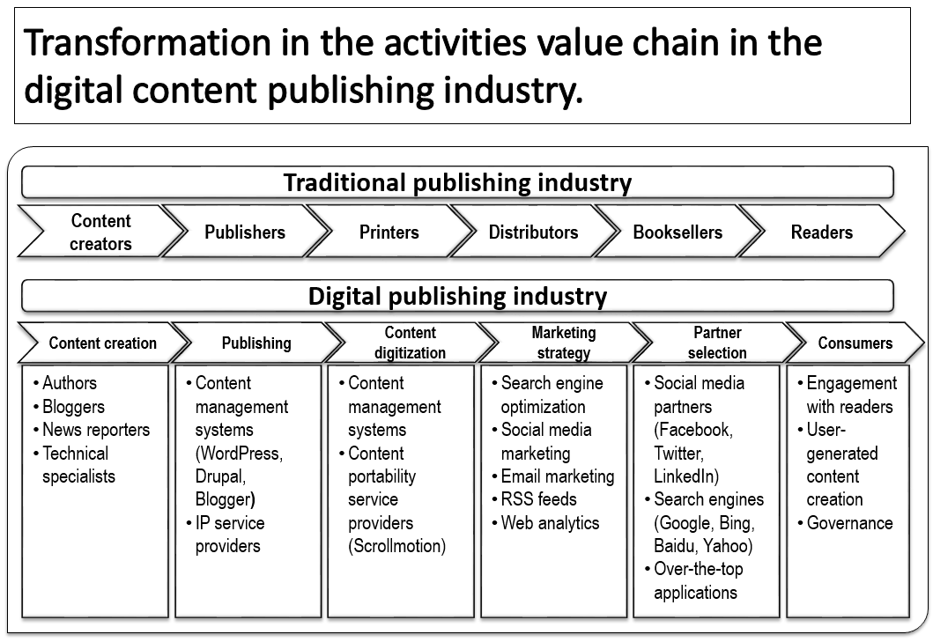

Source: Created by the case authors.

Exhibit 2: Types of Web 2.0 and Social Media Websites

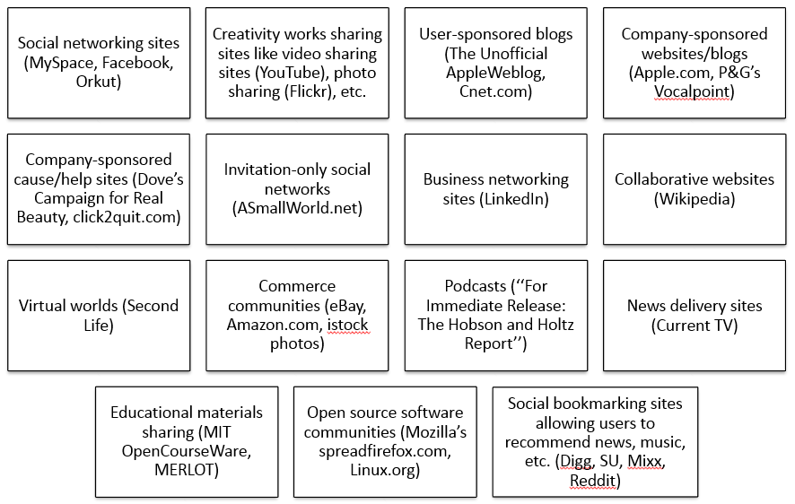

Source: Framework adapted from W. Glynn Mangold and David J. Faulds, “Social Media: The New Hybrid Element of the Promotion Mix,” *Business Horizons* 52, no. 4 (July 2009): 357–365.

Exhibit 3: Domain Specific Metrics from WebsiteOutlook.com (Available in the public domain)

1. Alexa rank 432,546
2. Estimated page views 2,250/day
3. Count of backlinks Over 3,500
4. Root domains linking back 438
5. Page authority 45/100
6. Domain authority 36/100
7. Moz rank 5.58/10.00
8. Spam score 0/17

Note: Alexa rank is an indicator of traffic to a website (i.e., page views). The rest of the parameters are indicators of a website’s importance or performance against quality audits of Moz. Moz is a website ranking and auditing firm that produces publicly available reports on website performance.

Source: Online Web Analytics Tool, http://tech-talk.org.websiteoutlook.com, accessed December 12, 2016.

Exhibit 4: Tech Talk Financials (in ₹)

|  |  |  |  |  |  |
| --- | --- | --- | --- | --- | --- |
| **Class** | **Category/Head** | **2016** | **2015** | **2014** | **2013** |
| Expenses | Physical Infrastructure | 20,750 | 20,450 | 19,850 | 55,450 |
| Advertising and Marketing | 310,450 | 270,450 | 235,560 | 167,560 |
| IT Infrastructure & Analytics | 19,720 | 19,680 | 19,680 | 56,780 |
| Human Resources | 160,000 | 155,000 | 145,500 | 125,500 |
| Advisory Services | 16,750 | 14,550 | 14,550 | 35,450 |
|  | Sum Total | 527,670 | 480,130 | 435,140 | 440,740 |
|  |  |  |  |  |  |
| Revenue | Content Advisory Services | 148,450 | 74,450 | 22,450 | 12,460 |
| Banner Advertisements | 228,000 | 210,000 | 145,450 | 55,000 |
| Sponsored Posts | 670,600 | 480,400 | 340,560 | 124,787 |
| SEO/SMO Enablement | 240,600 | 210,450 | 190,120 | 126,570 |
| Print Publishing | 71,500 | 70,580 | 69,000 | 65,450 |
|  | Sum Total | 1,359,150 | 1,045,880 | 767,580 | 384,267 |
|  |  |  |  |  |  |
|  | Profit | 831,480 | 565,750 | 332,440 | –56,473 |

Note: * ₹ = INR = Indian rupees.

Source: Company documents.

Exhibit 5: Key Performance Indicators from Tweets in 28 days

1. Number of tweets 348
2. Number of impressions 34,750
3. Twitter profile visits 1,848
4. Mentions and retweets 394
5. Likes 317
6. Link clicks 248

Source: Company documents.

Exhibit 6: Key Interests of Followers

%

1. Music 87
2. Movies and Television 86
3. Hobbies and Interests 79
4. Music and News 78
5. Photography 66
6. Technology 65
7. Tech News 61
8. Politics 60
9. Business and News 60
10. Management 58

Source: Company documents.

Exhibit 7: Household income categories of Followers (In US$)

%

1. $75,000–$99,999 20
2. $60,000–$74,999 12
3. $40,000–$49,999 11
4. $150,000–$199,999 11
5. $100,000–$124,999 8

Note: US$1.00 = ₹67.92, on December 30, 2016.

Source: Company documents.

Exhibit 8: Estimated net worth of Followers (IN US$)

%

1. $1–$100,000 33
2. $100,000–$1,000,000 27
3. $2,500–$24,999 11
4. $150,000–$249,999 11
5. $250,000–$374,999 9
6. $100,000–$149,999 9
7. $50,000–$74,999 6

Source: Company documents.

Exhibit 9: Top countries of Page Visitors in 28 days

%

1. United States 29
2. Russia 17
3. United Kingdom 5
4. Canada 4
5. Ukraine 4
6. India 3
7. Turkey 3
8. Spain 2
9. Germany 2
10. Philippines 2

Source: Company documents.

**Exhibit 10: Social Media Analytics**

|  |  |  |
| --- | --- | --- |
|  | **Analysis Metrics** | **Description** |
| Descriptive Analytics | Tweet Metrics | Analysis of tweet statistics pertaining to users and topics, tweets over times, hashtags in tweets, and @user mentions per tweet. |
| User Metrics | Analysis of user statistics such as status, favourite, and follower counts, their activity and visibility, and formation of user groups. |
| URL Metrics | Comprises useful information pertaining to the links used in tweets, such as the number of URLs used in tweets, tweets per URL, user groups that share similar URLs, and top URLs and domains followed and shared by users. |
| Content Analytics | Word Analysis | Comprises term frequency analysis using topic modelling and detailed analysis such as the clustered document level approach. |
| Hashtag Analysis | Refers to the analysis of hashtags frequently used by users, including the association among hashtags and users using similar hashtags. |
| Sentiment Analysis | Refers to the analysis of entire tweets and clustered tweets for emotion and polarity. |
| Network Analytics | Topological Analysis | Pertains to network parameters such as average path length, shortest path, network layout, and diameter. |
| Centrality Analysis | Comprises parameters such as degree, eigenvector, and betweenness centrality for analyzing the user network. |
| Community Analysis | Pertains to network density, modularity analysis, and clustering coefficient in social networks. |

Source: Created by the case authors from Bongsug (Kevin) Chae, “Insights from Hashtag #Supplychain and Twitter Analytics: Considering Twitter and Twitter Data for Supply Chain Practice and Research,” *International Journal of Production Economics* 165 (July 2015): 247–259.

Exhibit 11: Tech Talk Topic word cloud

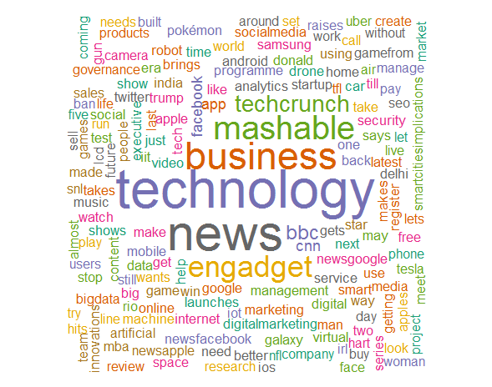

Source: Company documents.

Exhibit 12: Sentiment Analysis: Polarity word cloud

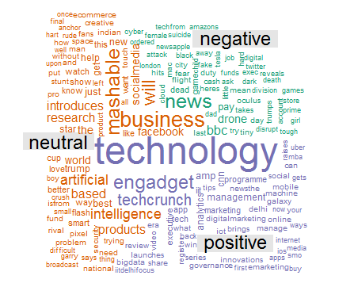

Source: Company documents.

Exhibit 13: Sentiment Analysis: Emotion word cloud

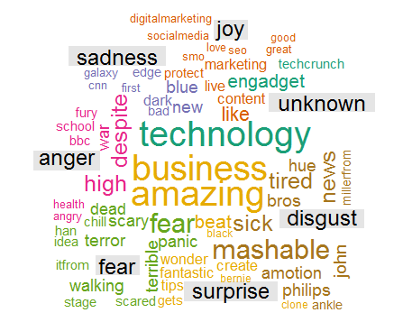

Source: Company documents.

Exhibit 14: Tech Talk Network Analysis

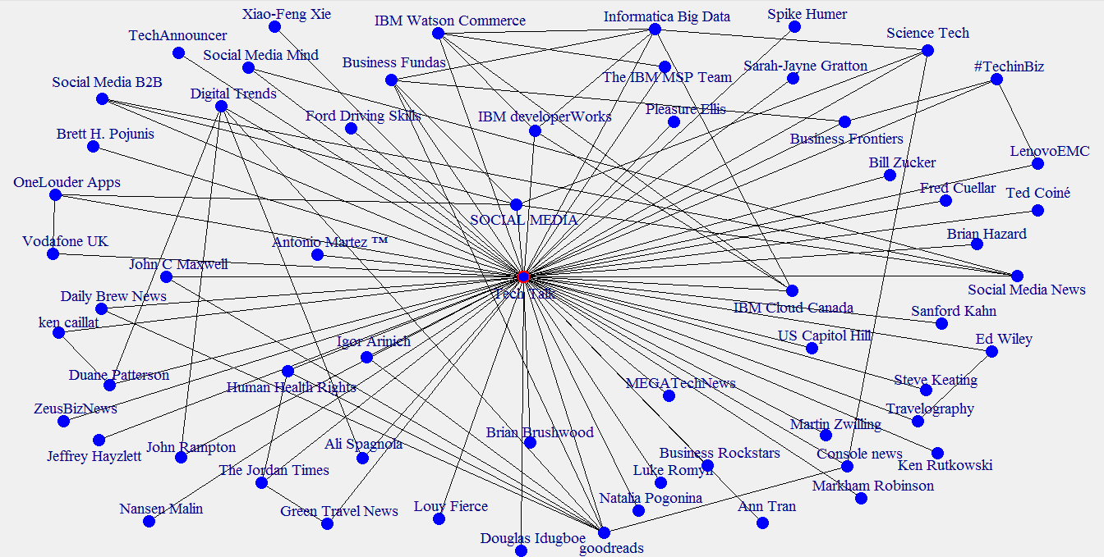

Source: Case authors’ analysis of Tech Talk’s Twitter followers.

Exhibit 15: Key Performance Indicators from Facebook Page

1. New page likes every month 9
2. Actions on page (%) 1.7
3. Reach per post (%) 48
4. Average engagement per post 25
5. Average clicks to website 6
6. Average phone number clicks 2
7. Page call to action clicks 2

Source: Company documents.

1. Rüdiger Wischenbart, “The Global Ranking of the Publishing Industry 2015,” 3-4, accessed May 10, 2017, www.wischenbart.com/upload/Wischenbart_Ranking2015_analysis_final.pdf.
2. John Sutter, “How Many Pages Are on the Internet?” CNN, September 12, 2011, accessed February 27, 2017, http://edition.cnn.com/2011/TECH/web/09/12/web.index/.
3. Harold Davis, *Search Engine Optimization: Building Traffic and Making Money with SEO,* (Newton, MA: O’Reilly Media, 2006), 11-12.
4. Aaron Vegh, “Chapter 9: Search Engine Optimization,” in *Web Development with the Mac* (Indianapolis, IN:Wiley Publishing Inc, 2010), 221–239; Amy Van Looy, “Chapter 6: Search Engine Optimization,” in *Social Media Management* (Cham: Springer International Publishing, 2016), 113–132.
5. W. Glynn Mangold and David J. Faulds, “Social Media: The New Hybrid Element of the Promotion Mix,” *Business Horizons* 52, no. 4 (July 2009): 357–365.
6. Arpan Kumar Kar, “Integrating Websites with Social Media—An Approach for Group Decision Support,” *Journal of Decision Systems* 24, no. 3 (November 2015): 339–353.
7. Danny Wong, “In Q4, Social Media Drove 31.24% of Overall Traffic to Sites,” Shareaholic Reports, Social Media (blog), January 26, 2015, accessed February 27, 2017, https://blog.shareaholic.com/social-media-traffic-trends-01-2015.
8. Mathew Ingram, “Facebook Has Taken over from Google as a Traffic Source for News,” *Fortune,* August 18, 2015, http://fortune.com/2015/08/18/facebook-google.
9. Arpan Kumar Kar, “Benefits of Social Media Marketing,” Business Fundas, 2015, accessed April 10, 2017, www.business-fundas.com/2015/benefits-of-social-media-marketing.
10. John Rampton, “Why Most Social Media Strategies Fail,” *Forbes,* April 22, 2014, accessed February 27, 2017, www.forbes.com/sites/johnrampton/2014/04/22/why-most-social-media-strategies-fail.
11. “About Us,” Tech Talk, accessed February 17, 2016, http://tech-talk.org/about/.
12. Pierre R. Berthon, Leyland F. Pitt, Kirk Plangger, and Daniel Shapiro, “Marketing Meets Web 2.0, Social Media, and Creative Consumers: Implications for International Marketing Strategy,” *Business Horizons* 55, no. 3 (February 2012): 261–271.
13. Bongsug (Kevin) Chae, “Insights from Hashtag #Supplychain and Twitter Analytics: Considering Twitter and Twitter Data for Supply Chain Practice and Research,” *International Journal of Production Economics* 165 (July 2015): 247–259.
14. Nimish Joseph, Arpan Kumar Kar, Vigneswara Ilavarasan, and S. Ganesh, “Review of Discussions on Internet of Things (IoT): Insights from Twitter Analytics,” *Journal of Global Information Management* 25, no. 2 (April 2017): 37–60; Akshat Lakhiwal and Arpan Kumar Kar, “Insights from Twitter Analytics: Modeling Social Media Personality Dimensions and Impact of Breakthrough Events,” in *Social Media: The Good, the Bad, and the Ugly* (Cham: Springer International Publishing, 2016), 533–544.