

9B17E015

mate1.com: digital dating dilemma

Charles Wasserman, Dharsana Vijayaratnam, Thomas Yuk, Sharon Bir, and Deb Elkink wrote this case under the supervision of Professor Derrick Neufeld solely to provide material for class discussion. The authors do not intend to illustrate either effective or ineffective handling of a managerial situation. The authors may have disguised certain names and other identifying information to protect confidentiality.

*This publication may not be transmitted, photocopied, digitized, or otherwise reproduced in any form or by any means without the permission of the copyright holder. Reproduction of this material is not covered under authorization by any reproduction rights organization. To order copies or request permission to reproduce materials, contact Ivey Publishing, Ivey Business School, Western University, London, Ontario, Canada, N6G 0N1; (t) 519.661.3208; (e)* [*cases@ivey.ca*](mailto:cases@ivey.ca)*;* [*www.iveycases.com*](http://www.iveycases.com)*.*

Copyright © 2017, Richard Ivey School of Business Foundation Version: 2017-11-24

Mauricio Idarraga had the perfect qualifications for his position as vice-president (VP) of operations for Mate1.com (Mate1), an online dating company headquartered in Montreal, Canada. His background in technology and finance had prepared him for a leadership position at the corporate level, while his South American roots, rich in family and community values, gave him a natural emotional intelligence that was essential for successfully managing interpersonal relationships—and at the moment, in the middle of Mate1’s weekly budget meeting, emotional intelligence was critical as emotions were running high.

“We are losing money by the second!” barked Andrew Stern, VP of marketing. “We need the market spend reports. Now!”

Idarraga nodded, instinctively aware of the rising frustration among his operations team members seated around the table. The imperative from marketing was indeed unambiguous: *Attract new online dating subscribers to Mate1’s website* (see Exhibit 1). The challenge lay in how to go about optimally allocating the precious marketing dollars, amounting to about CA$125,000[1] per week, and this depended on finely tuned, high quality, real-time business intelligence (BI) reports from the firm’s data warehouse. Unfortunately, the Dino server that hosted the warehouse frequently crashed, leaving the data-driven company relying on guesswork for days at a time.

Idarraga understood that timely marketing reports were a priority. Sub-optimal advertising that failed to drive customers to the website, day to day and minute to minute, directly affected revenue and profitability. But he wondered if this problem was a symptom of a larger malignancy. Was Mate1 pursuing the right strategy to achieve its big-picture objectives?

**THE ONLINE DATING INDUSTRY**

Idarraga had found his way naturally into the online dating industry when he joined the Mate1 team. The pace of life in North America was much busier than it was in his home country of Colombia and, he had realized, made “meeting online” a perfect answer for many people seeking a partner. Indeed, over the previous decade, online dating had become the number one method of connection for those who rejected the more traditional bar and nightclub scenes or the limited network of introductions by friends. Exchanging emails or instant messages let people engage in low-risk conversations to assess whether they had found a good fit before committing to a live date. This also opened up a much larger pool of singles, leveraging technology to make matches based on common interests, shared values, and attractiveness. By 2013, 30 to 40 million North Americans used online dating sites,[2] and usage was increasing across different age groups (see Exhibit 2).

Online daters could choose from a surplus of services across an array of niche service types. Two business models existed in the industry: fee-based subscriptions (which generated revenue by collecting credit card data from users) and advertisement (ad)-supported “free” accounts (which generated revenue via advertising and click-through and up-selling activities). The global online dating industry was a $3.7 billion market, with the United States accounting for 70 per cent of that total.[3] Online daters appeared to be unaffected by the general price sensitivity seen in most other sectors; dating sites were able to charge premium subscriptions of up to $78 per month.[4]

The United States had the most mature market in the industry—and the most competitive. Through mergers and acquisitions, the largest conglomerate in this space was Match Group Inc., which owned many well-known brands including Match.com, Tinder, Plenty of Fish, and OKCupid, together representing 22 per cent of the global market and over 50 per cent of the North American market.[5] Strategic acquisitions had allowed Match Group Inc. to dominate the market in a number of key dating niches, thereby gaining a greater share of the total online dating user base.

Many companies attempted to differentiate their services by targeting a niche market. For example, Ashley Madison, a Canadian-based company, provided “discreet relationships” for people looking for a fling to escape the “mundane, boring, everyday activities” of marriage and family life.[6] Others, such as eHarmony, focused on long-term relationships through “algorithm-based” matching and “science-based” compatibility spotting, with integrated Facebook analytics to understand a user’s friend base and find prospective partners—an automated service mimicking a professional human matchmaker.[7]

Online dating relied on state-of-the-art technology to reach prospective users, and the industry was one of the first to successfully utilize native mobile applications (apps)[8] for commercial purposes. Robust technology was necessary to create and maintain extensive databases of member information as well as support real-time messaging and notifications. Cyber security was a major concern for site owners, who had invested significant sums of money to maintain and safeguard the anonymity of their clients’ personal information.

**The MATE1 Model**

Brother-and-sister duo Charles and Elizabeth Wasserman founded Mate1 in 2004 after brainstorming ideas for a technology start-up with a proven business model. The Wassermans had been raised in an entrepreneurial family culture. Their grandfather had emigrated from Poland at the end of World War II, bringing with him experience in the needle trade from the old country. He and his son became magnates in Montreal’s renowned textile industry, founding a garment manufacturing business and passing along their spirit of innovation to the junior Wassermans. Through family investment and mentorship, Mate1 grew to become one of the largest online dating companies in the world within two years of its launch. With a full-service offering related to mainstream/casual dating, and both desktop (web) and mobile (app) platforms, Mate1 operated throughout North America and in English-speaking countries around the world. By 2013, Mate1 had grown to 40 employees, and its mobile app had become one of the 15 highest-grossing social media apps in the United States (see Exhibit 3).

Mate1’s success and competitive advantage was attributed to the Wassermans’ credo that customers came first, and Idarraga, joining the company in 2015, fit right in with the company’s philosophy. He believed that good businesses always took care of their tier-one problems—and for a client who was single and did not want to be, meeting someone was a tier-one problem. Idarraga made a number of physical changes at Mate1’s headquarters, such as replacing the traditional reception desk with a ping-pong table, which conveyed a positive and playful message, and spurred employees to challenge each other in weekly tournaments.

The Mate1 brand was targeted to older consumers, 35 to 65 years of age, with more disposable income and the willingness to pay a subscription fee. Mate1’s monthly fee of $59.95 covered full access to its services. With over 35 million members and 8,000 new users registering daily, the service was available from both the desktop and mobile apps (see Exhibit 4).

The mobile infrastructure was non-native, which meant that a common app codebase sat atop a framework that supported website, Android, and iOS experiences. Operating in an industry heavily influenced by new technology, Mate1 was continuously driven to adapt its technological capabilities, business strategies, and product innovations to maintain high customer growth. Emerging technology was having a significant impact. The advent and market adoption of smartphones, for example, had disrupted and transformed the industry: just three years previously, Mate1 had had no mobile products and only 5 per cent mobile usage, yet by the time Idarraga had joined the company, 90 per cent of new clients had signed up using their mobile phone.

Idarraga believed that the next generation of online dating was likely to incorporate new and emerging technologies, such as artificial intelligence and virtual reality, to provide increasingly deeper and more robust product experiences for customers.

**Technology Infrastructure**

Operations relied on a multi-tiered, service-oriented architecture that was largely built on open source software and that ran primarily on the Java virtual machine (JVM) platform. JVM was a popular computing platform for online businesses because it allowed a given piece of software—say, a program to display a data input form on the screen—to be written once and then run on multiple different platforms (e.g., in a desktop browser or inside a mobile tablet or phone app). As a result, it was less time consuming and much less expensive to deploy existing services when a new user technology platform popped up. (See Exhibit 5 for an illustration of overall data flow.)

The company’s reporting platform was event driven, which meant that it was designed to respond to user actions in real time. The logging server captured every data event (e.g., mouse click, screen tap, key press) in Mate1’s distributed message queue, a detailed activity log. The site saw approximately 1,000 to 3,000 active user sessions at any moment.

Operations managed two additional servers, named Dino and Raptor. Raptor was a small BI system used for quick and less-demanding calculations. Dino was the main BI machine that carried the biggest computational and data transformation workload; its main role was to receive most of the data and events that occurred within the entire Mate1 system in order to summarize, archive, and compute specific metrics and reports. Dino also served as an exploration tool used by the BI, product, and marketing teams to perform ad-hoc discoveries. With an increasing demand for data, transformations, and reports, the system was encountering a significant input–output bottleneck, leading to daily software panics, hardware crashes, and restarts. The estimated lost revenue because of these crashes was estimated to be about $5,000 per day.

**Subscription Business Model**

Subscription business models in the online dating industry typically suffered from high customer turnover in the range of 90 per cent annually, and Mate1’s turnover was in line with this industry average. However, leading large-scale players such as Match.com and eHarmony were adding pressure, as they worked to grab an ever-increasing share of the market. Ad-supported dating sites and apps such as Plenty of Fish and Tinder were also becoming more aggressive. Idarraga knew that if they were ignored, these competitors would eventually dominate the industry. Maintaining a positive churn of new subscribers to replace expiring ones was paramount to Mate1’s ongoing success.

User data were employed in making decisions about products, as well as for digital marketing and ad publishing. With the advent of smartphones and tablets, the user interface and user experience had become central product differentiators. Digital firms like Mate1 carefully tracked their marketing effectiveness using a variety of key performance indicators such as unique log-ins, new registrations, and retention rates (see Exhibit 6). This data came from sources such as Google Analytics, Facebook Analytics, and a firm’s own internal tracking systems.

Ninety per cent of Mate1’s new customers signed up directly after clicking a paid ad. As a result of the turnover rate and its reliance on paid advertising, the company spent $15,000 per day on digital advertising to maintain sufficient churn. The profitability of these advertising campaigns hinged on accurate, up-to-date reports. On any given day, Idarraga saw over 200 media buys, 60,000 unique customers clicking on ads, 8,000 registrations, and hundreds of new subscriptions being generated. This data, along with client demographic information, funnelled into a single report that the company’s media buyers used to make time-sensitive optimizations on their campaigns (see Exhibit 7).

Decisions related to ad bidding, demographic targeting, segmentation, choice of ad copy, and landing page were made multiple times per day. The report utilized a predictive analytical model to project future revenues and to calculate a lifetime return on investment for each campaign. When the report failed to update, the media buyers lost the ability to make timely decisions on their campaigns, resulting in sub-optimal profitability, to the tune of thousands of dollars per day.

**Digital Media Buying**

Marketing had changed drastically over the past few decades, with “market segmentation” no longer limited to the question of which geographical area to blanket with what sorts of static mass media advertising (television, radio, billboards, buses, flyers). Idarraga and his Mate1 team were dealing with prospective buyers who could now be segmented in much greater detail and approached with finely tuned messages, using media not confined to static ads but employing dynamic content. The long-standing marketing framework of product, place, promotion, and price had evolved dramatically as a result of the Internet and ubiquitous digitalization.

The introduction to North America of the smartphone, starting with Apple’s iPhone in 2007 and followed by mobile tablets, proved to be a turning point in online dating. Desktop marketing had matured, and the mobile industry was just beginning to take off when Stern, VP of marketing, joined Idarraga and the team in 2012 to oversee Mate1’s entry into this “wild, wild west” of mobile marketing innovation. (Stern had run some of his first pre-Mate1 ad campaigns for a phone-in chat line—related to online dating—but no marketing strategy yet existed in that arena.) Mate1’s customer base was shifting heavily to mobile usage, bringing with it an exponential rate of growth. By 2016, only 5 to 10 per cent of new acquisitions found their way to Mate1 through the desktop, and the mobile interface experience had become a central product differentiator. It seemed many people were using mobile apps to seek true love.

Lacking the brand image and recognition of the big-name competitors, Mate1 developed its marketing approach by thinking outside the box. The company was constantly on the lookout for new ideas, new products, and new targeting techniques, using competitive intelligence to check out what other companies were doing. For example, under Stern’s direction, Facebook became Mate1’s top venue for advertising. As a social network itself, Mate1 perceived itself as doing the same thing Facebook was doing—connecting people. In a natural segue, Facebook users naturally clicked on Mate1 ads as they popped up and piqued their interest. Ads were targeted and delivered directly to individual users based on the extensive information available to Facebook, one of the largest data owners in the world. (Facebook tracked data related to user age, gender, devices employed, phone carriers, content viewed, groups joined, location, and personal preferences—a seemingly endless bank of information.)

Facebook’s segmenting, targeting, and deep data skills made it a perfect partner for Mate1. A single user click on the Facebook connection button prominent on Mate1’s website brought Facebook a wealth of information for future targeting of ad campaigns. Collaboration abounded. For example, in 2016, Mate1 accepted Facebook’s offer of a two-day product and marketing brainstorm session, to help reach women over the age of 35 (previously not a strong sector for the dating company). Facebook sweetened the pot with a promotional gift worth $26,000 towards Mate1’s ad spend. As a result of this collaboration, Mate1 became the first dating company to adapt Facebook’s carousel ad, incorporating multiple images in a single ad unit; dating company competitors did not catch up until a full month later.

Although 40 to 80 per cent of Mate1’s daily ad spend went to Facebook, social media was not the only aspect of its advertising strategy. One of the company’s strengths was its ability to manage partnerships, such as those with Google, Twitter, Yahoo, Snapchat, and Bing, as well as a host of affiliate partners.[9]

While Mate1 received 90 per cent of its traffic from paid ads and 10 per cent from organic searches, many online dating companies invested far more heavily in the “art” of search engine optimization—a set of techniques designed to move a company’s website into a top spot in search engine results. Some of the more highly recognized brands in the dating industry enjoyed close to a 50–50 split between paid and organic marketing—a result of years of building equity through branded advertising to bring about a high level of brand awareness and word-of-mouth referrals. However, Mate1 made the strategic decision to avoid search engine optimization, except for specific apps towards known high-yielding results, and instead build its core value through paid ads.

Stern attributed Mate1’s marketing success to a focus on its “back end”—analytics gathered through its internal tracking system. Mate1’s proprietary system allowed the company to directly measure the results of every ad campaign, every A/B test, and every click indicating a preference. The company kept track over time of which landing pages were most or least effective, which buttons users tended to press or avoid, which colours they preferred, and which they disliked. The most important aspect of Mate1’s ad strategy was its commitment to building out a broad, well-formed testing structure that consistently gathered real-time data—data that could be used to determine what was working and what was not.

To determine the best digital media purchases, Mate1 did not follow the complicated, multi-tiered approach of most online dating companies, such as manipulating algorithms, focusing on brand identification, relying on investors, or spending millions on awareness. Instead, measures and numbers from real operations were preferred to selecting testing samples. Return on investment was calculated by looking at returns for every dollar actually spent by real customers, rather than modelling returns based on some arbitrary estimate. Performance was judged on actual credit card membership purchases, rather than typical metrics such as clicks per thousand impressions (CPM), cost per click (CPC), or even cost per action or acquisition (CPA). Every marketing choice was directly checked against profitability. This resulted in a somewhat flat marketing funnel and enabled the direct measurement of effectiveness.

**CURRENT SITUATION**

Back at his desk after the morning operations team meeting, Idarraga looked around at his office staff. All were within arms’ reach, regardless of their position in the company, since he had ordered the cubicle dividers ripped out as a way to foster a collegial working culture. He looked at the handwritten testimonial from a grateful client, framed and hanging on the wall as a reminder to all that Mate1 cared about the individual over mass numbers: “I’m on my way,” the once-lonely man had penned. “Eventually I’ll know where I’m going, while a lady by my side will surely help immeasurably.”

Mate1 faced some serious challenges. Ninety per cent of subscriptions were derived from paid marketing, with only 10 per cent coming from organic methods such as word of mouth, referrals, and delayed advertising effects. Advertising spend averaged $500,000 per month, which ate into the firm’s profit margin. Meanwhile, a recent surge in membership owing to a series of successful ad campaigns had exceeded the capacity of the BI database and could quickly result in a potentially disastrous reporting lag.

Idarraga thought about the company’s client base and wondered, Could Mate1 maintain its position in the market with its existing customer acquisition strategy? Was it making optimal use of its resources? He needed to come up with a solution soon; Mate1’s owners, the Wasserman siblings, were eagerly expecting his recommendations for how to fix the media-buying issue and the performance issues. How would he meet the firm’s aggressive two-year objective to achieve 50 per cent growth in revenue and 15 per cent growth in net operating margins?

Amid the collegial conversations and clattering keyboards around him, Idarraga was lost in thought, with several possibilities and recent discussions running through his head.

Most immediately, addressing the Dino server performance problem was critical to “keeping the lights on” day to day. The estimated cost for an upgraded server was just $6,800, and this seemed like an easy and obvious solution. This would satisfy the VP of marketing and provide Mate1 with real-time data for media-buying decisions to gain more members.

However, a more sobering challenge was that the current media-buying process did not seem very scalable. Every new customer was associated with a significant advertising cost, making the company exclusively reliant on costly digital advertising to acquire customers. How sustainable was this business model for the future?

One idea that had been proposed was to acquire an ad-supported dating site that offered “free” subscriptions. Over the long term, Mate1 could leverage this site as a major source of new clients at a much lower advertising cost per subscriber, thereby increasing profit margins. Several second-tier, ad-supported dating sites had already been considered as possible acquisition targets. The growth outlook of such firms was likely to underperform industry growth; they therefore might be relatively inexpensive to purchase. High-growth companies in the online dating industry were sometimes valued at 1 × Revenue or 5 × EBITDA (earnings before interest, tax, depreciation, and amortization); however, underperforming companies would see lower valuations, and perhaps their owners would be motivated to sell. How much should Mate1 consider investing in this kind of acquisition?

Idarraga remembered yet another recent discussion he had had with Mate1’s owners. Given the firm’s historical track record, the fact that it was debt-free, and the existence of heavy consolidation in the industry, was it time to explore divesting and selling the business to a leading competitor? Mate1 held a unique position because of its premium user base of older members as well as its state-of-the-art digital marketing strategy and team, and in fact it had recently been approached by a larger player. How much was this 12-year-old company really worth?

Idarraga needed to develop his recommendations quickly. The company was losing revenue by the hour, and the owners wanted action.

**Exhibit 1: MATE1.COM WEBSITE**

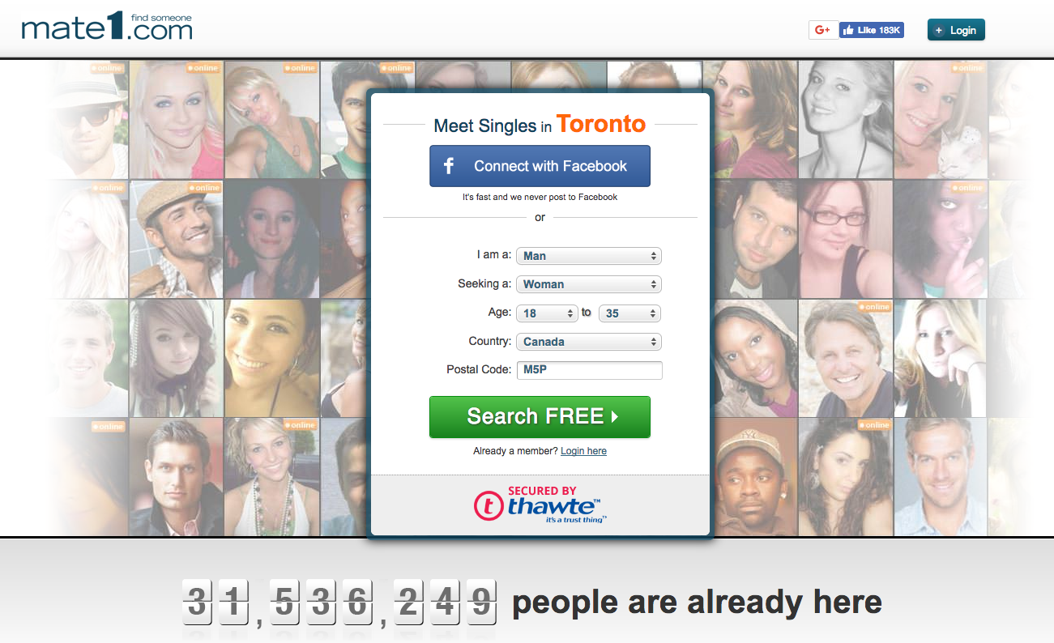

Source: Company website, www.mate1.com, accessed August 13, 2017.

**Exhibit 2: ONLINE DATING BY AGE GROUP**

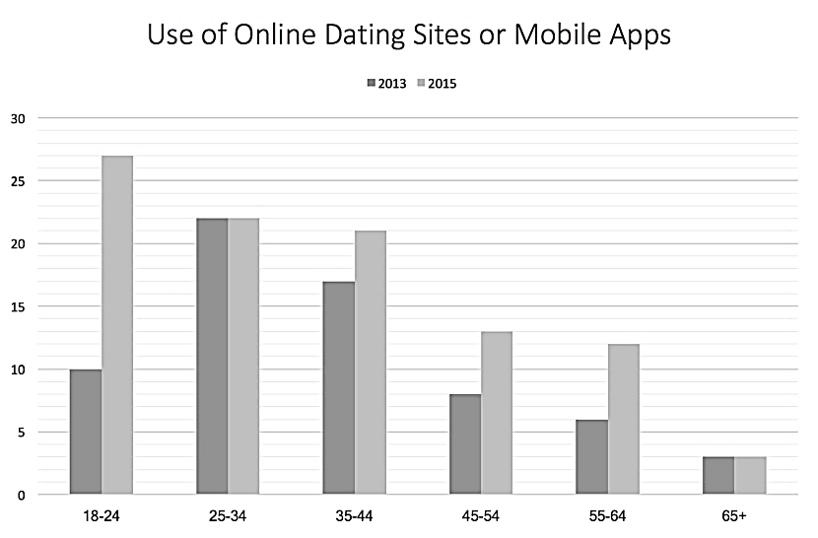

Source: Created by authors using data from Aaron Smith and Monica Anderson, “5 Facts about Online Dating,” Pew Research Center, February 29, 2016, accessed August 10, 2017, www.pewresearch.org/fact-tank/2016/02/29/5-facts-about-online-dating/.

**Exhibit 3: MATE1.com COMPARATIVE STATEMENT (CA$000s)**

|  |  |  |  |  |
| --- | --- | --- | --- | --- |
|  | 2013 | 2014 | 2015 | 2016 |
| Total Revenue | 12,798 | 11,359 | 10,141 | 8,425 |
| Cost of Goods Sold | 10,943 | 10,748 | 6,817 | 5,793 |
| Gross Margin | 1,855 | 611 | 3,324 | 2,632 |
| Operating Expense | 1,021 | 975 | 2,619 | 2,226 |
| Net Profit Before Tax | 834 | (364) | 706 | 406 |
| Income Taxes | 224 | (98) | 62 | 68 |
| Net Income After Tax | 610 | (266) | 823 | 339 |

Source: Company records.

**Exhibit 4: MATE1.com USER CHANNELS**

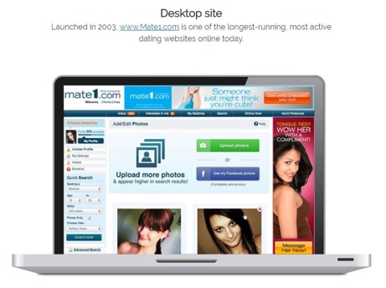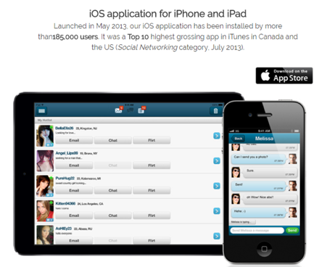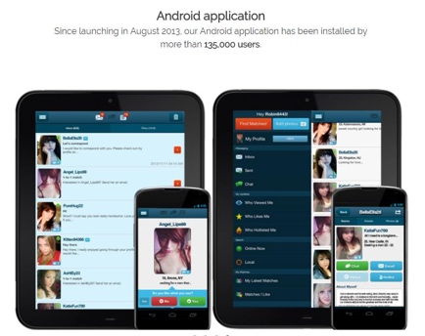

Desktop Website Mobile-iOS Mobile-Android

(Launched 2003) (Launched May 2013) (Launched August 2013)

Source: Company records.

**Exhibit 5: MATE1.com DATA PIPELINE**

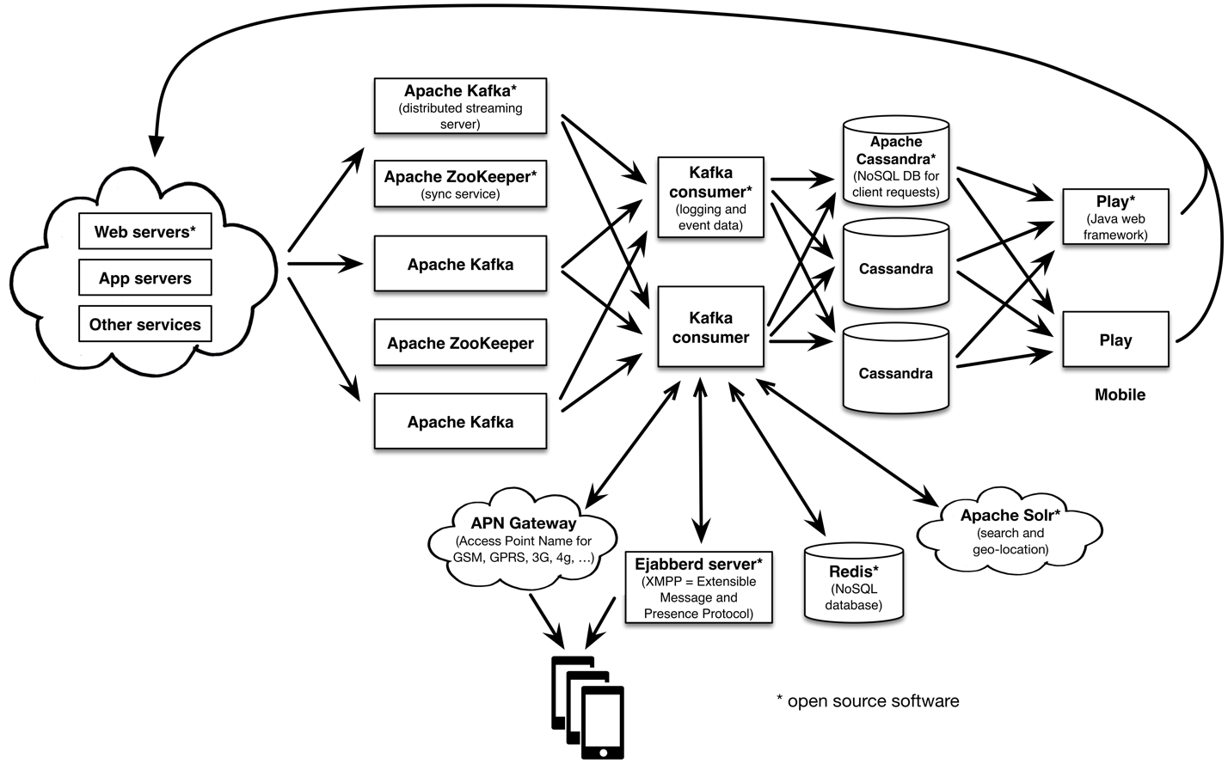

Source: Created by the case authors based on company records.

**Exhibit 6: SUMMARY of KEY PERFORMANCE INDICATORS (in CA$)**

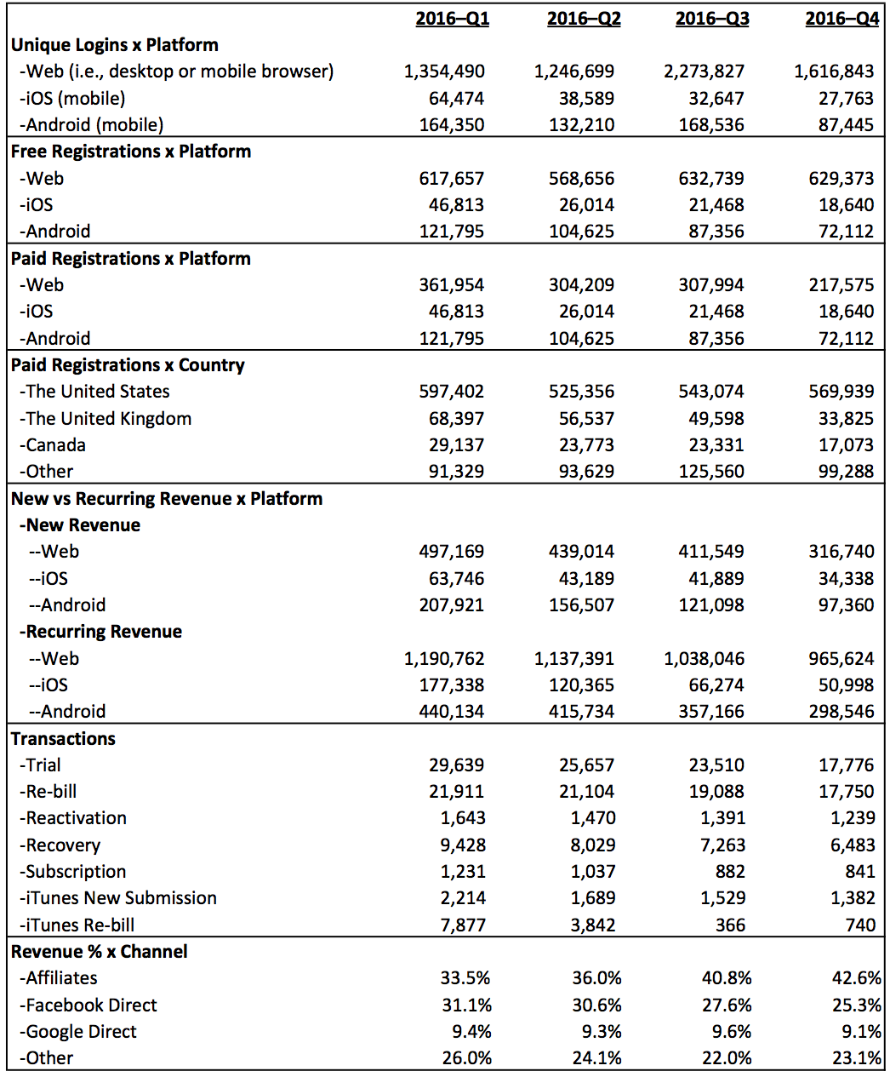

Source: Created by the case authors based on company records.

**Exhibit 7: mate1.com ADvertising CAMPAIGN REPORT**

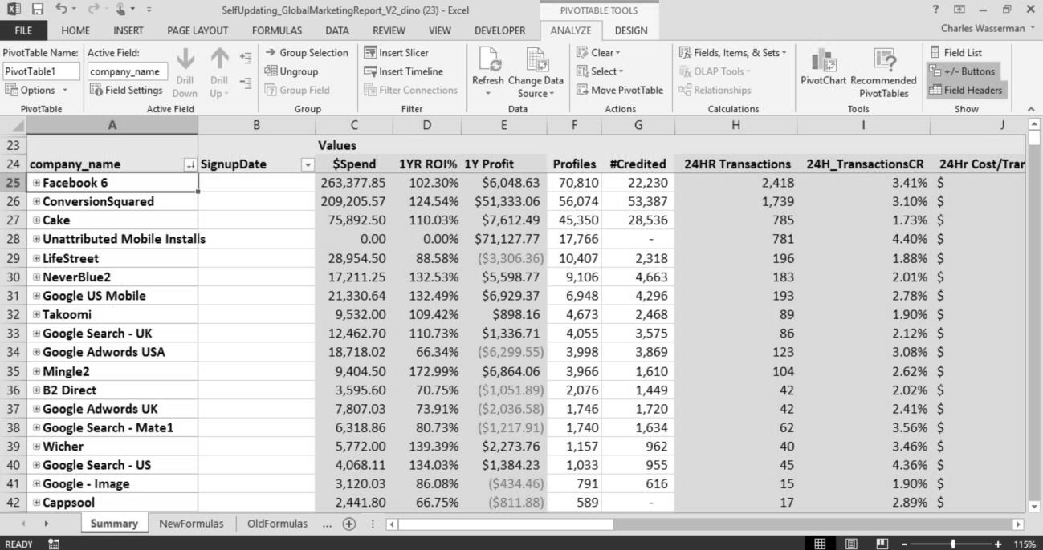

**Column definitions:**

**Company Name**: Company name of our traffic supplier

**Signup Date**: Date at which a user registers for free on the site

**Spend**: Ad spend recorded on the date it was incurred

**1YR ROI %**: A projection of ROI one year after ad spend was incurred

**Profiles**: A free registration (requiring username, password, date of birth, and email address)

**#Credited**: Free registrations that fire the third-party tracking pixel

**24HR Transactions**: All transactions (trials, monthly, and multi-month purchases) occurring within a 24-hour period from signup

**24H_TransactionsCR**: Conversion rate of Profiles to 24HR Transactions

Source: Company records.

1. All dollar amounts are in Canadian dollars.
2. Linda Cotrina, “7 Best Mobile Apps for Dating,” *Canadian Living*, July 23, 2014, accessed February 19, 2017,www.canadianliving.com/life-and-relationships/relationships/article/7-best-mobile-apps-for-dating.
3. Interview with Elizabeth Wasserman, April 2016.
4. Street Authority, “This Online Dating Stock Is A ‘Buy,’” Yahoo! Finance, May 24, 2016, accessed February 10, 2017, http://finance.yahoo.com/news/online-dating-stock-buy-173000789.html.
5. Interview with Elizabeth Wasserman, op. cit.
6. Ashley Madison website, accessed February 16, 2017, www.ashleymadison.com.
7. Katie Engelhart, “Online Dating and the Search for True Love—or Loves,” January 30, 2013, accessed February 10, 2017, www.macleans.ca/society/life/true-loves/.
8. A “native application” was designed and built for a specific platform. While a conventional web page could serve content to both desktop and mobile browsers, a native app often provided higher user performance and could take advantage of special features of a device (e.g., camera, accelerometer). However, to build one was resource-intensive.
9. Mate1 ads appearing on affiliate search engines, websites, apps, and related services brought in fresh traffic.