

9B17M010

the access to medicine index (A): engaging stakeholders and attracting funding

Ken Mark wrote this case under the supervision of Professors Afshin Mehrpouya and Diane-Laure Arjaliès solely to provide material for class discussion. The authors do not intend to illustrate either effective or ineffective handling of a managerial situation. The authors may have disguised certain names and other identifying information to protect confidentiality.

*This publication may not be transmitted, photocopied, digitized or otherwise reproduced in any form or by any means without the permission of the copyright holder. Reproduction of this material is not covered under authorization by any reproduction rights organization. To order copies or request permission to reproduce materials, contact Ivey Publishing, Ivey Business School, Western University, London, Ontario, Canada, N6G 0N1; (t) 519.661.3208; (e)* [*cases@ivey.ca*](mailto:cases@ivey.ca)*;* [*www.iveycases.com*](http://www.iveycases.com)*.*

Copyright © 2017, Richard Ivey School of Business Foundation Version: 2017-01-17

“The most striking thing is the fact that we have done this index at all,” exclaimed Wim Leereveld, the chairman and chief executive officer of the Access to Medicine Foundation (ATMF). The Access to Medicine Index (ATMI, or the Index), which was based on a methodology guided by stakeholder consultation, was a biannual ranking of pharmaceutical (pharma) firms’ effects on the access to needed medicines in low- and lower-middle-income countries.[1] It was mid-July 2010, just weeks after the successful launch of the second iteration of the Index, the Access to Medicine Index 2010 (Index 2010). Leereveld was sitting at his desk in Haarlem, Netherlands, considering many challenges and the potential approaches for each challenge.

Following the successful launch of Index 2010, its endorsement by some of the most legitimate actors in the access-to-medicine field (including the World Health Organization, or WHO), and the securing of multiyear financing from three highly prestigious funders in 2009,[2] Leereveld had demonstrated that the ATMI had staying power and relevance in the access-to-medicine policy field.

He noted that the media typically covered the launch of novel developments—the ATMI, for example—but such attention soon faded away, leaving behind the reality of attending to operations. Ensuring the survival of a private regulatory organization was, in the end, no different from nurturing a technology start-up. Funders needed to be brought on board, stakeholders—such as government, civil society, and the pharmaceutical giants—needed to be engaged, criticisms needed to be reviewed, and if necessary, appropriate responses needed to be prepared.

As was the situation in most ventures, envisioning the ideal state was the easy part, whereas maintaining relevance in the policy landscape, attaining operational excellence, and surviving financially were more challenging. With more stable funding and stakeholder relations, Leereveld was at the point of meeting with his team to devise the ATMF’s strategy and tactics for the next few years.

**The Global Pharmaceutical Industry**

The pharmaceutical sector was driven by research; discovery; and product sales related to the prevention, diagnosis, and treatment of human diseases. The global pharmaceutical market was dominated by U.S., European, and Japanese firms. Due to improved health care and aging, over the past few decades, the disease priorities of developed economies had significantly changed, moving away from infectious diseases to noncommunicable diseases, such as cancer, diabetes, and cardiac diseases.

The global market for drugs was estimated at US$880 billion[3] in 2011, an increase of 5–7 per cent over 2010. The market was expected to grow at between 3 and 6 per cent per year for the next five years. Rapid growth in demand—between 10 and 13 per cent a year—was expected from countries in emerging markets.[4] Large pharmaceutical firms, such as Pfizer, Sanofi-Aventis, Novartis, and GlaxoSmithKline, faced several challenges, including numerous patent expiries of “blockbuster drugs”[5] and the slowing down of growth in the Western markets. In addition, competition had become fiercer from generics manufacturers (which specialized in producing off-patent medicines at low cost), especially those from India, such as Ranbaxy, Cipla, and Dr. Reddy’s; Teva from Israel; Canada’s Mylan; and Germany’s Ratiopharm.

In emerging markets, growth was expected to be driven by governments’ efforts to improve health care and medical services for the least developed countries, through funding and facilitation by private foundations such as the Wellcome Trust, the Bill & Melinda Gates Foundation, and the Clinton Foundation; state aid agencies, including the United States Agency for International Development, the United Kingdom’s Department for International Development (DFID), and France’s Agence Française de développement.

Leereveld’s interest in the sector had grown out of his concern that the high price and low accessibility of safe and efficacious medicines meant that billions of people in developing countries were left without access to medicines at a very high social and human cost.

**The Access to Medicine Challenge and the Role of Big Pharma**

According to the WHO, more than two billion people lacked access to needed affordable, accessible, and high-quality medicines. This issue resulted in significant suffering and loss of life for a large portion of the world population. Tuberculosis, human immunodeficiency virus/acquired immune deficiency syndrome (HIV/AIDS), malaria, several tropical infectious diseases, and neonatal infections such as diarrhea and pneumonia continued to be the primary causes of death and suffering in low-income countries and communities. In medium-income countries such as China and Brazil, not only did such diseases continue to cause significant challenges for their low-income communities but the expanding middle class also faced health-care issues similar to those experienced in richer nations, such as cancer, cardiac diseases, diabetes, and obesity. This phenomenon was known as the “double burden of diseases.” In September 2000, as part of its Millennium Development Goals, the United Nations identified the need to co-operate with pharmaceutical firms to “provide access to affordable drugs in developing countries.”[6]

Prior to the 1990s, the international pharmaceutical industry had less of a presence in developing countries. Such markets primarily depended on local or regional generic drugs, which were copies of on- or off-patent medications or traditional medicines. However, the presence of the international pharmaceutical industry increased significantly in developing countries following the introduction of intellectual property protection under the Trade-Related Aspects of Intellectual Property Rights (TRIPS) agreement facilitated by the World Trade Organization in 1994 and the saturation and slow growth of Western pharmaceutical markets.

Nonetheless, generic drugs remained the most important source of medicines in developing countries, and patented products developed by pharmaceutical companies were needed only when new life-saving medicines were introduced. A key issue was the emergence of antimicrobial resistance, a phenomenon whereby a microorganism developed resistance to a drug originally designed to treat infections caused by it. The WHO indicated that antimicrobial resistance was a global concern because “many standard medical treatments will fail or turn into very high risk procedures,” resulting in higher mortality rates.[7] Combatting antimicrobial resistance for diseases prevalent in developing countries, such as HIV/AIDS, malaria, and tuberculosis, required the development of new drug molecules. In addition, there was a need to develop formulations of medicines that were suitable for the unique conditions in countries and communities where people were living in poverty. For example, some medicines required refrigeration, which was challenging in hot climates where maintaining a “cold chain” (i.e., a temperature-controlled supply chain) was technically difficult, leading to a need to develop heat-resistant formulations. It was also important to develop fixed-dose combinations, which facilitated use by patients by combining multiple drugs for treating a disease in a single pill.

Clinical trials were also needed to ensure that medicines were safe and efficacious for the target populations that were specifically affected in developing countries. For example, whereas HIV infection among infants and pregnant women was not common in developed economies, these same populations were often the recipients of HIV medicines in developing countries and regions, such as in sub-Saharan Africa.

Research on diseases that were present only in developing countries—the so-called “neglected” tropical diseases—continued to be underfunded because of lack of a functioning market for treating such diseases. Some of these diseases, which caused significant morbidity and mortality in countries that had a tropical climate, included sleep disorder, leishmaniasis, and dengue fever.

While everyone agreed on the urgency of the need to develop treatments for these diseases, there was no consensus among the stakeholders regarding the expectations from the pharmaceutical industry in terms of addressing this need. One challenge was accommodating different viewpoints. For example, different stakeholders held radically different viewpoints on the role of pharmaceutical companies in such countries and communities. Organizations such as Doctors Without Borders and many other civil society organizations believed that the business interests of pharmaceutical companies frequently conflicted with social needs, especially in terms of the patenting of medicines and how they were priced in developing countries.

Such organizations had previously involved the pharmaceutical companies in diverse litigations/controversies related to the companies’ behaviour regarding patents, pricing, marketing, and lobbying activities. In contrast, the pharmaceutical companies responded that their research and discovery of new remedies fulfilled fundamental health needs and that both intellectual property protection throughout the world and the competitive pricing of products were essential to the sustainability of their research operations.

The dialogue between stakeholders had been historically dysfunctional, as evidenced by the so-called “name-and-shame” campaigns and litigations that such stakeholders had used as their primary tactics against each other. The nongovernmental organizations (NGOs) became suspicious about pharmaceutical companies’ motives and potential for positive societal change, and, regardless of the attendant financial implications, expected the pharmaceutical companies to ensure affordability and accessibility of their medications based on their “licence to operate.” However, most mainstream investors were primarily concerned with the implications for the pharmaceutical companies’ financial performance as a result of activities related to broadening the access to medicine. Several litigation cases had been initiated between governments and pharmaceutical firms or generics firms. In 1998, in a widely known and cited case, 39 of the largest pharmaceutical companies sued Nelson Mandela’s South African government, accusing it of procuring generics medicine and suspending patent protection for HIV/AIDS antiretroviral medicines.[8]

In addition to lack of consensus about the companies’ responsibility, there had been no independent and legitimate reporting of the effect of pharma companies on access to medicines in developing countries and communities. The companies, NGOs, and some international organizations prepared different reports about the companies’ social impact; however, none of them was considered to be independent and neutral by all stakeholder groups.

**The Access to Medicine Index—A Potential Solution**

The ATMI aimed to address these gaps by providing a platform for dialogue among the stakeholders to decide on their expectations from the pharma companies regarding the access to medicine. In addition, the ATMF aimed to collect data based on those expectations and then prepare company reports and rankings to compare how well companies fulfilled their stakeholders’ expectations. By publishing the rankings and communicating them to the stakeholders, Leereveld believed he could motivate the companies to improve their position in future iterations of the Index, which would ideally lead to greater access to medicine for the societies in need.

Leereveld believed that competition and dialogue were key to changing companies’ behaviour in relation to the access-to-medicine issue. He stated, “Companies closely observe each other. They know how to compete. Companies may mind about what other stakeholders think about them, but they mostly are interested in the opinion of their peers.”

Leereveld believed both that the stakeholders in this sector needed to talk to each other more frequently to establish society’s expectations from the companies, and that any set of expectations formulated without the engagement of the companies themselves would have only limited potential for changing the companies’ practices. Finally, he believed that an effective dialogue should not only focus on the negative externalities of companies (which were already being discussed by many) but also report on the positive impacts of the companies’ behaviours in target societies. Such a tool, he believed, should document the best and innovative practices to facilitate learning between pharmaceutical companies.

**Leereveld and the Access to Medicine Foundation**

The Access to Medicine Foundation (ATMF) was a not-for-profit organization founded by Leereveld in 2003; in 2004, it developed the goal of motivating pharma companies to address the issue of lack of access to needed medications in developing countries and communities. The ATMF’s most significant project was the ATMI.

For 20 years, Leereveld had worked for a company he co-founded, which sold data to the pharma industry. He then sold the company and started his work in the access-to-medicine area. In the first years of the ATMF, Leereveld faced difficulty convincing key organizations such as the pharma companies, international NGOs, and the WHO, about the validity of his idea for the ATMI. These difficulties led to challenges in securing funding.

Initially, he worked alone and had no sources of funding. From this point and until the launch of the first Index in 2008, Leereveld overcame a wide range of barriers, ranging from being an unknown figure in the health policy space, to lack of funding, to convincing a highly skeptical pharmaceutical industry and recruiting the technical team to execute the project.

By the start of 2008, Leereveld had secured limited funding from several sources, mostly NGOs, including Oxfam Novib (Netherlands), Hivos, and Cordaid, and had already succeeded in discussing the Index and finding support in a few pharma companies. Moreover, he had partnered with Innovest Strategic Value Advisors (Innovest), an environmental and social research firm, to undertake the technical work and research.

However, the future funding of the Index was not secured; Leereveld owed money to subcontractors, including Innovest; and most pharma companies and other stakeholders continued to be skeptical about the Index. At the time, he was even thrown out of a pharma company headquarters while trying to present the Index idea. Leereveld persevered and, with the subcontractor’s team, started to assemble the methodology for the first ATMI.

**Creating the Access to Medicine Index**

Based on stakeholder consultation, the Innovest team designed a methodology to measure the level of companies’ fulfilment of societal expectations. This methodology for Index 2008 included 29 indicators across eight technical areas, including equitable pricing, patents, research & development, and capacity building. The weight of each technical area in scoring was assigned on the basis of stakeholder inputs. The ATMF had no in-house team, so the Innovest team took the lead in managing stakeholder consultation and finalizing the methodology based on the stakeholder consultation. The process included an online survey targeting hundreds of experts from different stakeholder groups, followed by two meetings with stakeholder representatives—one in Washington and the other in London—to discuss contentious issues regarding the social responsibilities of pharmaceutical companies in relation to the issue of access to medicine in developing countries.

This methodology was then used to analyze the policies and practices of the 20 largest global pharmaceutical companies, and this analysis was used to construct a ranking. To do this, the Innovest index team used publicly available data from the companies. In addition, the team attempted to meet with the companies to collect additional data based on the methodology needed for scoring and ranking. The Innovest index team also used other sources of data, including the WHO patent databases, Factiva news analyses, and some reputed NGO reports. Only eight out of the 20 pharma companies covered by the Index 2008 responded to the interview requests.

The pharmaceutical industry was consulted separately and after consultation with other stakeholders. On some issues, such as the need for better disclosure by companies, consensus was easy to achieve, whereas other issues, such as patents and “data exclusivity” issues related to competition with generics companies, remained extremely contentious, and no consensus could be achieved. In such situations, the Index team decided on an official stance for the ATMI. Stakeholder views (see Exhibit 1) were captured during a stakeholder consultation process (see Exhibit 2).

The foundation was able to launch the first iteration of the ATMI in 2008 (see Exhibit 3).

With the successful launch of ATMI 2008 and its wide media coverage, the world seemed to take notice of Leereveld’s new platform. The ATMI received news coverage in the *Financial Times*, the *New York Times*, and *The Lancet*. Stakeholders’ reactions were varied: several investors, some companies, and some civil society actors supported it, while other civil society actors, such as Oxfam America and Health Action International, were vocal critics, pointing to the ATMI’s significant methodological weaknesses, its close alignment with the industry’s viewpoint, and its overreliance on companies’ disclosure and under-reliance on companies’ output and impact. Tim Reed of Health Action International opined:

The core approach of the index, published by a foundation led by a former industry marketing consultant, assesses the pharmaceutical companies on a five-point scale according to criteria developed by a Dutch investment research consultancy. The weakness of the study lies in its “on-paper” approach to measuring the effectiveness of corporate social responsibility programmes. Moreover, the method leaves the results vulnerable to attack. The index is based on information made available by pharmaceutical companies and a few non-governmental organisations, with the largest input coming from surveys of the pharmaceutical industry itself.[9]

Some also thought that Index 2008 was too positive and seemed too aligned with the industry’s general viewpoint. Finally, some believed that the pharmaceutical companies primarily used the ATMI as a tool for improving their reputation. International organizations such as the WHO did not react to the launch of Index 2008. Several companies remained doubtful about the merit of the Index. For example, after Index 2008 was launched, Julia King, the head of GlaxoSmithKline’s corporate social responsibility department, wrote an article criticizing the Index, arguing that there was a crucial qualitative aspect to judging performance against social responsibility targets:

Data is important in corporate responsibility as in every aspect of business. But performance is largely qualitative—about how well you do things as well as how much you do. Comparing performance must be based on judgements more than measurements. So while I welcome efforts to make comparisons easier, I don’t want to see the complexities of responsible behaviour reduced to simple tables—even when GSK [GlaxoSmithKline] comes out on top![10]

Similarly, the president of Pfizer Foundation raised concerns about the Index’s methodology in a letter to the editor in the *Financial Times*, calling it “deeply flawed.”[11] The Index’s relations to the industry and other powerful stakeholders needed to be built. This was a challenging task, especially because Leereveld and the ATMF were unknown in this field, and multi-stakeholder rankings were quite new in the global health policy communities. The challenge for Leereveld was to generate sufficient interest and build sufficient momentum so that the ATMF would attract funding, partners, and additional stakeholders.

**ATMI—Early Success, Building Momentum**

The Index 2008 caught the attention of Bill Gates when he was reading the *Financial Times* following the launch of the Index. The Bill & Melinda Gates Foundation later decided to provide the ATMF with multi-year funding as part of its overall agenda for supporting “creative capitalism.” In an interview with the *Financial Times Magazine*, Bill Gates said, “When I talk to executives from pharmaceutical companies, they tell me that they want to do more for neglected diseases—but they at least need to get credit for it. [The Access to Medicine Index] does exactly that.”[12]

In addition, the U.K. government’s DFID and the Dutch Ministry of Foreign Affairs followed suit, and these three highly reputed funders in the health-care area cofinanced the Index.

With the security of new, reputable funders, the Index team started work on Index 2010, in which the ATMF attempted to address several of the stakeholder critics.

For stakeholder consultation, the ATMF decided to change the process so that all stakeholders had equal opportunity to provide input. That is, unlike with Index 2008, in which the industry was consulted separately after all the stakeholders, in Index 2010, the industry participated in the stakeholder meetings along with all the other stakeholders (see Exhibit 4). The stakeholder representatives were also formalized in a committee called the “Expert Review Committee.”

In addition, the Index team started to consult stakeholders from the low- and medium-income countries by organizing a consultation meeting in Kenya with 18 NGOs from Africa, India, and Latin America.

The subcontractor in charge of managing the consultation process and designing and executing the Index 2010 was MSCI Group (which in 2010 acquired RiskMetrics, which had acquired Innovest in 2009). MSCI Group significantly revamped the methodology and the Index 2010 consequently increased its focus on the output and impact of the companies’ initiatives compared with their policies and inputs. In addition, the indicators for Index 2010 were categorized as commitments, transparency, performance, and innovation indicators. This categorization made it possible to differentiate between companies with good policies and disclosure, and companies with outstanding operational performance and impact in the target communities. Furthermore, the development team attempted to diversify the data sources used to avoid an overreliance on company data.

Innovation indicators were added because the stakeholders all believed that the sector needed more innovative business models to address the access-to-medicine challenges in developing countries and communities. While some innovations such as bottom-of-the-pyramid pricing approaches were now increasingly common in the sector, business model innovation was needed to improve areas such as supply chain safety, collaborative research for neglected diseases, technology transfer, and improving the accessibility and affordability of medications in diverse national settings to people living with varying economic, social, regulatory, and technical challenges.

The changing structure of methodologies for the Index from 2008 to 2010 can be seen in Exhibit 5.

The pharmaceutical companies showed a high level of interest in the Index 2010 consultation and its data collection process, to the extent that 19 out of the 20 largest global pharmaceutical companies covered by the Index provided detailed data in response to requests from the ATMI team.

Index 2010 was launched in June 2010. The Index received endorsements from a wide range of influential organizations, including the WHO, the DFID, and a wider set of NGOs than had endorsed Index 2008. By 2011, a large number of ranked companies had reacted to the Index and cited it in their annual reports, where they could highlight positive dimensions of their performance. Furthermore, many large and reputable institutional investors had pledged their support for the ATMI by signing the ATMF’s “Investor Statement,” which committed the signatories to three principles: (1) the importance of access to medicine as potentially material to long-term shareholder value creation, (2) the role that pharmaceutical firms play in addressing access to medicine issues, and (3) the Index’s contribution to creating greater awareness about the issue of access to medicine.[13] Some NGOs, such as Doctors Without Borders, however, maintained their negative stance toward the Index and decided not to engage with the ATMF.

Overall, Index 2010 succeeded in achieving the support of a wider range of stakeholders due to its more comprehensive methodology and more balanced viewpoint on several contentious issues.

**Looking forward to the next five years**

Leereveld noted the various issues that had emerged since the first two indexes were launched. He faced a multitude of concerns from stakeholders, including the following:

* Concerns raised by pharmaceutical firms about the high level of resources needed to prepare the data for the Index. Some firms had questioned the country and disease scope of the Index, which they thought did not cover some priority areas.
* Criticisms from some NGO executives who believed the ATMI continued to be too “close” to industry and dependent on industry’s data to be impartial.
* Demands from funders for proof of ATMI’s impact on access to medicine.

Leereveld wondered how best to build on the momentum that the foundation had generated: strategically, what should be the next steps for the Index?

The authors acknowledge the contribution of the Access to Medicine Foundation and École des hautes études commerciales de Paris (HEC Paris) in the preparation of this case.

Afshin Mehrpouya is an assistant professor in the Accounting and Management Control department of HEC Paris, and Diane-Laure Arjaliès is an assistant professor at the Ivey Business School.

**Exhibit 1: Sample of stakeholder views on access to medicines**

|  |  |  |  |
| --- | --- | --- | --- |
|  | **Access to Medicine** | **Patents** | **Prices** |
| **Activist NGO Representative** | Access to medicine is a responsibility of pharma companies. It is their reason for existence and the basis for their licence to operate. They should not be prioritizing profits over their responsibility. | Patents represent a key barrier to access for new medications; human life should come first. Big pharma is pushing for excessive intellectual property protection in developing countries, resulting in barriers for the supply of generic equivalents, which leads to unaffordable prices. | Big pharma charges excessive prices for medications. Prices in low- and medium-income countries should not include research and marketing costs; prices should be based on affordability criteria and the income levels of target populations. |
| **Research-Based Pharma Executive** | The pharmaceutical industry is already contributing to access to medicine by developing new remedies and by making them available throughout the world. The affordability and accessibility issues are multi-stakeholder challenges, and the company cannot do much on its own. | Patents are essential to sustaining innovation in the sector and to the development of new medications. Patents should be enforced in all countries that benefit from the resulting medications. | To continue innovating, the industry needs to charge its research and marketing costs. It is not up to the industry alone to resolve affordability issues. |
| **Generics Industry Executive** | The generics industry is the key provider of affordable essential medications to developing countries. The research-based pharma industry poses barriers to access, due to patent protection. | The pharma industry lobbies for excessive protection of its products, which leads to reduced access. | The generics industry should be free to produce low-cost supplies of medicines. The generics industry is the key contributor to the affordability of medicines. |
| **Mainstream Investment Manager** | Access is a key strategic issue for companies and signifies their success in targeting high-growth emerging markets. | Patent protection is needed in all intellectual property-intensive sectors. | Companies should be innovative in finding pricing approaches that can target the fast-growing emerging markets. |
| **Responsible Investor** | Access is the ethical responsibility of the pharma companies and they should do their share. | Patents should be enforced as long as they do not limit access to affordable, accessible, quality medicines. | While companies should charge prices that cover their costs, prices should not be a barrier to access. |

Note: NGO = nongovernmental organization

Source: Company files.

**Exhibit 2: The Index 2008 stakeholder consultation process**

**ATM**

**questionnaire**

**Stakeholder**

**roundtables**

**scoping report**

**& stakeholder**

**review**

**Industry**

**engagement**

**industry**

**engagement**

**report**

**industry &**

**stakeholder**

**review**

**access to**

**medicine index**

**published**

**access to**

**medicine index II**

**published**

**August – Sept 2006 II**

Over 200 experts on ATMs were identified and sent questionnaires. Innovest derived a set of initial benchmarks for discussion based on the responses.

**Oct – Nov 2006 III**

Fifteen key stakeholders took part in roundtables in London and New York to refine the benchmarks and ideas presented by Innovest.

**February 2007 IV**

The Access to Medicine Foundation published the first report on the initial Index development phase, utilizing stakeholder input and expertise.

**FEEDBACK**

It is critical to the evolutionary development process of the Index that feedback opportunities are provided to support ongoing analysis.

**September 2007 VI**

The Access to Medicine Foundation published the second interim report on the initial Index development phase, utilizing industry input, and expertise.

**November 2007 VII**

The Access to Medicine Foundation published the third report on the second interim report, utilizing feedback from the industry and its stakeholders.

**Spring 2008 VIII**

Innovest will assess company performance using the Index framework and publish the first AtM Index. Companies will be asked to contribute to specific metrics.

**Spring 2009 VIII**

Each year the Access to Medicine Foundation will publish an updated Index, including a detailed reassessment of all benchmarks.

**Background Research**

**July 2006 I**

A broad questionnaire was formulated through extensive analysis of a large body of research on ATMs, including key reports from ICCR, PSG, DFID, WHO, and Oxfam.

**May – August 2007 V**

Innovest met with 36 company representatives to discuss, evaluate, and critique the first report and initial Criteria, Indicators, and Potential Metrics.

Note: ATM = access to medicine; ICCR = Interfaith Center on Corporate Responsibility; PSG = PSG Institute of Medical Sciences & Research; DFID = the United Kingdom’s Department for International Development; WHO = World Health Organization.

Source: Innovest Strategic Value Advisors, Innovest Health Care Team, *Access to Medicine Index 2008: Industry and Stakeholder Review—Final Report*, 7, November 2007, accessed October 4, 2016, https://accesstomedicinefoundation.org/publications/2008-access-to-medicine-index-industry-stakeholder-review/.

**Exhibit 3: The 2008 and 2010 Access to Medicine Indices**

**Access to Medicine Index 2008**

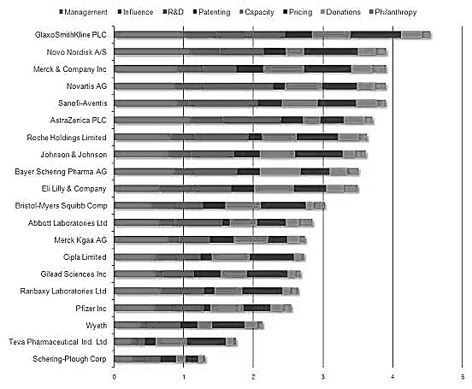

**Access to Medicine Index 2010**

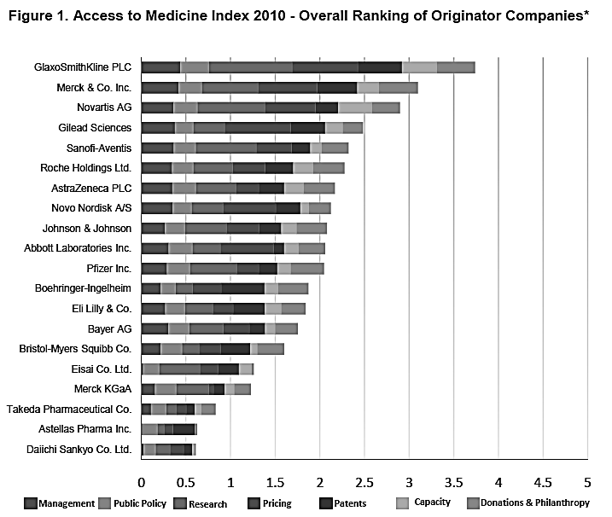

Source: Company files.

**Exhibit 4: Stakeholders consulted by the Access to Medicine Index team—and the Expert Review Committee for ATMI 2010**

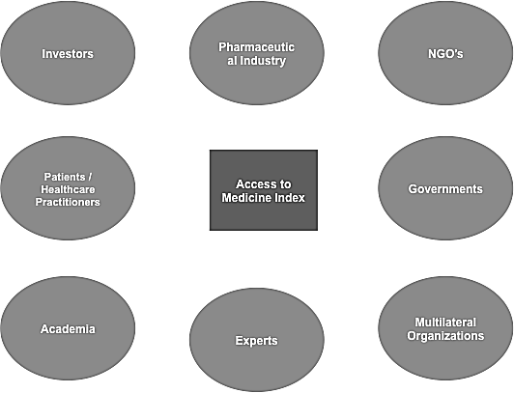

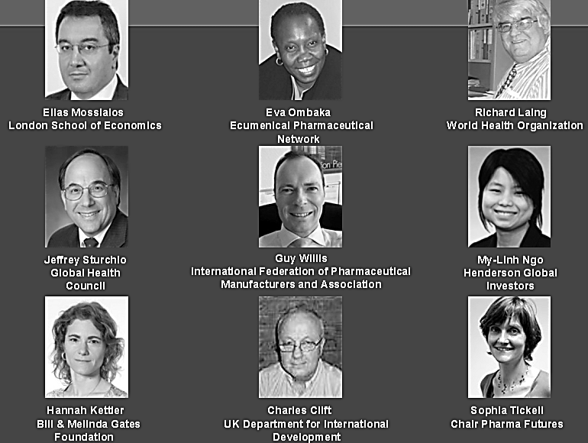

Note: Patients and health-care practitioners were not consulted because they did not have any organization qualified to represent them. The patient groups we found were all too close to the industry to be considered appropriate representatives of patients.

Source: Company files.

Exhibit 5: Structure of methodologies for Index 2008 and Index 2010

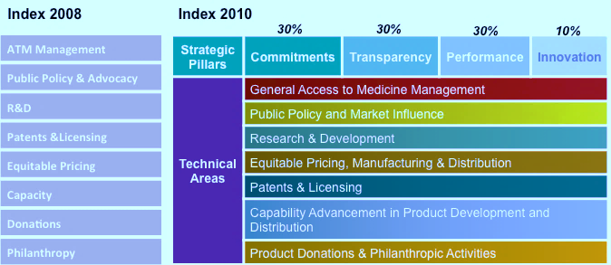

Note: ATM = Access to Medicine; R&D = research and development

Source: Access to Medicine Foundation, *Access to Medicine Index: Methodology & Stakeholder Review*, 28, March 2010, accessed October 4, www.accesstomedicineindex.org/sites/2015.atmindex.org/files/2010_access_to_medicine_index_

methodology_staka. eholder_review.pdf.

1. The low- and lower-middle-income countries were identified based on the World Bank’s country income classifications (see The World Bank, “World Bank Country and Lending Groups,” 2016, accessed August 1, 2016, http://data.worldbank.org/about/country-and-lending-groups). Further adjustments on country scope were applied for subsequent iterations of the Index.
2. The three prestigious funders were the Bill & Melinda Gates Foundation, the U.K. Department for International Development, and the Dutch Ministry of Foreign Affairs.
3. All currency amounts are shown in U.S. dollars unless otherwise specified.
4. Patricia Van Arnum, “The Global Divide in Pharma Industry Growth,” *PTSM: Pharmaceutical Technology Sourcing and Management* 9, no. 12 (2013), accessed August 1, 2016, www.pharmtech.com/global-divide-pharma-industry-growth.
5. Blockbuster drugs were popular drugs that generated annual sales of at least $1 billion.
6. United Nations Integrated Implementation Framework, “MDG 8—Access to Essential Medicines,” accessed August 1, 2016, http://iif.un.org/content/mdg-8-access-essential-medicines.
7. World Health Organization, “Antimicrobial Resistance,” factsheet, September 2016, accessed August 1, 2016, www.who.int/mediacentre/factsheets/fs194/en/.
8. Tatiana Andia Rey, “South Africa vs. Big Pharma: Duking It Out over Patent Law,” *Global Rights* (blog), January 27, 2014, accessed April 4, 2016, <https://dejusticiablog.com/2014/01/27/test-post/>.
9. Tim Reed, “The New Access to Medicine Index,” *The Lancet* 372, no. 9642 (2008): 890, accessed August 1, 2016, www.thelancet.com/pdfs/journals/lancet/PIIS0140-6736(08)61395-1.pdf.
10. Julia King, “League Tables Cannot Make Sense of a Complex Picture,” Ethical Performance, September 2008, accessed August 1, 2016, www.ethicalperformance.com/editorial/article/5236.
11. Robert L. Mallett, “Medicines Index Is Deeply Flawed,” Access to Medicine Index, June 23, 2008, accessed August 1, 2016, www.accesstomedicineindex.org/sites/2015.atmindex.org/files/publication/Medicines_Index_is_deeply_flawed.pdf.
12. Barbara Kiviat and Bill Gates, “Making Capitalism More Creative,” *Time Magazine*, July 31, 2008, accessed August 1, 2016, <http://content.time.com/time/subscriber/article/0,33009,1828417-2,00.html>.
13. Access to Medicine Index, “Investor Statement: Access to Medicine Index,” January 26, 2016, accessed August 1, 2016, www.accesstomedicineindex.org/sites/2015.atmindex.org/files/general/160126atm_investorsstatement.pdf.