

**9B17M040**

**HILLBERG & BERK: AIMING TO SPARKLE IN THE DESIGNER JEWELLERY BUSINESS**

*Selena Shannon Pritchard wrote this case under the supervision of Professor W. Glenn Rowe solely to provide material for class discussion. The authors do not intend to illustrate either effective or ineffective handling of a managerial situation. The authors may have disguised certain names and other identifying information to protect confidentiality.*

*This publication may not be transmitted, photocopied, digitized, or otherwise reproduced in any form or by any means without the permission of the copyright holder. Reproduction of this material is not covered under authorization by any reproduction rights organization. To order copies or request permission to reproduce materials, contact Ivey Publishing, Ivey Business School, Western University, London, Ontario, Canada, N6G 0N1; (t) 519.661.3208; (e)* [*cases@ivey.ca*](mailto:cases@ivey.ca)*;* [*www.iveycases.com*](http://www.iveycases.com)*.*

*Copyright © 2017, Richard Ivey School of Business Foundation* *Version: 2017-04-25*

In September 2016, Rachel Mielke, chief executive officer (CEO) of Hillberg & Berk (H&B), was reviewing plans for H&B’s newly expanded flagship store and office building in Mielke’s hometown of Regina, Saskatchewan, Canada. In doing so, she reflected on the nine years since she had started H&B. In that time, H&B had grown tremendously (see Exhibit 1) and had established a recognized brand in the competitive designer jewellery landscape. At the top of Mielke’s mind was how to manage the company’s signature Sparkle Collection. Accounting for more than 70 per cent of sales, the collection had been a tremendous hit for the company. Now Mielke wondered how she could capitalize on the success of this product and build loyalty with the rest of the jewellery designed and offered by H&B. While H&B was no longer a small company, nor a large one, Mielke knew that how she managed her company’s strategy going forward would have significant implications for its ability to maintain sustainable growth.

Company Introduction

Mielke founded H&B in 2007 out of a personal passion for jewellery design and entrepreneurship. Mielke’s goal for the company had been to create a world-class jewellery brand that empowered women and met them at every important life milestone. She aspired for the brand to align with her core beliefs and to remain authentic, which was evident in many elements of the company’s brand presence, including the name—the company was named for Mielke’s grandmother, Hilda Bergman, and Mielke’s dog, Berkley. The company had seen impressive growth as a result of building a loyal customer following. In her home province of Saskatchewan, Mielke had generated a lot of buzz and earned media for the brand, especially after her success on the Canadian Broadcasting Corporation’s television program *Dragons’ Den* and the company’s high-visibility partnerships with the Canadian Olympic team, the Canadian Football League, Tacori Diamonds, and Olympic gold medallist ice dancer Tessa Virtue.

*Dragons’ Den* was a popular television show in Canada, wherein five successful Canadian business people (known as the “Dragons”) heard pitches from a variety of entrepreneurs. Mielke’s *Dragons’ Den* pitch was particularly helpful in getting the brand off the ground. In 2008, Mielke pitched the Dragons, asking for $200,000[1] in exchange for 20 per cent of the company. Mielke impressively managed her time with the Dragons, noting how all the elements of her products were designed by H&B and had been featured in 2008 in a gifting lounge at the Oscar Awards in Los Angeles, California. At the time, H&B had $110,000 in annual revenue, which Mielke had generated while working part-time. For 2009, Mielke forecasted $420,000 in revenue. Brett Wilson, a Saskatchewan native and “Dragon,” bought into Mielke’s pitch and invested $200,000 in exchange for 30 per cent of the company. The deal went through, and Wilson became and remained a trusted coach for Mielke.

By 2016, H&B had more than 120 employees and had delivered more than $10 million in annual revenue. H&B had also remained committed to its original goal of empowering women. By 2016 the company had contributed more than $600,000 to national and international women’s organizations.

THE Designer Jewellery Industry

H&B operated in the affordable segment of the designer jewellery industry (defined by items that retailed for less than US$1,500). Within this segment, H&B viewed its closest group of competitors as Swarovski, PANDORA, Kendra Scott, and Alex and Ani (see Exhibits 2 and 3). The jewellery industry had grown at rates of between 5 and 6 per cent annually and was expected to total US$275 billion in global annual sales by 2020. Most companies in the industry were localized, with a few exceptions. However, brands had started to consolidate and drive international brand presence. It was expected, for example, that Swarovski would become one of the top global brands by 2020 (see Exhibit 3). In 2015, branded jewellery accounted for 20 per cent of overall jewellery sales; however, that number was expected to grow to 30–40 per cent of all sales by 2020.[2]

The greatest consumer growth in the industry had been in purchases of affordable, designer jewellery by three consumer groups: “new money” consumers who sought to display their newfound wealth, emerging market consumers who sought brands they trusted to represent their upgraded lifestyles, and finally, young consumers who viewed wearing certain brands as a preferred way to express themselves.

Wholesale remained the key distribution method to consumers;[3] however, brands were both expanding their e-commerce presence and opening bricks-and-mortar retail locations as an avenue for sharing their brand stories. For example, H&B competitor PANDORA had expanded from 200 locations in 2009 to more than 1,800 in 2016, and Swarovski had grown from only two stores in 1990 to more than 2,680 stores in 2016.[4]

While in the past the jewellery industry had comprised high- and low-end brands, a hybridization appeared to be occurring, resulting in brands offering products at a variety of price points in an effort to attract new consumers. At the same time, luxury brands such as Harry Winston and Cartier had doubled down on their exclusivity and high price point, maintaining a luxury brand image.[5]

Empowering Women

Through education, inspiration and opportunity, we are women empowering women—one sparkle at a time.

H&B Manifesto

Empowering women was a clear goal for H&B. Mielke noted that most global jewellery collections were designed by men, for women. As the company founder, Mielke considered that having women running the company was vital: “I think that our company being run primarily by women and having a fresh perspective on jewellery, it’s unusual. Most of the major global players in the industry are run primarily by men, were started by men, and I don’t think there are a lot of amazing up and coming brands that are female-driven.”

H&B had invested heavily in internal training and development to ensure that its workforce had the skills needed to grow with the company. Mielke noted that her focus was on the well-being of H&B’s workforce. H&B worked to empower employees by building collaborative, cross-functional teams. The company had also used innovative strategies to inspire creativity throughout its workforce. One program that was launched early at H&B was One of a Kind Friday, in which all employees, regardless of their position in the company, designed one-off pieces that would potentially be sold at H&B’s flagship retail store in Regina. Surprisingly, not just those who were experienced designers had products sell well, as one of the best-selling designers to emerge from One of a Kind Friday was H&B’s production manager. As H&B scaled, it continued this tradition, launching One of a Kind monthly runs that were sold both online and at its retail locations. These collections commanded a premium price, with necklaces being sold for up to $3,500.

The company had made considerable effort to give back to local and international women’s organizations and had launched collaborations with charitable organizations, including the Canadian Breast Cancer Foundation, the Malala Fund, and Dizzy Feet Foundation. Mielke remarked: “I think that our focus on philanthropy and our passion about empowering women and finding ways that our brand can help make our community and make our country a better place by the success of our company also positions us as a very unique brand.”

As Mielke contemplated H&B’s growth, maintaining a culture true to its core values was non-negotiable. Mielke’s focus was to ensure that H&B did not grow at the expense of its work culture and values that she and her senior leadership team had worked hard to establish.

Customer Service and Distribution

When building H&B, Mielke had realized the critical importance of communicating the brand’s story. Like others in the industry, Mielke found the most effective way to do so was through bricks-and-mortar retail locations. Therefore, a key tactic in the company’s marketing strategy was building its physical retail presence. H&B prided itself on providing quality customer experiences. The company expected that every person who entered the stores would be treated like a guest in the brand’s home.

The retail store teams were expected to immerse themselves in their local communities—building connections by attending events, organizing local charitable donations, developing meaningful relationships, and promoting H&B products. Employees were empowered to make decisions to provide the best possible experience and to “surprise and delight” customers when a connection was built. These gestures included gifting a soon-to-be bride with “something blue” earrings or larger efforts such as gifting Sparkle Ball earrings to mothers displaced by the disastrous 2016 fires in Fort McMurray, Alberta.

H&B had invested heavily to build its e-commerce presence, recognizing the growth potential of the online market. However, Mielke noted that the online channel alone would not enable the company to scale: “We are seeing over and over again companies that are trying to start up as online only, switching to bricks and mortar because you just can’t tell your brand story well enough, you can’t scale online.”

H&B had evolved its distribution strategy over time, selling through both boutique retailers and its own locations, including its online store; a street-front location housed in a character home in Regina; and mall locations in Edmonton, Alberta, and in Saskatoon, Saskatchewan that were either full-size stores or “Sparkle Bar” kiosks that had a smaller footprint (see Exhibit 4). H&B had found the best success in its full-size bricks-and-mortar locations. While the Sparkle Bar locations were popular, Mielke was concerned that these kiosk-like locations did not make it as easy to provide customers with a full brand experience. The cost of each additional full-size retail location was expected to be $1 million, comprising $500,000 for construction costs and $500,000 for marketing and start-up costs.

H&B had also been selling through The Shopping Channel (TSC), with Mielke herself appearing on television and sharing the H&B story. These appearances proved to be popular and helped spread the word about H&B product throughout Canada. Mielke expected TSC to sell 15,000 pieces in 2016.

When Mielke considered the company’s next steps, she knew an effective distribution strategy would be critical. As she considered expansion within Canada (see Exhibit 5), Mielke deliberated on which locations and tactics would best enable H&B to build a national and international brand presence without compromising on a quality service experience.

THE Sparkle Collection

Launched in spring 2011 with the Sparkle Ball earring, the Sparkle Collection had quickly become (and remained) a mainstay of the H&B brand, accounting for more than 70 per cent of the company’s total annual revenue. The collection had expanded to include necklaces, bracelets, charms, and earrings. Mielke noted, “Sparkle is the doorway into our brand, but we absolutely need to have product offerings beyond Sparkle and we need to develop more products like Sparkle.” Sparkle Ball earrings were available in three sizes and were priced from $50–$80, while items in the Sparkle Collection ranged from $50–$265.

The Sparkle Ball had become an iconic product in the H&B brand. Mielke noted: “It’s also a beautiful product that you can wear every day and then it gets other people noticing the jewellery and commenting on it and then they talk about Hillberg & Berk.” The Sparkle Ball earring had proved a powerful tool for branding the company, and the earrings had been an official product of the Canadian Olympic team during the 2016 Rio Summer Olympic and Paralympic Games. Throughout the games, female athletes wore the earrings, both in competition and at notable events, including the opening ceremony. Sparkle Ball earrings were also part of an official partnership with the Canadian Football League (CFL) in that the company had designed custom coloured earrings that were worn by each CFL cheerleading team during games. H&B also ran complementary promotional activities during CFL games in Edmonton and Regina.

While Mielke celebrated the success of the Sparkle Collection, she remained aware that having a hugely successful product led to a multitude of questions on how to proceed: “It’s a good opportunity because we know that we are on to a home-run product but, on the other hand, it’s a big liability or stress that our company has because so much of our growth and expansion is tied up in the success of one product.”

THE Product

Beyond the Sparkle Collection, H&B continued to grow and innovate its core collection and develop new lines. One such innovation was a line designed in collaboration with Canadian Olympic gold medallist ice dancer Tessa Virtue. The line was designed for and marketed to a younger, edgier audience and offered at a more affordable price point, with prices ranging from $65–$200. The line had seen success and had enabled H&B to connect with a wider consumer group.

H&B also had a core collection of products that were released twice a year, one collection for spring–summer and one for autumn–winter. These collections offered a wide array of necklaces, earrings, rings, and bracelets. These products were made with high-quality materials such as semi-precious gemstones, Swarovski crystal, and sterling silver. The earrings in these lines typically ranged from $65 to $245, bracelets from $75 to $265, necklaces from $75 to $1,500, and rings from $65 to $140.

The Tacori diamond collection was a departure from H&B’s other collections in that it was designed by Tacori but distributed by H&B. Tacori was a family-owned, luxury jewellery designer specializing in diamond jewellery. It was most known for its bridal and engagement lines. Tacori’s products were custom designed and handcrafted in California, and commanded a premium price. Most ring settings retailed for thousands of dollars before the addition of a centre stone. Tacori primarily retailed through partnerships, such as its collaboration with H&B. The partnership was chosen by Mielke to be able to better understand what it meant to sell diamonds and high-end engagement, wedding, and anniversary jewellery. Mielke saw value in this relationship in that it allowed H&B to offer diamond jewellery without yet committing to fine jewellery design and diamond inventory management.

THE Supply Chain

With the rapid growth of the Sparkle Collection, H&B faced challenges with its supply chain. The company had sourced its Sparkle Balls from a single offshore supplier; however, there had been difficulties with consistent replenishment and quality. As this product represented a high proportion of the company’s sales, it was critical for H&B to find a way to improve this sourcing relationship.

The company was also looking at ways to innovate its Sparkle Ball earrings to make them more durable and longer lasting. Mielke noted that the earring was like a fine garment and needed to be treated as such. However, H&B’s customers had a perception that the product could be worn more frequently and in a variety of conditions. Therefore, instead of trying to change customers’ behaviour, H&B launched an internal competition with the goal of designing a more robust Sparkle Ball.

Talent Resources

To date, H&B’s growth had been organic, and Mielke had built a loyal team that supported the company’s evolution. However, Mielke had one current consideration for sourcing talent:

Right now I am trying to figure out how we bring more experience into the company while still empowering the team within. So I would say—how do we find that experience within where we are located? If the people aren’t from Saskatchewan, how do we attract them to come to the province and want to live and have a family and have a career in our province?

Brand Power

I am so passionate about the brand being authentic because people have become a lot more savvy on building a brand, but brands are built and die without any authenticity.

CEO, Rachel Mielke

H&B’s success had largely been found in the company’s brand reputation. In H&B’s home province of Saskatchewan, the brand had high awareness and adoption. H&B had garnered unique opportunities to build its brand, including having been commissioned to design a broach for the Queen of England on behalf of the Saskatchewan government. The Queen had liked the broach so much that she had worn it on multiple occasions, including to a high-profile event at the Royal Ascot Racecourse. The company’s brand had also been greatly aided by earned media. Stories about the company being funded through *Dragons’ Den*, and its products being gifted at the Oscars and worn by Olympic athletes had been consistently shared through local and national news sources.

Mielke had personally focused most of her attention on building the brand:

I would say that most of my focus over the years has gone into brand, even over other things, even over design of product or organizational structure or processes and procedures. So maybe a bit to my detriment some of those things aren’t where they should be, but I feel strongly that, at the core of the success of a company, has to be a truly authentic brand and brand experience, and that’s what I am extremely passionate about creating.

With the popularity of H&B’s signature Sparkle products had come copycat designs, from both large designers such as Swarovski and smaller jewellery producers in the company’s home market of Saskatchewan. Strong brand recognition, however, was one way that Mielke saw to overcome the replication of H&B’s signature product.

Mielke now considered how to leverage the brand equity that she had built in an attempt to grow the company in a way that aligned with her goals of building a sustainable business and a healthy corporate culture.

Conclusion

As Mielke reflected on the importance of the Sparkle Collection she noted:

Sparkle is like the easy first purchase for people and it gets people, I think, interested and passionate about and addicted to our brand and then, eventually, hopefully that consumer comes back to buy a necklace or another pair of earrings or something in our collection. I am constantly thinking about diversification and how do we go from Sparkle to the next generation of Sparkle and how do we graduate that consumer from Sparkle into something else.

Mielke now faced a turning point in the H&B story, as she positioned the company for further growth. Mielke and her team considered the following questions: how would they manage their flagship Sparkle Collection, which currently accounted for more than 70 per cent of H&B’s sales? How would they manage supplier relationships that they were outgrowing? How would they leverage H&B’s brand presence to overcome copycat designs? How would H&B maintain its corporate culture while facing rapid growth?

The Ivey Business School gratefully acknowledges the generous support of the Ernst & Young Fund in the development of this case.

Exhibit 1: Hillberg & Berk’s FINANCIAL ANALYSIS, 2014–2017

|  |  |  |  |  |
| --- | --- | --- | --- | --- |
|  | **April 30, 2014** | **April 30, 2015** | **April 30, 2016** | **April 30, 2017** |
| **Total Sales** | $2,647,228 | $5,917,261 | $10,323,513 | $15,000,000 |
| **COGS (as a % of sales)** | 21.75 | 18.34 | 25.02 | 25 |
| **Gross Profit (as a % of sales)** | 78.25 | 81.66 | 74.98 | 75 |
| **Marketing (as a % of sales)** | 10.66 | 15.83 | 18.51 |  |
| **Payroll (as a % of sales)** | 28.86 | 25.75 | 29.23 |  |
| **Net Income (as a % of sales)** | 22.50 | 21.90 | 9.52 |  |

Note: COGS = cost of goods sold. The material in this exhibit has been disguised for reasons of confidentiality. Forecasted sales for 2017 were provided as of November 30, 2016.

Source: Company files.

Exhibit 2: Hillberg & Berk’s COMPETITOR PRODUCT ANALYSIS

|  |  |
| --- | --- |
| **Brand** | **Earring Collection Range** |
| **Swarovski** | CA$69–$345 |
| **Hillberg & Berk** | Sparkle Collection  CA$50–$115  Core Collection  CA$65–$245  Tacori (available through H&B)  CA$253–$1,089 |
| **PANDORA** | CA$20–$400 |
| **Kendra Scott** | US$45–$295 |
| **Alex and Ani** | US$25–$45 |

Source: Swarovski, www.swarovskigroup.com/S/home/index.en.html, accessed October 7, 2016; Hillberg & Berk, www.hillbergandberk.com, accessed October 7, 2016; PANDORA, http://pandoragroup.com, accessed October 7, 2016; Kendra Scott, www.kendrascott.com, accessed October 7, 2016; Alex and Ani, www.alexandani.com, accessed October 7, 2016.

Examples from the Sparkle Collection

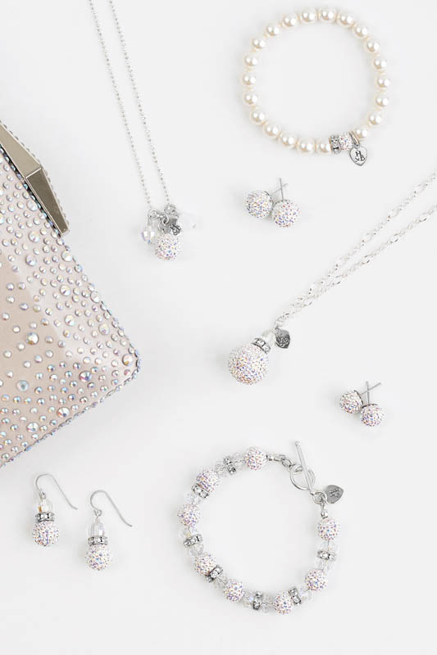

Source: Company files.

Exhibit 3: Hillberg & Berk COMPETITOR ANALYSIS

| **Company** | **Number of Stores** | **Revenue** | **Product Categories** | **Comments** |
| --- | --- | --- | --- | --- |
| **Swarovski** was a private company founded in Austria in 1895. The Crystal Group was the jewellery and collectible arm of the business. The company was a family-run company, and a fifth generation family member remained on the board. | 2,680 stores worldwide, 1,380 operated by Swarovski, 1,300 operated by partners | €2.6 billion (Crystal Group only) | Necklaces, pendants, earrings, bracelets, rings, charms, men’s jewellery, activity-tracking jewellery, watches, bags, wallets, pens, crystal decorations, and sculptures | Swarovski also operated 12 subsidiaries. These businesses produced a wide range of products, most of which required cut lead glass; however, the company also produced high-fashion products, museums, and entertainment. |
| **PANDORA** was a publicly traded jewellery business founded in Denmark in 1982. The company had seen rapid growth based on the popularity of its charm bracelets. | More than 1,800 stores worldwide, the majority of which were franchised 9,300 other non-branded points of sale | DKK16.6 billion (approximately €2.2 billion) | Charms, bracelets, rings, earrings, necklaces, and pendants | Seven out of 10 women in PANDORA’s target demographic reportedly knew and recognized the PANDORA brand. |
| **Kendra Scott** was a private company based in Austin, Texas. The namesake founder had started the company from her house in 2002. | 39 company-run stores | Reported to be US$150 million in 2015 | Necklaces, earrings, bracelets, rings, charms, jewellery organizers, and “colour bar” custom items | The first Kendra Scott store opened in 2010. The company had been particularly successful by offering products from its “colour bar,” an in-store and online option where could customers pick coloured stones that were made into jewellery using a selection of standard designs, as customers watched. |
| **Alex and Ani** was a private company founded in 2004 in Cranston, Rhode Island. The company opened its first store in 2009. | 65 company-owned stores as of 2015, and concession stands and partnerships with hundreds of stores and boutiques, including Nordstrom and Hudson’s Bay | Reported to be US$500 million in 2015 | Bracelets, rings, earrings, necklaces, handbags, wallets, scarves, cuff links, blankets, and perfumed mists | Alex and Ani’s products were popular gifts, with the US$28 zodiac bracelet being a reported top seller. |

Note: € = euro; US$1 = €0.878 on September 30, 2016.

Source: PANDORA, “The PANDORA Story,” accessed October 4, 2016, http://pandoragroup.com/en/Media/Pandora_In_Brief/the-pandora-story; Swarovski, “About Swarovski: Corporate Facts,” accessed October 4, 2016, www.swarovskigroup.com/S/aboutus/Facts.en.html; Amy Anderson, “Meet Kendra Scott: Homemade Millionaire,” *Success*, March 7, 2016, accessed October 4, 2016, www.success.com/article/meet-kendra-scott-homemade-millionaire; Clare O’Connor, “Alex and Ani’s Carolyn Rafaelian Joins Self-Made List as Jewelry’s Richest Woman,” *Forbes*, June 3, 2016, accessed October 4, 2016, www.forbes.com/sites/clareoconnor/2016/06/03/alex-and-anis-carolyn-rafaelian-joins-self-made-list-as-jewelrys-richest-woman/#427fd5da2e93.

Exhibit 4: Hillberg & Berk STORE LOCATIONS

|  |  |  |  |
| --- | --- | --- | --- |
|  | **Store Name** | **Location** | **Store Type** |
| **1** | Flagship | Regina, Saskatchewan | Standalone Store |
| **2** | Cornwall | Regina, Saskatchewan | Sparkle Bar |
| **3** | Midtown | Saskatoon, Saskatchewan | Standalone Store |
| **4** | Centre | Saskatoon, Saskatchewan | Pop-Up Standalone Store* |
| **5** | West Edmonton Mall | Edmonton, Alberta | Sparkle Bar |
| **6** | Kingsway Mall | Edmonton, Alberta | Sparkle Bar |

*Expected to remain open until spring 2017

Source: Company files.

One of H&B’s Sparkle Bars

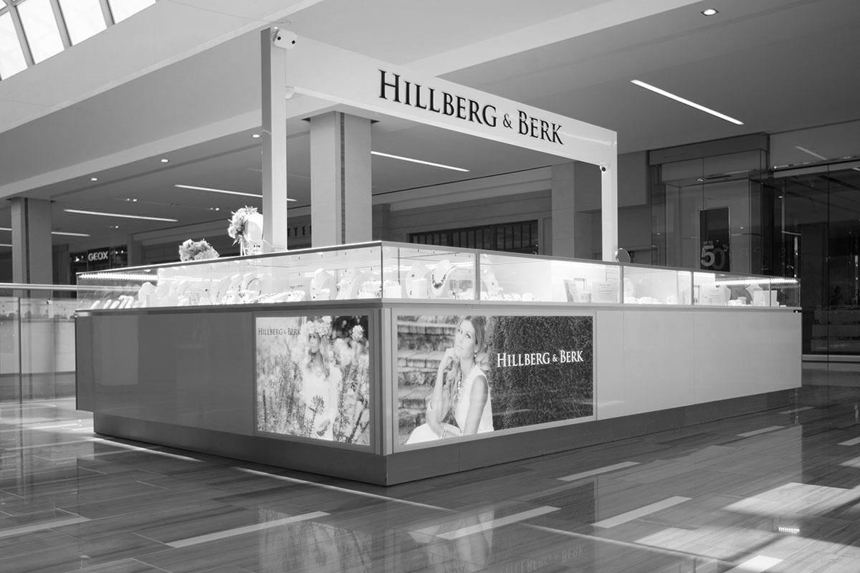

One of H&B’s Standalone Retail Stores

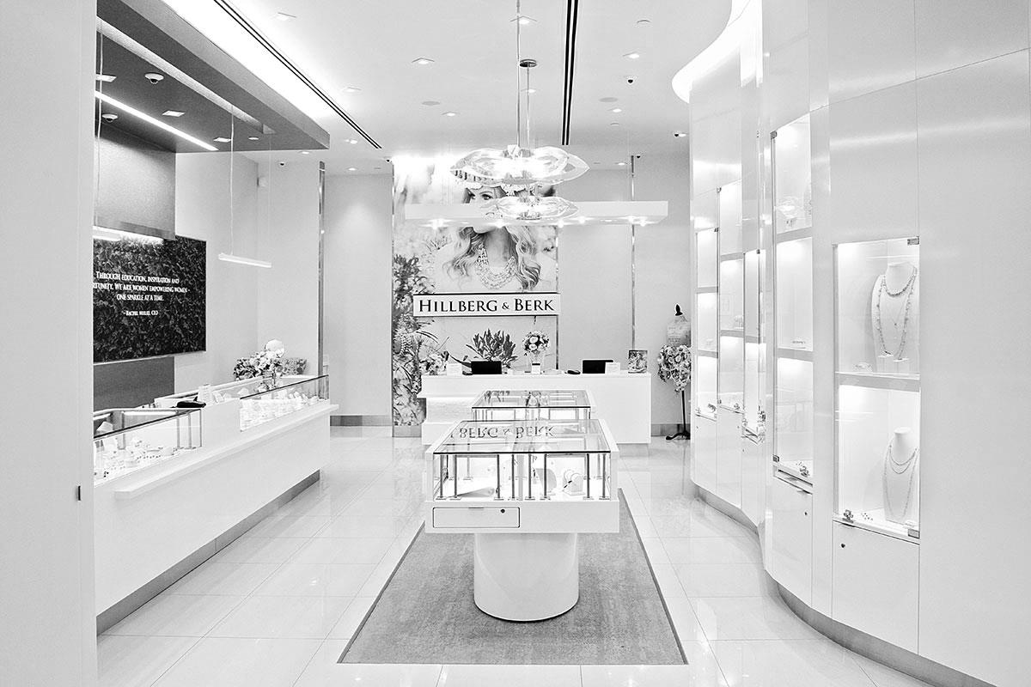

Source: Company files.

Exhibit 5: POPULATION STATISTICS, CANADA

Saskatchewan’s Population

According to Statistics Canada, Saskatchewan’s population was estimated to be 1,142,570, as of January 1, 2016.

Gender

Of the Saskatchewan Census population for 2011, 50.50 per cent was female while 49.50 per cent was male. The comparable values for the 2006 Census population were 50.91 per cent female and 49.09 per cent male.

2011 Census Populations by Province or Territory and Age Group

|  |  |  |  |  |  |  |  |
| --- | --- | --- | --- | --- | --- | --- | --- |
|  | **Age Group** | | | | | | |
|  | **0–14** | **% of Total** | **15–64** | **% of Total** | **65 and Over** | **% of Total** |
| **Canada** | 5,607,345 | 16.75 | 22,924,290 | 68.48 | 4,945,055 | 14.77 |
| **Newfoundland and Labrador** | 76,625 | 14.89 | 355,800 | 69.15 | 82,105 | 15.96 |
| **Prince Edward Island** | 23,060 | 16.45 | 94,360 | 67.30 | 22,785 | 16.25 |
| **Nova Scotia** | 138,215 | 15.00 | 630,140 | 68.37 | 153,370 | 16.64 |
| **New Brunswick** | 113,575 | 15.12 | 513,960 | 68.42 | 123,635 | 16.46 |
| **Quebec** | 1,258,625 | 15.93 | 5,386,695 | 68.16 | 1,257,685 | 15.91 |
| **Ontario** | 2,180,775 | 16.97 | 8,792,725 | 68.42 | 1,878,325 | 14.62 |
| **Manitoba** | 231,160 | 19.13 | 804,655 | 66.60 | 172,450 | 14.27 |
| **Saskatchewan** | 197,855 | 19.15 | 681,815 | 65.98 | 153,705 | 14.87 |
| **Alberta** | 684,790 | 18.79 | 2,554,745 | 70.08 | 405,720 | 11.13 |
| **British Columbia** | 677,365 | 15.39 | 3,033,980 | 68.95 | 688,715 | 15.65 |
| **Yukon Territory** | 5,865 | 17.30 | 24,940 | 73.57 | 3,095 | 9.13 |
| **Northwest Territories** | 9,010 | 21.73 | 30,055 | 72.48 | 2,400 | 5.79 |
| **Nunavut** | 10,425 | 42.67 | 20,420 | 63.99 | 1,060 | 3.32 |

Source: “Saskatchewan Population by Age and Sex Report: 2011 Census of Canada,” May 29, 2011, accessed October 7, 2016, www.stats.gov.sk.ca/stats/pop/2011AgeSex.pdf.

1. All currency amounts are in Canadian dollars unless otherwise indicated.
2. Linda Dauriz, Nathalie Remy, and Thomas Tochtermann, “A Multi-Faceted Future: The Jewelry Industry in 2020,” *McKinsey Insights*, February 2014, accessed October 4, 2016, www.mckinsey.com/industries/retail/our-insights/a-multifaceted-future-the-jewelry-industry-in-2020.
3. Claudia D’Arpizio, Federica Levato, Daniele Zito, and Joëlle De Montgolfier, *Luxury Goods Worldwide Market Study: A Time to Act; How Luxury Brands Can Rebuild to Win*, fall–winter 2015, 2, accessed October 4, 2016, www.bain.com/Images/BAIN_REPORT_Global_Luxury_2015.pdf.
4. Dauriz, Remy, and Tochtermann, op. cit.
5. Ibid.