** **

9B17M050

BUSINESS MODELS AND the Online Venture Challenge (A): The decision over version 2.0

Professors Chris Street and J. Robert Mitchell wrote this case solely to provide material for class discussion. The authors do not intend to illustrate either effective or ineffective handling of a managerial situation. The authors may have disguised certain names and other identifying information to protect confidentiality.

*This publication may not be transmitted, photocopied, digitized, or otherwise reproduced in any form or by any means without the permission of the copyright holder. Reproduction of this material is not covered under authorization by any reproduction rights organization. To order copies or request permission to reproduce materials, contact Ivey Publishing, Ivey Business School, Western University, London, Ontario, Canada, N6G 0N1; (t) 519.661.3208; (e)* [*cases@ivey.ca*](mailto:cases@ivey.ca)*;* [*www.iveycases.com*](http://www.iveycases.com)*.*

Copyright © 2017, Richard Ivey School of Business Foundation Version: 2018-05-30

“Well, one way or another, we’re going to have to commit in a week. But will it be one product or two?” Josh Del Begio looked over at his brother, Caleb, and considered what Caleb had just asked him. In five days, the brothers were scheduled to travel to the United States Association of Small Business and Entrepreneurship (USASBE) academic conference being held in San Diego, from January 10–12, 2016. Although it was only a short flight from where the brothers were based (Vancouver, British Columbia, Canada) to San Diego, this trip represented a potentially long voyage from where Josh and Caleb’s business began. They had been working on the product for almost two years, in addition to their full-time jobs, to develop and sell their primary product, the Online Venture Challenge (OVC), a tool for entrepreneurship educators, but they had yet to break into the educational market, which had seemed so promising at first. Josh and Caleb believed their web-based software was unique in its ability to create an environment for actually starting an online business, while also providing a suite of evaluation systems for professors to monitor students’ progress, give them feedback, and grade their work. Yet the product was failing to capture sales, and the brothers wondered why this was the case.

After several discussions about how to continue building the OVC, the brothers decided to start development of a second product. This decision was especially influenced by Caleb’s conversation two months earlier with a professor who declined to use the OVC. Instead, the professor suggested that he would rather have an online environment for developing and analyzing business ideas based on the Business Model Canvas and the Lean Canvas, both popular tools for visualizing business models (see Exhibit 1). The professor believed this second product would then complement the existing OVC product by giving students a better environment to analyze their online business development ideas. However, what had started as a complementary product began to take on a life of its own, as it became increasingly apparent that this development might be capable of standing alone instead of being a product add-on. While the brothers were initially intrigued by the idea of creating a new product (and a new revenue stream), it was soon apparent that developing and selling two products would not be easy for a start-up that still lacked a popular, revenue-generating product.

As Caleb and Josh saw it, the upcoming USASBE conference was the ultimate test for the new business idea. This conference brought entrepreneurship professors from around the world to one location. The Del Begio brothers had already paid for a booth at the conference as a way to market the OVC and gain perspective and feedback from the attendees. This feedback would help them understand why they might not be getting the traction they had hoped for, and what faculty were looking for in terms of classroom resources. Yet in light of this new idea, Caleb and Josh had to decide how to position their product line. Was the OVC going to be one primary product that had multiple complementary features? Or should their two products be positioned as two separate but complementary products? Or was it better to have two stand-alone products and two corresponding businesses? The brothers needed to better understand their own business ideas to determine the approach they should take at the conference; fittingly, the new tool they had created might actually help them to do just that.

development history

The initial idea for the first product, the OVC, originated from an experience that Caleb had in an entrepreneurship course at Royal Roads University in 2010. The course involved a semester-long project that was actually called the Online Venture Challenge. In this project, students were required to design and launch a web-based business. As part of the project, students had to create their own e-commerce websites and sell products; this aspect resulted in redundant effort across the class, and seemed to take away from the primary focus on creating the product. Caleb recognized there was a better way to create a platform for students to use, and thought that it would be especially helpful if they could continue using the platform after the course was over—it would also mean an ongoing revenue stream for Caleb.

Caleb worked to develop two different business ideas following the entrepreneurship course: one was a window cleaning business that he started himself; the other was a roof cleaning business that he started with his brother, Josh. By the summer of 2014, the window cleaning business had been sold for a small profit, and the roof cleaning business was still in operation, although the brothers were looking for a buyer. At this point, Caleb was living with several roommates in Whistler, British Columbia, and worked for Guestfolio, a software company. Through one of these roommates, Caleb met the application (app) store manager for Shopify, a successful Canadian-based e-commerce platform, and she responded positively to Caleb’s description of his OVC idea. Specifically, she suggested that Caleb not only create the OVC e-commerce platform but also do so using the Shopify application programming interface (API) platform.

Because this business idea pushed Caleb into a new space (coding instead of cleaning), his first step was to enroll in the BitMaker Labs “Code Camp” in Toronto. Through this course, he learned the basics of coding and also connected with other Shopify developers. Doing so enabled him to design and build a prototype (i.e., a minimum viable product) of his e-commerce platform, with the intent of marketing it to the higher education market. Beginning in October 2014, Caleb began full-time development of the system with Mitch Crowe, a friend who was then working as a freelance programmer and development consultant, who could do contract work for the OVC.

The OVC was intended to be a platform to facilitate students’ web-based businesses. The model behind OVC was that professors would register their courses on the system, and then students would each register and pay a CA$25[1] subscription fee for the semester. This fee would be used to cover both a Shopify subscription and an OVC subscription. Students would then use these online tools to create the retail site that they would use to sell products online. As they did so, their professors could monitor the businesses using a “professor dashboard” that would include metrics such as sales revenue, length of time to reach sales milestones (e.g., $500, $1,500, $2,500), number of customers, different social media sales channels that were being used, and which learning modules students had completed.

Once the product was created in late 2013, Caleb began recruiting customers for the business. One of the first professors to commit to using the product was a professor that Caleb had worked with at Royal Roads University in Victoria, British Columbia. Two professors, one from the University of Mississippi and one from the University of Minnesota Duluth, also committed to using the OVC. These latter two professors were connected to Caleb through word-of-mouth promotion from the first professor in Victoria. These commitments were heartening for Caleb, and resulted in three classes of students using the system; however, this revenue was not enough to sustain the business. To assist in further development of the market and enable additional sales of the OVC, Caleb eventually recruited his brother Josh (as a co-founder) and his friend Andrew Miller (as an employee). The initial agreement was that Caleb would be responsible for system development, and Josh and Miller would be responsible for marketing and sales. By this time, the retention rate for professors who continued using the system was approximately 100 per cent, while about 12 new professors were first-time subscribers in September 2015.

SPECIFICS OF THE Online Venture challenge

The OVC was designed to help both professors and students. The main problem that the OVC intended to solve was that professors lacked (1) a way for students to quickly and efficiently create retail websites, and (2) a way to effectively monitor and evaluate individual students’ progress. For students, the system was seemingly valuable because it integrated actual retail website functionality (enabling sales) with a professor interface that was capable of monitoring student progress (enabling learning). This combination resulted in an experiential learning environment that equalled or surpassed competing products such as marketing simulations. The OVC site provided value in three ways: first, it was an all-in-one solution to professors for teaching and assessing student activity through student assessment tools; second, it offered an integrated e-commerce platform service for students to collaborate and develop an electronic retail storefront using Shopify to handle all the design and financial functions—thereby earning students money; finally, it “gamified” learning, allowing students to actually create a business, as opposed to taking part in an artificial simulation or research project for class (see Exhibit 2).

In thinking about the business model for the OVC, Josh and Caleb sat down prior to the USASBE conference to calculate just how large the potential market was for their product. By their calculations, the total addressable market was approximately $6 million. In terms of the number of potential users, in 2013, more than 400,000 students were taking entrepreneurship courses each year, and almost 9,000 faculty members were teaching these courses globally.[2] These professors were the critical decision-makers for accessing the student buyers of the OVC. Although it was helpful to have such a concentrated group of decision-makers, getting professors to buy into the service was labour-intensive, because many professors did not like making changes to courses that they may have been teaching for several years.

The OVC was originally intended to operate in a similar way to the university textbook business model, where professors wanting to use the OVC experiential exercise would include it as part of their course, and require that students purchase an OVC subscription (as outlined in the course outline or syllabus). Using this system, professors could create a unique workspace for the course and invite students to join that space. Students could then follow the link provided by the professor, pay the subscription fee, and create an account to join the professor’s specific course through the OVC website.

There were two different types of general subscribers to the OVC: instructors and students. Each of these groups was reached in different ways. Instructors were contacted through direct email marketing, cold calls, and referrals as a way of introducing them to the OVC and its unique benefits. Contrastingly, students were reached through the online platform itself as a result of professor buy-in. In the online platform, students were encouraged to give feedback and receive support as necessary. Caleb understood the importance of ensuring that both professors and students were satisfied with the level of support they received. To facilitate this satisfaction, the team at the OVC was working to develop a well-curated resource library for professors and students to find information on topics such as how to use the OVC platform, how to interpret the web-based analytics data that was available on the OVC, and how to benefit from the features at Shopify.

The use of the Shopify API platform was critical because it allowed the OVC to seamlessly offer an e-commerce platform that enabled easy site design and financial transaction management functions. The availability of the Shopify resources freed up the OVC to create more high-quality learning content for professors to provide to students through the OVC platform, and to provide fast and simple platform support to both professors and students. The OVC thus offered professors the ability to track important metrics related to student progress (e.g., sales revenue, different social media sales channels used, and online learning modules completed).

The primary costs of the OVC were involved with application development, web hosting, marketing to professors, and customer support. The idea behind the OVC business model was to have it be simple and adaptable to ensure that the business was flexible and costs were low, as the OVC team worked to figure out the market.As part of figuring out the market and working to sell the OVC, Caleb, Josh, and Miller preferred to rely on referrals, but they also realized the importance of utilizing a “cold call” approach as a way of accessing entrepreneurship professors. Specifically, they sought to reach out to professors who taught entrepreneurship in business schools, but also saw opportunities to supply exercises to professors teaching entrepreneurship in other programs or non-university settings.

FRUSTRATIONS AND OPPORTUNITIES IN SELLING

As part of his continued efforts in selling, Josh made a cold sales call to a professor at a prestigious university in the Eastern United States. At the end of the call, after listening to Josh’s sales pitch, the professor said he was not interested in the OVC course platform product. However, he was interested in the professor interface, the analysis aspects of the site, and the business design services, which were modelled after the popular Business Model Canvas tool (see Exhibit 1). In his work, this professor had been looking for an online tool to use with his consulting business that would walk his corporate clients through the process of testing the viability of a new venture and also be capable of tracking and showing individual/team progress. After hearing this response, Josh wondered whether a larger market existed for the kind of tool this professor described, as opposed to the OVC platform he had been working to sell. He also wondered whether a new product could be the bridge between the OVC and this market. Accordingly, on October 14, 2015, Josh met with Caleb and Miller to discuss his progress and the feedback he had just received regarding the new possibilities with the professor interface.

On the one hand, the timing of this meeting was fortuitous because the partners were readying for the upcoming USASBE 2016 academic conference, where they had planned to showcase the OVC. This conference would be a great place to gather feedback from the many entrepreneurship professors that would come from Canada, the United States, and all over the world. On the other hand, the timing was stressful because it could mean reworking the business’s plans, and potentially, more development work on the product that Josh and Caleb would showcase at the USASBE 2016 conference. Depending on what they decided to do in light of the recent feedback, the founders of the OVC needed to decide whether they would offer (1) one primary product that had multiple complementary features, (2) two separate, but complementary products, or (3) two stand-alone products and businesses, serving two different markets.

Based on his recent discussion with the professor from the Eastern United States, Josh argued in favour of stand-alone products and businesses for three main reasons: (1) the total market for the OVC was too small, and narrowed what the business partners were doing; (2) the partners were spending too much time promoting the product because it required convincing very independent and opinionated customers with their own ideas about teaching; and (3) the OVC required professors to teach their class in a specific, standardized way—something that went against the notion of academic freedom.

However, there were also reasons to see the OVC as one primary product that had multiple complementary features: (1) the partners already had paying customers; (2) they had a developed product with key partnerships with Shopify; and (3) there was not much time to substantially change directions at this point. By the end of the meeting, the partners had not decided which approach to take, but determined that they would present both the original OVC product and the new product idea at the USASBE conference in January 2016. Therefore, they had nine weeks to figure out what the product was, develop a reliable demonstration version, and understand how it fit with their existing business model—if it fit at all.

On November 1, 2015, Caleb and Mitch Crowe, the Del Begio brothers’ friend and contract worker, started building the new product, which they named Launchboard, with the goal of having a minimum viable product (MVP) demonstration version available for the 2016 USASBE conference. The concept for Launchboard centred around the Business Model Canvas and the Lean Canvas that were both interactive and allowed users to make development plans and record their progress in working through the assumptions and testing for each section of the Business Model Canvas or a similar Lean Canvas model (see Exhibit 1). With such a short development timeline, Caleb and Crowe adopted the same approach that they had used for the OVC in terms of registering individuals, forming teams, assigning tasks, and monitoring progress. The main difference that emerged with the new product was how Launchboard focused on the evaluation tasks of starting a new business, whereas the OVC focused on launching a new business on Shopify.

The partners worked on Launchboard non-stop until January 1, 2016, at which point the team had a demonstration version available on Google’s Firebase, a development platform that, among other attributes, was useful for rapid prototyping. Using the Firebase platform reflected the trade-offs being made to meet the January deadline: the main design strength of Firebase was speed, with less emphasis on the product being scalable to the level that the partners would need if their market turned out to be as large as they anticipated. Essentially, the OVC partners decided to build a disposable Launchboard product that was suitable only for demonstrating the concept of what the product could eventually be.

MOVING FORWARD

In spite of the potential technological issues that could surface down the road, Caleb hoped that in having an MVP at the USASBE conference, the partners would be able to clarify and develop the business model going forward. Because they had invested substantial time and money in the OVC product, Josh and Caleb had a tentative plan to sell OVC aggressively at the USASBE conference and increase revenue through that product, with the fallback strategy being to demonstrate Launchboard and gather as much feedback as possible. Yet even with this fallback plan in place, several questions remained: Would all of the effort spent on the OVC be wasted? Would the last two months of work on Launchboard prove similarly pointless? Was there some way forward that could combine these two different ideas? One way or another, Josh and Caleb knew they would find the answers to many of these questions at the USASBE conference.

Exhibit 1: THE Business Model Canvas and the lean canvas

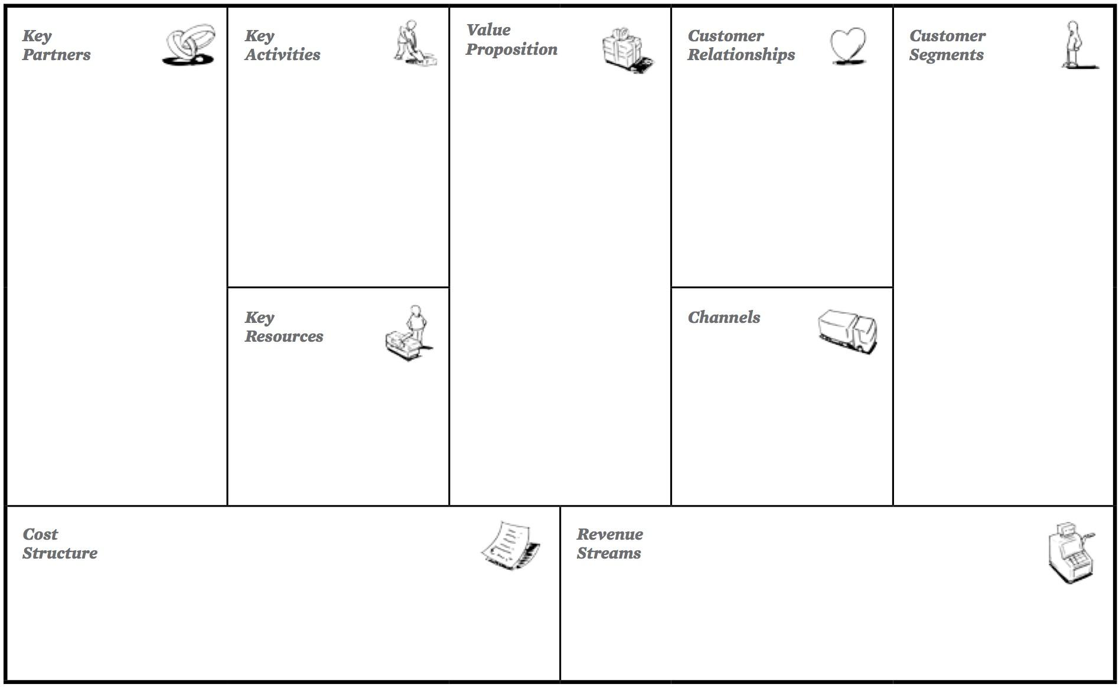

Source: “The Business Model Canvas,” Strategyzer, accessed September 22, 2015, www.businessmodelgeneration.com/canvas/bmc.

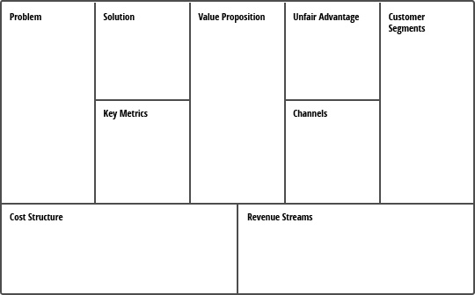

Source: “The Lean Canvas,” CanadaOne, accessed March 7, 2017, [www.canadaone.com/images/lean%20canvas-sm.jpg](http://www.canadaone.com/images/lean%20canvas-sm.jpg).

Exhibit 2: Layout and Professor Interface of the Online Venture Challenge

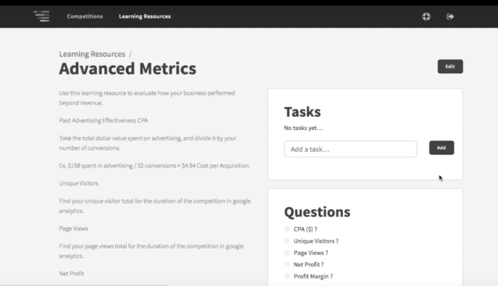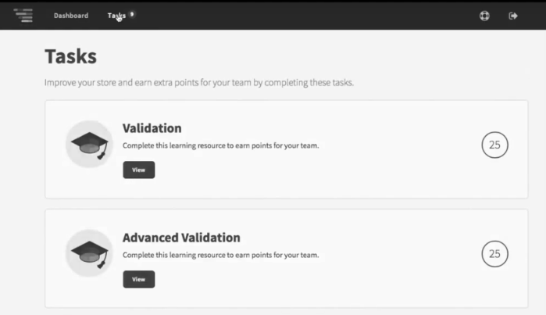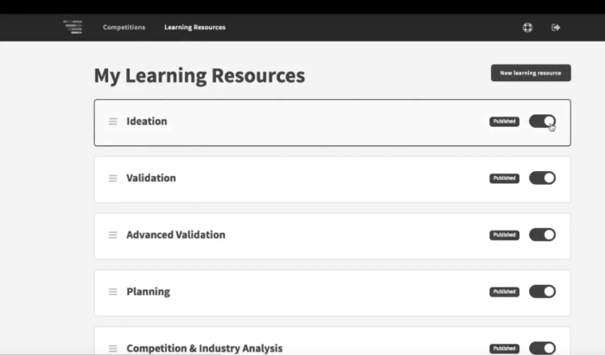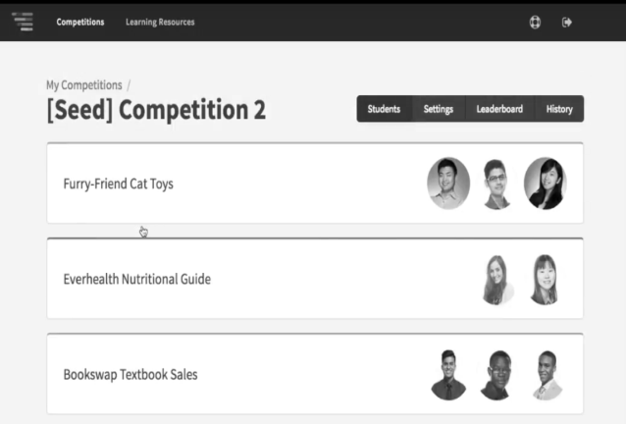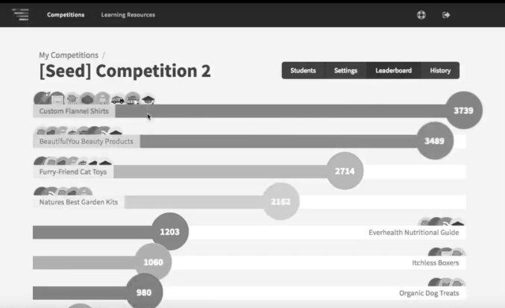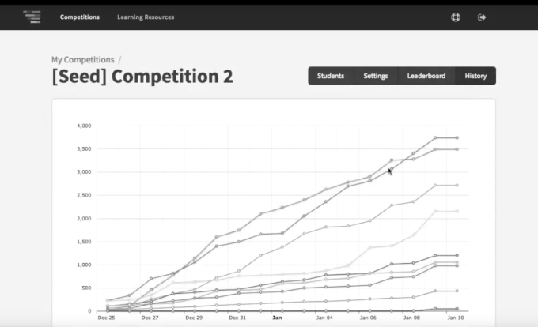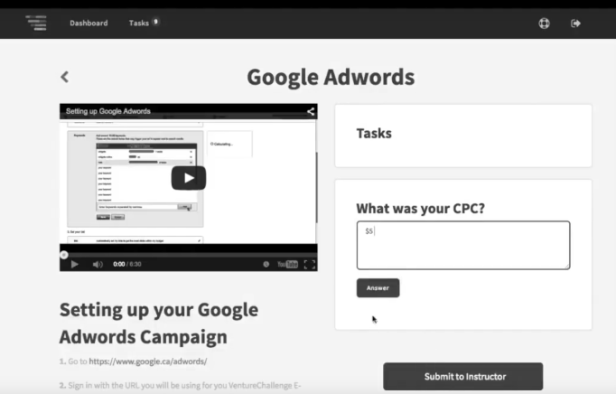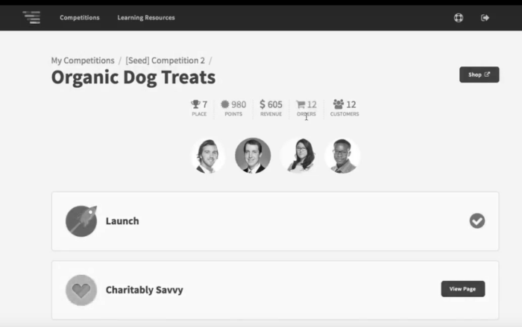

Source: Company files.

1. All currency amounts are in Canadian dollars unless specified otherwise.
2. Ewing Marion Kauffman Foundation, *Entrepreneurship Education Comes of Age on Campus*, 1, 2013, accessed October 7, 2016, www.kauffman.org/~/media/kauffman_org/research reports and covers/2013/08/eshipedcomesofage_report.pdf.