

9B17M062

Ana by Karma: One Scarf, One Hope

Lei Li and Fei Zhu wrote this case solely to provide material for class discussion. The authors do not intend to illustrate either effective or ineffective handling of a managerial situation. The authors may have disguised certain names and other identifying information to protect confidentiality.

*This publication may not be transmitted, photocopied, digitized, or otherwise reproduced in any form or by any means without the permission of the copyright holder. Reproduction of this material is not covered under authorization by any reproduction rights organization. To order copies or request permission to reproduce materials, contact Ivey Publishing, Ivey Business School, Western University, London, Ontario, Canada, N6G 0N1; (t) 519.661.3208; (e)* [*cases@ivey.ca*](mailto:cases@ivey.ca)*;* [*www.iveycases.com*](http://www.iveycases.com)*.*

Copyright © 2017, Richard Ivey School of Business Foundation Version: 2017-04-28

New Year’s Day of 2016 was fast approaching. Quin S. Q. Thong sat at her desk in a small office on the 15th floor of Langham Place, Mongkok, Hong Kong. She was trying to work out the total sales volume of handmade Bhutanese scarves of Ana by Karma, a social enterprise that Quin had founded approximately 18 months earlier. To her delight, a preliminary count showed that since the inception of Ana by Karma, at least 3,650 scarves had been sold in Hong Kong, Mainland China, Singapore, Malaysia, and other countries. The original goal had been to reach such a sales volume after five years.

Things were going well for Ana by Karma. Just a few weeks earlier, Quin had organized a successful tour to Bhutan for a group of family and friends who had been enthusiastic supporters of Ana by Karma. During the tour, Quin delivered a photography workshop and a wealth management seminar for some Bhutanese children who were living in poverty; all expenses for these programs were covered by the surplus of Ana by Karma. She was also excited to learn after her return from Bhutan that the gift shop of a five-star hotel near the Wan Chai district of Hong Kong was willing to carry Ana by Karma scarves.

While relishing her experience over the past 18 months, Quin considered the challenges ahead. The operational activities of Ana by Karma were solely dependent on the efforts of staunch volunteers, including herself. Was it time to hire a full-time coordinator in Bhutan? Was it time to hire a full-time assistant, perhaps in Mainland China? How could Ana by Karma evolve sustainably and fulfil its social mission in the long run? Would it be possible for her to run Ana by Karma on a full-time basis in the not-so-distant future?

Background

Quin Thong was born and raised in Malaysia, and moved to Hong Kong in 1998, when she married her Hong Kong-born husband. She was a chartered accountant, who had risen to the top of her profession and could work as a chief financial officer (CFO) or chief operating officer of large companies. She taught some MBA programs in China as a visiting lecturer, enjoyed being the chairperson of the CFO Summits organized by the Association of Chartered Certified Accountants, and taught children the art of wealth management. She ran a non-governmental organization (NGO) called Global Women Connect and had an active social media personality, with more than 30,000 fans on Weibo, a Chinese microblog. She loved travelling, and had been to the most unlikely places, including Syria, Iran, and Ethiopia, to name a few. But it was Bhutan, a place she had first visited in 2003, that captured her heart.

Karma Yangchi was a young Bhutanese woman from a small, little-known village on the eastern side of Bhutan. It took three hours for her to walk to the main bus stop, where she could catch an overnight bus to Thimphu, the capital of Bhutan. Unschooled, due to family circumstances, she, like many other Bhutanese girls, had learned the traditional art of Bhutanese weaving at a young age of 12. To make up for her lack of education, her father had promised her a craft shop when she grew up; however, he died in his 40s, leaving Karma without any education and without hope for a livelihood. Without education, Karma could not speak and write in English, nor speak or write well in the Bhutanese national language, Dzongkha. She spoke fluently in only her village dialect.

Quin first got to know Karma and her husband, Ugyen, in 2003, when Quin had visited Bhutan as a tourist. In that meeting, they had exchanged gifts. Little did Quin realize how precious the gift was—a handwoven Kira, a large piece of cloth that the women in Bhutan wore as a traditional costume.

In the intervening period before the next visit, Quin and Ugyen, who spoke and wrote English well, exchanged emails, greetings, and ideas. Quin visited Karma again, from June 15 to June 25, 2014, and was sad to find that Karma and her entire family were still living in dire circumstances after 11 years.

Therefore, Quin made a steely resolution to help the couple. Quin knew Karma had a great eye for colours and patterns, as manifested in Karma’s skill set and the Kira she had given Quin as a gift. But as Quin also rightly observed, a Kira was not a saleable product to a tourist. Not only was it expensive, it was also not of use to a non-Bhutanese person. So, Quin came up with an idea to offer to buy a sewing machine so that Karma could weave simple cotton cloth, which she could then sew into bags, cushion covers, or pencil boxes that could be purchased by souvenir shops for tourists’ consumption.

In Quin’s mind, the sewing machine would cost US$200.[1] Karma shook her head vigorously at the idea. Quin softened the approach by suggesting it as a $200 loan instead, and once again the idea was rejected by Karma. Scratching her head, Quin then took off her scarf and passed it to Karma and asked, with Ugyen helpfully interpreting, “Can you make one of these things, Karma?” Karma took the soft silk scarf in hand, examined it very carefully, stretched it out to see how long it was and with a small smile on her lips, nodded her head at Quin. “Oh, good,” Quin exclaimed. “Make me a few and I will sell these for you and raise funds for your sewing machine.”

THE Founding of Ana by Karma

A few days later, Karma took eight scarves to Quin’s hotel room. Using social media platforms such as Facebook and WeChat (the Chinese version of Twitter), Quin posted photos of the scarves, which were beautifully woven in the freshest colours of the rainbow. Quin knew right away that these scarves could sell. But she could not have guessed that more than 40 scarves would be ordered on the same day. And she never dreamed that the orders would reach 100 within two weeks after her return to Hong Kong from Bhutan. Friends from Hong Kong, Mainland China, Singapore, Malaysia, and even Dubai and the United States all clamoured for the beautiful scarves.

When the sales reached 100 scarves, it felt like a small flame had leapt into Karma’s heart. Karma asked Ugyen to write Quin an email—a very serious email:

Dear Ana (Sister)

I have an action plan. I will make 3,650 scarves from 25 June 2014 to 25 June 2019. Please help me sell them, thank you. Karma[2]

With mixed feelings, Quin read the email. Should she say “No” and crush Karma’s hope, or say “Yes” and worry about how to sell the scarves later? Quin finally said, “Yes.”

However, distributing 100 scarves and selling 3,650 scarves were clearly two different matters. One might be luck and hobby, whereas the other would be a business venture entailing some strategy, an action plan, and much discipline. As Quin later confessed, she was completely unsure about how this endeavour would evolve. “I feel like a blind lady riding a blind tiger” (see Exhibit 1).

A Blind Lady Riding a Blind Tiger

Making a Brand

It was quickly agreed among the three that the brand should be Ana by Karma, where Ana stood for sisters and Karma was Karma. It meant Karma had handmade the scarf with love and care for her sisters all over the world. Making the scarves was a labour of love. After all, Karma could only make one scarf a day. The work was very labour-intensive.

Although the name “Ana by Karma” was familiar-looking in English, two of the three words were actually Bhutanese words. Some friends and customers interpreted “Karma” in “Ana by Karma” to mean they would receive good karma when they supported the brand. Quin hand-drew three designs of the Ana by Karma logo and asked her friends to cast their votes via WeChat. The one with the most votes became the logo (see Exhibit 2).

Clarifying the Responsibilities

With Ugyen as the interpreter, Quin and Karma would speak by telephone to sort out the work to be done. After every phone call, Quin would write out the agenda and then the minutes. In this way, the small team got to work with a relatively clear division of responsibilities.

Karma looked after production, quality control, and design. She also recruited and trained some new weavers to follow the Ana by Karma designs. Each scarf was 100 per cent handmade with mostly natural materials. Ugyen was responsible for the incorporation of Ana by Karma and other legal requirements in Bhutan. He was also in charge of packing and delivering the scarves. Quin took care of sales, marketing, customer service, and accounting. On top of that, Quin shared with the team money management principles and business tips to try to make the operations more efficient.

Exploring Sales and Marketing

The first few hundred scarves were all sold for a price that was not enough to cover the full cost of making them. Quin just wanted to help initially and doubted whether this venture would go very far. But as the sales climbed to more than 400 scarves, Quin decided that appropriate pricing must be put in place to make the venture viable in the foreseeable future. The price would need to at least cover the labour and material costs of the weavers, the packaging and shipping fees, the bank transaction fees, and marketing expenses (e.g., brochures, promotional events, and travelling).

Quin organized a few professional forums and parties to spread the Ana by Karma story and to sell scarves if any participants wanted to purchase them. These events were held in Shanghai, Hong Kong, and Kuala Lumpur. During the events, Quin often handed over the ordered scarves, collected cash, and photographed customers wearing the scarves, which was another way to promote them. Such a practice evolved quickly into a campaign called “Buy a Scarf, Get to Model.”

Because this idea worked so well, Quin held a tea party at Sinan Mansions’ historic villa in Shanghai on November 22, 2014, drawing almost 80 guests who came together to be models for an upcoming scarf fashion book for Ana by Karma. The party was organized through WeChat with the guests paying for the costs through Alipay. The guests were also welcome to purchase scarves at a promotional price of CN¥200[3] each. Another party was held in the home of an international musician in Hong Kong on December 7, 2014, attracting 50 influential elites from the Hong Kong high society to come and listen to the story of Ana by Karma.

The announcements of the parties, and the images of the gatherings and the “scarf models” were posted and reposted by Quin and her friends on social media such as WeChat and Facebook (see Exhibit 3). Wishing to minimize marketing expenses, Quin relied on social media to spread the word. She also set up a free Facebook marketing page for the Ana by Karma story and scarves. She would post thoughtful messages to share with her friends and acquaintances, thereby reaching out to a larger audience (and potential supporters) in a personable way (see Exhibit 4).

As Bhutan was known for being a happy country, it appeared that Ana by Karma was not only a good cause but also a happy project. Indeed, it seemed like Bhutanese weavers handmade the scarves with love, and transferred happiness to people around the world through the scarves; the supporters across the nations, in turn, brought back the happiness by helping the under-privileged Bhutanese women. Soon, “weaving happiness one scarf at a time” and “one scarf, one hope” became main taglines of Ana by Karma. By the end of 2014, approximately 1,000 scarves had been sold or used as samples for promotion. Eighty per cent of the customers were from Quin’s social network.

Growing Pains and Hope

Quality Control

When Quin agreed to sell 3,650 scarves for Karma, she knew that she was about to ride a tiger. She soon found herself in a dilemma:

I went all out selling . . . I think in a couple of weeks, I sold 300 or 400, then the teething problems started to show up: bad quality of scarf, delivery problems . . . . I would ask Karma and Ugyen, “What happened?” They didn’t say anything; they didn’t answer my email; they didn’t take my phone calls. I didn’t know until later that they became scared whenever they did something wrong, and hid like ostriches.

It turned out that to meet the growing demand, Karma had recruited people who had varying weaving skills. Initially, Quin had problems with only five pieces. Then there were issues with 10 or 12 pieces out of 100. In some scarves, overlapping laces were coming out; other scarves were not soft and supple and could stand up like a piece of paper. Quin was upset by such poor quality control. “I kept telling them that it’s important to have quality scarves. Since they were not listening, I issued an ultimatum. Let’s finish the orders on hand, and stop this venture.” She further added angrily, “You give me ‘rubbish’ scarves and I am paying for your mistakes. This cannot go on.” Although Quin threatened to ship back the poor-quality scarves, she never did so, which made Karma continue to send substandard scarves over to Quin. “I say I’ll send them back but I never do. As I am already working full time, I really don’t have time to do more. . . . I have got a lot of pressures from my husband. I have got lousy scarves. . . . It has nearly made me quit.”

Then a different thought crossed Quin’s mind. “You know, they are so different from me. I am using my standard to measure them. Is there something I can change instead of scolding?” It occurred to Quin that the weavers should be trained. She knew a famous village in Bhutan that made textile materials for the royal family and the elites. She thought about hiring someone from that village to teach Karma and other weavers but had no idea how to find such a person. So the idea did not go anywhere until one day, Quin was having a conversation with Tenzin Lekphell, the chief executive officer of the Institute of Management Studies of Bhutan, who happened to know a woman from that village. After talking with Quin, the woman agreed to do the training.

On January 22, 2015, with Quin writing the curriculum and the woman providing the training, a historic Women Overachievers Weaving (WOW) workshop was conducted. For the first time ever, women from the weaving communities all over Bhutan gathered in the capital city, Thimphu, for a formal training workshop. Fully sponsored by Ana by Karma, the weavers were taught best practices in advanced weaving, standard operating procedures, business ethics, problem-solving, and teamwork. The training worked. The team that had been taught in the WOW workshop produced scarves that were of the quality and standard required.

Quin found that the woman was a good trainer and, compared with Karma, was easy to communicate with. She understood the problems and was able to solve them. Quin asked her to be the local coordinator and they signed a one-year agreement. “So having this coordinator on board, working alongside Karma, I suddenly found the confidence [again] to go out and sell scarves. . . . I feel that we can go further.”

Voluntary Support and Corporate Partnerships

While grappling with the operational issues in Bhutan, Quin continued to attract enthusiastic individual and corporate supporters, particularly in Hong Kong and Mainland China.

Helen Pu, a human resource manager with the Suzhou-based subsidiary of a Swedish company, had attended Quin’s guest lecture as an MBA student at Shanghai University. She became a big fan of Quin as she felt that Quin embodied almost a perfect combination of feminine tenderness and professional prowess. Pu also attended the tea party in Shanghai on November 22, 2014, and immediately had the urge to help with the cause of Ana by Karma. With Christmas fast approaching, Pu bought a scarf and asked Quin to ship it as a gift of happiness to a friend in Thailand who had been feeling depressed. To her surprise, Pu also received many enthusiastic responses from her social network after she posted the Ana by Karma story via WeChat. Pu started to spend her spare time helping with Ana by Karma and soon set up a Wei-Dian, a micro-store online, and became the key volunteer in promoting and selling Ana by Karma scarves in Mainland China. In addition, Helen’s good friend, Ivy Xu, co-owner of a local coffee shop called SooCafe, kindly offered the second floor of the coffee shop to showcase Ana by Karma scarves. Quin admitted that Pu’s passion and energy in helping with the cause was a key motivator for her to continue at a time when she had felt frustrated with the scarves’ quality and delivery problems and other issues.

Almost at the same time as Pu started to play an active role in Ana by Karma, an important volunteer emerged in Hong Kong. Dr. Leo Ho was a business executive who had become a university lecturer. He had taken an early retirement from a multinational company and was teaching MBA students at multiple universities in Greater China, including Hong Kong Baptist University and Tongji University in Shanghai. Ho was himself an avid volunteer with several charitable organizations. He heard about Quin’s initiative from an MBA student in Shanghai, and soon after, met with Quin to learn more about Ana by Karma. Ho quickly became a strong supporter, telling the Ana by Karma story whenever he was teaching MBA students. He would later sell a few hundred Ana by Karma scarves to his MBA students.

Apart from attracting individual volunteers, Quin also won corporate support in various forms. For example, Vistra Group, a Hong Kong-based professional services provider, sponsored the launch of Quin’s book, *Weaving Rainbows in the Himalayas: The Art of Bhutanese Scarf Tying* (see Exhibit 5). The book featured the project of Ana by Karma and included many photos of Quin’s friends and acquaintances wearing scarves in different styles. Swarovski also provided bling–bling crystals to be applied to the Ana by Karma scarves being showcased at a corporate gala dinner. Perhaps the most notable case, thanks to Pu’s help, was the partnership with Suzhou-based Ruolin, a Spanish-invested social enterprise, where more than 80 per cent of its employees had a disability, including its corporate lawyer, Rock Lee. Ruolin had been making packaging boxes for L’Oréal. Under the agreement with Ana by Karma, Ruolin would provide packages for the scarves sold in Mainland China.

PMQ Exhibition and Emerging Business Model

Word of Ana by Karma spread further after Quin’s book was launched in April 2015. Unexpectedly, Quin was approached by Londie, a former MBA classmate who was coordinating the exhibitions at PMQ, a hub for design and creative industries in Hong Kong. Londie had learned about Ana by Karma from Quin’s Facebook posts and was willing to offer Quin a space of 400 square feet (37 square metres) for the month of August for a reasonable rental fee. Quin had never thought about doing a PMQ exhibition for Ana by Karma because of the expense, and her tiny, volunteer-based venture was not even incorporated in Hong Kong at the time. Also, she didn’t have the staff or experience for operating at such an exhibition. Nevertheless, she understood that PMQ was an attraction to both tourists and Hong Kong residents and it wasn’t easy to rent a space there; therefore, she decided to proceed. The PMQ exhibition turned out to be a remarkable success.

Establishing Retail Outlets in Hong Kong

At the time of launching her scarf book in April 2015, Quin had a chance, through a mutual friend, to meet the director of operations of the Asia Society in Hong Kong. Quin was able to sign an agreement with the gift shop of Asia Society to carry Ana by Karma scarves. Prior to the PMQ exhibition, this shop was the only retail outlet for Ana by Karma in Hong Kong.

During the PMQ exhibition, Quin frequently received useful information on retail stores that might be interested in promoting and carrying Ana by Karma scarves. For example, three different individuals (who did not know each other), including a journalist with a Buddhist magazine, introduced Quin to Han Li, a well-respected and popular Buddhist gift shop. Cynthia Hui, the founder–manager of Han Li, was a Buddhism enthusiast and a volunteer for various social causes, especially those related to Buddhism:

I added Quin’s Facebook. The more I followed Quin’s Facebook [regarding Ana by Karma], the more I want to support them. . . . She is not just a “do-do-do” type; she is thinking about ways to encourage the whole community to participate in it. . . . She actually empowers the women and children in Bhutan.

By the end of 2015, Han Li had become Ana by Karma’s largest retail outlet and was selling nearly 200 scarves a month. After the PMQ exhibition, other retailers, such as the gift shops of Chi Lin Nunnery and Tao Fong Shan Christian Center, also started to promote Ana by Karma scarves. Quin was able to convince the retail outlets to follow her pricing strategy. She advised the retailers to sell at a price between HK$330 and 360.[4] Quin resisted the common practice of raising the price to HK$600 or more on the tag that stated “HANDMADE,” as her aim was to sell as many scarves as possible to benefit the weavers. Each scarf sale meant one weaver received a day of paid work.

Emergence of the “Management Team”

Quin believed that the more important consequence of the PMQ exhibition was that she started to see an emerging management team for Ana by Karma in the future. In the process of preparing for the PMQ exhibition, Quin reached out to William Chu, her former colleague in a marketing research firm. She learned that Chu had resigned from his job and wanted to change his career. He was enrolled in a master’s program on NGO management at the University of Hong Kong. Chu was very interested in Quin’s initiative and served as one of the volunteers to help Quin with the PMQ exhibition. Chu thought that Ana by Karma was facing a challenge of scaling up and needed to set some strategic targets and build a team to manage the business.

The most exciting outcome for Quin was that Jon Allcock joined her in supporting Ana by Karma. With a bachelor’s degree from Cambridge and a PhD from Bristol in the United Kingdom, Allcock had worked as a management consultant for more than five years. One day in August 2015, he stopped by PMQ with his wife and was attracted to the exhibition of Ana by Karma because the couple had just returned from a trip to Bhutan. After chatting with Quin, he left his contact information and offered to help if needed. Later, they contacted each other a couple of times and agreed that Allcock could help with the brochure and the website.

Allcock was impressed with Quin’s creativity and entrepreneurship, given that Quin was an accountant by training:

She seeks a task to be done and figures out [how] to do it. . . . Most of the time she did it herself. . . . First, the logo: [I asked,] “Who did you get the design from?” “Oh, I did it myself.” [Then I asked,] “Who created these postcards?” “I did it myself.” Everything is . . . “I just had this idea. Then I just did it.”

From Allcock’s perspective, the brochure and the website Quin had developed with some external help were unclear and inconsistent in terms of brand positioning and the key messages being communicated. Allcock helped quickly redesign the website and the brochure. Quin felt that Allcock was really a doer and so was Pu. Interestingly, Pu, Allcock, and Chu all agreed that, to move forward, Ana by Karma needed to have a core team and a structure. Allcock seemed to say it well: “[Ana by Karma] is still largely a business [that] starts in Quin’s head and hard drive. . . . As Quin walks away, the whole thing dies. That’s tricky.”

Quin’s Spiritual Experience

Quin reflected on her experiences:

The exhibition in PMQ has a lasting spiritual impact on me . . . . All the things happened [without a] plan. I just put one foot in front of another, and miracles happened. But when I look back, even if I planned it, it would not be as good as this.

I am a very practical person, a professional accountant by training. [I] prepare, plan, and make things happen, right? You don’t let things happen. Running Ana by Karma . . . is letting things happen. Of course when [the thing] arrives, I still have to deal with it. . . . Since all this has happened, I relax much more. . . . I am more accepting that there are good things to happen. They will happen. Don’t worry too much. I often say, Ana by Karma is God’s gift to me to learn to be a better person, to have more trust, to have faith. . . . I am still on a learning journey spiritually.

The Emerging Business Model

Quin estimated that approximately 60 per cent of the revenues flew back to the Bhutanese weavers to cover materials, labour, packaging, and shipping. The direct payment for weavers was higher than what a souvenir shop or retailer in Bhutan would typically pay them. These weavers had mostly no income when they first came to Ana by Karma; however, after weaving scarves, many of them were “upgraded” to low income[5] as a result of making scarves alone, an activity they could do alongside looking after their families, cooking, and cleaning. It was certainly an improvement in their economic conditions without imposing major disruptions to their duties as housekeepers.

In addition, Quin decided to use the remaining revenues (after covering marketing and financial transaction costs) to train the weavers and their children. The WOW workshop on January 22, 2015, sponsored 60 weavers from all over Bhutan for training. Quin also came up with the idea of training the weavers’ children in photography skills. When she spoke to the weavers, all of them mentioned that they were making scarves as a way to help secure their children’s future. Therefore, Quin also decided to focus on their children and see how to equip them for the future. She believed that the kids enjoyed learning skills that would likely be useful for them in the future, and photography was a way to nurture creativity in children.

Bhutan was still a mysterious country to many people. “We knew it was the happiest country on earth. We knew they had a young and handsome king with a beautiful queen by his side. We knew the Hong Kong actor Tony Leung Chiu-Wai and the Hong Kong actress Karina Lau Ka-Ling were married there. But that’s about all we knew.” With this limited knowledge in mind, Quin developed a plan of arranging for Bhutan tours for her friends, supporters of Ana by Karma, to experience what she herself had experienced. The first tour in November 2015 coincided with the 60th birthday celebrations of the Fourth King, the father of the Fifth King—the reigning monarch. On that visit, Quin’s friends and family met with the weavers and their children, attended school to help teach wealth management to primary-school students, dressed up in traditional Bhutanese costumes, and received invitation to the King’s birthday party. “The big picture is not *just* about selling scarves. It is about creating meaningful connections; it is about laying seeds of happiness in the world.”

It was perhaps due to the uniqueness of the scarves that Ana by Karma faced little competition at this time. The machine-made scarves and the handmade scarves from other countries were positioned quite differently. There were also a few instances in Bhutan and elsewhere in which some individuals or organizations learned about Ana by Karma and tried to imitate its practices but failed. Although some potential rivals would likely emerge in the future, Quin wondered whether other people would be willing to do the same things as she and her core team of volunteers were doing.

Moving Forward

Quin was sitting at her desk, pondering her next steps with Ana by Karma. For the first time, she tried to look at some numbers and do a little calculation. Ana by Karma recruited 72 weavers (including part-timers). The operations were coordinated reasonably by the weaving teacher-turned supervisor and Karma. Some weavers embellished their signature motifs onto the scarves so that it was clear who had designed and made the scarf.

Quin looked at the sales volume and revenues of Ana by Karma and examined the geographical distribution over the past 18 months (see Exhibits 6 and 7). The total sales revenue by the end of 2015 reached a little over HK$660,000. The sales had been growing strongly with Hong Kong and Mainland China accounting for 70 per cent of all sales. Some of the new sales channels resulting from the PQM exhibition had yet to materialize, especially with regard to the markets outside of Hong Kong but prospects were looking good. Quin was particularly hopeful that the demand in Mainland China, Malaysia (Quin’s home country), and Singapore would increase significantly. Nevertheless, at some point, Quin would run out of her network of friends to market to. She would need to explore new markets. Should she develop more corporate clients as Ho had once suggested? Would she need to consider new designs or new materials for scarves or new items, such as bags and accessories for women to increase the share of contributions from the existing customer base?

Quin was glad that there was a small surplus in 2015 after roughly deducting the marketing expenses (16 per cent), financial transaction fees (2 per cent), and training expenses for the weavers and their children (4 per cent). She knew that there were some cost items not accounted for, in particular, the hidden costs of personnel, as nobody outside Bhutan was paid.

She would soon hire a full time manager/coordinator in Bhutan so that the recruitment and training of new weavers and the management of operations could be enhanced. Was it time for her to also hire a full-time assistant for Hong Kong and Mainland China? She would need to offer an annual salary of more than HK$50,000.

She learned over time that it was easy to start a project like Ana by Karma but that it was difficult to ensure its sustainability. If she should consider building a core team of three to five people, as Pu, Allcock, and Chu seemed to have suggested, what would be the minimum business scale required to make it happen. She had once discussed with Pu the possibility of selling 5,000 scarves every month. Would such an increase be possible in the coming two to three years?

The authors would like to acknowledge the support of the Institute of Asia Pacific Studies at the University of Nottingham Ningbo China and the able assistance of Wendy Ye, Sue Yang Lu, Zhuhang Wu, Dongjie Qiu, and Amy Tian.

Exhibit 1: Quin’s Self-drawn Perception of “A Blind Lady Riding a Blind Tiger”

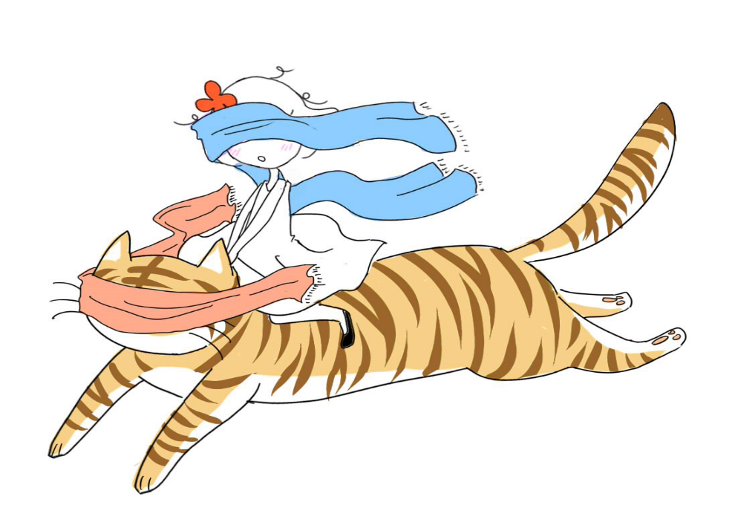

Source: Illustrated by Quin Thong, founder of Ana by Karma.

Exhibit 2: Ana by Karma’s Logo

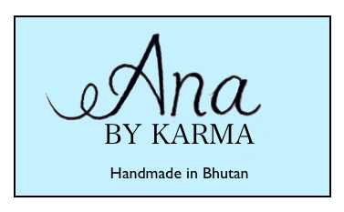

Source: Illustrated by Quin Thong, founder of Ana by Karma.

Exhibit 3: The Tea Party in Shanghai on November 22, 2014

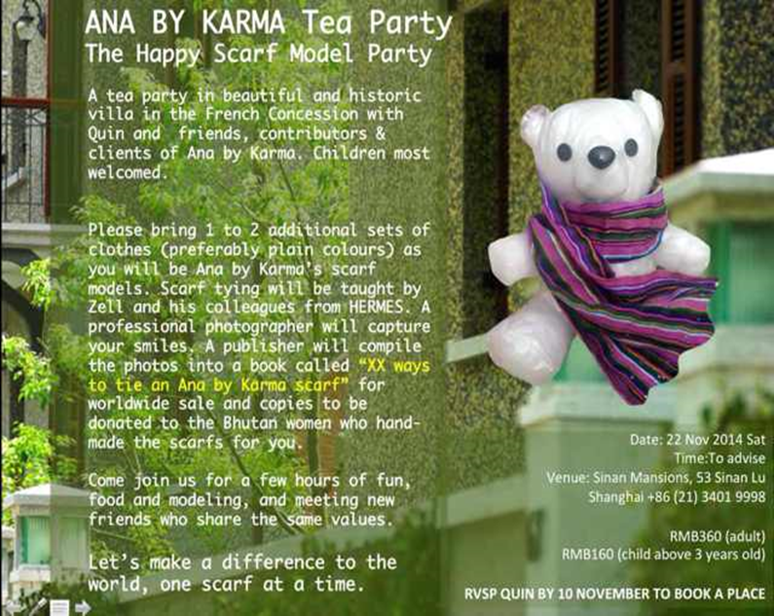

Source: Quin Thong’s WeChat.

Exhibit 4: Selected Promotional Messages from Quin’s WeChat

1. Rachel Chan, a Chief Catalyst quotes “ONLY INNOVATION, NOT CHARITY, CAN TRULY HELP THE POOR” this is the case for Ana by Karma, handmade Bhutanese scarf . . . it not only changed Karma’s life, it changed mine too. Innovation—way to go.
2. I never dreamed that being a social entrepreneur can be so fulfilling, even when I am doing this as a hobby. Friends who lost touch reconnected because they want to do something for Ana by Karma, allowing us to rejuvenate our friendship in a new rosy light. New friends turned up at my doorstep, opened arms and warm hearts, ready to embrace this happy project as their own.
3. CSR is not about reputation nor PR. Peter Drucker 30 years ago said, “turn a social problem into economic opportunity and economic benefit, into productive capacity, into human competence . . . into wealth.”
4. Weaving happiness one scarf at a time.
5. Rules for happiness: something to do; something to love; something to hope for.

Note: CSR = corporate social responsibility; PR = public relations.

Source: Unedited messages from Quin Thong’s WeChat.

Exhibit 5: The Cover of Quin Thong’s Scarf book

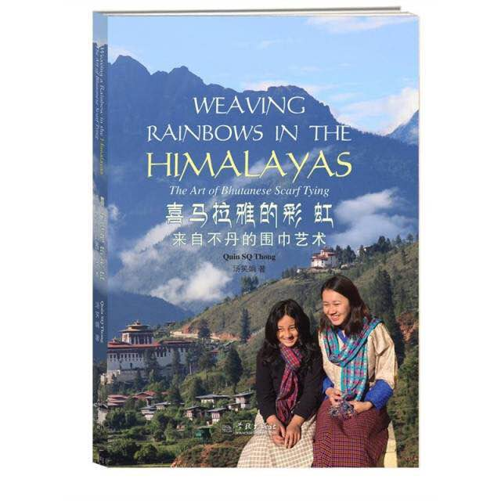

Source: Quin Thong’s WeChat.

Exhibit 6: ana by Karma’s Sales Revenues, 2014–2015 (HK$ ‘000)

Note: US$1 = HK$7.75

Source: Created by the authors using company documents.

Exhibit 7: ana by karma sales by country, June 2014–December 2015

Source: Created by the authors using company documents.

1. All currency amounts are shown in U.S. dollars unless otherwise noted.
2. Quin noted that Karma Yangchi was planning to work together with her sister, Karma Tshomo, to make 3,650 scarves within five years. Since a weaver could make one scarf a day, it would be possible to achieve the goal should they both work tirelessly. In other words, Karma was thinking only about making scarves and not worrying about the sales. She might have taken it for granted that Quin could help sell the scarves as long as she and her sister could make them.
3. ¥ = CN¥ = Chinese yuan; CN¥1 = US$0.16 on November 22, 2014.
4. HK$ = Hong Kong dollar; US$1 = HK$7.75 on December 21, 2015.
5. The typical monthly salary in Thimphu in 2015 was BTN6,000–7,000; BTN = Bhutanese ngultrum; BTN1 = US$0.02 on December 21, 2015. A few weavers working with Ana by Karma were said to earn as much as their husbands.