

9B17M076

EDMONTON CITY CENTRE AIRPORT: A SUSTAINABILITY CHALLENGE FOR A GROWING CITY

Neetu Sharma, Kristel Owens, Graham Graff, Trent Nabe, and Poonam Randhawa wrote this case under the supervision of Professor Joel Gehman solely to provide material for class discussion. The authors do not intend to illustrate either effective or ineffective handling of a managerial situation. The authors may have disguised certain names and other identifying information to protect confidentiality.

*This publication may not be transmitted, photocopied, digitized, or otherwise reproduced in any form or by any means without the permission of the copyright holder. Reproduction of this material is not covered under authorization by any reproduction rights organization. To order copies or request permission to reproduce materials, contact Ivey Publishing, Ivey Business School, Western University, London, Ontario, Canada, N6G 0N1; (t) 519.661.3208; (e)* [*cases@ivey.ca*](mailto:cases@ivey.ca)*;* [*www.iveycases.com*](http://www.iveycases.com)*.*

Copyright © 2017, Richard Ivey School of Business Foundation Version: 2017-06-01

Starting in 1995, many of the flights at Edmonton City Centre Airport (ECCA) had been diverted to Edmonton International Airport (EIA), which was located in Leduc, 30 kilometres south of Edmonton’s city centre (see Exhibit 1). By 2008, ECCA’s two runways required an estimated CA$10 million[1] in capital upgrades and $35 million in additional maintenance costs over the next 10 years. In light of these facts, city council had begun to consider whether maintaining ECCA was feasible or if other alternatives would put the land to better use.

If ECCA closed, city council foresaw multiple prospective uses for the land. For instance, Edmonton was experiencing an exponential population growth rate and an anticipated need to supply additional housing for 150,000 citizens by 2019 (see Exhibit 2). This population increase would further support trending suburban development, which presented a significant financial concern; for every $1 spent on suburban development, the City of Edmonton had to invest an estimated $0.80 towards the development of corresponding infrastructure. These combined factors made the 536-acre ECCA land a hot topic citywide and a main focus for city council.

In November 2011, city council asked Mark Hall, City of Edmonton Land Director, to explore various opportunities for the land. The alternatives available for consideration were maintaining ECCA and the status quo by completing the necessary repairs; selling the property to a real estate developer, thereby generating immediate revenue for other City of Edmonton projects; or closing ECCA, and the City of Edmonton would act as the land developer for a community project.

KEY STAKEHOLDERS

Edmonton City Council

At the time of the ECCA decision-making process, Steven Mandel was approaching his last term as the mayor of Edmonton.

City of Edmonton’s Land Director, Mark Hall

Hall had worked for the City of Edmonton in diverse roles over many years. At the time of the ECCA dilemma, he served in the corporate properties branch and was thus aware of ECCA discussions and debates. With Hall’s assistance, the city councillors hoped to find a clear and sustainable solution to the challenges presented by ECCA.

HISTORY OF EDMONTON CITY CENTRE AIRPORT (ECCA)

Throughout its 80-year history, ECCA had held as many names as it had roles: The Hagmann Farm, Jimmy Bell’s Air Harbour, Blatchford Field, #2 Air Observer School, Royal Canadian Air Force Western Air Command, Industrial Airport, and Municipal Airport.[2] In 1926, the Edmonton and Northern Alberta Aero Club received a $400 grant to transform a patch of farmland into a runway by cutting down willow bushes and packing down soil. Officially declared an “Air Harbour,” this site saw the first trained pilots graduate from the site in 1927. Two years later, Edmonton’s city council authorized $35,000 of expenditures for the airfield and Blatchford Field was born. Named after Keith Alexander (“Kenny”) Blatchford, who was mayor of Edmonton from 1924 to 1926 and later a member of parliament, Blatchford Field became Canada’s first licensed airfield.[3]

During the next 35 years, the airport played an important role in commercial and military aviation, serving not only the Edmonton region, but also destinations within Canada and the United States.[4] In the 1950s, however, a new generation of larger aircraft required longer runways, which a space-confined ECCA could not accommodate. Thus, the search began for another airfield site in the Edmonton region.[5] The airport was supposed to be closed in 1963 when EIA was completed. However, due to active political opposition based on the ECCA’s historical importance and the value that it held in being located near to downtown, the airfield was saved. The airfield operated under different names and mandates, with perhaps one of the most important mandates being its role in providing MedEvac services.[6] In 1995, the citizens of Edmonton voted 77 per cent in favour of consolidating scheduled air traffic at EIA and keeping ECCA open to general and corporate traffic.[7]

HISTORY OF EDMONTON INTERNATIONAL AIRPORT

Prior to 1955, Edmonton’s primary aviation hub was the airfield north of downtown, ECCA, which housed a flight school and a military airfield. As Edmonton grew, however, and because industrial and residential neighbourhoods hemmed in ECCA, the city required more land to house a larger-scale airport.

By 1955, it was obvious that ECCA was inadequate for the innovative jet airliners, which would need two-mile runways and spacious terminals to accommodate over 100 passengers with each flight. A site for EIA was selected near Nisku, Alberta and Transport Canada purchased 7,600 acres of land for a total cost of $1,469,657. With an unwritten “gentleman’s agreement,” the original landowners were allowed to lease back and continue to farm the land until it was needed for further development of the airport. EIA remained Canada’s largest airport in land area, with more than half of its land still under cultivation.[8]

EIA had always competed with ECCA. EIA advocates had long desired to expand its network of international destinations. However, because of the success and profitability of ECCA in creating convenient business air travel in downtown Edmonton, Canadian authorities refused EIA’s expansion due to insufficient revenues and a lack of clear growth strategies. ECCA’s niche market was in direct competition with EIA’s regional travel options and growth plans, which led to an enduring dispute between EIA and ECCA.

In 1995, however, there was overwhelming public support to close ECCA. Fuelled by this public support, EIA began the development of a $450 million construction project to upgrade its facilities in anticipation of what it perceived as the inevitable shutdown of ECCA. Expansion plans for the airport included a new terminal for international flights, a new site for Air Canada, a repurposing of the existing Air Canada terminal for WestJet Airlines Ltd. to accommodate the rapid growth of its regional travel program, additional security and screening infrastructure, and a new cargo management facility.[9]

Although air travel at EIA decreased significantly between the late 1980s and the early 1990s, demand increased in the late 1990s. Despite having been constructed to support 2.8 million passengers, EIA was actually accommodating nearly 3.8 million passengers. This imposed urgency for the completion of the expansion project.[10] In 2009, EIA anticipated that it was only a matter of time until city council voted to shut down ECCA. The shutdown would require EIA to absorb the entirety of Edmonton’s regional business travel, further justifying EIA’s expansion for international travel and large facility upgrades.

EDMONTON’S LAND DEVELOPMENT INDUSTRY

At the same time that news travelled about ECCA’s necessary renovation costs and its potential closure, land developers had also anticipated Edmonton’s next great real estate opportunity. Following the financial crisis of 2008, a lengthy recession depressed the real estate market into a difficult period marked by value losses, increased foreclosures, and reduced rental property revenues.[11] The economic downturn, combined with an opportunity to develop over 500 acres of land near the downtown core, provided land developers with the potential for a large-scale project that could infuse citizens with optimism for the future. With the anticipated first wave of millennials entering the workforce, industry experts were predicting a flood of young adults into the city core to live closer to work and to enjoy their preferred downtown lifestyle.[12]

It was rumoured that key stakeholders in Edmonton land development, including Brookfield Residential Properties Inc., Yorkton Group International Inc., and Melcor Developments Ltd., were submitting large proposals to the City of Edmonton to purchase the entire ECCA land site for redevelopment purposes. One land developer in particular, The Katz Group, was well known for innovative large-scale projects. Therefore, selling the land was a viable proposition for city council to consider.

The Katz Group, headquartered in Edmonton, was one of Canada’s largest privately owned enterprises. As well as being a successful real estate and land developer, also owned diverse businesses, including pharmacies and sports and entertainment facilities. Founder and chairman Daryl Katz was a well-known and well-liked local celebrity. The Katz family had made its first fortune in the pharmacy industry, owning and operating over 475 drugstore locations across central and western Canada. The Katz Group also owned the city’s National Hockey League (NHL) team, the Edmonton Oilers. With Edmonton being home to the third-oldest arena in the NHL, Katz had also planned to build a new arena in the downtown core. With a vision to create a legacy in Edmonton, and with plans to rebuild the downtown core and make the city an international icon, Katz was an ideal candidate to undertake a major land development project like ECCA.

SWEDISH SUSTAINABILITY MODEL

In other parts of the world, sustainability had been explored with different models of implementation and with differing degrees of success over the years. Sweden, a globally acclaimed proponent of sustainable land development, was one such example. Following Sweden’s economic boom in the 1990s, a strong demand for housing led to a strategy to build inwards, rather than outwards.[13] The innovative Scandinavian country thus raised the bar for northern-climate cities with large-scale redevelopments and integrated approaches to harvesting and reusing resources. If successfully completed, these ambitious commitments to produce local renewable energy and to reduce energy consumption would produce leading-edge communities that would attract international visitors eager to witness the ground-breaking sustainable initiatives first-hand.

Sweden completed the first phase of a 395-acre redevelopment of a harbour-front brownfield site in the city of Malmö. Västra Hamnen (“Western Harbour”), an industrial waterfront zone, was planned to be fully redeveloped to house 10,000 residents and to support a total of 30,000 people who would either work or study in the area.[14] The urban development plan included a large expansion of Malmö University, featured a seaside park, and hosted a mobility centre that offered bicycle parking and bio-fuelled cars. Outdoor energy-efficient lighting and accessible public transportation encouraged people to walk and enjoy the boardwalk and public artworks. The area was intended to become Europe’s first carbon-neutral district and to serve as a global example of a sustainable city. Thus, Västra Hamnen also became known as “The City of Tomorrow.”

Developers submitted bids to the city of Malmö and, of the many applicants, more than 20 were chosen to build in Västra Hamnen. Selection was based on contractors’ abilities to meet the goals of the large-scale project: sustainable housing powered by renewable energy, attractive and affordable housing, and a revitalized brownfield site for economic growth. The successful candidates signed The Quality Programme, which listed contract guidelines for building with minimal environmental impact.[15]

The housing plan was dense (approximately 20 units per acre) and strategically placed to maximize efficiency.[16] High-rises along the shoreline formed a wind shelter around smaller blocks and courtyards. Most units featured windows and mirrors predominantly as a way to maximize the use of natural light and passive solar energy. Natural materials and energy-efficient or water-saving appliances were also emphasized. Green rooftops captured rainwater for gardens and insulation, and rooftop solar panels were used to heat the buildings and provide electricity to the district system.

Ecologically, the development included a local district energy system powered entirely by renewable energy sources—a combination of wind, solar, heat from seawater, and biogas. Electricity was generated by solar and wind energy, and hot-water heating was sourced from seawater and solar energy. Buildings were heated and cooled by an aquifer energy storage system that stored heat extracted from seawater. In the summer, warm water filled cavities in the limestone underground, and cold, stored water was pumped up for usage in the district cooling system. In winter, a heat pump increased the water temperature. A geothermal system was used to heat and cool the water.

The automated waste system had separate receptacles for garbage, organic waste, and recyclables that connected to an underground pipeline system. Receptacles, both inside buildings and outdoors, sucked these through an underground pipeline system that ended at a central storage area for municipal waste truck pickup. At the time, waste materials were composted, but plans for a pre-treatment plant included turning organic waste into biogas to generate electricity and vehicle fuel.

However, at the time of the project development, costs were much higher than anticipated due to the new technologies to meet these high standards and the slowdown in the housing market. Consequently, the development’s estimated rental costs were $2,000 per month for a 1,000-square-foot unit compared with $1,500 for similarly sized units elsewhere. Offsetting the price difference, at least partially, was an expectation of 25 per cent lower energy costs in addition to longer building lifespans expected to support higher resale values.[17]

FINANCIAL BACKGROUND

The City of Edmonton, located in oil-rich Alberta, depended on the strength of the oil market for a significant portion of its economy. At the time of the ECCA decision, a financial recession in the United States had dropped the price of oil from a record peak of $147.27 per barrel in July 2008 to less than $60 per barrel in subsequent months,[18] leaving the future of Alberta’s oil revenues in a highly uncertain state. For its capital budget, the City of Edmonton was dependent on both provincial grants and property tax revenues that were tied to the real estate market and the economy. While most Canadian cities, including Edmonton, had survived prior shocks to the real estate market, the job market and local economy were forecast not to remain resilient if oil prices remained depressed.

Financial Comparison of Alternatives

City council faced several financial implications regarding what to do with the large area of prime ECCA land located near downtown Edmonton. Upholding the status quo and maintaining ECCA operations was an attractive option because the city would not be placed in a controversial situation. However, maintaining ECCA would come at a steep cost because the city would need to invest tens of millions of capital dollars in the infrastructure over the next few years. Additionally, opportunity costs were associated with keeping the airport operational, particularly because downtown buildings were restricted in height due to the Airport Protection Overlay, a set of regulations that constricted downtown development. Furthermore, ECCA was operating a breakeven cost model and was not expected to ever become profitable, given its small and restricted scale.

The prospect of closing the airport left the city with two primary options: to sell or to develop the land. An immediate sale of the land was expected to generate approximately $250 million. Moreover, interested buyers who were more than qualified as potential developers had unofficially approached various councillors and administrators. Therefore, the city could plan the sale of the land, dispose of the land systematically in a short period of time, and expect revenue, all within a short timeframe of a year or two. Given the uncertain economic environment in 2011, such a significant cash flow would bolster the city treasury or be used for other much-needed projects that had been postponed due to a lack of financing.

A third option existed, which was a staged development of the land that would provide residences for over 30,000 people. This option, however, required a significant cash outlay upfront. The cash inflows from sales were expected to occur over 20 to 25 years, in an effort by the city to avoid flooding the local market with homes. The investment option would thus be long-term and the city would hold the investment risk, which would be subject to unforeseeable real estate demand and price fluctuations.

Yet another consideration was the adding of a sustainability dimension to the development plan. This dimension, however, would involve a cost premium due to both the new technology and the limited number of builders able to commit to such a novel concept. Because consumer demand for a sustainable neighbourhood was unknown, the city would, here again, be left managing the risk.[19]

One financial advantage to an infill development (using ECCA land for residential purposes) was a reduction in operating costs because an infill development would be cheaper to service than an expanded suburban development. If the city could divert 30,000 residents from new suburbs to the downtown area, the reduced need for additional infrastructure development over time would decrease overall operating costs such as snow clearing, garbage collection, and road maintenance.

MOVING FORWARD

In 2008, an interesting factor arose that influenced decision making related to the ECCA development. The City of Edmonton developed “The Way Ahead” (see Exhibit 3), a document that proposed Edmonton’s strategic vision over the next 40 years, as well as its strategic goals for the next 10 years. “The Way Ahead” contributed significantly to city council’s mind-set for overall municipality decision making. In contemplating the sustainability of ECCA land, in particular, the project’s decision making needed to consider the goals of “The Way Ahead” document.

Although no official offer to purchase ECCA land had been considered by council, potential buyers did exist and the expected sale price of the complete parcel would be approximately $250 million. If council pursued this option, the immediate and long-term financial impact of the sale on the city’s budget would be extraordinary for its population of one million. Situated in downtown Edmonton, ECCA land could, for example, be used for a world-class development that could support the co-existence of commercial and residential lifestyles simultaneously. This multi-purpose development could promote many economic benefits such as job creation and increased tourism revenues. This option would also silence the critics of city development, as many development industry experts believed that the city was either unqualified or should not be competing with land developers.

In 2009, on behalf of ECCA stakeholders, the Canadian Business Aviation Association released a report outlining future plans for ECCA and the reasons why ECCA should be maintained as an operational airport. Within this report were plans to reduce noise and light pollution and increase revenues by garnering corporate business interest in utilizing the airport for northern flights to Alberta’s oil sands. Additional plans included the development of a “Mayo Clinic of the North”—a healthcare concept intended to create a national centre of excellence for healthcare services in Canada. While these clinic plans alone were promising, the persuasive voices arguing to keep ECCA’s MedEvac Services intact presented city council with an ethical dilemma. If MedEvac Services were to be transferred to EIA, the increase in patient transportation times to Edmonton’s major hospitals would be dramatically increased. As documented in a report regarding MedEvac Services, some of Edmonton’s highest-ranking medical officials wrote letters to city council expressing their opposition to the closure of ECCA. These letters were inspired by the sensitive, timely nature of medical care required for MedEvac Services’ patients. Between 2006 and 2008, ECCA accommodated an average of 3,867 MedEvac Services flights per year, of which approximately 350 were deemed “time critical” (see Exhibits 4 and 5). Although it was difficult to estimate, some officials believed that between five and eight more patients would die each year should MedEvac Services be moved to EIA.

Ultimately, the future of ECCA land would be determined by city council, which recognized, in this situation, an immense opportunity for environmental leadership. Hall believed that a plan needed to be formulated that would inspire Edmontonians to seek a brighter future for the city. After months of research and feedback, Hall had created a vision for the city’s future and was ready to make a clear recommendation to city council so it too would deliver a strong future for the ECCA land.

EXHIBIT 1: Location of Edmonton City Centre Airport

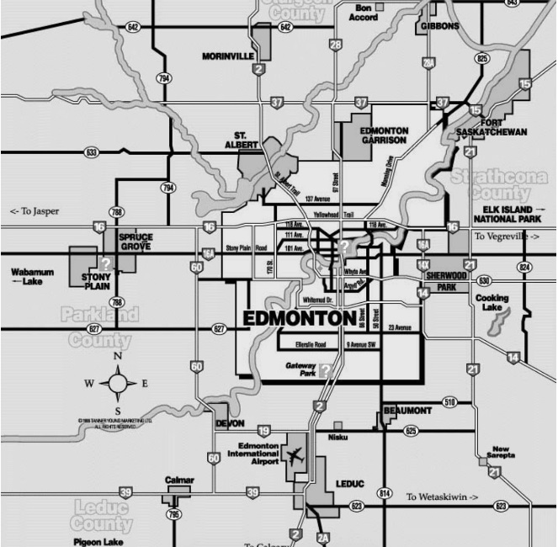

Medevac,

Royal Alexandra Hospital

ECCA

Medevac Relocation, University of Alberta Hospital

EIA

Source: Created by the authors with data from City of Edmonton files.

EXHIBIT 2: Expected Population Growth of the City of Edmonton

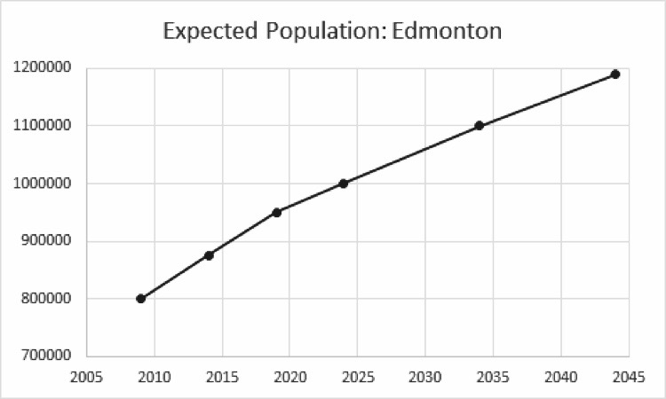

Population

Year

Source: Created by authors using data from City of Edmonton files.

EXHIBIT 3: City of Edmonton’s 10-Year Strategy: “The Way Ahead”

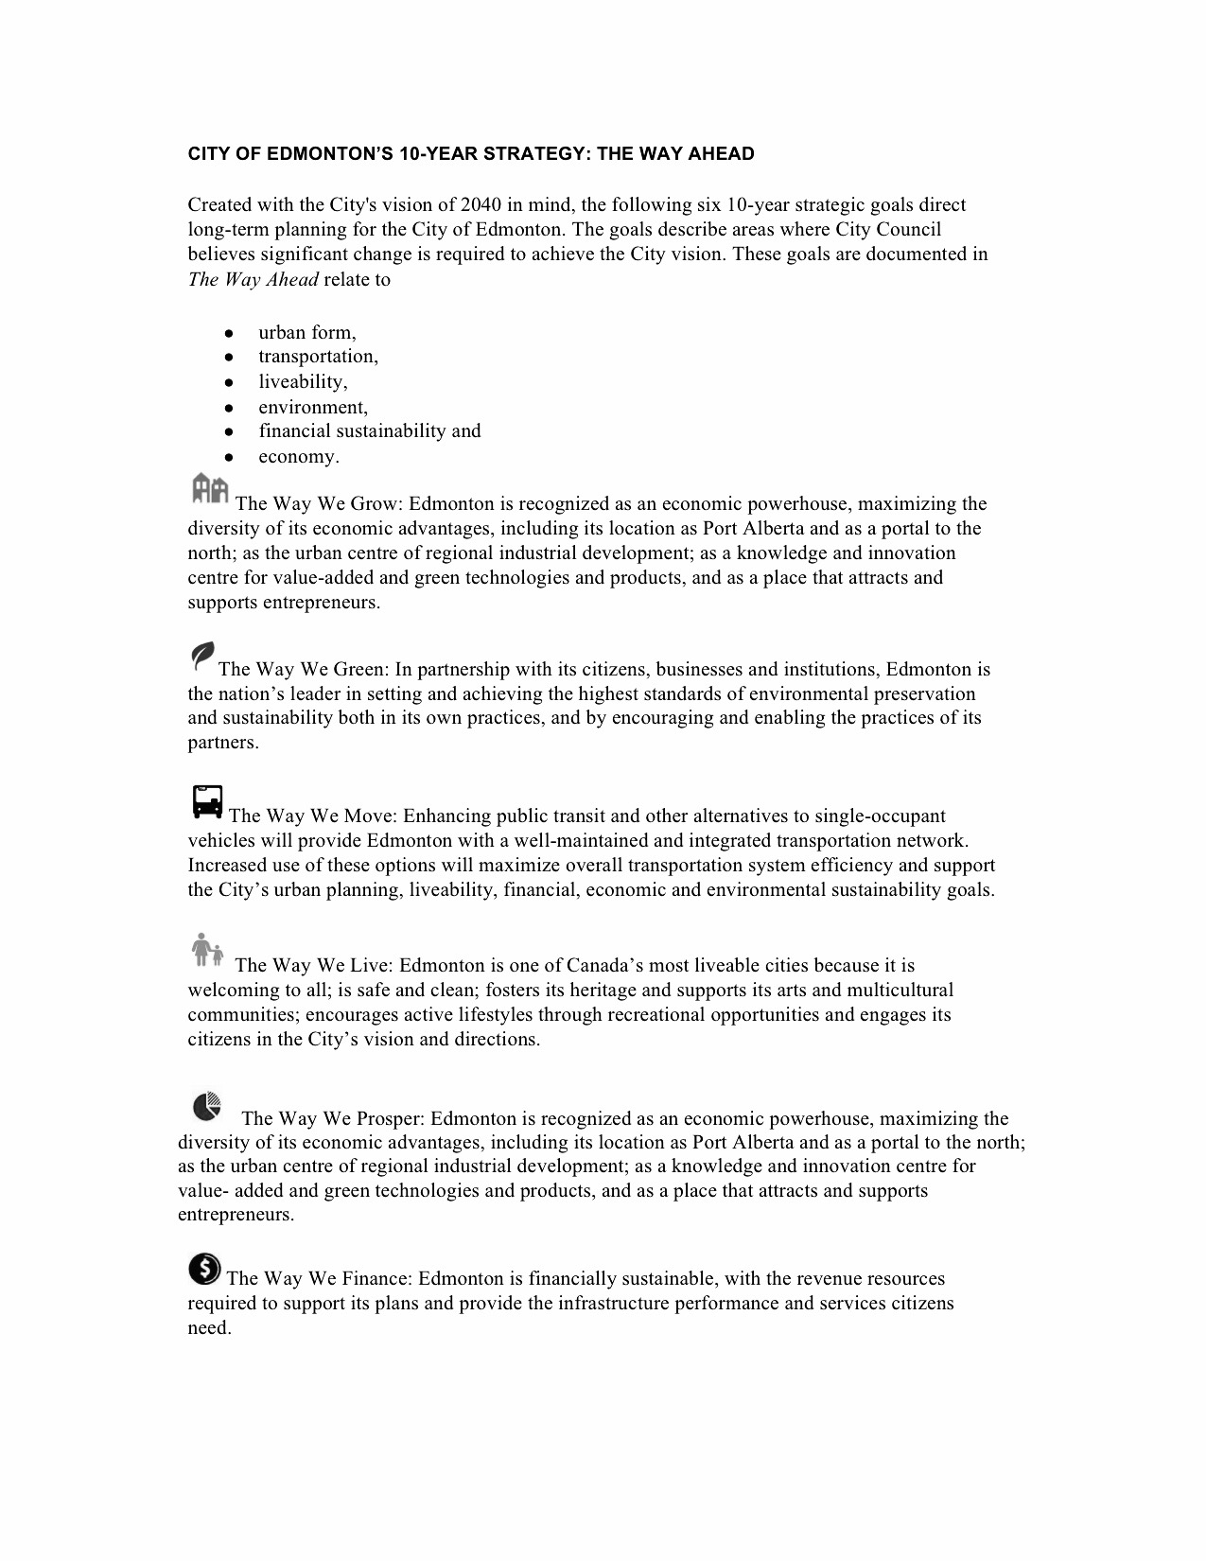

Source: City of Edmonton files.

EXHIBIT 4: MedEvac Services’ Transport Times

Average Transport Times from ECCA to Edmonton’s Major Hospitals

|  |  |
| --- | --- |
| **Edmonton EMS from ECCA** | **Average transport time** |
| ECCA to UAH-258 | 17:51 |
| ECCA to RAH-86 | 8:38 |

**Average Transport Times from EIA to Edmonton’s Major Hospitals**

|  |  |  |
| --- | --- | --- |
| **Travel time from EIA to** | **Heli-shuttle** | **Ground ambulance** |
| UAH/Stollery | 12 minutes | 26 minutes |
| RAH | 13 minutes | 42 minutes |

Source: Created by authors with data from City of Edmonton files.

EXHIBIT 5: ECCA MedEvac Services Traffic, 2006–2008

Total MedEvac Traffic Using ECCA

|  |  |
| --- | --- |
| **Year** | **Total** |
| 2006 | 3,377 |
| 2007 | 4,232 |
| 2008 | 3,993 |

2008 Fixed-Wing and Rotary Totals

|  |  |
| --- | --- |
| Originating in province | 3,686 |
| Originating out of province | 161 |
| Unknown | 146 |
| Total | 3,993 |

Source: Created by authors with data from City of Edmonton files.

1. All currency amounts are in CA$ unless otherwise specified.
2. “History: Edmonton’s Historic City Centre Airport,” EIA, 2015, accessed October 29, 2015, http://corporate.flyeia.com/

   edmonton-area-airports/edmonton-city-centre/history.
3. “History: Edmonton’s Historic City Centre Airport,” op. cit.
4. Ibid.
5. Ibid.
6. Ibid.
7. Ibid.
8. “EIA History: The Story of Edmonton International Airport,” EIA, accessed November 1, 2015, http://corporate.flyeia.com/

   about-us/eia-history.
9. Ibid.
10. Ibid.
11. ULI: Urban Land Institute and Price Waterhouse Coopers, *Emerging Trends in Real Estate 2009* (October 2008), 1, accessed November 3, 2015, http://uli.org/wp-content/uploads/ULI-Documents/EmergingTrendsUS2009.pdf.
12. Alberta Venture Staff, “Top 5 Real Estate Trends: The Things You Need to Know about Where Markets Are Heading,” *Alberta Venture*, May 25, 2015, accessed November 3, 2015, http://albertaventure.com/2015/05/top-5-real-estate-trends.
13. Andrea Gaffney, Vinita Huang, Kristin Maravilla, and Nadine Soubotin, *Hammarby Sjostad Stockholm, Sweden: A Case Study* (Fall 2007), 13, accessed November 1, 2015, www.aeg7.com/assets/publications/hammarby%20sjostad.pdf.
14. Margaret Steele, *Taking an Integrated Approach to Sustainable Community Design: A Brief Overview of EQuilibriumTM Communities Projects and a Sample of Other National and International Projects*, accessed March 30, 2017, www.oaa.on.ca/oaamedia/documents/Taking%20an%20Intergrated%20Apporach%20to%20Sustainable%20Community%20Design.pdf.
15. CMHC SCHL: Home to Canadians, *Innovative Buildings: Bo01 Sustainable Housing Development Malmö, Sweden* (September 5, 2005), accessed November 5, 2015, https://www.cmhc-schl.gc.ca/en/inpr/su/hirimu/inbu/upload/innovative-buildings-bo01-sustainable-housing-development.pdf.
16. Ibid.
17. “Sustainable Cities: Malmö: Bo01—An Ecological City of Tomorrow,” DAC & Cities, January 21, 2014, accessed November 3, 2015, www.dac.dk/en/dac-cities/sustainable-cities/all-cases/master-plan/Malmö-bo01---an-ecological-city-of-tomorrow.
18. Ari J. Officer, “What Caused the Big Slide in Oil Prices,” *Time*, November 14, 2008, accessed August 24, 2016, http://content.time.com/time/business/article/0,8599,1859380,00.html.
19. NRU Publishing-Vancouver Edition, “News: Sprawl Rethinking Suburbia,” Sustainable Prosperity: Making Markets Work for the Environment, January 27, 2014, accessed December 2015, http://nkp.smartprosperity.ca/news/sprawl-rethinking-suburbia.